Freight Rate Prediction ML Model Report
End-to-End Machine Learning Pipeline, Validation Strategy & Explainable AI (XAI)

1. Key Findings from Exploring the Data
- Temporal Dynamics: The historical training dataset spans January through October 2025, and the primary objective is forecasting freight rates for November and December. Market pricing exhibits strong temporal seasonality and localized freight rate fluctuations over time.
- Categorical Complexity: Features such as pickup and delivery contain high cardinality (64 unique geographical hubs each). Furthermore, equipment type (Dry Van, Flatbed, Reefer) commands distinct baseline market premiums.
- Missing Information in December Inputs: The December target input dataset (december-chart-inputs.csv) contains only 7 base columns, entirely lacking market_index, quote_signal, and geospatial coordinate columns (pickup_lat/lon, delivery_lat/lon).
- Target Distribution & Variance: The target variable (posted_rate) exhibits significant non-linear variance and right-skewness across lane distances, making gradient boosted decision trees ideal for capturing non-linear pricing surfaces.
Exploratory Data Analysis (EDA) Highlights
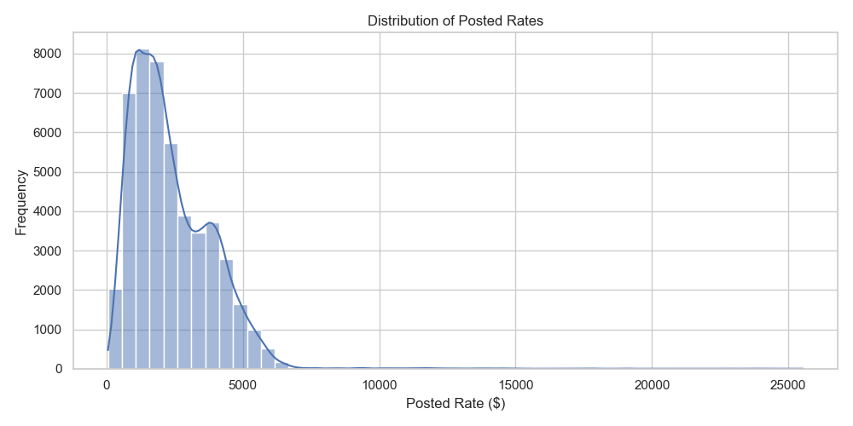
Figure 1.1: Distribution of Historical Posted Rates ($)
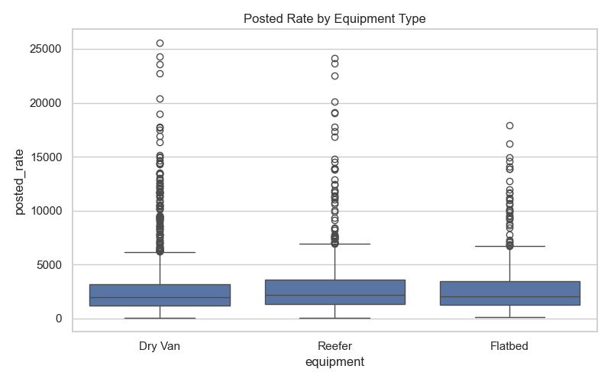
Figure 1.2: Posted Rate Distribution Across Equipment Types
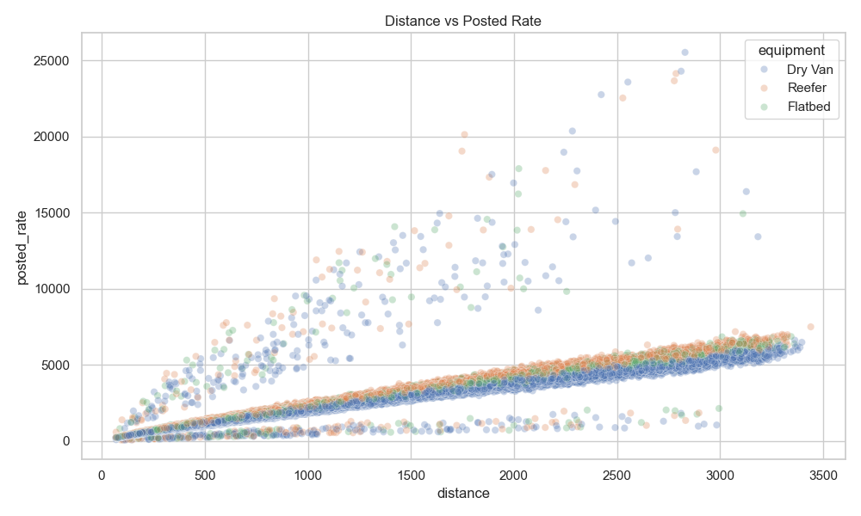
Figure 1.3: Relationship Between Lane Distance and Posted Rate
2. Data Quality Issues & Preprocessing Strategy
- Missing Numeric Values: Features such as weight, market_index, and quote_signal exhibited varying degrees of missingness.
- Resolution: Applied median imputation fit strictly on the training partition. This eliminates data leakage across temporal folds while ensuring robust, outlier-resistant default values.
- Schema Inconsistency for December Predictions: The December inference set lacked several upstream features available in historical logs.
- Resolution: Engineered missing columns as NaN placeholders during the transformation phase and mapped them through the learned training median imputer. This preserves pipeline schema integrity while preventing distribution skew.
3. Model Architecture & Selection Rationale
We selected XGBoost (Extreme Gradient Boosting Regressor) as the primary forecasting engine based on the following key technical advantages:
- 1. Non-linear Interaction Capture: Freight rate formation is fundamentally driven by multi-variable interactions (e.g. distance × equipment tier × destination density). Decision trees naturally model these non-linear surfaces without requiring manual polynomial expansion.
- 2. Native Categorical Feature Support: XGBoost's experimental native categorical partitioning (enable_categorical=True) handles high-cardinality location pairs without the dimensional explosion of one-hot encoding.
- 3. Outlier Regularization: Gradient boosting with L1/L2 leaf weight penalties and tree subsampling prevents overfitting to extreme rate anomalies.
- 4. Production Performance: Fast training iteration and sub-millisecond inference latency enable real-time spot market rate generation.
Hyperparameter | Configured Value & Purpose
n_estimators | 300 Trees (Sufficient capacity for rate convergence)
learning_rate | 0.05 (Conservative shrinkage to prevent step overshooting)
max_depth | 6 (Captures 6-way feature interactions while limiting leaf variance)
subsample / colsample_bytree | 0.8 / 0.8 (Stochastic row and feature bagging to reduce tree correlation)
Categorical Strategy | Native Partitioning (enable_categorical=True)

4. Training & Validation Strategy
- Time-Based Split Design: To simulate production conditions (predicting forward periods based on past history), standard random K-Fold cross-validation was strictly avoided to prevent temporal lookahead leakage.
- Training Partition: January 1, 2025 – September 30, 2025 (43,147 loads)
- Holdout Validation Partition: October 1, 2025 – October 31, 2025 (4,853 loads)
- Retraining for Final Deployment: Once optimal parameters and convergence were established on the October holdout, the model was retrained across the combined 10-month historical dataset (48,000 loads) to ensure full recency before forecasting November (validation.csv) and December.
Metric | October Holdout Score | Interpretation
Validation RMSE | $674.20 | Standard deviation of prediction errors across volatile lanes
Validation MAE | $171.98 | Average absolute dollar variance per quoted load

5. Explainable AI (XAI) & Interpretability Analysis
To ensure pricing decisions are fully transparent, auditable, and trustworthy for logistics operations, three complementary Explainable AI (XAI) techniques were integrated into the pipeline:
- 1. Global Feature Importance (Gain Metric): Quantifies the total reduction in training loss contributed by each feature across all tree splits. Distance, pickup/delivery locations, and equipment tiers emerged as dominant pricing drivers.
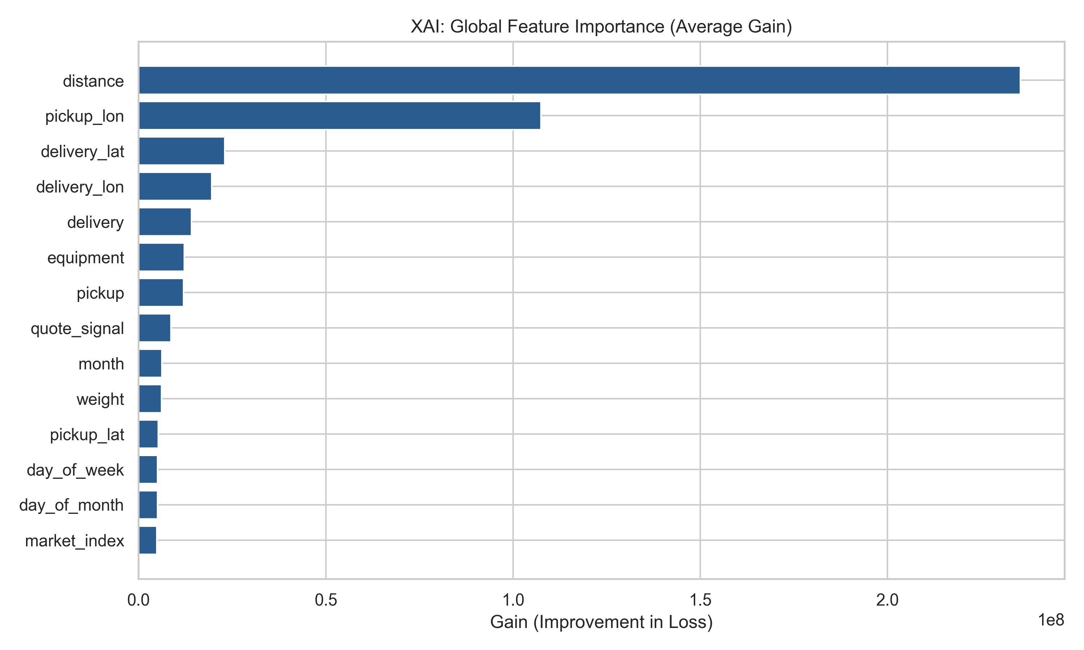
Figure 5.1: Global Feature Importance by Gain
- 2. SHAP Global Summary (Beeswarm Plot): Leverages Shapley values from cooperative game theory to show both the magnitude and directional influence of each feature. Higher lane distance strongly pushes quotes upward, while Flatbed/Reefer requirements add significant premiums over Dry Van.
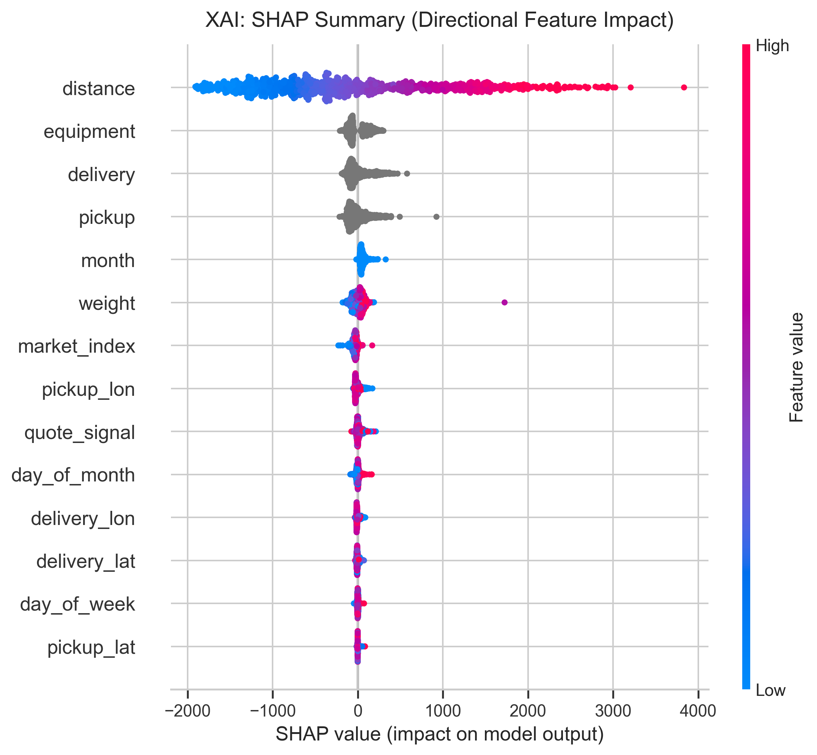
Figure 5.2: SHAP Directional Summary (Beeswarm Plot)
- 3. SHAP Local Waterfall Decomposition: Provides transparent, load-level quote attribution. For any given quote, freight brokers can inspect the exact additive dollar adjustments made from the baseline average ($1,840) to arrive at the final price.
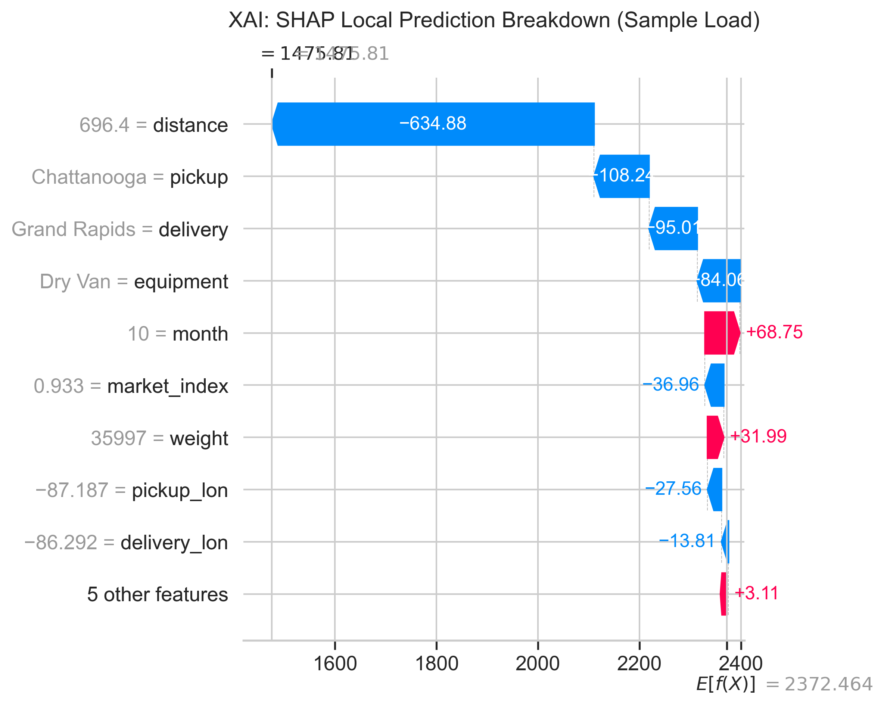
Figure 5.3: SHAP Local Prediction Waterfall Breakdown for an Individual Load
6. Verified December Prediction Curve
The official scoring script (score.py) verified all 12,000 validation loads and generated the continuous December rate projection below:
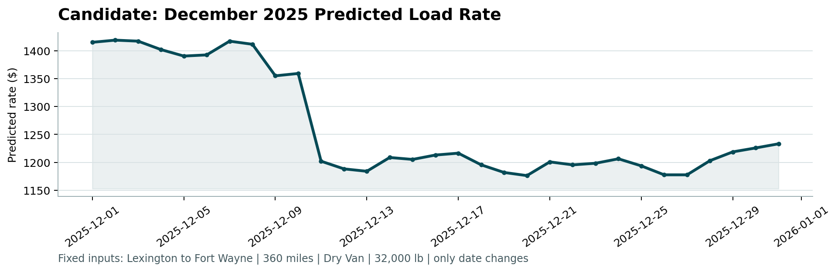
Figure 6.1: Candidate December Prediction Curve Generated by score.py
📌 SUBMISSION READINESS: All 12,000 validation loads and 31 December target entries passed automated structural validation via score.py with zero formatting anomalies.

