MULTI-OBJECTIVE TRAFFIC
SIGNAL OPTIMIZATION
Consolidated project and performance report
Multi-Agent Reinforcement Learning (PPO) with ARIMA-aided state forecasting in SUMO

Executive summary
This project evaluates adaptive traffic-signal control in SUMO using a shared-policy, multi-agent PPO controller. Four intersections are controlled using local traffic-state observations augmented with short-horizon ARIMA inflow forecasts. The controller is compared with fixed-time signal timing using the current evaluation artifact, results/evaluation_metrics.csv.
Across the reported 10-episode evaluation, the MARL policy reduced per-step waiting time by 93.1%, CO2 emissions by 22.5%, and fuel consumption by 22.5% relative to the fixed-time baseline. These exceed the project targets (>10% waiting-time reduction; >5% CO2 and fuel reduction). The improvement is promising, but training logs show worsening episode-level metrics, and multiple archived/sanity artifacts describe different runs. Results should therefore be treated as simulation evidence rather than proof of stable training or field readiness.
Outcome | Observed change | Project target
Waiting time | 93.1% lower | Target >10%: achieved
CO2 emissions | 22.5% lower | Target >5%: achieved
Fuel consumption | 22.5% lower | Target >5%: achieved

Project overview
The system frames each signalized intersection as an agent. A shared PPO policy is trained in the SUMO microscopic-traffic simulator through TraCI. Traffic demand can be calibrated from Delhi traffic-density CSV traces; the project configuration enables dataset-driven route patching and deterministic simulation settings.
- Network: four signalized intersections (TL00, TL01, TL10, TL11).
- Observation: lane queue length, waiting time, current signal phase, and a five-step ARIMA inflow forecast.
- Actions: maintain the phase, switch to the next phase, or extend green; timing constraints include minimum/maximum green and yellow transitions.
- Objective: reduce traffic delay and environmental costs through a configurable reward combining waiting time, CO2, and fuel.

Evaluation setup
The current run summary identifies PPO (PyTorch), 10 training episodes, a multi-objective reward, and aggressive logarithmic scaling for CO2 and fuel. The project configuration specifies a shared policy, learning rate 3e-5, discount factor 0.995, 1-second simulation steps, minimum/maximum green of 10/60 seconds, and a 4-second yellow interval. Evaluation uses 10 episodes, with baseline-versus-agent comparison reported in per-step averages. The fixed-time reference uses 30-second green and 4-second yellow timing.
Reported units follow the project plot labels: waiting time in seconds, CO2 in mg, and fuel in ml, expressed as per-step values. The CSV does not provide uncertainty intervals; the percentage reductions are descriptive aggregate comparisons.

Aggregate results
Metric | Fixed-time baseline | MARL PPO | Reduction | Reported unit
Waiting time | 187.85 | 12.94 | 93.1% | s/step
CO2 emissions | 166,988.47 | 129,398.23 | 22.5% | mg/step
Fuel consumption | 54,179.74 | 41,984.94 | 22.5% | ml/step

Interpretation. The largest measured gain is in waiting time. Emissions and fuel also improve in the aggregate, which is consistent with less stop-and-go traffic. At the episode level, the MARL agent has lower waiting time in all 10 paired episodes; CO2 and fuel are lower in 8 of 10 episodes, so environmental gains are not uniform for every demand instance.

Baseline versus MARL comparison
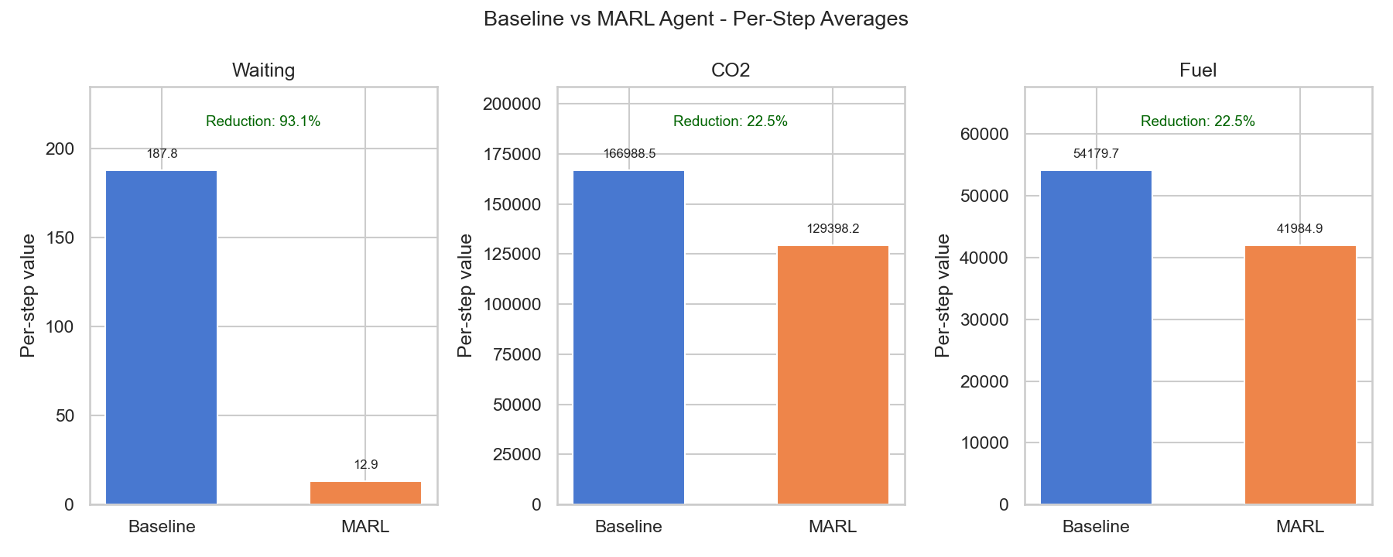
Figure 1. Per-step averages from the current baseline-versus-MARL comparison plot.

Training behavior and interpretation
The current training log contains 10 recorded episodes. From its first to last row, mean reward changes from -943.7 to -1,192.2 (more negative), while mean waiting time rises from 13.2 to 61.4. CO2 and fuel also rise over these endpoints. The training plot therefore does not show a simple monotonic convergence pattern. Training-episode values and evaluation aggregates are distinct measurements and should not be conflated.
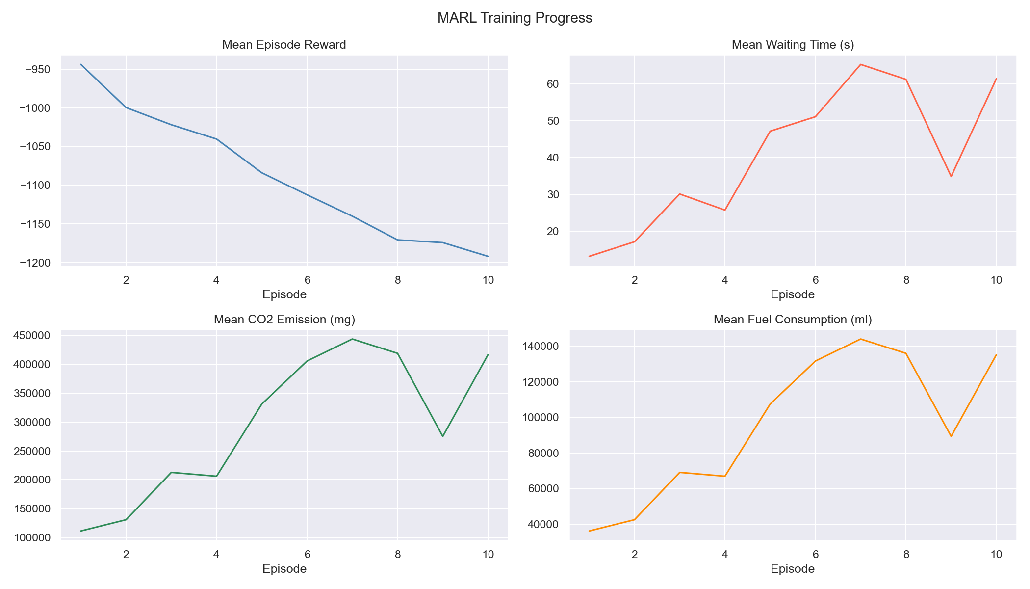
Figure 2. Training history recorded in results/training_logs.csv.

Data quality and run reconciliation
- Primary result source: results/evaluation_metrics.csv, consistent with report/model_performance_report.md and the comparison plot; this is the source of headline numbers in this document.
- The report/main.tex draft and archived evaluation_metrics_20260406_000359.csv contain an earlier result snapshot (about 92.95% waiting-time and 22.29% CO2/fuel reduction). These values are not mixed with the current CSV values (93.1% and 22.5%).
- Sanity evaluation CSVs are single-episode checks with zero waiting time in both conditions and near-zero or negative emissions/fuel improvement. They are not treated as the primary benchmark.
- Some draft/configuration details differ across artifacts (for example, the TeX draft mentions 150 training episodes, while the current run summary/configuration say 10). The current CSVs and current run summary take precedence for this report.

Limitations and recommended next steps
- Repeat evaluation across multiple independent random seeds and report means, variability, and confidence intervals; retain episode-level paired comparisons.
- Verify that the evaluated checkpoint, training log, run configuration, and reported CSVs are all produced by the same run; record a run ID and configuration snapshot with each artifact.
- Investigate the divergent training curves and perform ablations for reward weights, normalization/scaling, and ARIMA features before claiming stable multi-objective learning.
- Before field deployment, validate on broader demand patterns and provide an external safety supervisor for legal phases, pedestrian clearance, emergency priority, and fail-safe fallback.

Conclusion
The current evaluation artifacts show substantial improvement over fixed-time control on waiting time, CO2, and fuel in SUMO. The result meets the stated project thresholds and supports further experimentation with ARIMA-aided multi-agent control. Training instability indicators, run-to-run differences, and the simulation-only setting warrant more reproducible, multi-seed validation before drawing stronger deployment conclusions.

Source artifacts
Source | Use in this report
report/model_performance_report.md | Run summary, headline results, targets, checkpoint/artifact notes.
report/main.tex | System design, methodology, older run snapshot, limitations.
results/evaluation_metrics.csv | Primary aggregate baseline-versus-MARL metrics.
results/training_logs.csv | Training history and trajectory caveat.
results/comparison_plot.png; results/reward_plot.png | Figures 1 and 2.
config/config.yaml | Current project simulation, PPO, state, action, and evaluation settings.

