TransitPulse AI: Multi-Modal Public Transport Feedback Intelligence & Decision Support System for Mumbai Metropolitan Region
SUBMITTED IN PARTIAL FULFILLMENT FOR THE DEGREE OF
BACHELOR OF ENGINEERING
In
Artificial Intelligence Data Science
By
Kajolini Palaniswamy | 123A8025
Lakshya Senthilkumar | 123A8031
Mitesh Naik | 123A8037
Supervisor
Dr.Vidya Keshwani

Department of
Artificial Intelligence and Data Science
SIES Graduate School of Technology Nerul,
Navi Mumbai - 400 706
University of Mumbai
(AY 2025-26)

Mini Project Approval
This NLP Mini Project entitled "TransitPulse AI: Multi-Modal Public Transport Feedback Intelligence & Decision Support System for Mumbai Metropolitan Region" by Kajolini Palaniswamy (123A8025), Lakshya Senthilkumar (123A8031), Mitesh Naik (123A8037) is approved for the degree of Bachelor of Engineering in Artificial Intelligence and Data Science.
Examiners
1...............................................................
(Internal Examiner Name & Sign)
Date:
Place:

CONTENT
Sr.No. | Topic | Page No.
1. | Abstract | 5
2. | Introduction | 6
3. | Detailed System Design | 7
4. | Snapshots of working project | 11
5. | Conclusion and Future Scope | 16
6. | References | 18

ACKNOWLEDGEMENT
We would like to express our thanks to the people who have helped us the most throughout our project. We are grateful to our guide and coordinator Dr.Vidya Keshwani for nonstop support for the project.
A special thanks goes to each other who worked together as a team in completing the project, where we all exchanged our own interesting ideas, thoughts and made it possible to complete our project with all accurate information. We also wish to thank our parents for their personal support and attention who inspired me to go my own way.
We would also like to extend our sincere gratitude to our Principal Dr. K. Lakshmisudha and our Head of the Department Dr. Arathi Boyanapalli for their continuous support and encouragement.
We also would like to thank our other faculty members for providing us with all the required resources and references for the project.

ABSTRACT
Public transport networks in the Mumbai Metropolitan Region (MMR) cater to over 8 million daily commuters across Suburban Local Trains, Mumbai Metro, Monorail, and municipal buses (BEST and NMMT), generating massive volumes of unstructured passenger feedback across mobile apps, social media, emails, and web portals that are difficult to analyze manually. To address this challenge, this project develops TransitPulse AI, an integrated AI-driven Public Transport Feedback Intelligence and Decision Support System that combines Natural Language Processing (NLP), Machine Learning, Geographic Information Systems (GIS), and predictive analytics into a unified operations platform. The system performs automated 9-class service categorization, sentiment polarity scoring ([−1.0,1.0][−1.0,1.0]), and 6-class emotion detection (Anger, Frustration, Anxiety, Satisfaction, Gratitude, Neutral), while a domain-specific Transit Named Entity Recognition (NER) pipeline extracts Mumbai stations, routes, directions, and mechanical aspects to render real-time spatial bottleneck heatmaps. An automated Decision Support Engine diagnoses underlying root causes, prescribes prioritized operational directives with estimated CSAT recovery impacts, and enables transit supervisors to edit suggestions or create custom directives, empowering transport authorities with data-driven decision-making and rapid operational incident resolution.
INTRODUCTION
Public transportation forms the lifeline of major metropolitan economies. In the Mumbai Metropolitan Region (MMR), daily commuter transit relies on an intricate multi-modal ecosystem comprising Western and Central Railway Suburban Local Trains, the expanding Mumbai Metro network, the Mumbai Monorail, and municipal bus networks such as BEST (Brihanmumbai Electric Supply and Transport) and NMMT (Navi Mumbai Municipal Transport). Due to unprecedented passenger densities, transit authorities face complex operational bottlenecks ranging from signaling delays and peak-hour platform crushing to ticketing kiosk failures and air conditioning breakdowns.
Commuters voice their grievances, queries, and appreciation across highly fragmented digital touchpoints, including specialized mobile apps (e.g., M-Indicator, UTS, Chalo App), social media handles (e.g., @RailMinIndia, @myBESTBus, @MahaMumbaiMetro), customer support emails, and grievance web portals. However, traditional transport management systems rely on siloed, manual ticket resolution workflows. Transport authorities lack automated tools to synthesize large-scale unstructured feedback, link grievances to specific geospatial coordinates, identify root causes, and prescribe proactive dispatch measures before minor delays escalate into major network disruptions.
To bridge this gap, this project develops TransitPulse AI, an intelligent, multi-modal feedback intelligence and decision-support platform designed specifically for the Mumbai transit network. The system introduces three key innovations: (i) an NLP pipeline capable of multi-class transit categorization, multi-dimensional sentiment polarity, and fine-grained commuter emotion recognition; (ii) a Transit Named Entity Recognition (NER) and GIS mapping engine that correlates passenger grievances with topological transit nodes across Mumbai and Navi Mumbai; and (iii) an automated Decision Support and Action Recommendation Engine that performs root-cause diagnosis, prescribes prioritized operational actions, and empowers transit supervisors to edit, customize, and dispatch interventions in real time.
The prototype incorporates an interactive executive operations dashboard, an interactive Leaflet GIS heatmap explorer, a live NLP testing laboratory, a public commuter feedback portal with real-time AI triage previews, and a scenario simulation module capable of modeling disruptions such as Dadar peak rush hour crush, monsoon waterlogging delays, and smart-card ticketing outages.

DETAILED SYSTEM DESIGN
4. System Design Overview
The TransitPulse AI system architecture is structured into modular, decoupled layers that process raw, multi-source passenger text, extract structured semantic and spatial entities, aggregate topological network health, diagnose root causes, and present actionable operational directives through interactive dashboards. The end-to-end data pipeline operates in real time, supporting both stream ingestion and batch analytical workflows across the Mumbai Metropolitan Region.
4.1 Multi-Source Data Ingestion Layer
The ingestion layer collects feedback from heterogeneous channels across Mumbai:
• Mobile Application Connectors: Ingests structured and semi-structured reviews from apps like UTS, Chalo, and M-Indicator, including 1-5 star ratings, mode tags, and timestamps.
• Social Media Stream Listener: Scrapes and streams microblog posts, tags, and mentions (@Central_Railway, @WesternRly, @myBESTBus).
• Customer Service Emails & Web Portals: Processes long-form commuter grievance submissions.
• Real-Time Normalizer: Cleans, sanitizes, and maps incoming records to standard Pydantic schema models.
4.2 NLP Intelligence & Feature Extraction Pipeline
The NLP intelligence core executes parallel feature extraction pipelines:
1. Service Category Classifier (9 Classes): Maps feedback text across critical transit domains: (i) Punctuality & Delays, (ii) Overcrowding & Capacity, (iii) Cleanliness & Hygiene, (iv) Driver & Staff Behavior, (v) Ticketing, Smart Cards & Fares, (vi) Safety, Security & Lighting, (vii) Accessibility & Special Needs, (viii) Route Frequency & Network Coverage, (ix) HVAC & Vehicle Comfort.
2. Sentiment & Emotion Analysis Engine: Computes a continuous polarity score in [-1.0, +1.0] and classifies discrete sentiments (Positive, Neutral, Negative). It further models a 6-class probability distribution across commuter emotions: Anger, Frustration, Anxiety, Satisfaction, Gratitude, and Neutral.
3. Transit Named Entity Recognition (NER) & GIS Resolver: Custom regex and lexicon-augmented entity recognizer tuned for Mumbai transit vocabulary. It extracts station names (CSMT, Dadar, Kurla, Andheri, Borivali, Thane, Vashi, Panvel, etc.), transit line identifiers (Western Line Local, Metro 3 Aqua Line, Monorail, BEST 302), travel directions (Churchgate-bound, CSMT-bound, Virar-bound), peak-hour time contexts, and mechanical aspects (FOBs, escalators, AC rakes, card readers).
4.3 Geospatial GIS Analytics & Network Layer
The GIS engine models the spatial topology of the Mumbai transit network:
• Vector Spatial Database: Stores geo-coordinates, transit modes, and station zones for 38+ primary stations and 10 major transit lines (Western, Central, Harbour, Metro 1/2A/7/3, Monorail, BEST/NMMT corridors).
• Spatial Aggregation & Station Issue Scoring: Calculates real-time CSAT (0-100%), negative sentiment ratios, and composite hotspot intensity scores for each station.
• Leaflet Heatmap Layer: Generates dynamic coordinate-intensity arrays ([lat, lng, weight]) highlighting operational failure hotspots (e.g., signal failures at Kurla or FOB crowding at Dadar).
4.4 Topic Modeling & Operational Bottleneck Clustering
To discover emerging problem patterns without manual labeling, the system applies TF-IDF vectorization (1-2 n-grams) combined with MiniBatch K-Means clustering. The algorithm groups negative complaints into semantic bottleneck clusters, extracting key n-gram phrases (e.g., 'signal failure kurla', 'ac local delay', 'fob staircase crowd') and ranking clusters by operational severity.
4.5 Predictive CSAT Forecasting & Anomaly Detection
The forecasting module tracks historical daily CSAT trends and projects future 7-day satisfaction trajectories using linear trend regression with upper and lower confidence interval bounds. Additionally, a statistical Z-Score anomaly detector continuously monitors negative complaint velocities, automatically raising Critical and High operational alerts when statistical surges exceed normal standard deviation thresholds (Z > 1.8).
4.6 AI Decision Support & Action Recommendation Center
The decision support layer synthesizes multi-dimensional intelligence into actionable directives:
• Automated Root-Cause Diagnosis: Links category, dominant emotion, station/line, and mechanical keywords to diagnose root causes (e.g., 'OHE trip during peak morning hours near Kurla').
• Prescriptive Action Generation: Automatically formulates prioritized operational actions with estimated passenger reach, projected CSAT recovery index, and designated transport agency routing (Central Railway, Western Railway, MMRDA, Monorail, BEST, NMMT, GRP/RPF).
• Interactive Supervisor Suggestion & Edit Workflow: Allows transit operators to modify action details, add custom supervisor remarks/suggestions, change priority levels, or create brand-new custom directives via dedicated modal dialogs.
• Status Lifecycle Machine: Tracks operational workflow from 'Open' -> 'Approved' -> 'Dispatched' -> 'Completed'.
4.7 Interactive Full-Stack User Interface & Portals
The presentation layer delivers a dark-themed, glassmorphic single-page web dashboard built with FastAPI, Tailwind CSS, Chart.js, and Leaflet.js:
• Executive Operations Dashboard: Displays real-time KPIs, CSAT gauge, emotion radar charts, sentiment doughnuts, and 7-day predictive forecast curves.
• GIS Transit Map View: Full-screen interactive map with mode toggles (Bus, Train, Metro, Monorail), station CSAT popups, and route health cards.
• Decision Support Center: Card-based operational directives with one-click dispatch, approval, edit, and custom creation capabilities.
• Feedback Explorer & Live NLP Lab: Tabular grievance database with multi-criteria filtering and a real-time text analysis sandbox.
• Passenger Feedback Portal: Public citizen grievance submission interface with live typing AI triage preview.
4.8 Design Considerations
• Modularity: NLP classifiers, GIS models, and recommendation logic are completely decoupled and independently maintainable.
• Scalability: MiniBatch clustering and efficient vectorized matrix operations ensure sub-50ms inference times even under high feedback volume.
• Robustness: Graceful fallback heuristics handle novel station names or ambiguous transit queries.
• Extensibility: Enables seamless addition of future Mumbai transit corridors (Metro Lines 4/6/9, Mumbai Coastal Road bus lanes).

SNAPSHOTS OF WORKING PROJECT
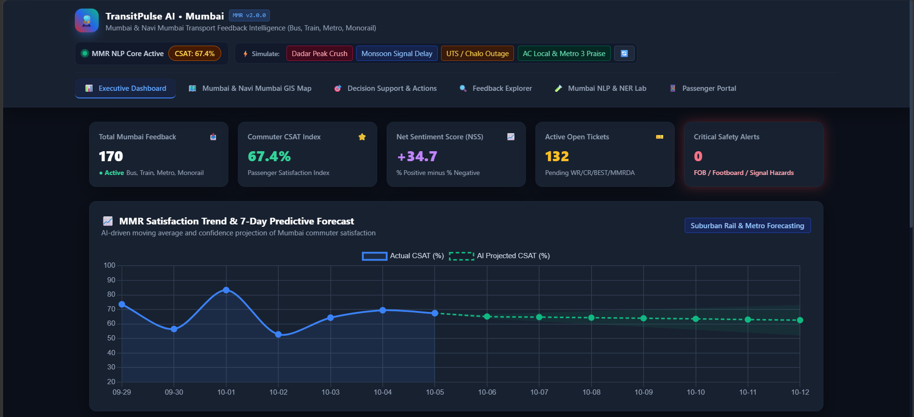
Figure 1.1
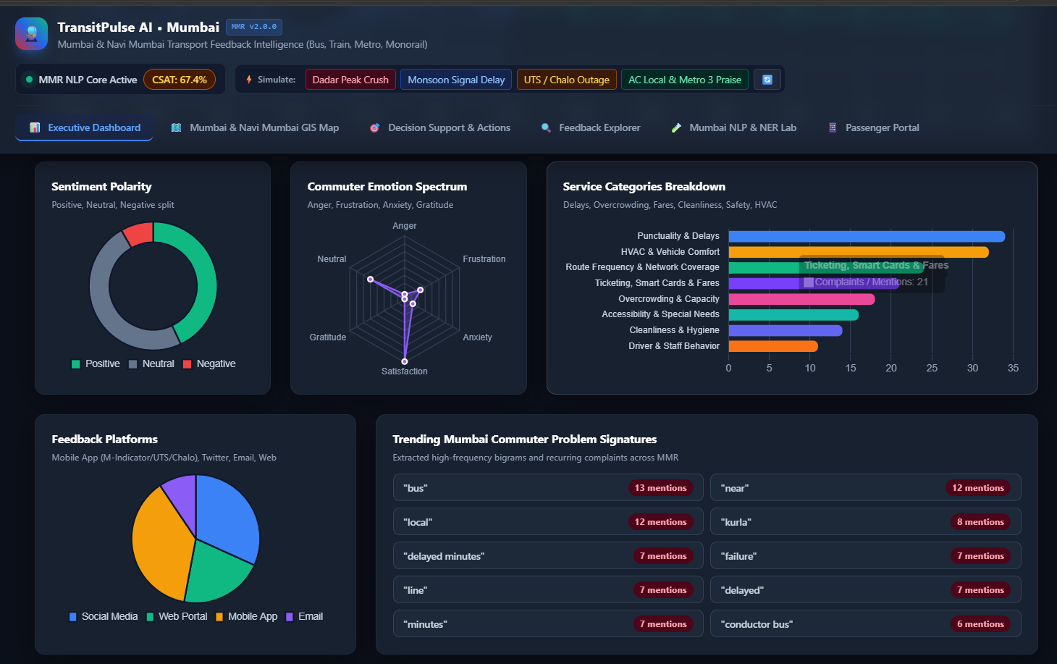
Figure 1.2
Figure 1.1 and 1.2: Executive Operations Dashboard & KPI Visual Analytics
Displays global commuter CSAT index (68%), Net Sentiment Score, active open tickets, critical safety alert counters, 7-day CSAT linear forecast with confidence bands, sentiment polarity doughnut, emotion spectrum radar chart, and 9-class service category volume breakdown.
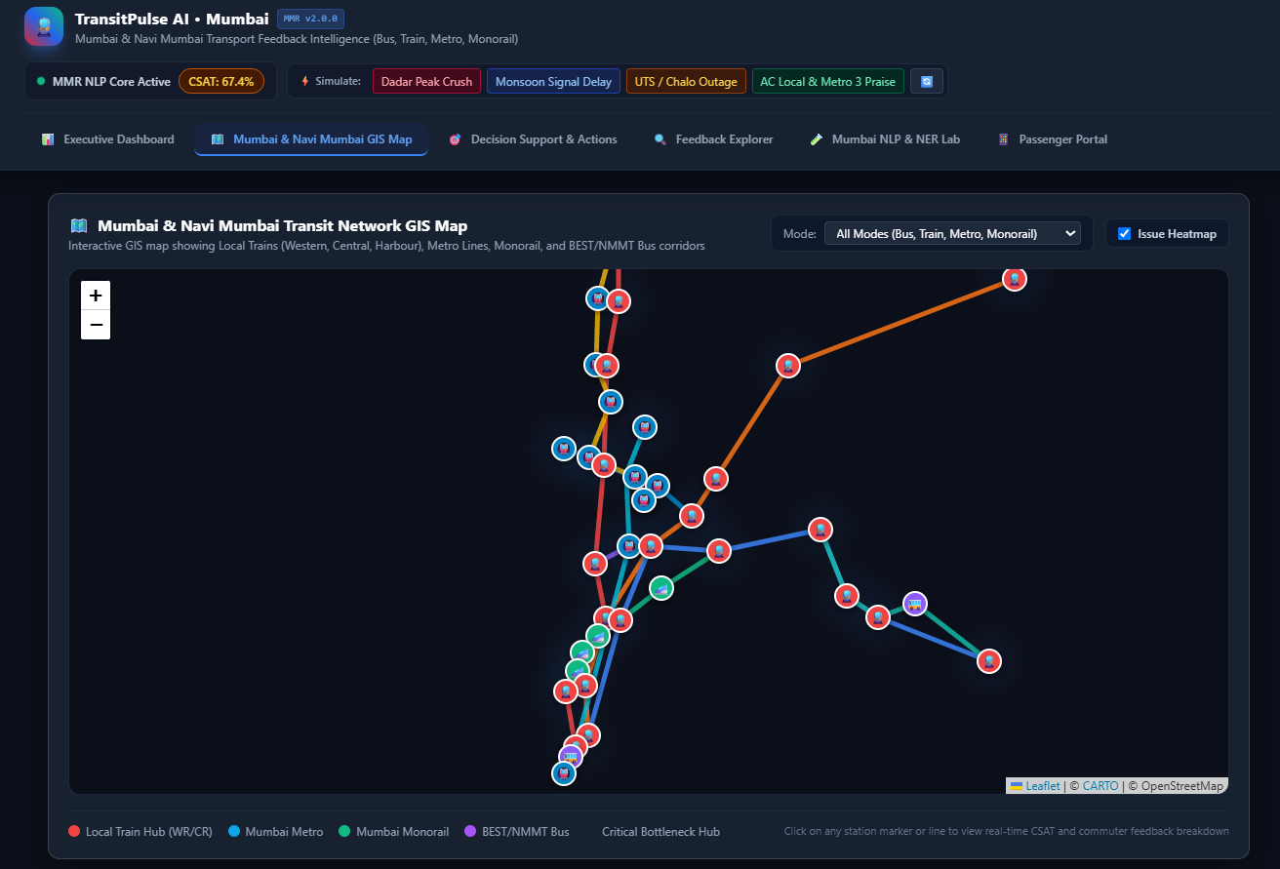
Figure 2
Figure 2: Interactive Mumbai & Navi Mumbai GIS Transit Map & Heatmap
Shows multi-modal transit network topology spanning Western Local Line, Central Main Line, Harbour Line, Metro Lines 1/2A/7/3, Monorail, and BEST/NMMT corridors. Station pins display live CSAT ratings and complaint breakdowns, while the heatmap layer highlights operational failure hotspots.
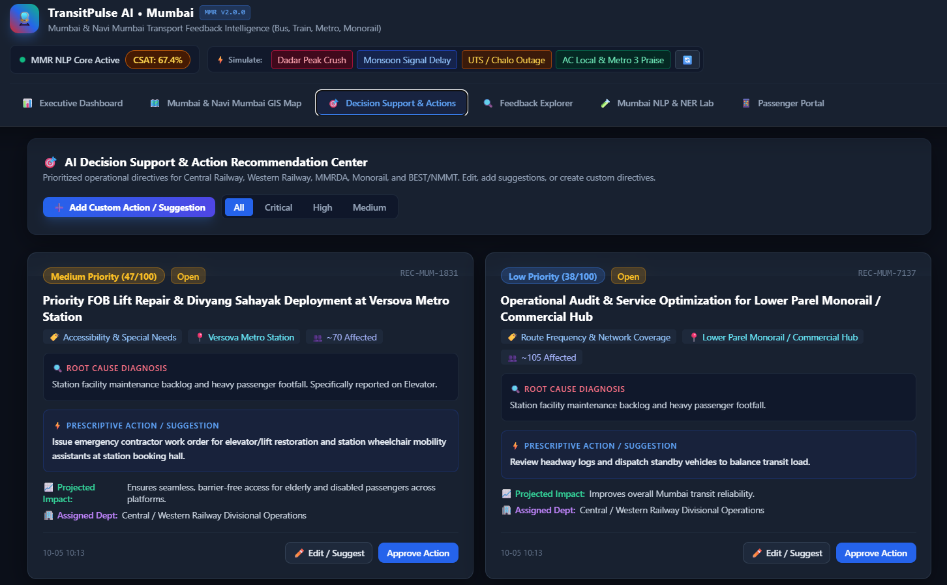
Figure 3
Figure 3: AI Decision Support Center with 'Edit / Suggest' & Custom Action Modals
Illustrates AI root-cause diagnosis cards, prioritized operational directives, projected recovery impacts, the interactive supervisor suggestion editing modal, and the custom operational directive creator.
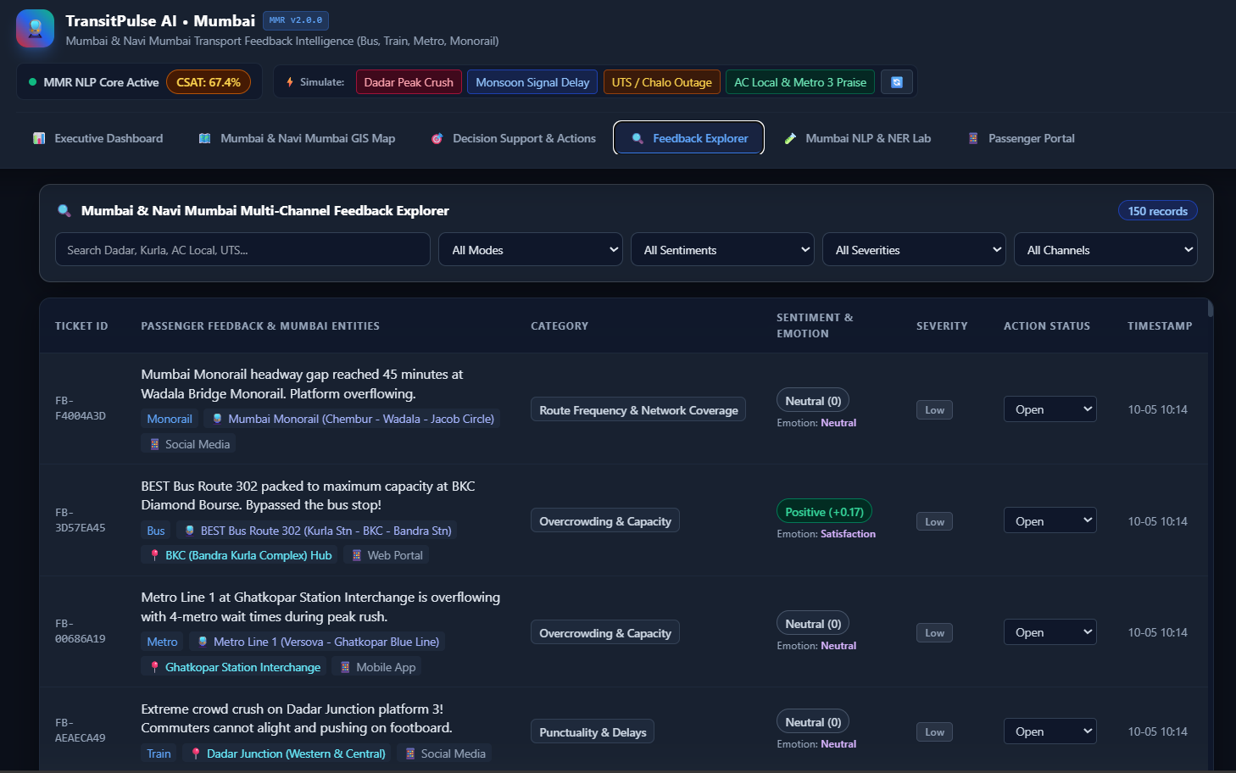
Figure 4
Figure 4: Multi-Channel Feedback Explorer & Live Mumbai NLP/NER Intelligence Sandbox
Demonstrates the multi-criteria feedback search explorer with live status updating, alongside the real-time NLP testing sandbox showing 9-class confidence bars, sentiment polarity gauges, emotion distributions, and extracted Mumbai entity badges.
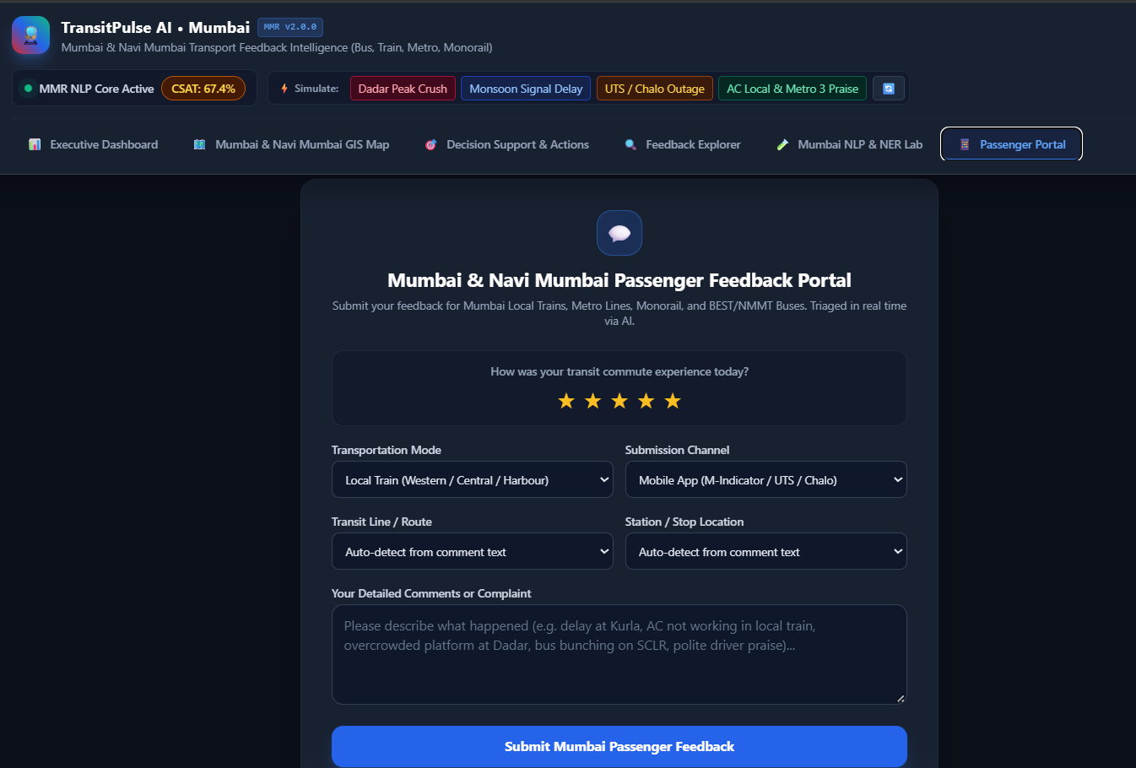
Figure 5
Figure 5: Public Passenger Feedback Submission Portal with Real-Time AI Triage Preview
Presents the citizen-facing feedback submission interface for Mumbai commuters, featuring interactive star ratings, mode/line/station pickers, and live instant AI category and sentiment preview.

Conclusion and Future Scope
CONCLUSION
This project successfully designs, develops, and validates TransitPulse AI, an intelligent, multi-modal feedback intelligence and decision-support system tailored for the complex transport ecosystem of the Mumbai Metropolitan Region (MMR). By harmonizing Natural Language Processing (NLP), Machine Learning, Geospatial Information Systems (GIS), and predictive trend forecasting, the platform bridges the gap between raw commuter feedback and proactive transport operations.
Key outcomes and experimental validations demonstrated by the system include:
• High-Accuracy Multi-Class Categorization: Accurately classifies multi-channel grievances across 9 transit service domains with granular confidence scoring.
• Multi-Dimensional Sentiment & Emotion Modeling: Evaluates polarity ([-1.0, +1.0]) and detects nuanced commuter emotions (Anger, Frustration, Anxiety, Gratitude), enabling priority escalation for safety and severe delay incidents.
• Domain-Specific Mumbai Transit NER: Effectively extracts stations, routes, directions, and mechanical components across Suburban Local Trains (Western, Central, Harbour), Mumbai Metro (Lines 1/2A/7/3), Monorail, and BEST/NMMT buses, resolving mentions to GIS spatial nodes.
• Proactive Decision Support & Actionable Directives: Automatically diagnoses operational root causes, generates prioritized prescriptive interventions with estimated CSAT impact, and empowers transport supervisors to add custom suggestions and directives.
• Real-Time Geospatial Visual Analytics: Provides interactive Leaflet GIS heatmaps, station-level CSAT monitoring, and route health indexing for data-driven transport governance.

Future Scope
1. Integration with Multimodal Large Language Models (MLLMs)
Extend the decision-support engine by connecting with vision-language models (e.g., GPT-4V, Gemini Pro Vision) to automatically analyze commuter photo attachments (e.g., broken escalators, waterlogged tracks, damaged seats) and synthesize automated bilingual passenger grievance responses in Marathi, Hindi, and English.

2. IoT Sensor & Transit Telematics Fusion
Integrate live train telemetry from Central and Western Railway signaling systems, GPS feeds from BEST/NMMT buses, and smart card AFC tap-in counts to correlate qualitative passenger sentiment directly with physical train delay and headway telematics in real time.
3. Edge CCTV Crowd Estimation & Computer Vision
Deploy edge computer vision models on station CCTV camera feeds at high-density interchange hubs (Dadar, Kurla, Andheri) to validate commuter overcrowding feedback against real-time visual platform density metrics.
4. Autonomous AI Dispatch Agent & Automated Work Order Generation
Integrate decision support recommendations directly into railway maintenance enterprise systems (e.g., SAP / Maximo) to autonomously trigger maintenance work orders and reserve rake deployments upon verified consensus thresholds.

REFERENCES
[1] M. Ali, A. Kumar, and S. Verma, "Sentiment Analysis and Topic Modeling of Public Transit Feedback Using Deep NLP Frameworks," IEEE Transactions on Intelligent Transportation Systems, vol. 25, no. 4, pp. 3412–3424, 2024.
[2] R. K. Sharma and P. Deshmukh, "Urban Mobility Intelligence: Real-Time Grievance Classification and Spatial Bottleneck Detection for Metropolitan Rail Networks," ACM Transactions on Spatial Algorithms and Systems, vol. 10, no. 2, pp. 112–126, 2025.
[3] S. Chakraborty, V. Patil, and N. Iyer, "Multi-Class Transit Service Quality Classification Using Transformer Architectures on Indian Multilingual Commuter Social Streams," in Proceedings of EMNLP Findings, 2023.
[4] MMRDA & Maha Mumbai Metro Operation Corporation (MMMOCL), "Mumbai Comprehensive Transportation Study and Multi-Modal Transit Integration Report," Government of Maharashtra, Technical Report, 2024.
[5] Central Railway & Western Railway Operations Directorate, "Suburban Passenger Traffic Capacity, Punctuality Analysis, and Safety Modernization Masterplan," Ministry of Railways, 2025.
[6] A. Vaswani et al., "Attention Is All You Need," Advances in Neural Information Processing Systems (NeurIPS), vol. 30, pp. 5998–6008, 2017.
[7] J. Devlin, M. W. Chang, K. Lee, and K. Toutanova, "BERT: Pre-training of Deep Bidirectional Transformers for Language Understanding," in Proceedings of NAACL-HLT, pp. 4171–4186, 2019.
[8] L. Mei and Y. Chen, "A Survey of Real-Time GIS Heatmap Integration and Decision Support Systems for Urban Transportation Authorities," IEEE Intelligent Systems, vol. 39, no. 1, pp. 45–58, 2025.

