Client: Good morning can you design website for small taxi company
Client: Alitaxis norwich ltd
I want good website where my customers can book taxi, Only long distances. I don’t want local city runs
Client: My company is in Norwich
Client: From Norwich to all cities nationwide and Airports:
Stansted Airport
Gatwick Airport
Heathrow Airport
Luton Airport
Manchester Airport
Me: Good Morning, yes I can build a fantastic website for your taxi booking company
Me: Alitaxis norwich ltd
Me: do you have a logo?
Client: I don’t have
Me: we will keep the site clean but conversion-focused. We don’t need dozens of pages, just the right ones that build trust and make bookings effortless
Client: Yes I want nice and simple
Client: Something like this:
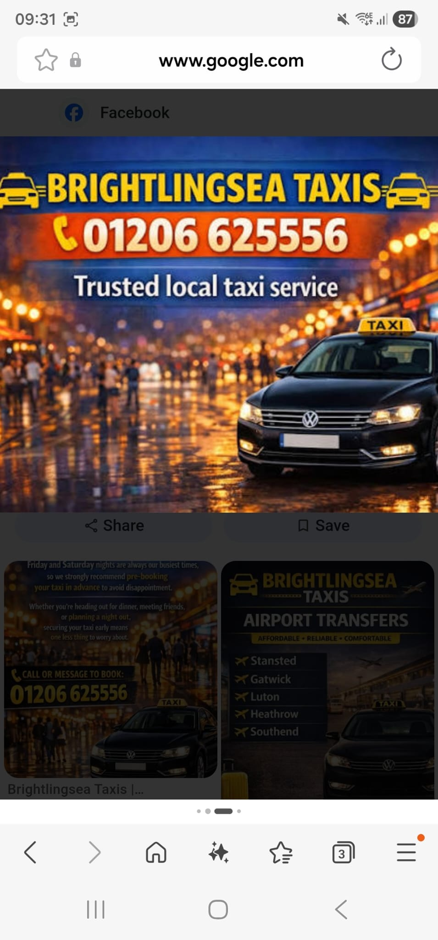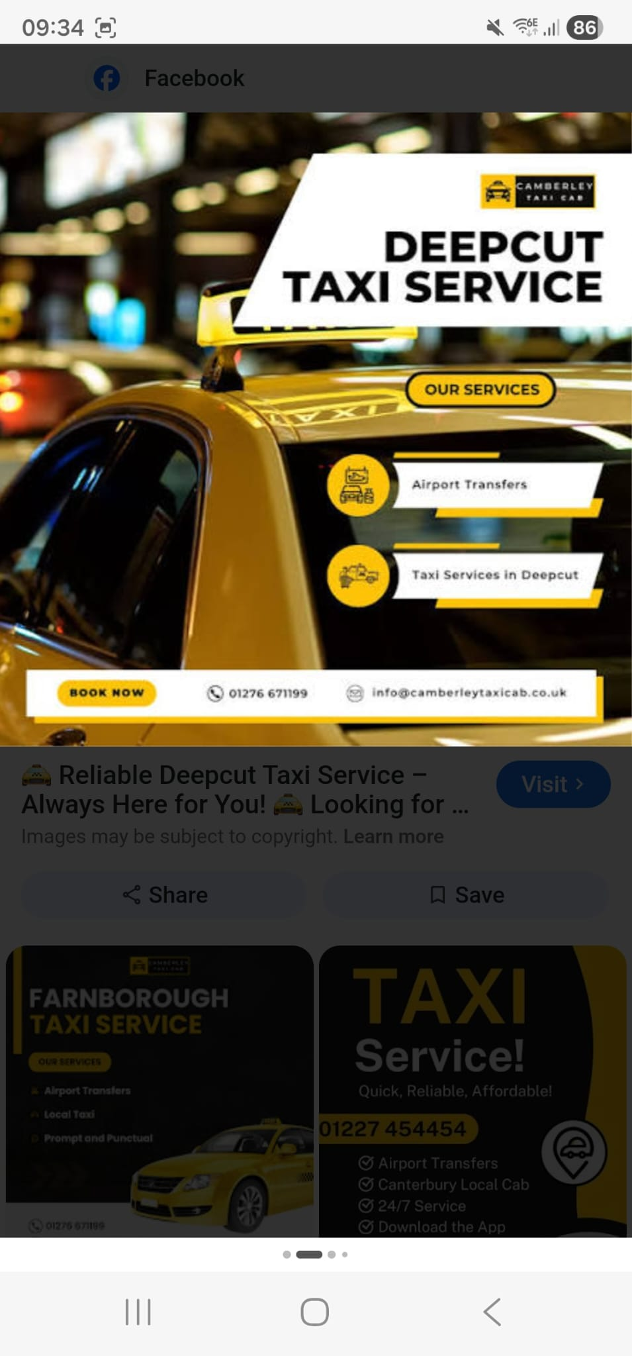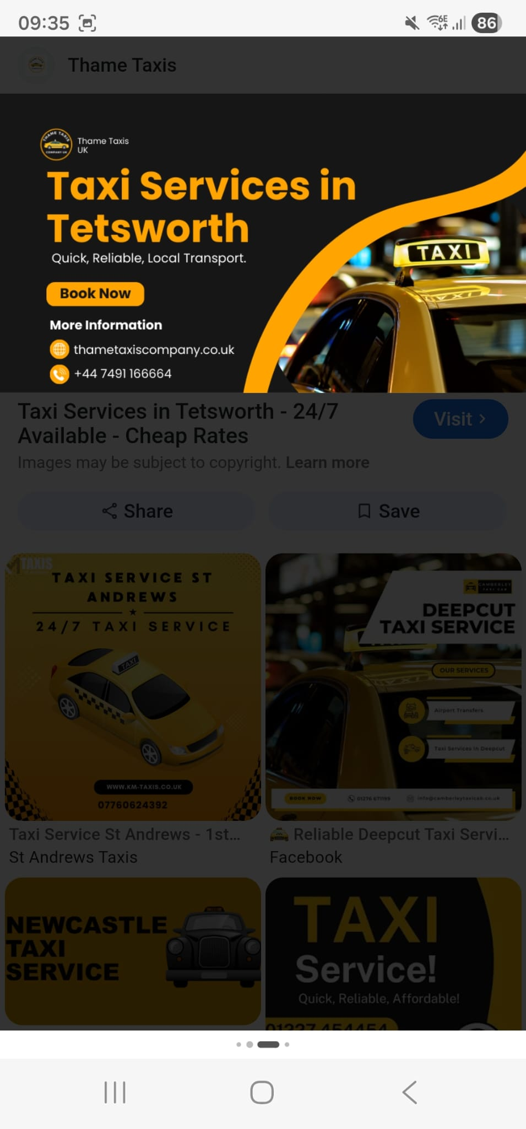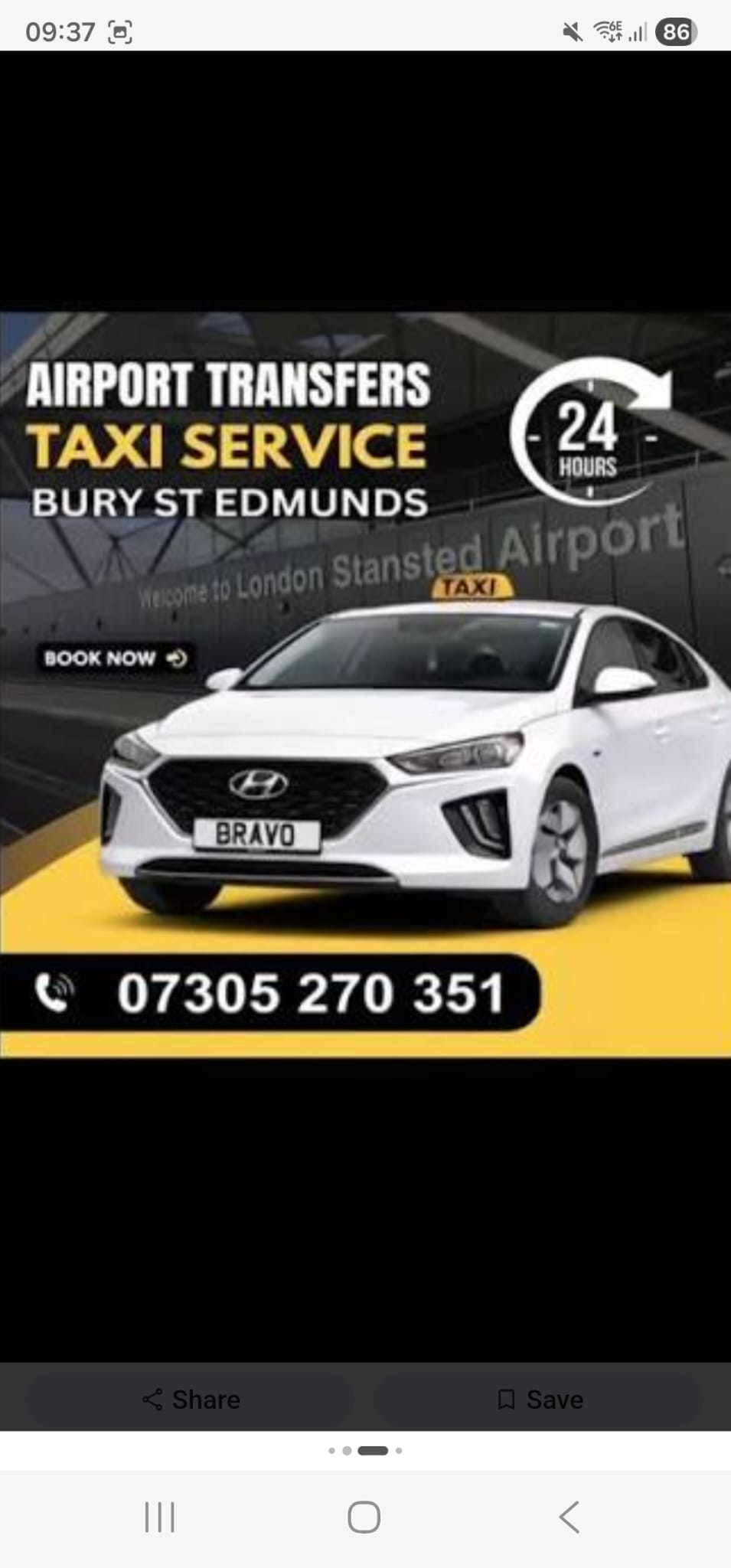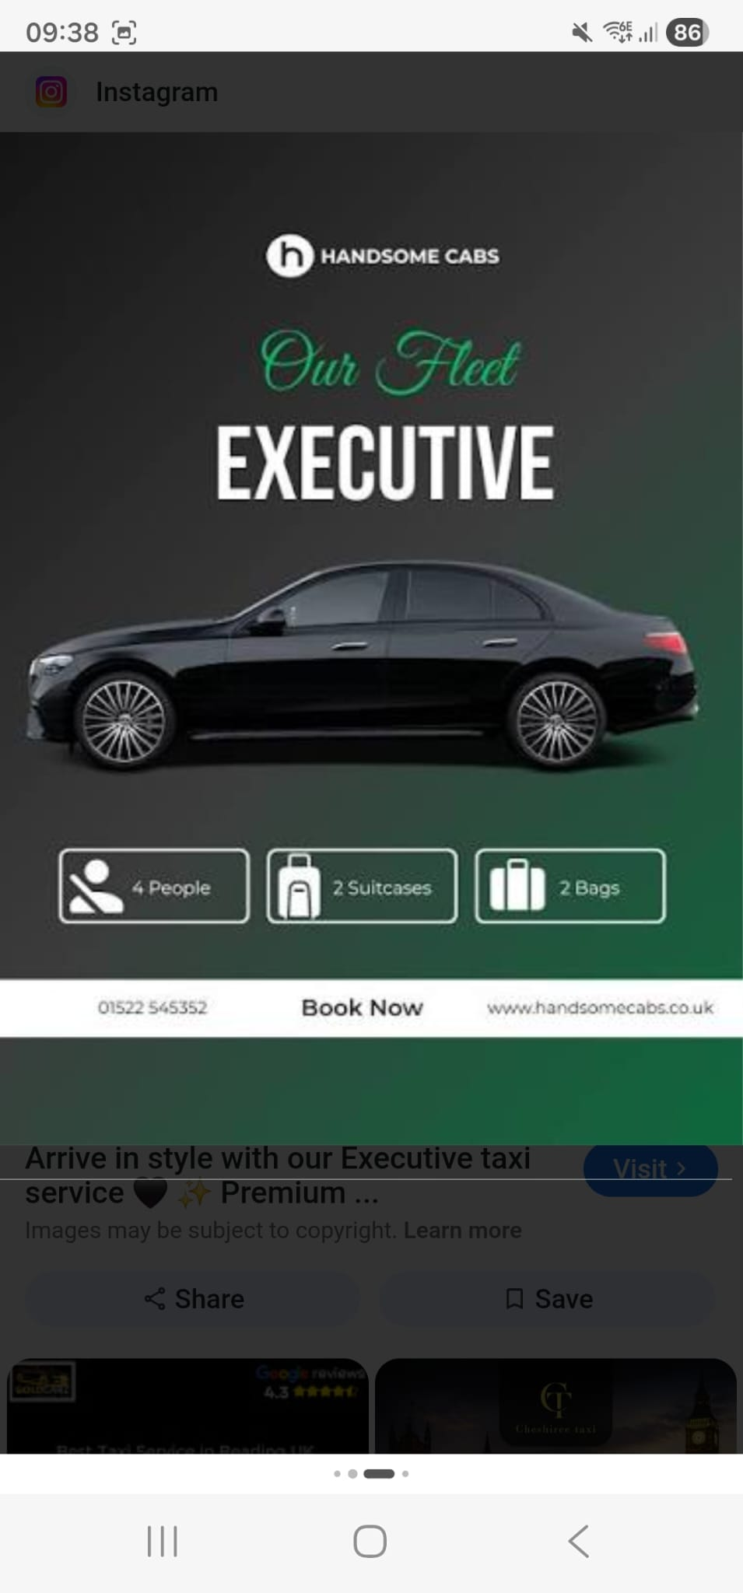
Me: I suggest this Website Structure:
* Home
* Book Taxi
* Airport Transfers
* Pricing
* Contact

Me: Google Maps Integration for Taxi Booking - Customers can view routes, track accurate distances, and get real-time fare estimates, all calculated automatically through Google Maps for a seamless, reliable ride experience
Me: Flexible Taxi Pricing Options - Take full control of your pricing with flexible options built for your business. Set rates by distance, time, or location, add base fares, and even enable a waiting list, giving you complete freedom to customise your pricing strategy
Me: Multiple Taxi Categories with Different Pricing - Create multiple taxi categories such as economy, standard, premium, or SUV, each with different pricing and vehicle options. Customers can compare options and choose the service that fits their budget and comfort level
Me: Optional Extra Services During Booking - Customers can easily choose to add services like a baby seat or a bouquet, giving them more flexibility while helping you increase your revenue
Me: Custom Checkout Fields for Taxi Booking - Customise your checkout fields to collect exactly what you need. Add options like passport details or image uploads, and securely gather all required passenger information before confirming a ride

Client: I suggest Website Structure to be:
* Book Taxi
* Stansted airport
* Gatwick Airport
* London Heathrow
* Contact
* mob 077XXXXXXXX
Alixxxxxxxxxxxx@gmail.com
Client: Have you designed anything yet, I just want something nice and simple
Me: currently I was working on website functionality and now I will start designing
Me: any color scheme in your mind?

Client: This kind of looks ok to me
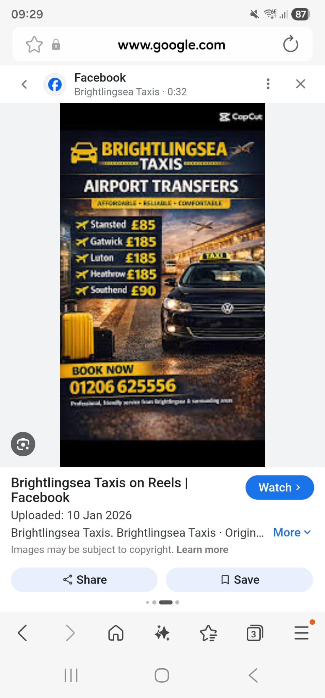

Client: Ok go ahead I am trusting your words. If work is good and trust worthy then
I well give more work Thanks

