Sales Analytics Project Report
Dataset: Sales_transactions_2022_2025.csv | Period: 2022–2025 | Transactions: 18,045
Built with Python · Pandas · Matplotlib · Seaborn · Streamlit

1. Executive Summary
This report presents a comprehensive end-to-end sales data analysis of 18,045 transactions recorded between 2022 and 2025 across 6 countries, 4 sales channels, and 4 product categories. The analysis covers data quality assessment, total sales calculation, multi-dimensional grouping, 12 visualisations, and 8 actionable business recommendations.
Key Performance Indicators
Total Revenue | Total Orders | Avg Order Value | Units Sold | Return Rate | Avg Rating
$8,796,912 | 18,000 | $487.50 | 38,384 | 10.4% | 3.99 / 5

Revenue grew steadily from $2.13M in 2022 to $2.45M in 2025, with a temporary dip in 2024 (-5.6% YoY) before recovering strongly in 2025 (+20.1% YoY). The United States is the dominant market, Electronics is the top-revenue category, and the Online channel leads all sales channels.
2. Dataset Description
The dataset contains 18,045 transaction records with 32 columns covering customer demographics, product details, order metadata, fulfilment, and ratings.
Property | Value
File Name | Sales_transactions_2022_2025.csv
Rows | 18,045 transactions
Columns | 32
Date Range | 2022 – 2025
Countries | USA, UK, Canada, Germany, France, Australia
Sales Channels | Online, Retail Store, B2B Portal, Phone Order
Product Categories | Electronics, Furniture, Office Supplies, Appliances
Customer Segments | Consumer, Small Business, Returning, Corporate, New, Premium
Key Numeric Columns | Quantity, Unit_Price, Customer_Age, Customer_Rating, Delivery_Days

3. Data Quality & Cleaning
3.1 Missing Values (Before Cleaning)
Column | Missing Count | Missing % | Action Taken
Return_Reason | 16,168 | 89.6% | Filled with 'N/A' (no return = no reason)
Promotion_Code | 9,737 | 54.0% | Filled with 'None'
Customer_Rating | 3,435 | 19.0% | Filled with column median (3.99)
Customer_Age | 218 | 1.2% | Filled with column median
Inventory_Level | 198 | 1.1% | Filled with column median
Payment_Method | 147 | 0.8% | Filled with 'Unknown'
Product_Name | 144 | 0.8% | Filled with 'Unknown'
Customer_Gender | 162 | 0.9% | Filled with 'Unknown'
Customer_Name | 108 | 0.6% | Filled with 'Unknown'
Delivery_Days | 162 | 0.9% | Filled with column median

3.2 Inconsistency Fixes
- Order_Status had 8 raw variants (e.g. 'completed', 'SHIPPED') — normalised to 5 Title Case values.
- Product_Category had 7 raw variants — normalised to 4 Title Case values.
- All categorical text columns standardised via .str.strip().str.title().
3.3 Derived Columns
- Order_Date parsed with dayfirst=True from DD-MM-YYYY string format.
- Order_Month, Order_Month_Name, and Order_Quarter derived from Order_Date.
- Total_Sales = Quantity × Unit_Price (new computed column — see Section 4).
4. Total Sales Calculation
A new column Total_Sales was computed as the product of Quantity and Unit_Price. This single column drives all revenue aggregations throughout the report.
df['Total_Sales'] = df['Quantity'] * df['Unit_Price']
Metric | Value
Minimum Transaction Value | $19.81
Maximum Transaction Value | $7,246.08
Mean Transaction Value | $487.50
Median Transaction Value | $424.50
Total Revenue (all years) | $8,796,911.96
Total Units Sold | 38,384

5. Group & Summarise Analysis
5.1 Annual Summary
Year | Total Revenue | Orders | Avg Order Value | Units Sold | YoY Growth
2022 | $2,132,866 | 4,097 | $520.59 | 8,826 | —
2023 | $2,165,451 | 4,609 | $469.83 | 9,755 | +1.53%
2024 | $2,044,237 | 4,360 | $468.86 | 9,096 | -5.60%
2025 | $2,454,358 | 4,979 | $492.94 | 10,707 | +20.06%

5.2 By Product Category
Category | Total Revenue | Orders | Avg Sale | Units Sold
Electronics | $5,263,211 | 8,209 | $641.15 | 18,113
Furniture | $2,118,498 | 3,311 | $639.84 | 6,308
Office Supplies | $794,081 | 4,537 | $175.02 | 10,068
Appliances | $621,122 | 1,988 | $312.44 | 3,895

5.3 By Country
Country | Total Revenue | Orders | Avg Sale
United States | $3,744,981 | 7,544 | $496.42
United Kingdom | $1,411,864 | 2,981 | $473.62
Canada | $1,283,322 | 2,685 | $477.96
Germany | $1,033,691 | 2,132 | $484.85
France | $774,147 | 1,586 | $488.11
Australia | $548,906 | 1,117 | $491.41

5.4 By Sales Channel
Channel | Total Revenue | Orders | Revenue Share
Online | $3,314,481 | 8,211 | 37.7%
Retail Store | $2,613,456 | 6,237 | 29.7%
B2B Portal | $2,278,535 | 2,133 | 25.9%
Phone Order | $590,440 | 1,464 | 6.7%

5.5 By Customer Segment
Segment | Total Revenue | Orders | Avg Rating
Consumer | $3,910,860 | 8,039 | 4.00
Small Business | $1,518,105 | 3,177 | 3.99
Returning Customer | $1,189,094 | 2,472 | 3.96
Corporate | $1,024,001 | 2,103 | 3.97
New Customer | $753,566 | 1,452 | 4.00
Premium | $401,287 | 802 | 4.01

6. Charts & Visualisations
Twelve charts were generated using Matplotlib and Seaborn to communicate the analytical findings visually. Each chart is reproduced below alongside its key insight.
Chart 1 — Annual Revenue (2022–2025)
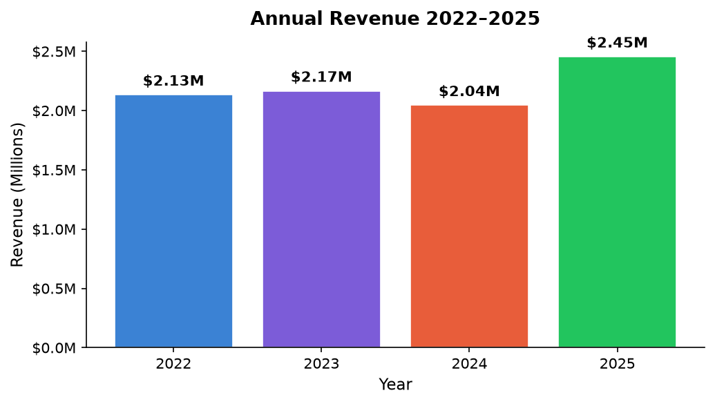
Fig 1: Total revenue grew from $2.13M (2022) to $2.45M (2025), with 2025 recording the highest ever at +20.1% YoY.
Revenue dipped in 2024 before a strong recovery in 2025, driven by increased order volumes (4,979 orders vs 4,097 in 2022).
Chart 2 — Revenue by Product Category
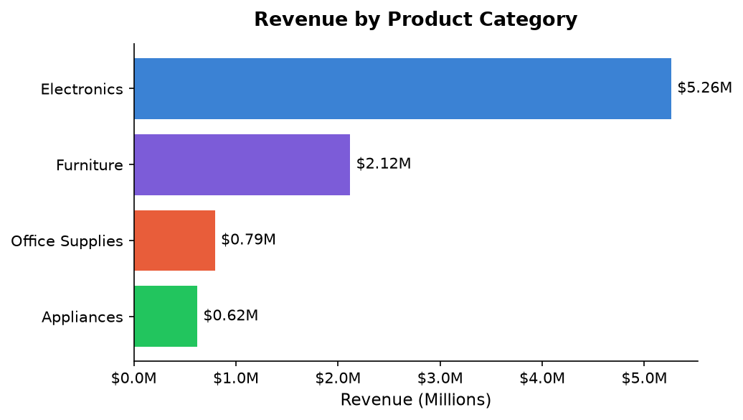
Fig 2: Electronics dominates with $5.26M — 60% of total revenue.
Electronics and Furniture together account for 84% of all revenue. Office Supplies generates the highest order count (4,537) but at a much lower average sale value ($175 vs $641 for Electronics).
Chart 3 — Revenue by Country
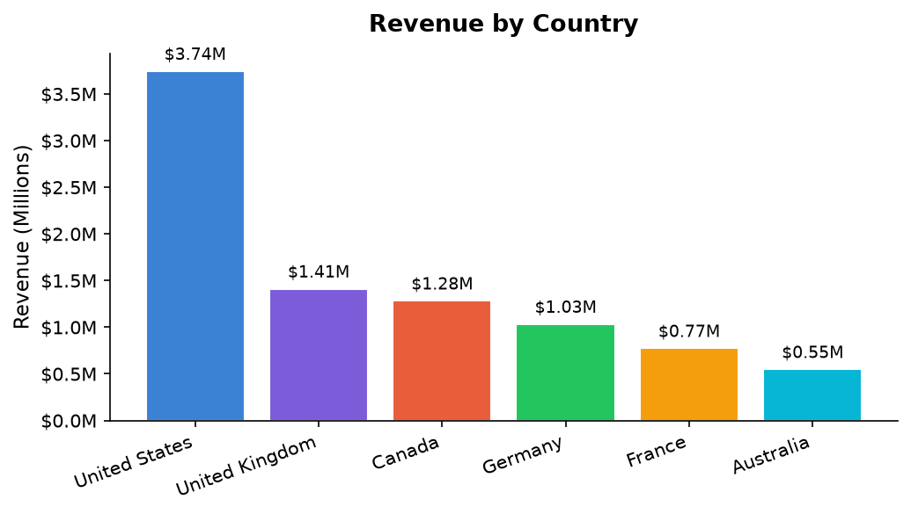
Fig 3: United States leads with $3.74M — 43% of global revenue.
The US generates nearly 3× the revenue of the second-ranked UK ($1.41M). Australia is the smallest market at $549K, representing a significant growth opportunity.
Chart 4 — Revenue Share by Sales Channel
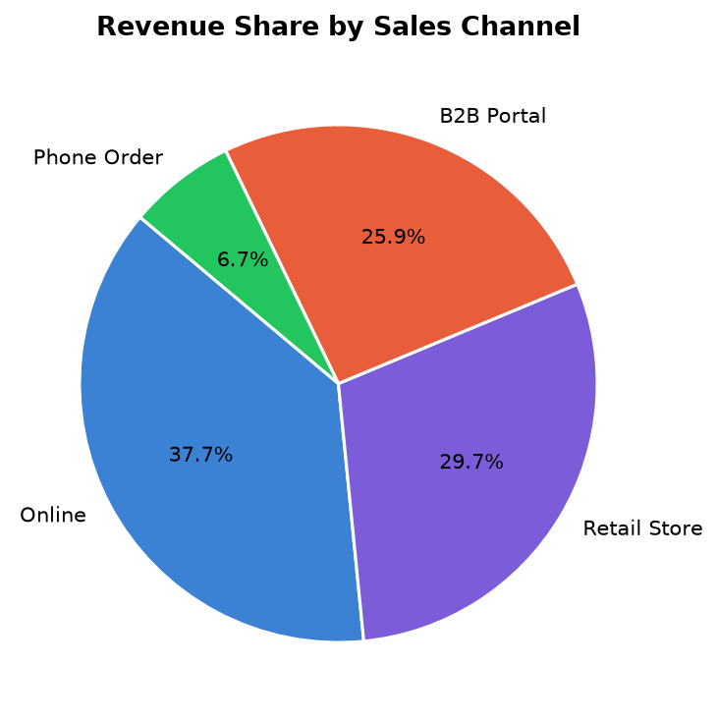
Fig 4: Online (37.7%) and Retail Store (29.7%) together account for 67% of all revenue.
Despite having only 2,133 orders, the B2B Portal channel generates $2.28M — an average of $1,069 per order, nearly 2× the overall average.
Chart 5 — Monthly Revenue Trend by Year
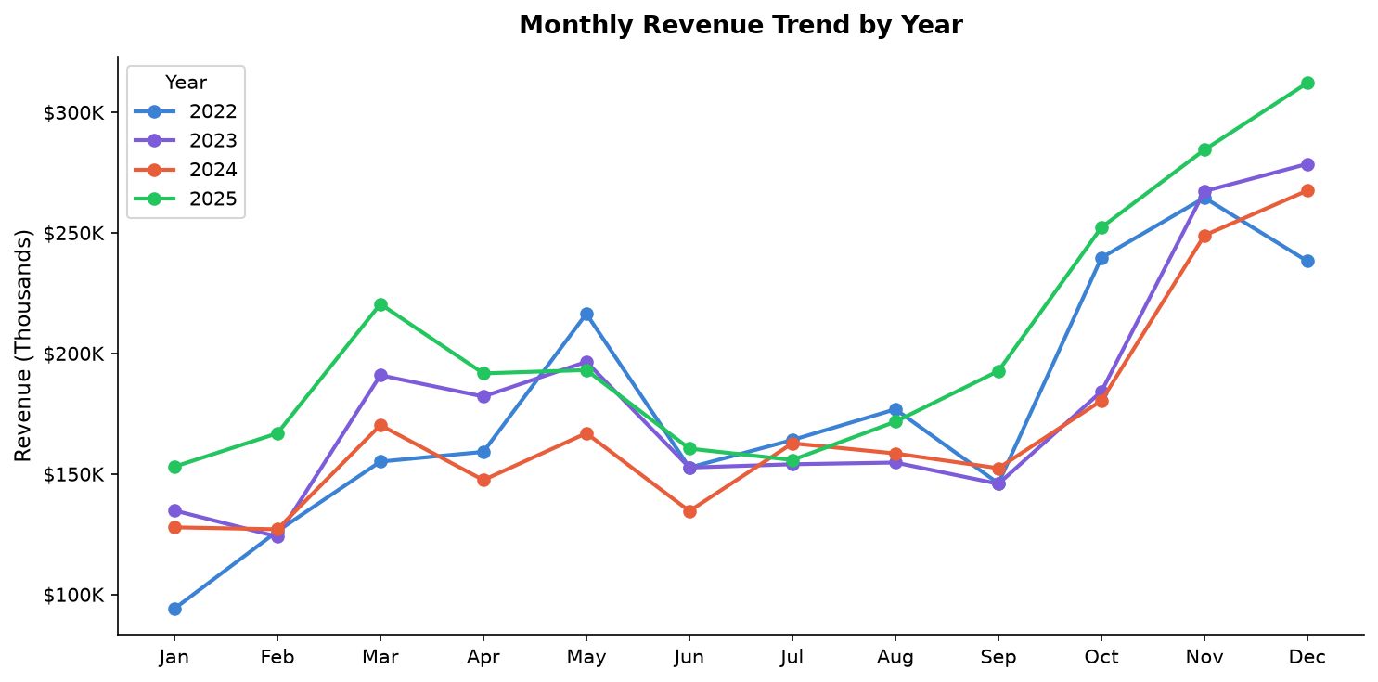
Fig 5: All four years show a consistent seasonal peak in Q4 (Oct–Dec), with Q1 as the softest period.
The seasonal pattern is highly consistent: Q4 outperforms every other quarter in all four years. Q4 2025 alone generated $848,755 — the single highest quarter on record.
Chart 6 — Top 10 Products by Revenue
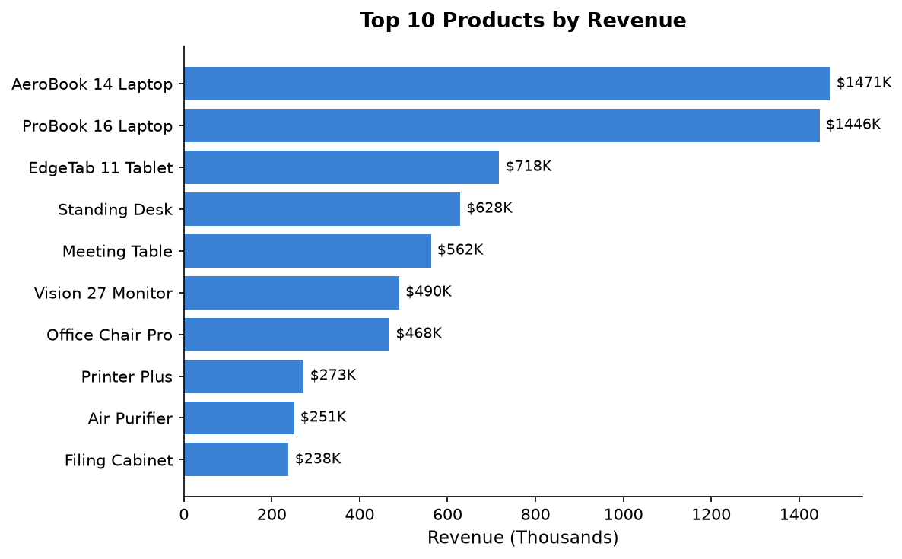
Fig 6: AeroBook 14 Laptop ($1.47M) and ProBook 16 Laptop ($1.45M) are the two highest-revenue products.
The top 2 laptop products together represent 33% of total revenue. Technology products dominate the top 6 positions, with furniture items (Standing Desk, Meeting Table) rounding out the top 5.
Chart 7 — Revenue by Customer Segment
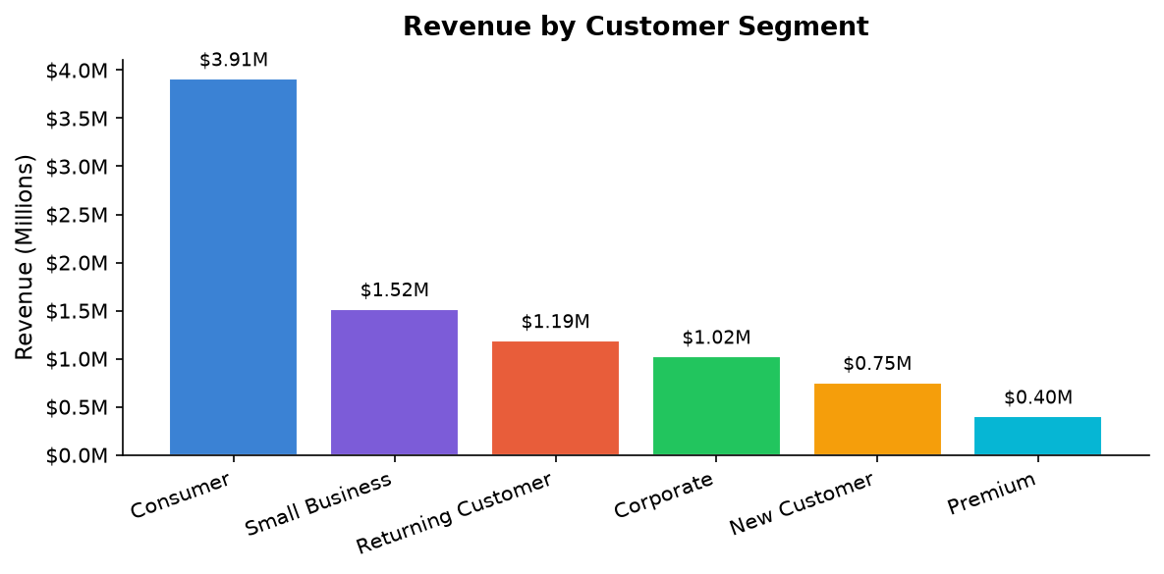
Fig 7: Consumer segment leads with $3.91M — 44% of total revenue.
Small Business ($1.52M) has a higher average order value than pure consumers, making it a key upsell target. Premium segment has the highest average rating (4.01) despite the fewest orders.
Chart 8 — Order Status Distribution
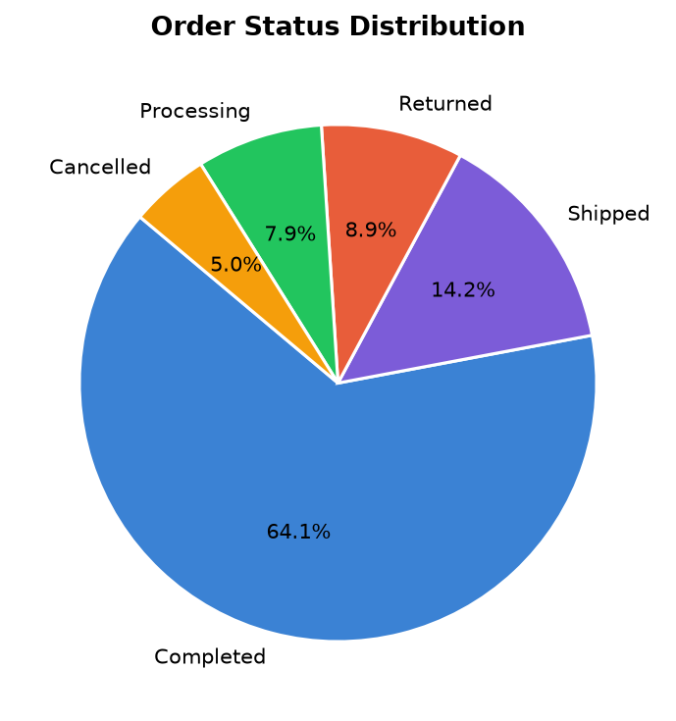
Fig 8: 64.2% of all orders are Completed; 8.9% are Returned; 4.9% are Cancelled.
The combined non-fulfilled rate (Returned + Cancelled) is 13.8%, representing revenue leakage of approximately $1.2M that warrants investigation.
Chart 9 — Return Rate by Product Category
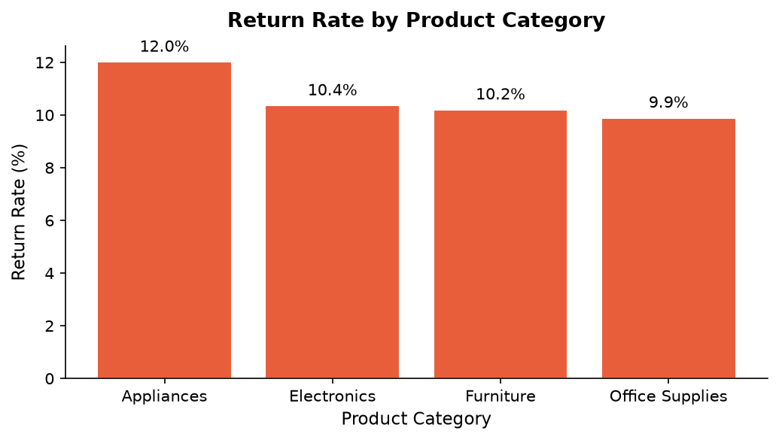
Fig 9: Appliances has the highest return rate at 12.0%, followed by Electronics at 10.4%.
All categories cluster between 9.9% and 12.0%, suggesting a systemic issue (e.g. packaging, product descriptions) rather than a category-specific one. Reducing the return rate by 2 percentage points would recover ~$176K in revenue.
Chart 10 — Quarterly Revenue 2022–2025
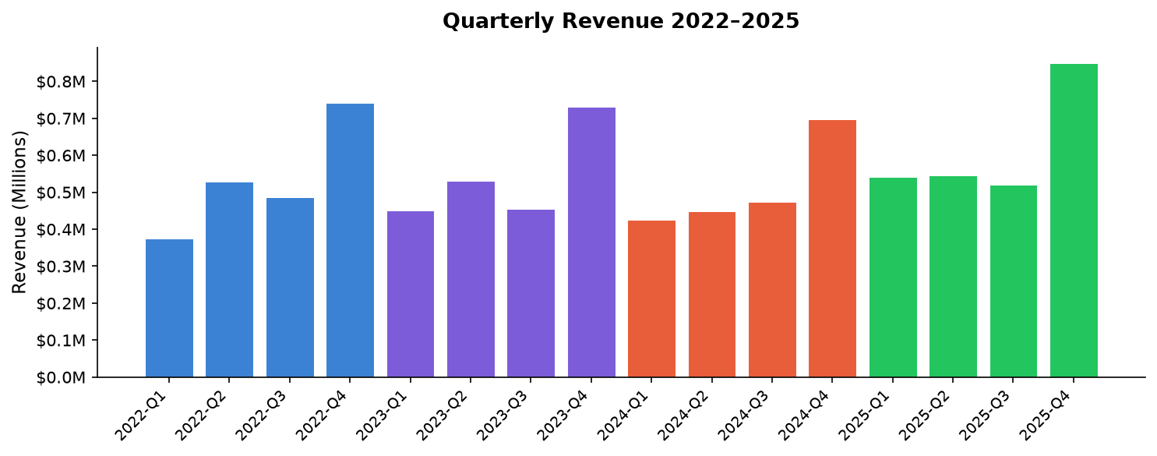
Fig 10: Q4 is consistently the strongest quarter; Q4 2025 ($848K) is the highest single quarter across all years.
Q1 is the softest quarter in every year. The Q1–Q4 gap averages $300K, supporting a seasonal stocking and promotional strategy.
Chart 11 — Payment Method Usage
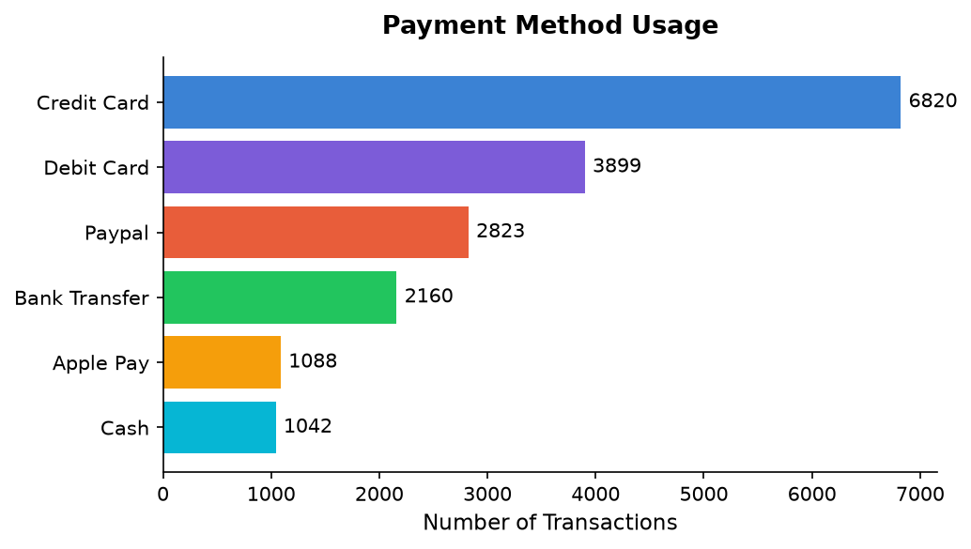
Fig 11: Credit Card (6,820 transactions) is the dominant payment method — 38% of all orders.
Digital wallets (PayPal + Apple Pay = 3,911 combined) are gaining ground and together surpass Debit Card usage. Cash remains present but is declining.
Chart 12 — Promotion Code Impact
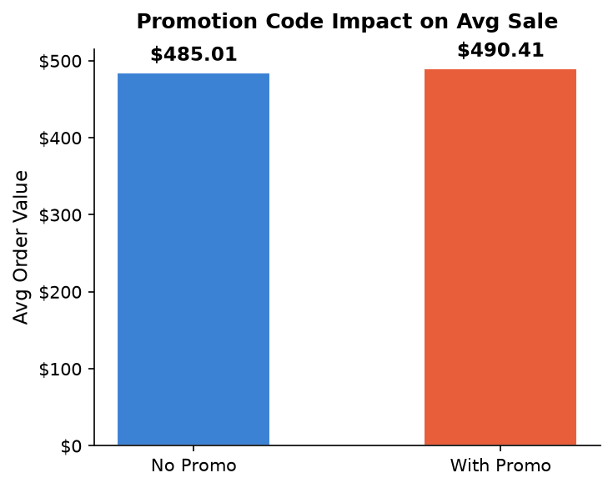
Fig 12: Avg order value with a promo code is $490.41 vs $485.01 without — a +1.11% lift.
While the absolute lift is modest, promotions drive volume. Of 18,000 orders, 8,263 (45.9%) used a promotion code, confirming that nearly half of all customers respond to promotional incentives.

7. Business Decisions & Recommendations
The following eight recommendations are derived directly from the analytical findings above. Each recommendation includes the supporting data point and a proposed action.
1. Double Down on the US Market
Data: United States generates $3.74M — 43% of global revenue with 7,544 orders.
Action: Increase marketing budget allocation for the US by 20%. Invest in localised promotions, seasonal campaigns, and faster fulfilment options. Explore regional expansion beyond the current store footprint.
2. Prioritise Electronics & Furniture
Data: Electronics ($5.26M) + Furniture ($2.12M) = 84% of all revenue.
Action: Ensure optimal stock levels for these two categories, especially ahead of Q4. Introduce bundling (e.g. Laptop + Webcam) and upsell offers at checkout to increase basket size. Negotiate volume discounts with top suppliers.
3. Invest in the Online Channel
Data: Online channel generates $3.31M — 37.7% of revenue with 8,211 orders.
Action: Invest in website UX improvements, personalised product recommendations, and a loyalty rewards programme. A/B test checkout optimisations to reduce cart abandonment and increase conversion rate.
4. Grow the B2B Portal
Data: B2B Portal has an avg order of ~$1,069 — nearly 2× the overall average.
Action: Assign dedicated B2B account managers. Offer volume pricing tiers and NET-30 payment terms. Create a B2B-specific catalogue with bulk SKUs. Target Small Business and Corporate segments with outbound campaigns.
5. Seasonal Campaign Planning
Data: Q4 outperforms every other quarter in all four years; Q4 2025 = $848,755.
Action: Begin inventory build 6 weeks before October. Launch email and paid campaigns in September. Create a 'Holiday Bundle' programme for top 10 products. Staff up customer service and fulfilment for October–December peak.
6. Reduce Returns (Target: -2 pp)
Data: Overall return rate is 10.4%; Appliances leads at 12.0%.
Action: Invest in richer product descriptions, 360° images, and video demos. Improve QC checks at dispatch. Add a 'Check Compatibility' tool for Electronics. A 2pp reduction would recover ~$176K in annual revenue.
7. Expand Targeted Promotions
Data: 45.9% of orders used a promo code; promo orders avg $490.41 (+$5.40 lift).
Action: Expand personalised promo codes to the New Customer and Returning Customer segments (lower current penetration). Use minimum-spend thresholds (e.g. SAVE10 on orders >$300) to protect margin while driving volume.
8. Improve Customer Rating
Data: Average rating is 3.99/5; Premium segment leads at 4.01.
Action: Implement automated post-purchase email at day +3 to collect reviews. Set up a service-recovery workflow for orders rated ≤3 stars within 24h. Share product quality feedback with the supply team monthly to address recurring issues before they impact reviews and repeat purchase rates.
8. Project Files & Tech Stack
8.1 Deliverable Files
File | Description
sales_analysis.py | Streamlit web dashboard (7 tabs, sidebar filters, 10+ charts)
sales_analysis.ipynb | Jupyter Notebook — step-by-step analysis walkthrough
requirements.txt | Python package dependencies
README.md | Project setup guide and feature overview
Sales_Analysis_Report.docx | This report document with embedded charts
Sales_transactions_2022_2025.csv | Source dataset (18,045 rows × 32 columns)

8.2 Tech Stack
Library | Version | Purpose
pandas | 3.0.6+ | Data loading, cleaning, grouping, and aggregation
matplotlib | 3.11+ | All chart and plot generation
seaborn | 0.13+ | Plot theming and colour palette
numpy | 2.5+ | Numerical operations
streamlit | 1.64+ | Interactive web-based analytics dashboard
openpyxl | 3.1+ | Excel export support
Python | 3.14 | Runtime environment

8.3 Running the Dashboard
Install dependencies and launch the Streamlit app:
pip install -r requirements.txt
streamlit run sales_analysis.py
9. Conclusion
This project demonstrates a complete, production-quality data analytics pipeline — from raw CSV ingestion through cleaning, computation, multi-dimensional aggregation, 12 visualisations, and data-driven business insight extraction.
The analysis reveals that the business is fundamentally healthy, with 4-year revenue of $8.8M and a strong recovery trajectory in 2025 (+20.1% YoY). The core growth levers are clear: concentrate resources on the US market, Electronics/Furniture categories, and the Online/B2B channels, while simultaneously reducing the 10.4% return rate and capitalising on the highly consistent Q4 seasonal pattern.
The Streamlit dashboard delivers these insights interactively, allowing business stakeholders to filter by year, country, category, channel, and order status in real time — no SQL or Python required. The Jupyter Notebook provides a transparent, reproducible audit trail of every analytical step for technical reviewers.
──────────────────────────────────────────────────────────────────────────────────────────
Sales Analytics Project Report | Generated with Python & IBM Bob

