# PHASE-2

**Project Title:** Transfroming healthcare with AI-Powered disease prediction based on patient data.

Github link:

[https://github.com/Lakspriya-2005/Transforming-healthcare-with-AI-powered-disease-prediction-based-on-patient-](https://github.com/Lakspriya-2005/Transforming-healthcare-with-AI-powered-disease-prediction-based-on-patient-data..git) [data..git](https://github.com/Lakspriya-2005/Transforming-healthcare-with-AI-powered-disease-prediction-based-on-patient-data..git)

# Problem Statement

* + Healthcare systems often struggle to predict diseases early due to lack of integrated data analysis. Manual diagnosis can be time-consuming and error-prone. By leveraging AI to predict diseases using patient data, healthcare providers can identify conditions early, improve treatment plans, and enhance patient outcomes.
  + This project focuses on building a machine learning model to predict the presence or risk level of a specific disease using patient demographic, lifestyle, and clinical attributes.
  + Significance: Enables preventive care, reduces healthcare costs, and improves quality of life.

# Project Objectives

* + Develop a predictive model that identifies potential diseases based on patient data.
  + Improve diagnostic efficiency using machine learning algorithms.
  + Deliver actionable insights to assist healthcare professionals in decision-making.
  + Enhance early detection and prevention strategies.
  + Build an accurate AI model for disease prediction.
  + Identify the key features influencing disease risk.
  + Interpret model outputs to guide clinical decisions.
  + Deploy a user-friendly web interface for real-time predictions.
  + Ensure ethical AI practices and patient data privacy

# Flowchart of the Project Workflow

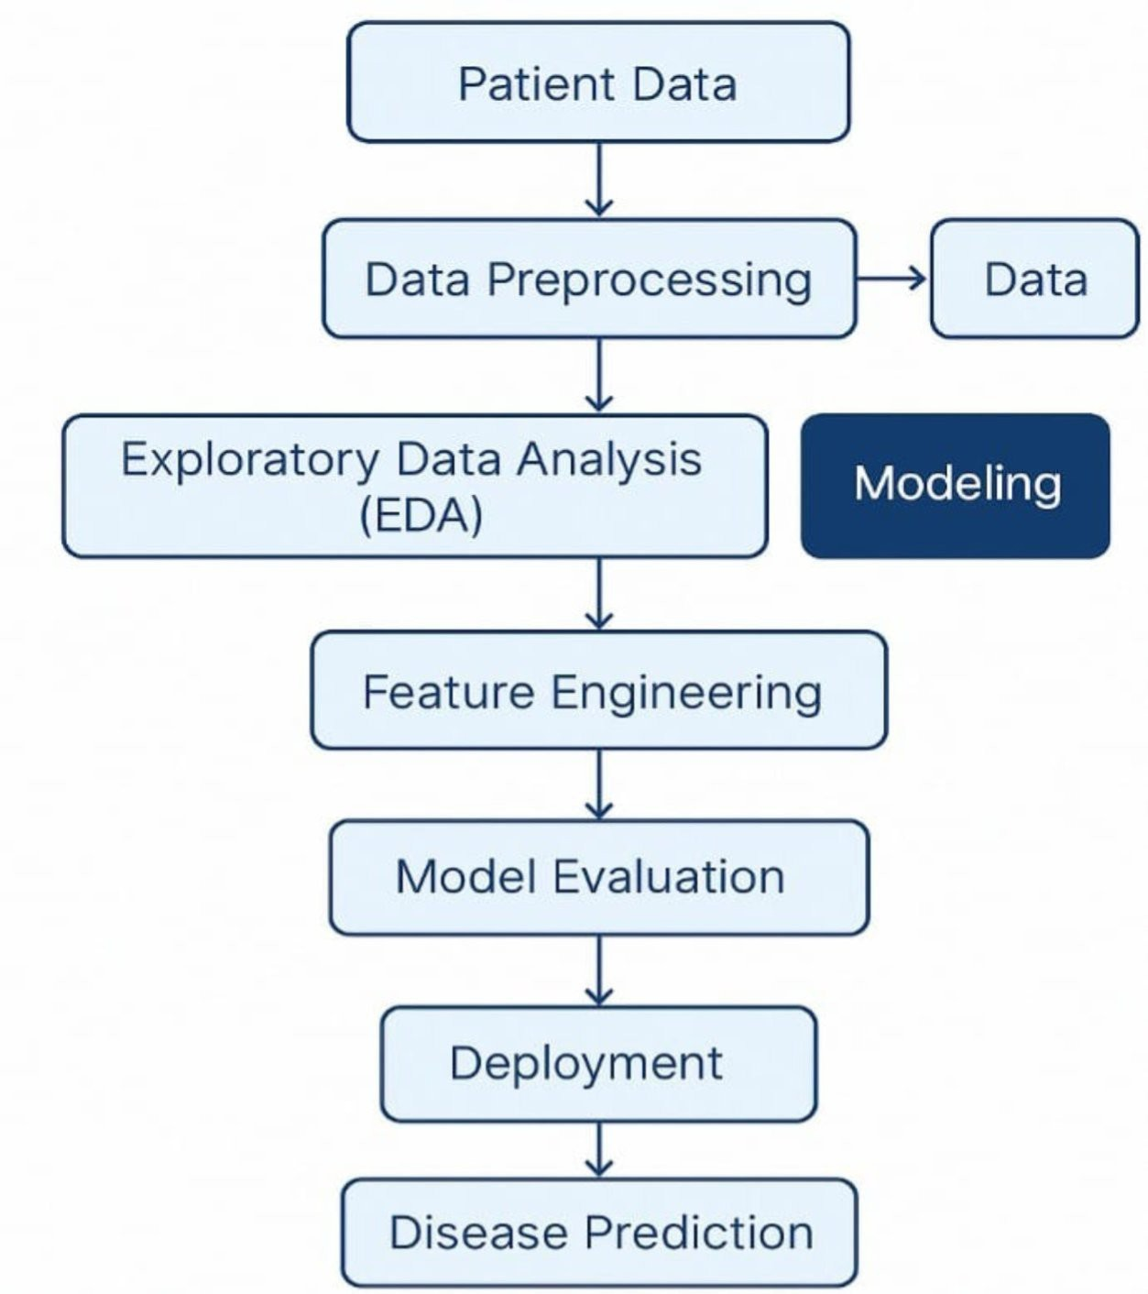

1. **Data Description**

## Dataset Name:

Could be sourced from open healthcare datasets.

## Source:

Public repositories like UCI, Kaggle, or hospital collaborations.

## Data Type:

Structured tabular (e.g., CSV).

## Records and Features:

1,00–100,0 records with 10–50 features.

## Target Variable:

Presence/absence or probability of diseases.(e.g.,stroke)

## Features:

id,Age, gender, hypertension,heart disease,work type,bmi,even married,smoking status ,stroke,etc..

* + **Dataset link:** [https://www.kaggle.com/code/manarmohamed11/stroke-prediction-](https://www.kaggle.com/code/manarmohamed11/stroke-prediction-eda?scriptVersionId=236663015&cellId=2) [eda?scriptVersionId=236663015&cellId=2](https://www.kaggle.com/code/manarmohamed11/stroke-prediction-eda?scriptVersionId=236663015&cellId=2)

# Data Preprocessing

* + Handle missing/null values.
  + Convert categorical variables via one-hot encoding or label encoding.
  + Scale numerical features using StandardScaler/MinMaxScaler.
  + Remove or cap outliers (using z-scores or IQR).
  + Address imbalanced data using SMOTE, oversampling, or class weights.

# Exploratory Data Analysis (EDA)

## Univariate:

Distribution of disease status, age, BMI, etc.

## Bivariate:

Compare features (e.g., glucose vs. disease outcome).

## Multivariate:

Correlation heatmaps, risk factor clusters.

## Key Insights:

* + - High cholesterol, older age, and sedentary lifestyle may correlate with higher disease risk.
    - Gender-specific trends may exist in disease occurrence.

# Feature Engineering

* + Create composite indicators (e.g., BMI from weight & height).
  + Derive binary flags (e.g., smoker = yes/no).
  + Remove redundant or highly correlated features.
  + Encode interaction effects (e.g., age × cholesterol).

# Model Building

## Algorithms:

* + - **Logistic Regression:** baseline model.
    - **Random Forest / XGBoost**: for non-linear patterns

Neural Networks (optional for large data).

* + **Train-Test Split**: 80/20 split using train_test_split.
  + **Cross-Validation:** 5-fold or 10-fold to ensure robustness.

## Evaluation Metrics:

* + - Accuracy
    - Precision, Recall, F1-score
    - AUC-ROC Curve
    - Confusion Matrix

# Visualization of Results & Model Insights

## Feature Importance:

* + - Visualized via bar charts (Random Forest, SHAP values)
    - Identify top 5–10 contributing factors

## Model Performance:

* + - Compare evaluation metrics across models
    - ROC curves and confusion matrices for final model

## Residual Analysis:

* + - Check for prediction bias (e.g., gender, ethnicity)

# Deployment & Interface

## Tool:

Gradio or Streamlit

## Features:

* + - Input patient data via sliders/forms
    - Get real-time disease prediction and risk score
    - Display risk explanation (via SHAP or LIME)

# Tools and Technologies Used

## Language:

Python

## Environment:

Google Colab, Jupyter Notebook

## Libraries:

* + - **pandas, numpy** – Data handling
    - **matplotlib, seaborn, plotly** – Visualization
    - **scikit-learn, xgboost, shap** – Modeling
    - **gradio, streamlit** – UI deployment

# Team Members and Contributions

* + Clearly mention who worked on:

## V.SANGEETHA:

* + - * Data cleaning

## C.NITHYAPRIYA:

* + - * EDA (Exploratory Data Analysis**)**

## S.K.LAKSHMIPRIYA:

* + - * Feature engineering

## S.MAHALAKSHMI

* + - * Model development
      * Documentation and reporting