Instruction by Ksawery Mielczarek

Quantum Photonics Laboratory

*km.mielczarek2@student.uw.edu.pl*

SPIDER

Do It Yourself

1. **Conducting measurements**

In order to reconstruct electric field $E(t)$ you need to measure four spectra:

* **phase spectrum ${I_{OSA}\left(ω\right)=\left|\tilde{E}\left(ω\right)+\tilde{E}\left(ω-Ω\right)e^{iωτ}\right|}^{2}$,**
* **temporal spectrum ${I_{OSA}\left(ω\right)=\left|\tilde{E}\left(ω\right)+\tilde{E}\left(ω-Ω\right)e^{iωτ}\right|}^{2}$,**
* **sheared spectrum ${I_{OSA}\left(ω\right)=\left|\tilde{E}\left(ω-Ω\right)\right|}^{2}$,**
* **non-sheared spectrum ${I_{OSA}\left(ω\right)=\left|\tilde{E}\left(ω\right)\right|}^{2}$,**

where $Ω$ is *shear* introduced by EOPM and $τ$ is *time delay* between polarizations introduced by PM fibers (1 m of fiber introduces roughly 0.95 ps of time delay). The time delay is relative anyway, so it does not matter, if just one polarization is both delayed and sheared or one is shifted and the second delayed.

The scheme of the experimental setup is shown below.

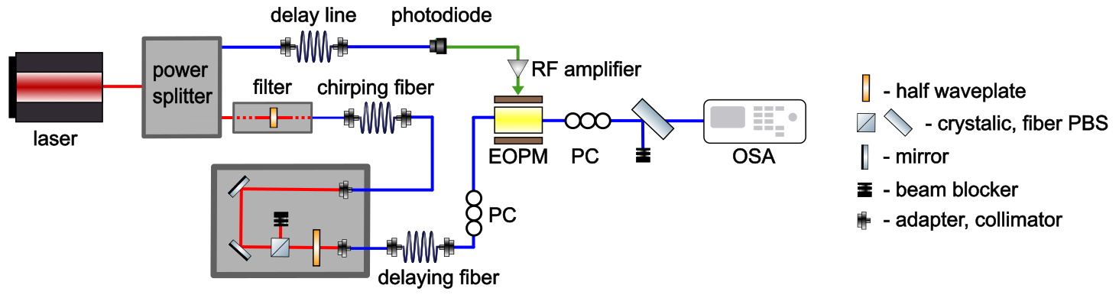

* The filter and chirping fiber may be replaced with any pulse-shaping system.
* I propose to use 80 m long delaying fiber.
* The power of pulses that I measured was typically 0.5-2 mW, which worked well.
* The grey box at the bottom is a precise polarization controller, which allows switching between measuring single polarization (sheared and non-sheared spectrum) and mixtures of two polarizations (phase and temporal spectrum).
* The regular polarization controller on the right is responsible for 50:50 polarizations mixing. It is not a big deal, if it is not in the perfect position (like 20:80) – this will cause lower output intensities, but no information should be lost.
* The middle regular polarization controller is responsible for compensating wrong alignment of axes of the PM fiber and the modulator. The modulator introduces 15 ps, therefore, if axes are not aligned perfectly, both in the measured spectra and in the reconstructed spectral phase the oscillations with period of 65 GHz will be present. If the spectral phase is slowly-varying, this may be corrected in post-processing. Otherwise, it is crucial to set the polarization controller in the right position, i.e. such that no matter what is the angle of the HWP in free space beam polarization controller, no 65 GHz oscillations will be visible in the measured spectrum. Obtaining this may take a while.
* Next step is to set the delay line in the correct position, i.e. so that the pulse to be spectrally shifted overlaps with the linear slope of the current induced by the pulse propagating through delay line. Let the power of the pulse guided to photodiode be equal to ~100 μm, which should nearly saturate the photodiode. Sweep the available positions of the delay line to find the correct delay, i.e. such that will introduce homogeneous spectral shift (make sure that left and right slope of the spectrum are equally shifted). Use precision of 0.05 mm.
* Decrease the power of the beam steering the modulator to ~10 μm. The spectral shift you want to utilize should be 5-20 GHz. For the pulses I measured 10 μm of power introduced 8-10 GHz of spectral shift, and the relationship between these two quantities was roughly linear.
* Time for measurements: use the HWP to switch between measuring mixture of polarization and measuring single polarization and use the EOPM to modulate the beam. This way you measure all four spectra as described at the beginning. Use highest sensitivity that OSA can provide. When you are measuring the non-sheared spectrum, make sure that you are measuring the modulated polarization with EOPM off and **not** the non-modulated polarization.
* Where you are measuring the mixture of polarizations, make sure that the visibility is as high as possible. At the same time, you may try to fix the *right* polarization controller in the best position. The best position is such that maximizes the output intensity while keeping the maximal visibility of the fringes (obviously, you need to play with HWP at the same time). However, this step is not crucial.

1. **Numerical part**

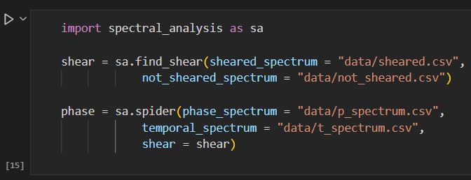The numerical analysis is pretty simple. I perform it in Python, particularly in the Jupyter Notebook – however, if needed, conversion of the code to work in pure Python should be very easy. The minimal working example (*example.ipynb*) is shown below.

All functions utilized (and also all the functions in the *spectral_analysis* module) do have a detailed description in the documentation, therefore I will skip it here.

The code shown above is the **minimal** working example – the *sa.spider* function has 16 optional arguments (each described in documentation) and *sa.find_shear* has 5 of them, hence a large domain for experiments and upgrades is provided.

Please note that SPIDER-reconstructed phase is indeterminate up to a constant (global phase), linear phase (temporal phase) and *probably* up to a sign (caused by $cos\left(x\right)=cos⁡(-x)$). Moreover the spectral intensity *might* be slightly shifted with respect to spectral phase be a value not greated than the shear. Because of the small values of the shears used this effect was typically negligible and I discovered it just recently and haven’t fixed it, yet.

If the measurement of the shear is somehow wrong, you can let the algorithm find the value of the shear on its own, by writing *shear = None*. However, I do not recommend this approach, as the result might be biased with quite a big error.