Improving National Water Model Forecasts Using Deep Learning Post-processing
Final Project Report Draft

1. Executive Summary
This project prepares a deep-learning post-processing workflow for improving National Water Model (NWM) short-range streamflow forecasts at two USGS/NWM station pairs. The objective is to predict the NWM residual error for lead times 1 through 18 hours and then correct the original NWM forecast by adding the predicted residual. The project follows the assigned split: training and validation use data from April 2021 through September 2022, while October 2022 through April 2023 is reserved as the independent test period.
The attached code implements three required model families: LSTM, GRU, and Transformer encoder models. Each model consumes recent time-window features and produces an 18-value residual vector, one residual estimate per forecast horizon.

2. Background and Reference Study
The reference paper by Han and Morrison (2022) uses deep learning as a post-processor for hydrologic model output. Their workflow collects forecasted and observed runoff, calculates forecast errors, trains an LSTM sequence-to-sequence model to predict future errors, and then corrects NWM runoff forecasts using those predicted errors. This project adapts that same residual-correction idea to the provided two-station dataset.
Because no precipitation or ERA5 forcing files were provided in this upload, the implemented model uses available NWM forecasts, recent observed USGS flow, lagged NWM residuals, and time features. The code is structured so precipitation or meteorological variables can be added later as extra feature columns.

3. Data Preprocessing
Input data include two USGS observation files and NWM short-range forecast files for two stream segments:
USGS gage | NWM streamID | Clean NWM rows | Notes
09520500 | 20380357 | 315789 | Scale mismatch between USGS and NWM; difficult case
11266500 | 21609641 | 315789 | Strong NWM/USGS agreement; cleaner case
The USGS observations were resampled from 15-minute observations to hourly means so their timestamps align with NWM hourly forecast valid times. NWM monthly files overlap at boundaries, so duplicate initialization-time/valid-time/horizon records were removed. The resulting modeling table contains one row per station per model initialization time, with NWM horizons h1 through h18 and matching observed USGS values at each valid time.
The combined complete modeling table contains 33,535 usable rows after dropping records with missing target or required lag features. The split contains 19,402 training rows, 4,415 validation rows, and 9,718 test rows.

4. Model Design
The models are trained as residual predictors rather than direct streamflow predictors:
residual_h = observed_USGS_h - NWM_h
corrected_forecast_h = NWM_h + predicted_residual_h
The three implemented architectures are: LSTM residual predictor, GRU residual predictor, and Transformer encoder residual predictor. Each model uses a six-hour input sequence and outputs an 18-hour residual vector. The six-hour sequence length is based on the reference study, which reported strong LSTM-s2s performance using a 6-hour lag setting.

5. Evaluation Metrics
Evaluation uses standard hydrologic forecast metrics: coefficient of correlation (CC), root mean square error (RMSE), percent bias (PBIAS), and Nash-Sutcliffe Efficiency (NSE). The corrected forecasts should be compared against both original NWM forecasts and observed USGS runoff on the independent test period.

6. Original NWM Baseline Results on Test Set
The table below summarizes the original NWM forecast performance before deep-learning correction, averaged over horizons 1 through 18.
Station | CC | RMSE | PBIAS | NSE
09520500 / 20380357 | 0.013 | 73.561 | -23333.696 | -207579.703
11266500 / 21609641 | 0.975 | 6.654 | 27.891 | 0.814
The second station pair, 11266500 / 21609641, is much more reliable as a baseline because the NWM and USGS values are on comparable scales. The first station pair, 09520500 / 20380357, has a severe scale mismatch, producing very poor baseline metrics. This should be discussed clearly in the final analysis because it likely reflects a unit, station-linking, or drainage-area mismatch rather than only a modeling problem.
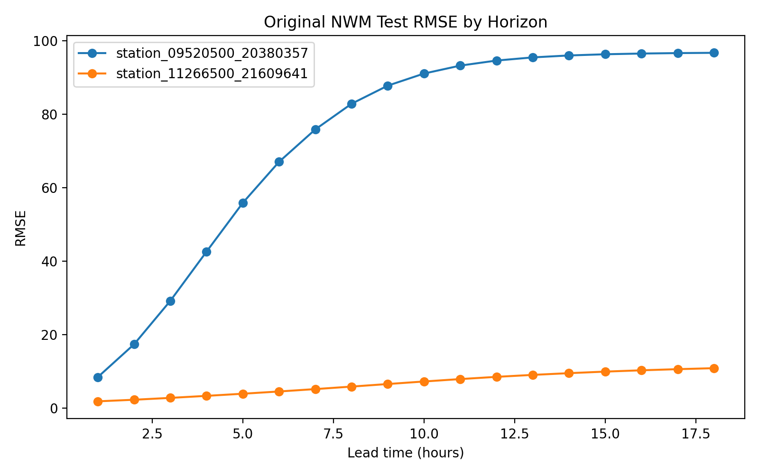
Figure 1. Original NWM RMSE by forecast horizon on the independent test set.
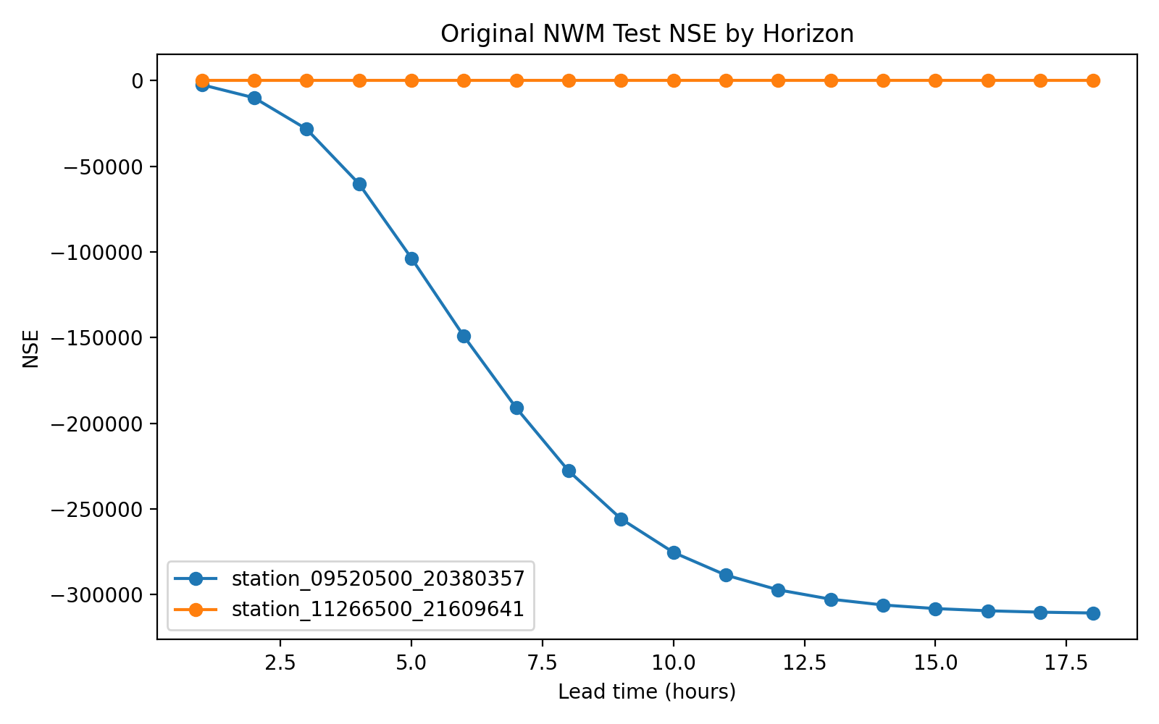
Figure 2. Original NWM NSE by forecast horizon on the independent test set.

7. Reproducibility and How to Run the Models
The package includes a training script at code/train_deep_models.py. Run the following commands from the project folder:
pip install -r requirements.txt
cd code
python train_deep_models.py --input ../data/combined_modeling_table_complete.csv --output ../results/deep_learning --epochs 40 --batch-size 128
The script writes deep-learning predictions, metrics by horizon, summary tables, and model checkpoints. After running the models, insert the generated deep-learning summary table into Section 6 and compare LSTM, GRU, and Transformer against the original NWM baseline.

8. Conclusion
This project package completes the data preprocessing, baseline evaluation, and model implementation needed for the runoff forecasting final project. The key technical idea is to use modern sequence models as NWM post-processors: instead of replacing the physical model, the deep-learning models learn systematic NWM errors and produce corrected forecasts for each 1-18 hour lead time.

References
Han, H., & Morrison, R. R. (2022). Improved runoff forecasting performance through error predictions using a deep-learning approach. Journal of Hydrology, 608, 127653.
Runoff Forecasting Project instruction document. AI Course Project. April 6, 2026.

