Enterprise Treasury AI Copilot
Architecture Document

Overview
This document describes the high-level architecture of the Enterprise Treasury AI Copilot. The platform is designed as a production-oriented Retrieval-Augmented Generation (RAG) application for treasury, finance, risk, and regulatory use cases.

Architecture Diagram
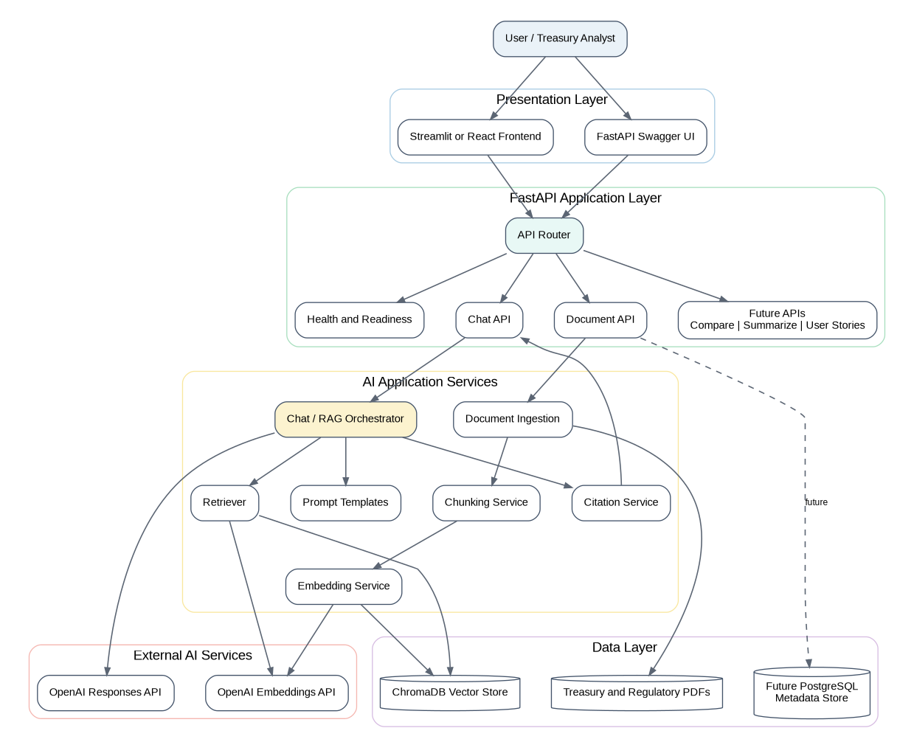

Architecture Layers
- Presentation Layer: Streamlit/React UI and FastAPI Swagger UI for users and developers.
- API Layer: FastAPI routes requests to document ingestion and chat services.
- AI Services: Document ingestion, chunking, embeddings, retrieval, prompt management, chat orchestration, and citations.
- Data Layer: PDF documents, ChromaDB vector store, and future PostgreSQL metadata.
- External Services: OpenAI Embeddings API and OpenAI Responses API.

Document Ingestion Flow
- PDF Upload → Document Loader → Chunking → Embeddings → ChromaDB Vector Store

Question Answering Flow
- User Question → Retriever → Prompt Builder → OpenAI Response → Citation Service → Final Answer

Future Enhancements
- Authentication (JWT/OAuth)
- PostgreSQL metadata catalog
- Redis caching
- Evaluation framework (RAGAS/LangSmith/DeepEval)
- AI agents and workflow orchestration
- Docker and Azure deployment
- Monitoring and observability

