Render Flow

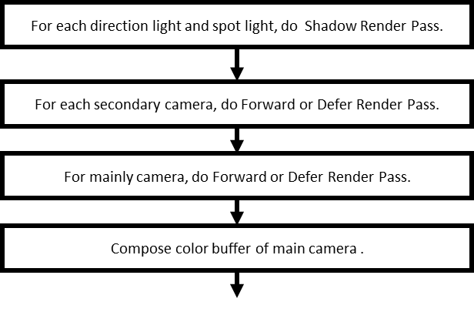

Figure 1. flow chart for rendering a frame.

The figure 1 shows how we render a frame in our engine. We will prepare shadow maps for each spot or direction light in current scene. For making shadow for each light, we need to prepare framebuffer for each cascade in one light. And then we render scene following figure 2.

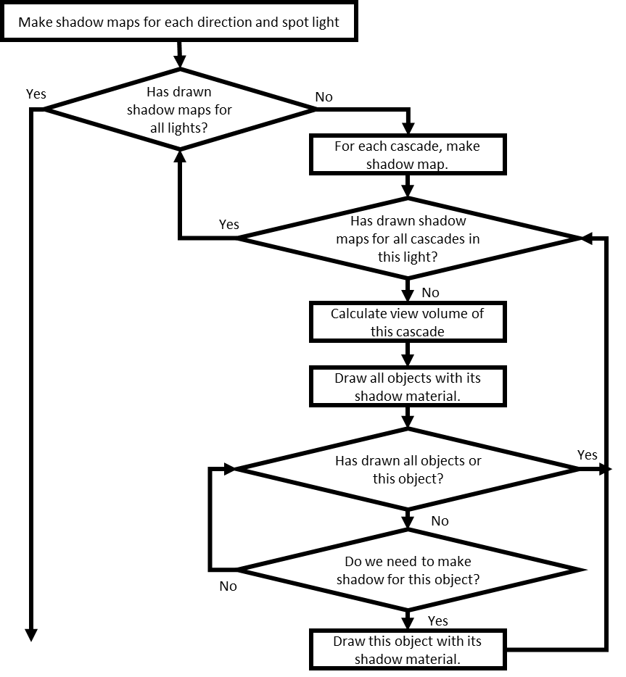

Figure 2. flow chart about making shadow maps for lights.

After preparing shadow map, we draw scene with camera that its color buffer is used to be texture of other object. And then we draw scene with main camera. Finally, we compose color buffers of main cameras to image in swapchain.

Vertex Buffer

Function RefreshBuffer

To refresh vertex buffer. If refresh data is large than old one, we will create new buffer.

