**UI Design:**

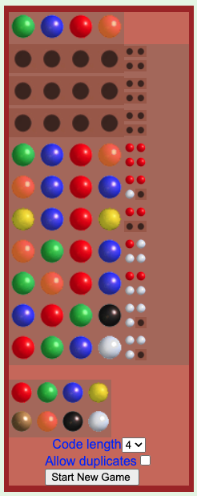

GUI shows:

1. Home Page: MasterMind game home page with colored balls.

* The user inputs their guess here as a string of characters representing colors.

1. Features supported:

a. Number of Pegs: 4/6/8 [User gets to select one]

b. Colors: Red (R), Green (G), Blue (B), Yellow (Y), Gold (G), Orange (O), White (W) and Black (B)

c. Number of Users: 1 (user vs computer)

d. Game Modes: Computer generates the code, user guesses

b. Allow Duplicates: When checked yes, the secret code that needs to be guessed can contain duplicate colors.

1. Button: To start a new game
2. The computer will generate a secret code consisting of the chosen no of pegs.

- Each peg can be one of 8 colors: Red (R), Green (G), Blue (B), Yellow (Y), Gold (G), Orange (O), White (W) and Black (B)

- You have 10 attempts to guess the code.

- After each guess, you will receive feedback:

- Black (B) indicates a peg is the correct color and in the correct position

- White (W) indicates a peg is the correct color but in the wrong position.

1. Classes:
   * Code:
     + Variables: sequence
     + Methods: inititalize
   * Player:
     + Variables: name
     + Methods: initialize
   * Game:
     + Variables : player, secret_code, attempts_left, code_length , black_pegs, white_pegs
     + Methods: initizialize, generate_secret_code, make_guess, compare_codes,

Relationships:

* + The Game class manages the overall game flow and interacts with the Code class to handle the secret code and guesses. The Game class also uses the Feedback class to generate feedback for each guess.

