HW3 – Reliable Inter‐process Communication

Desing Issues

This documents contains some diagrams of the implemented protocols. In following pages, a component, sequence and class diagram are drawn respectively.

Component Diagram

This diagram shows all components and relationships between them in the game.

Sequence Diagram

In this one, only the process of registration is illustrated. Since all protocls follow a request-reply pattern for communication, this figure are presented as a sample.

Class Diagram

Simillar to the previous diagram, some classes are drawn as samples. There are at least two specialized doer classes for each protocol, so some of them are selected to show the detail of implementation. Comprehensive class diagrams for derived classes from PlayerDoer, FightManagerDoer and BalloonManagerDoer are created in the related projects of my Visual C# project.

Protocols

Following figures illustrate how defined protocols work. Each label is the name of a message class desinged for the specific protocol.

1. Registration

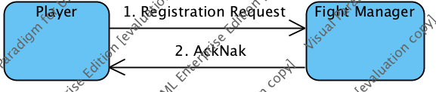

1. Deregistration

*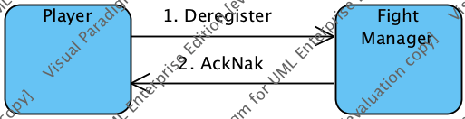*

1. Player's Location

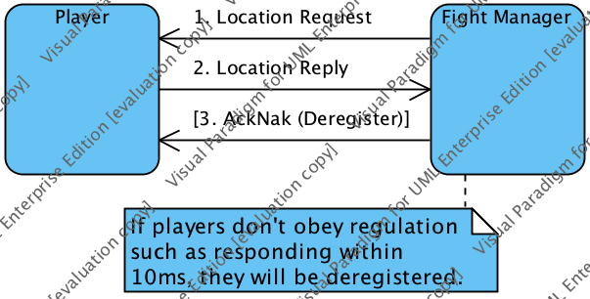

1. Current Player List

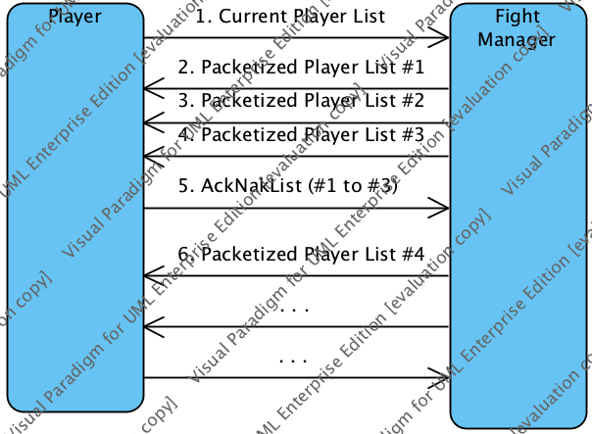

1. Player's Most Recent Location

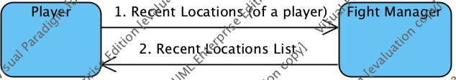

1. Instigate a Fight

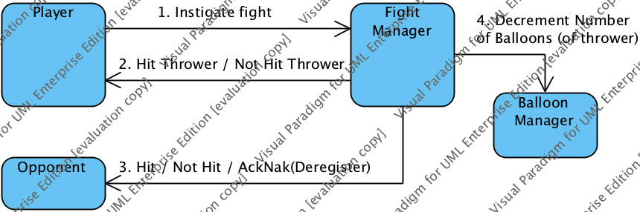

1. Join a Fight

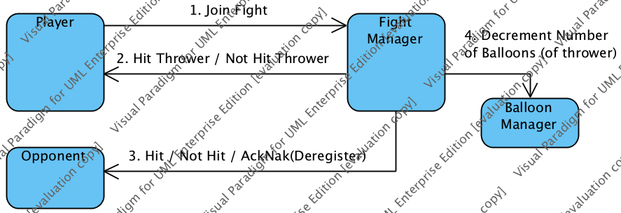

1. In-process Fight List

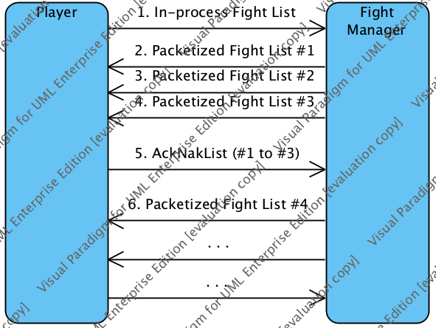

1. Players of a Specific Fight

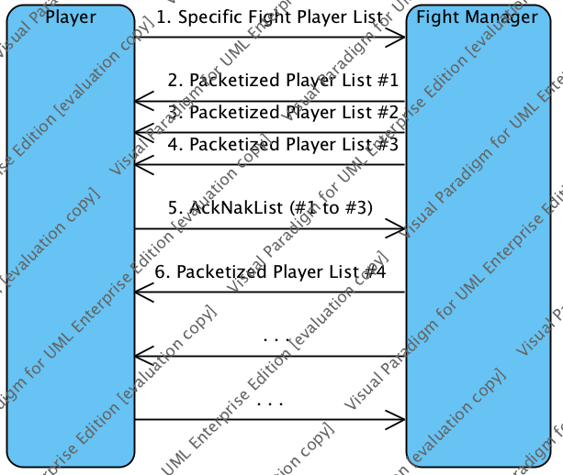

1. An Empty Balloon Request

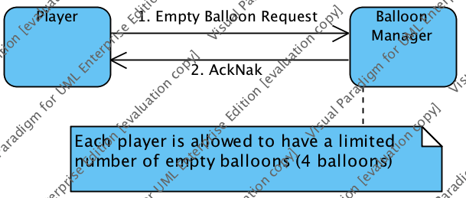

1. Amount of Water Request

