A   
 Project Report on   
Online Examination System



Submitted by:   
 Lalit Kumar   
 Roll No : 185020   
 Branch : CSE (B.Tech)

Certification

This is to be certified that Lalit Kumar, student of National Institute of Technology, Hamirpur in the department of

Computer Science and Engineering has worked on the

College Project Entitled with:

“Online Examination System”

Under the guidance of

Dr. Naveen Chauhan

................. ….............................   
Authorized Dr. Naveen Chauhan   
Signature   
Dated:

ACKNOWLEDGEMENT

I am very thankful to Dr. Naveen Chauhan ,to give me the   
opportunity to build this project and guide because without

his guidance it would not be possible to build this project.   
Last but not the least I would like to thank the entire   
National Institute of Technology Computer Science

Department for allowing me to proceed with the project.

ONLINE EXAMINATION SYSTEM

PURPOSE:

The purpose of on-line exam simulator is to take online exam in an efficient manner and no time wasting for checking the paper. The main objective of on-line exam simulator is to efficiently evaluate the candidate thoroughly through a fully automated system that not only saves lot of time but also gives fast results. For students they give papers according to their convenience and time and there is no need of using extra thing like paper, pen etc.

SCOPE

* Scope of this project is very broad in terms of other manually taking exams. Few of them are:-
* This can be used in educational institutions as well as in corporate world.
* Can be used anywhere any time as it is a web based application(user Location doesn’t matter).
* No restriction that examiner has to be present when the candidate takes the test.

 FEATURES:

* Secure
* Easy to use
* Reliable and accurate
* No need of examiner

Software Requirements Specification   
Development Environments   
Hardware :   
Intel core 2 duo T6400 2.00 GHz with 2GB RAM, 250 GB hard disk   
space and other Standard accessories.   
Environment and Applications:   
Microsoft Windows 7.   
Microsoft Visual Studio 2010.   
Microsoft Internet Explorer.   
Operating environment:   
Hardware configuration:   
The minimum configuration for hardware is given below:

Intel® Pentium® or higher processor.   
65 MB RAM or higher   
Software configuration:   
Microsoft® Windows® XP or later versions   
A standard web browser.   
NodeJs installed

Technologies Used :

Backend : NodeJs

Database : Mongodb

Frontend : HTML,CSS,JS,BootStrap

Detailed design specification:

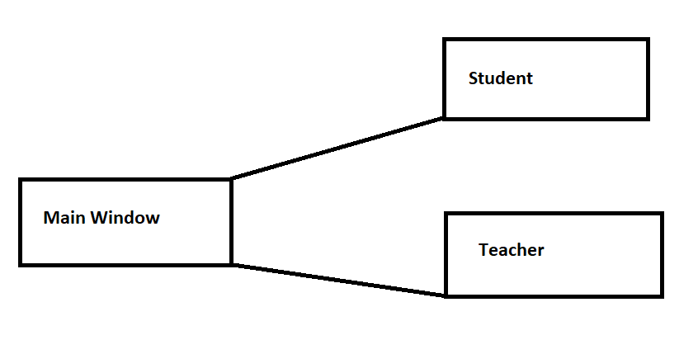

Home Page

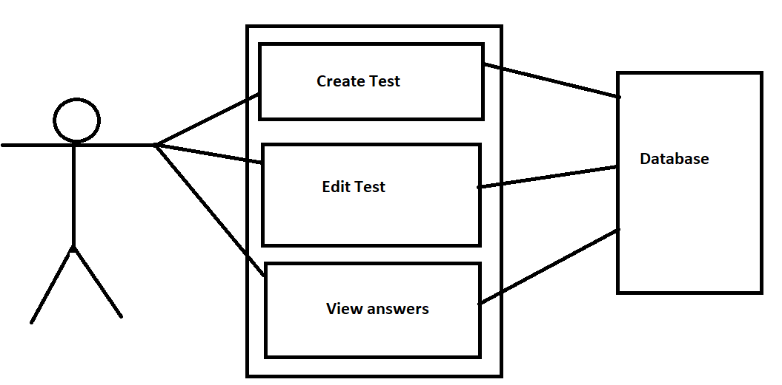

Teacher’s Window

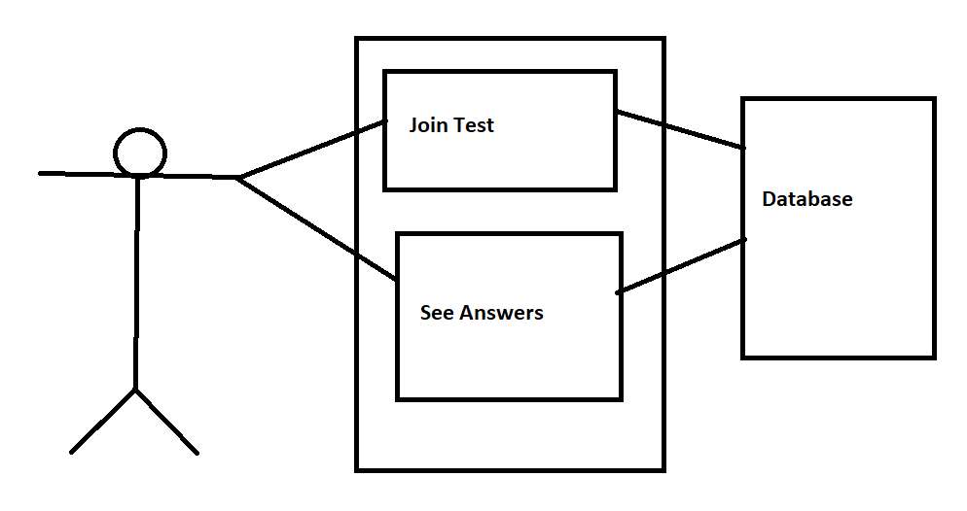

Student’s Window

SDLC (Software development Life Cycle)   
Every activity has a life cycle and software development process is not an exception for the same. Even if you are not aware of SDLC you still must be following it unknowingly. But if a software professional is aware about SDLC he can execute the project in a much controlled fashion. One of the big benefits of this awareness is that hot blooded developers will not start directly execution (coding) which can really lead to project running in an uncontrolled fashion. Second it helps customer and software professional to avoid Confusion by   
anticipating the problems and issues before hand. In short SDLC defines the various stages in a software life cycle. But before we try to understand what SDLC is all about. We need to get a broader view of the start and end of SDLC. Any project started if it does not have a start and end then its already in trouble. It’s like if you go out for a drive you should know where to start and where to end or else you are moving around endlessly.

Iterative model   
The iterative waterfall model is used in the development of the system. The system is developed in increments, each increments adding some functional capability to the system until the full system is fully implemented. The advantage of this approach is that it will result in better testing, as testing   
of each increment is easier than testing the entire system in totality. Furthermore, this approach provided us with important feedback that was very useful in the implementation of the system.

Development Schedule   
The work on the proposed ONLINE EAMINATION SYSTEM was started on 9th June 2021. The following Gantt chart has explained the estimated duration of the different phases of the software development work diagrammatically

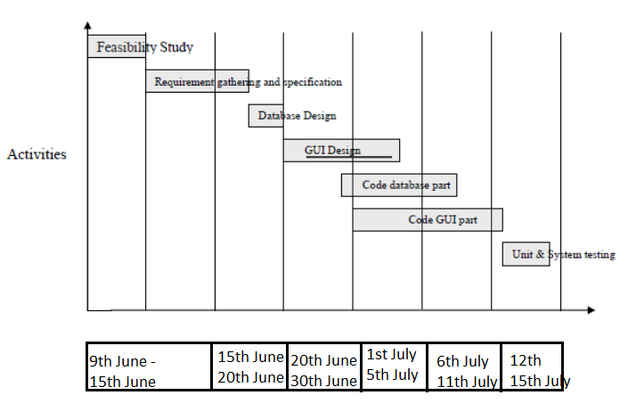

Implementation Details

Database Tables

* Answers : Store information about all answers submitted by students(name,testId,answers).
* Marks : Store information about marks given to each student in each test(name of student,marks,test).
* Students : Store information about students(email,encrypted password).
* Teachers : Store information about teachers(email,encrypted password).
* Tests : Store information about each test(started/stopped,teacher name,testId, questions)

Home Page

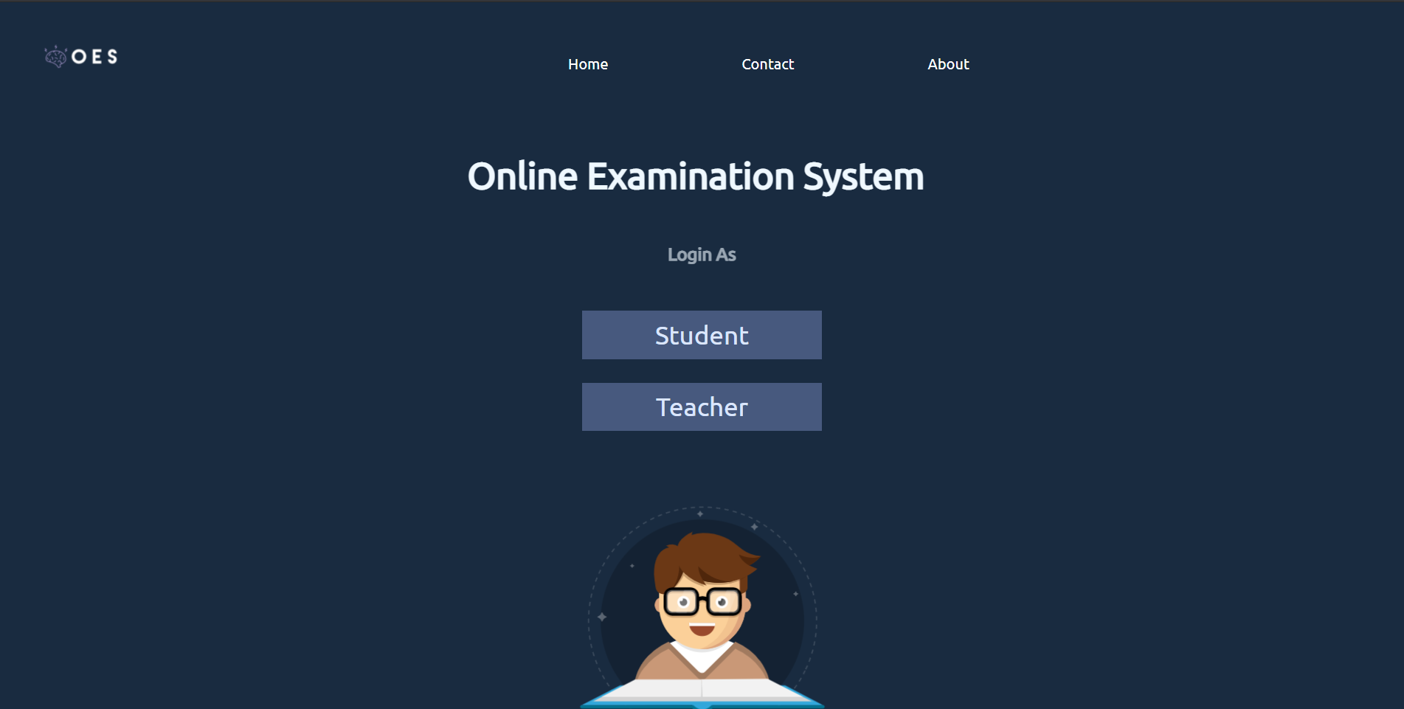

In Teachers Section

Login window

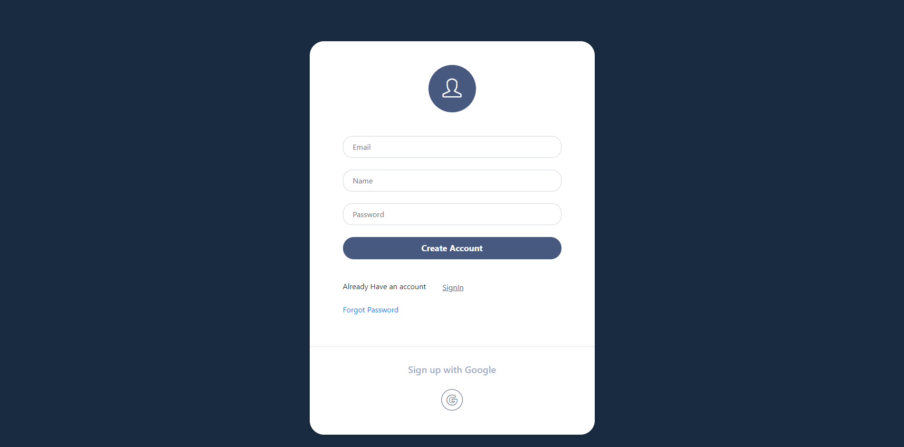

Teacher can login/signup with email,password or google login

After Login

Teacher Dashboard

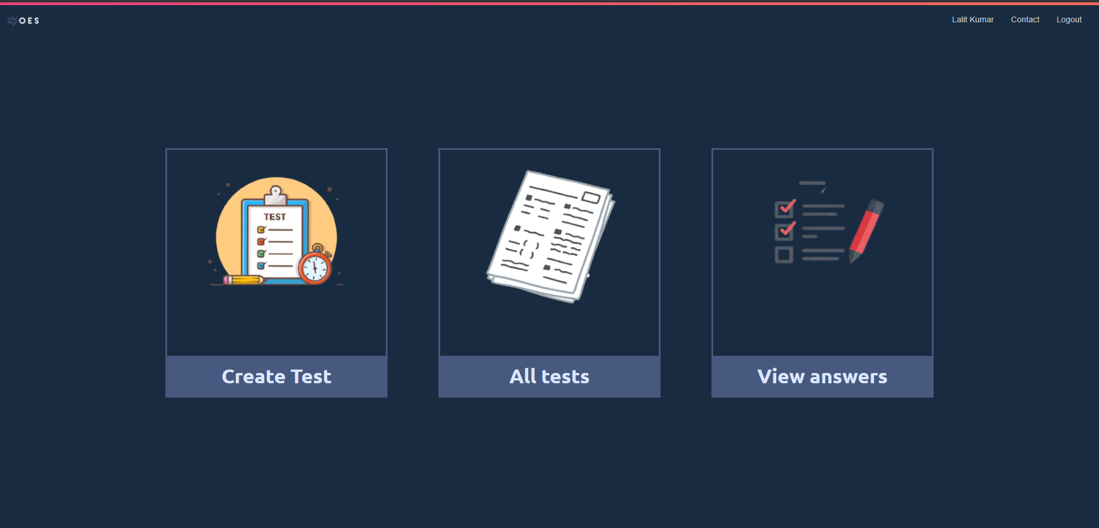

After Creating test

A random test id is generated (created via uuid npm package)

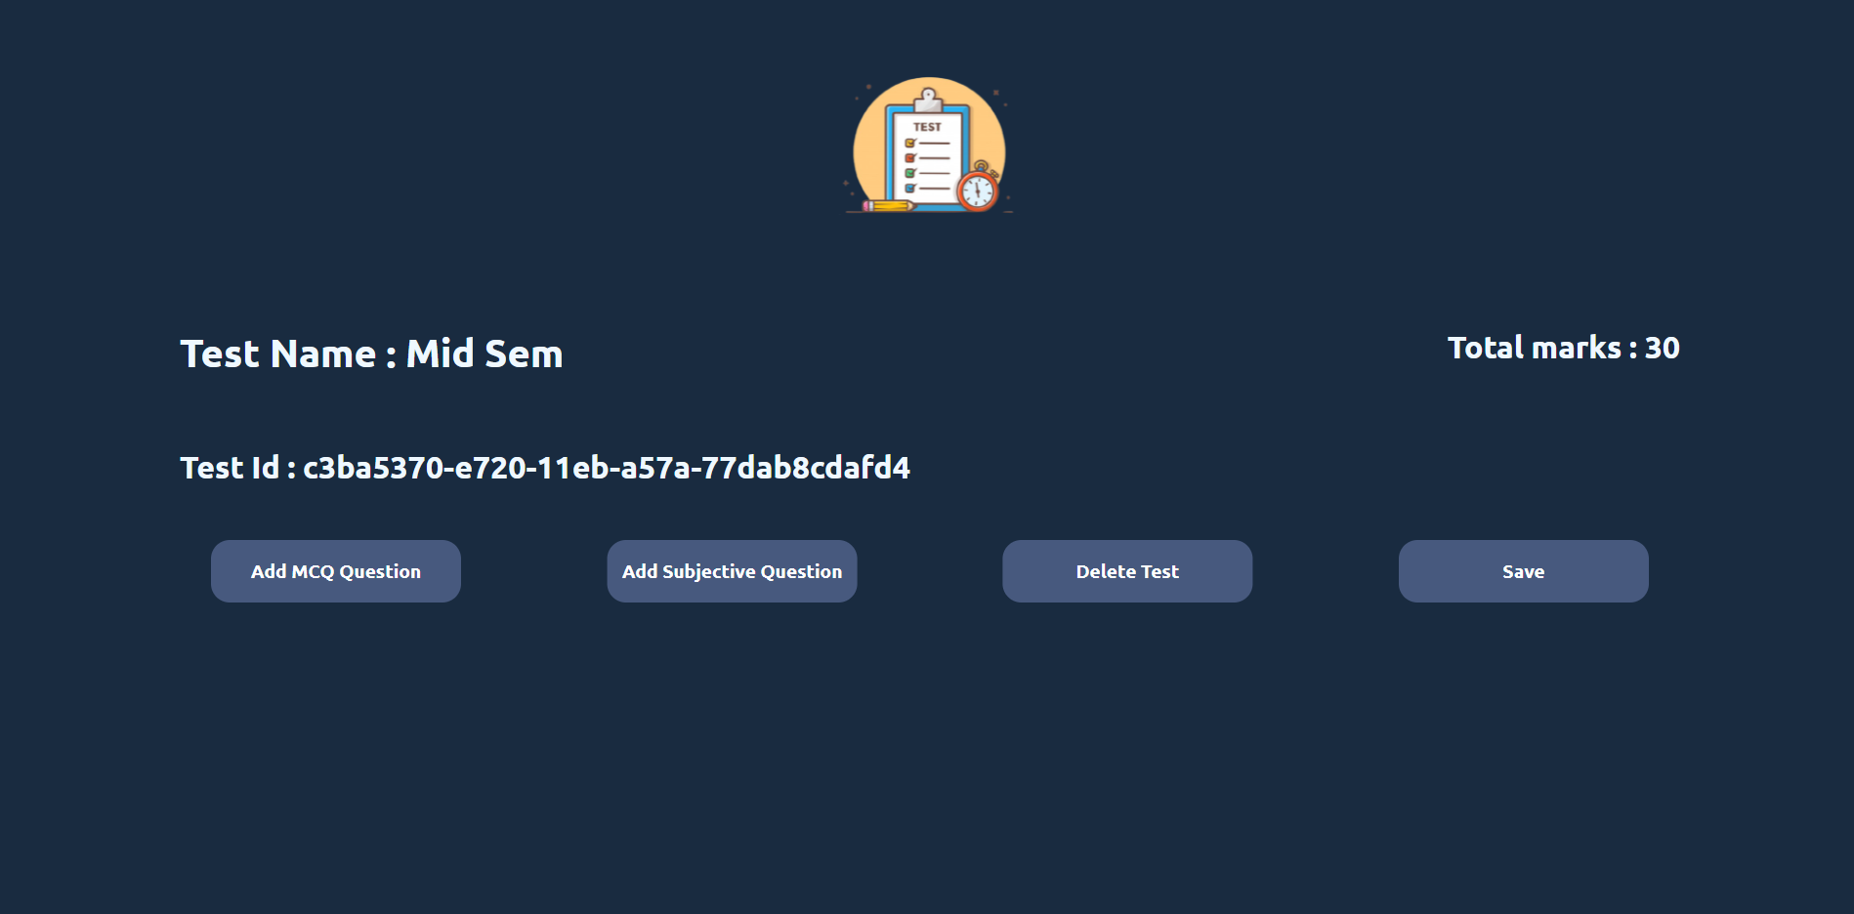

You can add mcq/subjective questions.

You can also delete test and view images.

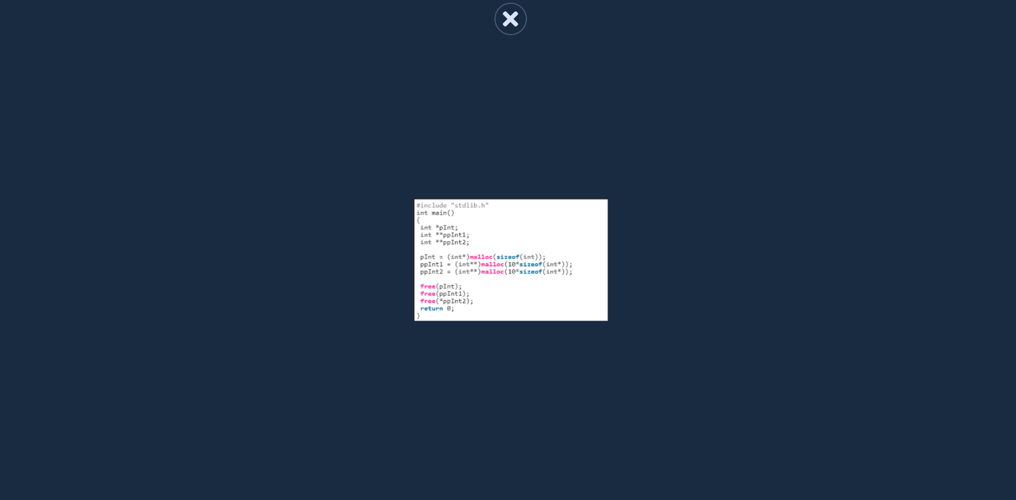

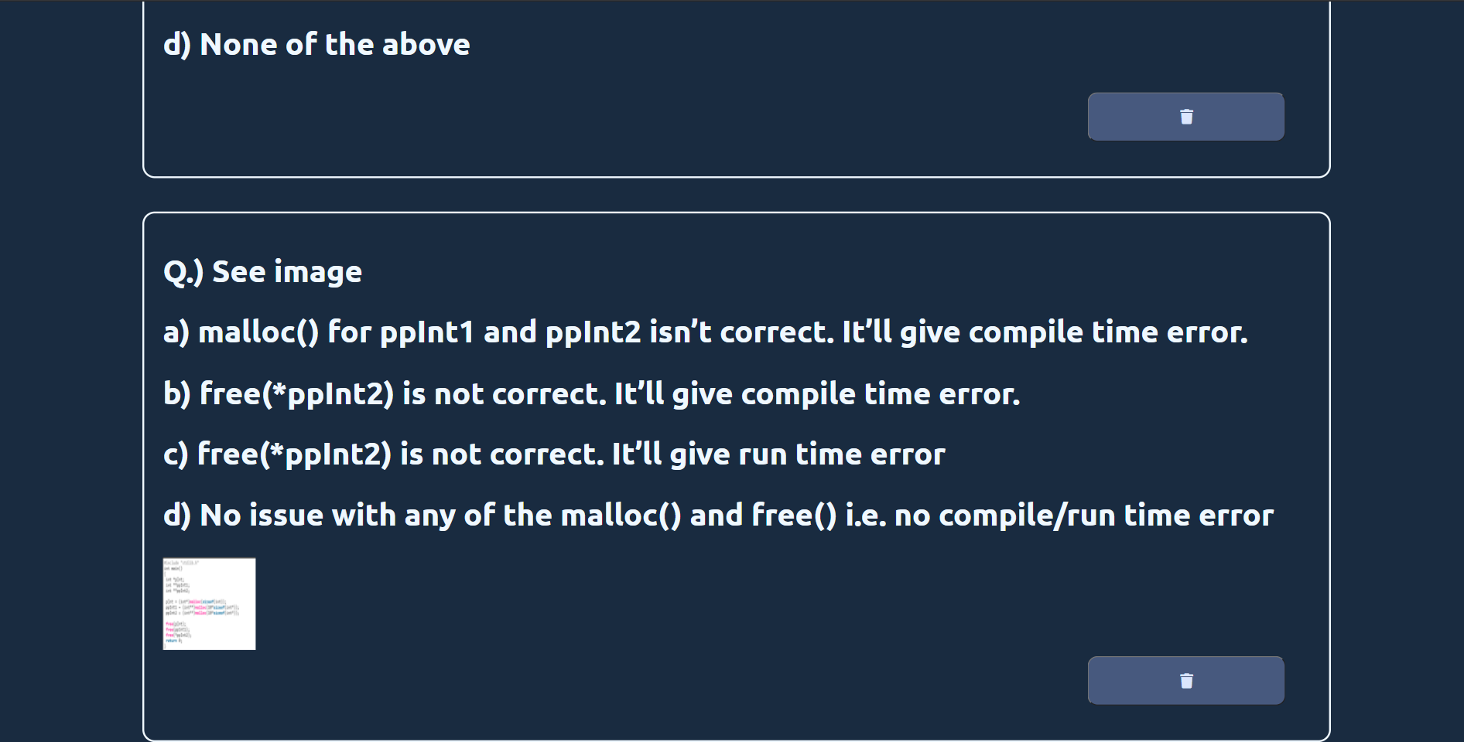

After clicking all test

You can delete or edit test. You can change status of test(on/off).

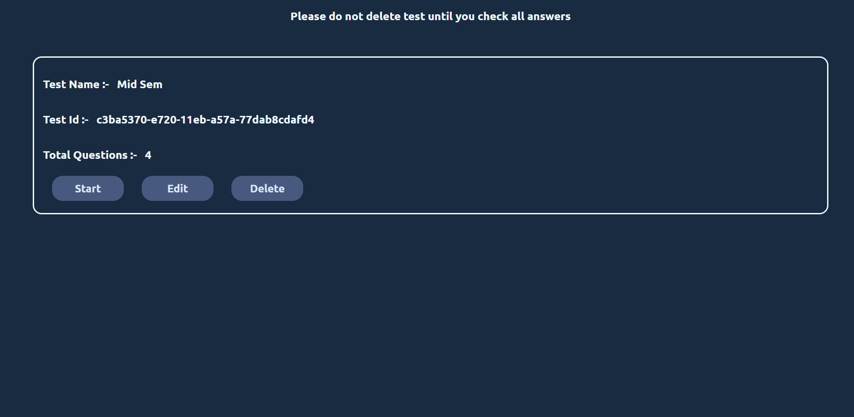

This id is required to join test.

After Login

Student Dashboard

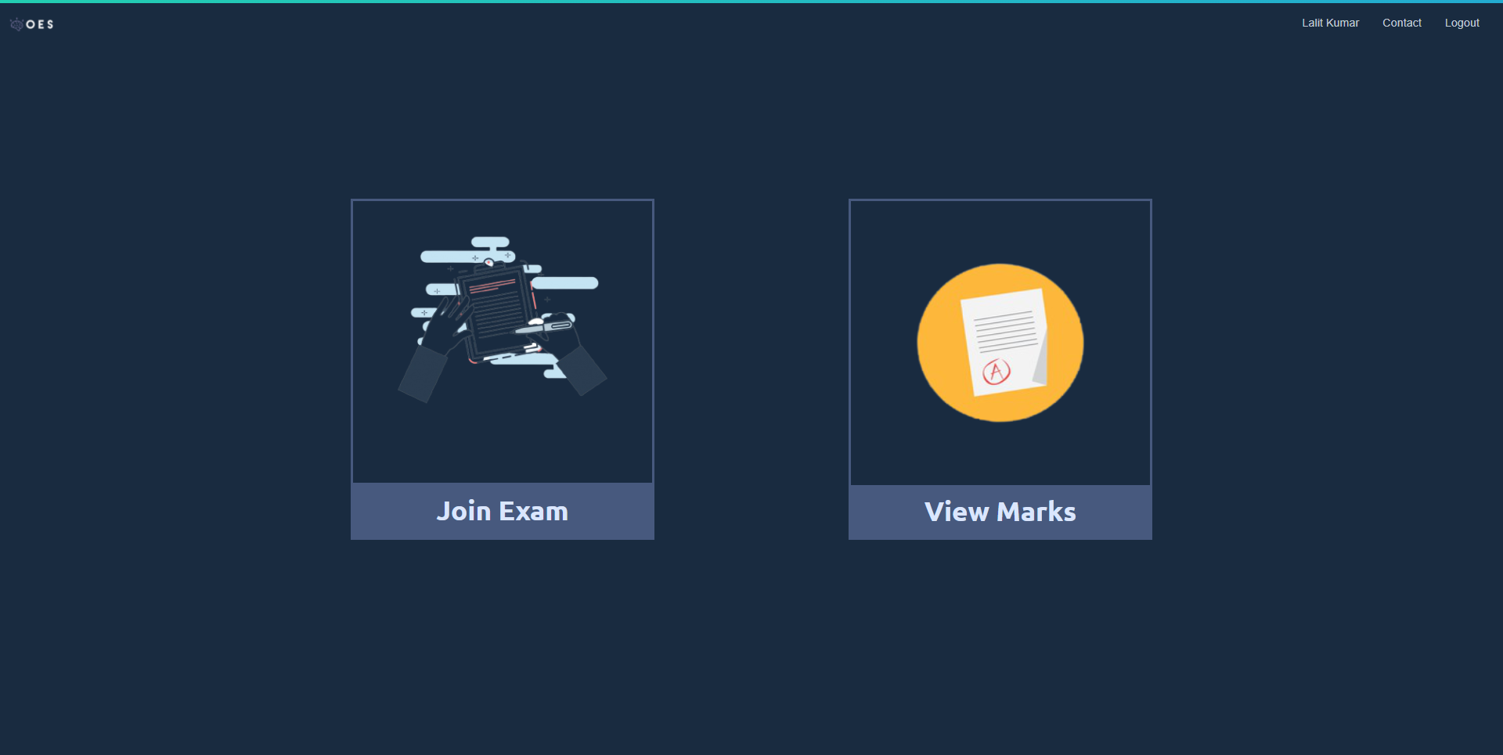

Student can join test by entering appropriate test id

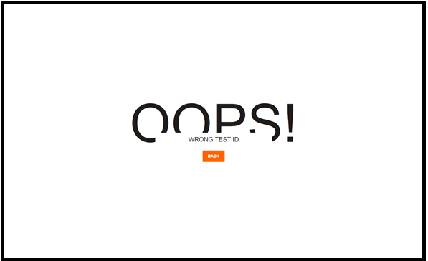

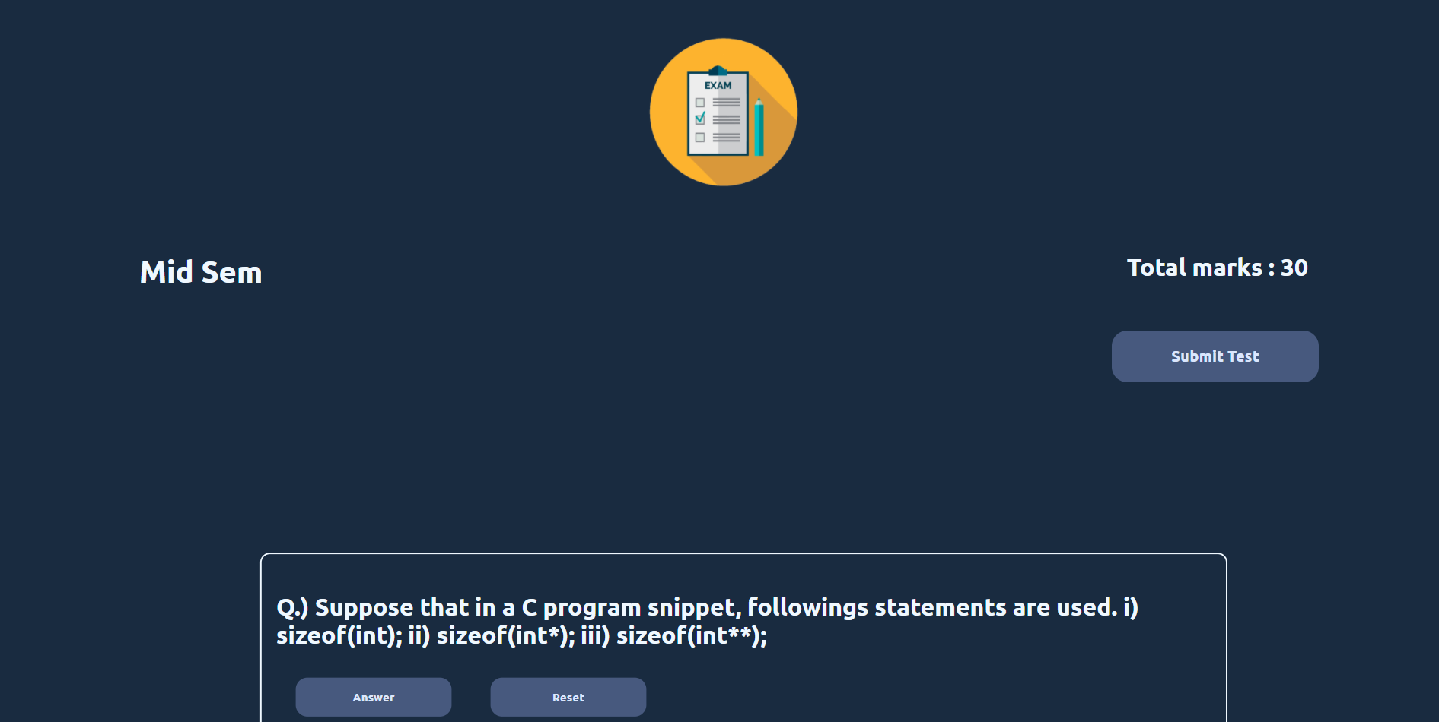

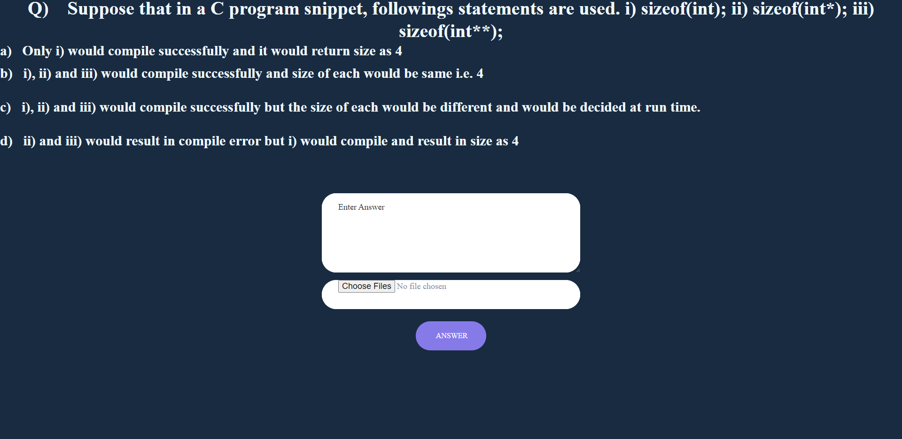

After Submitting

Teacher can see each students answers

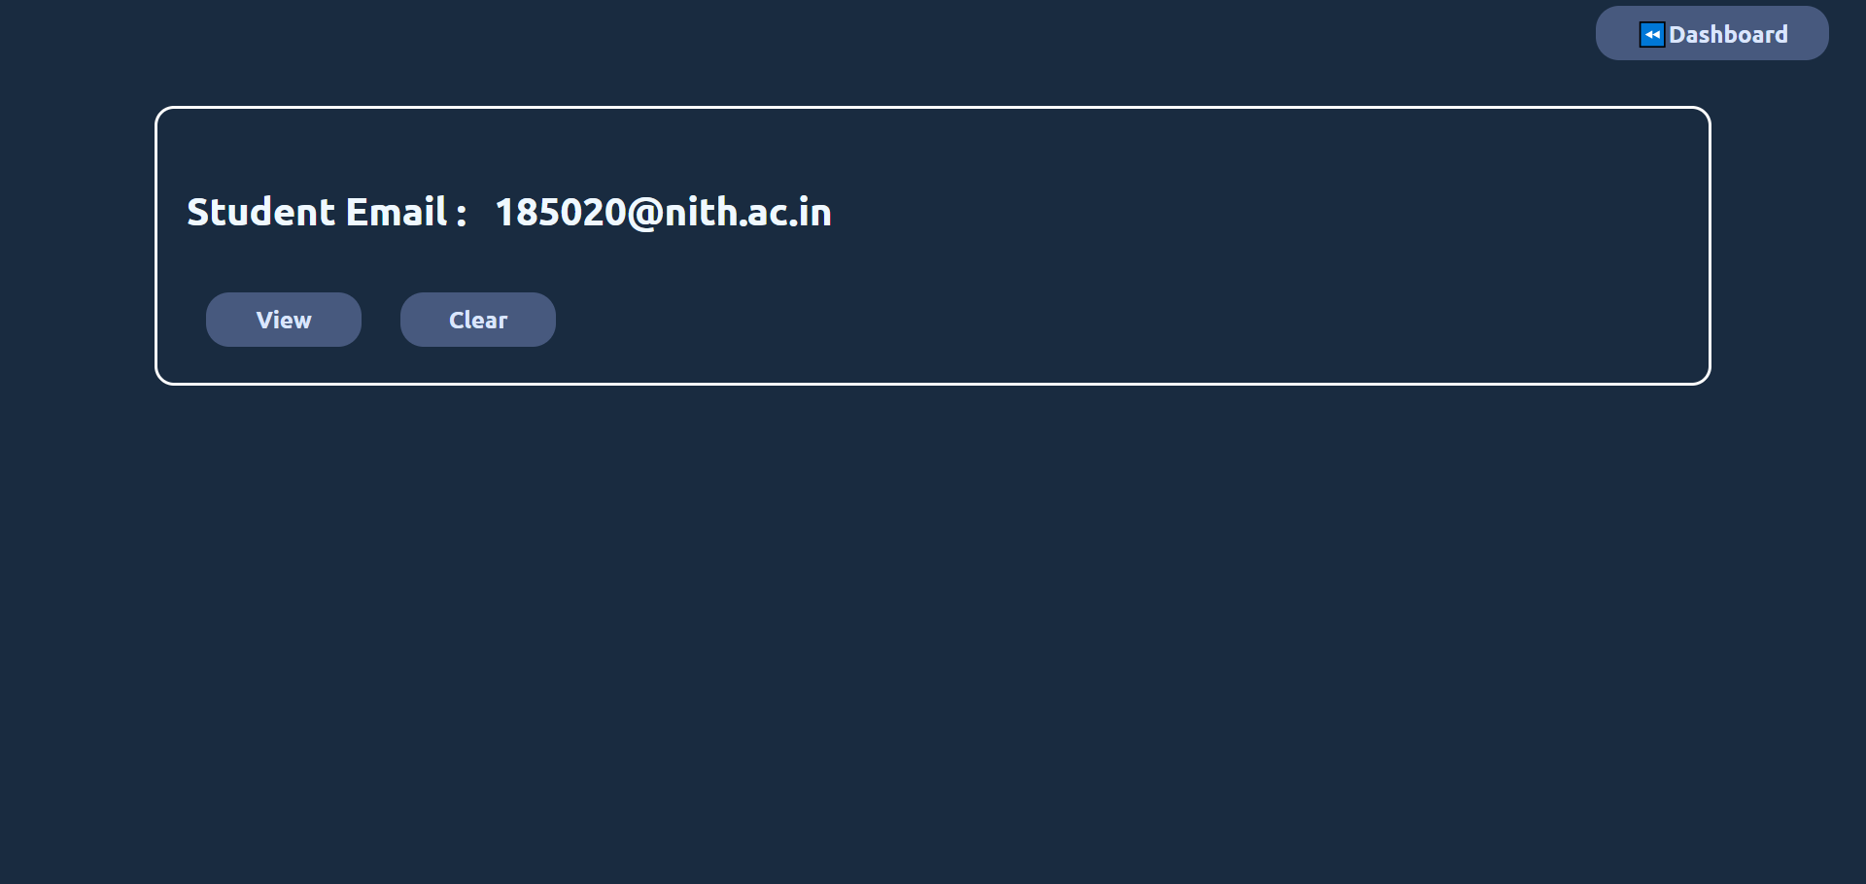

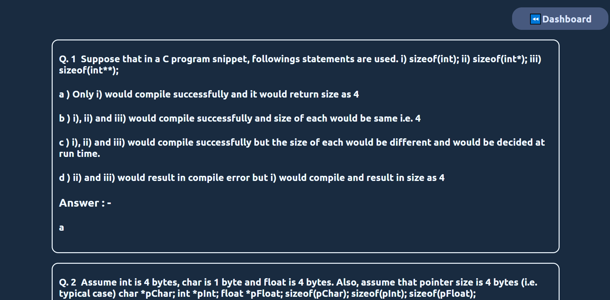

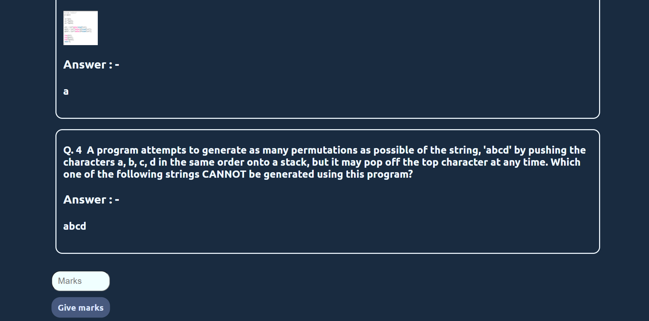

Teacher can give marks

Students can see their marks in each test

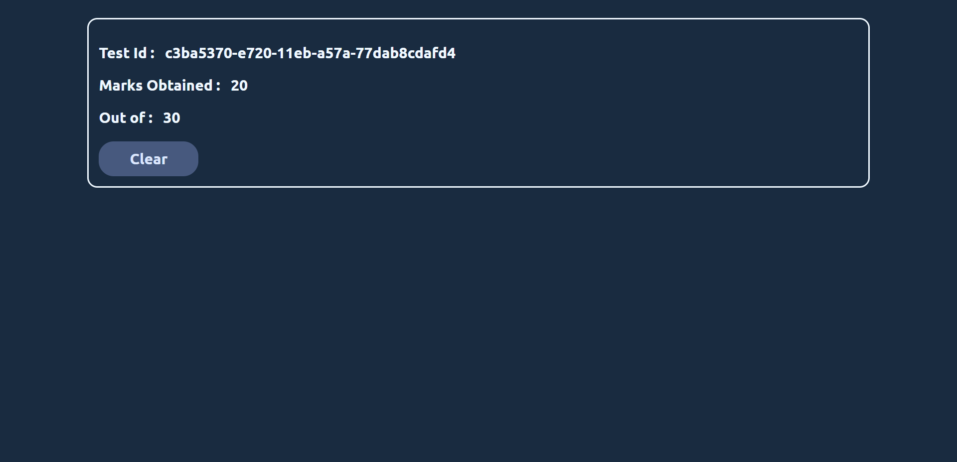

If teacher or students forgot his password

he can change his password by clicking forgot password. A email is sent to the registered email with a link where he can change his password.

References :

NodeJs : <https://nodejs.org/en/>

BootStrap : <https://getbootstrap.com/>

HTML : <https://www.w3schools.com/html/>

CSS : <https://www.w3schools.com/css/>

JS : <https://www.w3schools.com/js/>

Express : <https://expressjs.com/>

Nodemailer : <https://nodemailer.com/about/>

Multer : <https://www.npmjs.com/package/multer>

Github : <https://github.com/Lalit-Kumar20/Online_Examination.git>