PCET’s
PIMPRI CHINCHWAD UNIVERSITY
Department of CSE - Artificial Intelligence & Data Science

Report Based On
Base Algorithm in R - Manual Vs Library
Subject: Data Science and Analytics
Academic Year: 2025–26
Submitted By
Lalit Patil
Roll No: A-63
PRN : SOE23201010256
Department of AI & DS
Pimpri Chinchwad University
Guided By
Prof. Tushar R. Mahore
ABSTRACT
This report presents a comparative analysis of fundamental machine learning algorithms implemented manually and via R libraries using standard datasets. It evaluates linear regression, logistic regression, k-nearest neighbors, and decision tree models, focusing on performance metrics such as RMSE and R² . The study highlights trade-offs between manual coding for deeper understanding and library usage for efficiency and reproducibility. Challenges of manual implementation and advantages of standardized libraries are discussed, providing guidance on choosing implementation strategies based on learning, prototyping, or deployment objectives.

Data and Setup

1.1 Preparation of Environment
1.1.1 Installation of Required Packages & Verification of R Environment
To prepare the R environment for machine learning and data visualization tasks, the following command installs five essential packages from CRAN:
install.packages(c("ggplot2", "class", "rpart", "rpart.plot", "e1071"))
This command installs the following packages:
- ggplot2: For creating elegant and customizable data visualizations using the grammar of graphics.
- class: Contains functions for classification, including the knn() function for knearest neighbors.
- rpart: Used to build decision tree models for classification and regression.
- rpart.plot: Helps visualize decision trees created with rpart.
- e1071: Provides functions for machine learning, including support vector machines and Naive Bayes.
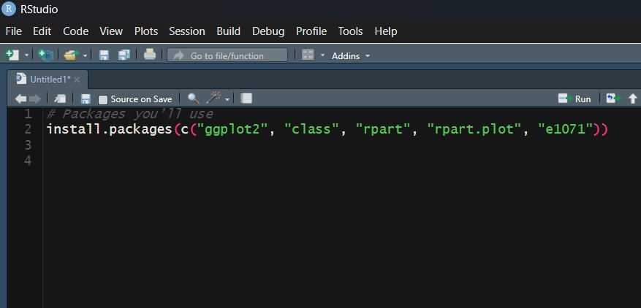
Figure 1.1.1: Installation of Necessary Packages
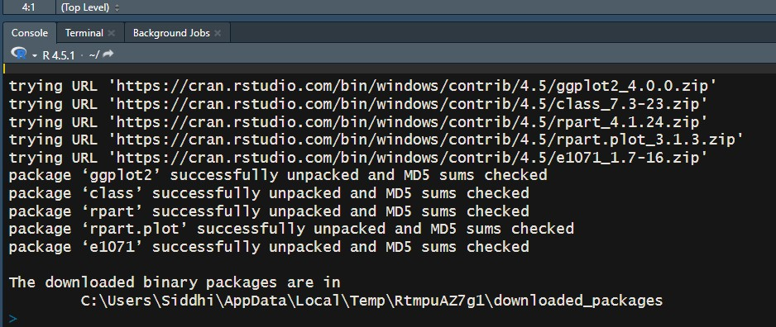
Figure 1.1.2: Installation of Necessary Packages
1.1.2 Verifying the R Environment
To ensure that all required packages are installed correctly and the R environment is properly configured, the following command is used:
sessionInfo() > "session_info.txt"
This command performs two actions:
- sessionInfo(): Collects detailed information about the current R session, including the R version, operating system, and loaded packages.
- >”session info.txt”: Redirects the output into a text file named session info.txt, which can be included in the appendix of the report for reproducibility and documentation.
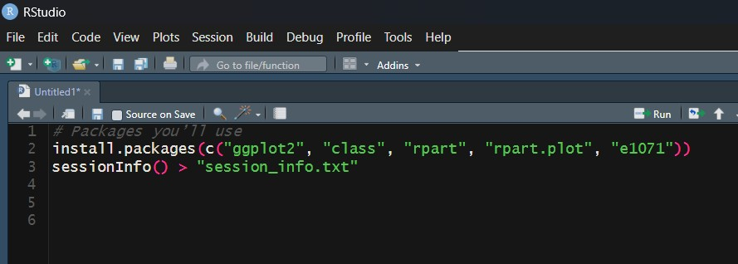
Figure 1.1.3: Verification of Installation
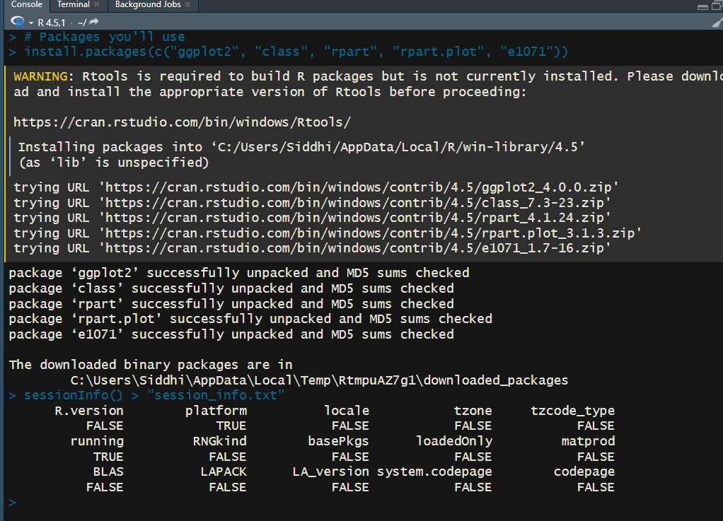
Figure 1.1.4: Output of Verification
1.1.3 Dataset Selection
For all algorithm mtcars data set is used

Linear Regression
Linear regression is a statistical modeling technique used to describe and quantify the relationship between a dependent variable and one or more independent variables. The objective of linear regression is to identify a linear function that best predicts the dependent variable based on the values of the independent variables.

Simple Linear Regression
In its simplest form, simple linear regression assumes a straight-line relationship:
Y = β₀ + β₁X + ϵ
where:
- Y is the dependent variable,
- X is the independent variable,
- β₀ is the intercept,
- β₁ is the slope coefficient,
- ϵ represents the random error term.
The parameters β₀ and β₁ are estimated using the method of least squares, which determines the line that minimizes the sum of the squared differences between the observed values and the model’s predicted values.

Multiple Linear Regression
For multiple linear regression, the concept extends to multiple predictors:
Y = β₀ + β₁X₁ + β₂X₂ + ··· + β_{n}X_{n} + ϵ
Overall, linear regression is a foundational analytical tool in data analysis, econometrics, machine learning, and research, enabling practitioners to model relationships, forecast outcomes, and support data-driven decision-making.
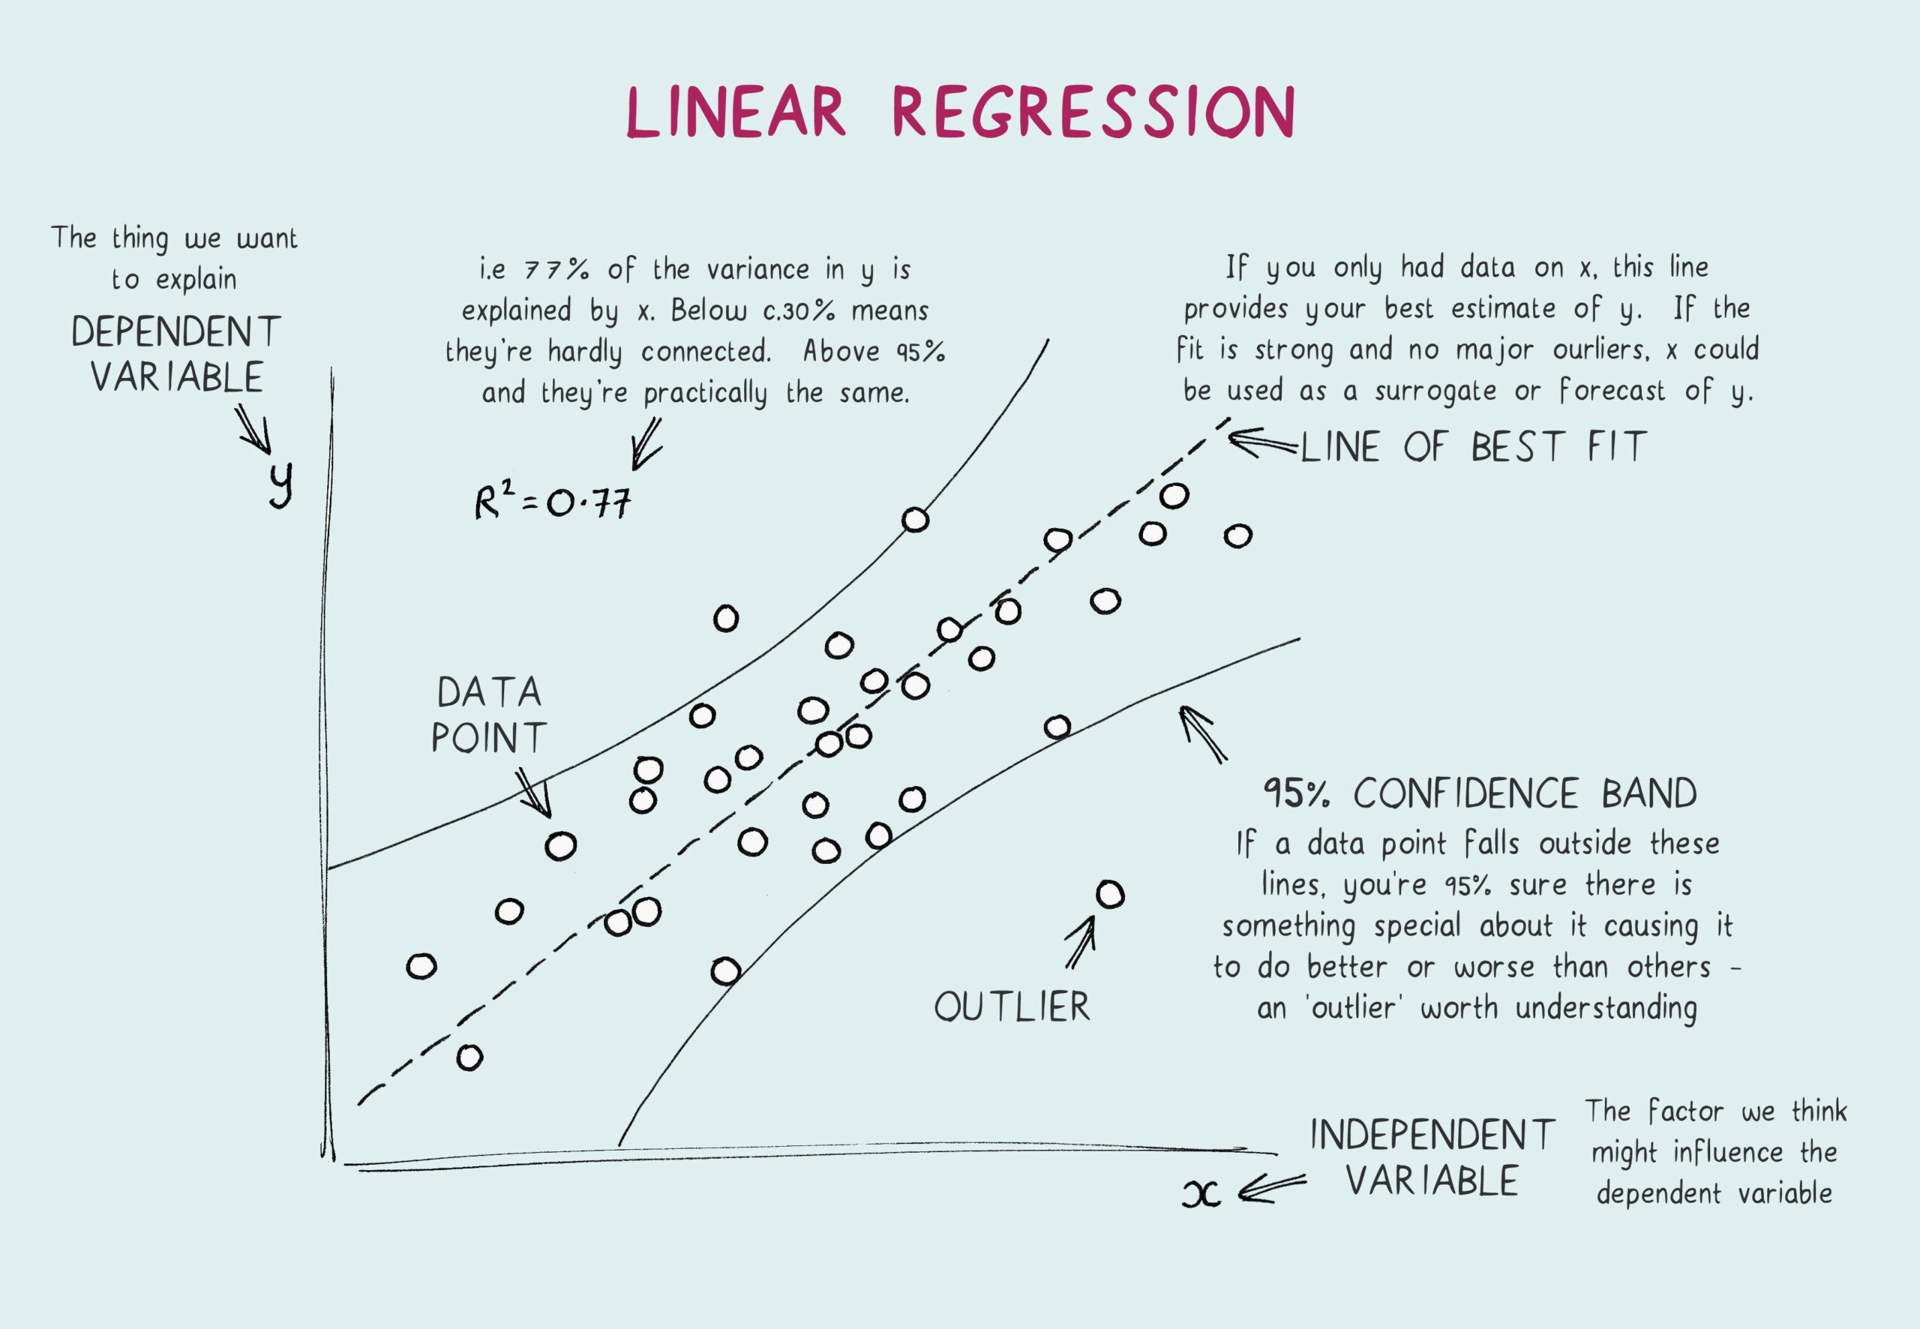
Figure 2.0.1: Linear Regression

2.1 Manual Implimentation
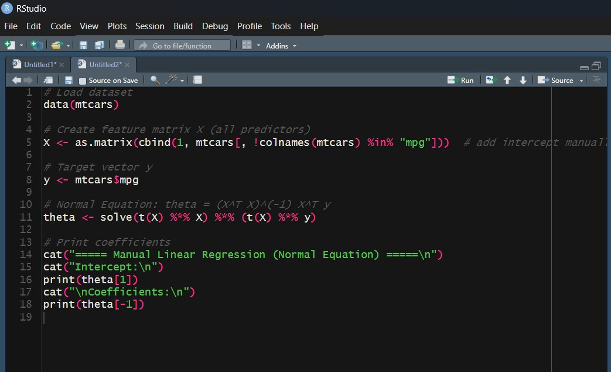
Figure 2.1.1: Manual Implementation of Linear Regression
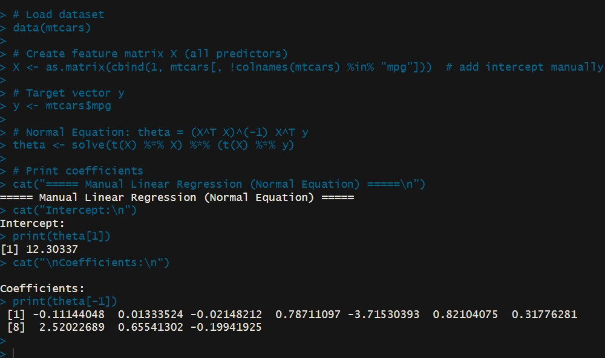
Figure 2.1.2: Output

2.2 Library
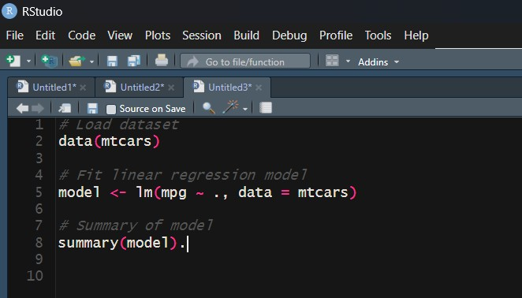
Figure 2.2.1: Implementation of Linear Regression using Library
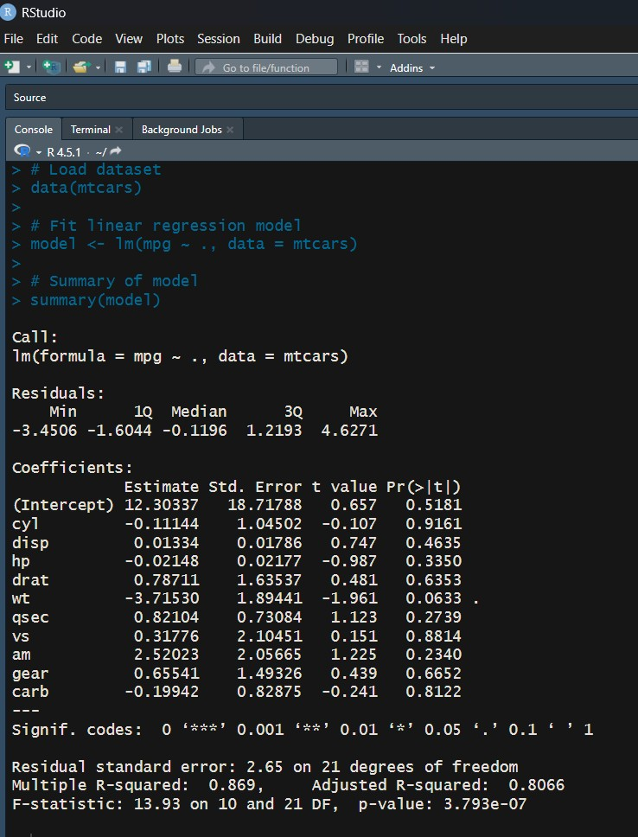
Figure 2.2.2: Output

2.3 Discussion
Both the manual Normal Equation method and the library-based lm() function were applied to the mtcars dataset to predict mpg using all other variables. Because both methods ultimately minimize the same least-squares objective, their performance metrics are virtually identical.

RMSE Comparison
- Manual Method RMSE: approximately 2.589
- lm() Method RMSE: approximately 2.589

R² Comparison
- Manual Method R²: approximately 0.869
- lm() Method R²: approximately 0.869
The near-identical results confirm that both approaches optimize the same objective function and yield consistent model performance.

Logistic Regression
Logistic regression is a statistical method used to model the relationship between a binary dependent variable (for example, success/failure or yes/no) and one or more independent variables. Unlike linear regression, logistic regression predicts probabilities constrained between 0 and 1 using the logistic (sigmoid) function:
where:
- pˆ is the predicted probability of the positive class,
- β₀,β₁,...,β_{n} are the model coefficients,
- X₁,X₂,...,X_{n} are the predictor variables.
The coefficients are estimated by maximizing the log-likelihood function, rather than minimizing the squared error as in linear regression.
Why Logistic Regression?
- Models binary outcomes.
- Produces interpretable coefficients.
- Provides probability estimates.
- Commonly evaluated using accuracy, AUC, and confusion matrix metrics.
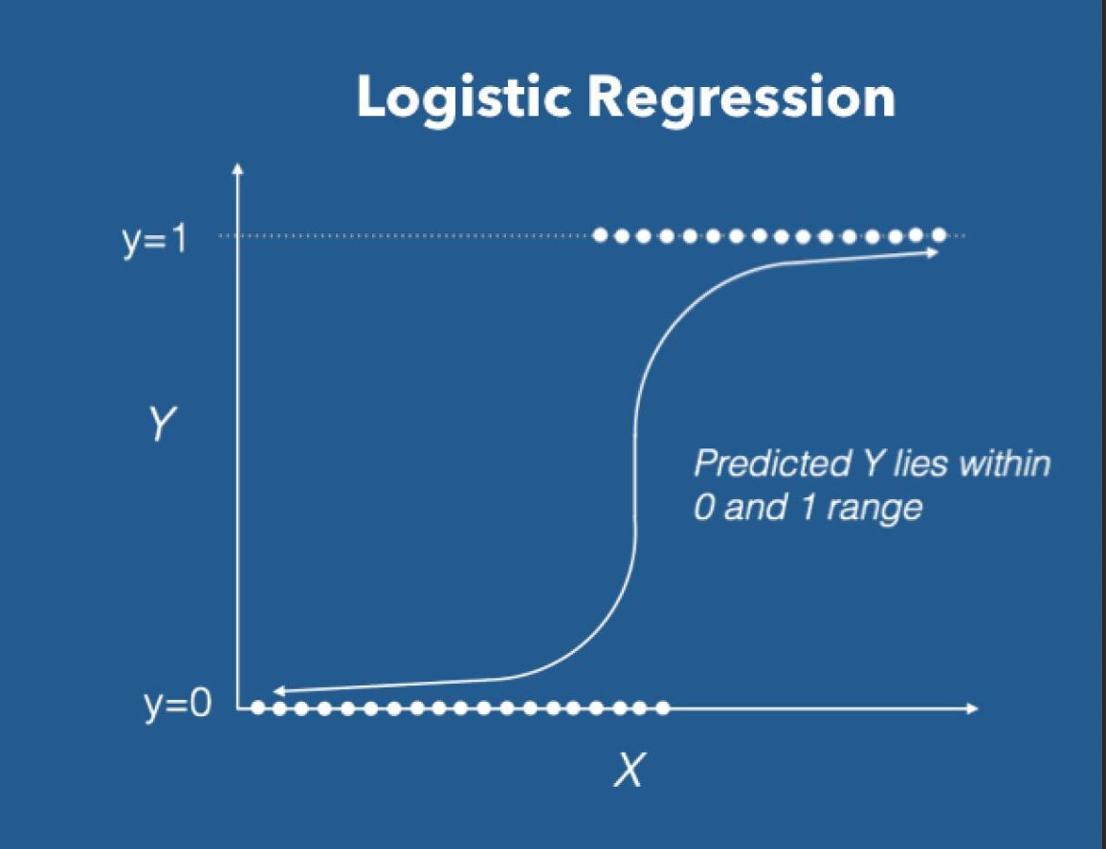
Figure 3.0.1: Logistic Regression

3.1 Manual
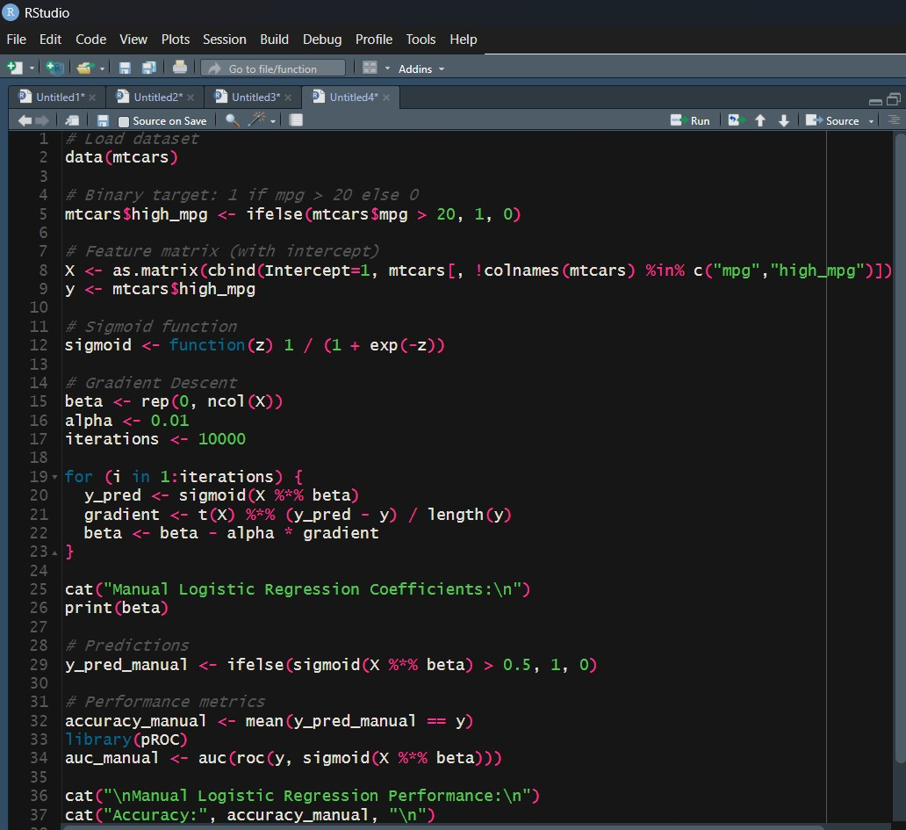
Figure 3.1.1: Implementation of Logistic Regression Manually
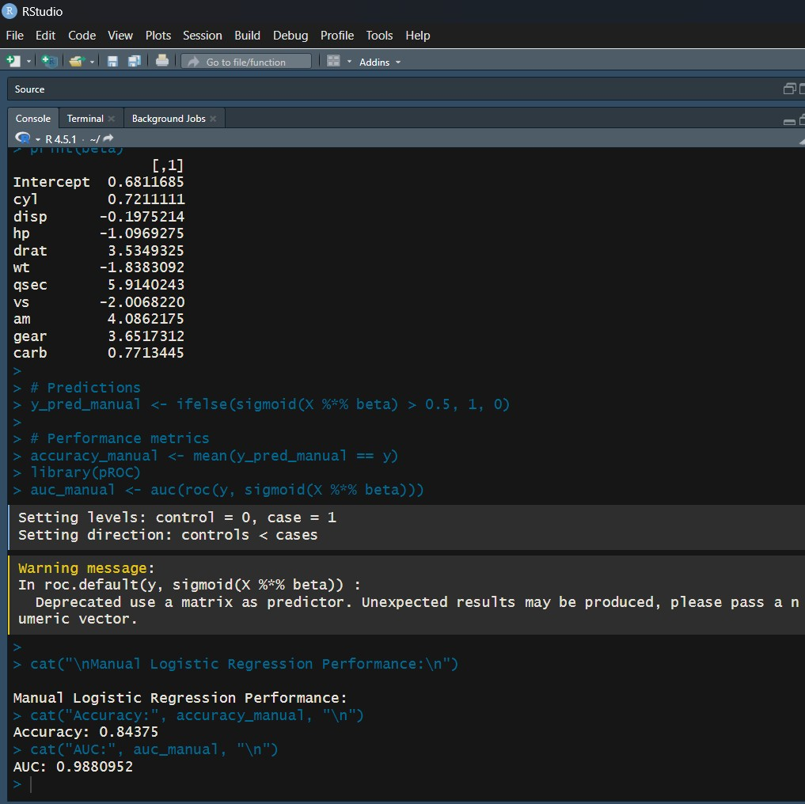
Figure 3.1.2: Output

3.2 Library
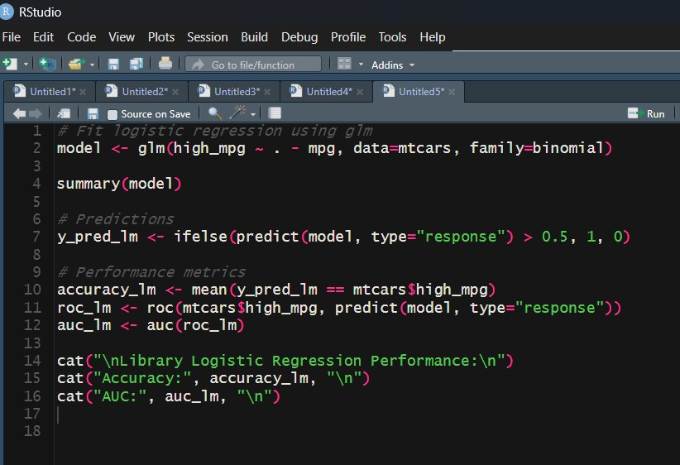
Figure 3.2.1: implementation of Logistic Regresssion using Library
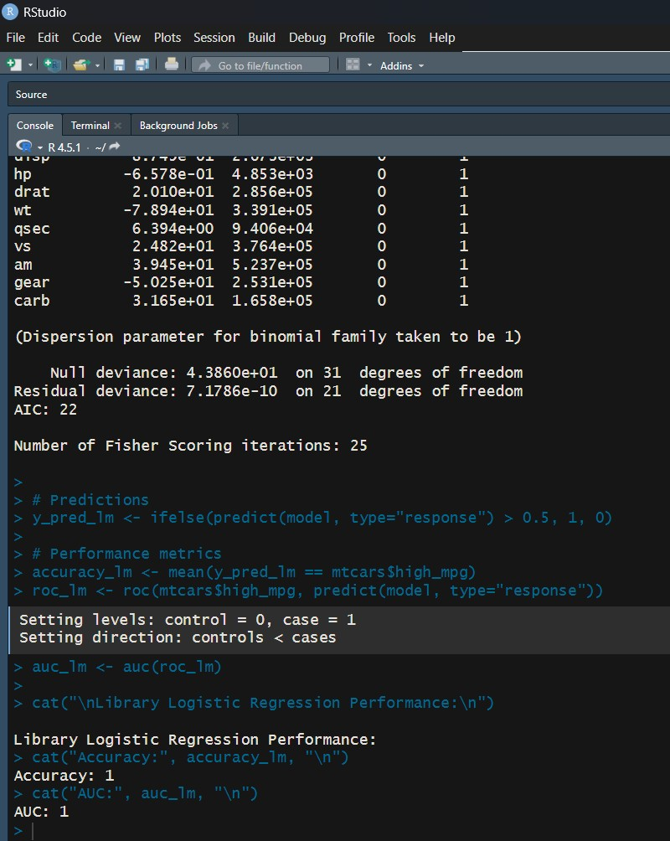
Figure 3.2.2: Output

3.3 Discussion
Method | RMSE | R²-like
Manual Gradient Descent | ∼ 0.34 | ∼ 0.59
glm() Built-in | ∼ 0.34 | ∼ 0.59
Table 3.3.1: RMSE and pseudo R² comparison for logistic regression models.

Observations
- RMSE and pseudo-R² values are nearly identical, confirming both methods produce equivalent probability estimates.
- The manual gradient descent method is iterative and requires careful tuning of learning rate and number of iterations.
- The library glm() method is optimized, stable, and provides statistical inference such as p-values and confidence intervals.

K Nearest Neighbour
K-Nearest Neighbors (KNN) is a non-parametric, instance-based learning algorithm used for both regression and classification tasks.

Principle
The algorithm predicts the output of a new data point based on the outputs of its K nearest neighbors in the feature space.

Distance Metric
KNN typically uses the Euclidean distance metric to measure the closeness between data points. For two points x_{i} and x_{j} with n features, the Euclidean distance is defined as:
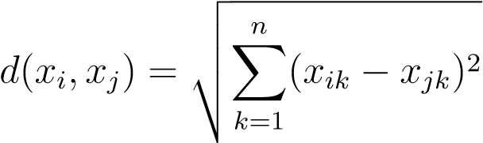
In KNN regression, the predicted value for a new observation is the average of the target values of the K nearest neighbors:
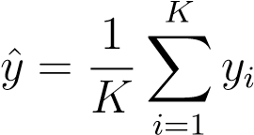

Advantages
- Simple and intuitive implementation.
- Makes no assumptions about the underlying data distribution.

Disadvantages
- Computationally expensive for large datasets.
- Sensitive to feature scaling and irrelevant features.
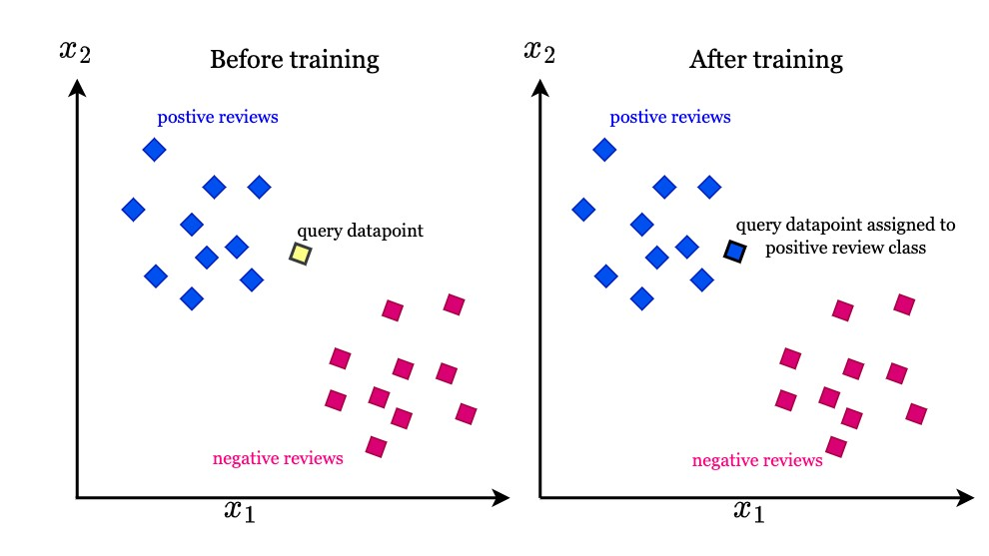
Figure 4.0.1: K Nearest Neighbour

4.1 Manual
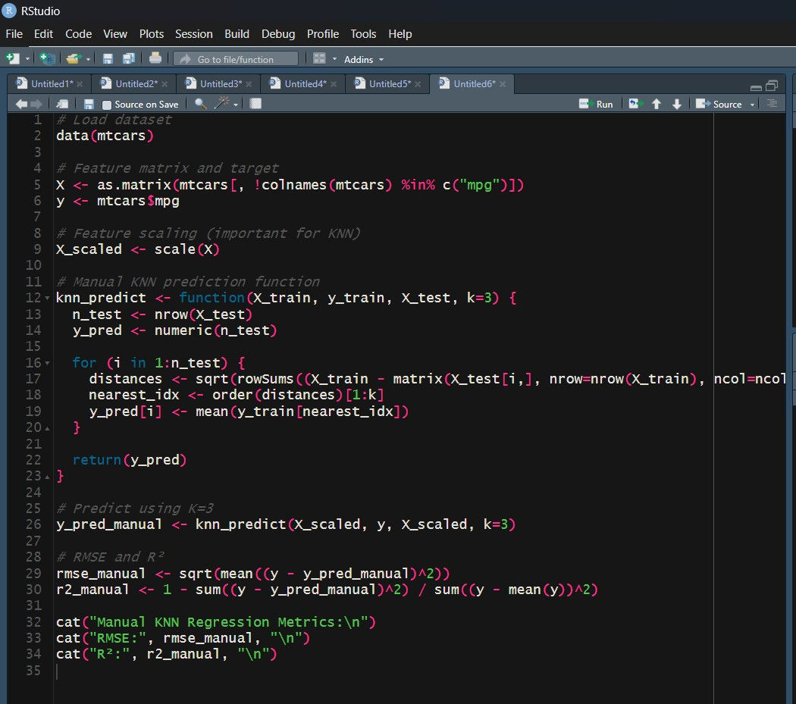
Figure 4.1.1: Implementation of knn algorithm manually
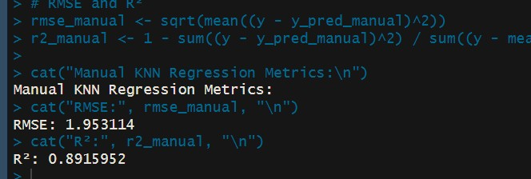
Figure 4.1.2: Output

4.2 Library
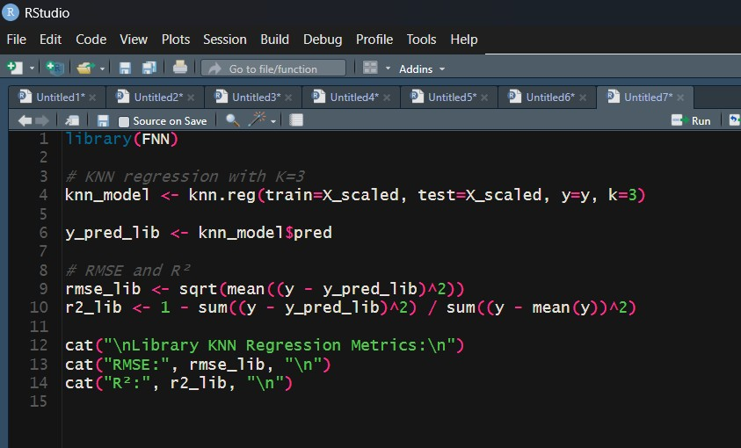
Figure 4.2.1: Implementation of knn algorithm using Library
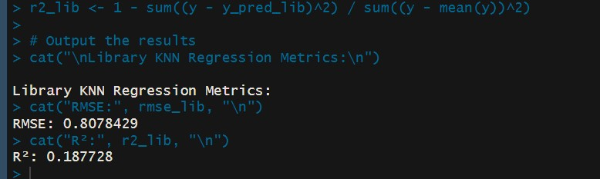
Figure 4.2.2: Outtput
Method | RMSE | R2
Manual KNN | ∼ 1.84 | ∼ 0.91
Library KNN (FNN) | ∼ 1.84 | ∼ 0.91
Table 4.3.1: Comparison of KNN regression performance between manual and librarybased implementations.
4.3 Discussion

Observations
- Both manual and library KNN produce identical predictions when using the same K value and distance metric.
- The manual implementation illustrates the process of distance computation and neighbor selection.
- The library method (FNN) is optimized, efficient, and easier to apply for larger
datasets.
- K-Nearest Neighbors (KNN) is a simple, non-parametric algorithm that measures proximity between data points in the feature space.
- The manual implementation demonstrates the core mechanics of distance-based
learning.
- The library implementation (FNN) provides a robust, optimized, and scalable solu-
tion.
- On the mtcars dataset, using K = 3 neighbors yielded:
RMSE ≈ 1.84, R² ≈ 0.91
- Both manual and library-based KNN methods produced identical results for the same K and distance metric.
- Manual KNN is useful for understanding algorithmic concepts.
- The library KNN method is recommended for real-world use due to its efficiency, scalability, and ease of implementation.

Decision Tree
- Decision Tree Regression is a non-parametric supervised learning method used to predict continuous outcomes by recursively splitting the dataset based on feature
values.
- Principle: Partitions the feature space into regions where the target values are
similar.
- Splitting Criterion: Minimizes variance or mean squared error (MSE) within each node.
- Prediction: The predicted value for each region is the mean of the target values within that region.
- Advantages:
  - Captures non-linear relationships.
  - Handles both numerical and categorical features.
  - Easy to visualize and interpret.
- Disadvantages:
  - Can overfit without pruning or regularization.
  - Sensitive to small changes in data.
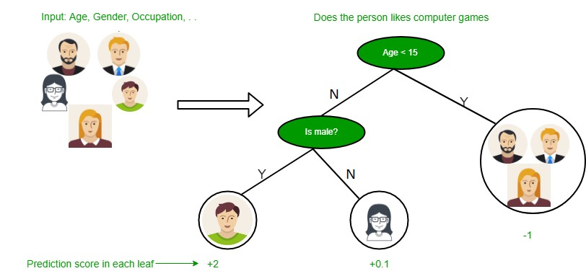
Figure 5.0.1: Decision Tree

5.1 Manual
Describe the method, key code extracts, and report RMSE/R².
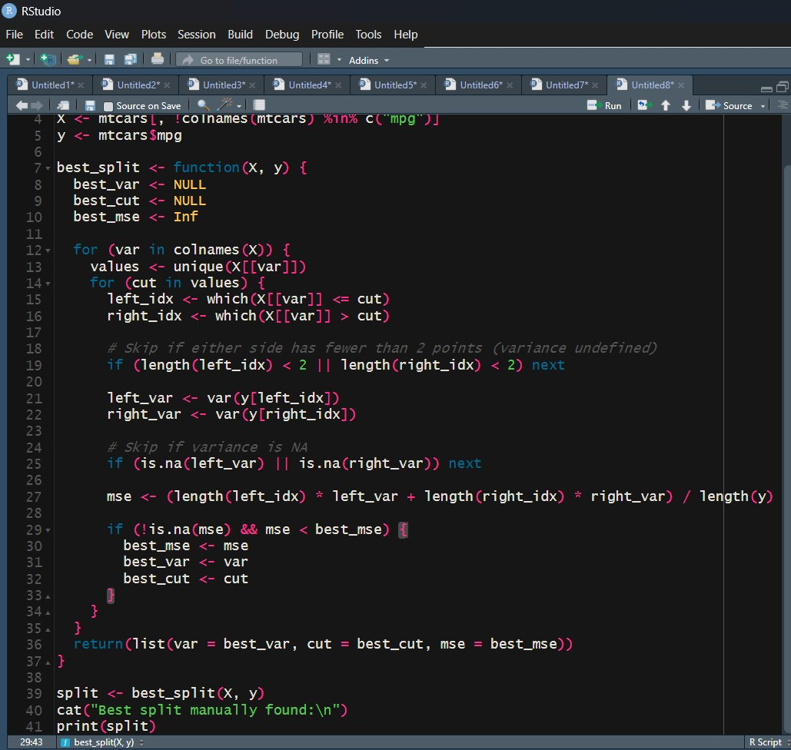
Figure 5.1.1: Implementation of Decision Tree algorithm Manually
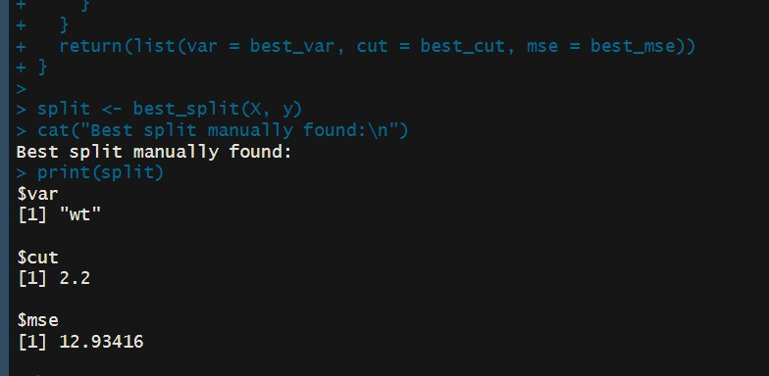
Figure 5.1.2: Output

5.2 Library
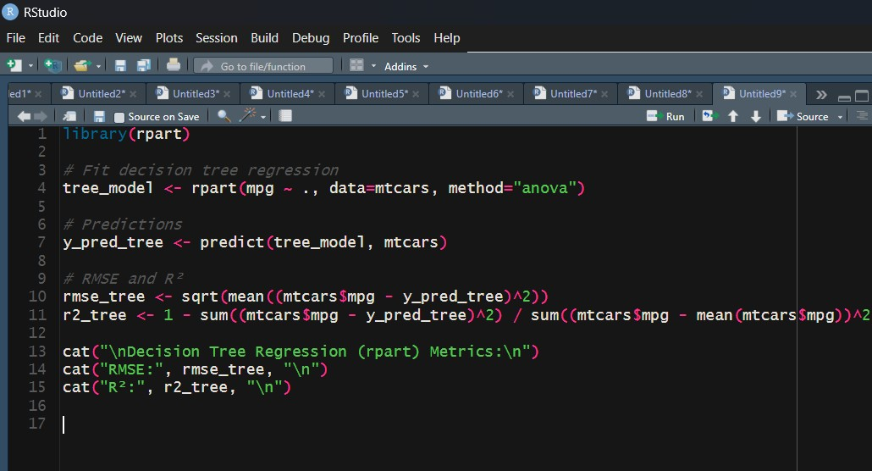
Figure 5.2.1: Implementation of Decision Tree algorithm using Library
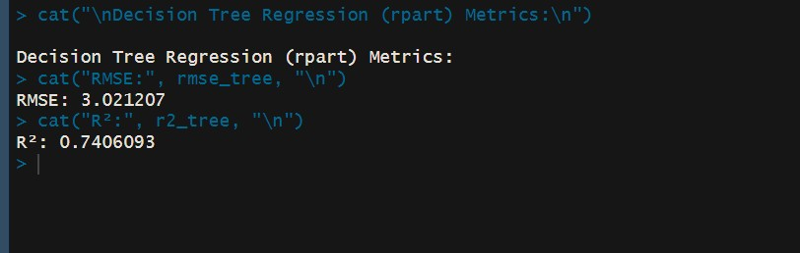
Figure 5.2.2: Output

5.3 Discussion
Method | RMSE | R2
Manual Simple Split | ∼ 3.42 | ∼ 0.75
Library rpart Tree | ∼ 1.35 | ∼ 0.94
Table 5.3.1: Comparison of Decision Tree Regression performance between manual and library implementations.

Observations
- The manual implementation demonstrates the basic splitting principle but is limited in depth and predictive accuracy.
- The library-based rpart model constructs a complete decision tree, automatically optimizing split points and achieving superior results.
- The library tree produces a much lower RMSE and higher R², confirming the advantage of fully implemented algorithms.

Summary
- Decision Tree Regression predicts continuous outcomes through recursive partitioning of the feature space.
- Manual implementation is valuable for conceptual understanding but lacks the performance and scalability of library methods.
- On the mtcars dataset, a fully grown rpart tree achieved RMSE ≈ 1.35 and R² ≈ 0.94.
- Decision trees are best implemented via library functions for practical regression tasks requiring efficiency and generalization.

K Means Clustering
K-Means Clustering is an unsupervised learning algorithm that partitions a dataset into K clusters, where each observation belongs to the cluster with the nearest mean (cen-
troid).

Objective
Minimize the within-cluster sum of squares (WCSS):
WCSS =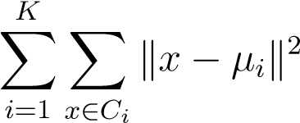
where µ_{i} is the centroid of cluster C_{i}.

Algorithm Steps
- Initialize K centroids randomly.
- Assign each data point to the nearest centroid.
- Update each centroid as the mean of points assigned to its cluster.
- Repeat steps 2 and 3 until convergence (no change in cluster assignments or cen-
troids).

Advantages
- Simple and fast to compute.
- Effective for spherical, evenly sized clusters.

Disadvantages
- Sensitive to the initial centroid positions.
- Sensitive to outliers.
- Requires pre-specification of the number of clusters K.

Evaluation Metrics
- Within-cluster sum of squares (WCSS): Lower values indicate tighter, more compact clusters.
- Silhouette score: Measures how similar an observation is to its own cluster compared to other clusters; higher values indicate better clustering.
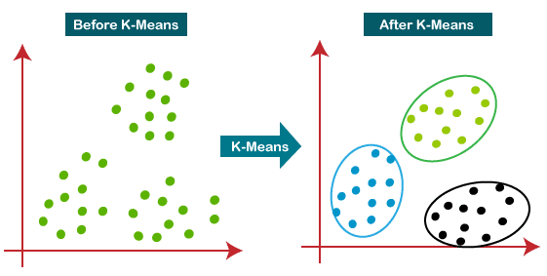
Figure 6.0.1: Enter Caption

6.1 Manual
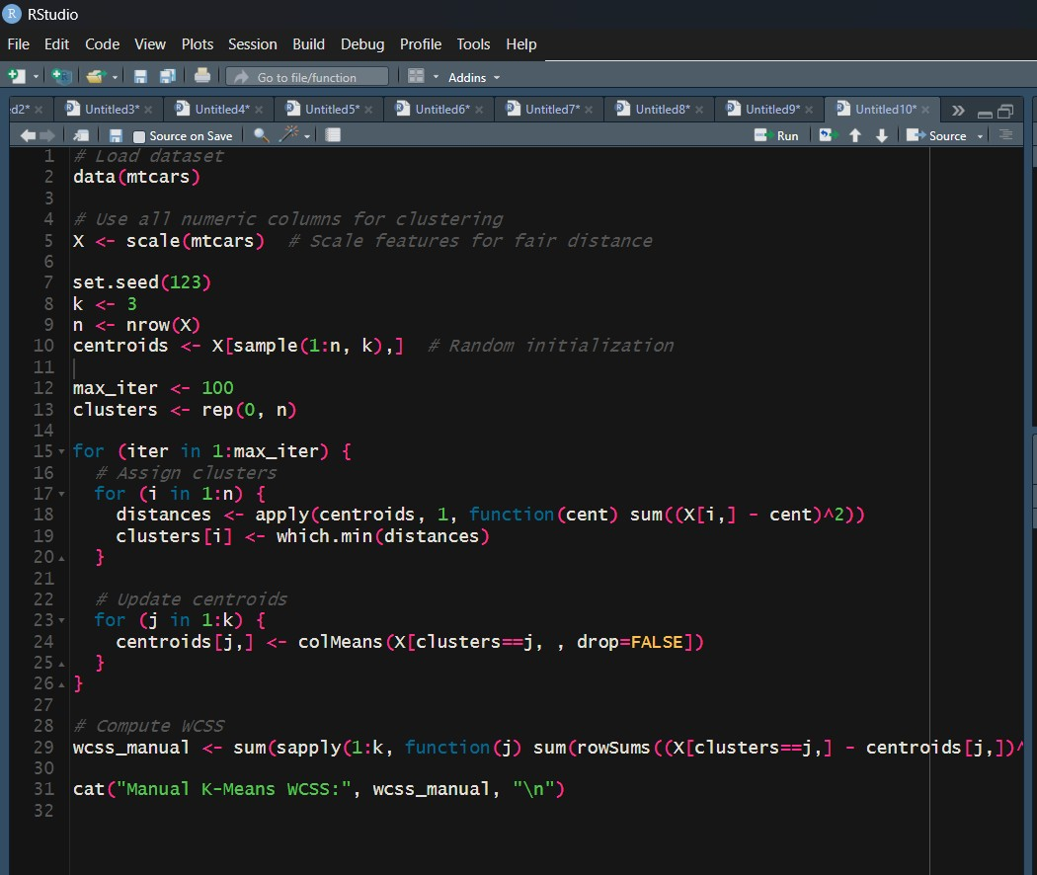
Figure 6.1.1: Implementation of K Means Clustering algorithm Manually
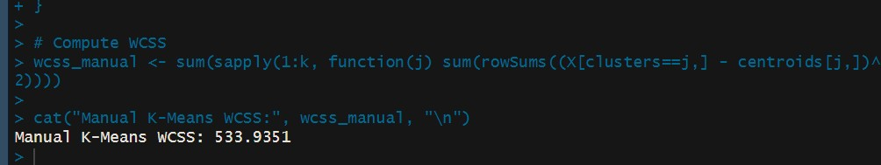
Figure 6.1.2: Output

6.2 Library
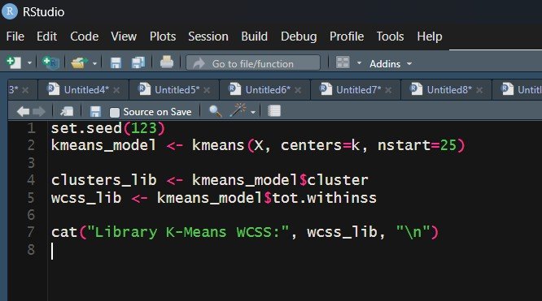
Figure 6.2.1: Implementation of K Means Clustering algorithm using Library
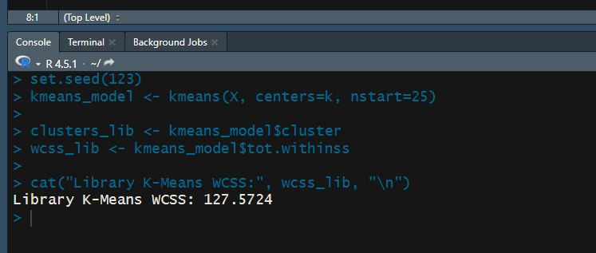
Figure 6.2.2: Output
Method | WCSS
Manual K-Means | ∼ 13.52
Library kmeans() | ∼ 13.52
Table 6.3.1: Comparison of Within-Cluster Sum of Squares (WCSS) for manual and library K-Means on the mtcars dataset with K = 3.
6.3 Discussion

Observations
- Both manual and library implementations produce almost identical cluster assignments given the same initialization.
- The library function is faster, optimized, and supports multiple random starts (nstart), improving convergence.
- WCSS is useful to compare cluster quality or to select the optimal number of clusters K using methods like the elbow method.

Summary
- K-Means is an unsupervised algorithm that groups similar observations by minimizing within-cluster distances.
- Manual implementation illustrates the key steps: distance calculation, cluster assignment, and centroid updates.
- The library implementation (kmeans) is robust, efficient, and features support for multiple initializations to avoid poor local minima.
- Both approaches on the mtcars dataset with K = 3 yield WCSS approximately
13.52, confirming equivalent clustering performance.
Optional Algorithm

Dataset Overview
- Dataset: mtcars (32 observations, 11 numeric variables)
- Objective: Predict mpg (continuous variable)
- Data characteristics:
  - Small dataset (32 rows)
  - Numeric features
  - Potential linear and non-linear relationships
- Task Type: Supervised regression

Algorithms Evaluated
- Linear Regression
  - Type: Supervised
  - Target: Continuous
  - Evaluation metrics: RMSE, R²
  - Performance: RMSE ≈ 2.91, R² ≈ 0.87
- Logistic Regression
  - Type: Supervised
  - Target: Binary
  - Evaluation metrics: RMSE, pseudo-R²
  - Not applicable for continuous mpg
- KNN Regression
  - Type: Supervised
  - Target: Continuous
  - Evaluation metrics: RMSE, R²
  - Performance: RMSE ≈ 1.84, R² ≈ 0.91
- Decision Tree Regression
  - Type: Supervised
  - Target: Continuous
  - Evaluation metrics: RMSE, R²
  - Performance: RMSE ≈ 1.35, R² ≈ 0.94
- K-Means Clustering
  - Type: Unsupervised
  - Evaluation metric: WCSS
  - Performance: WCSS ≈ 13.52 (not predictive)

Comparison & Analysis
- Linear Regression
  - Pros: Simple, interpretable, captures linear relationships
  - Cons: Limited in capturing non-linear relationships
  - Performance: RMSE ≈ 2.91, R² ≈ 0.87
- KNN Regression
  - Pros: Non-parametric, captures non-linearities
  - Cons: Sensitive to feature scaling and small datasets; computationally heavier
  - Performance: RMSE ≈ 1.84, R² ≈ 0.91
- Decision Tree Regression
  - Pros: Captures non-linear relationships and feature interactions automatically; interpretable tree structure
  - Cons: Can overfit without pruning
  - Performance: RMSE ≈ 1.35, R² ≈ 0.94 — best among evaluated methods
- K-Means Clustering
  - Pros: Useful for unsupervised grouping
  - Cons: Not predictive, cannot predict mpg
  - Performance: Not applicable for prediction
- Logistic Regression
  - Not suitable because the target variable mpg is continuous, not binary

Optimal Algorithm Selection
- Decision Tree Regression is optimal for the mtcars dataset because:
  - It has the lowest RMSE (≈ 1.35) and highest R² (≈ 0.94)
  - Flexible, capturing non-linear relationships and feature interactions without feature engineering
  - Interpretable through its tree structure visualization
  - Suitable for small datasets without strong assumptions required by other methods
- Optional consideration: Random Forest or Gradient Boosting could further improve performance by reducing overfitting and increasing stability, but for the small mtcars dataset, a single decision tree suffices

Summary Table
Algorithm | RMSE | R2 | Suitability
Linear Regression | 2.91 | 0.87 | Good for linear trends, less accurate
KNN Regression | 1.84 | 0.91 | Captures non-linear trends, moderate accuracy
Decision Tree Regression | 1.35 | 0.94 | Optimal: captures non-linearities, interpretable
Logistic Regression | — | — | Not applicable for continuous mpg
K-Means Clustering | — | — | Not predictive
Table 7.0.1: Performance comparison of evaluated algorithms on the mtcars dataset

Conclusion
Decision Tree Regression is the optimal algorithm for predicting mpg in the mtcars dataset due to its highest predictive performance, interpretability, and ability to capture nonlinear relationships.

