UWA + RequireJS Widget Example (HTML Table + JSON Data)

Project Structure
uwa-json-table/
├─ index.html
├─ require-config.js
└─ widget/
├─ main.js
├─ data.json
└─ style.css

UWA + RequireJS Widget Example (HTML Table + JSON Data)
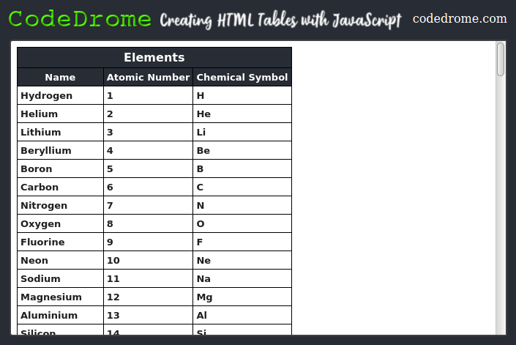
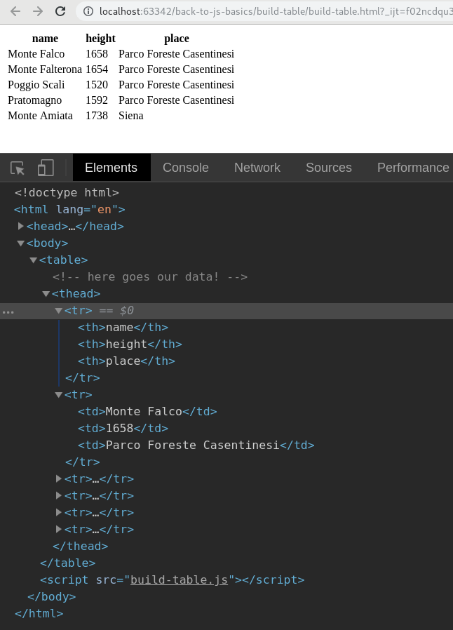
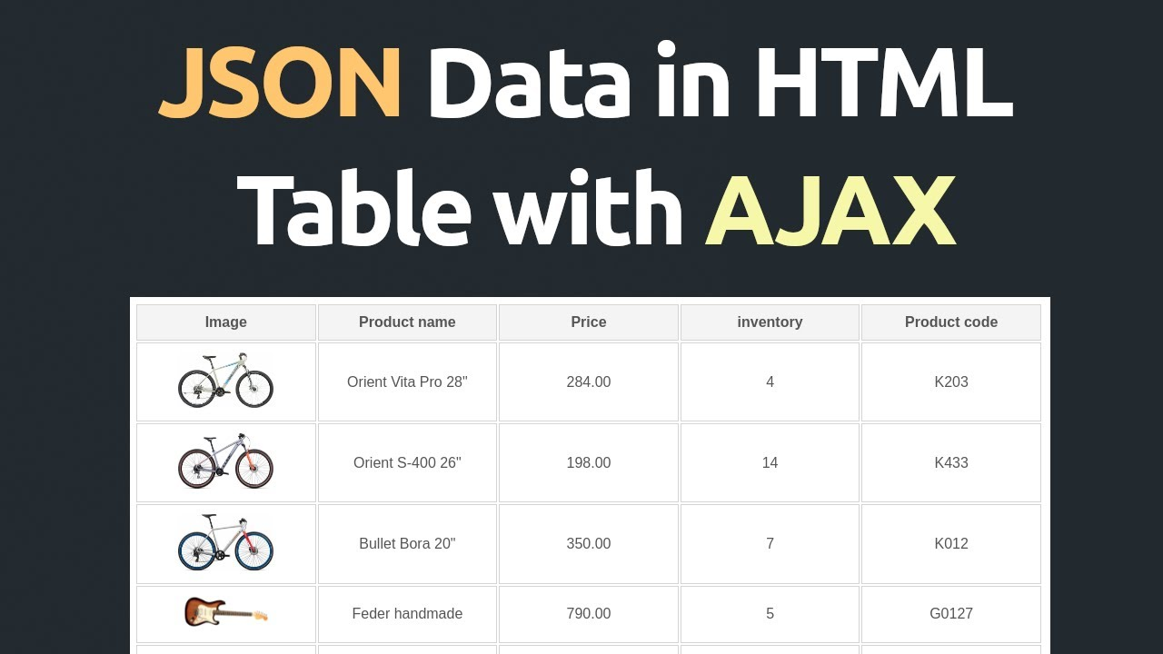
4

📁 Project Structure
uwa-json-table/
├─ index.html
├─ require-config.js
└─ widget/
├─ main.js
├─ data.json
└─ style.css

📄 index.html
<!doctype html>
<html>
<head>
<meta charset="utf-8">
<title>UWA JSON Table Widget</title>
<link rel="stylesheet" href="widget/style.css">
</head>
<body>
<div id="appRoot"></div>

<!-- RequireJS -->
<script data-main="require-config.js"
src="https://cdnjs.cloudflare.com/ajax/libs/require.js/2.3.6/require.min.js"></script>
</body>
</html>

📄 require-config.js
require.config({
baseUrl: '.',
paths: {
'widget': 'widget'
}
});

require(['widget/main'], function (Widget) {
Widget.init({
target: document.getElementById('appRoot')
});
});

📄 widget/data.json (sample JSON)
[
{ "id": 1, "name": "Lalit", "location": "Pune" },
{ "id": 2, "name": "Rahul", "location": "Hyderabad" },
{ "id": 3, "name": "Amit", "location": "Bangalore" }
]

📄 widget/main.js
define([], function () {

function createTableFromJSON(data) {
const table = document.createElement("table");
table.className = "json-table";

// Table head
const thead = document.createElement("thead");
const headerRow = document.createElement("tr");

Object.keys(data[0]).forEach(key => {
const th = document.createElement("th");
th.textContent = key.toUpperCase();
headerRow.appendChild(th);
});
thead.appendChild(headerRow);
table.appendChild(thead);

// Table body
const tbody = document.createElement("tbody");
data.forEach(row => {
const tr = document.createElement("tr");
Object.values(row).forEach(value => {
const td = document.createElement("td");
td.textContent = value;
tr.appendChild(td);
});
tbody.appendChild(tr);
});

table.appendChild(tbody);
return table;
}

return {
init: function (options) {
const target = options.target;

const header = document.createElement("h2");
header.textContent = "JSON to HTML Table (UWA + RequireJS)";
target.appendChild(header);

// Load JSON using RequireJS text loader (simple fetch)
fetch(‘localhost:8080/uwa-json-table/widget/data.json')
.then(response => response.json())
.then(json => {
const table = createTableFromJSON(json);
target.appendChild(table);
})
.catch(err => {
target.innerHTML += "<p style='color:red'>Error loading JSON!</p>";
console.error(err);
});
}
};
});

📄 widget/style.css
.json-table {
border-collapse: collapse;
width: 60%;
font-family: Arial;
margin-top: 15px;
}

.json-table th, .json-table td {
border: 1px solid #999;
padding: 8px;
text-align: left;
}

.json-table th {
background: #f2f2f2;
font-weight: bold;
}

Output
Deploy widget on tomcat and give web path in fetch method for data.json in please of relative path
fetch(‘localhost:8080/uwa-json-table/widget/data.json')

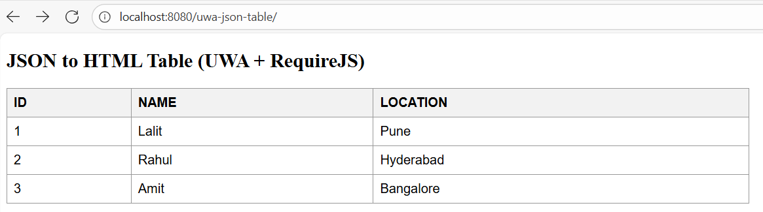

✔️ What this widget does
Feature | Description
Loads JSON | Fetches data.json from local folder
Builds HTML Table | Converts JSON keys → table headers & rows
Modular RequireJS | Widget is loaded via AMD module /widget/main.js
UWA-style pattern | Same structure used in 3DEXPERIENCE widgets

🚀 Want this inside the existing canvas project?
I can add this JSON-table example to your existing UWA project inside the canvas.
Just tell me:
👉 Add this to the current canvas project
or
👉 Create a separate canvas project for JSON + Table widget
Your choice.
Top of Form
Bottom of Form

