**Output:-**

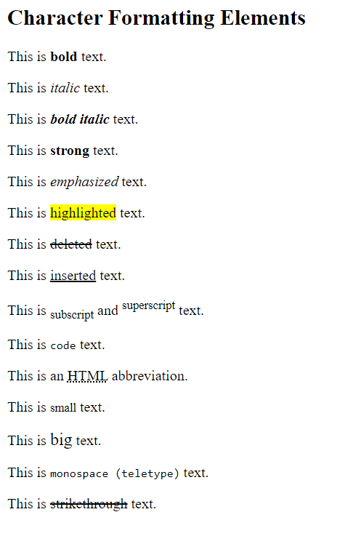

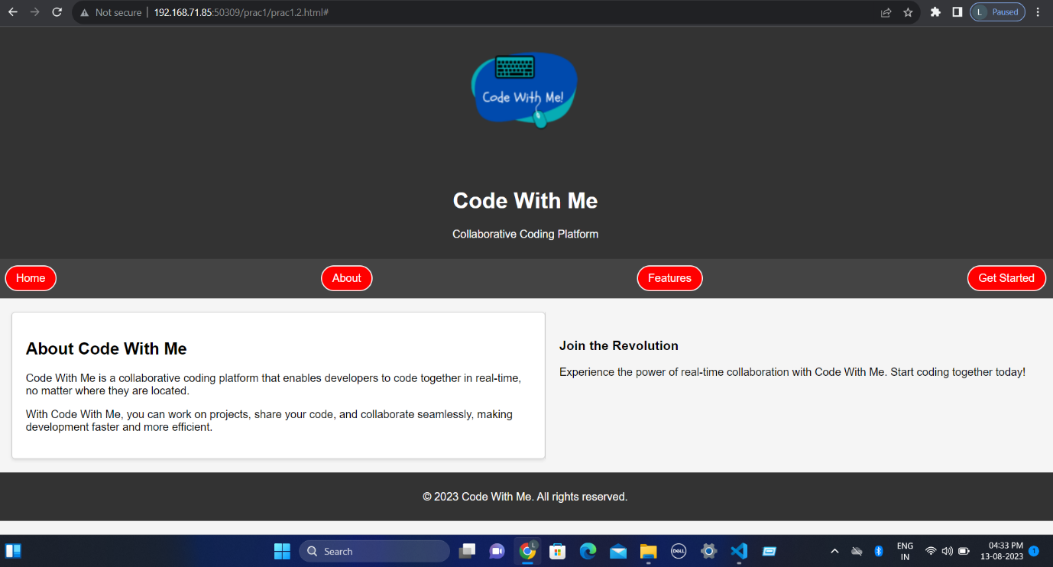

**Output:-**

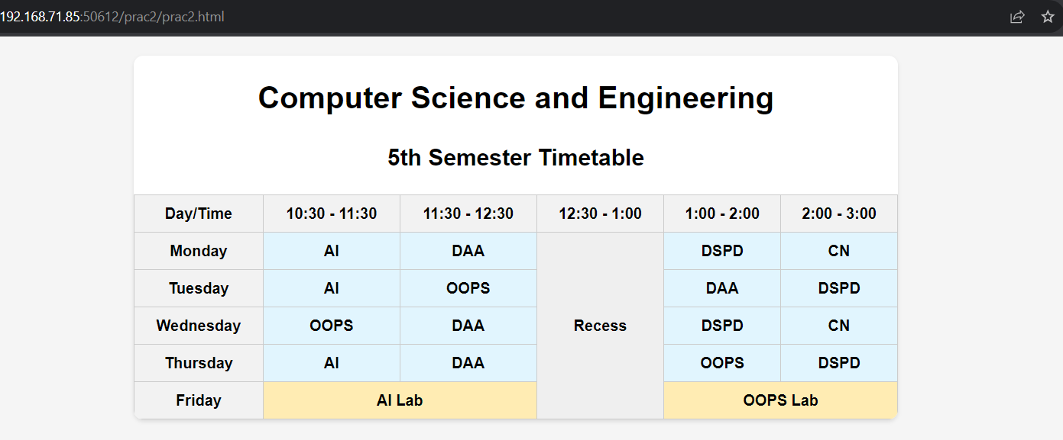

**Output:-**



**Code:**

<!DOCTYPE html>

<head>

<meta charset="UTF-8">

<meta name="viewport" content="width=device-width, initial-scale=1.0">

<link rel="stylesheet" href="styles.css">

<title>Code With Me - Programming Languages and Collaboration</title>

</head>

<body>

<header>

<img src="https://code-with-me.com/wp-content/uploads/2020/07/jlkjlke1596080279267.png"

alt="Code With Me Screenshot" width="200">

<h1>Code With Me</h1>

<p>Exploring Programming Languages and Collaboration Activities</p>

</header>

<main>

<div class="intro-container">

<div class="intro-column">

<h2>Welcome to the Code With Me Forum!</h2>

<p>Are you passionate about programming and eager to collaborate with fellowdevelopers? Look no further! The Code With Me Forum is your hub for engaging discussions, learning from others, and exploring the exciting world of coding languages and collaboration activities.</p>

<p>Whether you're a seasoned coder or just starting your programming journey, this community is here to support you. Connect with like-minded individuals, share your experiences, and gain insights into various programming languages that power our digital world. From Python's elegance to JavaScript's versatility, and everything in between, we're here to celebrate the diverse languages that drive innovation.</p>

<p>But that's not all – collaboration is the heart of our community. Dive into discussions about pair programming, group projects, and remote teamwork. Discover best practices, share your success stories, and learn from challenges faced by fellow developers in their collaborative endeavors.</p>

<p>So join us on this exciting journey of knowledge sharing, skill-building, and camaraderie. Let's

learn, grow, and code together at Code With Me!</p>

</div>

</div>

<section id="projects">

<h2>Featured Projects</h2>

<div class="project-block">

<div class="project-item">

<h3> SmartCity Traffic Management System</h3>

<p>The company developed an advanced SmartCity Traffic Management System, integrating AI-powered

traffic cameras and real-time data analytics to optimize traffic flow. This project successfully

reduced traffic congestion by 30% and improved overall road safety through automated traffic

signal adjustments and congestion alerts for commuters.</p>

</div>

<div class="project-item">

<h3>EcoGuard Drone Surveillance</h3>

<p>The company implemented the EcoGuard Drone Surveillance system to protect wildlife in a national

park. This project involved deploying a fleet of autonomous drones equipped with thermal cameras

and AI algorithms to monitor and deter poaching activities. As a result, the project

significantly reduced illegal hunting and contributed to the conservation of endangered species.

</p>

</div>

</div>

</section>

</main>

<section id="languages">

<h2>Programming Languages</h2>

<div class="language-block">

<div class="language-item">

<h3>Python</h3>

<p>Python is a versatile and beginner-friendly programming language...</p>

</div>

<div class="language-item">

<h3>JavaScript</h3>

<p>JavaScript is a dynamic scripting language used for creating interactive websites...</p>

</div>

<div class="language-item">

<h3>Java</h3>

<p> Java is a versatile, object-oriented programming language known for its platform independence...</p>

</div>

<div class="language-item">

<h3>HTML (Hypertext Markup Language)</h3>

<p> HTML is a markup language for creating the structure and content of web pages....</p>

</div>

</div>

</section>

<footer>

<p>&copy; 2023 Code With Me</p>

</footer>

</body>

</html>

**CSS:-**

body {

font-family: Arial, sans-serif;

margin: 0;

padding: 0;

}

header {

background-color: #333;

color: white;

text-align: center;

padding: 1rem;

}

header h1 {

margin: 0;

}

main {

max-width: 1300px;

margin: 0 auto;

padding: 2rem;

}

.item {

display: flex;

max-width: 800px;

margin: 0 auto;

background-color: #fff;

box-shadow: 0px 0px 10px rgba(0, 0, 0, 0.1);

}

.intro-container {

max-width: max-content;

padding: 2rem;

margin: 2rem;

background-color: #f9f9f9;

border-radius: 8px;

box-shadow: 0px 2px 4px rgba(0, 0, 0, 0.1);

}

.intro-column {

padding: 20px;

}

.img-container {

max-width: 1220px;

padding: 2rem;

margin: 2rem;

background-color: #f9f9f9;

border-radius: 8px;

box-shadow: 0px 2px 4px rgba(0, 0, 0, 0.1);

}

img {

max-width: 100%;

height: auto;

border-radius: 5px;

}

footer {

background-color: #333;

color: white;

text-align: center;

padding: 1rem;

}

#projects {

margin-top: 2rem;

}

.project-block {

display: flex;

justify-content: space-between;

gap: 2rem;

}

.project-item {

flex: 1;

background-color: #fff;

padding: 1rem;

border-radius: 8px;

box-shadow: 0px 2px 4px rgba(0, 0, 0, 0.1);

}

#languages {

padding: 20px;

}

.language-block {

display: flex;

justify-content: baseline;

gap: 2rem;

flex-wrap: wrap;

padding: 5px 5px 40px 5px;

}

.language-item {

flex: 1;

max-width: 300px;

background-color: #fff;

padding: 1rem;

border-radius: 8px;

box-shadow: 2px 5px 5px 5px lightgrey;

}

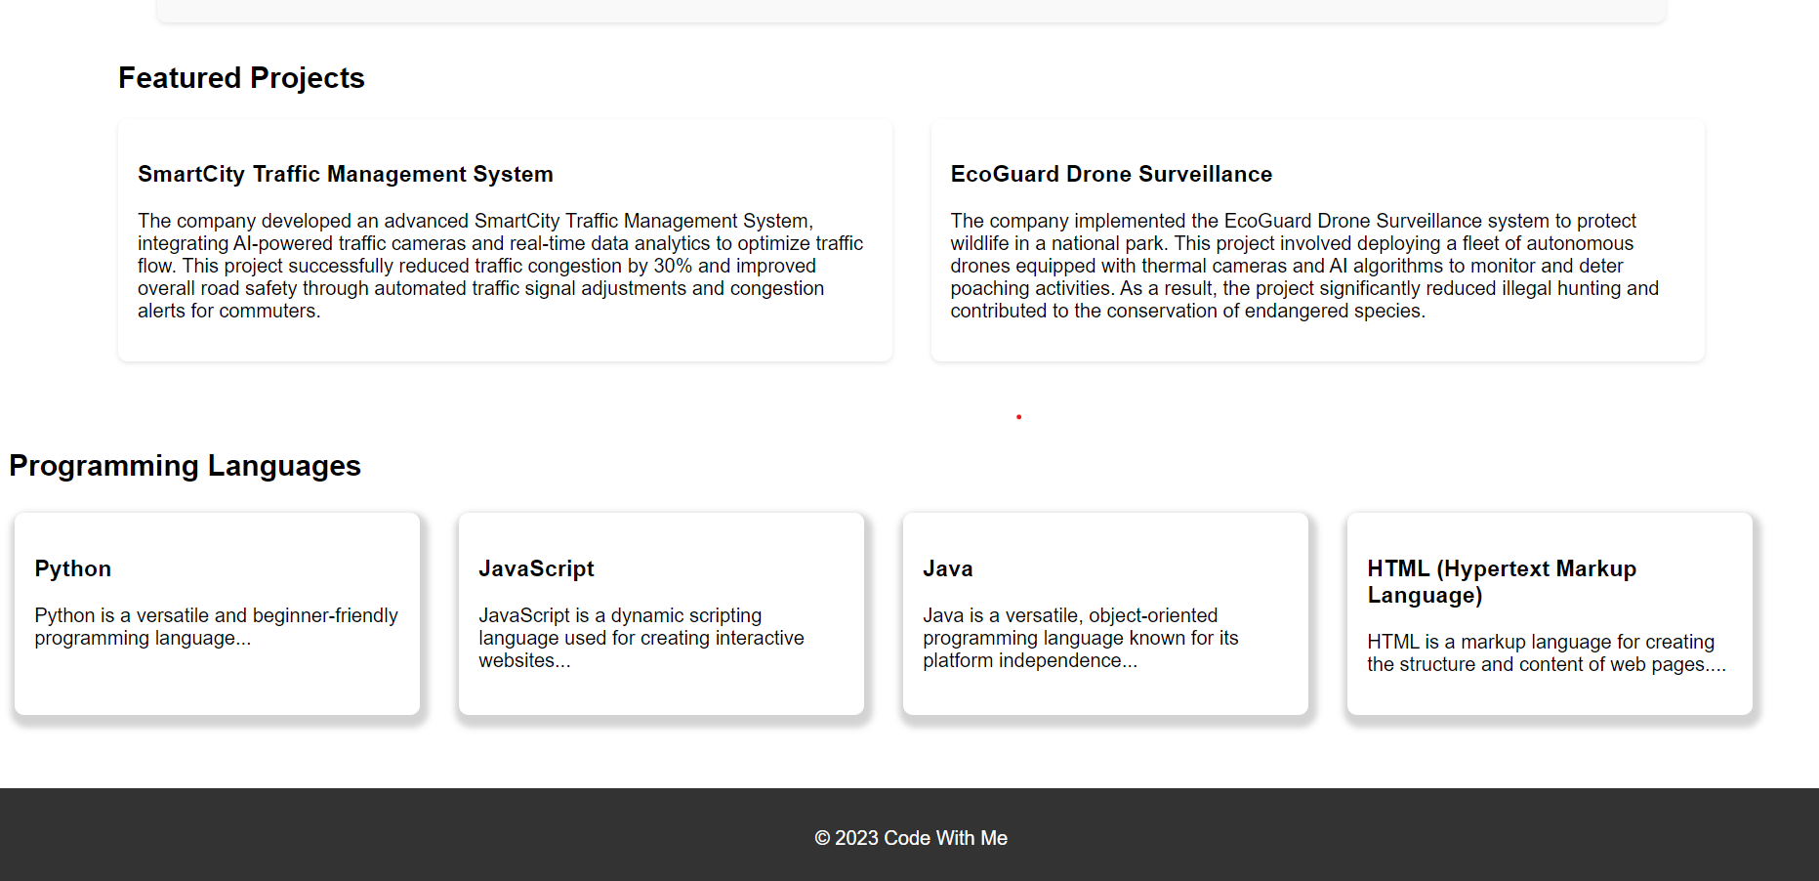 **Output:-**

Code:-

<!DOCTYPE html>

<html>

<title>

practical 5

</title>

<head>

<style>

body {

display: flex;

justify-content: center;

align-items: center;

height: 100vh;

margin: 0;

}

#text {

font-size: 5pt;

color: blue;

transition: font-size 0.5s;

}

</style>

</head>

<body>

<div id="text">Growing Text</div>

<script>

const textElement = document.getElementById('text');

let fontSize = 5;

let growing = true;

function updateTextSize() {

if (growing) {

fontSize += 1;

textElement.style.fontSize = fontSize + 'pt';

if (fontSize === 50) {

growing = false;

textElement.style.color = 'red';

textElement.textContent = 'Shrinking Text';

}

} else {

fontSize -= 1;

textElement.style.fontSize = fontSize + 'pt';

if (fontSize === 5) {

growing = true;

textElement.style.color = 'blue';

textElement.textContent = 'Growing Text';

}

}

}

setInterval(updateTextSize, 100);

</script>

</body>

</html>

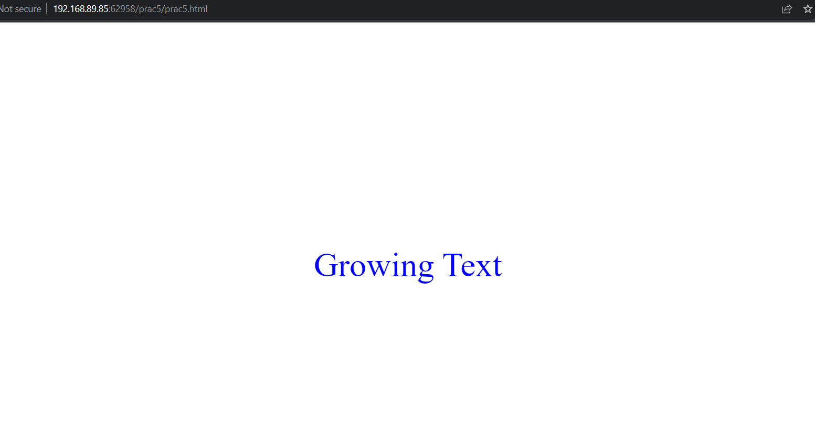Output:-

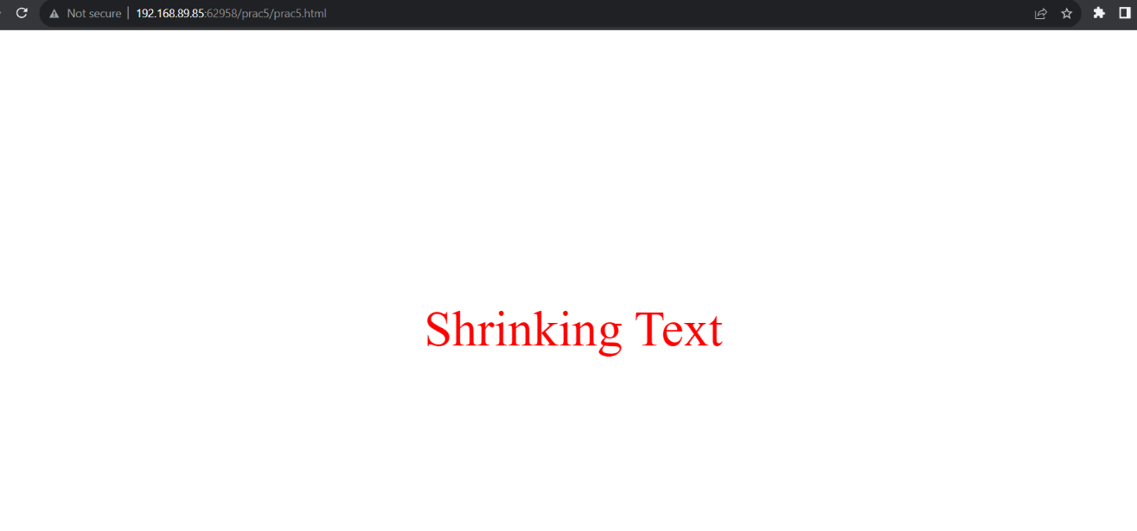

Code:-

<!DOCTYPE html>

<html>

<head>

<title>Squares and Cubes Table</title>

<style>

body {

font-family: Arial, sans-serif;

background-color: #f5f5f5;

text-align: center;

padding-top: 10px;

}

table {

width: 90%;

border-collapse: collapse;

margin: auto;

}

th,

td {

border: 1px solid #0d0b0b;

padding: 10px;

text-align: center;

font-weight: bold;

}

th {

background-color: lightblue;

}

tr {

background-color: white;

}

</style>

</head>

<body>

<h1>Squares and Cubes Table</h1>

<table border="1">

<tr>

<th>Number</th>

<th>Square (n<sup>2</sup>)</th>

<th>Cube (n<sup>3</sup>)</th>

</tr>

<script>

function calculateSquaresAndCubes() {

const table = document.querySelector('table');

for (let i = 0; i <= 10; i++) {

const row = table.insertRow();

const numCell = row.insertCell(0);

const squareCell = row.insertCell(1);

const cubeCell = row.insertCell(2);

numCell.textContent = i;

squareCell.textContent = i * i;

cubeCell.textContent = i * i * i;

}

}

calculateSquaresAndCubes();

</script>

</table>

</body>

</html>

**Output:-**

