Customer Diversification and Revenue Optimization of a Medical Equipment Supplier

Submitted by

Name: Haifa Abdul Sathar

Roll number: 23f1002330



IITM Online BS Degree Program,

Indian Institute of Technology, Madras, Chennai Tamil Nadu, India, 600036

**Contents**

1. Executive Summary 3
2. Organization Background 3
3. Problem Statement 4
   1. Problem statement 1 4
   2. Problem statement 2 4
4. Background of the Problem 4
5. Problem Solving Approach 5
6. Expected Timeline 6
7. Expected Outcome 8

# EXECUTIVE SUMMARY

**Al Wafer Medical Equipments and General Trading LLC**, a leading B2B and B2C medical equipment supplier based in Dubai, UAE, is currently facing challenges related to customer concentration and fluctuating sales. A significant portion of its revenue comes from a small group of customers, making the business vulnerable to the risk of financial instability or revenue loss. If one or more key customers reduce or cease their purchases, it could significantly impact the company’s financial health. Additionally, the fluctuation in sales has led to revenue volatility, making it difficult to forecast and optimize operational decisions.

This Project aims to address these issues by implementing data-driven strategies to reduce dependence on a few major clients and to stabilize and grow sales. Various methods of analysis using the data provided by the owner, such as visualization of the features by plotting graphs, computing percentages and ratios, understanding key metrics through descriptive statistics, grouping the dataset into segments of similar nature and continuous communication with the owner on possible reasons for the observed trends and feasible changes will help to tackle the identified problems. By diversifying its client portfolio and introducing more efficient sales strategies, Al Wafer can not only mitigate the risk of revenue loss but also drive a sustainable growth in a competitive market. This initiative will ensure long-term financial resilience and establish a more balanced revenue stream for the business.

# ANALYSIS PROCESS AND METHODS

The process of data analysis includes defining the problem, data collection, organization, cleaning, transformation, applying analysis techniques and drawing conclusions.

## **Project Initiation and Data Collection**

## The journey started by contacting the owner and communicating about the project. The owner was informed about the benefits the organization will achieve by cooperating and sharing essential data which led him to agree to the proposal. The combined purchase and sales data of one year recorded in Excel sheets were shared by the owner to be analyzed. Precautionary measure of backing up the original file was taken in case of loss or deletion of the data. .

## **Data Cleaning and Processing**

## The data provided was structured and required minor cleaning before processing. A check for duplicate and missing entries was carried out. The Customer and Supplier names were uniformly formatted across all the sheets and some mistakes in date entries were corrected.

## **Data Analysis Process**

## The data analysis started by examining the characteristics of the dataset through descriptive statistics. The data provided by the owner was compiled in excel sheets named with month names from September 2023 to August 2024. Although monthly expenses were not recorded, an estimate of Annual Expenses was shared which was entered in an extra sheet at the end. Each sheet contained details given below

## Purchase Report

|  |  |  |  |  |
| --- | --- | --- | --- | --- |
| SI NO | Voucher Number | Voucher Date | Cash/Party | Bill Amount |
| Serial No. of entry | Voucher No. of transaction | Date of Transaction | Name of Supplier | Purchase Amount in Aed |

Sales Invoice Report

|  |  |  |  |  |
| --- | --- | --- | --- | --- |
| SI NO | Voucher Number | Voucher Date | Cash/Party | Bill Amount |
| Serial No. of entry | Voucher No. of transaction | Date of Transaction | Name of Customer | Sales Amount in Aed |

## A combined report was created in a new sheet named ANNUAL REPORT which contained the columns of the Purchase Reports and Sales Invoice Reports of all the months under respective headings. Two new Columns corresponding to the weekdays and months of each transaction were also added. This new dataset gave a more concise base for further analysis.

## **Customer Analysis**: To understand the customer base, cumulative percentages of revenue contribution was calculated. For this, the customers were arranged in descending order of their Bill Amount Totals. Two columns were populated with Cumulative Sums and Cumulative Percentages. By examining the cumulative percentage column, it was observed that a few high-bill entities (such as AL SANAIYA DRUG STORE) contributed a large portion of the total bill amount. Approximately 80% of the cumulative bill amount was generated by the top 15-20 entities, out of the 130 unique entities, indicating a concentrated customer base. This concentration implies that a few customers significantly influence the overall revenue, which could have implications for business stability and risk. This insight paved way to more detailed analysis of the customer base.

## To get a visual feedback, a pie chart was plotted as pie charts provide best visualization to understand proportions of a whole. Later, on plotting line charts for the purchases of each customer (Fig. 1), an abnormal trend was observed. There was a sudden cease of a high valued customer and sudden emergence of another high valued customer in the same period which is shown in the graph below

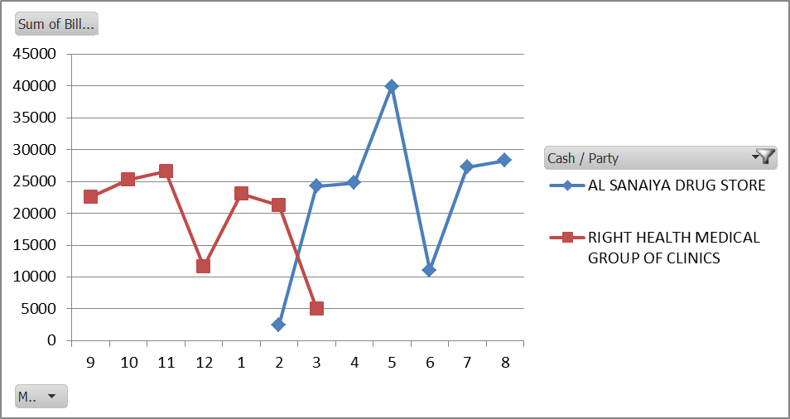

Fig. 1 Trend lines of two high valued customers

## On discussion with the owner it was understood that it was a change in name of the entity, RIGHT HEALTH MEDICAL GROUP OF CLINICS to AL SANAIYA DRUG STORE. Hence, this change was made throughout the dataset to give precise results. This changed the number of unique entities to 129 and a revised pie chart showed that almost 50% of the revenue was contributed by just 3 top customers. On further examination of the buyers a potential risk of churn was observed in a number of customers as there were many who either decreased or completely stopped their purchases.

## To address these issues it was decided to cluster the customer base which will help in discovering natural groupings in customer behavior and support more targeted strategies of retention and reengagement. Recency Frequency Monetary (RFM) Analysis was chosen for this purpose which scored each customer based on their Recency (number of days since last purchase), Frequency (number of purchases made in the given period) and Monetary (total amount spent) values from a scale of 5(high) to 1(low) each. Three score columns were populated with the scores by dividing the three RFM metrics into 5 percentiles each using the percentile function in excel. A new column was populated by concatenating the three scores into an RFM score. The RFM score divided the whole base into various segments such as Champions, Loyal Customers, At Risk, Potential Loyalists, Hibernating Customers, New Customers and others. These segments can guide targeted marketing strategies, loyalty programs, or re-engagement campaigns.

## **Revenue Analysis**: With the Purchase and Sales amounts over a period of one year, the performance of the business was analyzed. The relation between the two variables was visualized through a scatter plot with Purchase on the x axis and Sales on the y axis to see if increase in purchases will translate to increase in sales. To quantify the relation, correlation coefficient was calculated to understand the strength and direction of the relation. The purchases and sales amounts across months were compared using a ‘Purchases vs. Sales’ clustered bar chart. A bar chart was chosen as it would give an easy visual comparison between the two factors. Although the purchases are stable, the varying sizes of bars of sales amount showed fluctuating sales. To find the reason behind the fluctuating sales, a trend line of major customer was plotted along the sales bar chart which provided more evidences of customer concentration as the major dips in sales were closely tied to drop in purchase of the major customer

# RESULTS AND FINDINGS

**Major findings from the analysis process:**

## Customer Concentration: A table of Cumulative Percentages of revenue contribution (Fig. 2) was created to observe customer concentration. Out of the 130 unique entities 21 entities, which is just 16% of the total customers, contributed approximately 80% of the revenue.

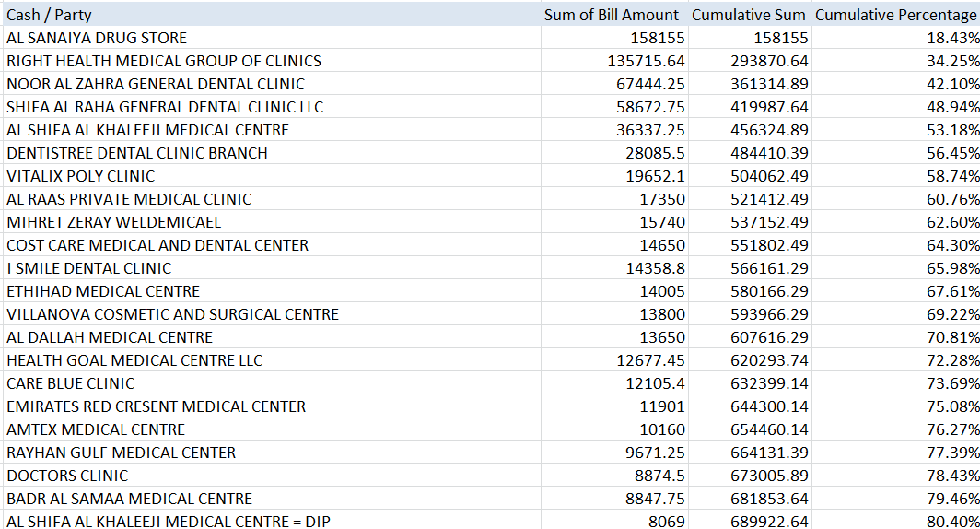

Fig. 2 Table of Cumulative Percentages

## Further a pie chart was plotted to visualize the proportion of revenue contributions.

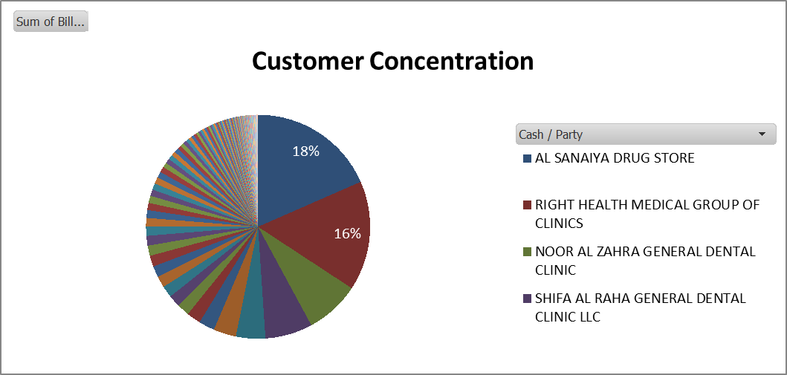

Fig. 3 Customer Revenue Contributions

## On examination of top customers and discussion with the owner it was found that RIGHT HEALTH MEDICAL GROUP OF CLINICS had changed their name to AL SANAIYA DRUG STORE which compelled a recalculation of cumulative percentages and proportions.

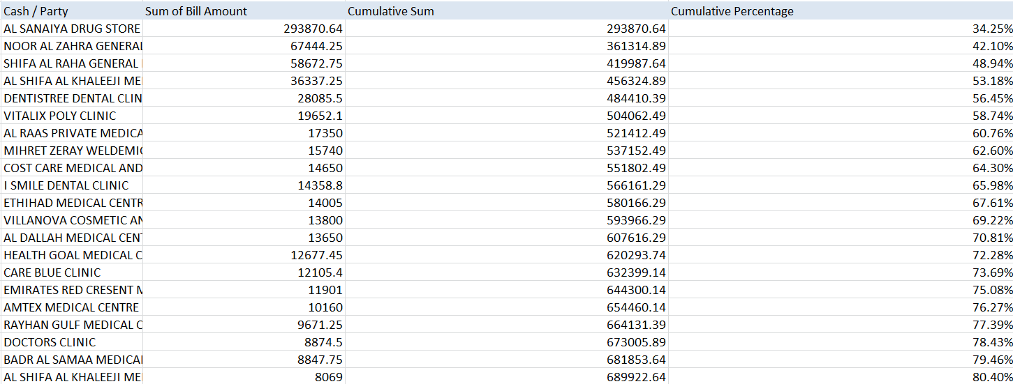

Fig. 4 Revised Cumulative Percentages

## The revised table shows that AL SANAIYA DRUGSTORE contributes an amount of 293,870.64 Aed which accounts to 34.25% of Total Sales. Now 20 entities out of the 129 unique entities, which are just 15% of the total customers, accounted for approximately 80% of Sales which emphasizes customer concentration.

## A pie chart was plotted again with the change identified to get a clear understanding.

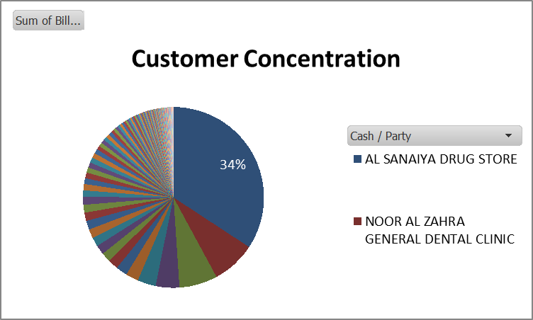

Fig. 5 Revised Customer Concentration Chart

## The revised chart emphasizes concentration of revenue in a few top customers as the chart shows approximately 50% sales coming from just 3 customers namely AL SANAIYA DRUG STORE, NOOR AL ZAHRA GENERAL DENTAL CLINIC and SHIFA AL RAHA GENERAL DENTAL CLINIC. This trend suggests a possible customer concentration risk.

## Customer Purchase Patterns and risk of Churn: Customer Purchases across the months from September 2023 to August 2024 was plotted to see purchase patterns in each customer across the months. The below Line Chart (Fig 6) shows visible decrease in sales or even complete cease of sales to various customers suggesting a possibility of customer churn. Features such as drop in purchase frequency or spend amount will help to predict the possible churning customers.

## [Customer Purchase Trends Sheet](https://docs.google.com/spreadsheets/d/1oWkwXI5-V3uLNs5kuB6wHXNHGvREyFzy/edit?usp=drive_link&ouid=116900928146612808956&rtpof=true&sd=true)

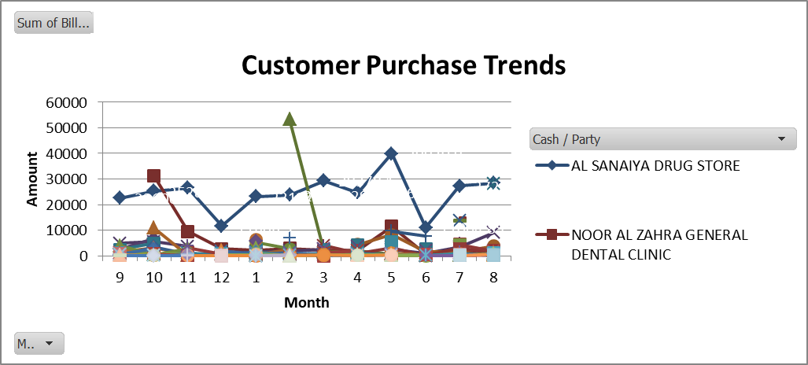

Fig. 6 Customer Purchase Trends

## Customer Segmentation Analysis: Observing the purchasing patterns of customers paved way to need of customer segmentation based on the customer behaviors as segmentation would help in identifying customers at risk of churn, potential high value customers etc. and devise tailored strategies for customer retention and driving sales. For this purpose, Recency Frequency Monetary (RFM) Analysis was carried out which is shown in the given table

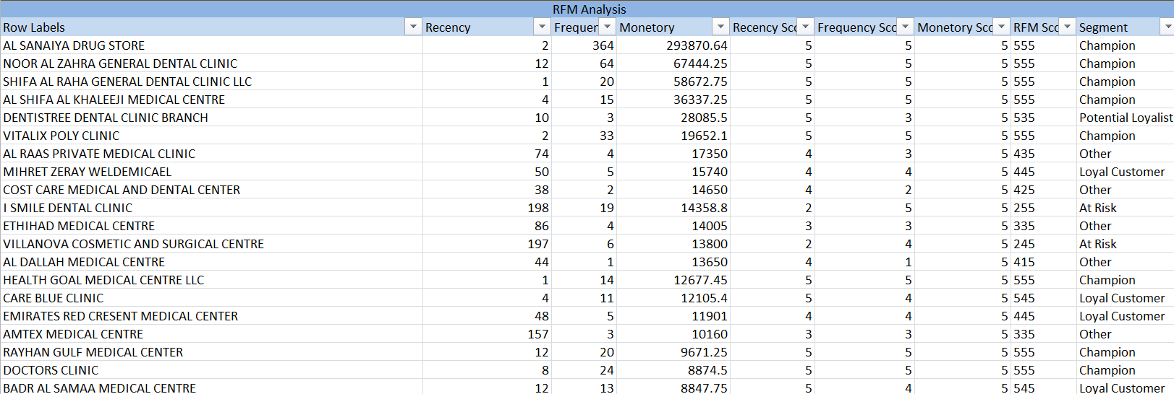

Fig. 7 RFM Analysis

## In this Analysis process, the customer base was divided into various segments based on the individual RFM scores. The different Segments identified were

## Champions: RFM scores like 555, indicating high recency, frequency, and monetary values.

## Loyal Customers: High frequency and monetary scores, moderate recency.

## At Risk: High frequency and monetary scores but low recency.

## Potential Loyalists: High recency, moderate frequency, and monetary.

## Hibernating Customers: Low scores across all three metrics.

## New Customer: High recency but low frequency and monetary, indicating a recent, small purchase.

## Analysis of each Segment:

## **Champions**

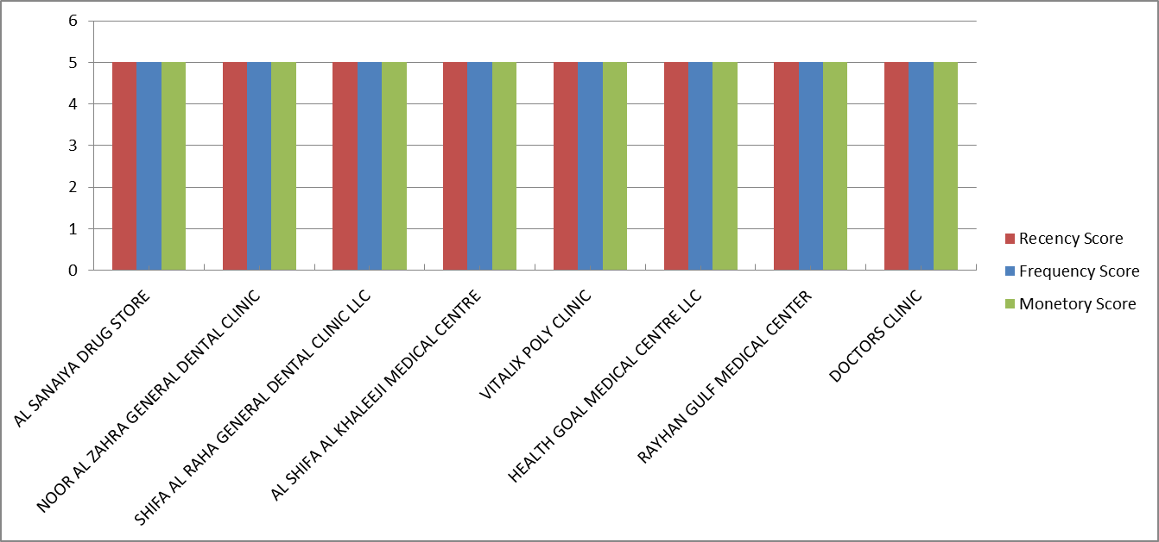

Fig. 8 Champion customers

## The Champions typically represent the most valuable customers. These are customers who buy frequently, spend a lot, and have purchased recently. They have an RFM Score of 555. A benchmark of 5–10% champions is often considered good for businesses with a mix of customer value. Here, we have identified 8 Champions which is a good starting point for the business but can potentially increase the count and gain more high valued customers.

## **Loyal Customers**

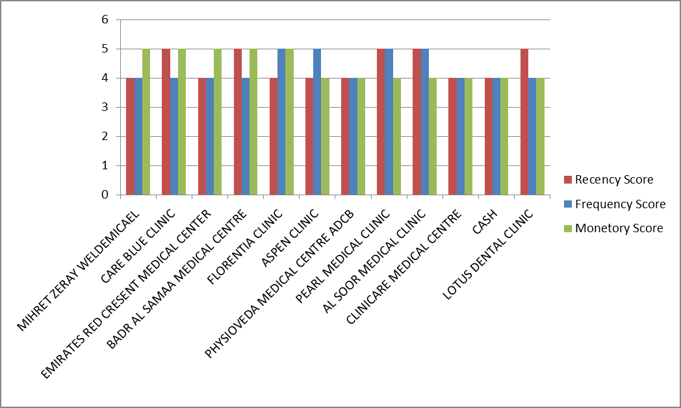

Fig. 9 Loyal Customers

## Loyal customers are those who make regular purchases but may not spend as much or buy as frequently as champions. They’re valuable because they return consistently, even if their average spend or recency isn’t as high as champions. Here we have identified 11 loyal customers out of 129 (around 8.5%) which can be considered as a positive sign. Loyal customers, like champions, can serve as a stable revenue base and can also be encouraged to increase their frequency or spending.

## **Potential Loyalists**

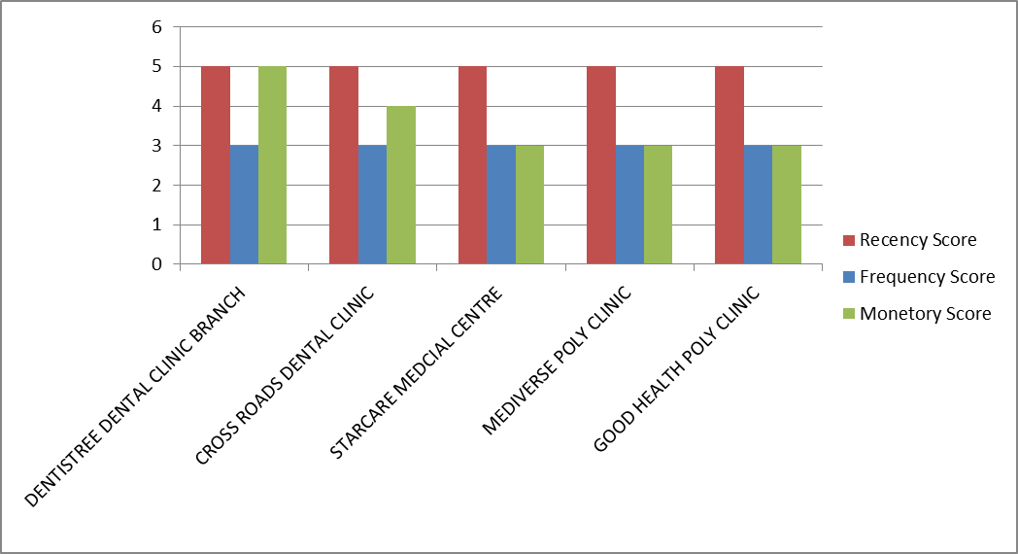

Fig. 10 Potential Loyalists

## Potential loyalists are customers who may have made recent purchases or have a decent purchase frequency but haven’t yet reached the same level of loyalty as loyal customers or champions. They represent a promising group to cultivate into more regular, high-value customers.

## **New Customers**

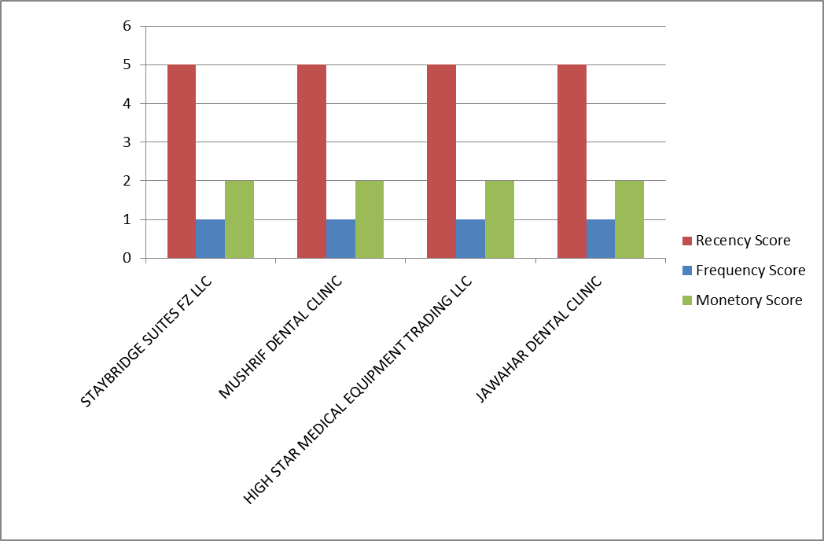

Fig. 11 New Customers

## New customers are those who have made a recent purchase but may not yet show patterns of loyalty or high spending. These customers are just beginning their journey with the business, making them ideal for early engagement.

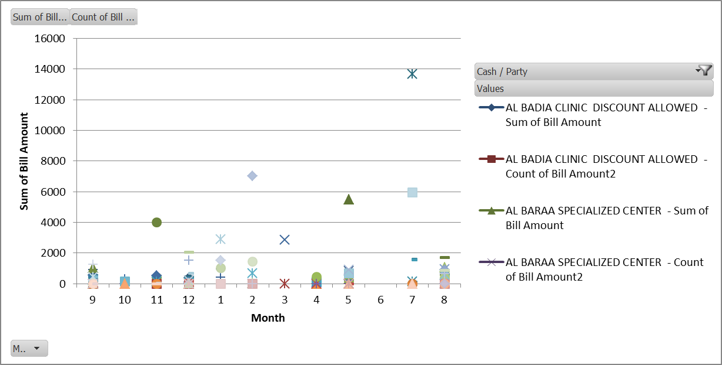

Fig. 12 One time Buyers

## **One Time Buyers:** 67 entities were identified as one time buyers. This may include new customers of varying monetary value who are not making repeat purchases. A high proportion of one-time buyers suggests that the business is facing challenges with customer retention. It’s often more profitable to encourage existing customers to make repeat purchases than to acquire new ones, so understanding why customers aren’t returning is crucial.

## **Hibernating Customers**

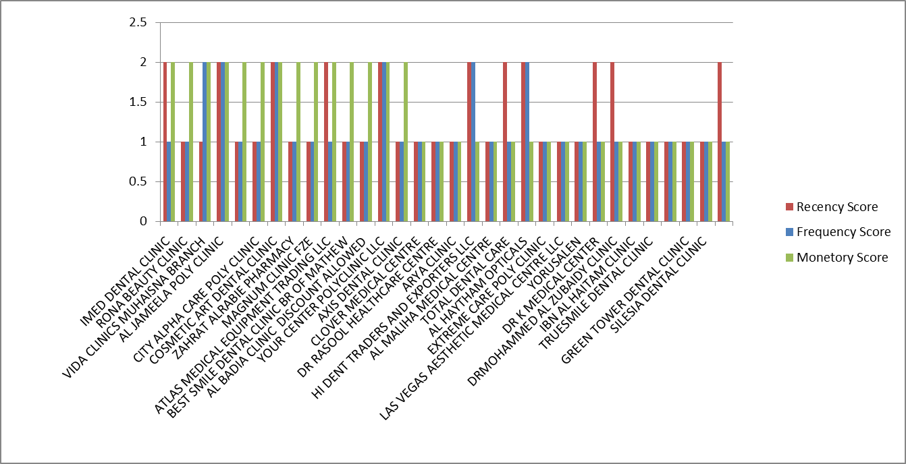

Fig. 12 Hibernating Customers

## Hibernating customers are those who haven’t made recent purchases and may show low purchase frequency and spending. They were once active but now have a low Recency score, indicating a need for re-engagement. 32 Customers were found to be from this segment. While a high proportion of hibernating customers can be a challenge, it also provides an opportunity. Successfully re-engaging even a portion of this group could boost overall retention and potentially convert some back to active or loyal customers.

## **At Risk**

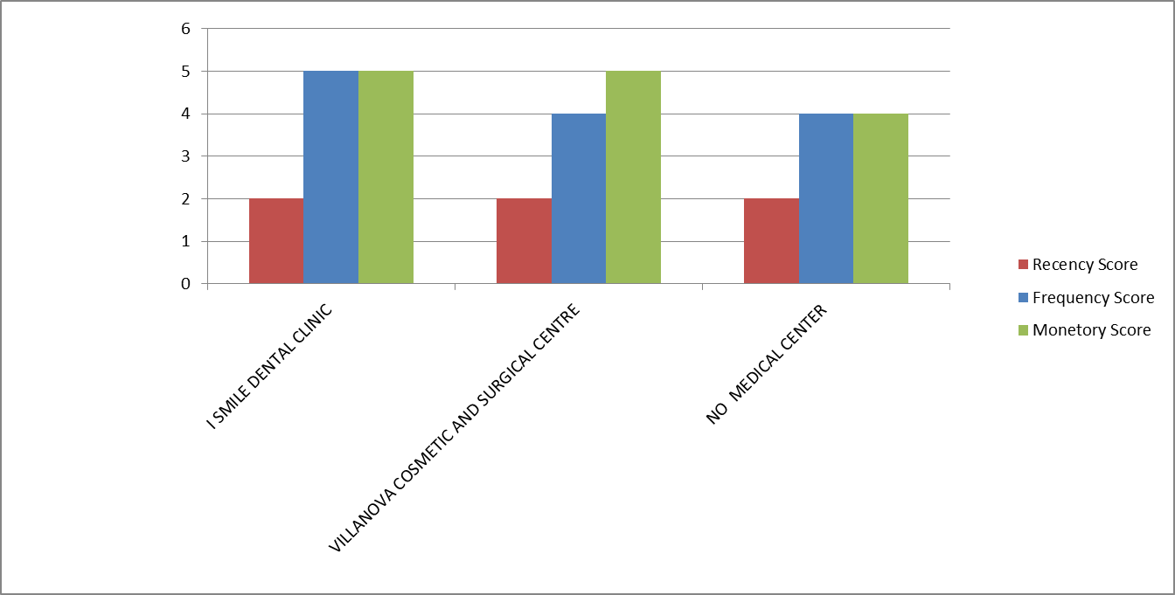

Fig. 13 Customers at Risk

## At-risk customers are those who used to engage with the business but have not made a purchase recently. Their buying frequency and spend may be moderate to high, but their Recency score is low, signaling a risk of churn. Keeping an eye on this group can help to prevent churn, and since it’s small, targeted efforts can be highly effective in bringing them back.

## **Others**

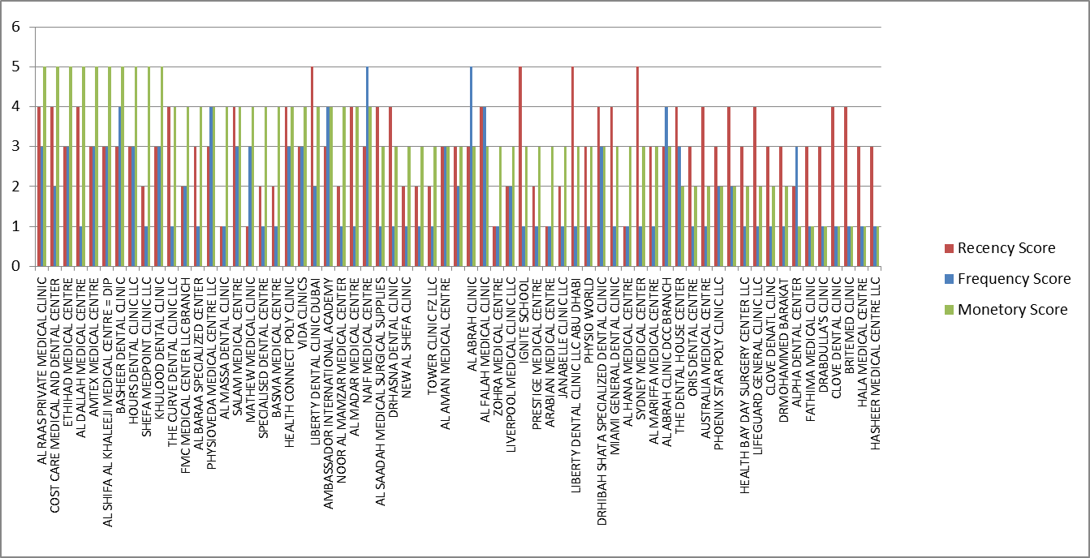

Fig. 14 Other Customers

## The "other” category includes customers who don’t strongly fit into other segments. The RFM scores in this segment tend to be low to moderate, with the majority receiving lower Recency and Frequency scores. 65 entities have been grouped into this segment. Many of these customers scored lower in Recency, indicating that they haven’t purchased recently, and low in Frequency, showing fewer repeat purchases. With further analysis,of this segment based on the scores, more groupings can be made:

## **Higher Monetary Scores (5)**: Some customers, such as AL RAAS PRIVATE MEDICAL CLINIC and COST CARE MEDICAL AND DENTAL CENTER, have high Monetary scores but lower Recency or Frequency. These might represent high-value customers who haven’t bought recently. Targeted re-engagement campaigns could encourage them to return.

## **Moderate Frequency Scores (3-4)**: Some, like BASHEER DENTAL CLINIC, have moderate Frequency and lower Recency. These customers may respond well to retention strategies like loyalty rewards or exclusive offers to boost Recency.

## **Low RFM Scores (1-2)**: Customers with consistently low scores, such as ZOHRA MEDICAL CENTRE, have minimal recent activity and low spending. It should be evaluated if re-engaging these customers would be cost-effective or if the focus should shift to higher-potential segments.

## Sales and Purchase Comparison:

## Descriptive Statistics of Sales and Purchases:

|  |  |  |
| --- | --- | --- |
|  | **PURCHASES** | **SALES** |
| count | 12.000000 | 12.000000 |
| mean | 46543.760000 | 71511.543333 |
| std | 15626.441883 | 28174.146077 |
| min | 30780.340000 | 30431.600000 |
| 25% | 35022.640000 | 54764.385000 |
| 50% | 40765.225000 | 63869.875000 |
| 75% | 55513.387500 | 98345.910000 |
| max | 76357.340000 | 106120.750000 |

## Purchases have a standard deviation of 15,626.44, while Sales have a much higher standard deviation of 28,174.15.This indicates that sales values fluctuate more than purchase values, suggesting that sales are less stable or more sensitive to market factors.

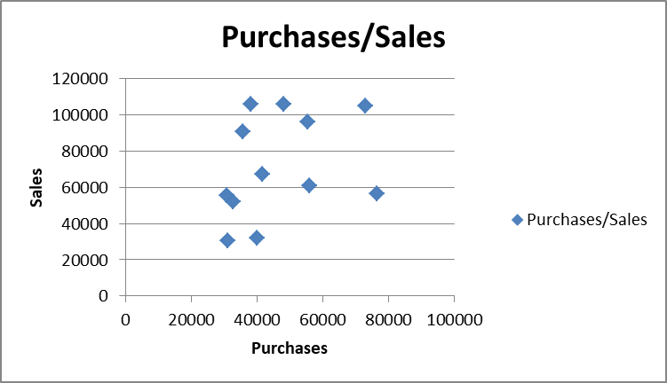

Fig. 15 Relation between Purchase and Sales

## To understand how **Purchases** and **Sales** relate to each other, a scatter plot was plotted. The correlation coefficient was calculated which resulted in 0.319029522. This indicates that there is some positive relationship between **Purchases** and **Sales**—as one tends to increase, the other also increases, but the relationship is not strong (visible in the graph). This could suggest that while there is some trend of sales increasing with purchases, there are other factors at play, and purchases don’t solely drive sales in a predictable manner.

## A clustered column chart (Fig 5) with columns of Purchases and Sales was plotted to compare the Monthly Purchases to Sales.

## In most months Sales exceed Purchases. Even though, there are fluctuations in the trend in some months like March and December which could indicate seasonal or market demand variations which affect the revenue generation. This analysis gives valuable insights for effective inventory management planning.

Fig. 6 Monthly Purchases vs. Sales

## Impact of Major Customers on Revenue Trends: A drop in sales in the months of December and June is closely tied to the drop in purchase by the major Customer emphasizing the reliance on major customers which is a risk of Customer Concentration. This dependence poses a high risk of financial instability to the business.

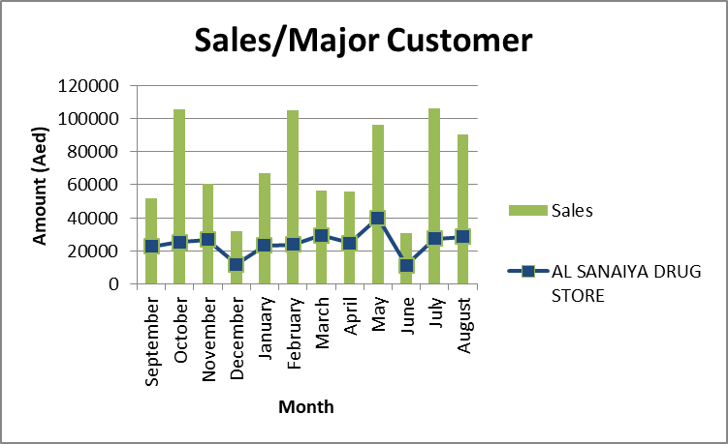

Fig. 7 Comparison of Sales trend and major customer trendline

## [Link to Analysis Sheets](https://docs.google.com/spreadsheets/d/1e23t9WCFHrCgsglwYpn6oYaiFo7D2n9h/edit?usp=drive_link&ouid=116900928146612808956&rtpof=true&sd=true)

# INTERPRETATION OF RESULTS

## **Irregular Purchases across Clients:**

## Most customers do not make consistent purchases every month. Some customers make purchases in certain months but show no transactions in other months. This irregular pattern could indicate a potential churn or that these customers only make purchases when they need specific items, rather than consistently.

## **Low Repeat Activity:**

## Some customers only appear in a few months, and their total contributions are quite low compared to others. Certain clinics make a purchase once and don't return in subsequent months, which could be a sign of churn, meaning they are not continuing their buying.

## **Active vs. Inactive Customers:**

## A number of customers are making sizable contributions in certain months, while others seem to have either minimal or one-time engagement. Revenue instability could be inferred if only a small number of clients are responsible for a majority of the sales, motivating a need for expansion of customer base.

## **Sales Exceeding Purchases:**

## The fact that sales exceed purchases in most months suggests that the business is generating a surplus from its operations. This is a positive indicator, as it means the company is able to sell more than it buys, which could be a sign of efficient operations and profitability.

## **Volatility in Sales**:

## Even though sales frequently exceed purchases, there are still fluctuations in sales trends, with some months showing dips. This could indicate seasonal or market demand variations that affect revenue generation. There is also a close tie of dip in overall sales with dip in purchase of major customer implying customer concentration.

# RECOMMENDATIONS

## From the RFM analysis, customer segments can be used to tailor marketing strategies to each customer group.

## Champions: Show appreciation with exclusive rewards, early access to new products, or VIP treatment. Encourage word-of-mouth by offering referral incentives.

## Loyal Customers: Reward loyalty with special discounts, exclusive access, or loyalty points. Engage them with feedback requests to show their opinions matter and increase their connection with the brand.

## Potential Loyalists: Offer incentives to encourage them to become repeat buyers, such as loyalty program enrollment or discounts on future purchases.

## New Customers: Make a great first impression with a welcome email and a special offer for a second purchase. Send information about popular products or services they haven’t tried yet to foster cross-selling opportunities.

## Hibernating Customers: Re-engage with special promotions, win-back campaigns, or "We miss you" messages. Send a survey or ask for feedback to understand why they may have disengaged.

## At-Risk Customers: Send reactivation offers or special discounts to bring them back. Reach out personally to understand if they had any issues or concerns. Remind them of the benefits of your products or services, possibly highlighting improvements or changes.

## Recommendations to stabilize revenue stream and grow the business:

## Capitalize on High Sales: During months when sales are significantly higher, understand what drives this increase. These periods could represent key opportunities for scaling up marketing and promotions to capitalize on already strong demand.

## Address Sales Dips: If these dips are seasonal, promotions or discounts can be introduced in those periods specifically to boost sales. If it's due to external factors like market shifts, adapt sales strategy accordingly.

## Expand Customer Base: Since sales are already exceeding purchases, increasing the customer base will likely translate directly into higher profits and stabilized revenue. Focus on expanding reach through advertising, social media campaigns, or expanding into new markets.