Customer Diversification and Revenue Optimization of a Medical Equipment Supplier

Submitted by

Name: Haifa Abdul Sathar

Roll number: 23f1002330



IITM Online BS Degree Program,

Indian Institute of Technology, Madras, Chennai Tamil Nadu, India, 600036

**Contents**

1. Executive Summary 2
2. Proof of Originality 2
3. Metadata 4
4. Descriptive Statistics 5
5. Analysis Process and Methods 7
6. Results and Findings 8

# EXECUTIVE SUMMARY

**Al Wafer Medical Equipments and General Trading LLC**, a leading B2B and B2C medical equipment supplier based in Dubai, UAE, is currently facing challenges related to customer concentration and fluctuating sales. A significant portion of its revenue comes from a small group of customers, making the business vulnerable to the risk of financial instability or revenue loss. If one or more key customers reduce or cease their purchases, it could significantly impact the company’s financial health. Additionally, the fluctuation in sales has led to revenue volatility, making it difficult to forecast and optimize operational decisions.

This Project aims to address these issues by implementing data-driven strategies to reduce dependence on a few major clients and to stabilize and grow sales. Various methods of analysis using the data provided by the owner, such as visualization of the features by plotting graphs, computing percentages and ratios, understanding key metrics through descriptive statistics and continuous communication with the owner on possible reasons for the observed trends and feasible changes will help to tackle the identified problems . By diversifying its client portfolio and introducing more efficient sales strategies, Al Wafer can not only mitigate the risk of revenue loss but also drive a sustainable growth in a competitive market. This initiative will ensure long-term financial resilience and establish a more balanced revenue stream for the business.

# PROOF OF ORIGINALITY

## [Letter from the Organization](https://drive.google.com/file/d/1pFno63gLmh-dYxrNF4nrK7FTvu2o5wC_/view?usp=drive_link)

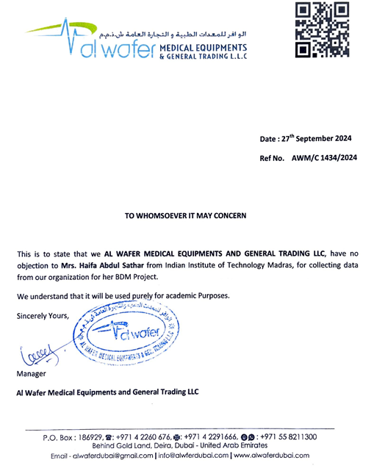

## [Images of the business](https://drive.google.com/drive/folders/1QYg0ZqrbUnSLJ-SpfU_UN8bHAumD3fuT?usp=drive_link)

## 

## [Google 360 view of Location](https://www.google.com/local/place/fid/0x3e5f4312c6128571:0x420b29b560285416/photosphere?iu=https://streetviewpixels-pa.googleapis.com/v1/thumbnail?panoid%3D5aGPdjSq2Kl0IjEk6orAtQ%26cb_client%3Dlu.gallery.gps%26w%3D160%26h%3D106%26yaw%3D250.63147%26pitch%3D0%26thumbfov%3D100&ik=CAISFjVhR1BkalNxMktsMElqRWs2b3JBdFE%3D)

## [Al Wafer Brochure](https://drive.google.com/file/d/1QHgPIhxnBL9WKZrzP1FHAtTvAB7ptT5d/view?usp=drive_link)

## [Purchase Invoice](https://drive.google.com/file/d/1U-21dU3_64TeMhZoYDwE9eWwGOf0j7MO/view?usp=drive_link)

## [Data Provided](https://docs.google.com/spreadsheets/d/1QRt_yKbPEUpGsX9A5sLSCnTrm4Mnxir3/edit?usp=drive_link&ouid=116900928146612808956&rtpof=true&sd=true)

## Interaction with the Owner

### [Interaction Video](https://drive.google.com/file/d/1SVWjkz5u-sYaNLz30G94S4T5gUR-QAEc/view?usp=drive_link)

### [Whatsapp Interaction](https://drive.google.com/file/d/1SVdR5GCKkhDntMn9-y-l1AbEWOwAMgNL/view?usp=drive_link)

## Social Media:

## [Website](https://alwafermedicalequipments.com/) | [Facebook](https://www.facebook.com/alwaferdubai/) | [Instagram](https://www.instagram.com/alwaferdubai/?hl=en)

# METADATA

The Business Owner provided the following details compiled in [Excel sheets](https://docs.google.com/spreadsheets/d/1YYA0cxOzilU6vZajQgLSLnS0bMEaGLWx/edit?usp=drive_link&ouid=116900928146612808956&rtpof=true&sd=true) for a period of 1 year. Each sheet corresponds to a month and has entries of the Suppliers, Purchase amounts, Customers, Sales amounts Dates etc.

## **Purchase** **Data** **Metadata**

|  |  |
| --- | --- |
| **KEY** | **DESCRIPTION** |
| SI No | Serial Number of the transaction entry |
| Voucher No | Unique ID given to each transaction |
| Voucher Date | The date of the transaction |
| Cash/Party | Supplier’s name |
| Bill Amount | Amount paid for the purchase |

* Title: Purchase Report.
* Description: Records of Purchase dates, Amount and Supplier names of each month per sheet.
* Date Range: 1st September 2023 to 31st August 2024.
* File Format: xlsx

## **Sales** **Data** **Metadata**

|  |  |
| --- | --- |
| **KEY** | **DESCRIPTION** |
| SI No | Serial Number of the transaction entry |
| Voucher No | Unique ID given to each transaction |
| Voucher Date | The date of the transaction |
| Cash/Party | Customer’s name |
| Bill Amount | Amount received for the sale |

* Title: Sales Invoice Report.
* Description: Records of Sales dates, Amount and Customer names of each month per sheet.
* Date Range: 1st September 2023 to 31st August 2024.
* File Format: xlsx

## **Annual Expenses Metadata**

|  |  |
| --- | --- |
| **KEY** | **DESCRIPTION** |
| Column 1 | Expense Detail |
| Column 2 | Expense amount |

## Title: Annual Expenses.

## Description: Records of Annual Expenses with their amounts.

* Date Range: 1st September 2023 to 31st August 2024.
* File Format: xlsx

# DESCRIPTIVE STATISTICS

A compact summary of key information about the dataset is derived using data metrics such as mean, standard deviation, quartiles etc.

## **Monthly Purchase Amount Statistics (1st Sep 2023 – 31st Aug 2024)**

|  |  |
| --- | --- |
|  | BILL AMOUNT (in Aed) |
| count | 12.000000 |
| mean | 46543.760000 |
| std | 15626.441883 |
| min | 30780.340000 |
| 25% | 35022.640000 |
| 50% | 40765.225000 |
| 75% | 55513.387500 |
| max | 76357.340000 |

* Total Purchase Amount for 12 months = Aed 558525.12
* Range = Aed 45577

## **Monthly Sales Amount Statistics (1st Sep 2023 – 31st Aug 2024)**

|  |  |
| --- | --- |
|  | BILL AMOUNT (in Aed) |
| count | 12.000000 |
| mean | 71511.543333 |
| std | 28174.146077 |
| min | 30431.600000 |
| 25% | 54764.385000 |
| 50% | 63869.875000 |
| 75% | 98345.910000 |
| max | 106120.750000 |

* Total Sales Amount for the 12 months = Aed 858138.52
* Range = Aed 75689.15

## **Monthly Statistics of Major Supplier (KOCHEH MEDICAL EQUIPMENT LLC)**

|  |  |
| --- | --- |
|  | BILL AMOUNT (in Aed) |
| count | 12.000000 |
| mean | 14609.508333 |
| std | 6435.690541 |
| min | 3594.000000 |
| 25% | 11932.000000 |
| 50% | 14101.500000 |
| 75% | 18993.900000 |
| max | 25695.000000 |

## **Monthly Statistics of Major Customer (AL SANAIYA DRUG STORE)**

|  |  |
| --- | --- |
|  | BILL AMOUNT (in Aed) |
| count | 12.00000 |
| mean | 24489.22000 |
| std | 7635.26926 |
| min | 11064.85000 |
| 25% | 22995.70000 |
| 50% | 25036.42500 |
| 75% | 27535.11250 |
| max | 39970.90000 |

## **Descriptive Statistics of Suppliers**

|  |  |
| --- | --- |
| Count | 869 |
| Unique | 83 |
| Top | WORLD DENTO MED EQUIPMENT LLC |
| Freq | 198 |

## **Descriptive Statistics of Customers**

|  |  |
| --- | --- |
| Count | 927 |
| Unique | 129 |
| Top | AL SANAIYA DRUG STORE |
| Freq | 364 |

# ANALYSIS PROCESS AND METHODS

The process of data analysis includes defining the problem, data collection, organization, cleaning, transformation, applying analysis techniques and drawing conclusions.

## **Project Initiation and Data Collection:** The journey started by contacting the owner and communicating about the project. The owner was informed about the benefits the organization will achieve by cooperating and sharing essential data which led him to agree to the proposal. The combined purchase and sales data of one year recorded in Excel sheets were shared by the owner to be analyzed. Precautionary measure of backing up the original file was taken in case of loss or deletion of the data. .

## **Data Cleaning and Processing:** The data provided was almost clean and required minor cleaning before carrying out further analysis. New features were added which may help in gaining more insights and a better analysis.

## **Exploratory Data Analysis (EDA) and Visualization Techniques:** A discussion with the owner and exploratory data analysis including descriptive statistics of each section, plotting various graphs etc. gave insights into the possible problems faced by the business. The graphs were selected carefully to disclose the underlying trends and patterns clearly. For instance, customer concentration proportions were depicted through pie charts as pie charts provide the best visual effect of showing proportions of a whole and showing the trend across months was done through line charts as it is a time series data. Recency Frequency Monetary (RFM) Analysis was done to segment the Customer base which will help in discovering natural groupings in customer behavior and support more targeted strategies of retention and reengagement. The data analysis process and visualization techniques rely on Microsoft Excel tools such as pivot charts, custom formulas etc. and Python libraries and functions such as pandas, matplotlib, openpyxl etc.

# RESULTS AND FINDINGS

**Major findings from the analysis process:**

## **Customer Concentration and Revenue Dependency:** To find the key customers based on the Total Sales Amount over a period of one year, a pie chart (Fig 1) was plotted as it could convey the proportion of revenue contribution of each customer. Two key Customers found were AL SANAIYA DRUG STORE and RIGHT HEALTH MEDICAL GROUP OF CLINICS contributing 18% and 16% respectively.

Fig. 1 Customer Concentration Plot

## On further analysis of each of the customers, abnormal trends were identified which is depicted in the following figure (Fig 2).

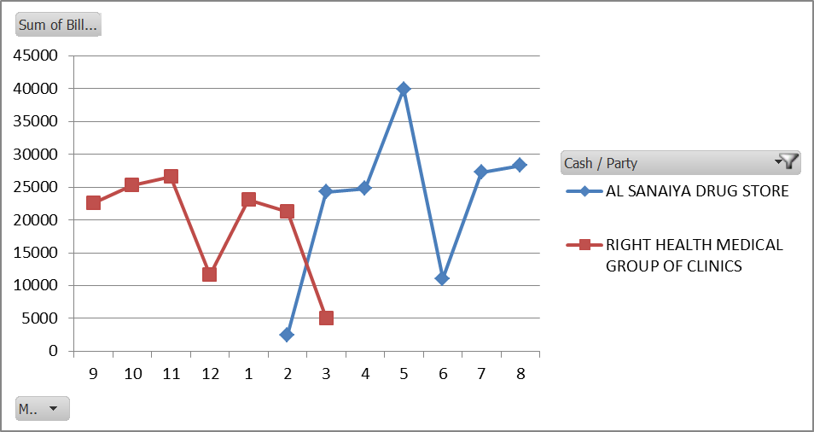

Month

Fig. 2 Sales of two major Customers

## Sudden cease of purchase of a key customer and sudden emergence of a high valued customer in the same period brought a sense of confusion which was communicated to the owner. On discussion with the owner it was found that it was a change in name of the organization and both the names corresponded to the major Customer RIGHT HEALTH MEDICAL GROUP OF CLINICS now, AL SANAIYA DRUG STORE. When the customer concentration was recomputed with the changed data the following graph (Fig 3) was obtained.

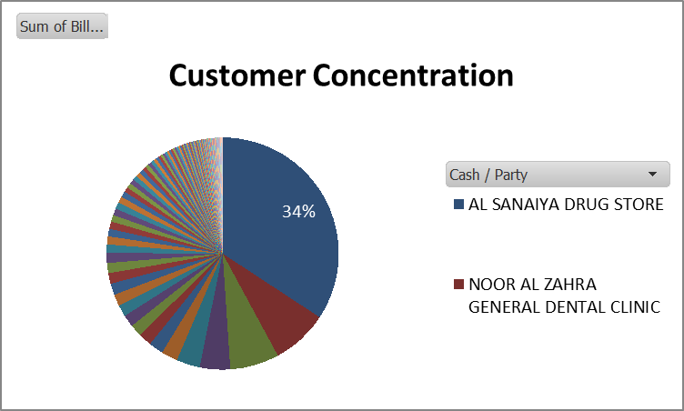

Fig. 3 Customer Concentration Plot

## 34% of the Annual Sales which amounts to Aed **293870.64** come from AL SANAIYA DRUG STORE and almost 50% of revenue comes from just 3 customers. This trend suggests a possible customer concentration risk.

## Customer Churn and Purchase Patterns: Customer Purchases across the months from September 2023 to August 2024 was plotted to see purchase patterns in each customer across time. The below Line Chart (Fig 4) shows visible decrease in sales or even complete cease of sales to various customers suggesting a possibility of customer churn. Features such as drop in purchase frequency or spend amount will help to predict the possible churning customers.

## [Customer Purchase Trends Sheet](https://docs.google.com/spreadsheets/d/1oWkwXI5-V3uLNs5kuB6wHXNHGvREyFzy/edit?usp=drive_link&ouid=116900928146612808956&rtpof=true&sd=true)

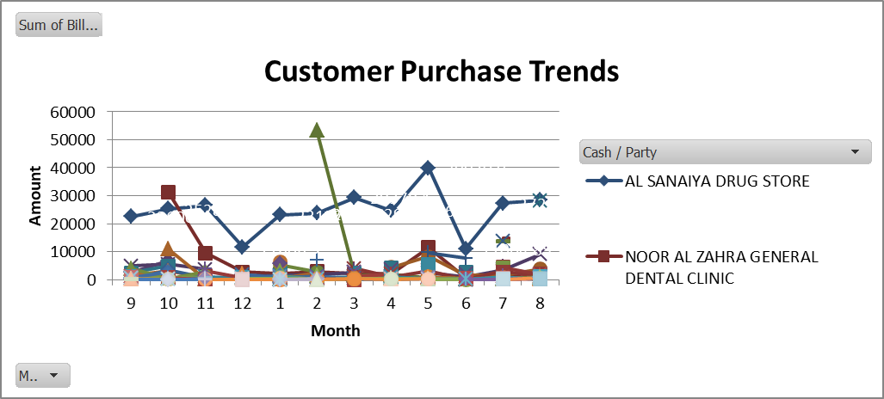

Fig. 4 Customer Purchase Trends

## Customer Segmentation and Analysis: RFM Analysis divided the customer base into different segments namely **Champions, Loyal Customers, At Risk, Potential Loyalists, Hibernating Customers, New Customer** and **Others.** [Customer Segmentation Sheet](https://docs.google.com/spreadsheets/d/1oWkwXI5-V3uLNs5kuB6wHXNHGvREyFzy/edit?usp=drive_link&ouid=116900928146612808956&rtpof=true&sd=true)shows RFM Analysis done. This segmentation allows to understand the customer base better and design tailored strategies for each group.

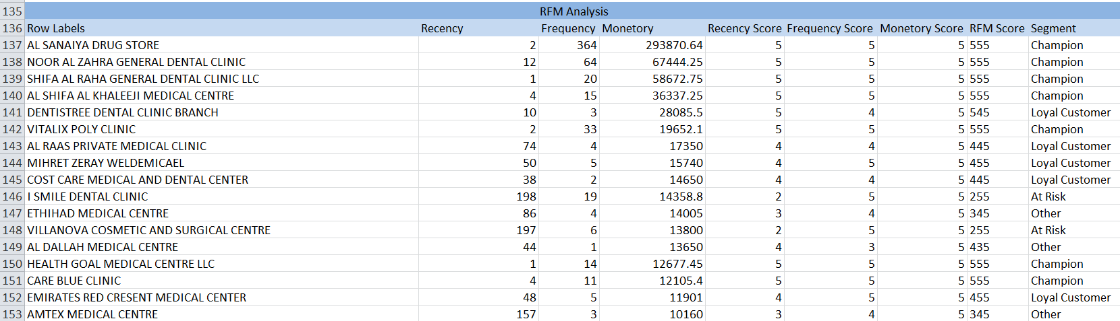

Fig. 5 Customer Segmentation

## Sales and Purchase Comparison: A clustered column chart (Fig 5) with columns of Purchases and Sales was plotted to compare the Monthly Purchases to Sales.

## In most months Sales exceed Purchases. Even though, there are fluctuations in the trend in some months like March and December which could indicate seasonal or market demand variations which affect the revenue generation. This analysis gives valuable insights for effective inventory management planning.

Fig. 6 Monthly Purchases vs. Sales

## Impact of Major Customers on Revenue Trends: A drop in sales in the months of December and June is closely tied to the drop in purchase by the major Customer emphasizing the reliance on major customers which is a risk of Customer Concentration. This dependence poses a high risk of financial instability to the business.

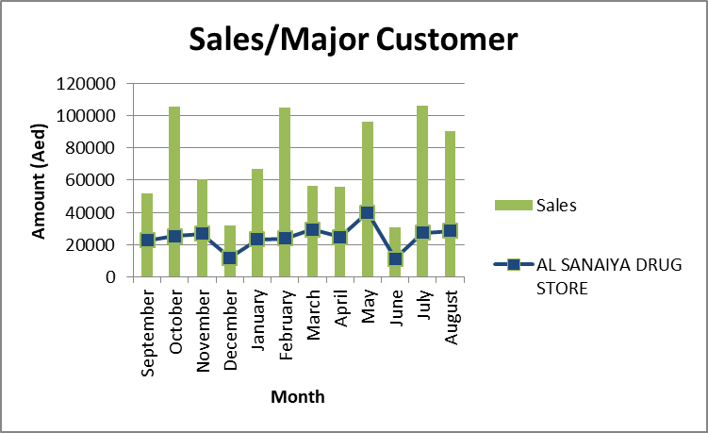

Fig. 7 Comparison of Sales trend and major customer trendline