Technology Stacks

MEAN

MERN

MEVN

M- MongoDB

E- Express.js

A-Angular

R- React.js

V – Vue.js

N- Node.js

------------------------------------------------------------

**Java Fullstack**

Frontend – Angular, React,Vue

Backend/middleware – Java

Database – Mysql , MongoDB

Programming language

* Machine level language – 0110 - microprocessor
* Assembly level language – ADD
* High level programming language - +

RAM – microprocessor - Machine level language

ALL – Assembler - MLL

HLL – compiler/Interpretor – MLL

**A Compiler takes a program as a whole.** **An Interpreter takes single lines of a code**.

Java

* High level programming language
* James gosling and team at Sun Microsystems
* 1995 – official realease
* Oracle corporation acquried- 2010

History of HLL

BCPL

* Basic combined programming language
* Martin Richards – 1962
* Occupy more memory

B

* Ken Thompson
* 1965
* Occupy less memory
* Unstructured

C

* Dennies Ritchie
* 1972
* Occupy less memory
* Structured

C++

* Stroustrup
* 1982
* Occupy less memory
* Object oriented
* Non portable

Java

* James gosling and team at Sun micro systems
* Occupy less memory
* Object oriented
* Portable

**Features of Java**

* Platform independent/portable/WORA
* Object oriented programming language

Abstraction

Encapsulation

Inheritance

Polymorphism

* WORA – Write Once Run Anywhere
* Multi threading

**Architecture -JAVA**

JDK – Java Development kit

JDK = JRE(Java Runtime environment) + Java compiler

JRE = JVM(Java Virtual Machine) + Java class libraries+ class loader + Bytecode verifier

JVM = JIT Compiler + Java interpretor + Runtime system

------------------------------------------------------------------------

Program.java(HLL) – javac (compiler) – Bytecode/ Intermidiate level code(Program.class)

Program.class – JVM (JIT) – MLL – operating system

There are 4 editions of Java

1.Java SE (Java Standard Edition)

2.Java EE (Java Enterprise Edition)

3.Java ME (Java Micro Edition)

4.Java FX

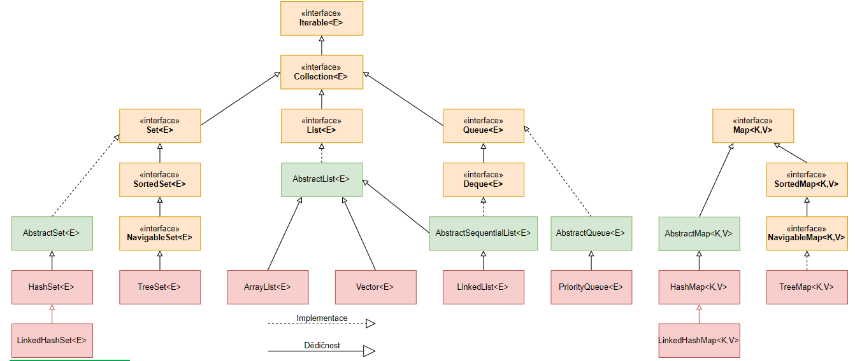

Java collections

Group of objects

We can achieve all the operations that you perform on data such as searching, sorting, insertion, manipulation and deletion.

Interfaces

Classes

Algorithm

Map – java.util.Map

Collection – java.util.Collection

List

Set

Queue

Map

---------------------------------------------------------------------------------------

Maven

Jenkins – CI- Continous integration

CD – continuous deployment / continuous delivery

Maven is a popular build tool- Compile – test - package

* Project management tool
* Provides a standard template for creating projects - archetypes
* Dependency management – GAV co ordinates
* G - group id – in.stackroute
* A- Artifact id – name of the project/dependancy
* V- version – version of the dependancy

Pom.xml

Project object model

* Dependencies
* Project co ordinates
* Plugin configuration
* Repo configuration
* packaging

Life cycle

* clean

pre clean

clean

post clean

* default

validate

compile

test

package

verify

install

site

deploy