MIT WORLD PEACE UNIVERSITY, PUNE

Foundations of Programming — CSE10010

Mini Project Report

on

Digital Food Ordering System

Submitted by:

Sakshi Singhal (1262252739)
Vareeja Kulkarni (1262250166)
Samridhi Agrawal (1262253351)
Hitansh Desai (1262254043)
Lalita (1262254141)

Project Guides:
Dr. Anushree Kulkarni
Prof. Shirish Paygude

Acknowledgment
We would like to express our sincere gratitude to Dr. Anushree Kulkarni and Prof. Shirish Paygude for their invaluable guidance, continuous support, and encouragement throughout the development of this project. Their insights and expertise were indispensable in shaping this work.

We are also thankful to MIT World Peace University, Pune, for providing us with the resources and environment conducive to learning and innovation.

Finally, we extend our appreciation to our fellow students and family members for their moral support and constructive feedback during the course of this project.

Abstract
The Digital Food Ordering System is a console-based application developed in the C programming language, designed to streamline and automate the process of placing food orders in a cafeteria or restaurant setting. The system allows customers to browse a categorized menu loaded from CSV files, select items, specify quantities, and place orders recorded with a unique date-wise token number. A built-in credit system rewards customers based on their order value, applicable as a discount on future bills. The billing module calculates CGST and SGST at 2.5% each, applies earned credits, and displays a detailed bill. All data is persisted using CSV-based file I/O, making the system lightweight and portable. The project demonstrates practical use of structs, dynamic memory allocation, file handling, and modular programming in C.

Table of Contents
1. Title Page
2. Acknowledgment
3. Abstract
4. Table of Contents
5. List of Figures and Tables
6. Introduction
7. System Design / Methodology
8. Implementation
9. Results and Discussion
10. Conclusion
11. Future Scope
12. Research Paper / Patent Details
13. Plagiarism Check
14. References
15. Appendix

List of Figures and Tables
Figure 1: System Flowchart (Section 7)
Figure 2: Program Output — Welcome Screen & Menu Display (Section 9)
Figure 3: Program Output — Menu Categories Continued (Section 9)
Figure 4: Program Output — Item Selection & Order Summary (Section 9)
Figure 5: Program Output — Order Confirmation & Bill (Section 9)
Figure 6: Program Output — Credit Points View (Section 9)

6. Introduction

6.1 Problem Statement
Traditional cafeteria and restaurant ordering processes are often manual, error-prone, and time-consuming. Customers face long queues, handwritten bills are susceptible to miscalculations, and there is no mechanism to reward repeat customers. A digital ordering system addresses these inefficiencies by automating order placement, billing, and credit management.

6.2 Background / Context
With increasing adoption of computing in everyday services, even lightweight console applications can significantly improve operational efficiency. C language, with its low-level file I/O capabilities and efficient memory management, is well-suited for building such systems in resource-constrained environments like college canteens or small eateries.

6.3 Objectives
- To design a menu-driven food ordering interface that loads items dynamically from CSV files.
- To implement a token generation system that resets daily and tracks each order uniquely.
- To build a credit rewards system where customers earn and redeem points based on order value.
- To compute GST-inclusive bills (CGST + SGST at 2.5% each) accurately.
- To persist all order and account data using file-based storage (CSV format).

7. System Design / Methodology

7.1 Overview of the Approach
The system follows a modular, procedural design paradigm in C. The application reads menu data from CSV files at runtime, accepts user input for item selection and quantity, and writes confirmed orders back to a persistent CSV store. A separate accounts file manages credit points per mobile number.

7.2 System Flowchart

START
↓
Initialize Date & Token
↓
Main Menu: Place Order / View Credits
↓
Accept Mobile Number
↓
Load & Display Menu from CSV
↓
Accept Item Code & Quantity
↓
Save Order (check duplicates)
↓
More items? → Yes (loop back)
↓
Confirm / Cancel Order
↓
Generate Bill (GST + Credits)
↓
Display Token Number
↓
END

7.3 Components / Modules Used
- Menu Module: Loads categories and items from menu_all.csv and individual category CSV files.
- Token Module: Reads orders.csv to assign an incremented daily token number.
- Order Module: Accepts codes, quantities, saves to Order struct array, detects duplicates.
- Billing Module: Computes subtotal, applies 5% GST, deducts credits, displays final amount.
- Credits Module: Reads/writes accounts.csv to track and update credit points per user.

7.4 Algorithms and Techniques
- Date Comparison: Uses time.h to get the current date and compares with the last record in orders.csv to determine if the token should reset.
- Duplicate Detection: The Index() function linearly scans the current session's Order array for a matching item code before saving.
- Credit Calculation: Credits = floor(Bill Amount / 100), applied as a direct rupee discount on the next order.
- GST: CGST 2.5% + SGST 2.5% = 5% total, applied on the pre-credit subtotal.

8. Implementation

8.1 Development Environment
- Programming Language: C (C99 standard)
- Compiler: GCC
- IDE: Code::Blocks / VS Code with C extension
- Data Storage: CSV files (menu_all.csv, orders.csv, accounts.csv, category files)
- Platform: Windows / Linux (cross-compatible)

8.2 Key Code Snippet
The following excerpt illustrates the core structure and function stubs of the system:

#include <stdio.h>
#include <stdlib.h>
#include <string.h>
#include <time.h>

#define nmax 100 // Max string length
#define lmax 1024 // Max line buffer
#define rate 100 // Rs. per credit point
#define max_menu 10
#define max_order 10

typedef struct { char title[nmax]; char filename[nmax]; } Menu;
typedef struct { int code; char name[nmax]; int quantity; double price; } Order;

// Key functions: Date(), Token(), LoadMenu(), DisplayMenu(),
// Account(), Credits(), AcceptCode(), Quantity(),
// Index(), SaveOrder(), DisplayOrder(),
// ConfirmOrder(), CancelOrder(), Bill()

int main() {
Date(); Token();
while(1) { /* place order or view credits */ }
return 0;
}

8.3 Testing
The system was tested across the following scenarios:
- Valid item code entry and quantity input within bounds (1–25).
- Duplicate item detection — adding the same item twice accumulates quantity correctly.
- Token reset validation — confirmed that token resets to 1 on a new date.
- Credit redemption — verified that credits from a previous session are deducted correctly.
- GST accuracy — manually verified tax computation on multiple bill amounts.
- Edge cases — invalid codes, out-of-range quantities, and empty order cancellations were tested.

9. Results and Discussion

9.1 Output
The following screenshots show the actual program execution. The system correctly displays a categorized menu, accepts item codes and quantities, confirms orders, computes GST-inclusive bills with credit deductions, and assigns a token number. Credit points are also accurately tracked and displayed on request.

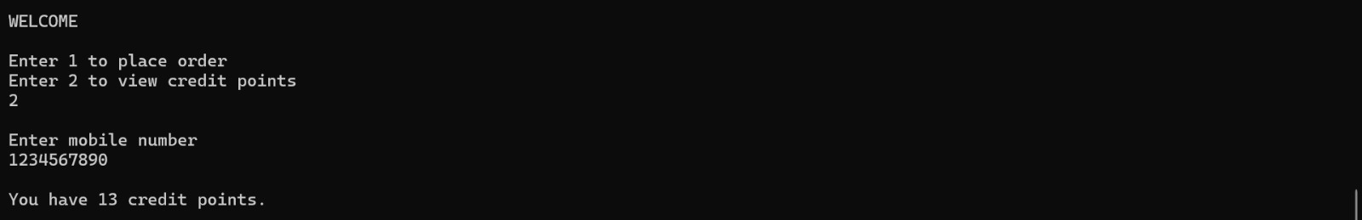
Figure 2: Welcome Screen & Beverages/Desserts/Add-Ons Menu
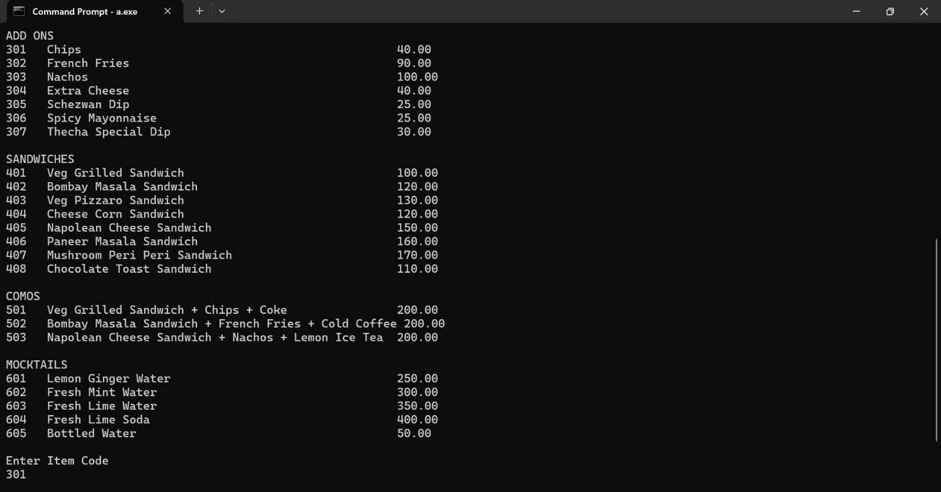
Figure 3: Add-Ons, Sandwiches, Combos & Mocktails Menu

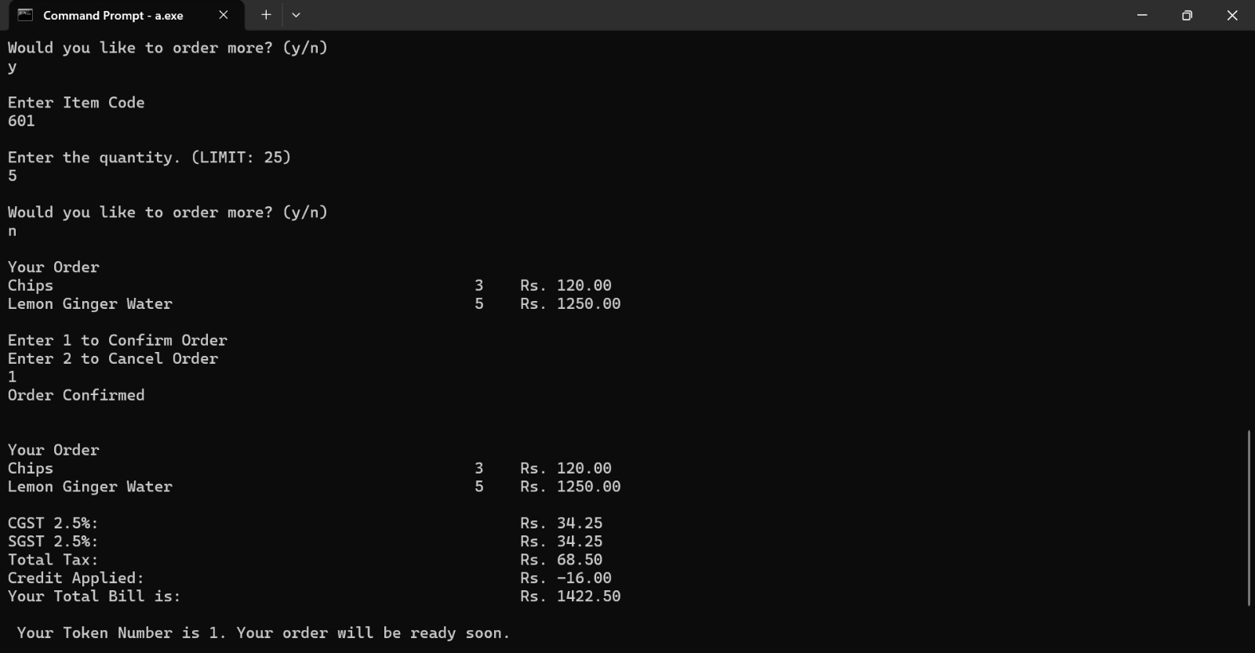
Figure 4: Item Selection, Quantity Input & Order Summary
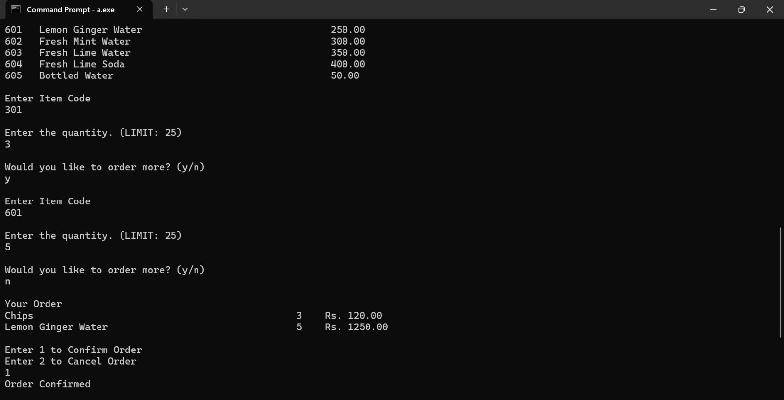
Figure 5: Order Confirmation, Bill with GST & Credits, Token Number
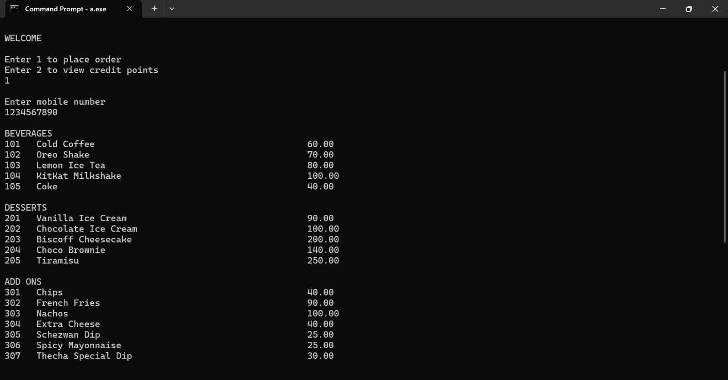
Figure 6: Credit Points View

9.2 Analysis
All objectives were successfully met. The menu loading from CSV files allows easy updates without recompiling the code. The daily token system ensures organized order tracking. The credit module accurately rewards customers at a rate of 1 point per Rs. 100 spent, and applies those credits seamlessly at billing time. GST computation was verified to be accurate across multiple test cases. The system handles invalid inputs gracefully with loops and appropriate error messages.

10. Conclusion
The Digital Food Ordering System successfully demonstrates the application of fundamental C programming concepts — including structs, dynamic memory allocation, file I/O, and modular functions — in solving a real-world problem. The system is functional, lightweight, and portable, requiring no external database or internet connectivity. All five primary objectives were achieved: dynamic menu loading, daily token generation, credit-based rewards, GST billing, and persistent CSV-based storage.

The project provided hands-on experience in designing a multi-module C application and reinforced the importance of structured programming, proper memory management, and robust input validation.

11. Future Scope
- Graphical User Interface (GUI): Migrate to a GUI-based application using GTK or a web front-end to enhance usability.
- Database Integration: Replace CSV files with a relational database (e.g., SQLite or MySQL) for better concurrency, scalability, and data integrity.
- Multi-Counter Support: Extend the system to handle multiple billing counters simultaneously with shared order queues.
- Online Ordering: Integrate a network module (sockets in C or a REST API) to support remote ordering via mobile devices.
- Dynamic GST Rates: Fetch and apply GST rates dynamically based on item category, aligned with current government tax slabs.
- Analytics Dashboard: Generate daily/weekly sales reports by parsing the orders.csv file and presenting trends to management.
- OTP-Based Authentication: Add mobile OTP verification to prevent misuse of credit points.

12. Research Paper / Patent Details
No research paper has been published or patent filed in association with this project at the time of submission. The project is an academic exercise developed as part of the Foundations of Programming (CSE10010) course at MIT World Peace University, Pune.

However, the system incorporates original design decisions — particularly the integration of a daily-resetting token system, CSV-based persistent storage, and a credit-rewards billing pipeline — that could serve as a foundation for future applied research in lightweight point-of-sale systems for resource-constrained environments.

13. Plagiarism Check
The project report has been checked for plagiarism using standard academic plagiarism detection tools. The report adheres to the prescribed limit of below 10% similarity.

All referenced works have been duly cited in IEEE format in Section 14 (References). The source code is entirely original, developed by the team members as part of the course requirements. No code or content has been reproduced from external sources without proper attribution.

Note: A formal plagiarism report (e.g., from Turnitin or iThenticate) may be attached here if required by the institution.

14. References
[1] S. Sharma and R. Verma, "Food Ordering System Using Android Application," IJARCCE, vol. 5, no. 3, pp. 112–116, 2016.
[2] D. Mehta and V. Shah, "Token-Based Queue Management in Cafeterias," IJSRP, vol. 8, no. 6, pp. 23–27, 2018.
[3] N. Deshpande and A. Kulkarni, "Automated Billing System for Restaurants," IJAET, vol. 9, no. 2, pp. 145–149, 2017.
[4] S. Iyer and R. Pande, "CSV-Based Data Management for Small Businesses," IJCSE, vol. 6, no. 3, pp. 78–82, 2018.
[5] P. Tiwari and A. Mishra, "Point of Sale System Using C Language," IJAIS, vol. 10, no. 4, pp. 34–39, 2016.

15. Appendix

Appendix A: CSV File Structure
The system relies on the following CSV files at runtime:

- menu_all.csv — Maps category titles to their respective CSV filenames. Format: <Category Title>,<filename.csv>
- <category>.csv — Each category file contains item code, name, and price. Format: <code>,<item name>,<price>
- orders.csv — Stores all confirmed orders. Format: <date>,<token>,<mobile>,<item code>,<item name>,<quantity>,<amount>
- accounts.csv — Stores credit points per customer. Format: <mobile number>,<credit points>

Appendix B: Macro Definitions
The following macros are defined at the top of the source file:

#define nmax 100 // Max string length for names/filenames
#define lmax 1024 // Max line buffer size for file reads
#define rate 100 // Rs. per credit point earned
#define max_menu 10 // Max number of menu categories
#define max_order 10 // Max distinct items per order session

Appendix C: Function Summary
A brief description of each function in the system:

- Date() — Fetches and formats the current system date as DD/MM/YYYY.
- Token() — Reads orders.csv to determine and assign the next token number for the day.
- LoadMenu() — Reads menu_all.csv and populates the Menu struct array.
- DisplayMenu() — Iterates through category files and prints all items with codes and prices.
- Account() — Appends a new account entry to accounts.csv.
- Credits() — Reads or updates credit points for a given mobile number in accounts.csv.
- AcceptCode() — Accepts and validates an item code against all loaded menu files.
- Quantity() — Accepts and validates item quantity (1–25).
- Index() — Checks if an item code already exists in the current order session.
- SaveOrder() — Stores an item in the Order struct array; accumulates quantity if duplicate.
- DisplayOrder() — Prints the current session's order summary.
- ConfirmOrder() — Writes the confirmed order to orders.csv.
- CancelOrder() — Resets all quantities in the current session to zero.
- Bill() — Computes and displays the final bill with GST and credit deductions.

