**Creating Lighting Based Project in Salesforce**

Introduction

In this project you experiment with the basic concepts of Lightning Web Components by creating an app that lets park rangers track bears.

In this project you work for Ursus Park, a fictitious national park. The application you create allows rangers to track bears that are wandering in the park.

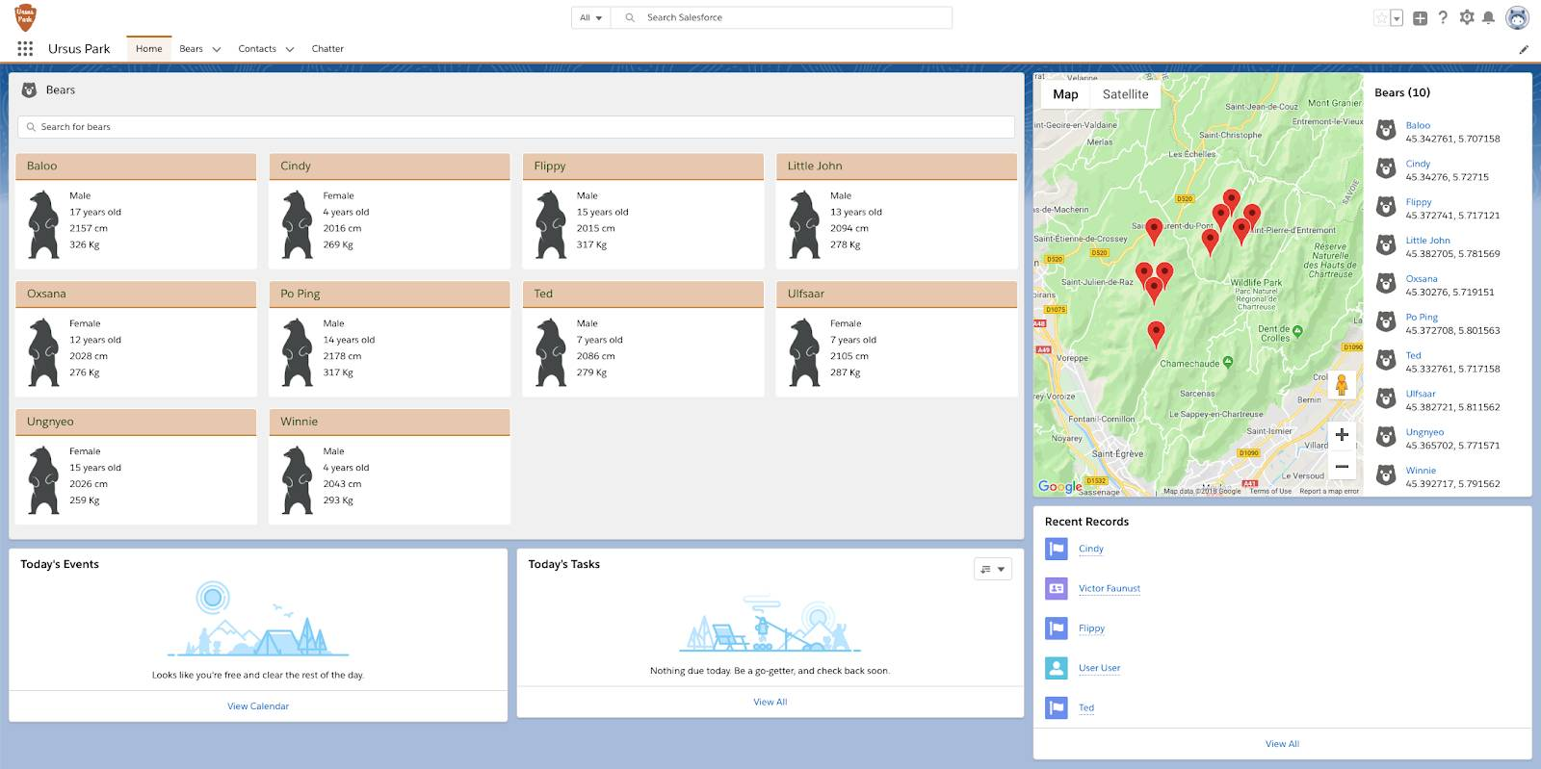

Authorize your Salesforce with the Salesforce CLI, save it with a bear-trackingalias and set the current user as the default user:

sfdx auth:web:login -s -a bear-tracking1

When a browser window with the Salesforce login page opens, enter your Salesforce credentials.

Deploy the app code to the org.

sfdx force:source:deploy -p force-app/main/default

Assign the Ursus Park User permission set to the current user.

sfdx force:user:permset:assign -n Ursus_Park_User

Import the sample data.

sfdx force:data:tree:import -p data/plan.json

Open the org in a browser.

sfdx force:org:open

From the App Launcher ( App Launcher), find and select Ursus Park. This opens the Lightning application.

Click the Bears tab and ensure that it’s populated with some sample data.

To retrieve custome object into visual studio

sfdx force:source:retrieve -m CustomObject:Sample__c

To retirve specific project in visual studio

sfdx force:source:retrieve -u Org -x ./package.xml

