What is Git?
- Git is the version control software.

What is GitHub?
- GitHub is where you host your projects online.

How to create git account in windows?
- The "Git account" is actually a GitHub account, which is a popular web-based hosting service for Git repositories.

- To start, you will create a free account on the GitHub website.

Step 1: Create a GitHub account
- Navigate to the GitHub website in your browser by going to https://github.com.
- Click the Sign up button in the top-right corner of the page.
- Enter your email address and click Continue.
- Create a strong password for your account and a unique username. Your username will be publicly visible and appear on your projects.
- Answer the on-screen prompts and solve the puzzle to verify that you are not a robot.
- A launch code will be sent to the email address you provided. Enter this code to verify your account.
- After confirming, you will be asked a few questions to tailor your experience. You can choose a free plan and skip any personalization questions.
Step 2: Install Git
To use your GitHub account with your local Windows PC, you need to install the Git command-line tools.
- Go to the official Git website at https://git-scm.com/download/win.
- Click the link to download the latest version for Windows.
- 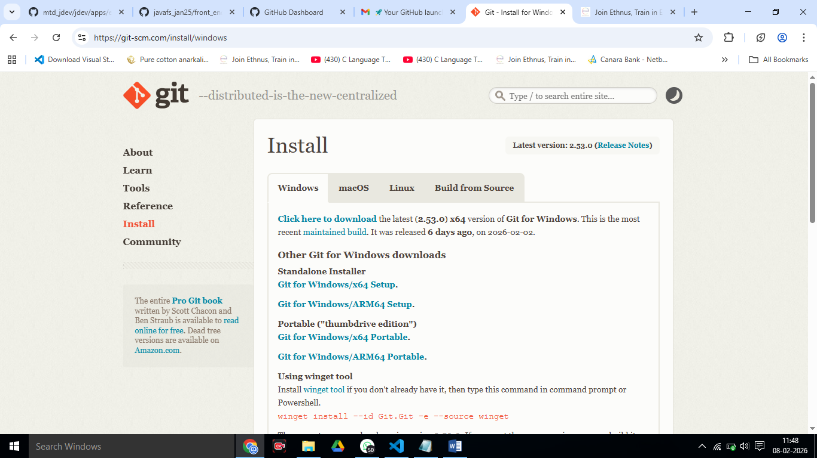
- Run the downloaded installer and follow the prompts. The default options are generally recommended for most users.
- Before clicking the Finish button -> select Launch Git Bash and click finish button.
- The Git installer includes a tool called Git Bash, which provides a Unix-like command-line interface for running Git commands on Windows.
- GIT Bash .
- 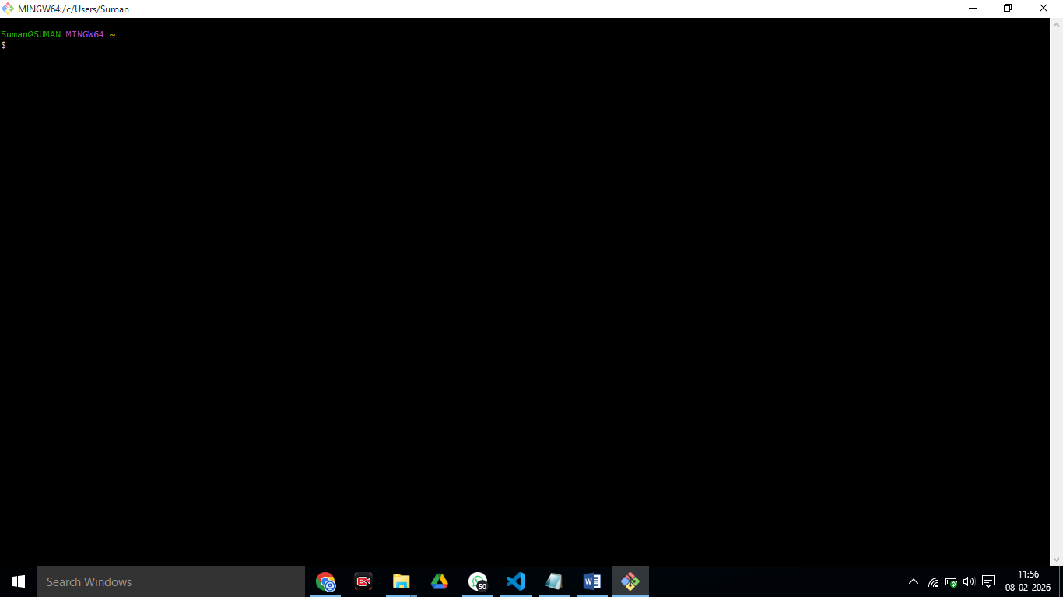

Step 3: Configure Git with your account
- After installation, open Git Bash from your Start Menu.
- Set your username and email address. This information will be attached to your commits so they are associated with your GitHub account.
  - Type the following command, replacing the name with your own:
  - $ git config --global user.name "Your Name"
  - Type the next command, replacing the email with your own:
  - $ git config --global user.email "your_email@example.com"

======================================================

Step 4: Use your GitHub account
You can now start using Git on your Windows PC and connect it to your new GitHub account.
- Create a new project:
  - Create a new repository on GitHub.com and then clone it to your computer. or
  - You can either initialize a new Git repository locally using git init
- reate a new repository on GitHub.com.
- Click on create new proect
- Provide details like name of the proect like “React_Java_Mongo_FullStack_Project”
- Then create new file. Type something about project in it and give name to your file ”Proect_notes”.
- Click on “commit changes” button.
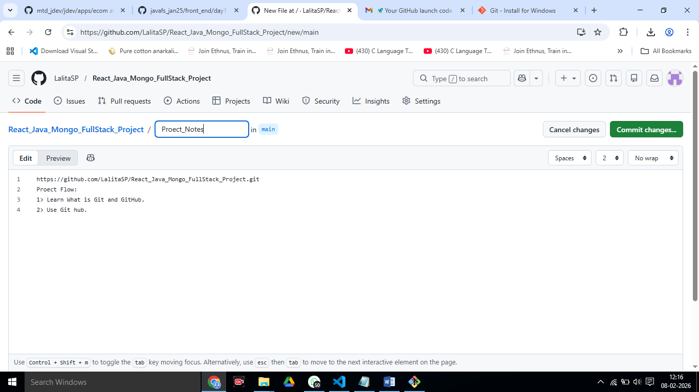
Next

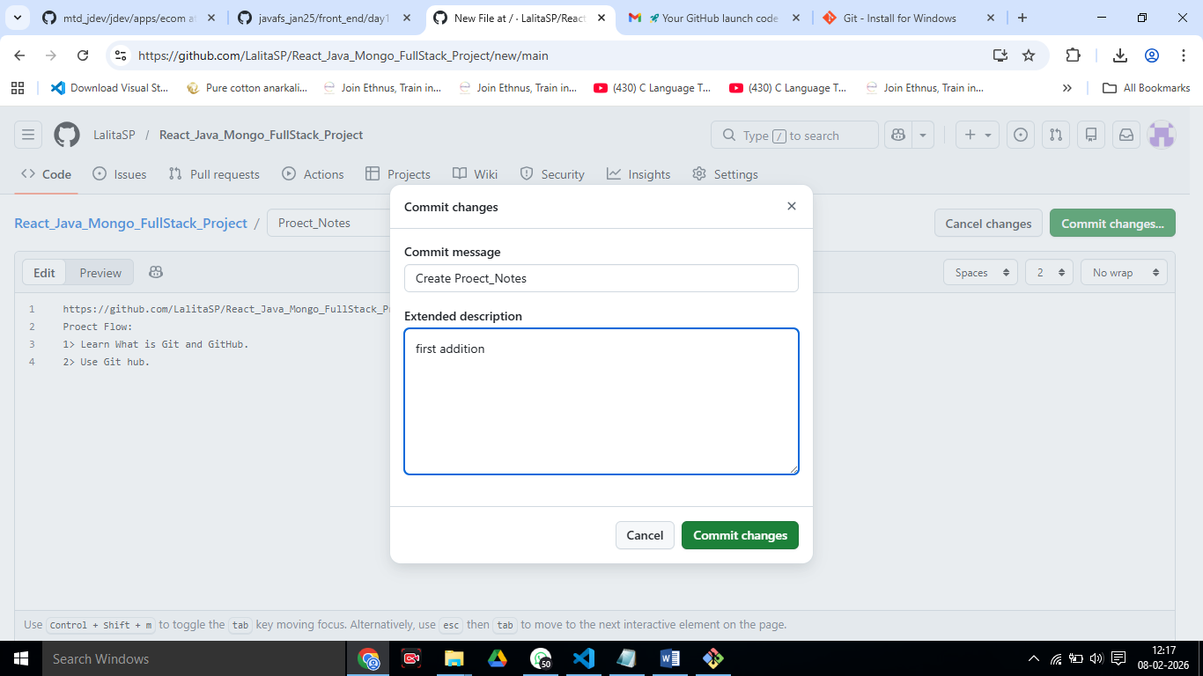

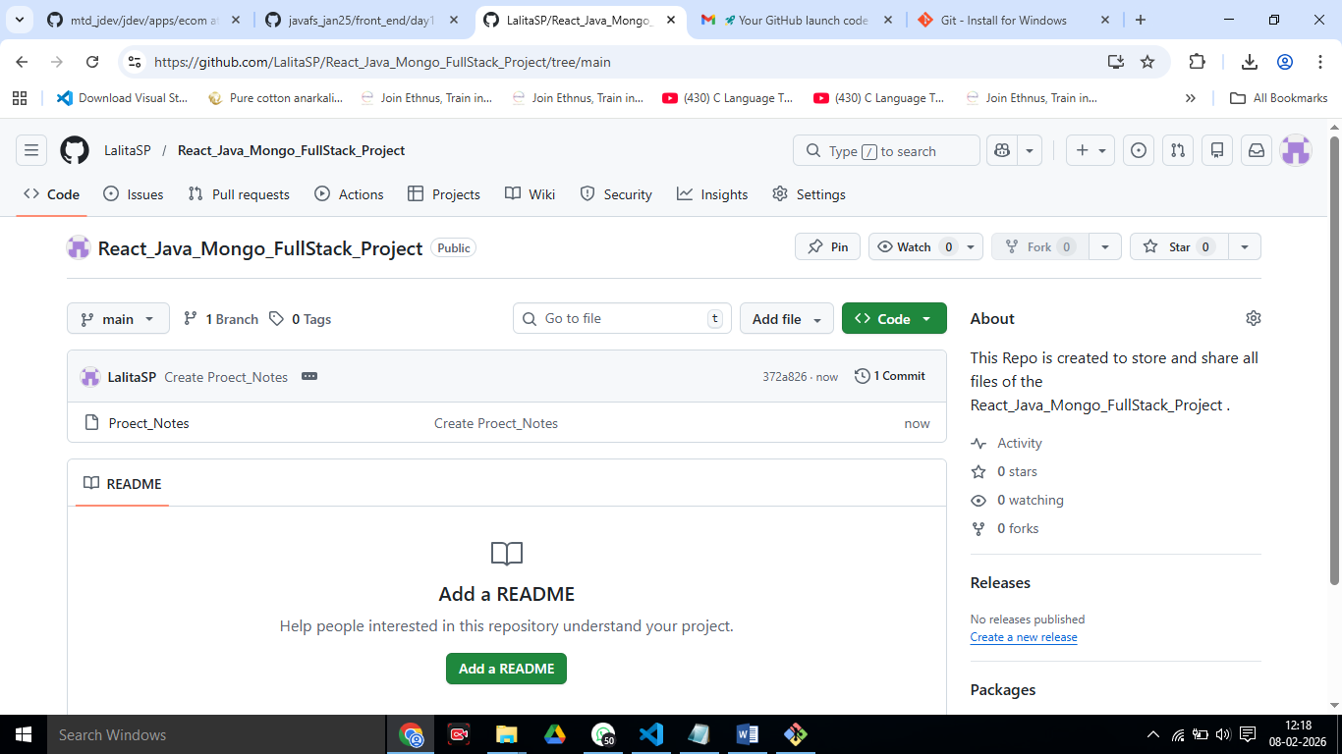
==================================================================
Clone this project repo to your computer folder:
Step 1: Copy Your GitHub Repository URL
- Open your GitHub repository in browser
- Click the green “Code” button
- Copy the HTTPS link
Example:
==========================================================================

Step 2: Open Folder Where You Want the Project
- Go to the folder where you want to keep your project
Example: D:\Projects
- Right-click inside the folder
- Click “Open Git Bash here”

Now we can use Git Commands to use our git project repo.

Step 4: Clone the Repository

Real-Life Analogy :
Think of GitHub repo like a Google Drive folder
Cloning = Downloading the full folder to your computer
In Git Bash, type:
git clone https://github.com/your-username/your-repo-name.git

cloning to…..
Paste your actual link here
Press Enter then This will create a folder with your repo name inside that directory

Step 5: Check if It Worked
Type:
ls
You should see your project folder name
Now open it:
cd your-repo-name <React_Java_Mongo_FullStack_Project>

then type

>ls

It will show the file you ceated in git repo.

Congratulations you have successfully CLONED Your Git Repo Project !!!!
=========================================================

How to Add a New File to Git Repo (from Git Bash) ?
Assume you already cloned your repo and are inside the project folder.

Step 1: Go to Your Project Folder
cd your-repo-name this is done already..
--------------------------------------------------------------

Step 2: Create a New File
Example (some text file):
$ touch notes.txt
On Windows, you can also create file normally using Notepad.

Step 3: Add Content to File
- Open and edit:
$notepad notes.txt
- notepad will open : Type in file some text.
- Save and close.
----------------------------------------------------------------------------------------

Step 4: Check Status (Very Important Habit)
git status
You’ll see:
Untracked files:
Notes.txt
------------------------------------------------------------------------------------------

Step 5: Add File to Git Staging Area
- git add Notes.txt

- Or add all files:using below command.
- git add .
---------------------------------------------

Step 6: Commit the File (Save Snapshot)
git commit -m "Added Notes.txt file"
The file will be added and below lines will be displayed:
ck_Project (main)
$ git commit -m "Added Notes.txt file"
[main a8ceb93] Added Notes.txt file
1 file changed, 1 insertion(+)
create mode 100644 Notes.txt

Step 7: Push to GitHub
- git push origin main
Now refresh GitHub page — your file will be there !!!!!!!!!!!!!!!!
This command will authenticate for pushes: When you push your code to GitHub for the first time, a pop-up window will ask you to log in with your GitHub credentials. The Git Credential Manager will securely store your login token so you won't need to sign in again for future pushes.
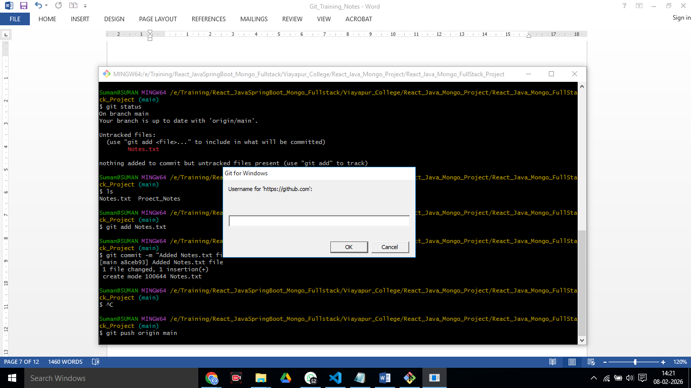
=================================================================================

GitHub Personal Access Token (PAT)

What is GitHub Personal Access Token (PAT)?
Think of PAT as a special key to your GitHub account — but safer than a password.
A Personal Access Token (PAT) is a secure replacement for your GitHub password when using:
- Git commands (push, pull, clone)
- VS Code Git sync
- APIs
- Automation (CI/CD)
It looks like this: It will look like: ghp_xxxxxxxxxxxxxxxxxxxxx
================================================================================

Why Do We Use PAT Instead of Password?
GitHub stopped allowing password login for Git operations.
So this fails :
Username: yourname
Password: your GitHub password
You must use PAT instead :
Username: yourname
Password: ghp_xxxxxxxx (token)

Reasons GitHub uses PAT:

Reason | Explanation

- More secure | - Token can be limited to repo access only

- Can expire | - You can set expiry date

- Can be revoked | - If leaked, you can disable it

- Limited permissions | - Token can access only what you allow

- Safer for automation | - Used in scripts & CI tools

==========================================================================

When Do You Need to Use PAT?
You’ll need PAT when:
Action | PAT needed?
git push | Yes
git pull (private repo) | Yes
Clone private repo | Yes
VS Code Git sync | Yes
Using GitHub API | Yes
Opening public repo | No
Cloning public repo | No (usually)

Use GitHub Token Instead of Password

Step 1: Create a GitHub Token (One-time)
- Open GitHub → Click your profile pic (top-right)
- Go to Settings
- Scroll down → Developer settings
- Click Personal access tokens → Tokens (classic)
- Click Generate new token (classic)
- Give name:
- windows-git
- Expiry: choose 90 days or No expiration
- Tick this box only: repo
10. Click Generate token
It will look like: ghp_xxxxxxxxxxxxxxxxxxxxx
IMPORTANT:
Copy the token immediately (you won’t see it again!)
Immediately send this Token to your email id instead or storing somewhere in file.

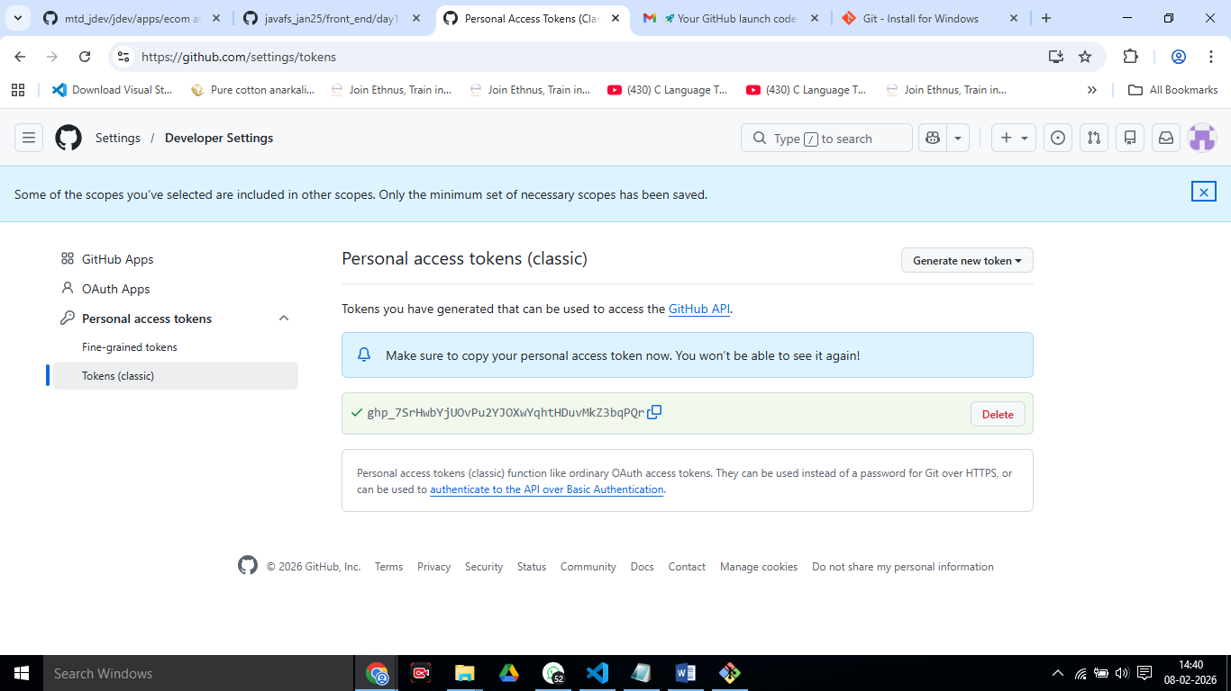

Step 2: Push Again (Use Token as Password)
Now in Git Bash:
$ git push origin main
It will ask:
Username: your-github-username
Password:
Enter:
- Username: <your name>
- Password: PASTE THE TOKEN (not your GitHub password)
It will push successfully
=====================================================

Step 3: Save Login (So You Don’t Repeat This)
Run:
git config --global credential.helper manager
Now Git will remember your token in Windows
=================================================

Why GitHub Did This?
Passwords are weak & unsafe for Git operations
Tokens are:
✔ more secure
✔ can be revoked
✔ limited permissions

===================

Most Important Git Commands (Cheat Sheet)
Command | Purpose
git --version | Check Git installed
git clone <url> | Download repo
git status | Check file status
git add <file> | Add file to staging
git add . | Add all files
git commit -m "msg" | Save changes
git push | Upload to GitHub
git pull | Download latest changes
git log | Show commit history
git diff | See changes
git branch | Show branches
git checkout <branch> | Switch branch
git checkout -b newBranch | Create new branch
git rm <file> | Delete file
git mv old new | Rename file
git remote -v | Show repo URL
git reset --hard HEAD | Undo all changes (⚠ dangerous)

Mini Example (Real Workflow)
touch main.c
notepad main.c
git status
git add main.c
git commit -m "Add main program"
git push origin main
=========================================================================

How to Pull Files from GitHub to Your Local Folder?
(Pull = download latest changes from GitHub → into your PC)

Step 1: Go Inside Your Repo Folder
cd your-repo-name
(If you’re already not there…)
------------------------------------------------------------

Step 2: Check Current Status (Optional but smart)
git status
If you see:
working tree clean
$ git status
On branch main
Your branch is up to date with 'origin/main'.

nothing to commit, working tree clean

You’re good to pull.
-----------------------------------------------

Step 3: Pull Latest Code from GitHub
$ git pull origin main
This will download new files + updates made on GitHub or by teammates.
How to check this ?

Got to git repo folder in website. Type something in Notes.txt file and commit it..
=====================================================

Example Output (Success)
Updating a1b2c3..d4e5f6
Fast-forward
new file: api.js
Now refresh your folder — files will appear locally

When Do You Use git pull?
Use git pull when:
✔ You edited files directly on GitHub website
✔ Your teammate pushed new code
✔ You switched PC
✔ You want latest version before starting work
============================================================================

Common Errors & Fixes

Error: “Your local changes would be overwritten by merge”
You changed files locally and didn’t commit.
Fix (safe way):
git add .
git commit -m "Save my local work"
git pull origin main
OR discard local changes (⚠ deletes your work):
git reset --hard
git pull origin main

Error: “Already up to date”

Super Easy Mental Model
git pull = download updates
git push = upload your changes
Like WhatsApp:
pull = receive messages
push = send messages

Mini Cheat Flow (Daily Routine)
git pull origin main # before starting work
...code...
git add .
git commit -m "My changes"
git push origin main # after finishing work

===================================================================

