Java Programming…
What is Java?

- Java is an Object-Oriented programming language, originally developed by James Gosling at Sun Microsystems and released in 1995 (which has since merge into Oracle Corporation).

- Java programs are platform independent which means they can be run on any operating system with any type of processor as long as the Java interpreter is available on that system.

- Java code that runs on one platform does not need to be recompiled to run on another platform, it’s called “write once, run anywhere” (WORA).

- Java Virtual Machine (JVM) executes Java code, but is written in platform specific languages such as C/C++/ASM etc. JVM is not written in Java and hence cannot be platform independent and Java interpreter is actually a part of JVM.

- Java is robust technology widely used to develop application software.

Where is Java being used?
- Earlier java was only used to design and program small computing devices but later adopted as one of the platform independent programming language and now according to Sun, 3 billion devices run java.
- Java is one of the most important programming language in today’s IT industries.

- JSP – Java is used to create web applications like PHP and ASP, JSP (Java Server Pages) used with normal HTML tags, which helps to create dynamic web pages.
- Applets – This is another type of Java program that used within a web page to add many new features to a web browser.
- J2EE – The software Java 2 Enterprise Edition are used by various companies to transfer data based on XML structured documents between one another.
- JavaBeans – This is something like Visual Basic, a reusable software component that can be easily assembled to create some new and advanced application.
- Mobile – Besides the above technology, Java is also used in mobile devices, many kind of games and services built-in Java. Today, all leading mobile service provider like Nokia, Siemens, Vodafone are using Java technology.
Types of Java Applications
- Web Application : Java is used to create server-side web applications. Currently, servlet, jsp, struts, jsf etc. technologies are used.
- Standalone Application : It is also known as desktop application or window-based application. An application that we need to install on every machine or server such as media player, antivirus etc. AWT and Swing are used in java for creating standalone applications.
- Enterprise Application: An application that is distributed in nature, such as banking applications etc. It has the advantage of high level security, load balancing and clustering. In java, EJB is used for creating enterprise applications.
- Mobile Application: Java is used to create application software for mobile devices. Currently Java ME is used for creating applications for small devices, and also Java is programming language for Google Android application development.
Features of Java
- Object Oriented – In java everything is an Object. Java can be easily expanded since it is based on the Object model.
- Platform independent – C and C++ are platform dependent languages hence the application programs written in one Operating system cannot run in any other Operating system, but in platform independent language like Java application programs written in one Operating system can able to run on any Operating system.
- Simple – Java is designed to be easy to learn. If you understand the basic concept of OOP java would be easy to master.
- Secure – With Java’s secure feature it enables to develop virus-free, tamper-free systems. Authentication techniques are based on public-key encryption.
- Architectural- neutral – Java compiler generates an architecture-neutral object file format which makes the compiled code to be executable on many processors, with the presence of Java runtime system.
- Portable – being architectural neutral and having no implementation dependent aspects of the specification makes Java portable. Compiler and Java is written in ANSI C with a clean portability boundary which is a POSIX subset.
- Robust – Java makes an effort to eliminate error prone situations by emphasizing mainly on compile time error checking and runtime checking.
- Multi-threaded – With Java’s multi-threaded feature it is possible to write programs that can do many tasks simultaneously. This design feature allows developers to construct smoothly running interactive applications.
- Interpreted – Java byte code is translated on the fly to native machine instructions and is not stored anywhere. The development process is more rapid and analytical since the linking is an incremental and light weight process.
- High Performance – With the use of Just-In-Time compilers Java enables high performance.
- Distributed – Java is distributed because it facilitates users to create distributed applications in Java. RMI and EJB are used for creating distributed applications. This feature of Java makes us able to access files by calling the methods from any machine on the internet.
- Dynamic – Java is considered to be more dynamic than C or C++ since it is designed to adapt to an evolving environment. Java programs can carry an extensive amount of run-time information that can be used to verify and resolve accesses to objects on run-time.
- Different Editions of Java Technology
- Java SE – Java SE or Java Standard Edition provides tools and API’s that you can use to create server applications, desktop applications, and even applets. These programs developed using Java SE can be run on almost every popular operating system, including Linux, Macintosh, Solaris, and Windows.
- JEE – Based on the foundation framework of the standard edition, Java Enterprise Edition helps in web application service, component model and enterprise class service oriented architecture (SOA).
- JME – Java Micro Edition or JME for short is an accumulation of Java APIs that are used for the development of software for devices like mobile phones, PDAs, TV set-top boxes, game programming.
- The platform of micro edition generally consists of an easy user interface, a robust security model and a wide variety of built-in networks for running Java based application.
- What you will need to run Java ?
- You will need the Java software development kit of JDK (Java Development Kit from
- https://www.oracle.com/technetwork/java/javase/downloads/index.html
- Follow the instructions on website to install it.
- Make sure that you add the java bin directory to your PATH environment variable.

Java Programming Structure
It is necessary to know the exact structure of the Java program. There may be many classes in the Java program, only one class defines the main method. Methods contain data type declaration and executable statements.
Example 1:
public class Hello
{
public static void main(String[] args)
{
System.out.println("Hello Java");
}
}
Program Output:
Hello Java
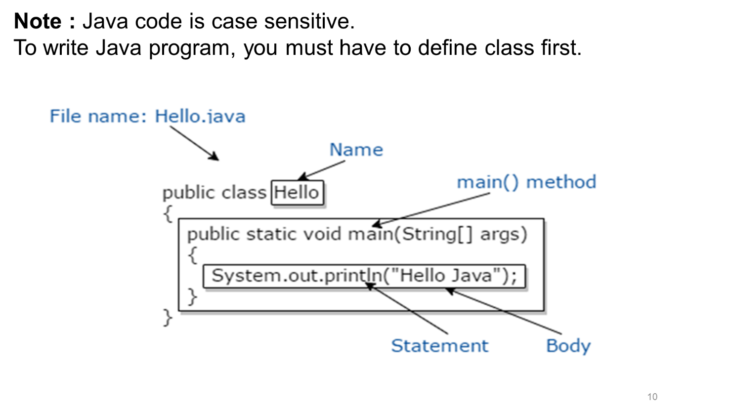

public class Hello
- The class keyword is used to declare a class in java. This creates a class called Hello. All class names required to start with a capital letter.
- The keyword public is an access modifier/specifier which represents visibility. Public means that it is accessible by any other classes.
{…}
- The 2 curly brackets are used to group all the commands together so it
is known that the commands belong to that class.
public static void main
- The word public means that it is accessible by any other classes.
- The word static is a keyword. If we declare any method as static, it is known as the static method. The core advantage of the static method is that there is no need to create an object to invoke the static method.
- Here the main method is executed by the JVM, so it doesn't require to create an object to invoke the main method. So it saves memory.
- The keyword void is the return type of the method. It means it doesn't return any value.
- main is a method where the program execution starts.
- Notice that the main method code has been moved to some spaces left. This is called indentation which used to make a program easier to read and understand.
- String[] args is used for command line argument. Here ‘args’ is string array that is used to store variable length string arguments.
System.out.println();
- System is a final class name and cannot be instantiated. Therefore all its members (fields and methods) will be static
- out is static member in System class which is instance of java.io.PrintStream.
Its access specifiers are public final. This gets instantiated during startup and gets mapped with standard output console of the host.
- println method prints text on the screen with newline. There are multiple println methods with different arguments (overloading). Every println makes a call to print method and adds a newline. print calls write() method.
- The data that is to be printed is put inside brackets. The words in inverted are called a string. Each letter is a character and a series of characters grouped together is called a string.
How to edit compile a java file using javac command.

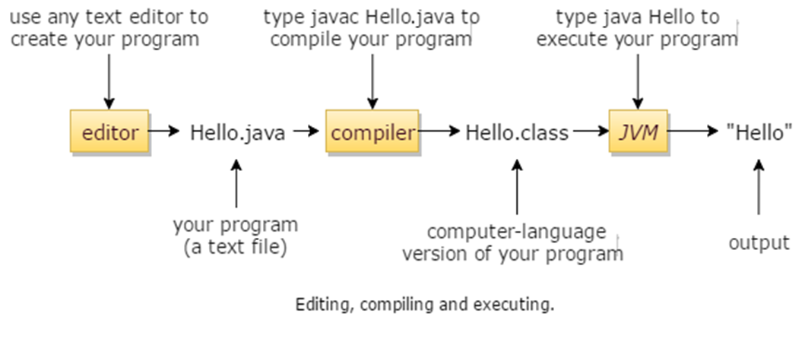

Java Development Kit (JDK)
JDK (Java Development Kit) includes a complete JRE (Java Runtime Environment) plus tools for developing, debugging, and monitoring Java applications. JDK is needed to develop Java applications and applets as well as run them.
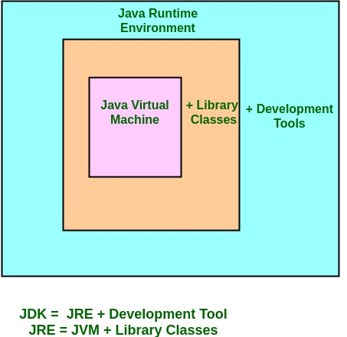
JVM – Java Virtual Machine
- The Java Virtual Machine is called JVM, is an abstract computing machine or virtual machine interface or engine that drives the java code.
- In other Programming Languages, compiler produce code for a particular system but Java compiler produce Bytecode for a Java Virtual Machine.
- Bytecode is an intermediary language between Java source and the host system.
- It is the medium which compile java code to bytecode which get interpret on different machine and hence it makes it Platform/Operating system independent.
JVM – Java Virtual Machine
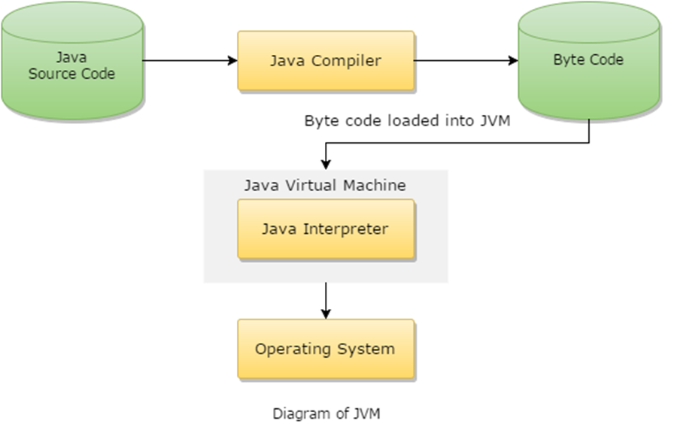

- JVM generates a .class(Bytecode) file, and that file can be run in any OS, but JVM should have in OS, because JVM is platform dependent.
- Platform Independent: Java is called platform independent because of Java Virtual Machine. As different computers with different operating system have their own JVM, when we submit ‘.class‘ file to any operating system, JVM interpret the bytecode into machine level language.
- JVM is the main component of Java architecture and it is the part of the JRE (Java Runtime Environment).
- A program of JVM is written into “C Programming Language” and JVM is Operating System dependent.
- JVM is responsible to allocate the necessary memory needed by the java program.
- JVM is also responsible to de allocate a memory space.

Access Modifiers in Java
- Default – No keyword required
- Private
- Protected
- Public

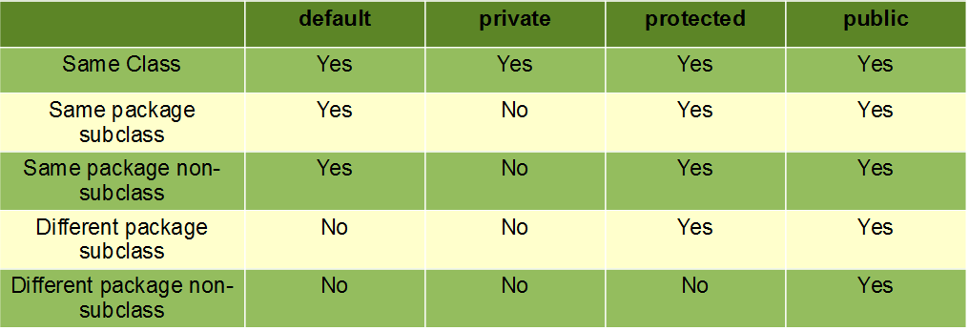
All Access Modifiers in one Program:
public class AccessModifierDemo {
public static void main(String[] args) {
SavingsAccount myAcc = new SavingsAccount();

System.out.println("--- Main Class Access ---");
// Public access
System.out.println("Bank Name: " + myAcc.bankName);
// Default access (Works here because we are in the same package)
System.out.println("Current Balance: $" + myAcc.balance);
// Protected access
System.out.println("Support Line: " + myAcc.backupContact);
// Private access check
myAcc.showPrivateData(); // Indirect access via public method

// System.out.println(myAcc.atmPin);
// UNCOMMENT ABOVE LINE TO SEE COMPILER ERROR: atmPin has private access

System.out.println("\n--- Triggering Subclass Display ---");
myAcc.displayMemberInfo();
}
}
class BankInfo {
// 1. PUBLIC: Accessible from anywhere
public String bankName = "Global Vibe Bank";
// 2. PRIVATE: Accessible ONLY inside this class
private String atmPin = "1234";
// 3. PROTECTED: Accessible in same package AND by subclasses
protected String backupContact = "+1-800-VIBE-BANK";
// 4. DEFAULT (No keyword): Accessible ONLY in the same package
double balance = 5000.0;
// Method to show private access inside the class
public void showPrivateData() {
System.out.println("Accessing Private PIN (Inside Class): " + atmPin);
}
}
// Subclass to demonstrate Protected access
class SavingsAccount extends BankInfo {
public void displayMemberInfo() {
System.out.println("--- Subclass Access ---");
System.out.println("Public Bank Name: " + bankName); // OK
System.out.println("Protected Contact: " + backupContact); // OK
System.out.println("Default Balance: " + balance); // OK (same package)
// System.out.println(atmPin); // ERROR: Private access
}
}
Output:
--- Main Class Access ---Bank Name: Global Vibe BankCurrent Balance: $5000.0
Support Line: +1-800-VIBE-BANK
Accessing Private PIN (Inside Class): 1234---
Triggering Subclass Display ------
Subclass Access –
Public Bank Name: Global Vibe Bank
Protected Contact: +1-800-VIBE-BANK
Default Balance: 5000.0
Getters and Setters :
To demonstrate Getters and Setters, we use a concept called Encapsulation. This involves keeping class variables private to protect the data and providing public methods (getters and setters) to interact with them safely.
The Logic :
- Private Variables: Restrict direct access from other classes.
- Getter Method: A method that returns the value of a private variable.
- Setter Method: A method that updates or sets the value of a private variable, often including validation logic.
- // Getter for Score
- public int getScore() {
- return score;
- }
- // Setter for Score (with logic to prevent invalid data)
- public void setScore(int newScore) {
- if (newScore >= 0 && newScore <= 100) {
- this.score = newScore;
- } else {
- System.out.println("Invalid score! Please enter a value between 0 and 100.");
- }
- }
- }
- public class Main {
- public static void main(String[] args) {
- Student s1 = new Student();
- // Modifying private data using Setters
- s1.setName("Aakash");
- s1.setScore(95);
- // Accessing private data using Getters
- System.out.println("Student Name: " + s1.getName());
- System.out.println("Student Score: " + s1.getScore());
- // Attempting to set an invalid score
- s1.setScore(150);
- }
- }
- Output
- Student Name: Aakash
- Student Score: 95
- Invalid score!
- Please enter a value between 0 and 100.

Java Interfaces
Java Interface
“An interface is a reference type in Java. It is similar to class. It is a collection of abstract methods. A class implements an interface, thereby inheriting the abstract methods of the interface.”
- Along with abstract methods, an interface may also contain constants, default methods, static methods, and nested types.
- Method bodies in interface exist only for default methods and static methods.
- Writing an interface is similar to writing a class. But a class describes the attributes and behaviors of an object. And an interface contains behaviors that a class implements.
- Unless the class that implements the interface is abstract, all the methods of the interface need to be defined in the class.
- An interface is similar to class in the following ways
- 1.The byte code of an interface appears in a .class file
- 2.An Interface is written in a file with .java extension
- 3.Interfaces may contain any number of methods
- 4.Interfaces can be arranged in packages and the file can be in a directory structure that matches the name of the package
- However, an interface is different from a class in several ways, including −
- You cannot instantiate an interface.
- An interface does not contain any constructors.
- All of the methods in an interface are abstract.
- An interface cannot contain instance fields. The only fields that can appear in an interface must be declared both static and final.
- An interface is not extended by a class; it is implemented by a class.
- An interface can extend multiple interfaces.
- Usage of Interface in Java
- 1.For achieving full data abstraction
- 2.Using Interface, you can use the concept of multiple inheritance
- 3.Interfaces can also be used to achieve loose coupling
- Properties of Interfaces in Java
- 1.Interfaces are implicitly abstract
- 2.Each and every method within an interface is also implicitly abstract
- For the above reason, they do not need to be declared abstract
- 3.All methods of an interface are implicitly public
- Defining Interface
- Interface is defined much like a class. The general form of defining an interface is:
<Access specifier> interface_name{
- return-type method1(parameter list);
- return-type method2(parameter list);
- type final-varName1=value;
- . . . . . . . .
- }

Implementing Interfaces
Once an Interface has been defined, one or more classes can implement that interface. For implementing interface, programmers need to use the clause “implements” in the class definition and then create the method defined by the interface.
If a class implements more than one interface, the interfaces are separated with a comma. In case, a class is used to implement two interfaces that declares the same method, then the same method will be used by clients of either interface.
//Java Program for Interface
interface Animal {
public void eat();
public void travel();
}
When a class implements an interface, you can think of the class as signing a contract, agreeing to perform the specific behaviors of the interface. If a class does not perform all the behaviors of the interface, the class must declare itself as abstract.
A class uses the implements keyword to implement an interface. The implements keyword appears in the class declaration following the extends portion of the declaration.
Example : //Java Program uses Interface
public class MammalInt implements Animal {
public void eat() {
System.out.println("Mammal eats");
}
public void travel() {
System.out.println("Mammal travels");
}
public static void main(String args[]) {
MammalInt m = new MammalInt();
m.eat();
m.travel()
}
}
//Java Program for Interface
interface Animal
{
public void eat();
public void travel();
}
Output :
Mammal eats
Mammal travels
17

