Flight App Workflow:

1. Install Required Software & Tools

1. Install Git
You’ll need Git for version control.
Download: Git
- Install and verify:
git --version

2. Install Apache Maven (Build Tool for Spring Boot)
Download: Apache Maven
After install, check:
mvn –v

What is Maven?
Apache Maven is a project management & build tool for Java.
In simple words:
Maven is the tool that downloads libraries, builds your project, runs tests, and packages your app into a JAR/WAR.
Before Maven, devs had to:
Manually download JAR files
Copy them into project
Manage versions by hand
Deal with “works on my machine” bugs
Maven automates all that.

Why Do We Use Maven in Spring Boot Projects?
Spring Boot projects depend on many libraries:
- Spring Web
- Spring Data JPA
- Jackson (JSON)
- Tomcat
- Validation
- Logging
- Testing
Instead of downloading 30+ JARs manually, Maven does this for you from Maven Central.
So:
Spring Boot + Maven = Automatic dependency management + easy build + easy run.

================================================================== What Problems Does Maven Solve?

Without Maven (Old Style)
project/
├── lib/
│ ├── spring-core.jar
│ ├── spring-web.jar
│ ├── jackson.jar
│ ├── tomcat.jar
│ └── 25 more jars 😵
Problems:
- Version conflicts
- Missing JAR errors
- Team members using different versions
- Hard to upgrade

With Maven (Modern Way)
project/
├── pom.xml 👈 all dependencies listed here
Maven:
✔ Downloads correct versions
✔ Handles transitive dependencies
✔ Keeps versions consistent
✔ Works same on all machines

pom.xml – Heart of Maven
<project>
<dependencies>
<dependency>
<groupId>org.springframework.boot</groupId>
<artifactId>spring-boot-starter-web</artifactId>
</dependency>
</dependencies>
</project>
This single dependency downloads:
✔ Spring MVC
✔ Tomcat
✔ Jackson
✔ Validation
✔ Logging
That’s why Spring Boot feels “one dependency does everything” – Maven handles the rest.---------------------------------------------------------------------------------------------------

What Maven Actually Does in a Spring Boot Project
Task | Maven’s Job
Download Spring libraries | ✔
Manage versions | ✔
Compile Java code | ✔
Run unit tests | ✔
Package JAR/WAR | ✔
Run Spring Boot app | ✔
Build same on every machine | ✔
Command you use daily:
mvn spring-boot:run

How Maven Works Internally (Simple View)
pom.xml
|
v
Maven reads dependencies
|
v
Downloads from Maven Central
|
v
Stores in local .m2 folder
|
v
Builds your Spring Boot project
Local cache:
C:\Users\YourName\.m2\repository
So next time build is faster ⚡

Maven Project Structure (Spring Boot)
flight-app
├── src/main/java 👈 Java code
├── src/main/resources 👈 properties
├── src/test/java 👈 tests
├── pom.xml 👈 Maven config
└── target 👈 build output
Maven enforces this structure, so all Java projects look similar across companies.

Maven Lifecycle (Build Flow)
When you run:
mvn clean install
Maven executes:
clean → compile → test → package → install
Spring Boot uses this lifecycle to:
✔ Compile your controllers/services
✔ Run tests
✔ Package app as JAR
✔ Prepare it for deployment

Step 1: Check Java is Properly Installed
Open Command Prompt and run:
java -version
javac -version
You should see versions printed.
If not, fix Java PATH first (Maven needs Java).

Step 2: Download Maven
Go to the official site: Apache Maven
Download:
Binary zip archive
Example: apache-maven-3.9.x-bin.zip

Step 3: Extract Maven
- Extract the zip file
- Move it to a simple path like:
C:\Program Files\Apache\maven
Final folder looks like:
C:\Program Files\Apache\maven\apache-maven-3.9.x\
Inside you should see:
bin
conf
lib

Step 4: Set Environment Variables (IMPORTANT)

4.1 Set MAVEN_HOME
- Press Windows + R → type:
sysdm.cpl
- Go to Advanced tab → Environment Variables
- Click New (System variables):
Field | Value
Variable | MAVEN_HOME
Value | C:\Program Files\Apache\maven\apache-maven-3.9.x
(Use your exact folder name)

4.2 Add Maven to PATH
In System Variables → Select Path → Edit → New:
%MAVEN_HOME%\bin
Click OK → OK → OK
Restart Command Prompt (important)

Step 5: Verify Maven Installation
Open new Command Prompt and run:
mvn -v
Expected output (example):
Apache Maven 3.9.x
Java version: 17
OS name: Windows 10
If you see this → Maven installed successfully!

Step 6: Test Maven with Your Spring Boot Project
Go to your project folder in terminal:
cd flightapp
mvn clean install
mvn spring-boot:run
If project runs → Maven is working perfectly !!!!!!!!!!!!!!!!!!!

Common Errors + Fix

mvn is not recognized as an internal or external command
Fix:
- PATH not set properly
- Restart terminal
- Check:
echo %MAVEN_HOME%

Java not detected by Maven
Fix:
Set JAVA_HOME:
JAVA_HOME = C:\Program Files\Java\jdk-17
Add to PATH:
%JAVA_HOME%\bin

Bonus (VS Code Integration)
VS Code automatically detects Maven once installed.
You’ll see:
Maven section in Explorer
▶ Run goals
🧩 Dependency tree

If you want, next I can guide you to:
👉 Create Spring Boot project using Maven inside VS Code UI (no website needed)
getting this error C:\Windows\System32>mongod --version 'mongod' is not recognized as an internal or external command, operable program or batch file.
No stress—this is a super common Windows setup hiccup 👍
It just means MongoDB is installed but not added to PATH, so Windows can’t find mongod.
Let’s fix it step-by-step.

How Maven is used in Spring Boot Project
Our project has:
pom.xml
Maven reads this file and:
✔ Downloads dependencies
✔ Builds your project
✔ Runs tests
✔ Packages JAR
✔ Manages versions

3. Install MongoDB Server (Database)
Download: MongoDB from website.
During install:
✔ Select Complete
✔ Enable Install MongoDB as a Service
Verify:
mongod --version
Start MongoDB (if not running):
mongod

4. Install MongoDB Compass (GUI Tool – Optional but Recommended)
Download: MongoDB Compass
Used to visually view Flight records.

5. Install VS Code Extensions

Using Maven in VS Code : Install extension:
Extension Pack for Java
Open VS Code → Extensions (Ctrl + Shift + X) → Install:
- Spring Boot Extension Pack
- Java Extension Pack

[Once SpringBoot project coding is complete Then we can use :
✔ Maven commands available in VS Code sidebar
✔ Right-click → Run Maven
✔ Build Spring Boot projects easily]

2️. Create Spring Boot Project (Backend API)
Go to:
Spring Initializr website
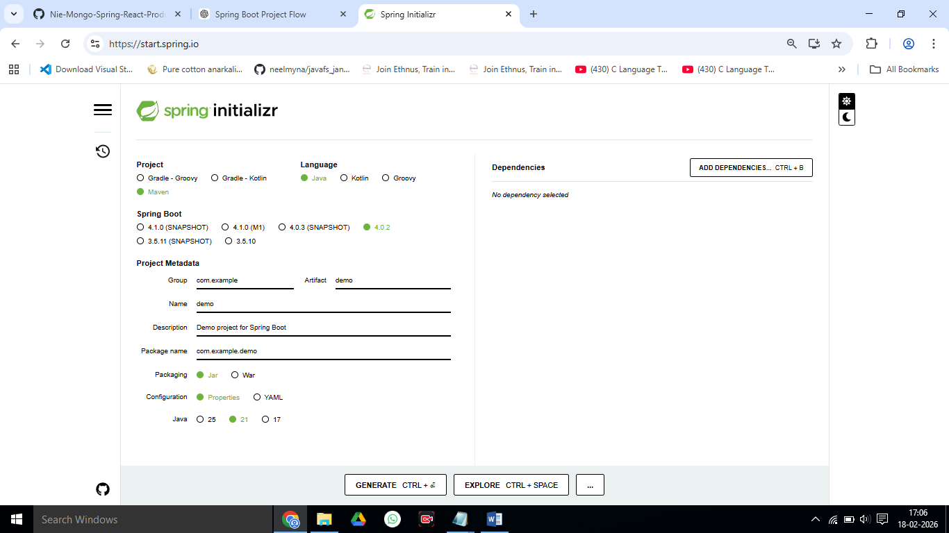
Fill:
Field | Value
Project | Maven
Language | Java
Spring Boot | Latest Stable
Group | com.tata
Artifact | flightapp
Packaging | Jar
Java | Your Java version

Include / select : Dependencies (Important!)
✔ Spring Web
✔ Spring Data MongoDB
✔ Lombok
What are these dependencies used for?

Spring Web
Dependency: spring-boot-starter-web
Used for: Building REST APIs

What it gives:
@RestController, @GetMapping, @PostMapping
Embedded Tomcat server (no manual server install)
JSON support (request/response)
HTTP handling

When we use it:
Whenever we are creating backend APIs for web or mobile apps.

Spring Data MongoDB
(Integration with MongoDB)
Dependency: spring-boot-starter-data-mongodb
Used for: Connecting Spring Boot with MongoDB

What it gives:
✔ MongoRepository for CRUD
✔ @Document mapping
✔ Automatic DB connection
✔ Query methods (findBySource, findByDestination)

When you use it:
When our database is MongoDB (NoSQL) instead of MySQL.

Lombok
Lombok
Used for: Reducing boilerplate Java code

What it gives you:
✔ Auto-generates getters & setters
✔ Constructors
✔ toString(), equals()
✔ Clean entity classes

Example (Without Lombok )
public class Flight {
private int id;
private String source;

public int getId() { return id; }
public void setId(int id) { this.id = id; }
}

With Lombok
@Data
public class Flight {
private int id;
private String source;
}

How These 3 Work Together in Your Project
Client (Browser / Postman)
|
v
Spring Web → REST API (Controllers)
|
v
Spring Data MongoDB → Database operations
|
v
Lombok → Clean model classes (no boilerplate)
============================================================

Click Generate → Download zip → Extract → Open folder in VS Code

3️.Run Project First Time
In VS Code terminal:
mvn spring-boot:run
We can also test in browser:
http://localhost:8080
If it runs without error → backend is alive!
Layer | Naming Style | Example
DB | lowercase | flightdb
Collection | lowercase plural | flights
Java Class | PascalCase | Flight
Field | snake_case or camelCase | flightCode / flight_code

4️. Configure MongoDB Connection
Open:
src/main/resources/application.properties
Add:
spring.data.mongodb.uri=mongodb://localhost:27017/flightdb
spring.data.mongodb.database=flightdb
server.port=8080
Create DB automatically:
mongosh
use flightdb

5. Create Flight Model (Entity)
package com.flightapp.model;

import org.springframework.data.annotation.Id;
import org.springframework.data.mongodb.core.mapping.Document;

@Document(collection = "flights")
public class Flight {

@Id
private String id;
private int flightNo;
private String source;
private String destination;
private double price;

public Flight() {}

public Flight(int flightNo, String source, String destination, double price) {
this.flightNo = flightNo;
this.source = source;
this.destination = destination;
this.price = price;
}

public String getId() { return id; }
public int getFlightNo() { return flightNo; }
public void setFlightNo(int flightNo) { this.flightNo = flightNo; }
public String getSource() { return source; }
public void setSource(String source) { this.source = source; }
public String getDestination() { return destination; }
public void setDestination(String destination) { this.destination = destination; }
public double getPrice() { return price; }
public void setPrice(double price) { this.price = price; }
}

6️. Create Repository (Mongo CRUD)
package com.flightapp.repository;

import org.springframework.data.mongodb.repository.MongoRepository;
import com.flightapp.model.Flight;

public interface FlightRepository extends MongoRepository<Flight, String> {
}

7️. Create Service Layer
package com.flightapp.service;

import java.util.List;
import org.springframework.beans.factory.annotation.Autowired;
import org.springframework.stereotype.Service;
import com.flightapp.model.Flight;
import com.flightapp.repository.FlightRepository;

@Service
public class FlightService {

@Autowired
private FlightRepository repo;

public Flight saveFlight(Flight flight) {
return repo.save(flight);
}

public List<Flight> getAllFlights() {
return repo.findAll();
}

public void deleteFlight(String id) {
repo.deleteById(id);
}
}

8️. Create REST Controller (API Endpoints)
package com.flightapp.controller;

import java.util.List;
import org.springframework.beans.factory.annotation.Autowired;
import org.springframework.web.bind.annotation.*;
import com.flightapp.model.Flight;
import com.flightapp.service.FlightService;

@RestController
@RequestMapping("/api/flights")
@CrossOrigin
public class FlightController {

@Autowired
private FlightService service;

@PostMapping
public Flight addFlight(@RequestBody Flight flight) {
return service.saveFlight(flight);
}

@GetMapping
public List<Flight> getFlights() {
return service.getAllFlights();
}

@DeleteMapping("/{id}")
public String delete(@PathVariable String id) {
service.deleteFlight(id);
return "Flight deleted!";
}
}
9️. Start backend server:
> mvn spring-boot:run
> Check mongoDB is running.
> mongosh

10.Test API (Postman / Thunder Clinet)
Install: Postman

▶ Create Flight (POST)
POST http://localhost:8080/api/flights
Body:
{
"flightNo": 101,
"source": "Delhi",
"destination": "Mumbai",
"price": 5500
}

▶ Get Flights
GET http://localhost:8080/api/flights

10. Recommended Project Structure
com.flightapp
├── Controller
├── Dto
├── Entity
├── Repository
├── Service
└── FlightappApplication.java

Next: Coding up All Java classes in all these above packages:

com.flightapp
├── controller ------>FlightController.java
├── dto ------>FlightDto.java
├── entity ------>Flight.java
├── repository ------>FlightRepository.java
├── service ------>FlightService.java
| ------>FlightServiceImpl.java
└── FlightappApplication.java

