Pyber Analysis

With Bubble plot showing the ride sharing data it is visible from the plot that the driver count is less which can be seen by the pie chart for driver count and this indeed effects the average fare and total rides per city .The overall fare is thus very high in the rural type.

The suburban follows the rural type with average fare being high, also it can be seen that the number of rides and the average fare is nearly in proportion even with lesser driver count.

The trend observed in Urban shows even with surplus drivers the average cost per trip has come down and the total number of rides also has reduced despite high driver count.

The analysis shows that average fare per city is less in Urban area tough the driver count and no of rides are more as compared to suburban and Rural cities, the analysis however can be further improved if the parameters like distance travelled.

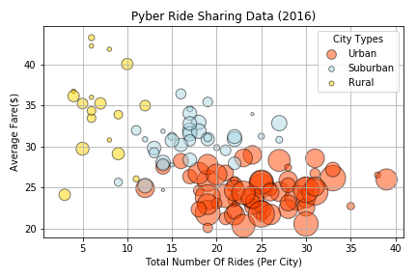

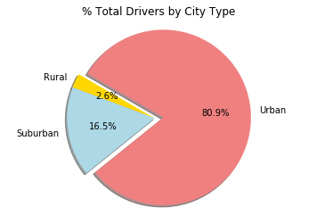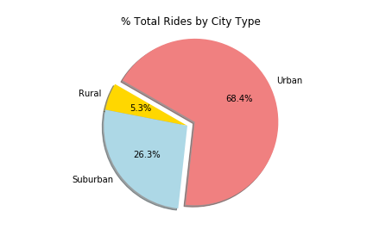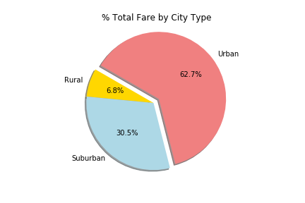

Pymaceuticals Analysis

In this study, 250 mice were treated through 11 varieties of drugs over the course of 45 days and physiological responses was monitored over the course of that time. Data shows four drugs Capomulin, Infubinol, Ketapril, and Placebo analyzed on the basis on tumor volume change , metastatic response and the survival rate.

The Mice tumor volume change is found least effective with Capomulin and the most effective being Ketapril over the course of 45 days and also during the course of treatment.

The metastatic response or metastatic spread with the usage of Capomulin was least in percentage followed by Infubinol,Ketapril and Placebo

Finally the survival rate over the course of 45 days was found highest with Capomulin and was least with Infubinol.With above criteria Capomulin could be selected on the basis of survival rate also on the basis of metastatic spread .

