**COGNIZANT**

**Week-1 Hands on**

**Assignments**

**Design patterns and principles,**

**Data structures and Algorithm**

**Name: *Lalith Kumar S***

**Super Set ID: *6372999***

**E-mail:**[***officiallalithkumar@gmail.com***](mailto:officiallalithkumar@gmail.com)

**Design patterns and principles**

**Question-1(Singleton Pattern)**

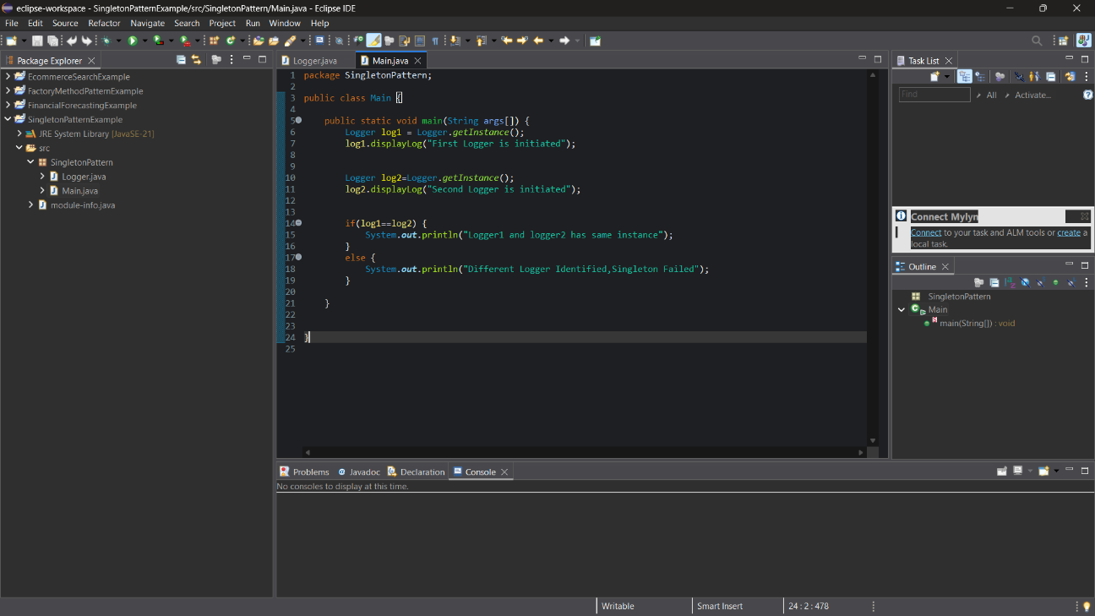**Main.java**

**Logger.java**

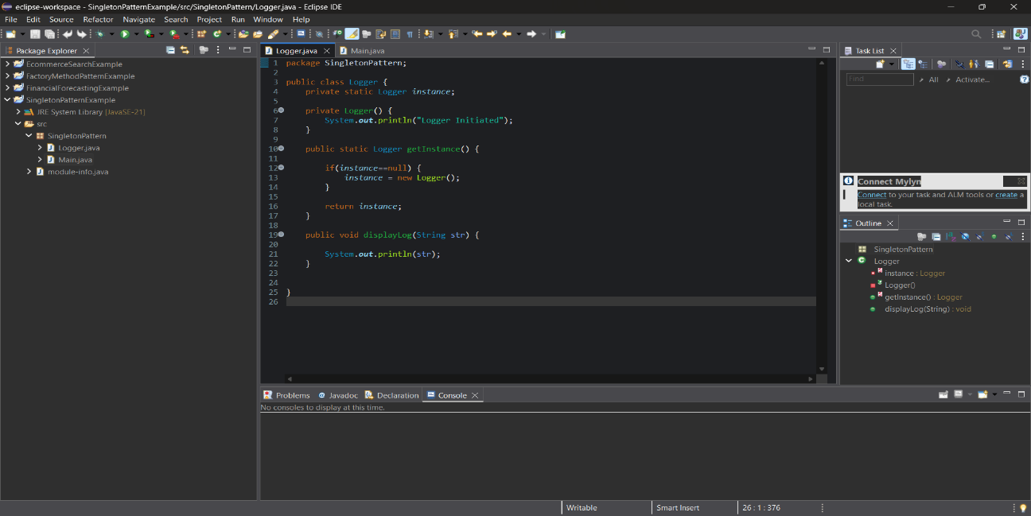

**Output:**

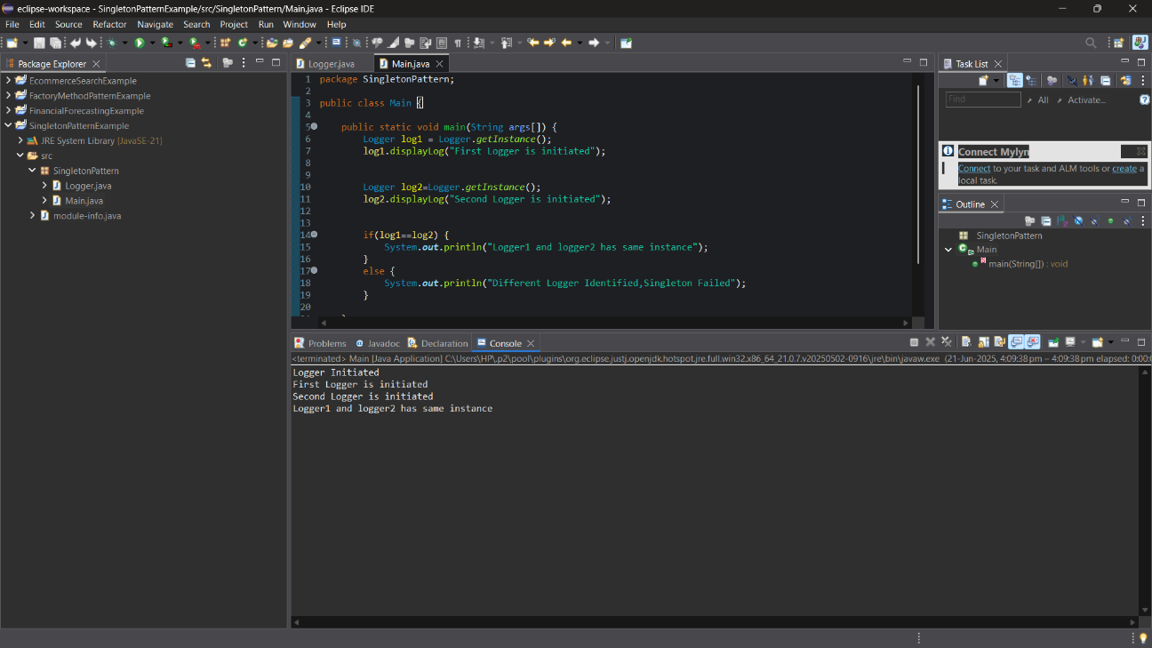

**Question-2(Factory Method Pattern)**

**Main.java**

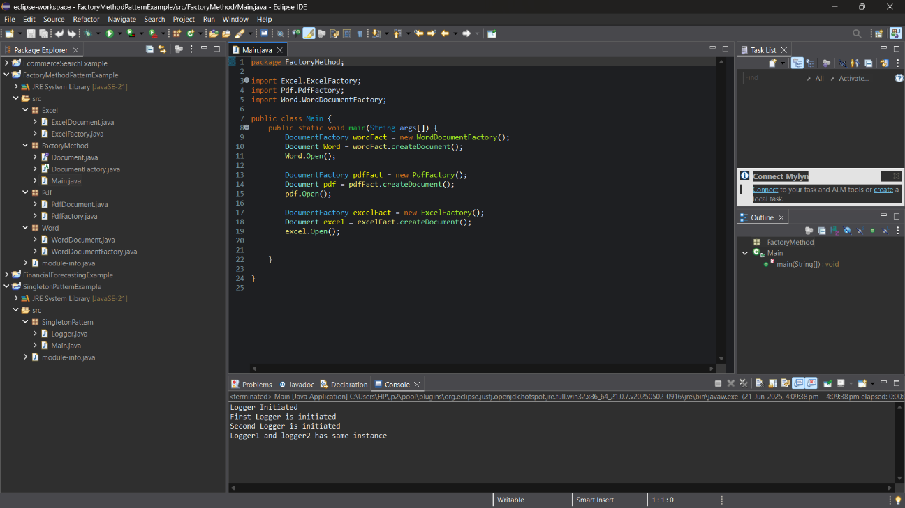

**WordDocument.java**

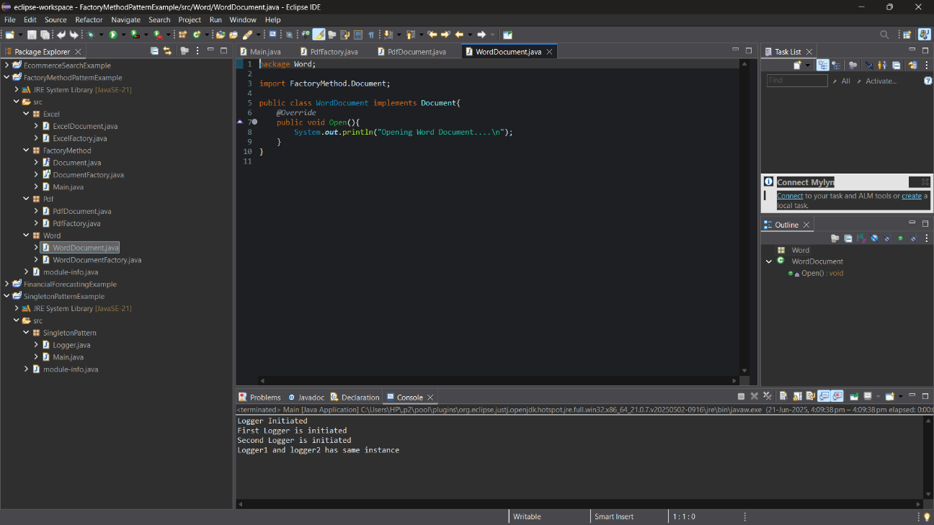

**WordDocumentFactory.java**

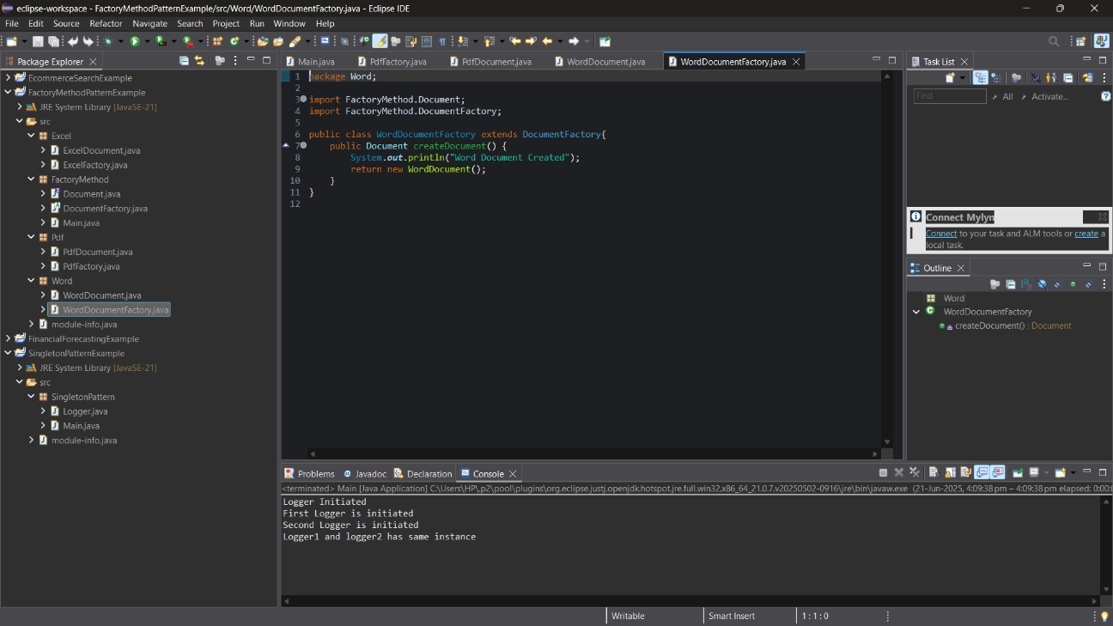

* Same types of classes are used for pdf and excel format documents

**Output:**

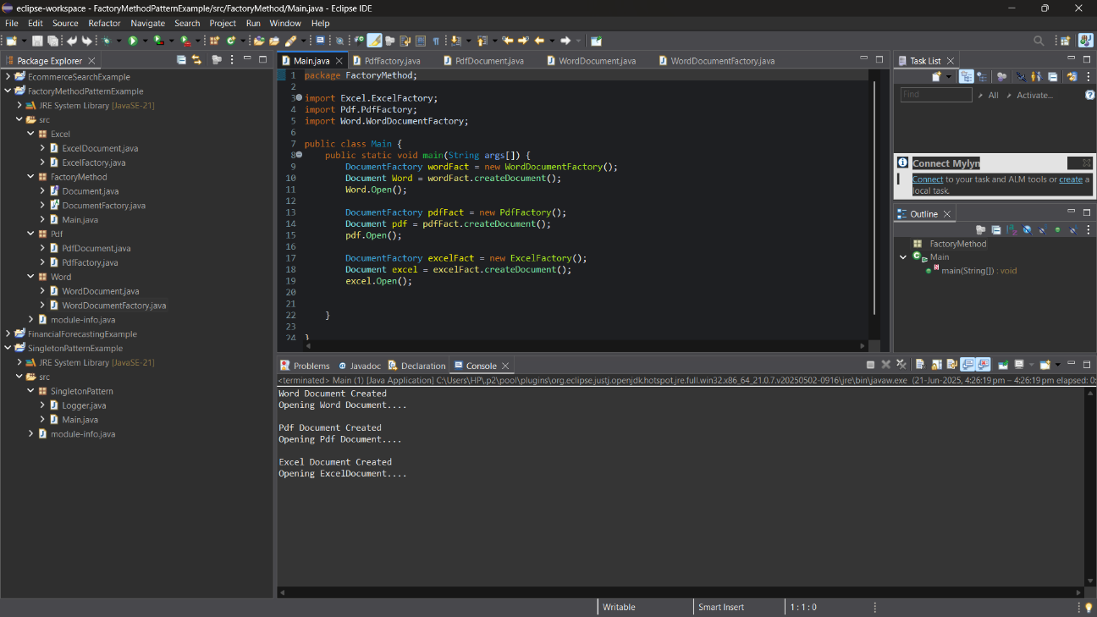

**Data structures and Algorithm**

**Question -1(Linear and Binary Search)**

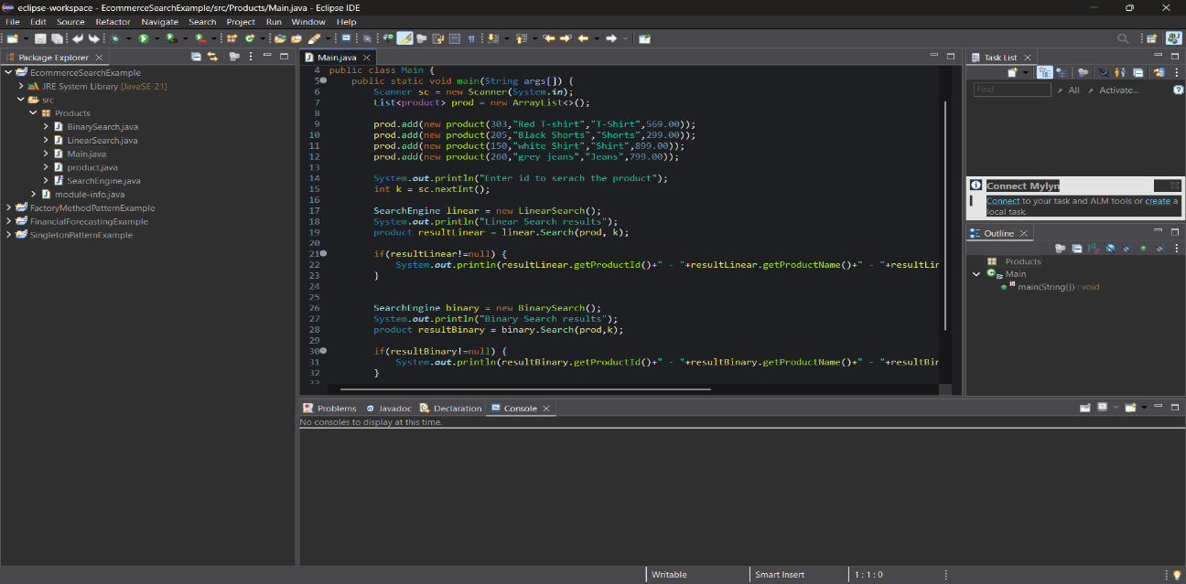**Main.java**

**Linear.java**

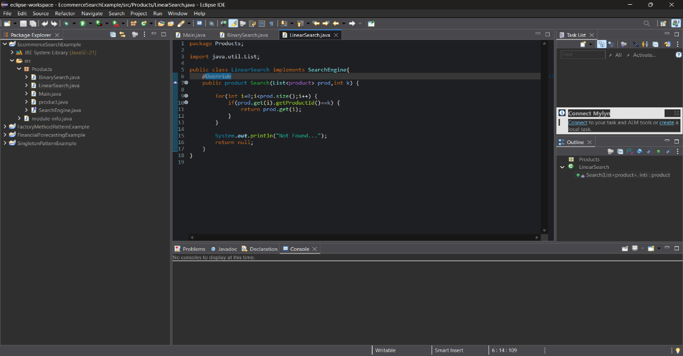

**Binary.java**

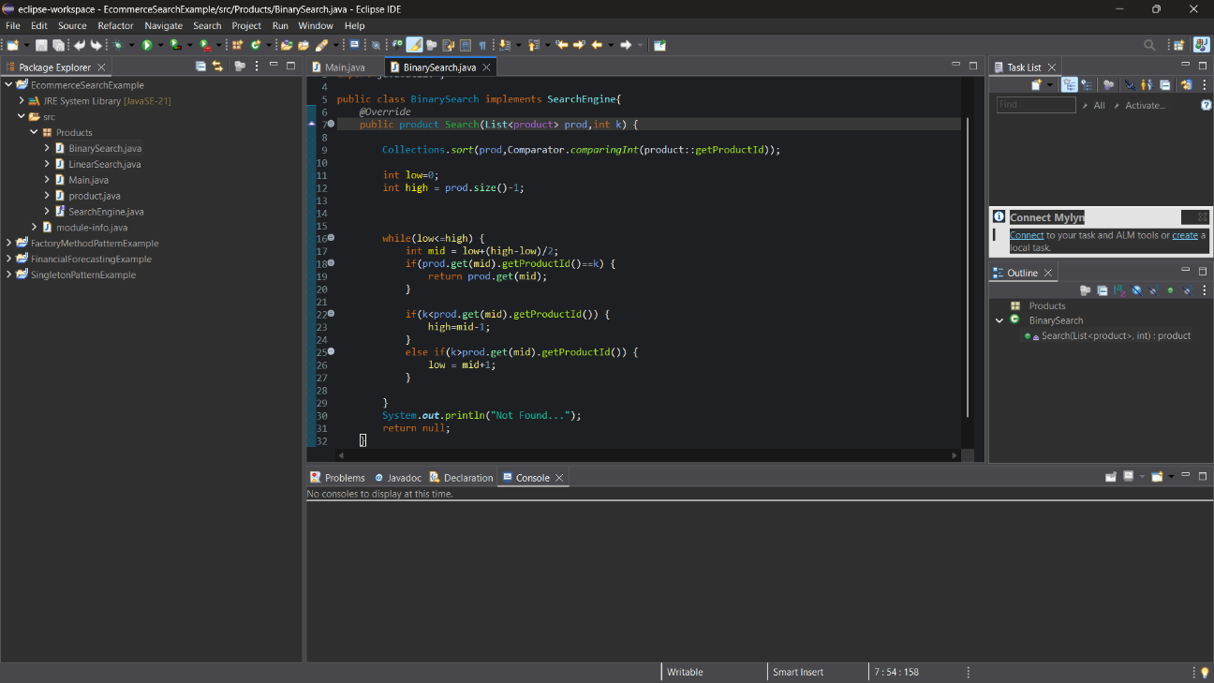

**Output:**

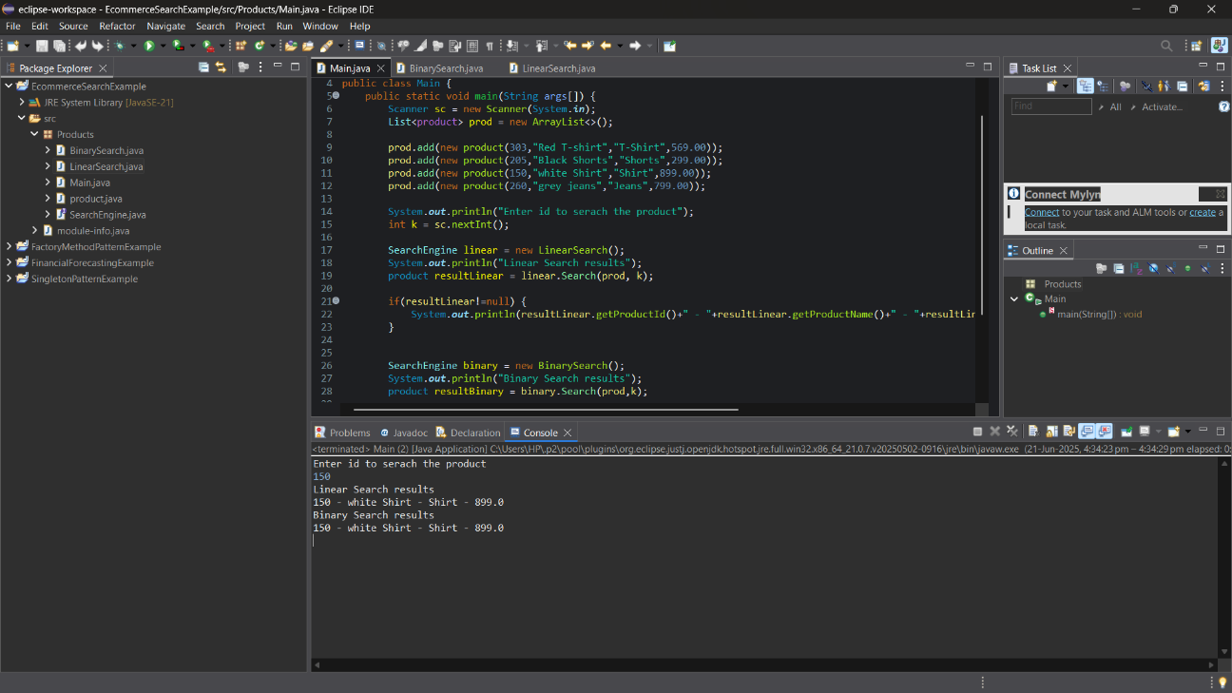

**Question-2(Financial Forecasting)**

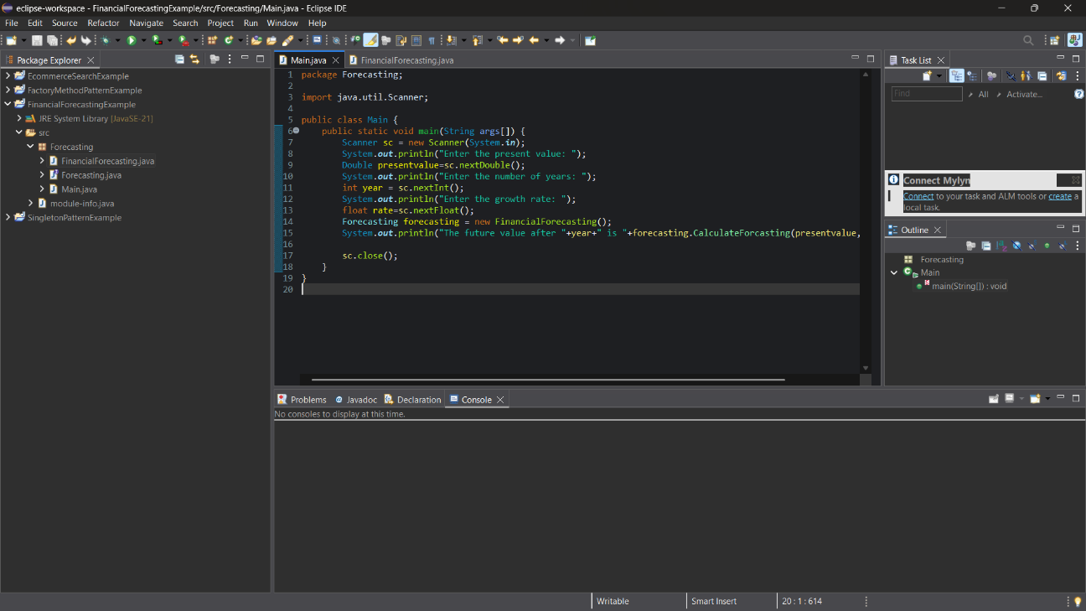**Main.java**

**FinancialForecasting.java**

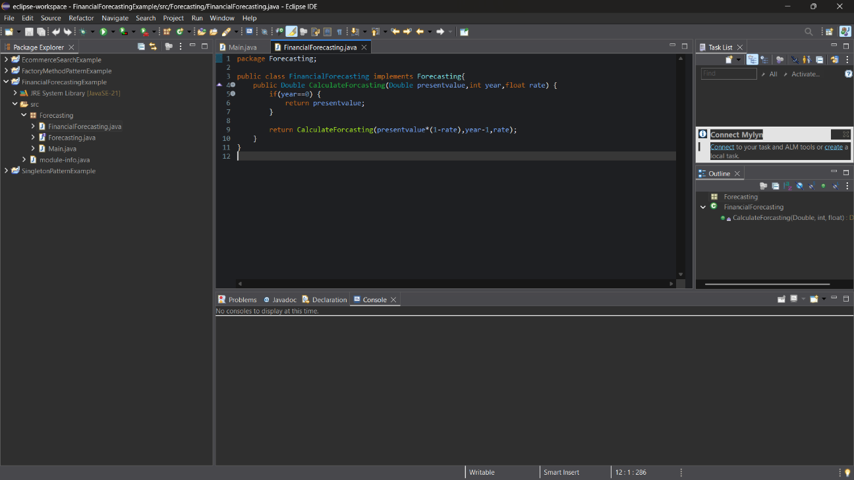

**Output:**

