**Design Thinking Project Workbook**

**Don't find customers for your product but find products for your customers**

**1. Team**

**Team Name:**

**Team Logo (if any):**

**Team Members:**

* [Lalith, Lead, 2320040048]
* [Eshwar, Idealogist, 2320040126]
* [Shreyas, Reseacher, 2320040063]

**2. Problem/Opportunity Domain**

**Domain of Interest: Your domain of interest diabetes prediction using machine learning falls within the healthcare industry, specifically in the field of medical diagnostics and preventive healthcare. Machine learning can help in early detection by analyzing patient data (such as blood sugar levels, BMI, family history, etc.) to predict the likelihood of developing diabetes.**

**Description of the Domain: The domain of diabetes prediction using machine learning focuses on leveraging data such as blood sugar levels, BMI, and lifestyle factors to predict an individual's risk of developing diabetes. This field faces challenges like ensuring data privacy, dealing with imbalanced datasets, and avoiding bias in predictions.**

**Why did you choose this domain?: I chose the domain of diabetes prediction using machine learning because it addresses a pressing global health issue with the potential for significant impact. Diabetes is a growing epidemic, and early detection is key to preventing complications and improving patient outcomes.**

**3. Problem/Opportunity Statement**

**Problem Statement: Diabetes is a chronic condition affecting millions worldwide, leading to severe health complications and substantial healthcare costs. Early detection is crucial for effective management and prevention of these complications. Traditional diagnostic methods often identify diabetes only after significant progression, underscoring the need for more proactive approaches.**

**Problem Description: The problem in diabetes prediction is that traditional diagnostic methods often detect the disease only after it has progressed, limiting opportunities for early intervention and prevention. This delay can lead to severe complications, including cardiovascular disease, kidney damage, and high healthcare costs.**

**Context (When does the problem occur): The problem occurs when healthcare**

**systems rely on traditional diagnostic methods, which often detect diabetes only after noticeable symptoms or complications have developed. This is especially common in routine health check-ups where risk factors like elevated blood sugar levels or family history may not trigger immediate action.**

**Alternatives (What does the customer do to fix the problem): To address delayed diabetes diagnosis, patients often rely on regular health check-ups, lifestyle changes, and basic screening tools like questionnaires or family history monitoring. Some also use mobile health apps to track health data, but these methods lack the precision and predictive power that machine learning offers for early detection and personalized insights.**

**Customers (Who has the problem most often): The primary groups affected by delayed diabetes diagnosis include individuals at risk, such as those with obesity, sedentary lifestyles, or a family history of diabetes. Healthcare providers also struggle to identify high-risk patients early due to limitations in traditional diagnostic methods.**

**Emotional Impact (How does the customer feel): Customers affected by delayed diabetes diagnosis often experience anxiety and frustration about their health and the healthcare system. Many feel fearful of developing serious complications, leading to a sense of helplessness when proactive measures are lacking. Confusion may arise from unclear guidance on monitoring and lifestyle changes, while guilt can accompany awareness of their risk factors. These emotions underscore the urgent need for improved.**

**Quantifiable Impact (What is the measurable impact): The quantifiable impact of delayed diabetes diagnosis includes significant financial losses and increased healthcare costs. Individuals with undiagnosed diabetes can face medical expenses that are up to three times higher than those who receive timely treatment.**

**Alternative Shortcomings (What are the disadvantages of the alternatives): Current solutions for addressing delayed diabetes diagnosis have several shortcomings. Regular health check-ups often fail to catch diabetes early, as they rely on standard tests that may miss prediabetes or subtle glucose level changes.**

**3. Addressing SDGs**

**Relevant Sustainable Development Goals (SDGs): The problem of delayed diabetes diagnosis and the opportunity for early prediction through machine learning directly impacts several Sustainable Development Goals (SDGs). Primarily, it aligns with SDG 3: Good Health and Well-being, as improving early detection and management of diabetes contributes to reducing morbidity and mortality associated with non-communicable diseases.**

**How does your problem/opportunity address these SDGs?: Solving the problem of delayed diabetes diagnosis by leveraging machine learning for early prediction directly contributes to SDG 3: Good Health and Well-being by facilitating timely interventions that reduce the risk of severe complications and improve overall health outcomes for individuals at risk of diabetes.**

**4. Stakeholders**

Answer these below questions to understand the stakeholder related to your project

* **Who are the key stakeholders involved in or affected by this project?**

The key stakeholders involved in this project include patients at risk of diabetes, healthcare providers, healthcare institutions, data scientists and developers, policymakers, insurance companies, and technology partners. Each group plays a vital role in shaping the success of diabetes prediction through machine learning.

* **What roles do the stakeholders play in the success of the innovation?**

Patients provide valuable data and feedback, while healthcare providers utilize the tool to improve patient outcomes. Healthcare institutions facilitate the implementation, and data scientists and developers build and refine the machine learning models. Policymakers support regulatory compliance, insurance companies influence adoption through coverage policies, and technology partners ensure robust data infrastructure.

* **What are the main interests and concerns of each stakeholder?**

Patients seek timely diagnosis and effective management but are concerned about data privacy. Healthcare providers aim to improve outcomes and rely on the tool's accuracy. Healthcare institutions focus on operational efficiency and cost, while data scientists prioritize data quality and ethical use. Policymakers want positive public health outcomes, and insurance companies are interested in cost reduction.

* **How much influence does each stakeholder have on the outcome of the project?**

Patients have a moderate influence through feedback, while healthcare providers and institutions have high influence as they directly implement the solution. Data scientists and developers also have high influence on the model's effectiveness, and policymakers and insurance companies can shape the project's financial viability. Technology partners have moderate influence based on system integration.

* **What is the level of engagement or support expected from each stakeholder?**

Active engagement is expected from patients in providing feedback, while healthcare providers are anticipated to offer high support in using the tool. Healthcare institutions should commit to integration, and data scientists will engage continuously in development. Policymakers will provide support through regulations, insurance companies will engage in coverage discussions, and technology partners will maintain ongoing support.

* **Are there any conflicts of interest between stakeholders? If so, how can they be addressed?**

Conflicts may arise between insurance companies, focused on cost reduction, and patients, seeking comprehensive care. These can be addressed through transparent communication, emphasizing the long-term cost savings of early detection, and ensuring patient interests are prioritized in discussions.

* **How will you communicate and collaborate with stakeholders throughout the project?**

Regular meetings, workshops, and feedback sessions will facilitate stakeholder collaboration. A dedicated platform for updates and communication will ensure ongoing dialogue, while stakeholder surveys will gather input and address concerns promptly.

* **What potential risks do stakeholders bring to the project, and how can these be mitigated?**

Patients may raise data privacy concerns, mitigated by implementing robust security measures. Healthcare providers might resist new tools, which can be addressed through training and demonstration of effectiveness. Financial constraints in institutions can be mitigated by presenting clear return on investment. Bias risks in models can be tackled by ensuring diverse data, and regulatory hurdles can be mitigated by early engagement with policymakers.

­­

**5. Power Interest Matrix of Stakeholders**

**Power Interest Matrix: Provide a diagrammatic representation of Power Interest Matrix**

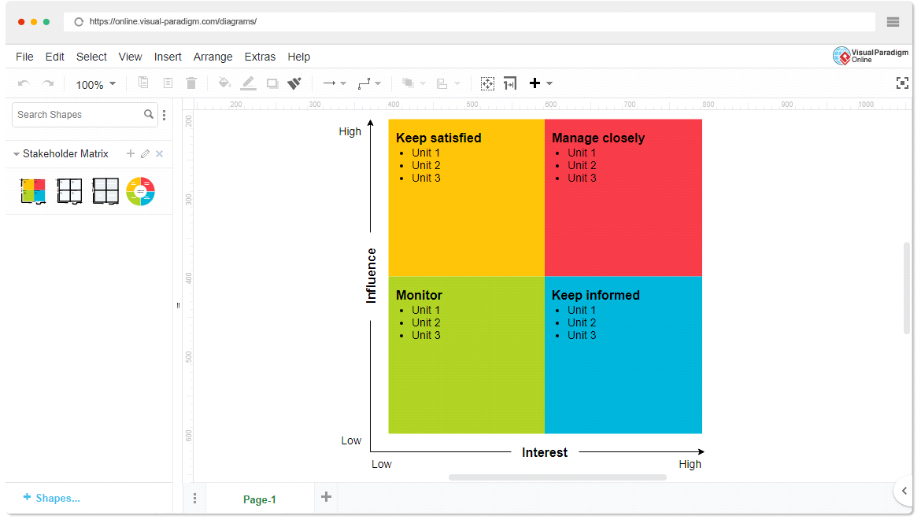

* High Power, High Interest: [Healthcare Providers]
* High Power, Low Interest: [Regulatory Bodies]
* Low Power, High Interest: [Technology Vendors]
* Low Power, Low Interest: [General Public]
* **Empathetic Interviews**

**Conduct Skilled interview with at least 30 citizens/Users by asking open ended questions (What, why/How etc) and list the insights as per the format below**

|  |  |  |
| --- | --- | --- |
| **I need to know**  **(thoughts, feelings, actions)** | **Questions I will ask**  **(open questions)** | **Insights I hope to gain** |
| Thoughts | "What do you think are the most significant impacts of climate change in your city?" | Understanding of perceived impacts and awareness of climate change |
| Feelings | "How do you feel about the potential consequences of climate change for future generations?" | Exploring emotional responses and concerns |
| actions | "Have you taken any steps to reduce your carbon footprint or prepare for climate-related events?" | Identifying personal behaviors and attitudes towards climate action |

**SKILLED INTERVIEW REPORT**

**(Examples are given. Erase them and fill with your user information.)**

|  |  |  |
| --- | --- | --- |
| **User/Interviewee** | **Questions Asked** | **Insights gained (NOT THEIR ANSWERS)** |
| Abhishek Verma,  Student | Which party do you vote for? | Citizens are not very open about their political preferences |
| Srinivasan P., Parent | How do you feel about the plans for a new capital? | Some citizens are sad that the capital is being relocated from Hyderabad. |
|  |  |  |
|  |  |  |
|  |  |  |

**Key Insights Gained:**

* **Insight 1**
* **Insight 2**

**Empathy Map**

* **Empathy Map**
* **Who is your Customer?**

**Description: This is where you specify the customer or user you are empathizing with. It could be a specific user persona or a general user segment.**

**Key points:**

* **Define the customer profile clearly (e.g., age, profession, interests).**
* **State their goals and needs related to the innovation or product.**
* **Context in which the user will interact with your solution.**
* **Who are we empathizing with?**

**Description: This area helps you define who the user is, what their situation looks like, and what role they play. It emphasizes understanding the user’s perspective in depth.**

**Key points:**

* **Define the user's characteristics (e.g., personality, values, and responsibilities).**
* **State the user's goals and challenges in their environment.**
* **What is the user's broader situation (professionally or personally)?**
* **What do they need to DO?**

**Description: This section identifies what actions or tasks the user needs to perform. It helps highlight the expectations and demands the user faces.**

**Key points:**

* **Clarify the tasks or actions the user needs to complete.**
* **What decisions do they need to make?**
* **How do they define success or failure in their tasks?**
* **What do they SEE?**

**Description: This focuses on the visual stimuli or environment that the user interacts with. It's important to consider what users see in their immediate surroundings and in their larger world.**

**Key points:**

* **What do users see in their physical and digital environment?**
* **What trends or competitors do they notice?**
* **How do these visual elements influence their behavior?**
* **What do they SAY?**

**Description: This section captures what the user might say in public, such as comments or feedback they give in conversations or on social media.**

**Key points:**

* **What might users express openly in conversation about their problems?**
* **How do they express their goals or frustrations?**
* **What are their words during customer interviews or feedback?**
* **What do they DO?**

**Description: This section focuses on what the user does, the actual behaviors they exhibit, and actions they take in different situations.**

**Key points:**

* **What observable actions do users take?**
* **What habits or routines do they follow?**
* **What might users do to try and solve their problems?**
* **What do they HEAR?**

**Description: This addresses what information the user receives from external sources, such as colleagues, media, or industry trends. It helps map the influences surrounding the user.**

**Key points:**

* **What are they hearing from peers, mentors, or the industry?**
* **What media or channels of information are they exposed to?**
* **Are there any strong influencers guiding their behavior?**
* **What do they THINK and FEEL?**

**Description: This is one of the most insightful sections, addressing the internal emotions, concerns, and motivations of the user. It helps identify their deep-rooted feelings.**

**Key points:**

* **What are their fears, worries, and anxieties?**
* **What are their motivations and desires?**
* **How do their thoughts and feelings align with their actions?**
* **Pains and Gains**

**Description: This section focuses on the user’s frustrations and their desired outcomes. It helps to frame the user’s challenges (pains) and the benefits they seek (gains).**

**Key points:**

* **What are the user’s main pain points?**
* **What would make their life easier or more fulfilling?**
* **What benefits do they hope to achieve from your product or solution?**

**8. Persona of Stakeholders**

**Stakeholder Name:**

**Demographics: Key characteristics of your target audience, such as age, gender, income, and location.**

**Goals: What the stakeholders or customers want to achieve in relation to the innovation.**

**Challenges: The obstacles or difficulties faced by stakeholders that the innovation aims to address.**

**Aspiration: The long-term desires or dreams of your target audience related to the innovation.**

**Needs: The essential requirements of your customers or stakeholders that must be met.**

**Pain Points: Specific problems or frustrations experienced by the target audience.**

**Storytelling: A narrative that highlights the journey of the stakeholder or customer, illustrating the problem and how the innovation can solve it.**

**Sample:**

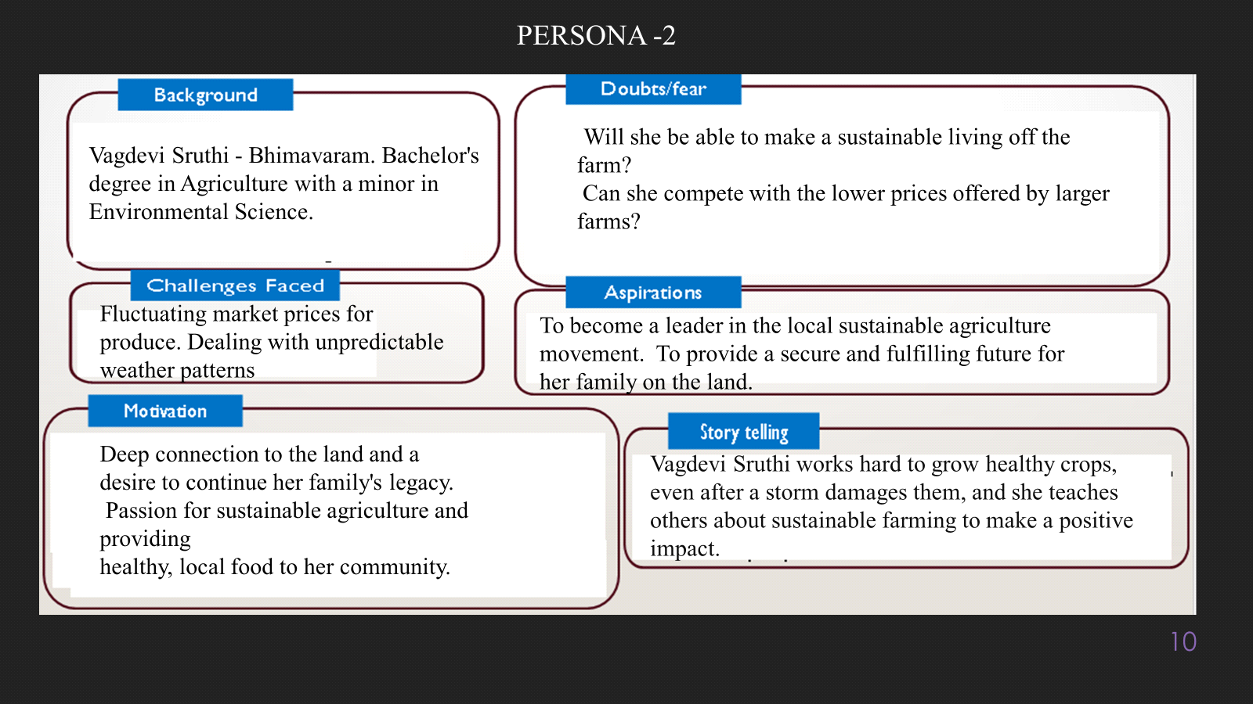

**10. Look for Common Themes, Behaviors, Needs, and Pain Points among the Users**

Analyse the data from your affinity diagram to uncover recurring patterns among your users, helping you better understand their expectations and challenges.

**Common Themes: Identify broad ideas or issues that repeatedly appear across different groups in your affinity diagram.**

**Common Behaviors: Observe how users consistently act or respond in relation to the problem or product throughout their journey.**

**Common Needs: Pinpoint essential requirements or desires that many users share, highlighting what they need for a better experience.**

**Common Pain Points: Look for frustrations or obstacles that frequently hinder the user experience, which your project can address.**

**12. Define Needs and Insights of Your Users**

**User Needs: Define the core requirements your users have in relation to the problem or product. These could be functional, emotional, or societal needs that your solution must address.**

**User Insights: Summarize the key understandings or observations you've uncovered about your users' behaviors, motivations, and pain points. These insights provide a deeper understanding of why users behave the way they do and what drives their decisions.**

**13. POV Statements**

**POV Statements:**

* [User] needs a way to [need] because [insight].

|  |  |  |  |
| --- | --- | --- | --- |
| PoV Statements  (At least ten) | Role-based or Situation-Based | Benefit, Way to Benefit,  Job TBD,  Need (more/less) | PoV Questions  (At least one per statement) |
| (Erase this example) When I drive to work, I want to avoid traffic jams so I don’t get in trouble with my boss for being late. | Situation | Way to Benefit | What can we design that will enable drivers to avoid traffic jams?  What can we design that will enable workers to avoid getting in trouble for being late to work? |
|  |  |  |  |
|  |  |  |  |
|  |  |  |  |
|  |  |  |  |

**14. Develop POV/How Might We (HMW) Questions to Transform Insights/Needs into Opportunities for Design**

Turn your user needs and insights into actionable opportunities by framing them as "How Might We" (HMW) questions. These questions will spark creative problem-solving and guide your innovation process.

* **How Might We: Based on the needs and insights you've identified, create open-ended questions starting with "How might we...?" These questions should aim to solve user pain points, enhance the experience, or address specific needs.**

**Examples:**

* **User Need: "Users need a quicker way to access customer support."**
* **HMW Question: "How might we create a more efficient and accessible customer support system?"**
* **Insight: "Users feel overwhelmed by too many options."**
* **HMW Question: "How might we simplify decision-making for our users?"**

**Task:**

**Write 3-5 "How Might We" questions based on your analysis of user needs and insights. These questions should challenge you to think of innovative solutions that can address user problems in meaningful ways.**

**This task encourages participants to think creatively about solving user problems, transforming challenges into opportunities for innovation.**

|  |  |
| --- | --- |
| User Need/Insight | "How Might We" Question |
| [State the user need or insight clearly] | **How might we... [formulate an open-ended question to address the need or insight]?** |

**16. Crafting a Balanced and Actionable Design Challenge**

The Design Challenge Should Neither Be Too Narrow Nor Too Broad and It Should Be an Actionable Statement with a quantifiable goal. It should be a culmination of the POV questions developed.

**Design Challenge:** [Actionable Statement]

**17. Validating the Problem Statement with Stakeholders for Alignment**

Ensure your problem statement accurately represents the needs and concerns of your stakeholders and users. This involves gathering feedback from these groups to confirm that the problem is relevant and significant from their perspective. By validating early, you can refine the problem statement to better align with real-world challenges, ensuring your solution addresses the correct issues.

**Validation Plan:**

**Stakeholder/User Feedback (Min. 10 Stakeholders/Experts):**

|  |  |  |  |
| --- | --- | --- | --- |
| Stakeholder/User | Role | Feedback on Problem Statement | Suggestions for Improvement |
| [Name/Group] | **[Role/Title]** | **[Does the problem resonate with them? Why or why not?]** | **[Suggestions for refining the problem statement]** |
| [Name/Group] | **[Role/Title]** | **[Does the problem resonate with them? Why or why not?]** | **[Suggestions for refining the problem statement]** |

**18. Ideation**

**Ideation Process:**

|  |  |  |  |
| --- | --- | --- | --- |
| Idea Number | Proposed Solution | Key Features/Benefits | Challenges/Concerns |
| Idea 1 | **[Brief description of solution]** | **[What are the key benefits of this solution?]** | **[What challenges or concerns exist?]** |
| Idea 2 | **[Brief description of solution]** | **[What are the key benefits of this solution?]** | **[What challenges or concerns exist?]** |
| Idea 3 | **[Brief description of solution]** | **[What are the key benefits of this solution?]** | **[What challenges or concerns exist?]** |
| Idea 4 | **[Brief description of solution]** | **[What are the key benefits of this solution?]** | **[What challenges or concerns exist?]** |
| Idea 5 | **[Brief description of solution]** | **[What are the key benefits of this solution?]** | **[What challenges or concerns exist?]** |

**18. Idea Evaluation**

Evaluate the Idea based on 10/100/1000 grams

|  |  |  |  |  |
| --- | --- | --- | --- | --- |
| Idea | Impact (10/100/1000 grams) | Feasibility (10/100/1000 grams) | Alignment (10/100/1000 grams) | Total Weight |
| Idea 1 | **[Assign weight]** | **[Assign weight]** | **[Assign weight]** | **[Sum of weights]** |
| Idea 2 | **[Assign weight]** | **[Assign weight]** | **[Assign weight]** | **[Sum of weights]** |
| Idea 3 | **[Assign weight]** | **[Assign weight]** | **[Assign weight]** | **[Sum of weights]** |
| Idea 4 | **[Assign weight]** | **[Assign weight]** | **[Assign weight]** | **[Sum of weights]** |
| Idea 5 | **[Assign weight]** | **[Assign weight]** | **[Assign weight]** | **[Sum of weights]** |

**Example:**

|  |  |  |  |  |
| --- | --- | --- | --- | --- |
| Idea | Impact (10/100/1000 grams) | Feasibility (10/100/1000 grams) | Alignment (10/100/1000 grams) | Total Weight |
| Idea 1 | **1000** | **100** | **1000** | **2100** |
| Idea 2 | **100** | **1000** | **100** | **1200** |
| Idea 3 | **100** | **100** | **100** | **300** |

Further, use solution concept form to scrutinize the idea

**Solution Concept Form**

**1. Problem Statement:**

* **[State the validated problem your solution addresses.]**

**2. Target Audience:**

* **[Describe the main users or customers who will benefit from this solution.]**

**3. Solution Overview:**

* **[Provide a brief description of the solution concept.]**

**4. Key Features:**

|  |  |
| --- | --- |
| **Feature** | **Description** |
| **Feature 1** | **[Briefly describe the main feature of your solution]** |
| **Feature 2** | **[Briefly describe another key feature]** |
| **Feature 3** | **[Briefly describe a third key feature]** |

**5. Benefits:**

|  |  |
| --- | --- |
| **Benefit** | **Description** |
| **Benefit 1** | **[What value does this solution bring?]** |
| **Benefit 2** | **[How does this solution solve the problem?]** |
| **Benefit 3** | **[What makes this solution stand out?]** |

**6. Unique Value Proposition (UVP):**

* **[Summarize why this solution is unique and why it will appeal to your target audience.]**

**7. Key Metrics:**

|  |  |
| --- | --- |
| **Metric** | **Measurement** |
| **Metric 1** | **[What is the key metric to measure success?]** |
| **Metric 2** | **[What is another key metric for tracking progress?]** |

**8. Feasibility Assessment:**

* **[Provide a brief evaluation of how achievable or practical this solution is (consider resources, time, and technology).]**

**9. Next Steps:**

* **[Outline the next steps for further developing or prototyping this solution.]**