CERTIFICATE

CENTER OF ASSESSMENT AND CERTIFICATION

Prompt G AI Engineering Safety Certification

This is to certify that

**Lalith**

**aravindan**

**Perungavuru**

has successfully completed all tasks of the assessment and received passing grades to earn the certificate in “Prompt Engineering Safety & AI Engineering Safety Professional Certification”, the assessment program offered by

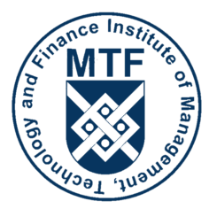

the Institute of Management, Technology & Finance.

**Igor Dmitriev**

President

Institute of management, Technology & Finance

Issued October 2023 Valid Diploma ID: MTF-October23-AOQfhO2mtL05ZL9mF5DwCl34V5NlBEt