

(23cse113) object oriented programming language

LAB document

# CSE-1st YEAR I SEMESTER (2024-2025)

SUBMITTED TO: SUBMITTED FROM:

|  |  |  |  |
| --- | --- | --- | --- |
| **NAME** | A.Lalith sai akshith | **NAME** | Raj kumar |
| **ROLL NO** | **AV.SC.U4Cse24301** | **DEPARTMAENT** | OOPS |
| **SECTION** | **CSE-A** | **DESIGNATION** | **PROFESSOR** |

INDEX

|  |  |
| --- | --- |
| **S.NO** | **TITLE** |
| 1. | Making website using basic html tags |
| 2. | Making an own website using html |
| 3. |  |
| 4. |  |
| 5. |  |
| 6. |  |
| 7. |  |
| 8. |  |
| 9. |  |

Week1:

program 1

AIM: To download and install java.

Procedure:  
step1:GO to browser and search “download java ”.

Step2: when you search you can see oracle website to

download java , click on it.

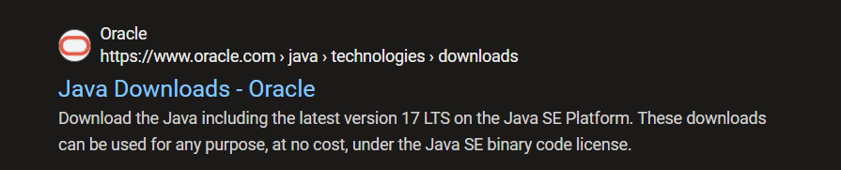

Step3:Download the java JDK21 version in linux/macOS/windows in “64x installer”.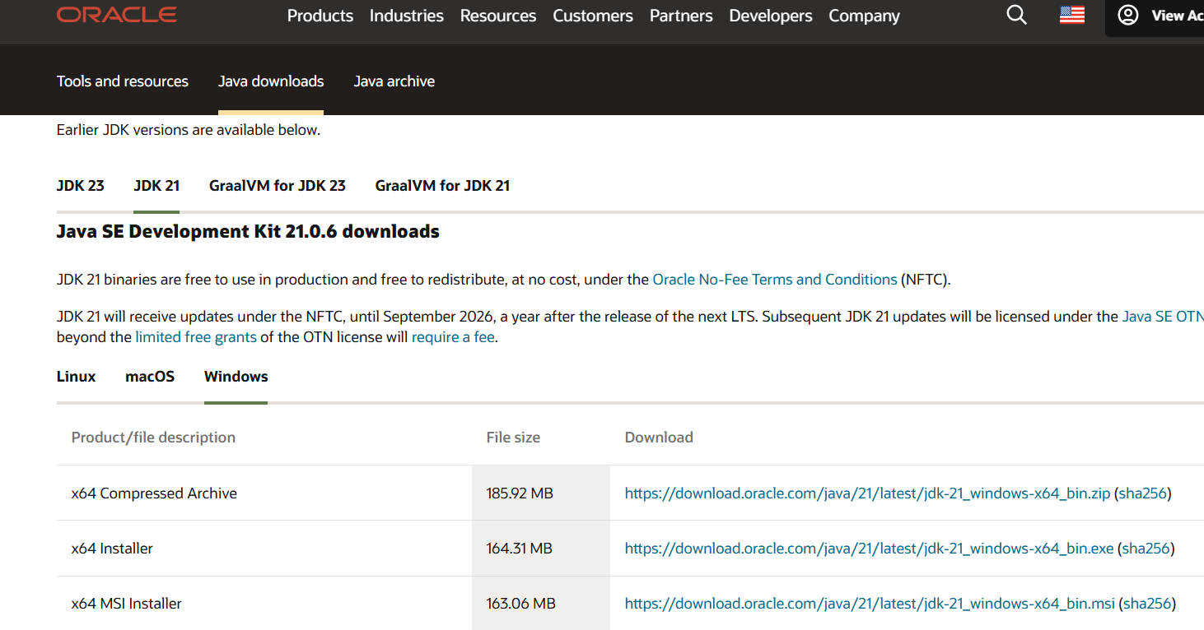

Step4: After downloading JDK 21 java version download the installer of java.



Step 5:After installing java Go to environment variable, click on path and add the java folder in it.

Step 6: Go to command prompt and type java –version.

You can see the version of java downloaded.

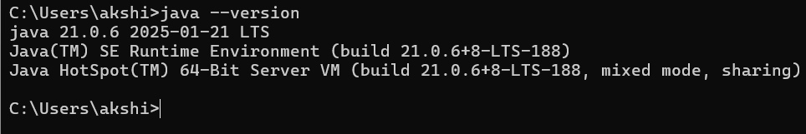

Program 2:java program to print the message welcome to java programming.

Aim:to create java program to print the message welcome to java programming.

PROCEDURE:

Step1: create a folder in and name it JAVA and create a notepad folder in JAVA folder and name it Helloworld.java.

Step 2: open the notepad folder and write the code of “welcome to java programming” . Ensure that the class and the file name is same.

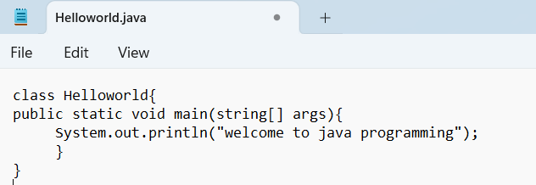

Step3: Save the notepad file and open the file in the command prompt window .

Step4:Compile the program by using command

Javac Helloworld.java and press enter.

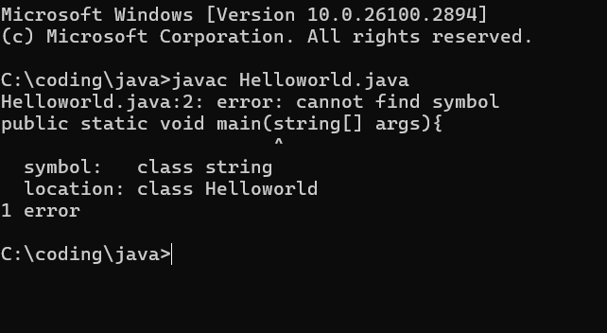

Step5: So we are getting an error which is in the class string. Go to notepad and correct the mistake in the class string.

Step6: Now save the java file and open the command window and type javac Helloworld.java and compile it.

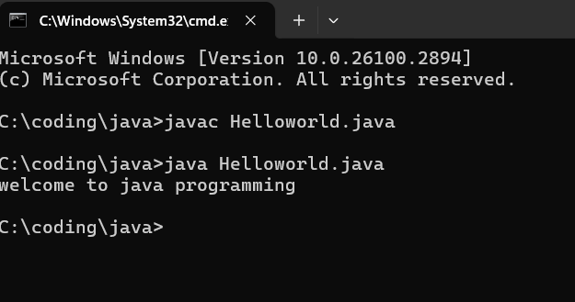

Now, the java program is correctly excecuted and there are no errors in the java program.

Program3: Write java program that prints name , roll number & section of a student.

Aim: To create java program that prints name , roll number & section of a student.

PROCEDURE:  
Step1: create new notepad folder and write the code of java program that prints name , roll number & section of a student.

Step2:Save the file as StudentInfo.java and open the notepad file in command prompt and compile javac studentInfo.java.

Step3: So we are getting 3 errors which is in the printing statement. Go to notepad and correct the mistake in the printing statement.

Step4: Now save the java file and open the command window and type javac StudentInfo.java and compile it.

Step5:Now, the java program is correctly excecuted and there are no errors in the java program.

Week 2:

Program3: Write java program that prints Area of rectangle

Aim: java program that prints Area of rectangle.

Step1: create new notepad folder and write the code of java program that prints the area of rectangle.

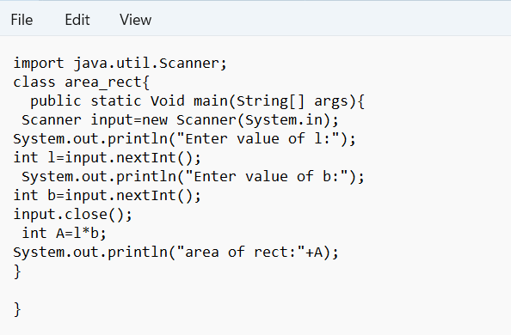

Step2:Save the file as area_rect.java and open the notepad file in command prompt and compile javac area_rect.java.

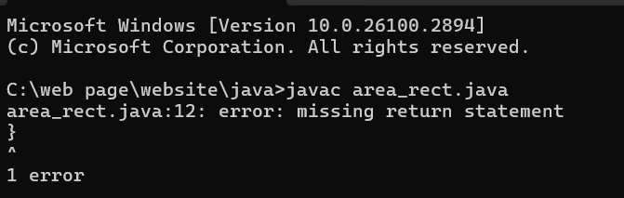

Step3: So we are getting error which is in the return statement. Go to notepad and correct the mistake in the printing statement.

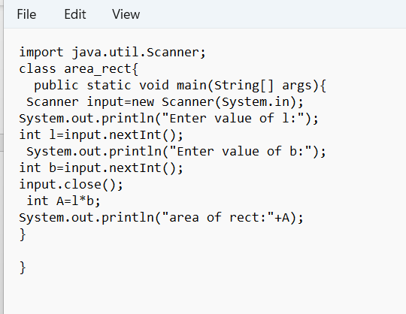

Step4: Now save the java file and open the command window and type javac area_rect.java and compile it.

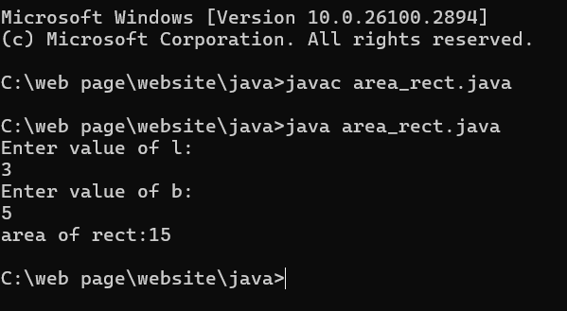

Step5:Now, the java program is correctly excecuted and there are no errors in the java program.

Program4: Write java program that prints factorial of number

Aim: java program that prints factorial of number.

Step1: create new notepad folder and write the code of java program that prints the factorial of number.

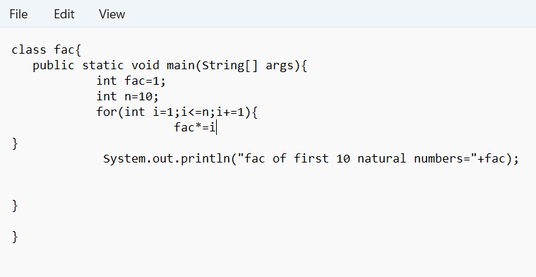

Step2:Save the file as fac.java and open the notepad file in command prompt and compile it.

Step3: So we are getting error which is in the fac*=i statement. Go to notepad and correct the mistake in the statement.

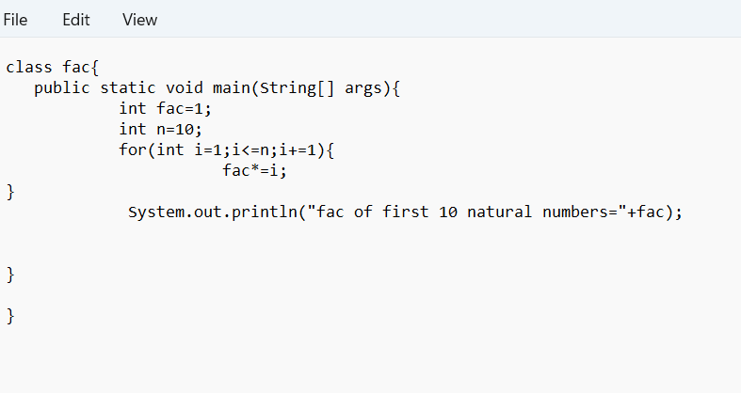

Step4: Add the semicoloum after error and Now save the java file and open the command window and type javac fac.java and compile it.

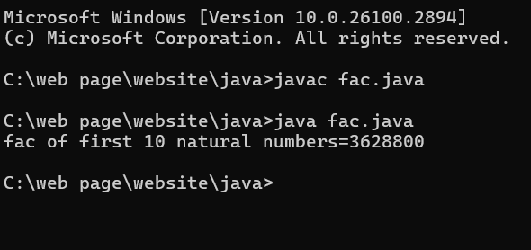

Step5:Now, the java program is correctly excecuted and there are no errors in the java program.

Program4: Write java program that prints largest of 3 numbers.

Aim: java program that prints largest of 3 numbers.

Step1: create new notepad folder and write the code of java program that prints the factorial of number.

Step2:Save the file as fac.java and open the notepad file in command prompt and compile it.

Step3: So we are getting 4errors which is in the c variable . Go to notepad and correct the mistake in the statement.

ERROR:

Add int c=input.nextInt();in the c input

Step4: Now save the java file and open the command window and type javac largest.java and compile it.Step5:Now, the java program is correctly excecuted and there are no errors in the java program.

Program5: Write java program that prints fibinocci of number.

Aim: java program that prints fibinocci.

Step1: create new notepad folder and write the code of java program that prints the fibinocci. 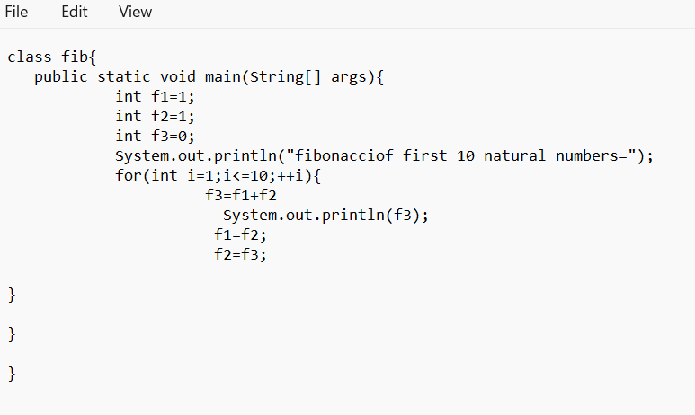

Step2:Save the file as fib.java and open the notepad file in command prompt and compile it.

Step3: So we are getting 1errors which is in the f3 variable . Go to notepad and correct the mistake in the statement.

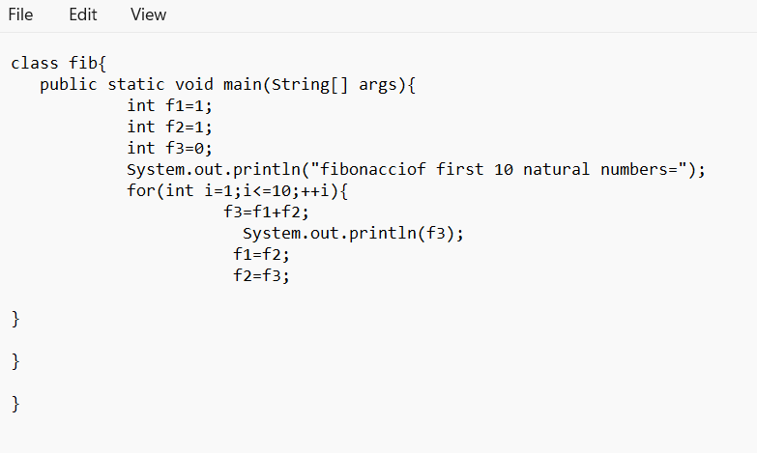

ERROR:

Add semicoloum after f3=f1+f2

Step4: Now save the java file and open the command window and type javac fib.java and compile it.

Step5:Now, the java program is correctly excecuted and there are no errors in the java program.

Program5: Write java program that prints fibinocci of number.

Aim: java program that convert Temperature from celcius to Fahrenheit

Step1: create new notepad folder and write the code of java program that convert Temperature from celcius to Fahrenheit

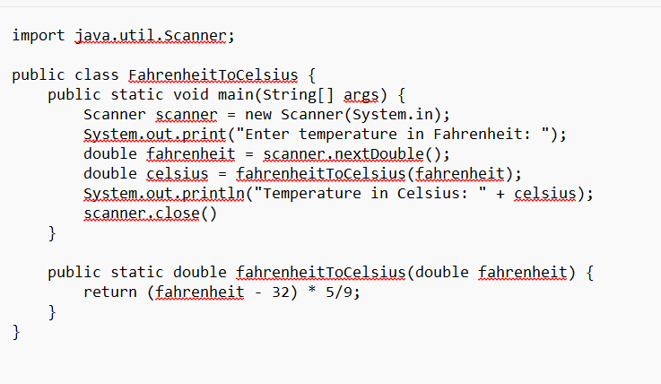

Step2:Save the file as temp.java and open the notepad file in command prompt and compile it.

Step3: So we are getting 1errors which is in the scanner close. Go to notepad and correct the mistake in the statement.

ERROR:

Add semicoloum after scanner close.

Step4: Now save the java file and open the command window and type javac temp.java and compile it.

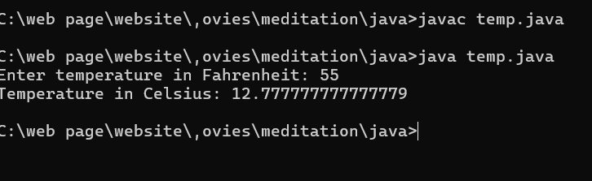Step5:Now, the java program is correctly excecuted and there are no errors in the java program.

Program5: Write java program that prints simple intrest of number by user.

Aim: java program that that prints simple intrest of number by user.

Step1: create new notepad folder and write the code of java program that prints simple intrest of number by user.

Step2:Save the file as simple.java and open the notepad file in command prompt and compile it.

Step3: So we are getting 1errors which is in the float. Go to notepad and correct the mistake in the statement.

ERROR:

Add semicoloum after Float SI;

Step4: Now save the java file and open the command window and type javac simple.java and compile it.

Step5:Now, the java program is correctly excecuted and there are no errors in the java program.

WEEK-3:

Aim: **To create java program with following instructions**

**1.Create a class with name car**

**2. Create four attributes named car_color Car_brand,fuel_type,mileage**

**3. Create three methods named start(), stop(). Service()**

**4. Create three objects named car1,car2 and car3**

Step1: create new notepad folder and write the code of java program that prints class with name car,attributes and three methods with three objects.

import java.util.*;

class car

{

public String Car_color

public String Car_brand;

public String fuel_type;

public int mileage;

public void start()

{

System.out.println("Car Started:");

System.out.println("Car color is :"+Car_color);

System.out.println("Car Brand is:"+Car_brand);

System.out.println("Car fuel type is:"+fuel_type);

System.out.println("Car mileage is:"+mileage);

}

public void service()

{

System.out.println("Car Started:");

System.out.println("Car color is :"+Car_color);

System.out.println("Car Brand is:"+Car_brand);

System.out.println("Car fuel type is:"+fuel_type);

System.out.println("Car mileage is:"+mileage);

}

public void stop()

{

System.out.println("Car Started:");

System.out.println("Car color is :"+Car_color);

System.out.println("Car Brand is:"+Car_brand);

System.out.println("Car fuel type is:"+fuel_type);

System.out.println("Car mileage is:"+mileage);

}

public static void main(String args[])

{ System.out.println("\nNIKHIL\n\n");

car car1 = new car();

car1.Car_color = "Blue";

car1.Car_brand = "Audi";

car1.fuel_type = "Deisel";

car1.mileage = 100;

car1.start();

car car2 = new car();

car2.Car_color = "Red";

car2.Car_brand = "Tesla";

car2.fuel_type = "EV";

car2.mileage = 200;

car2.stop();

car car3 = new car();

car3.Car_color = "Yellow";

car3.Car_brand = "BMW";

car3.fuel_type = "Petrol";

car3.mileage = 300;

car3.service();

}

}

Step2:Save the file as car.java and open the notepad file in command prompt and compile it.

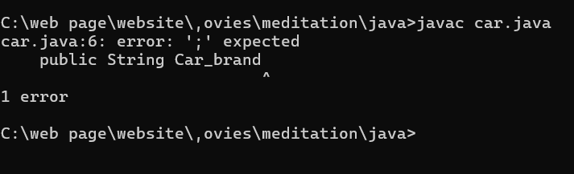

Step3: So we are getting 1errors which is in the string Car_brand. Go to notepad and correct the mistake in the statement.

ERROR:

|  |  |  |  |
| --- | --- | --- | --- |
| **S No** | **Error Type** | **Cause of error** | **Rectification** |
| **1** | **Syntax Error** | **Missing ‘;‘** | **‘;‘ added** |

Step4: Now save the java file and open the command window and type javac car.java and compile it.

Step5:Now, the java program is correctly excecuted and there are no errors in the java program.

Program5:

Aim: java program **To create a class bankAccount with methods deposit() and withdrawl**

**Code:**

Step1: create new notepad folder and write to create banlk account with method to deposoit and withdrawl.

Step2:Save the file as Main1.java and open the notepad file in command prompt and compile it.

Step3: So we are getting 1errors which is in the main string. Go to notepad and correct the mistake in the statement.

ERROR:

|  |  |  |  |
| --- | --- | --- | --- |
| **S.No** | **Error type** | **Reason for error** | **Rectification** |
| **1** | **Logical error** | **Incorrect symbol :** | **Formula rectified** |

Step4: Now save the java file and open the command window and type javac Main1.java and compile it.

Step5:Now, the java program is correctly excecuted and there are no errors in the java program.