**Employee Management System**

**Technologies used:**

**Frontend**-visual studio and React

**Backend**-Intellij Springboot

**Database** -MySQl and MYSQL workbench

**VideoLink:** [**https://drive.google.com/file/d/1__sMw5ozqIQUKn79m5Kw-hi1u6t0eRuI/view?usp=sharing**](https://drive.google.com/file/d/1__sMw5ozqIQUKn79m5Kw-hi1u6t0eRuI/view?usp=sharing)

**Building an Employee Management System using React for the frontend and Spring Boot for the backend is a popular choice due to their robustness and compatibility.**

**Project setup:**

**Steps to download frontend project from GitHub in VS code**

1. You can do this by pressing **Ctrl + Shift + P** (Windows/Linux) or **Cmd + Shift + P** (Mac). This will open a command palette at the top of the editor.
2. **Clone Repository**: In the command palette, type **Git: Clone** and select the option that appears. Alternatively, you can press **Ctrl + Shift + P** (Windows/Linux) or **Cmd + Shift + P** (Mac) and type **Git: Clone** and press Enter.
3. You will be prompted to enter the URL of the GitHub repository you want to clone. Paste the URL and press Enter.
4. Choose the local directory where you want to clone the repository. Once selected, press Enter.
5. If the repository is private or requires authentication, you may be prompted to provide your GitHub username and password or personal access token. Enter the required credentials and press Enter.
6. VSCode will start cloning the repository from GitHub to your local machine. You will see a progress indicator in the status bar at the bottom of the editor.
7. Once the cloning process is complete, VSCode will open the cloned repository in a new window automatically.
8. Enter cd busbooking
9. And type npm run dev
10. Open browser with http://127.0.0.1:3000/

**Steps to download backend project from GitHub in VS code**

1. **Open the Project from Version Control**: In the IntelliJ IDEA welcome screen, or if you have an existing project open, you can go to **File** > **New** > **Project from Version Control** > **Git**.
2. **Clone Repository**: In the URL field, enter the URL of the GitHub repository you want to clone. You can find this URL on the GitHub repository page. Then click **Clone**.
3. **Select Destination Folder**: Choose the local directory where you want to clone the repository. Once selected, click **Clone**.
4. **Authenticate (if required)**: If the repository is private or requires authentication, IntelliJ IDEA will prompt you to provide your GitHub username and password or personal access token. Enter the required credentials and click **OK**.
5. **Wait for Cloning to Complete**: IntelliJ IDEA will start cloning the repository from GitHub to your local machine. You will see a progress indicator in the bottom right corner of the IntelliJ IDEA window.
6. **Open Cloned Project**: Once the cloning process is complete, IntelliJ IDEA will open the cloned project in a new window automatically.
7. **Configure Project Settings (if necessary)**: Depending on the project, you may need to configure additional settings such as SDK, project structure, dependencies, etc.
8. **Run BusReservationBackendApplication file**
9. **Its runs in http://localhost:8080**

**MySQL work bench set up(**And add all the comments given below😊)

create database user_management;

use user_management;

insert into users(email,name,password,username)values("admin@gmail.com","admin","$2a$10$53BR2W9D0JXlXQJQKlSIM.alYjsArrV6oA.U5c7aMwJRzVxG3RXB6","admin");

insert into users(email,name,password,username)values("john@gmail.com","user","$2a$10$x4OkEBWj64beItTVQgbcFOjEi9bcqqySHQQ8SYwCV9.nHuUb07X5.","john");

insert into roles(name)values("ROLE_ADMIN");

insert into roles(name)values("ROLE_USER");

insert into users_roles values(1,1);

insert into users_roles values(2,2);

**Screenshots**

***HomePage***



***Login page***

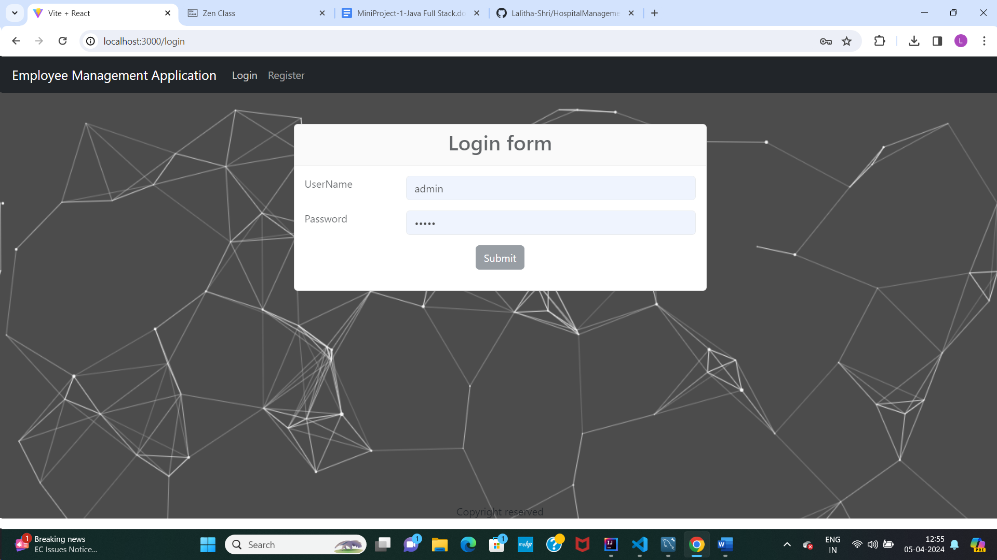

***Admin page***

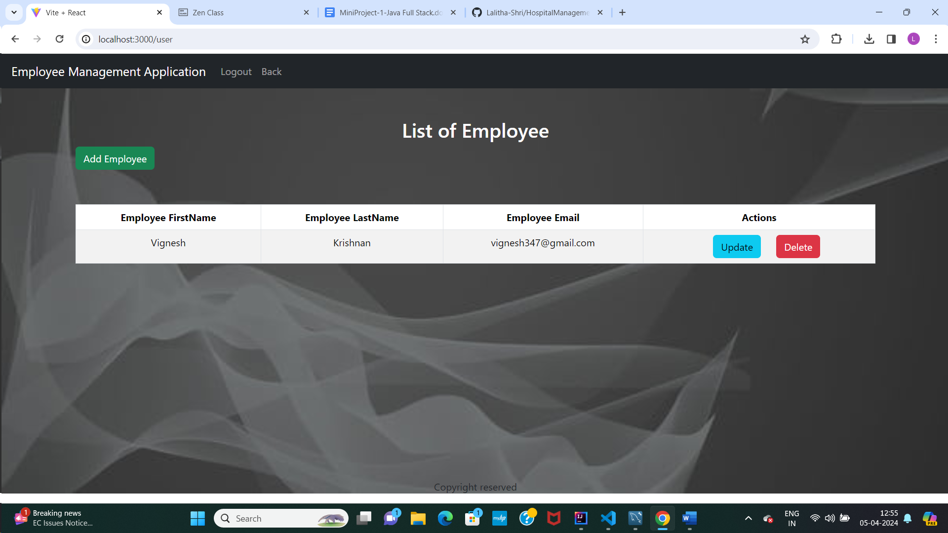

***Update Employee***

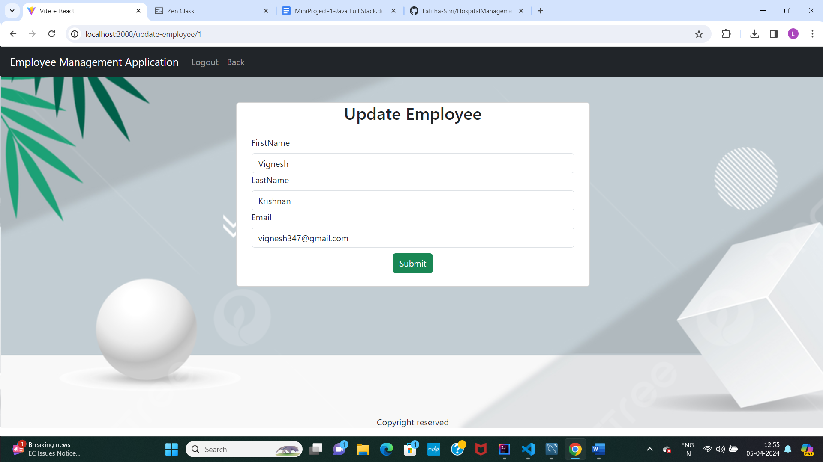

***Add employee***

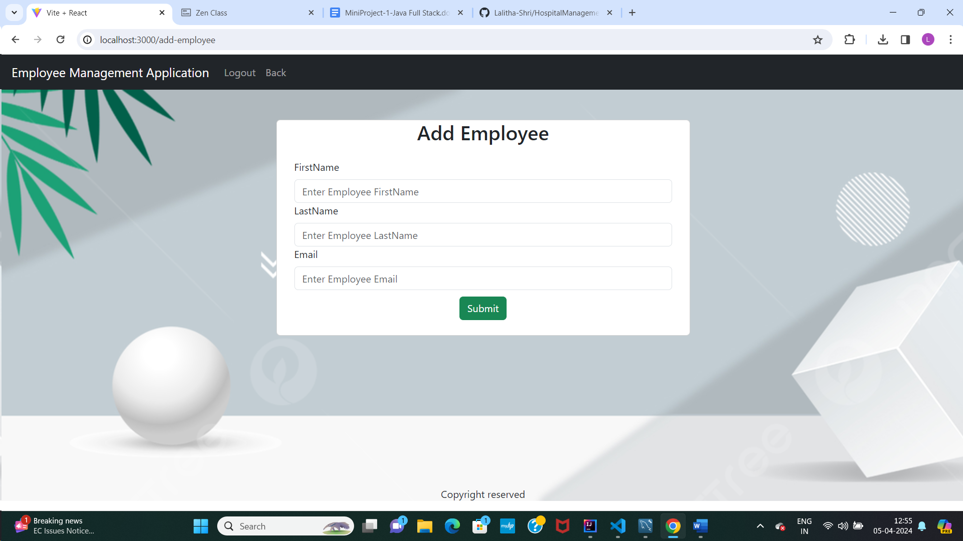

***List of employee display***

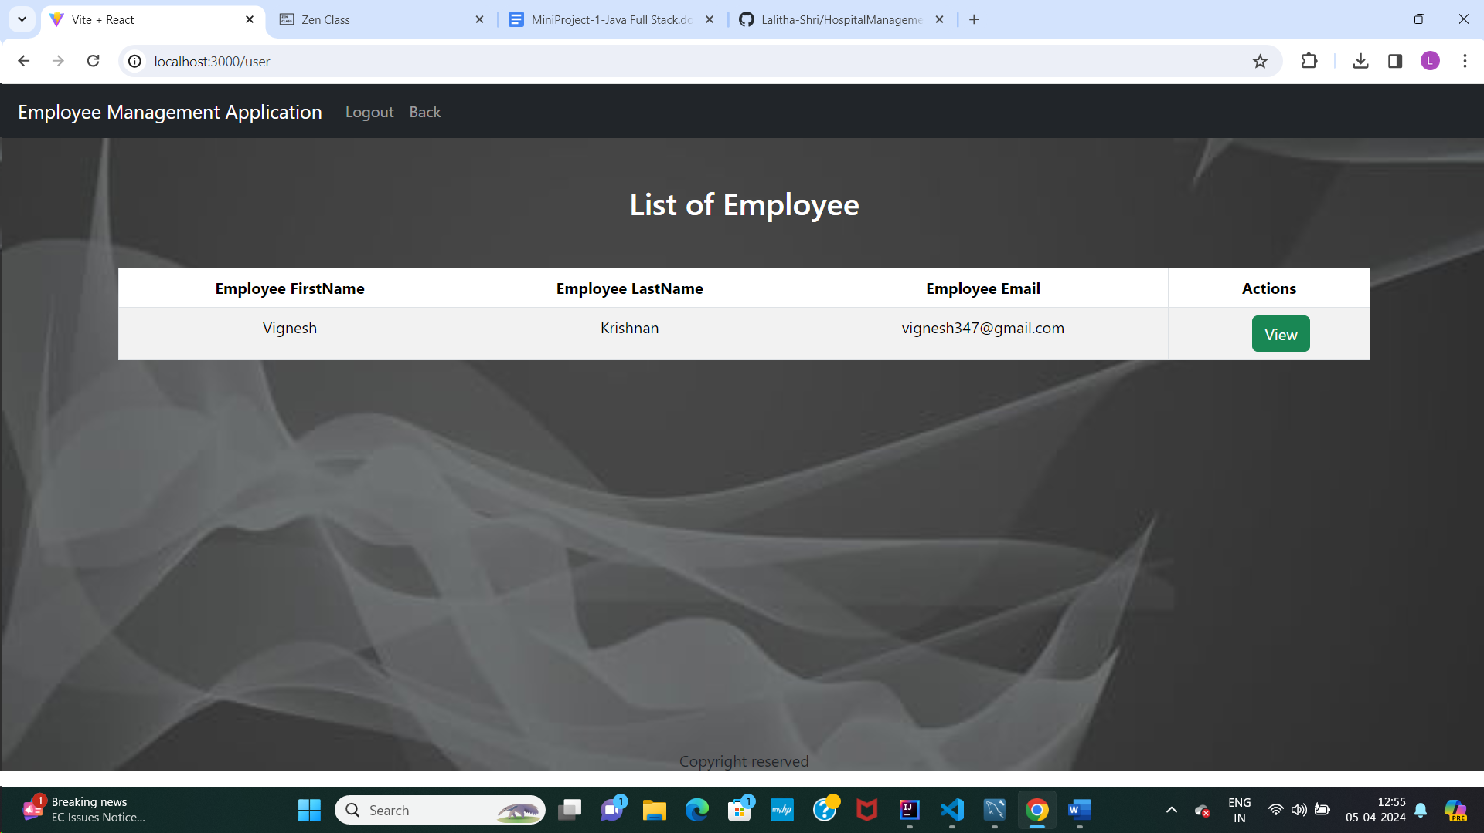

***View Employee***

