**MySql Guvi task**

1. Write a query to display ename and salary of employee whose salary are greater than or equal to 2200

**Query :**

**select ename,sal from Empl where sal>=2200;**

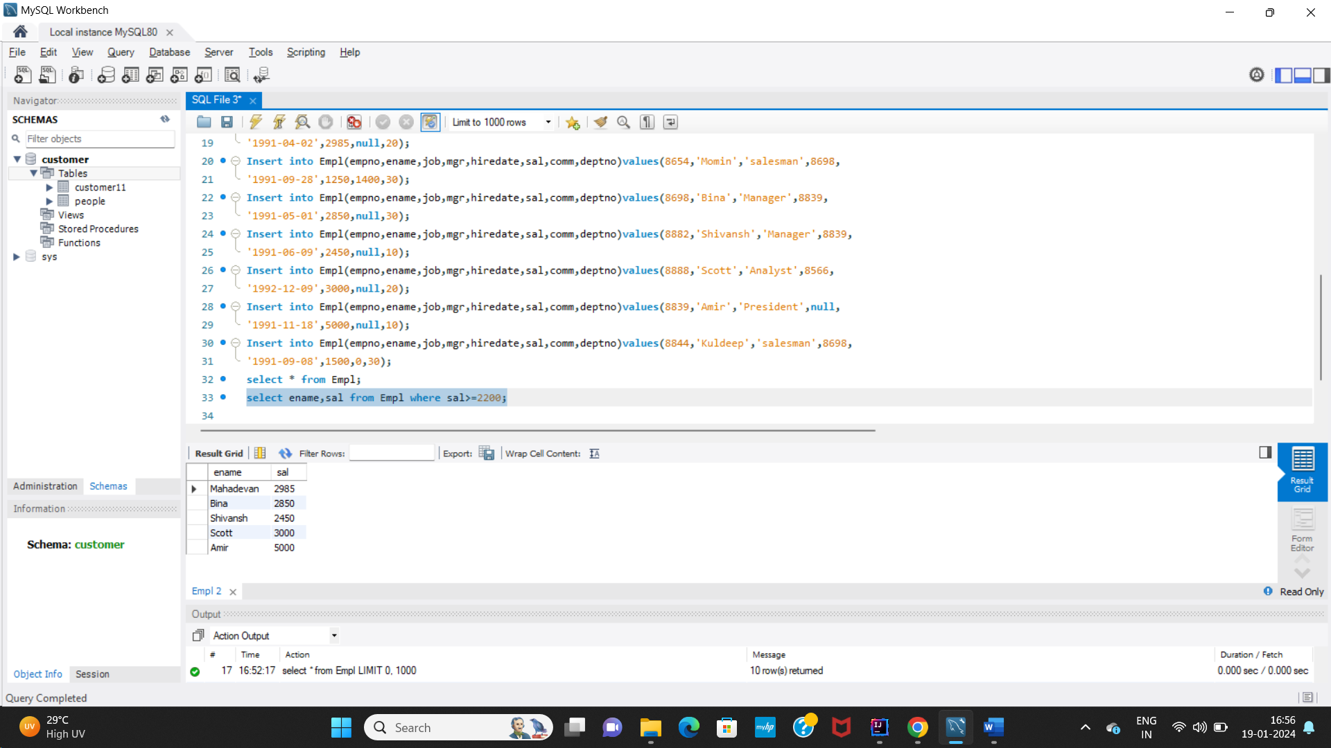

1. Write a query to display details of employee who are not getting commission:

**Query :**

**select * from Empl where comm IS NULL;**

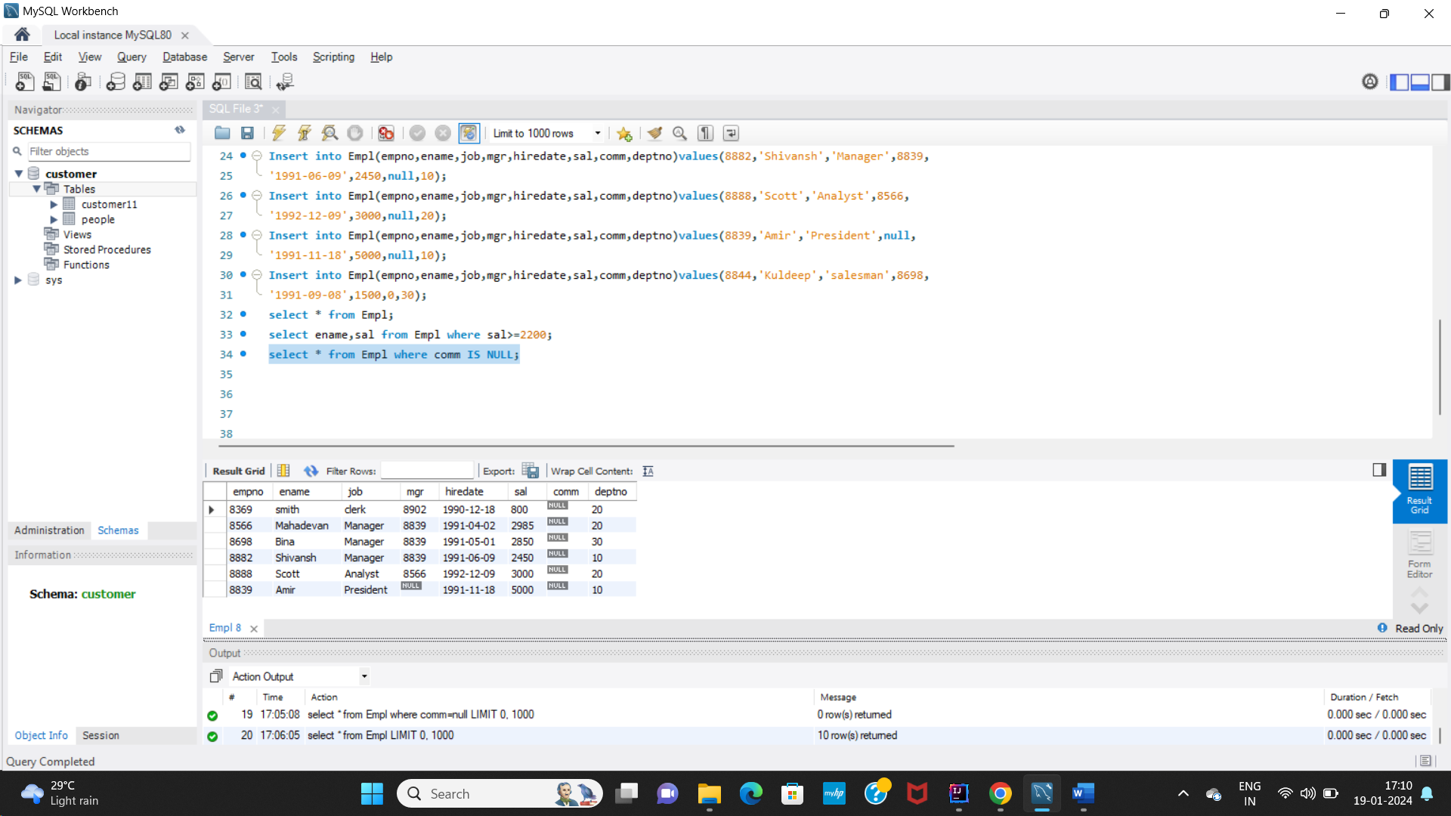

1. write a query to display the name,job title and salary of employee who don’t have their salary in the range of 2500 to 4000:

**Query :**

**select * from Empl where sal NOT BETWEEN 2500 and 4000;**

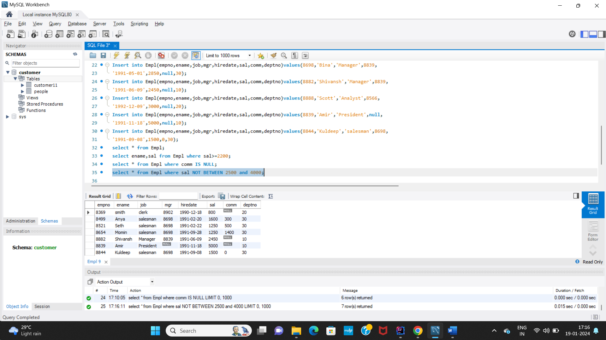

1. Write a query to display the name, job title and salary of employee who don’t have a manager?

**Query :**

**select ename,job from Empl where mgr IS NULL;**

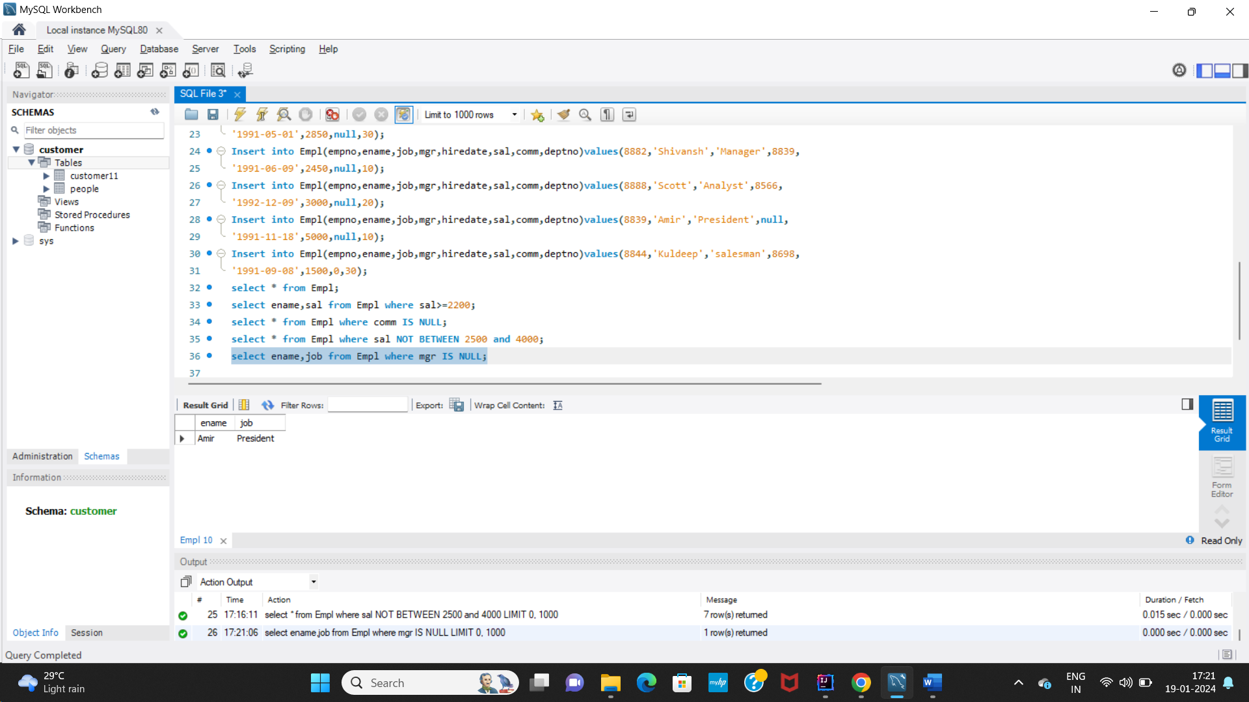

1. Write a query to display the name of employee whose name contains ‘a’ as third alphabet:

**Query :**

**Select ename from Empl where ename like "__a%";**

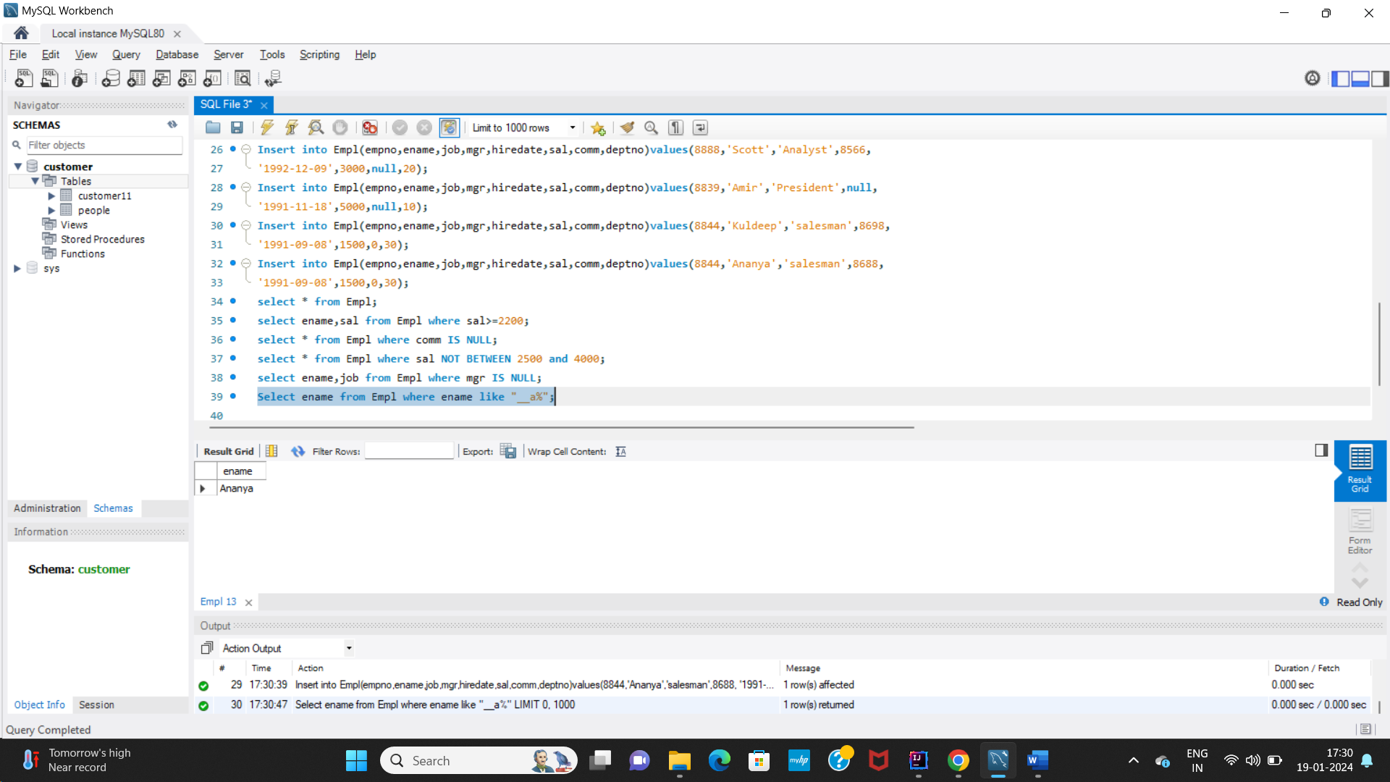

1. Write a query to display the name of employee whose name contains ‘t’ as last alphabet:

**Query :**

**Select ename from Empl where ename like "%t";**

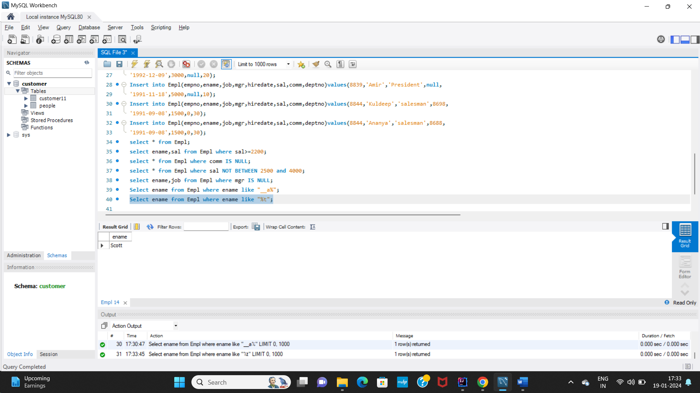

1. **Write a program for jdbc connection and insert the given data.**

**Output of First record insertion:**

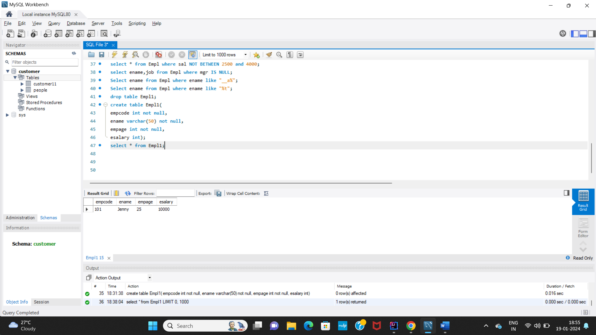

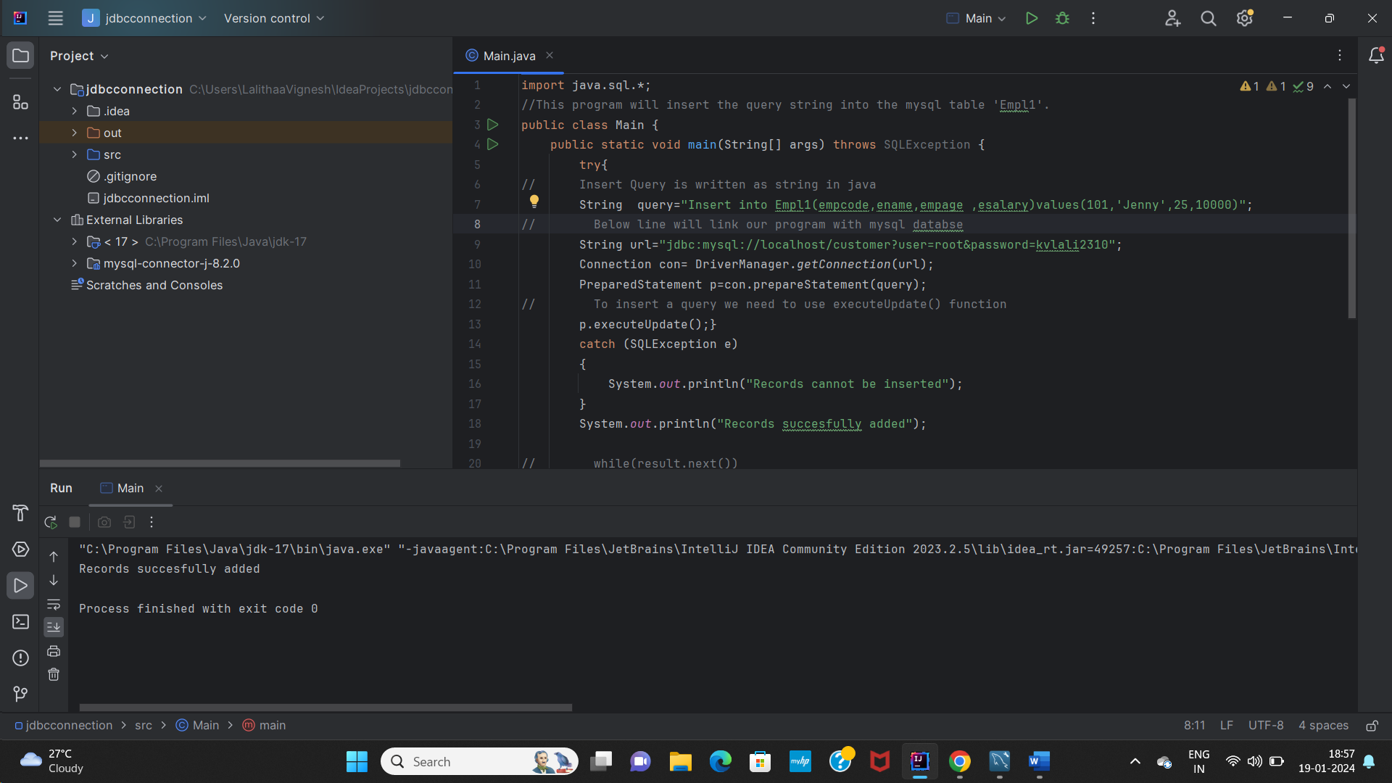

**Output: After inserting all 5 records:**

