**MONGODB-Task1**

1. Find all the information about each products

**Query :db.product.find()**

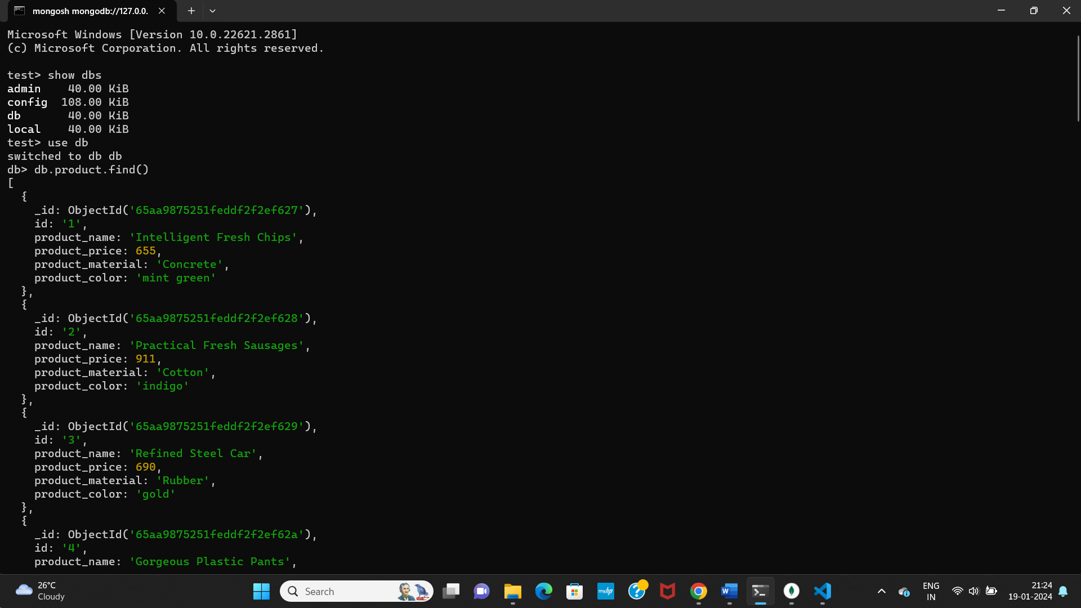

1. .Find the product price which are between 400 to 800

**Query :** **{db.product.find({product_price:{$gte:400,$lte:800}})}**

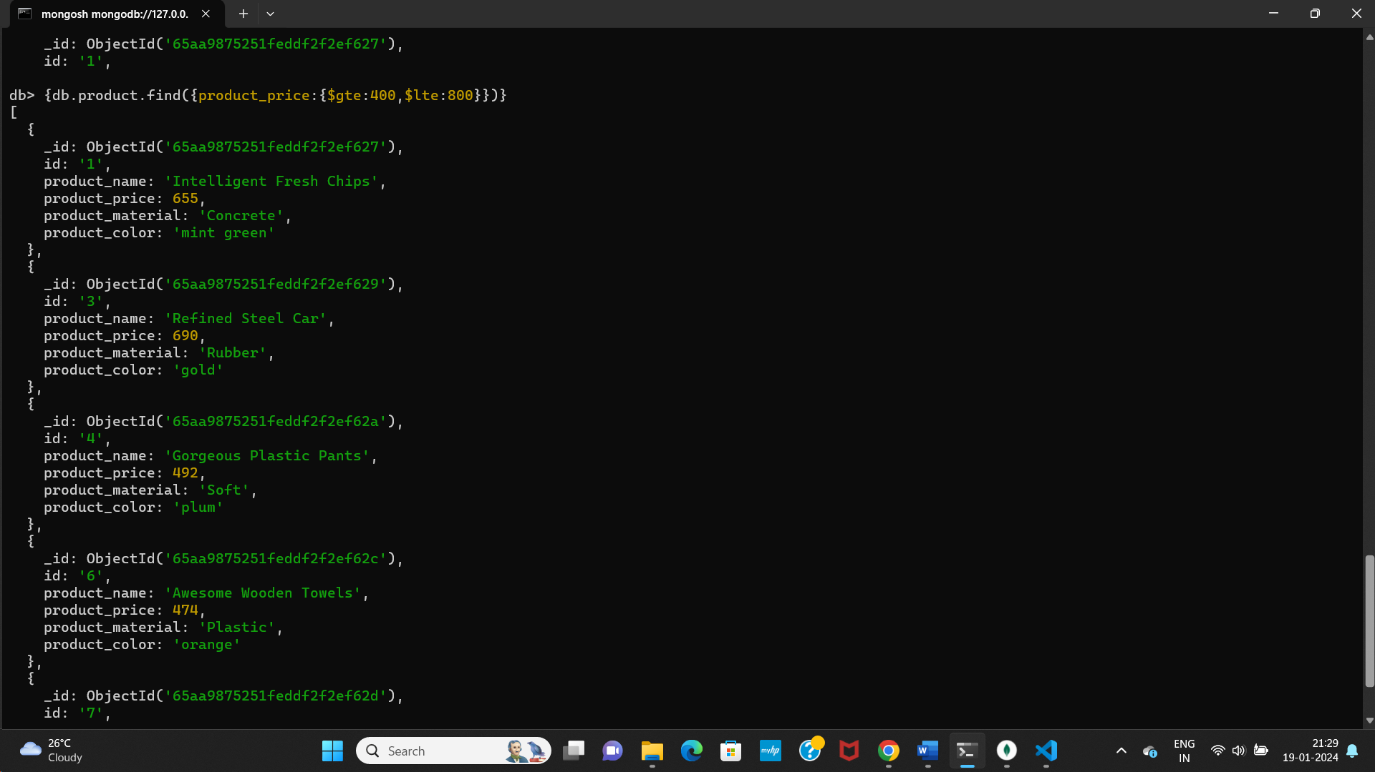

1. Find the product price which are not between 400 to 600

**Query:**

**db.product.find({product_price: {$not: {$gt: 400, $lt: 600}}})**

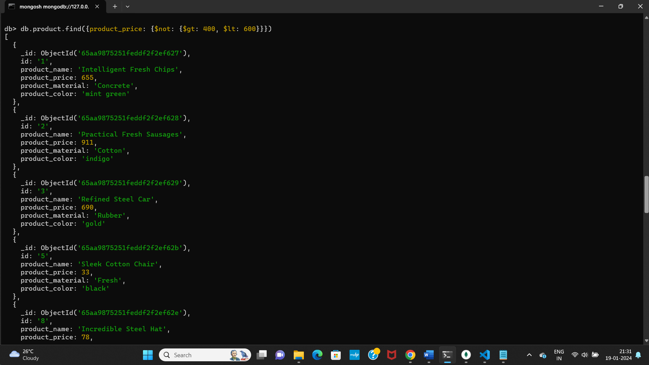

1. List the four product which are grater than 500 in price

**Query : db.product.find({product_price:{$gt:500}}).limit(4);**

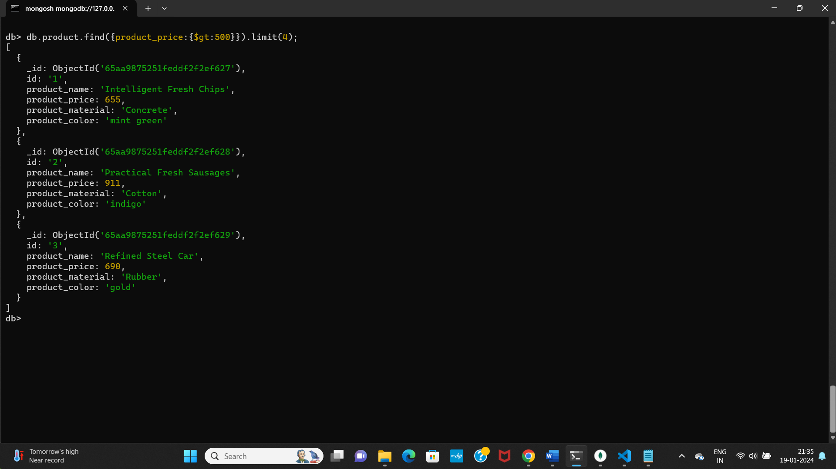

1. Find the product name and product material of each products

**Query:** **db.product.find({},{product_name:true,product_material:true})**

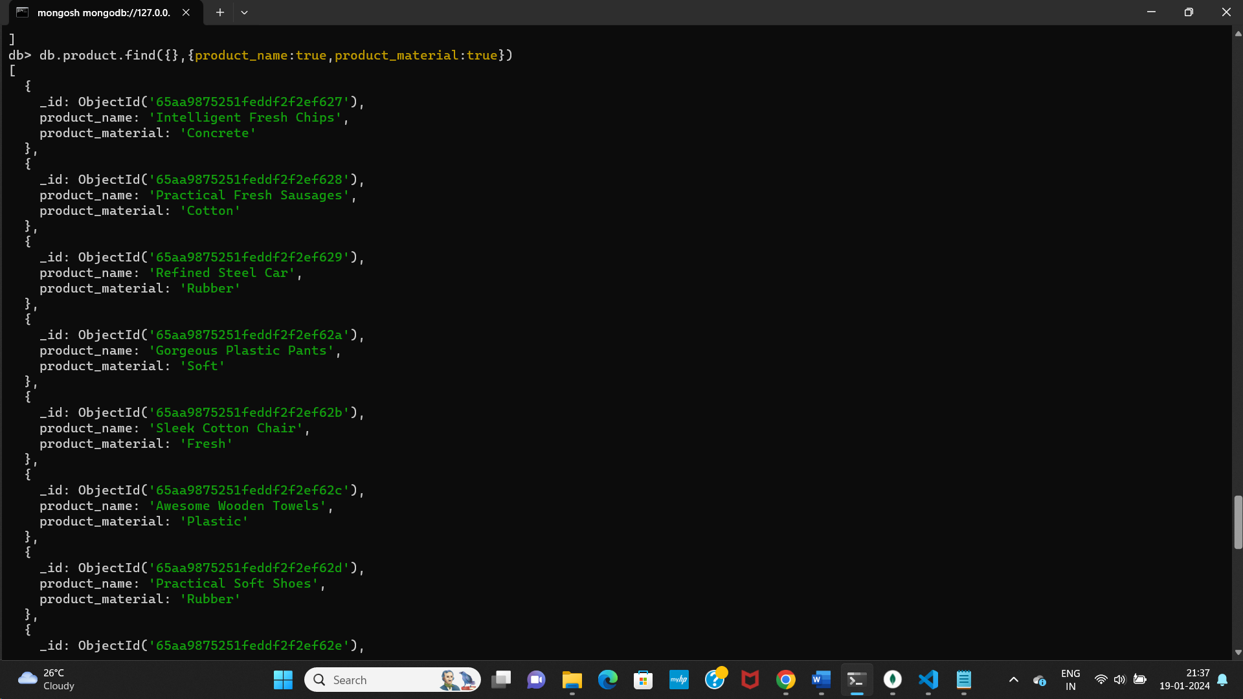

1. Find the product with a row id of 10

**Query : db.product.find({id:'10'})**

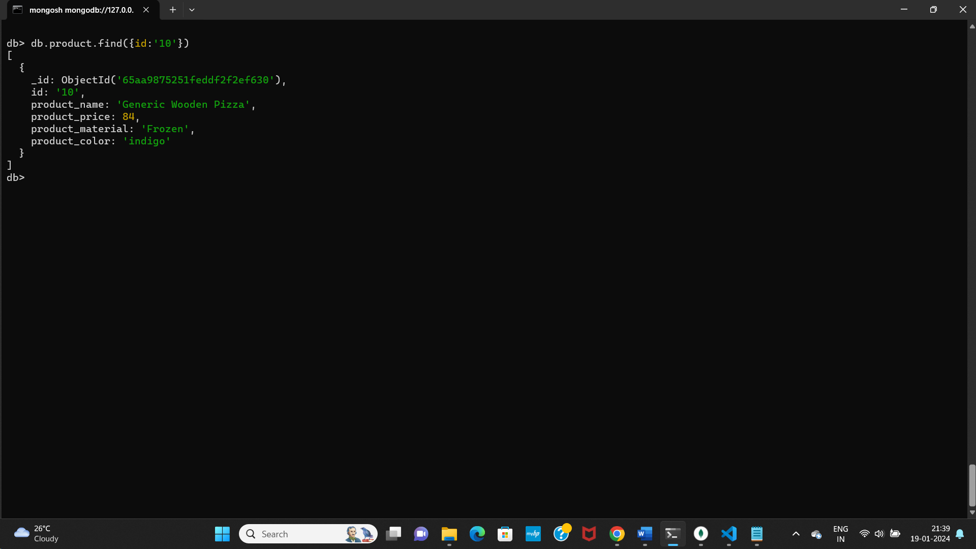

1. Find only the product name and product material

**Query :**

**db.product.find({}, { product_name: 1, product_material: 1,_id:0})**

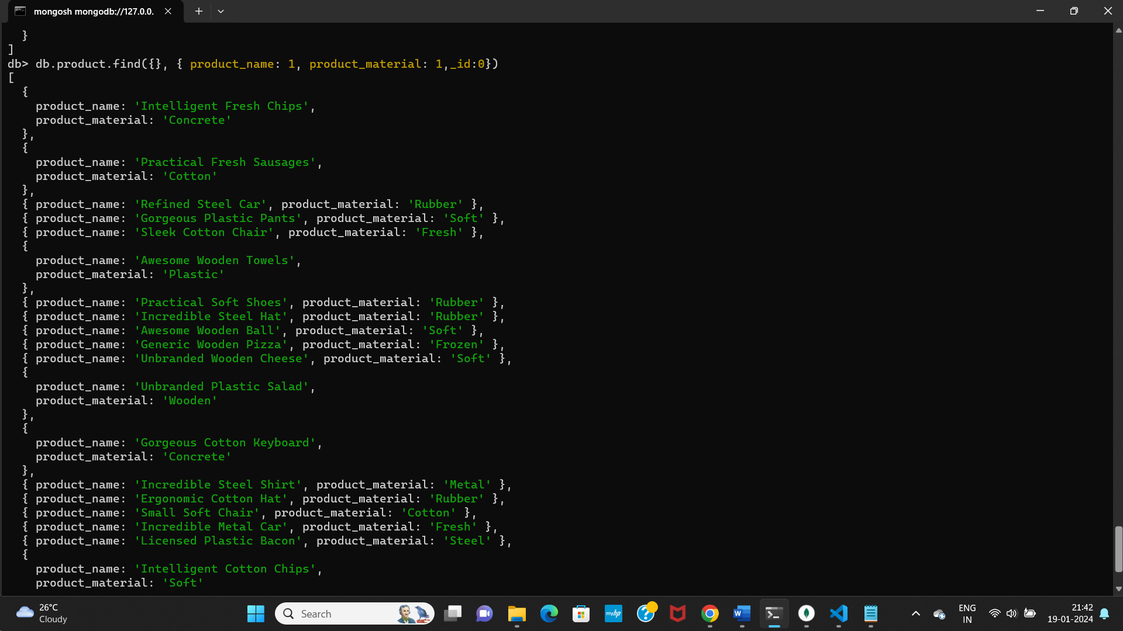

1. Find all products which contain the value of soft in product material

**Query : db.product.find({product_material:'Soft'})**

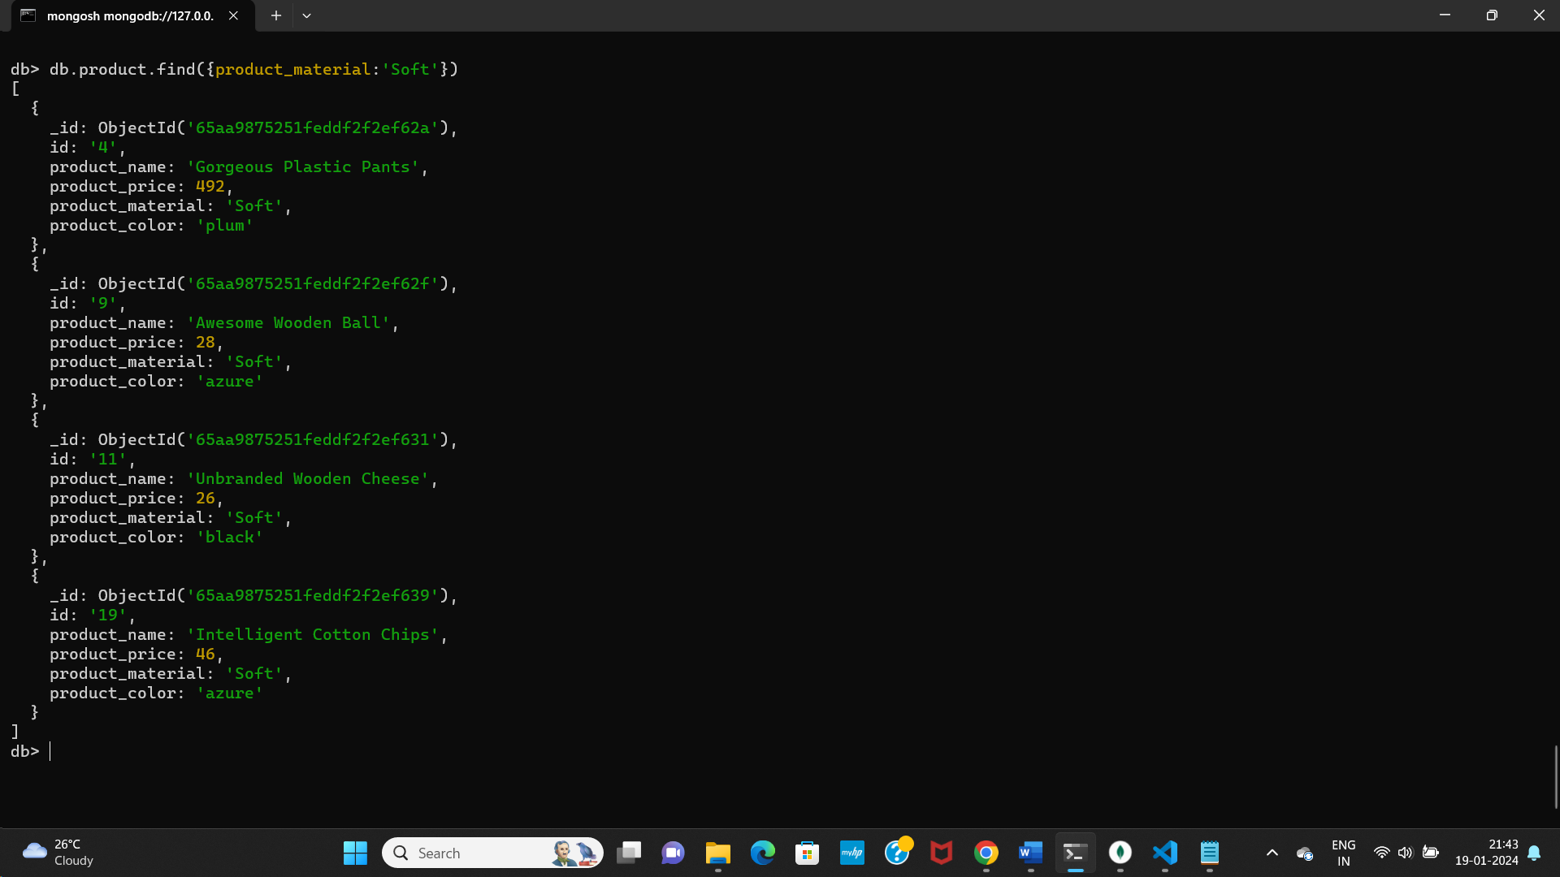

1. Find products which contain product color indigo  and product price 492.00

**Query: db.product.find({product_color:'indigo',product_price:492.00})**

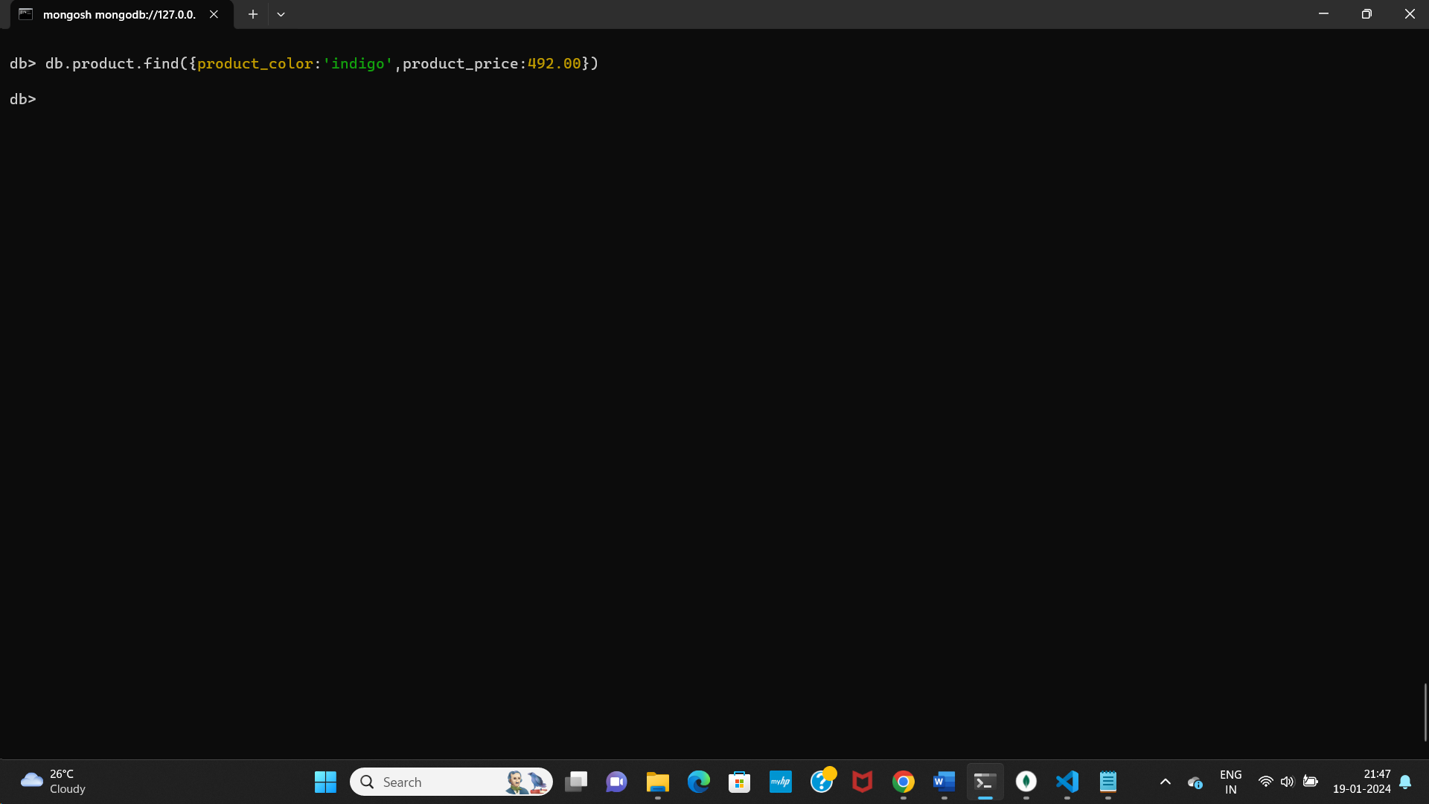

10.Delete the products which product price value are same

**Query:**

**1.var duplicatePrices = db.product.aggregate([{ $group: { _id: "$product_price", count: { $count: {} } } },{ $match: { _id: { $ne: null },count: { $gt: 1 } } }]).toArray().map(doc => doc._id);**

**2.db> db.product.deleteMany({ product_price: { $in: duplicatePrices } });**

