ANALOG ELECTRIC CIRCUITS

PROJECT REPORT

METAL DETECTOR CIRCUIT USING 555 TIMER IC

Submitted by:

AVUTHU SASHIDHAR REDDY 19BEC0534

P.V.S SREE LALITHA 19BEC0530

G. AUSTEN SANJAY 19BEC0535

INTRODUCTION

Development of security equipment is one of the leading areas of concern that is growing globally. Public areas like airports, theaters etc use metal detectors for safety to detect anyone with any metal(arms etc…). In this project we attempt to design and simulate one such metal detector circuit using a 555 timer ic.



CONCEPT BEHIND THE PROJECT

Inductors are coils of enameled copper wires in various shapes and sizes. Parameters of inductors are determined by the core in the inductor as it can create drastic changes the value of inductance. Inductors with no core have air as the medium of flow of magnetic field and have inductances of a very low value. On the other hand, inductor coils wound on any core(ferrite or an iron core) enormously increasing inductances. This value is much more than the air cored one of the same size and shape.



This figure shows a few air cored inductors which will have low inductance

For the RLC circuit as shown in the figure below, the reactance or impedance between terminals “a” and “c” depends on the values of L and C if the applied signal frequency is constant. This implies that change in the value of inductance can lead to change in the impedance.

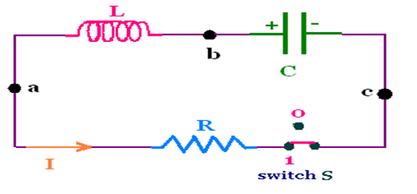

The vitality of this property in the project is explained in the working section.

555 TIMER IC

* The 555 timer IC is an integrated circuit (chip) used in a variety of timer, delay, pulse generation, and oscillator applications.
* The 555 generally operates in 3 modes: astable mode, mono-stable mode and bi-stable mode.

1. Astable mode

There will be no stable level at the output. So the output will be swinging between high and low. This character of unstable output is used as a clock or square wave output for many applications.

2. Mono-stable mode

This configuration consists of one stable and one unstable state. The stable state can be chosen either high or low by the user. If the stable output is set at high (1), the output of the timer is high (1). At the application of an interrupt, the timer output turns low (0). Since the low state is unstable it goes to high (1) automatically after the interrupt passes. Similar is the case for a low stable monostable mode.

3. Bi-stable mode

In bistable mode, both the output states are stable. At each interrupt, the output changes from low (0) to high (1) and vice versa, and stays there. For example, if we have a high (1) output, it will go low(0) once it receives an interrupt and stays low (0) till the next interrupt changes the status.

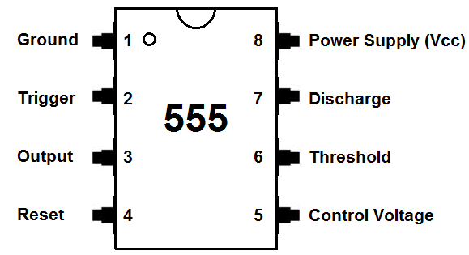

Pinout of the 555 timer IC

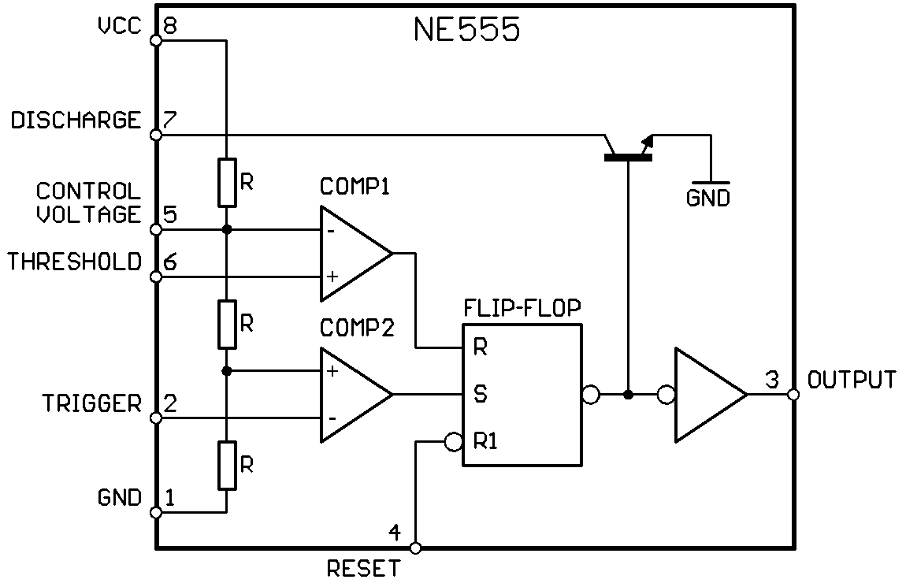

Construction of the 555 timer IC

CIRCUIT DIAGRAM

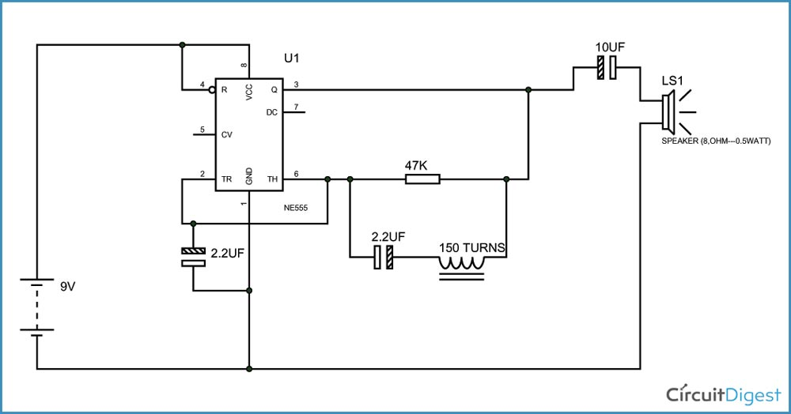

Components:

1. +9 supply voltage

2. 555 IC

3. 3. 47KΩ resistor

4. 2.2µF capacitor (2 pieces)

5. Speaker (8Ω)

6. 170Turns of 10cm diameter coil (any gauge would work)

WORKING

The figure above shows the circuit diagram of metal detector. The 555 IC timer here acts as a square wave generator and it generate pulses with frequencies audible to human. The capacitor between pin2 and pin1 should not be changed as it is need to generate audible frequencies. A metal core inductor has a high inductance value over an air cored one.

Remember the coil wound here is an air cored one, so when a metal piece is brought near the coil, the metal piece acts as a core for the air cored inductor. By this metal acting as a core, the inductance of the coil changes or increases considerably. With this sudden increase in inductance of coil the overall reactance or impedance of the RLC circuit changes by a considerable amount when compared without the metal piece.

An oscillator which produces AC current that passes through a coil producing an alternating magnetic field. A part of the metal is near to the coil, eddy current will be induced in the metal. This produces a magnetic field of its own. If another coil is used to measure the magnetic field. The change in the magnetic field due to the metallic object can be detected. The LC circuit activates the proximity sensor when it senses any metal close to it.

This sensor glow the LED and makes a buzzer.

CIRCUIT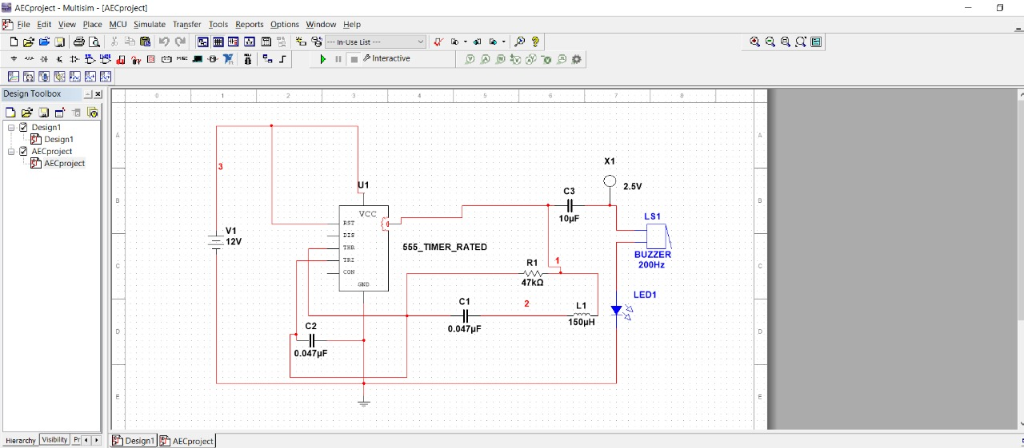

SIMULATION

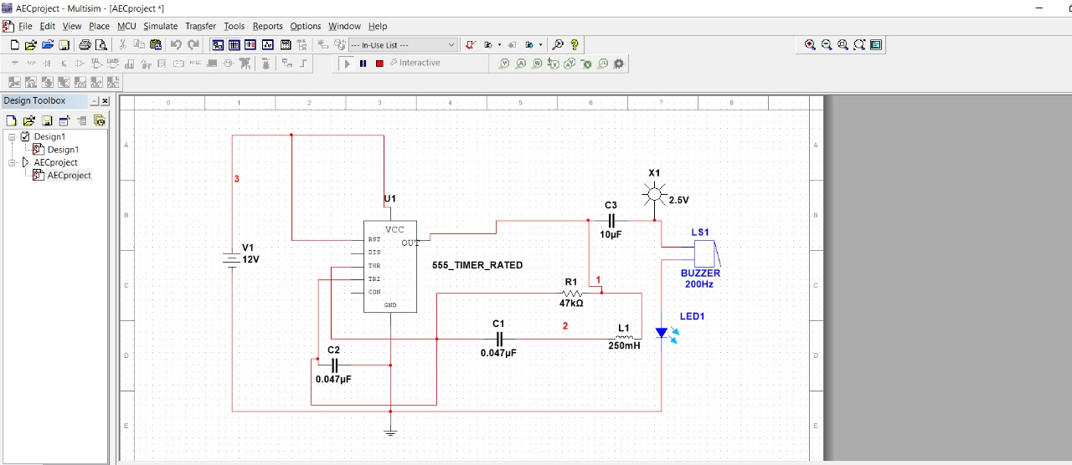

CALCULATION OF TIME CONSTANT

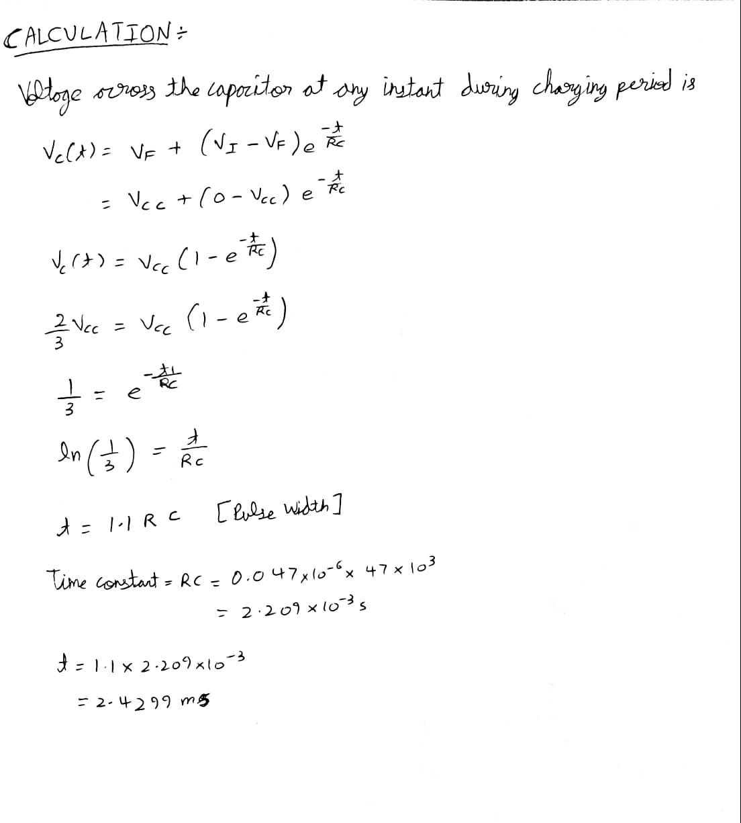

**Metal Detector Robotic Vehicle Operated by Android Application**

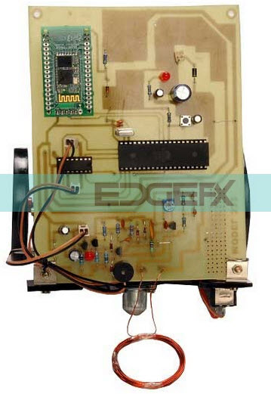The main intention of this project is to design a robotic vehicle which can detect metals ahead of it on its path. This robotic vehicle is controlled by an android applicationThis project includes a metal detector circuit that is interfaced to the control unit, that generates an alarm to the user when a metal is near to it. An [8051 microcontroller](https://www.elprocus.com/8051-microcontroller-architecture-and-applications/) is used for the desired operation. At the transmitter side, an Android application is used to send commands to the receiver. The robot moves forward, backward, right or left. At the receiving end, two motors are [interfaced to the 8051 microcontroller](https://www.elprocus.com/peripherals-interfacing-to-the-microcontroller-8051-in-electronics/) for the movement of the vehicle.

The android application acts as a remote while the receiver end Bluetooth device is fed to the microcontroller to drive DC motors through motor driver IC for desired operation. A metal detector circuit is placed in the robot, and the operations of the robot are carried out automatically if it detects any metal underneath. As soon as the robot detects a metal, it generates an alarm sound. Furthermore, this project can be developed by fixing a wireless camera to the robot So that the operator can control the robotic movement remotely by watching it on a screen