**SENSORS PROJECT**

**TEAM MEMBERS:**

1)Lavnya Gune-19BEC0367

2)Shreyas Khandekar-19BEC0541

3)Saloni Koshe-19BEC0579

4)Ankita Mandal-19BEC0543

5)Vinay Jadhav-19BEC0374

6)Vaishnavi Tangirala-19BEC0403

7)Sree Lalitha P.V.S-19BEC0530

**ABSTRACT**

A basic Proximity sensor is designed to detect the presence of nearby objects without any physical contact. Proximity sensors basically employ an InfraRed(IR) LED transmitter and IR receiver to achieve proximity detection purpose. This proximity sensor comprises of three Infra-red LEDs and one IR receiver for higher accuracy. Infrared sensors are widely used as distance or proximity sensors and for obstacle avoidance in robotics. A Proximity sensor is designed using an infrared distance sensor which is used to detect the object and generally followed up by a buzzer to alert the user. This voice assisted proximity sensor replaces the buzzer with an audio output. This sensor employs infrared distance sensor to detect the object within the specific distance range of the sensor and then provides simplified instructions to the user according to which user can make decisions. In this case, we use the voice assisted proximity sensor to help a blind person to commute. This sensor provides directions to the user to the objects present in front of the sensor and helps him to move accordingly.

# TABLE OF CONTENTS

AKNOWLEDGEMENT 05

ABSTRACT 06

TABLE OF CONTENTS 07

LIST OF FIGURES 09

Chapter I: INTRODUCTION

1.1 INTRODUCTION 10

1.2 MOTIVATION 11

1.3 OBJECTIVE 11

Chapter II: VOICE ASSISTED PROXIMITY SENSOR

2.1 BASIC LAYOUT 12

2.2 COMPONENTS USED

2.2.1 BREADBOARD 13

2.2.2 IR LED 14

2.2.3 IR RECEIVER 15

2.2.4 ARDUINO UNO BOARD 16

2.2.5 OUTPUT DEVICE(EARPHONES) 19

2.2.6 BATTERY 20

Chapter III: WORKING AND SOFTWARE DESIGN

3.1 WORKING PRINCIPLE

3.1.1 SENSOR PRINCIPLE 21

3.1.2 ARDUINO PRINCIPLE 24

3.1.3 TALKIE LIBRARY 24

3.2 CIRCUIT DIAGRAM

3.2.1 CONNECTION TO IR SENSOR 25

3.2.2 CONNECTION TO VOICE OUTPUT 26

3.2.3 OVERALL CIRCUIT 27

3.3 SOURCE CODE

3.3.1 SENSOR CODE 27

3.3.2 VOICE OUTPUT CODE 28

3.3.3 OVERALL CODE 30

Chapter IV: RESULTS & DISCUSSIONS

4.1 RESULTS 32

4.2 APPLICATIONS 34

4.3 LIMITATIONS 34

Chapter V: CONCLUSION & FUTURE SCOPE 35

REFERENCES 36

# LIST OF FIGURES

Chapter I

Fig 1.1 Classification of proximity sensors 10 Chapter II

Fig 2.1 Block diagram of the circuit 12

Fig 2.2 Breadboard 13

Fig 2.3 IR LED 14

Fig 2.4 IR Receiver 15

Fig 2.5 Arduino Uno board 16

Fig 2.6 Earphones 19

Fig 2.7 Battery 20

Chapter III

Fig 3.1 Principle of IR Sensor 21

Fig 3.2 No reflecting surface 22

Fig 3.3 Moving object 23

Fig 3.4 Stationary object 23

Fig 3.5 Connection to IR sensor 25

Fig 3.6 Connection to audio output 26

Fig 3.7 Overall circuit 27

Chapter IV

Fig 4.1 Serial monitor(When there is no reflecting surface) 32

Fig 4.2 Serial monitor(When there is a moving surface) 33

Fig 4.3 Serial monitor(When there is a stationary surface) 33

# CHAPTER I

## INTRODUCTION

### 1.1 INTRODUCTION

A proximity sensor is a type of sensor to be able to detect the presence of nearby objects without any physical contact. A proximity sensor often emits an electromagnetic field or a beam of electromagnetic radiation (infrared, for instance), and looks for changes in the field or return signal. The object being sensed is often referred to as the proximity sensor's target.

Different proximity sensor targets demand different sensors:

PROXIMITY SENSOR

S

INDUCTIVE

ULTRASONIC

CAPACITIVE

PHOTOELECTRIC

***Fig.1.1 CLASSIFICATION OF PROXIMITY SENSORS***

Inductive: This type of sensor is used to detect nearby metallic objects. The sensor creates an electromagnetic field around itself or on a sensing surface.

Capacitive: This type of sensor is used for detection of metallic objects and non-metallic objects.

Photoelectric: This type of sensor is used to detect objects. A light source and receiver are the main components of such sensors.

Ultrasonic: These proximity sensors direct ultrasonic sound waves (i.e. high frequency sound waves beyond the audible frequencies) to a target and measure the time taken for the sound waves to return; the further away the object the greater the time taken.

A capacitive proximity sensor might be suitable for a plastic target, an inductive proximity sensor always requires a metal target. An inductive proximity sensor always requires a metal target.

So, we generally opt for photoelectric or ultrasonic proximity sensors which mostly don’t depend on the type of the object.

Ultrasonic proximity sensors are used for long range applications whereas photoelectric proximity sensors(such as IR sensors, optical sensors) are used for short range applications.

In this project we use IR(infra-red) proximity sensor.

### 1.2 MOTIVATION

Proximity sensors are used everywhere in these days, starting from smartphones to antiaircraft warfare. This method of detection of objects without any physical contact is highly useful and is applicable everywhere. Even sophisticated washrooms consist of proximity sensors and airplanes can also be controlled using these sensors. Application of these sensors are developing rapidly in today’s world.

Visually challenged people are always trying their best to be normal and comfortable in their surroundings. However, their lives and activities are greatly restricted due to loss of eyesight.

So, our main motive is to develop a type of sensor which will aid a visually challenged person throughout his journey of life. This project is a near replacement to the visual sense of a blind person. This project acts as a third eye for the blind.

### 1.3 OBJECTIVE

Voice assisted proximity sensor will become a great help to blind people because this kind of tool is able to detect objects in specific range. When an object is detected, voice is heard from the earphones which will alert the user about the object and gives him directions accordingly. As the position of object varies, instructions are given to the user which will help him to navigate. Hence, the user is able to avoid obstacles better using this newly designed tool or device.

# CHAPTER II

## VOICE ASSISTED PROXIMITY SENSOR

### 2.1 BASIC LAYOUT

IR LED

IR

RECEIVER

AUDIO/VOICE

OUTPUT

ARDUINO

BATTERY

***Fig.2.1 BLOCK DIAGRAM OF THE CIRCUIT***

Initially the IR LED transmitter is powered up by the Arduino and the LED generates infrared rays around it. The IR receiver, which is powered by the Arduino, receives the reflected IR rays in the presence of an object. These reflected rays are sensed by the IR receiver and transfers the appropriate analog signals to the Arduino which are then analyzed by the Arduino. Depending upon the signals received and analyzation, an appropriate audio/voice output signal is generated and is given to the user using earphones or speakers.

The whole system is powered by the Arduino and the Arduino is powered by an external battery.

### 2.2 COMPONENTS USED

#### 2.2.1 BREADBOARD

A breadboard is a solderless device for temporary prototype with electronics and test circuit designs. Most electronic components in electronic circuits can be interconnected by inserting their leads or terminals into the holes and then making connections through wires where appropriate. The breadboard has strips of metal underneath the board and connect the holes on the top of the board. The metal strips are laid out as shown below. Note that the top and bottom rows of holes are connected horizontally and split in the middle while the remaining holes are connected vertically.Note how all holes in the selected row are connected, so the holes in the selected column. The set of connected holes can be called a node. A modern solderless breadboard socket consists of a perforated block of plastic with numerous tin-plated phosphor bronze or nickel silver alloy spring clips under the perforations. The clips are often called *tie points* or *contact points*. The number of tie points is often given in the specification of the breadboard. The spacing between the clips (lead pitch) is typically 0.1 inches (2.54 mm). The edge of the board has male and female dovetail notches so boards can be clipped together to form a large breadboard.

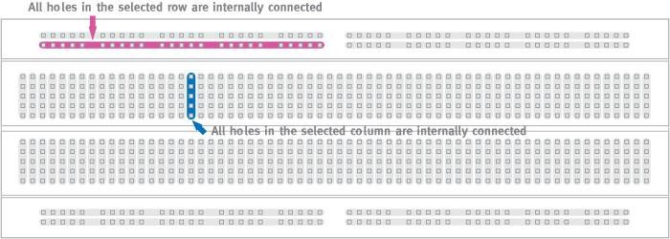

#### Fig.2.2 BREADBOARD

##### 2.2.2 IR LED

An **IR LED** is a specially designed LED which transmits infrared rays. These rays are not able to be seen by the human eyes as it’s not in the range of human visible electromagnetic radiation spectrum. We can only see light rays from violet to red whose wavelength travels from 380 (violet light) to 750nm (red light).

The IR LED is same aspect as the normal LED. IR LED stands for “Infrared Light Emitting Diode”, they allow to emit light with the wavelength of up to 940nm, which is the infrared range of electromagnetic radiation spectrum. The wavelength range varies from 760nm to 1mm. These are mostly use in the remote control of TV’s, cameras and different types of electronic instruments. The semiconductor material used to make these LEDs are gallium arsenide or aluminium arsenide. Mostly used in IR sensor as it is the combination of IR receiver and IR transmitter (IR LED).

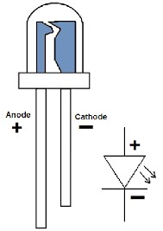

***Fig.2.3 IR LED TECHNICAL SPECIFICATIONS* :**

* Forward current (IF) is 100mA (normal condition) and 300mA (max.)
* 1.5A of surge forward current
* 1.24v to 1.4v of forward voltage
* Temperature for storage and operation varies from -40 to 100 ℃
* Soldering Temperature should not exceed 260 ℃
* Power Dissipation of 150mW at 25℃ (free air temperature) or below
* Spectral bandwidth of 45nm
* Viewing angle is 30 to 40 degree

##### 2.2.3 IR RECEIVER

Photodiodes, as the name suggest these are just another type of diodes. These diodes also have an anode and cathode just like normal LED. But, unlike LED’s these do not emit light. Instead, when they detect light, they allow some current to flow through it. The amount of current that flows through the Photodiode is directly proportional the amount of light detected by the Photodiode.

Due to this property of Photodiode, it is fairly used in situations where light must be detected. It is also commonly used with IR transmitter (IR LED) to form an IR pair and used in applications like object detection, counter, encoder and much more.

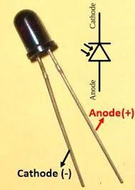

#### Fig.2.4 IR RECEIVER

***TECHNICAL SPECIFICATIONS* :**

* Wavelength Sensitivity (λP): 940nm
* Open Circuit Voltage: 0.39V
* Reverse breakdown voltage: 32V
* Reverse Light current: 40μA
* Reverse Dark current: 5nA
* Rise Time/ Fall Time: 45/45nS
* View Angle: 80 deg
* Package: 5mm

##### 2.2.4 ARDUINO UNO BOARD

Arduino is a software company, project, and user community that designs and manufactures computer open-source hardware, open-source software, and microcontroller-based kits for building digital devices and interactive objects that can sense and control physical devices. The project is based on microcontroller board designs, produced by several vendors, using various microcontrollers. These systems provide sets of digital and analog I/O pins that can interface to various expansion boards and other circuits. The boards feature serial communication interfaces, including Universal Serial Bus (USB) on some models, for loading programs from personal computers. For programming the microcontrollers, the Arduino project provides an integrated development environment (IDE) based on a programming language named *Processing*, which also supports the languages C and C++. The first Arduino was introduced in 2005, aiming to provide a low cost, easy way for novices and professionals to create devices that interact with their environment using sensors and actuators. Common examples of such devices intended for beginner hobbyists include simple robots, thermostats, and motion detectors.

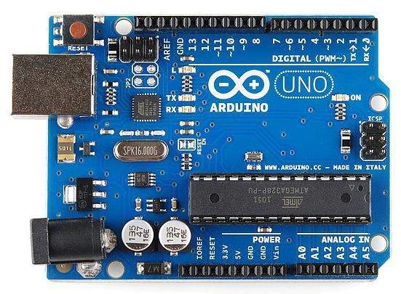

#### Fig.2.5 ARDUINO UNO BOARD

Arduino is a single-board microcontroller meant to make the application more accessible which are interactive objects and its surroundings. The hardware features with an opensource hardware board designed around an 8-bit Atmel AVR Microcontroller or a 32-bit

Atmel ARM. Current models consists a USB interface, 6 analog input pins and 14 digital I/O pins that allows the user to attach various extension boards.

The Arduino Uno board is Microcontroller based on the ATmega328. It has 14 digital input/output pins in which 6 can be used as PWM outputs, a 16 MHz ceramic resonator, an ICSP header, a USB connection, 6 analog inputs, a power jack and a reset button. This contains all the required support needed for microcontroller. In order to get started, they are simply connected to a computer with a USB cable or with a AC-to-DC adapter or battery. Arduino Uno Board varies from all other boards and they will not use the FTDI USB-to-serial driver chip in them. It is featured by the Atmega16U2 (Atmega8U2 up to version R2) programmed as a USB-to-serial converter.

***SOFTWARE AND PROGRAMMING:-***

The Arduino project provides the Arduino integrated development environment (IDE), which is a cross-platform application written in the programming language Java. It originated from the IDE for the languages Processing and Wiring. It is designed to introduce programming to artists and other newcomers unfamiliar with software development. It includes a code editor with features such as syntax highlighting, brace matching, and automatic indentation, and provides simple one-click mechanism to compile and load programs to an Arduino board. A program written with the IDE for Arduino is called a "sketch".

The Arduino IDE supports the languages C and C++ using special rules to organize code.

***FEATURES OF ARDUINO UNO:-***

* It is an easy USB interface. This allows interface with USB as this is like a serial device.
* The chip on the board plugs straight into your USB port and supports on your computer as a virtual serial port. The benefit of this setup is that serial communication is an extremely easy protocol which is time-tested, and USB makes connection with modern computers and makes it comfortable.
* It is easy-to-find the microcontroller brain which is the ATmega328 chip. It has a greater number of hardware features like timers, external and internal interrupts, PWM pins and multiple sleep modes.
* It is an open source design and there is an advantage of being open source is that it has a large community of people using and troubleshooting it. This makes it easy to help in debugging projects.
* It is a 16 MHz clock which is fast enough for most applications and does not speeds up the microcontroller.
* It is very convenient to manage power inside it and it had a feature of built-in voltage regulation. This can also be powered directly off a USB port without any external power. You can connect an external power source of 12v (maximum) and this regulates it to both 5v and 3.3v.
* 13 digital pins and 6 analog pins. This sort of pins allows you to connect hardware to your Arduino Uno board externally. These pins are used as a key for extending the computing capability of the Arduino Uno into the real world. Simply plug your electronic devices and sensors into the sockets that correspond to each of these pins and you are good to go.
* This has an ICSP connector for bypassing the USB port and interfacing the Arduino directly as a serial device. This port is necessary to re-boot your chip if it corrupts and can no longer used by your computer.
* It has a 32 KB of flash memory for storing your code.
* An on-board LED is attached to digital pin 13 to make fast the debugging of code and to make the debug process easy.
* Finally, it has a button to reset the program on the chip.
* Sound is output on digital pin 3 and/or 11. It can drive headphones directly or add a simple audio amplifier to drive a loudspeaker.

##### 2.2.5 OUTPUT DEVICE (EARPHONES)

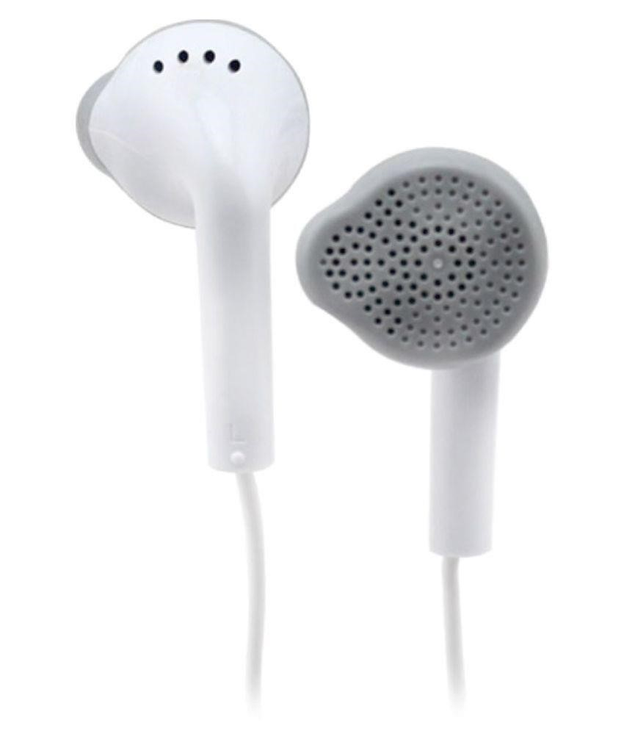

***Fig.2.6 EARPHONES***

***TECHNICAL SPECIFICATIONS* :**

* Impedance (Ohm) 32
* Sensitivity (db/mW) 108
* Jack Diameter (in mm) 3.5
* Rechargeable Battery No
* Max Power Input (mW) 30
* Frequency Range(Hz) 6 – 40,000

##### 2.2.6 BATTERY

The **nine-volt battery**, or **9-volt battery**, is a common size of battery that was introduced for the early transistor radios. It has a rectangular prism shape with rounded edges and a polarized snap connector at the top. This type is commonly used in walkietalkies, clocks and smoke detectors.

The nine-volt battery format is commonly available in primary carbon-zinc and alkaline chemistry, in primary lithium iron di-sulphide, and in rechargeable form in nickelcadmium, nickel-metal hydride and lithium-ion. Mercury-oxide batteries of this format, once common, have not been manufactured in many years due to their mercury content.

Following figure shows the representation of a typical 9V battery.

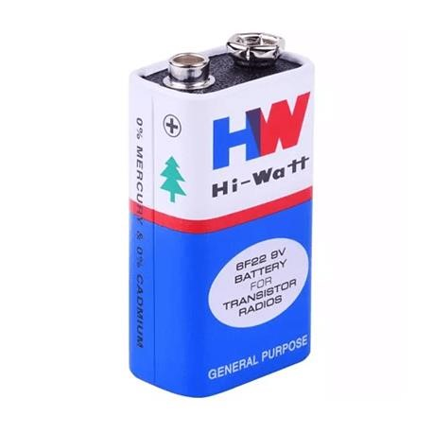

#### Fig.2.7 BATTERY

***TECHNICAL SPECIFICATIONS* :**

* Nominal Voltage 9V
* Impedance 1,700 mΩ at 1kHz
* Typical Weight 45g
* Typical Volume 22.8 cm³
* Terminals Miniature Snap
* Storage Temperature Range 5ºC to 30ºC
* Operating Temperature Range -20ºC to 54ºC
* Designation IEC-6LR61

# CHAPTER III

## WORKING AND SOFTWARE DESIGN

### 3.1 WORKING PRINCIPLE 3.1.1 SENSOR PRINCIPLE

An IR sensor consists of two parts, the emitter circuit and the receiver circuit. This is collectively known as a photo-coupler or an optocoupler.

The emitter is an IR LED and the detector is an IR photodiode. The IR photodiode is sensitive to the IR light emitted by an IR LED. The photo-diode’s resistance and output voltage change in proportion to the IR light received. This is the underlying working principle of the IR sensor.

The type of incidence can be direct incidence or indirect incidence. In direct incidence, the IR LED is placed in front of a photodiode with no obstacle in between. In indirect incidence, both the diodes are placed side by side with an opaque object in front of the sensor. The light from the IR LED hits the opaque surface and reflects to the photodiode.

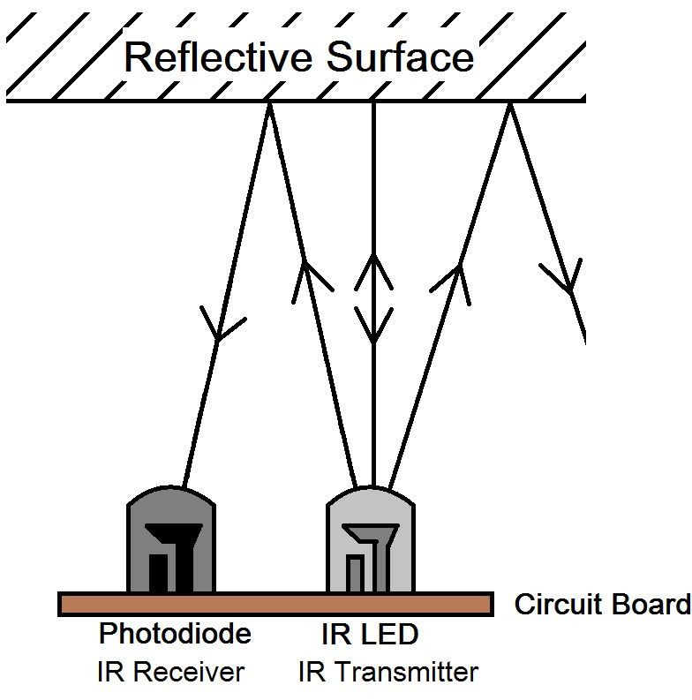

#### Fig.3.1 PRINCIPLE OF IR SENSOR

Depending upon the position of the object, three cases arise as mentioned below:

Case 1:No reflecting surface

Case 2:Moving surface

Case 3:Stationary reflecting surface Case 1:

When there is no reflecting surface in front of the IR sensor, the rays emitted by the IR LED are not reflected by any surface or an object. Hence the IR receiver does not detect any radiations and will not produce any analogous voltage.

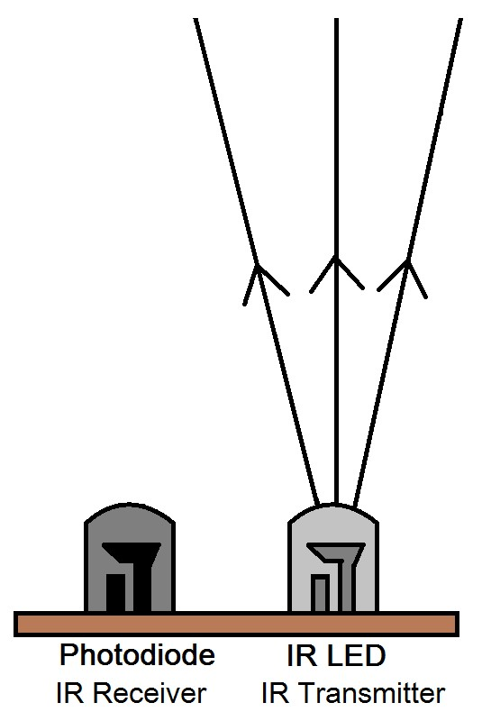

#### Fig.3.2 NO REFLECTING SURFACE

Case 2:

When there is a moving surface in front of the IR sensor, initially the sensor detects the presence of the object due to the reflected radiations which are detected by the IR receiver(IR photodiode). Later as the surface passes by, there are no reflected radiations as there is no surface present in front of the sensor and hence the IR photodiode does not generate any analogous voltage.

As shown in the fig. 3.3 , initially due to the presence of a reflecting surface the IR photodiode detects these reflected radiations and produces analogous voltage and when the object passes by there is no analogous voltage produced by the IR photodiode.

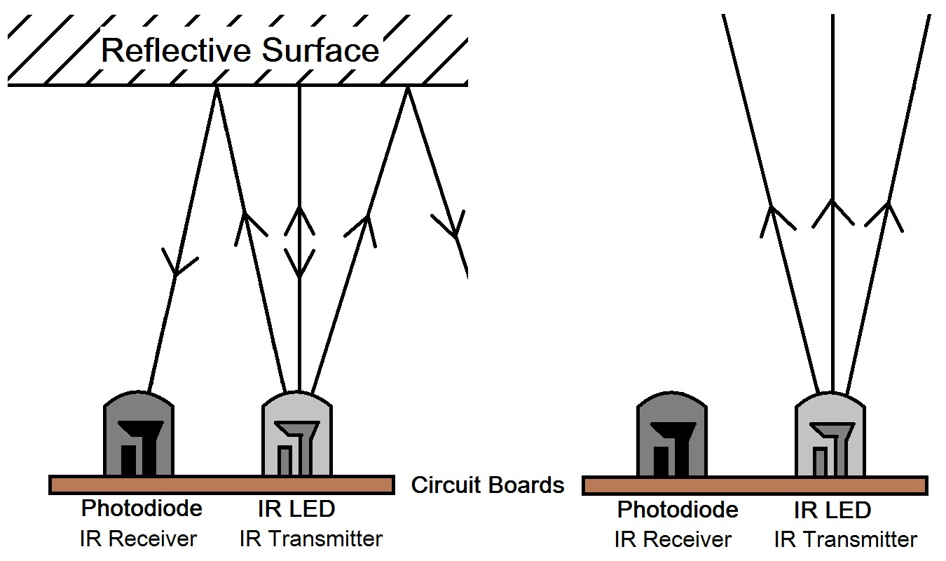

#### Fig.3.3 MOVING OBJECT

Case 3:

When the object is stationary, the rays emitted by the IR LED are continuously reflected by the surface of the object. Due to this, the IR photodiode continuously receives these reflected radiations and detects the presence of an object and an analogous voltage is produced.



#### Fig.3.4 STATIONARY OBJECT

**3.1.2 ARDUINO PRINCIPLE**

As explained in the above section, we get three different analogous voltages depending upon the position of the object. These analogous voltages are given to the Arduino by the IR photodiode which are converted into digital values and can be observed by programmer on the serial monitor of the Arduino software. Depending on these digital values programming is done, and three different voice output commands are designed.

The programming is done in such a way that the incoming digital values are compared to few standard readings and then the audio output is generated accordingly.

**3.1.3 TALKIE LIBRARY**

In order to generate an audio/voice output, a specific speech library is required to be installed on the standard Arduino software.

Talkie is Speech library for Arduino which comes with over 1000 words of speech data that can be included in projects. Most words only take a fraction of a KB. It is a software implementation of the Texas Instruments speech synthesis architecture.

**Word dictionaries:**

* Vocab_UK_Acorn - a male UK English voice. 165 words related to home computing. 16K bytes in total. Data originally part of Acorn Computers Speech Synthesiser, and famously voiced by BBC's Kenneth Kendall.
* Vocab_US_Clock - a female US English voice. 35 words related to time of day. 4K bytes in total. Data of unknown origin from ROM serial number VM71003A.
* Vocab_US_TI99 - a deep male US English voice. 360 words related to home computing. 32K bytes in total. Data originally part of Texas Instruments TI-99/4A Speech System.
* Vocab_US_Male - a male US English voice. 206 words related to aeronautics. 16K bytes in total. Data of unknown origin. ROM serial number VM61002.
* Vocab_US_Male_Large - a male US English voice. 402 words related to aeronautics. 48K bytes speech data. Data of unknown origin. ROM serial number VM61003/4/5.
* Demo_Toms_Diner - demo of the work-in-progress Talkie compressor. 24K bytes music data. Tom's Diner was written/recorded by Suzanne Vega.

**Audio output:**

Talkie sets up a special very high speed PWM, so audio can be taken directly from pin 3 with no other filtering.

Note that Talkie uses Timers 1 and 2 for this purpose, which may conflict with PWM outputs or other libraries.

### 3.2 CIRCUIT DIAGRAM 3.2.1 CONNECTION TO IR SENSOR

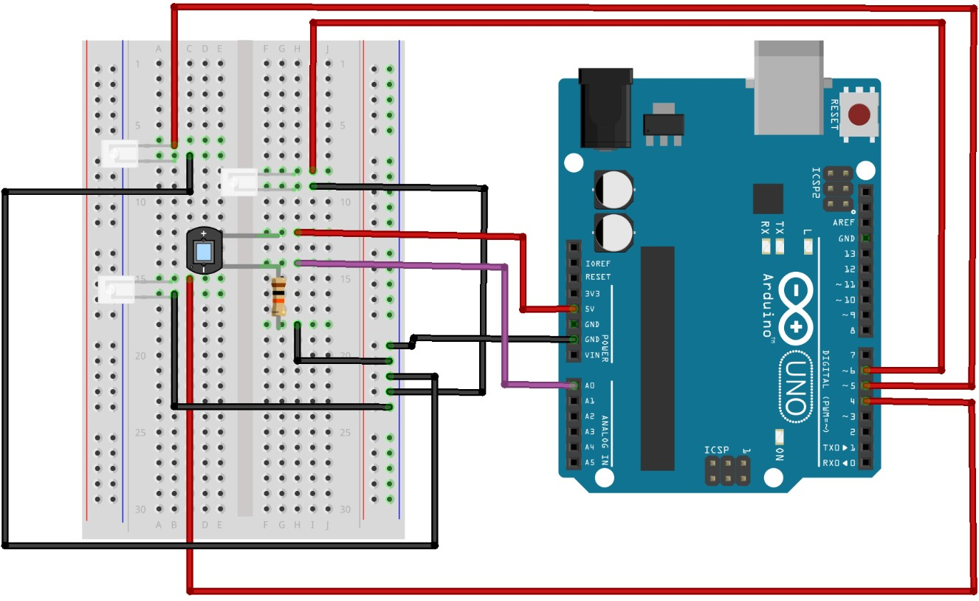

#### Fig.3.5 CONNECTION TO IR SENSOR

The connections are as follows:

* IR LED anode pins are connected to 4,5,6 digital pins of Arduino respectively.
* IR LED cathode pins are grounded.
* IR photodiode anode pin is connected to 5V pin of Arduino.
* IR photodiode cathode pin is connected to one end of a 10k Resistor and analog pin A0 of Arduino.
* The other end of Resistor is grounded.

##### 3.2.2 CONNECTION TO AUDIO OUTPUT

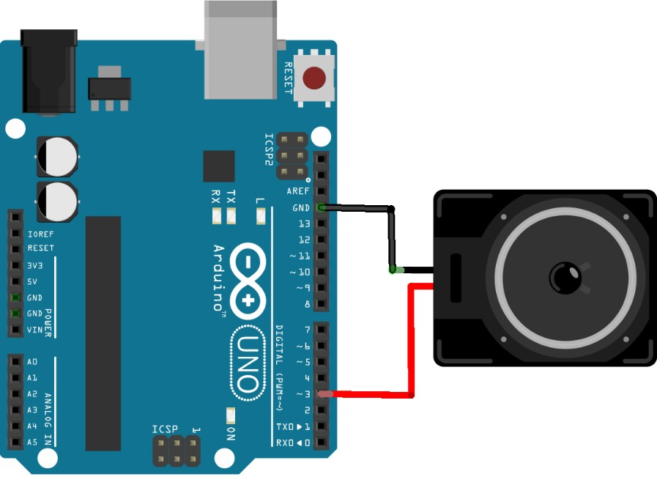

#### Fig.3.6 CONNECTION TO AUDIO OUTPUT

The connections are as follows:

* The anode pin of audio output is connected to digital pin 3 of Arduino.
* The cathode pin of audio output is grounded.

***NOTE:***

Earphones do not need an external amplifier and connected as explained above.

But in case of connecting a speaker an external amplifier is required.

##### 3.2.3 OVERALL CIRCUIT

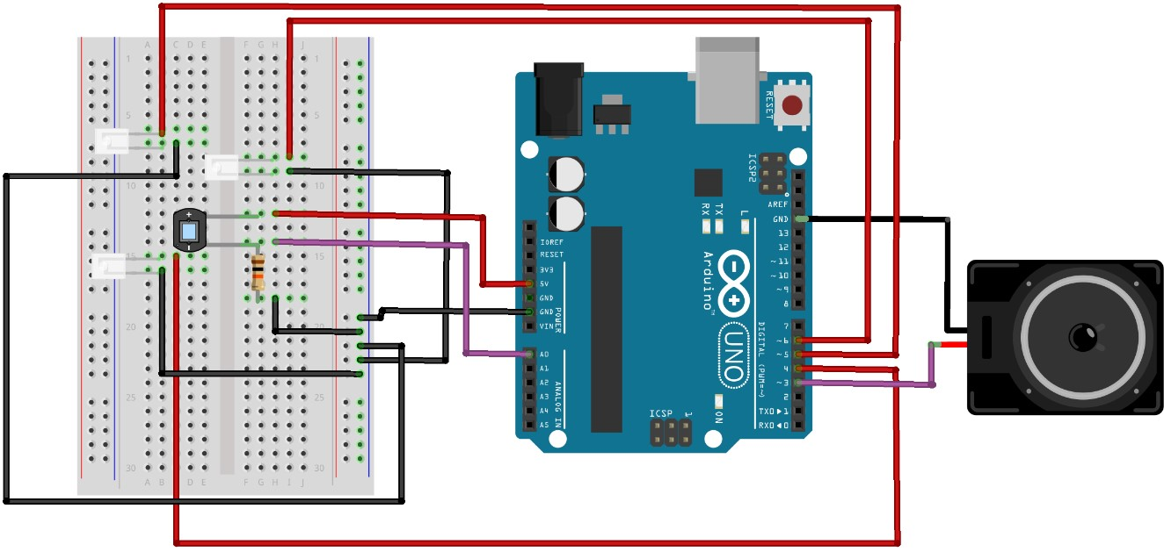

***Fig.3.7 OVERALL CIRCUIT***

### 3.3 SOURCE CODE 3.3.1 SENSOR CODE

**void setup() {**

**pinMode(A0,INPUT);**

**pinMode(4,OUTPUT);**

**pinMode(5,OUTPUT);**

**pinMode(6,OUTPUT);**

**Serial.begin(9600);**

**}**

First, we define the program in the Arduino to interact with the IR sensor for taking the analogous voltage obtained from the IR photodiode due to detection of reflecting IR rays.

First, we define a float value named irpd.

#### float irpd;

Next in the setup, we declare Analog pin **A0** as Input, and Digital pins **4, 5, 6** as Output, and then start serial communication.

Now, in the loop, we set the Digital pins 4,5,6 high to switch ON the IR LED’s and then read the analogous voltage values from Analog pin A0. As this project involves reading of three values, we serially print the three values.

|  |
| --- |
| **void loop() {** |
| **digitalWrite(4,HIGH); digitalWrite(5,HIGH);** |
| **digitalWrite(6,HIGH);** |
| **irpd=analogRead(A0);**  **Serial.print("1st reading : "); Serial.println(irpd); irpd=analogRead(A0);** |
| **Serial.print("2nd reading : ");** |
| **Serial.println(irpd); irpd=analogRead(A0);** |
| **Serial.print("3rd reading : ");** |
| **Serial.println(irpd);**                    **}** |

**3.3.2 AUDIO OUTPUT CODE**

The Arduino is programmed to give audio/voice output. By default, the Arduino has digital pin 3 which gives audio output.

We define the libraries required to generate voice output.

**#include "Talkie.h"**

**#include "Vocab_US_Lar**

**ge.h"**

**Talkie**

**voic**

**e**

**;**

Then in the loop, we define the conditions to give the voice output according to the analogous voltages are read.

When there is an object before the sensor, the values read by the sensor exceeds 25 which is digital value of the analog voltage obtained. In this case the voice output is “CAUTION

SLOW” as mentioned below.

|  |
| --- |
| **void loop() {** |
| **if(irpd>25)**                          **{**                            **voice.say(sp4_CAUTION);**                      **voice.say(sp2_SLOW);**                      **delay(500);**                          **}**                            **e**  **lse** |

**{**

**}**

In case of stationary object, due continuous reflections of IR rays, the values read by the sensor exceed 35(digital conversion of analog voltage values). Here the voice output to the user is “PLEASE TURN LEFT” so that the person will change his path of movement.

**if(irpd>35)**

**{**

**voice.say(sp4_PLEASE);**

**voice.say(sp2_TURN);**

**voice.say(sp2_LEFT);**

**}**

**e**

**lse**

**{**

**}**

**delay(1000);**

In case , if there is no reflecting surface or any object in front of the sensor, then the values read by the sensor will be very low and will be less than 24. In this case the voice output to the user is “WAY IS CLEAR, MOVE ON” so that the user can continue his path.

|  |
| --- |
| **if(irpd<24)** |
| **{** |
| **voice.say(sp4_WAY);** |
| **voice.say(sp4_IS); voice.say(sp3_CLEAR); delay(500); voice.say(sp2_MOVE);** |
| **voice.say(sp4_ON);** |
| **}**                            **e**  **lse**                          **{**                            **delay(1000);**                        **}**                          **}** |

Appropriate delays are provided in between each reading so that the audio/voice output is in sync with the movement of the object before the sensor.

For every 4 seconds the 1st reading is taken.

**3.3.3 OVERALL CODE**

**float irpd;**

**#include "Talkie.h"**

**#include "Vocab_US_Large.h"**

**Talkie voice; void setup() {**

**// put your setup code here, to run once:**

**pinMode(A0,INPUT); pinMode(4,OUTPUT); pinMode(5,OUTPUT); pinMode(6,OUTPUT);**

**Serial.begin(9600);**

**}**

**void loop() {**

**// put your main code here, to run repeatedly: digitalWrite(4,HIGH); digitalWrite(5,HIGH); digitalWrite(6,HIGH); irpd=analogRead(A0); Serial.print("1st reading : "); Serial.println(irpd);**

**if(irpd>25)**

**{**

**voice.say(sp4_CAUTION); voice.say(sp2_SLOW);**

**delay(500);**

**} else {**

**}**

**delay(1000); irpd=analogRead(A0); Serial.print("2nd reading : "); Serial.println(irpd);**

**if(irpd>35)**

**{**

**voice.say(sp4_PLEASE); voice.say(sp2_TURN);**

**voice.say(sp2_LEFT);**

**} else {**

**}**

**delay(1000); irpd=analogRead(A0); Serial.print("3rd reading : ");**

**Serial.println(irpd);**

**if(irpd<24)**

**{**

**voice.say(sp4_WAY); voice.say(sp4_IS); voice.say(sp3_CLEAR); delay(500); voice.say(sp2_MOVE);**

**voice.say(sp4_ON);**

**} else**

**{**

**delay(1000);**

**}**

**}**

# CHAPTER IV

## RESULTS & DISCUSSIONS

### 4.1 RESULTS

The results in the three cases(no reflecting surface, moving surface, stationary surface ) are as follows:

When there is no surface to reflect the rays, output heard is: “**WAY IS CLEAR , MOVE ON**” , the respective digital values(displayed on serial monitor) are as shown in the figure 4.1

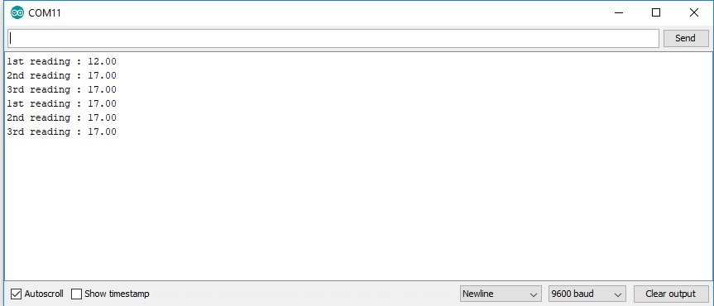

***Fig. 4.1 SERIAL MONITOR (WHEN THERE IS NO REFLECTING SURFACE )***

When there is a moving surface, initially the output heard is: “**CAUTION SLOW**” and when the surface moves away from the sensor the output heard is: “**WAY IS CLEAR, MOVE ON**”, the respective digital values(displayed on serial monitor) are as shown in the figure 4.2

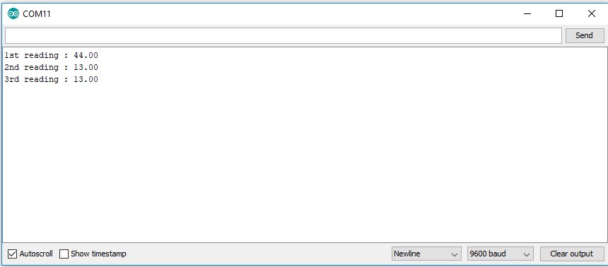

#### Fig. 4.2 SERIAL MONITOR (WHEN THERE IS A MOVING SURFACE )

When there is a stationary surface to reflect the rays, output heard is: “**CAUTION SLOW,**

**PLEASE TURN LEFT**” , the respective digital values(displayed on serial monitor) are as shown in the figure 4.3

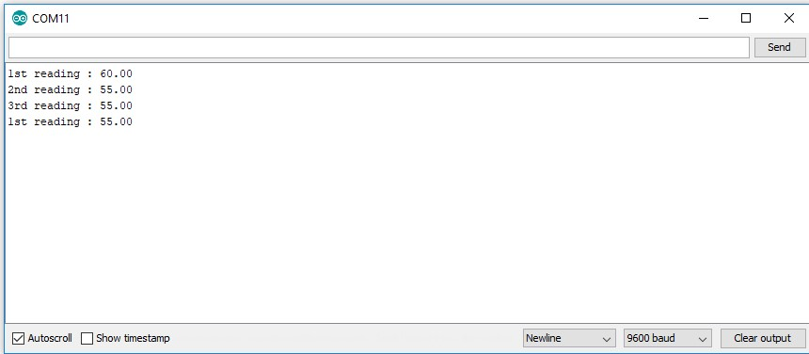

***Fig. 4.3 SERIAL MONITOR (WHEN THERE IS A STATIONARY SURFACE )***

### 4.2 APPLICATIONS

* Parking sensors, systems mounted on car bumpers that sense distance to nearby cars for parking.
* Ground proximity warning system for aviation safety.
* Vibration measurements of rotating shafts in machinery.
* Sheet break sensing in paper machine.
* Anti-aircraft warfare
* Roller coasters
* Conveyor systems
* Mobile devices
* Positioning forklift truck
* Attenuating radio power in close proximity to the body, in order to reduce radiation exposure.
* Automatic faucets
* Detection of liquid levels
* Determine the direction of movement

### 4.3 LIMITATIONS

* The range of this sensor is very limited and is useful only up to 15cm.
* This sensor detects the presence of objects only when in front of the sensor.

# CHAPTER V

## CONCLUSION & FUTURE SCOPE

One of the basic requirements of a blind person is to commute easily on their own without the help of others. Most of the people hesitate to ask for help as everyone tries to live their life independently. However, their life and activities are greatly restricted by loss of eyesight. Frequently used Walking stick or a walking cane is a tool which can help them to detect object in front of them and avoid it.

But the walking stick is limited in range because the stick only detects the object when the stick taps the object or ground. A Voice Assisted Proximity Sensor can help them to avoid obstacles better without tapping the object or ground.

Voice Assisted IR Sensor can be used to detect the object within the distance range of 1cm to 20 cm as it is small in size and very efficient in detecting the object. A Voice output(Instruction) is employed as the signalling element which generates sound in earphones when the object is sensed by the IR Proximity sensor. The Instruction given in the Earphones depends on the output voltage of IR distance sensor and changes with the type of object(Stationary, Moving & No object).

The data taken from the experiment shows that the output voltage from the IR Proximity sensor is changing when the distance between object and IR distance sensor is increasing/decreasing which in turn affects the voice(Instruction) heard by the person in the earphones.

To sum up, the objective of this project is successfully achieved, and a Voice Assisted Proximity Sensor is successfully created to detect the object in front of the user within the specific distance range which can help visually impaired in mobility.

This design provides an excellent platform to have a wide variety of scope for the future:

* Different sensors such as temperature, gas sensors can be used to make the project more effective in hostile conditions for the user.
* Moreover, shape detection test for objects that move at different rotational speeds across several distances will further be considered.
* Navigation can be done in future in order to make this system considering additional parameters.

# REFERENCES

**[1]**[**.https://en.m.wikipedia.org/wiki/Proximity_sensor**](https://en.m.wikipedia.org/wiki/Proximity_sensor)

**[2]**[**.https://www.sciencedirect.com/topics/computer-science/proximity-sensor**](https://www.sciencedirect.com/topics/computer-science/proximity-sensor)

**[3]**[**.http://wiring.org.co/learning/tutorials/breadboard/**](http://wiring.org.co/learning/tutorials/breadboard/)

**[4]**[**.https://components101.com/ir-led-pinout-datasheet**](https://components101.com/ir-led-pinout-datasheet)

**[5]**[**.https://components101.com/photodiode-pinout-datasheet**](https://components101.com/photodiode-pinout-datasheet)

**[6]**[**.https://www.arduino.cc/**](https://www.arduino.cc/)

**[7]**[**.https://learn.sparkfun.com/tutorials/what-is-an-arduino/all**](https://learn.sparkfun.com/tutorials/what-is-an-arduino/all)

**[8]**[**.https://en.wikipedia.org/wiki/Nine-volt_battery**](https://en.wikipedia.org/wiki/Nine-volt_battery)

**[9]**[**.http://maxembedded.com/2013/08/how-to-build-an-ir-sensor/**](http://maxembedded.com/2013/08/how-to-build-an-ir-sensor/)

**[10]**[**.github.com/going-digital/Talkie/blob/master/README.md**](http://github.com/going-digital/Talkie/blob/master/README.md)

**[11]**[**.https://www.auroras.eu/wireless-proximity-sensor-applications-and-benefits/**](https://www.auroras.eu/wireless-proximity-sensor-applications-and-benefits/)