

A Project Report On

**Placement Management System**

**By**

**LALITHABAI**

**B.E(CSE)**

**Batch:** 2020 – 5759

**Center: Thane**

Under the Guidance of,

**Chittaranjan Ghosh.**

**Technical Trainer**

**EduBridge**

(School of coding)

## Introduction:

Placement Management System manages student information in the college with regard to placement. It improves existing system. It has the facility of maintaining the details of the student, thereby reducing the manual work. It will save time and energy which are spending in making reports and collecting data. Placement Management System can be accessed throughout the college with proper login provided.

. **Modules:-**

* Student Module
* Recruiter Module
* Admin Module

I have developed this Application in **Java, JSP, Servlets, Hibernate and MySQL.** It’s a web-based projects so I have used **HTML, CSS, JavaScript and Bootstrap ,Thymleaf**.

The main objective of the placement management system is to reduce manual work and time. It is difficult and time-consuming to collect all the details from each student. To avoid this problem, we have planned to develop a web-based placement management system. In Admin module, admin can add the Category and Products in the specific category. He can also view the total number of users at present in the website. And category and product details also. Admin can only see the admin page and cart if he wants to order something.

* It manages the details of student records, placement training, different placements happening in and out of the college.
* Saves the time of placement officer and faculties.
* This system makes student information more secure.

Admin Module: Admin can able to handle recruiter portal and student portal. It provides access to the Recruiter for uploading new jobs as well as to track the process of job application with a username and password.

Recruiter Module: Recruiter can access this website by signing up. Recruiter can post jobs for student from his portal as well as he/she can update job portal for student

Student Module: Students can view the Jobs applied by the company, Students can apply for Jobs, Students can view the Jobs applied by themselves, Students can change the password as well as Student can update profile.

**Software Requirements:**

**Front end:** Java/J2EE technologies (Servlet, JSP), HTML, CSS, JavaScript, Bootstrap, Thymleaf, Hibernate.

**Back end**: MySQL workbench 8.0 CE.

**Middleware/Server:** Apache Tomcat v8.5. IDE: Spring tool suite for Java EE Developers

**Browser:** Best result on Google Chrome

**Operating System:** Window

# Data Dictionary:

* Create Database placement;

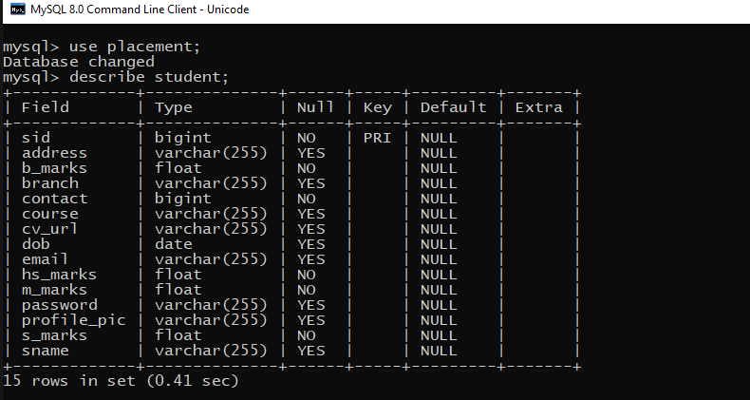

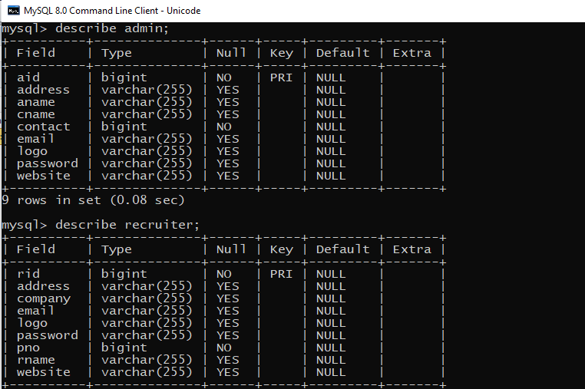

# Screenshots:-

## Home Page:

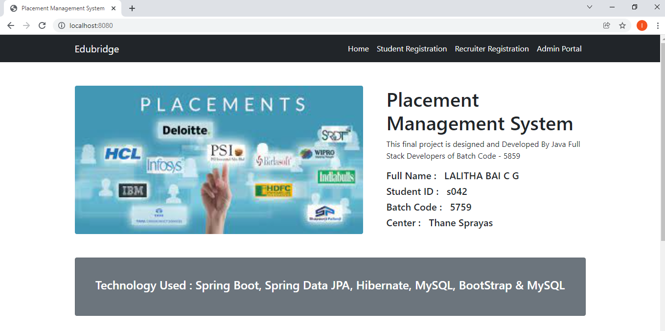

Student Registration:

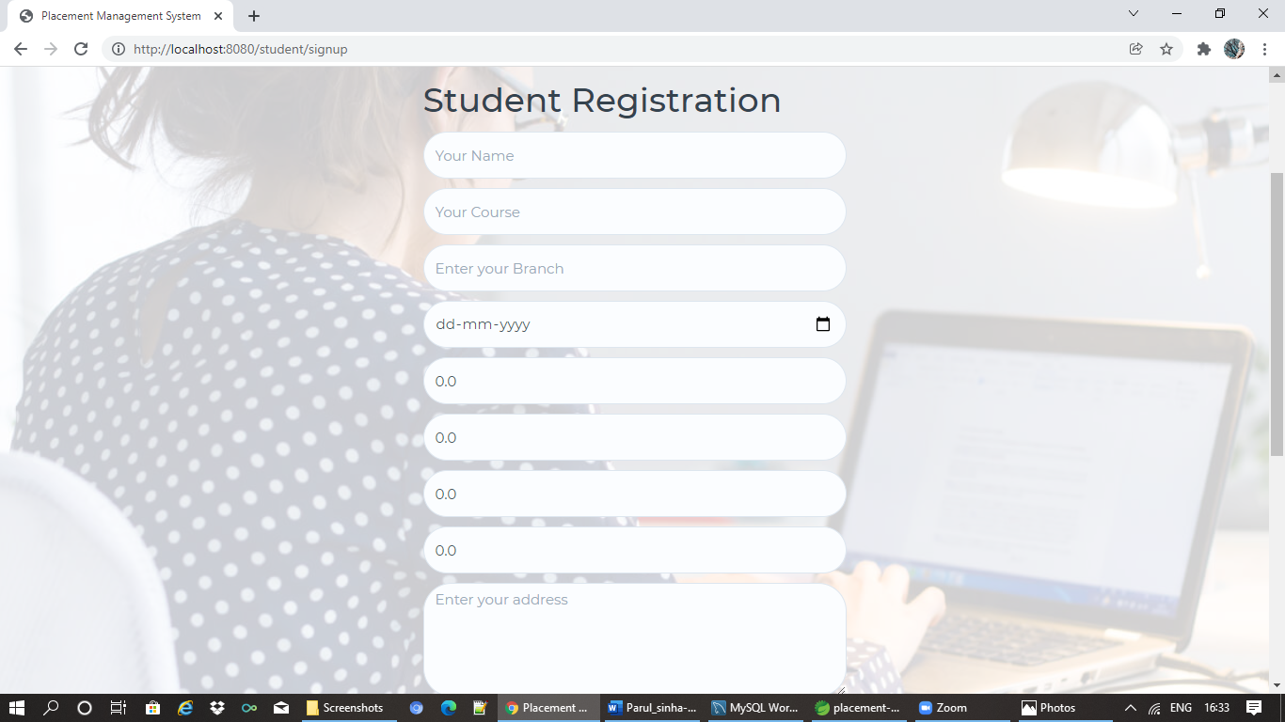

Recruiter Registration:

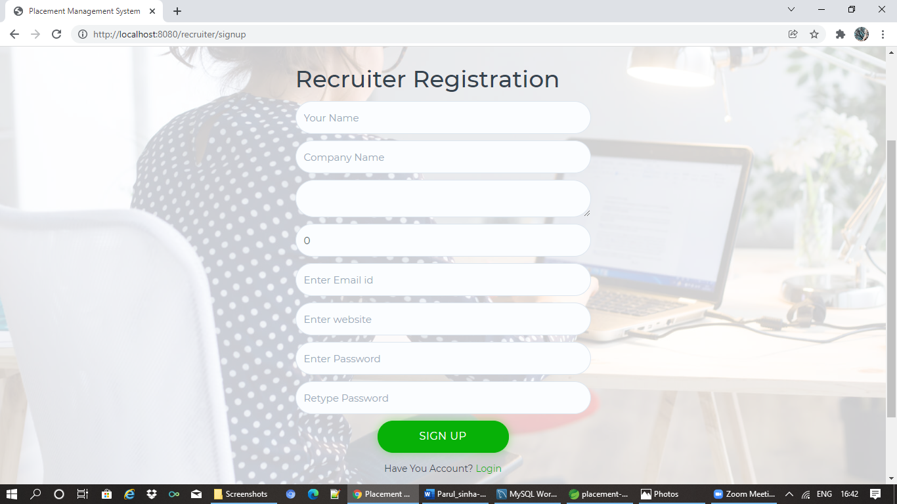

Admin Registration:

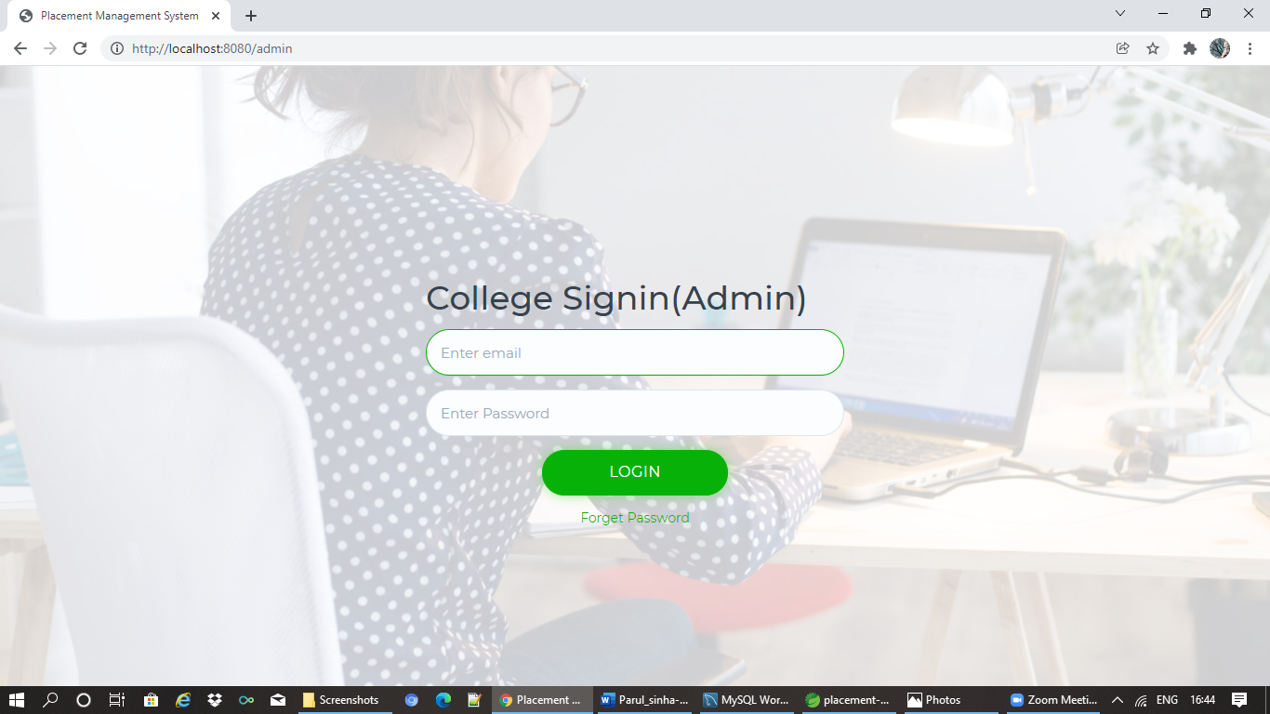

**Student-Dashboard Page:**

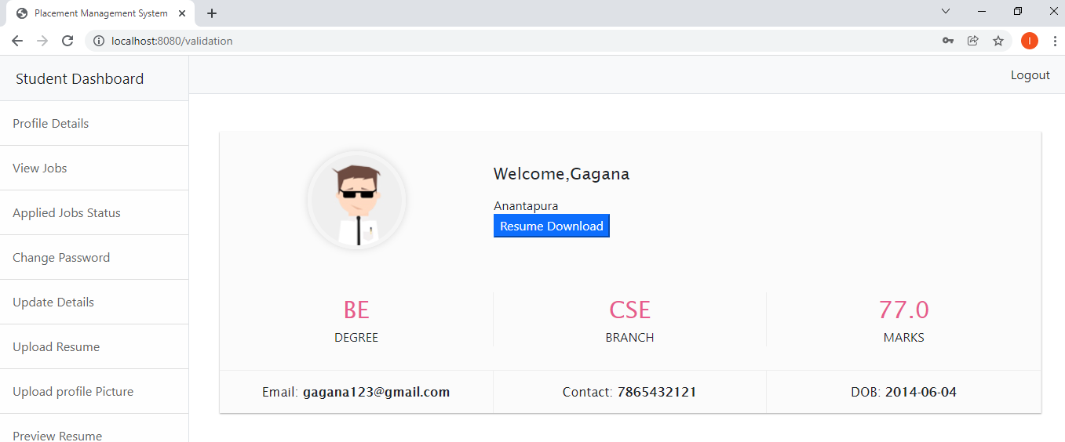

**Recruiter-Dashboard Page:**

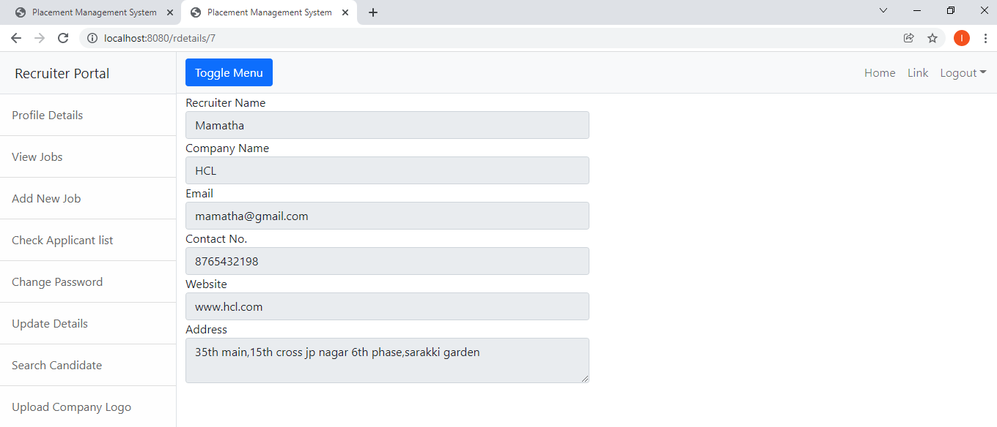

**Admin-Dashboard Page:**

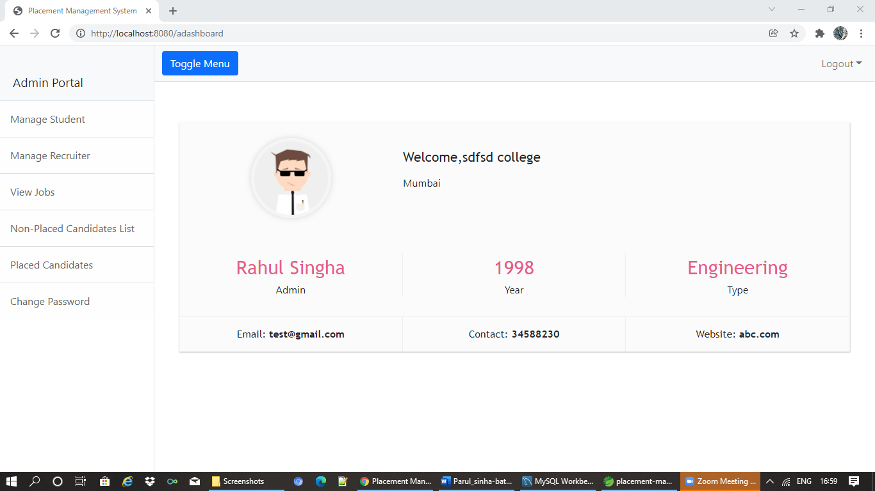

**Student-Job-Dashboard Page:**

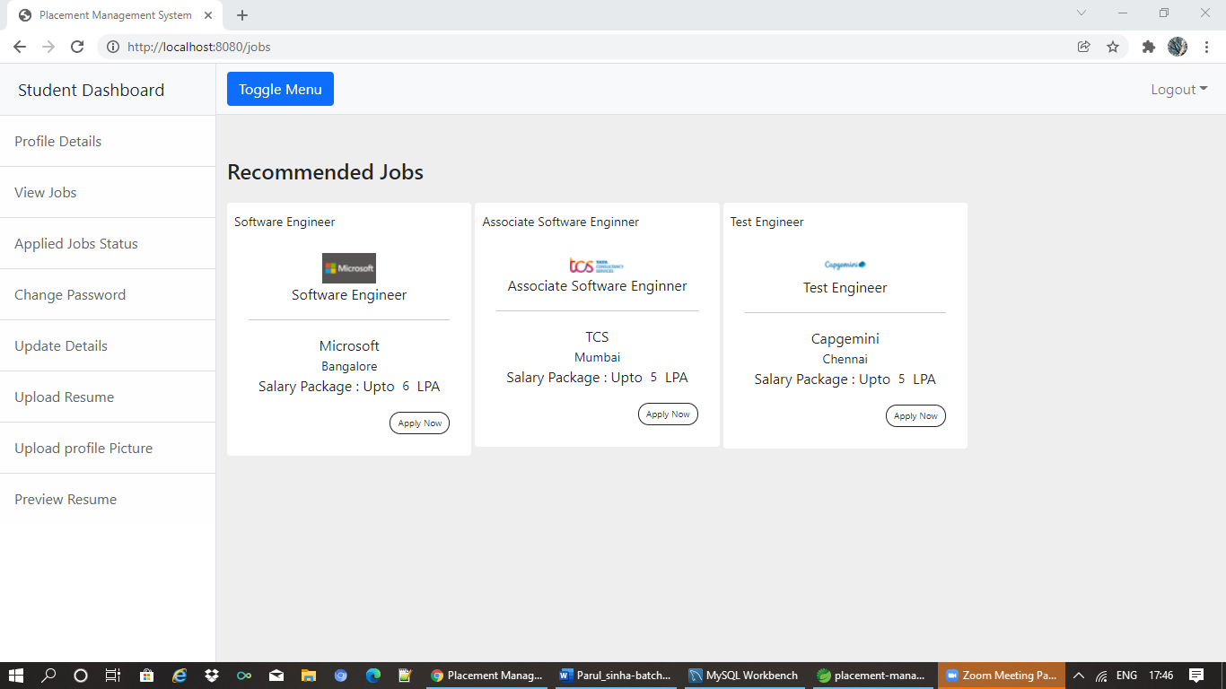

**Student-Applied-Jobs-Status-Dashboard Page:**

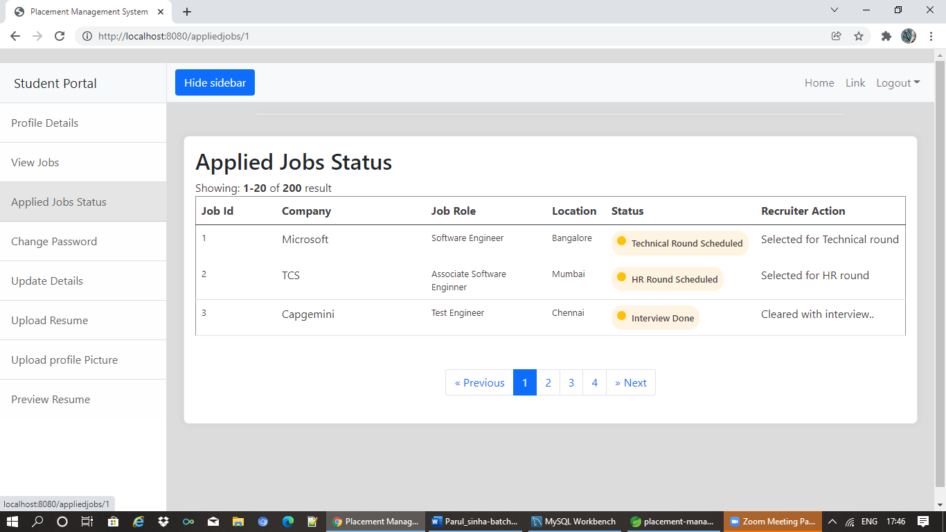

Recruiter Add-new-job-page:

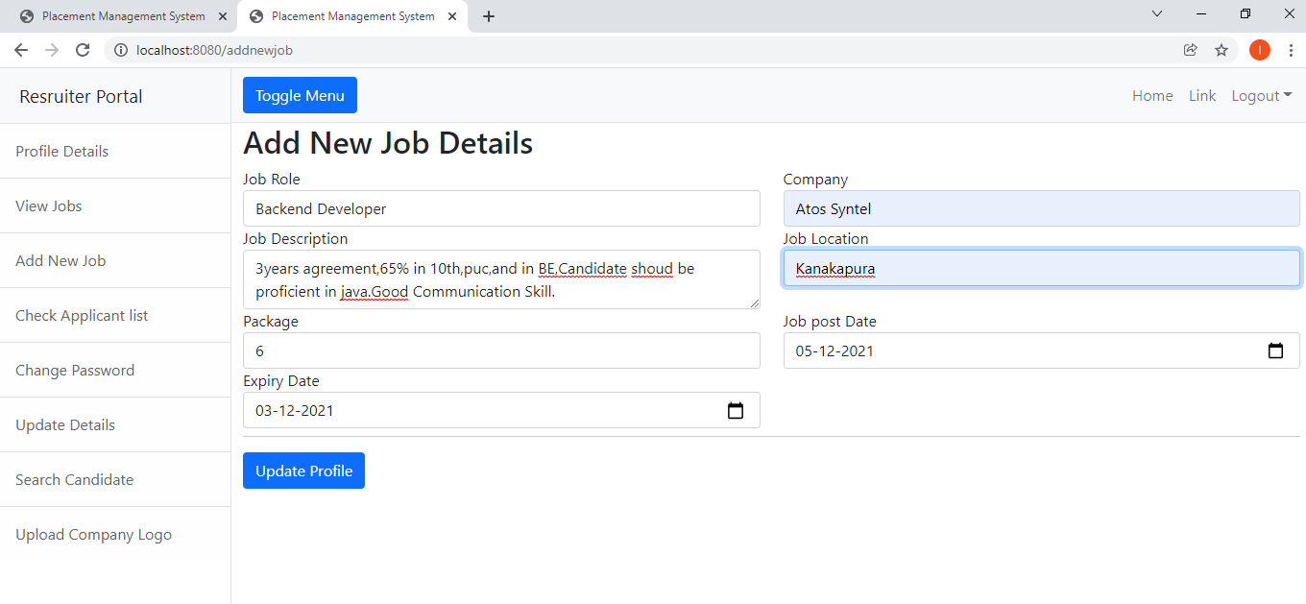

**Recruiter-View-Jobs-page:**

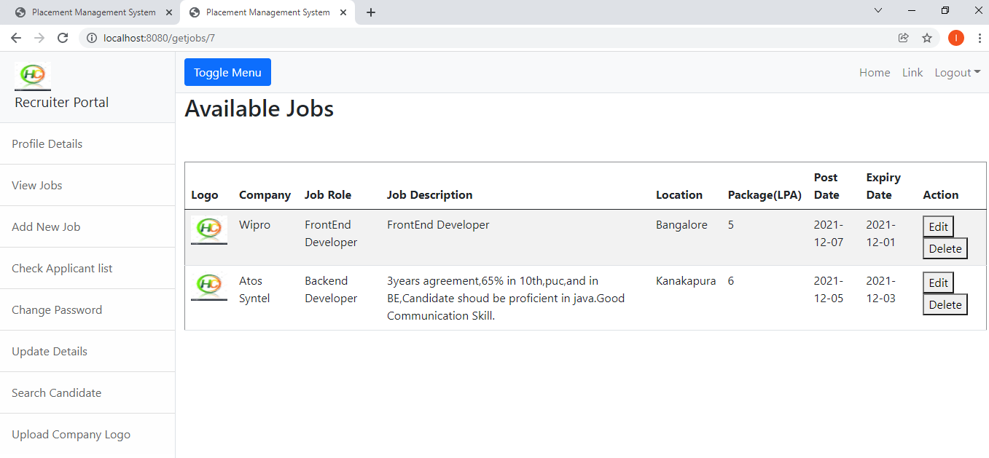

**Recruiter Job-Applicant-Details:**

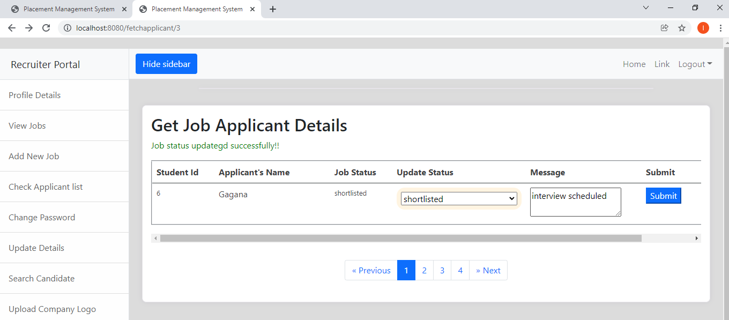

**Admin-Job-List-Portal:**

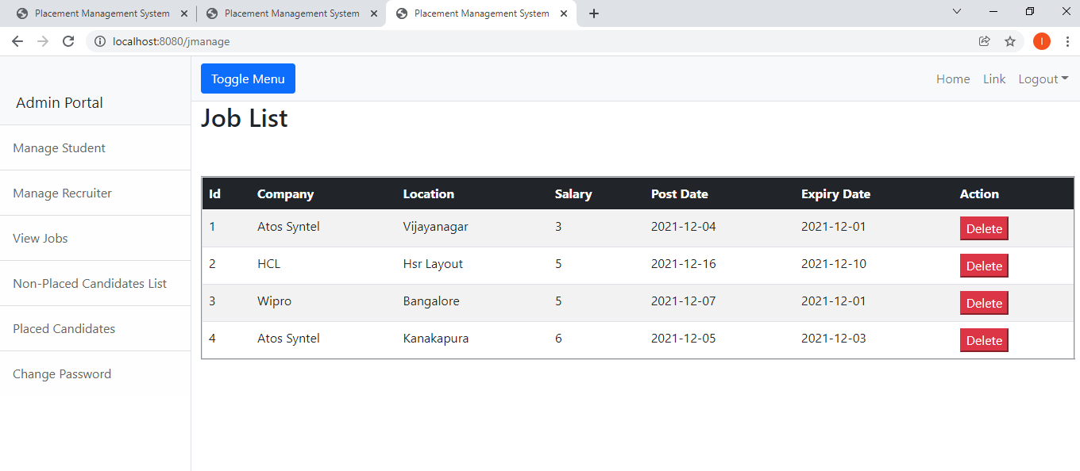

**Admin-Placed-Candidate-List:**

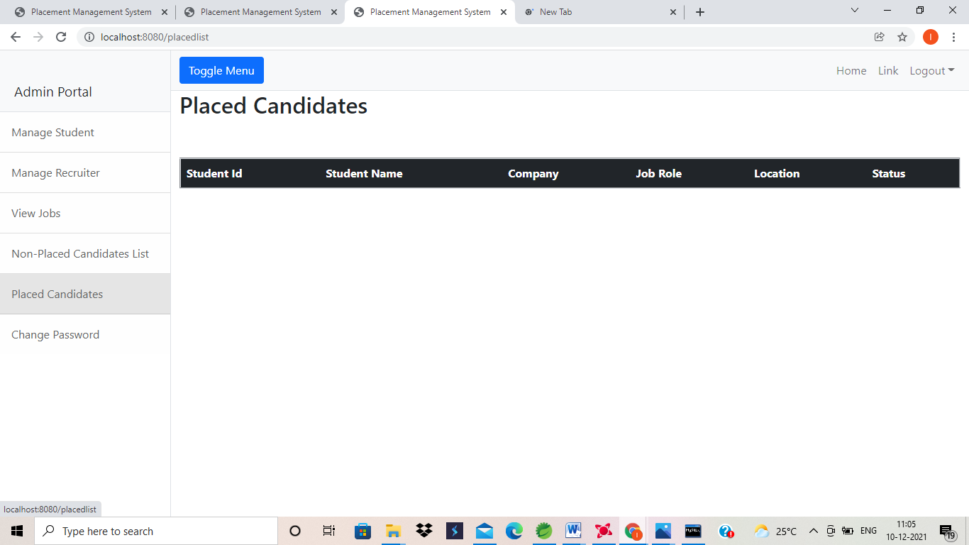

**Admin-Non-Placed-Candidate-List:**

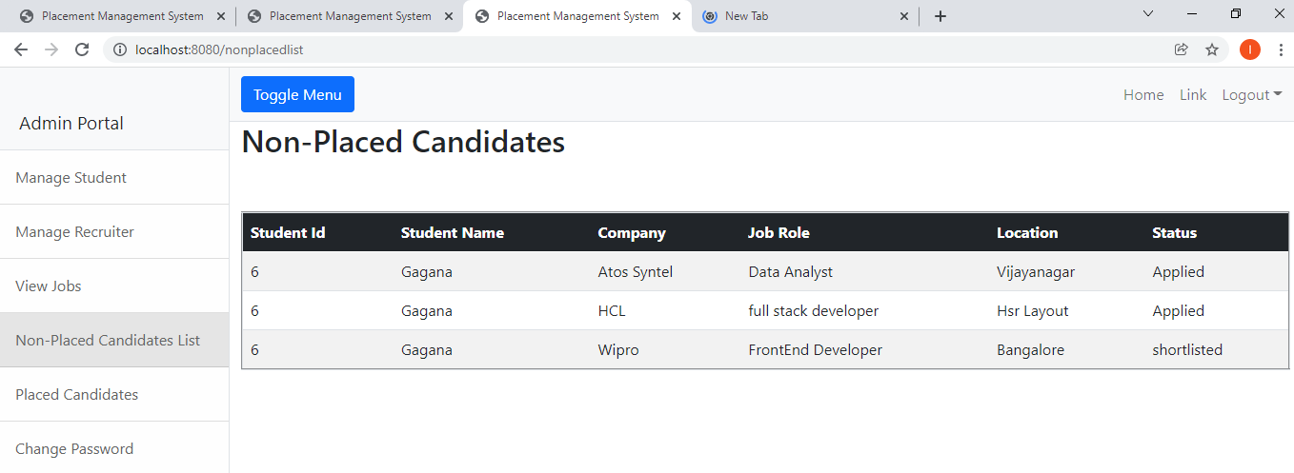

**Thank you…..**

**Suggestions?......**