Moderation layer creation : APIs created to detect PII,CII etc

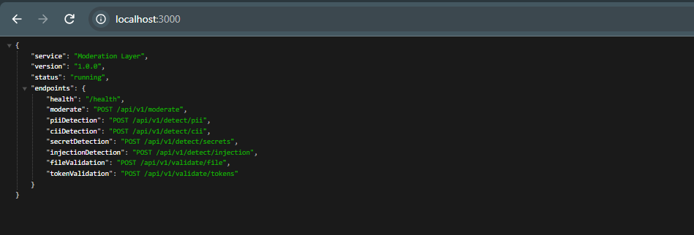

Postman collection: Moderation layer
