Formatting options in Ms writer:

I.Steps of changing a paragraph(text) to a custom style:
1.Styles and formatting:A paragraph can be added in and it can be designed according to our requirement.The different styles and formatting options can be used to select a particular style .The format painter can be used to fill the format in the complete paragraph.The formatting options can also be used to select new style which is created by us.Name the style and its attributes and save the particular style.We can apply this style to the rest of the document by selecting the verses for which we have to apply it.
The above dialog box appears .Select the style which you would like to be utilised in the text where you would like it to be applied.
2.Format painter:
This is the symbol for format painter.The format painter is used to adjust the same
style to the complete selected text.

3.Image insertion:
i. Inserting image from a file
ii. inserting graphics from gallery with drag and drop
iii. inserting a scanned image
iv. inserting graphics from openoffice draw
v. inserting a calc chart into a text document

i.Inserting image from a file:
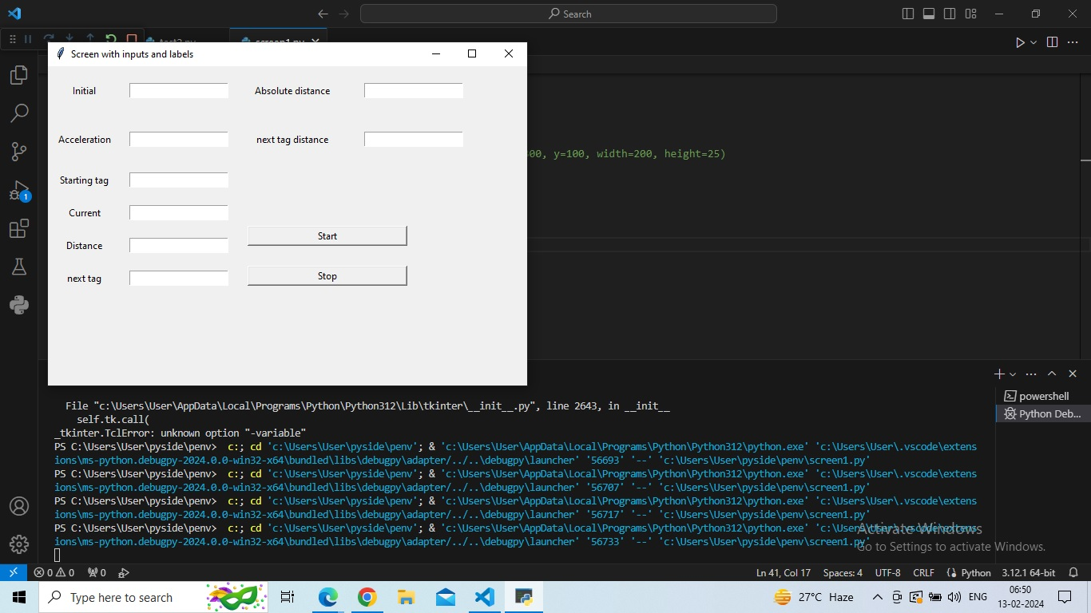
ii.inserting graphics from gallery with drag and drop:


the navigation for inserting above images is Tools-gallery-select the picture.

iii.inserting a scanned image:

navigation:insert -picture-from scanned pictures-select source

iv.inserting graphics from impress or draw:

open the image in impresss or draw and paste it in the original document.

v.Inserting a calc chart into text document:

We have to insert the required chart in the space we have highlighted and copy and paste the graph from the document we have created in openofficecalc.

5.Inserting images and autoshapes:

Preparing Images for Black-and-White Printing
If color images are to be printed in grayscale, check that any adjacent colors have good contrast and print dark enough. Test by printing on a black-and-white printer using a grayscale setting. Better still: change the “mode” of the image to grayscale, either in a photo editor or in Writer itself (see Modifying an Image).
For example, the following diagram looks good in color. The circle is dark red and the square is dark blue. In grayscale, the difference between the two is not so clear. A third element in the diagram is a yellow arrow, which is almost invisible in grayscale.
.

Changing the colors of the circle and the arrow improves the contrast and visibility of the resulting grayscale image.


If the document will be available in black-and-white print only, a better result can often be obtained by choosing grayscale fills, not color fills — and you don’t have to guess and test to see if you’ve made good choices.

II.Adding Images to a Document
Images can be added to a document in several ways: by inserting an image file, directly from a graphics program or a scanner, or from the OOo Gallery.
Inserting an image file
When the image is in a file stored on the computer, you can insert it into an OOo document using either of the following
Drag and drop
Open a file browser window and locate the image you want to insert.
Drag the image into the Writer document and drop it where you want it to appear. A faint vertical line marks where the image will be dropped.
This method embeds (saves a copy of) the image file in the Writer document. To link the file instead of embedding it, hold down the Control+Shift keys while dragging the image.
Insert Picture dialog
Click in the OOo document where you want the image to appear.
Choose Insert > Picture > From File from the menu bar.
On the Insert Picture dialog, navigate to the file to be inserted, select it, and click Open. At the bottom of the dialog are two options, Preview and Link. Select Preview to view a thumbnail of the selected image on the right, so you can verify that you have the correct
Linking a image file
If the Link option in the Insert picture dialog box is selected, Writer creates a link to the file containing the image, instead of saving a copy of the image in the document. The result is that the image is displayed in the document, but when the document is saved, it will contain only a reference to the image file—not the image itself. The document and the image remain as two separate files, and they are merged together only when you open the document again.
Linking an image has two advantages and one disadvantage:
Advantage – Linking can reduce the size of the document when it is saved, because the image file itself is not included. The file size is usually not a problem on a modern computer with a reasonable amount of memory, unless the document includes many large graphics files. Writer can handle quite large files.
Advantage – You can modify the image file separately without changing the document because the link to the file remains valid, and the modified image will appear when you next open the document. This can be a big advantage if you (or someone else, perhaps, a graphic artist) is updating images.
Disadvantage – If you send the document to someone else, or move it to a different computer, you must also send the image files, or the receiver will not be able to see the linked images. You need to keep track of the location of the images and make sure the recipient knows where to put them on another machine, so the document can find them. For example, you might keep images in a subfolder named Images (under the folder containing the document); the recipient of the file needs to put the images in a subfolder with the same name (under the folder containing the document).

Embedding linked images
If you originally linked the images, you can easily embed one or more of them later if you wish. To do so:
Open the Writer document in OOo and choose Edit > Links.
The Edit Links dialog box shows all the linked files. In the Source file list, select the files you want to change from linked to embedded.
Click the Break Link button.
Save the document in ending.

