Results:

Heavy-Write clinet output  
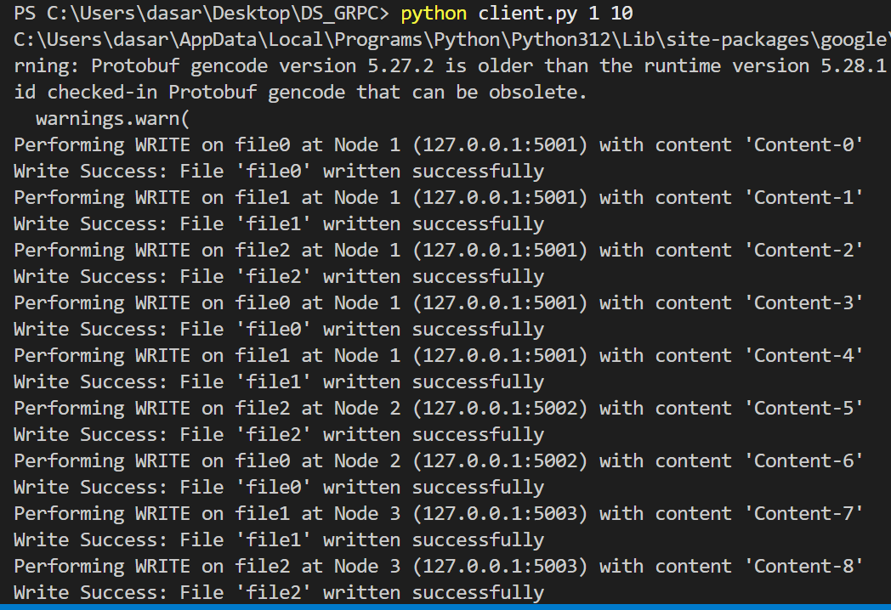

Heavy-read client output:

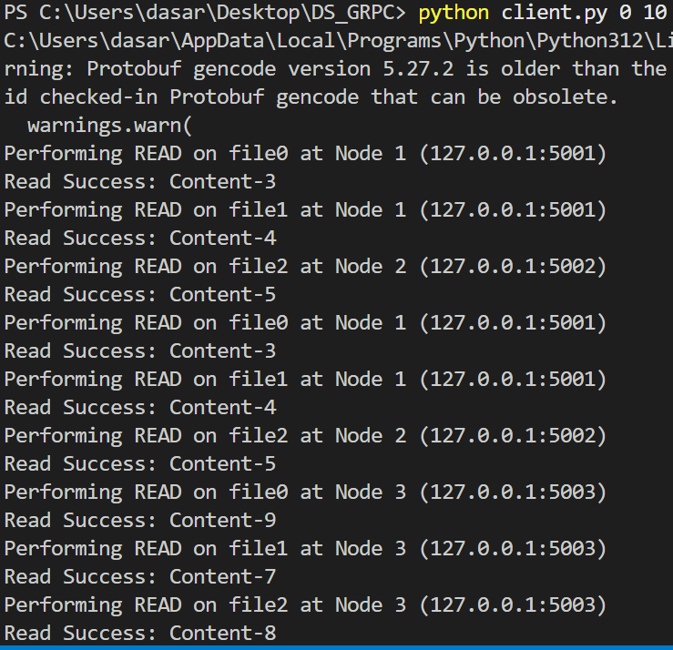

Balanced client output:

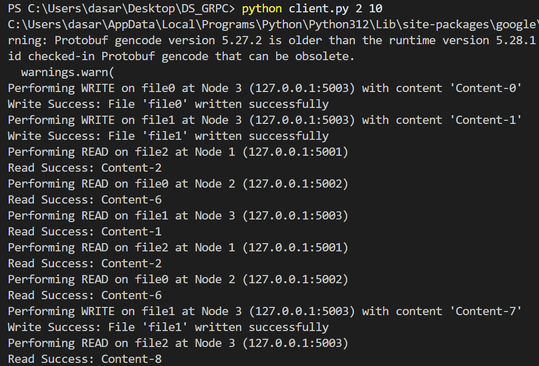

Node state of node1 & node2

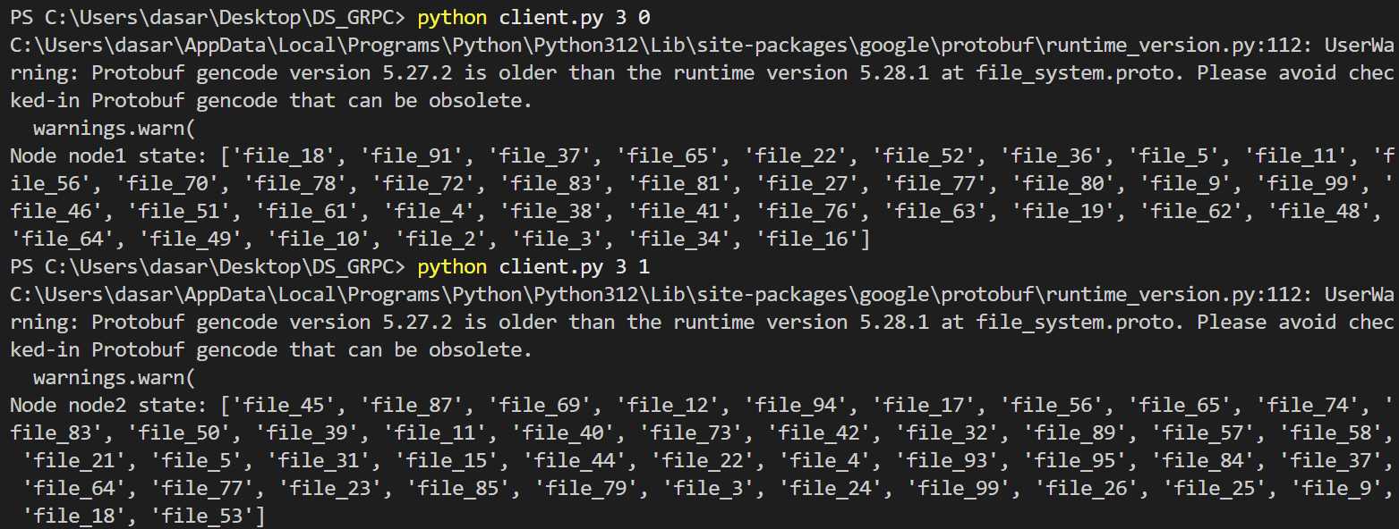

Running

python server.py node1 50051 &

python server.py node2 50052 &

python server.py node3 50053 &

python client.py 0 100 # 100 operations, mostly reads #read-heavy

python client.py 1 100 # 100 operations, mostly writes #write-heavy

python client.py 2 100 # 100 operations, equal reads and writes #balanced client

python client.py 3 0 # Fetch the state of a random node # node status

Report

**Abstract**:

In today’s digital world, distributed file systems are essential for managing large-scale data across multiple servers. While existing systems like HDFS and Ceph offer solutions for storing and retrieving files, they often struggle with challenges like scalability, fault tolerance, and handling diverse workloads efficiently. This paper presents a new distributed file system designed to address these challenges by providing a more flexible, reliable, and scalable approach.

This paper introduces a distributed file system designed to efficiently store, manage, and retrieve files across multiple nodes, with an emphasis on scalability and fault tolerance. The system consists of three main components: a **SuperNode**, which coordinates the overall file operations and maintains metadata; **DataNodes**, where the actual files are stored; and **Clients**, which interact with the system to perform file operations. To ensure data consistency and reliability, we implement a **quorum protocol**, which directs read and write requests to the appropriate DataNodes based on factors like load and availability. The system supports different types of workloads, including read-heavy, write-heavy, and balanced, and allows clients to query the state of the file system at any given time. Through a series of experiments, we evaluate the system’s performance in terms of speed, scalability, and fault tolerance. The results show that the file system is capable of handling a large number of operations efficiently while recovering gracefully from node failures. This approach provides a solid foundation for building distributed systems that can be easily scaled and maintained, making it well-suited for real-world applications.

1. **Introduction**:

In the era of big data, distributed file systems (DFS) have become critical for managing and storing vast amounts of data across a network of machines. Systems such as the Hadoop Distributed File System (HDFS) and Ceph have been developed to meet the increasing need for scalability, fault tolerance, and efficient data retrieval. However, these systems often face challenges, such as suboptimal performance under varying workloads, difficulties in maintaining consistency across nodes, and slow recovery from node failures. These limitations become even more pronounced as the scale of the system increases, leading to potential bottlenecks and performance degradation in real-world applications.

One of the major challenges in existing DFS architectures is balancing read and write operations efficiently. Traditional systems typically treat read and write operations equally, which can lead to performance bottlenecks when one type of operation (e.g., writes) dominates the system. Additionally, while fault tolerance mechanisms like replication and data recovery are implemented in many systems, handling these mechanisms efficiently without compromising performance remains a difficult task. Furthermore, monitoring the health and state of the system, especially when scaling up, is a complex and often overlooked aspect.

To address these challenges, we propose a novel distributed file system that incorporates a **quorum protocol** to ensure consistency, fault tolerance, and efficient load balancing. Our system consists of three main components: a **SuperNode**, which manages metadata and coordinates file operations; **DataNodes**, where files are stored and retrieved; and **Clients**, which interact with the system to perform read and write operations. The key innovation in our approach lies in the dynamic handling of varying workloads (e.g., read-heavy, write-heavy, or balanced), intelligent routing of requests, and the ability to query the state of the file system at any time.

The primary contributions of this paper are as follows:

1. **A scalable and flexible file system architecture**: The system is designed to handle diverse workloads and scale efficiently as the number of clients and nodes increases.
2. **Implementation of a quorum protocol**: The protocol ensures data consistency and fault tolerance, even during node failures or network partitions.
3. **Real-time monitoring capabilities**: Clients can query the state of the file system, providing transparency and ease of management.
4. **Performance evaluation**: We provide a detailed performance evaluation of the system, showing its advantages in terms of throughput, latency, and fault tolerance compared to existing systems.
5. **Background**:

Distributed File Systems (DFS) are essential in today’s world of big data and cloud computing, where vast amounts of data need to be stored and accessed across a network of machines. These systems allow for scalable, fault-tolerant storage solutions, ensuring that data is available and safe even if one or more machines fail. Popular examples of such systems include **Hadoop Distributed File System (HDFS)**, **Ceph**, and **Google File System (GFS)**. These systems have become the backbone of modern applications that handle large-scale data, from cloud storage platforms to big data analytics.

Despite their widespread use, existing DFS solutions still face a number of challenges, especially when dealing with large-scale operations and varying user needs:

1. **Fault Tolerance and Consistency**: One of the core strengths of DFS is its ability to recover from node failures and ensure data is not lost. However, ensuring that data remains consistent across many nodes, especially during failures, is tricky. For example, if one server goes down while reading or writing data, the system must ensure that the data isn’t corrupted or lost.
2. **Load Balancing**: In real-world systems, not all file operations are the same. Some systems are read-heavy, with lots of data being accessed but not modified, while others are write-heavy, where large amounts of data are frequently updated. Traditional DFS often doesn’t adapt well to these different types of loads. As a result, some servers may become overloaded with requests, causing slowdowns, while others might be underutilized.
3. **Mixed Workloads**: Many existing systems treat read and write operations equally, but in practice, this often leads to problems when a system needs to handle both types of operations simultaneously. For example, a write-heavy system might struggle to keep up with frequent reads, and vice versa. The lack of flexibility in handling mixed workloads can lead to inefficiencies, longer response times, and overall slower system performance.
4. **System Monitoring and Management**: As distributed systems grow larger, it becomes harder to keep track of what’s happening on each machine. In many traditional DFS solutions, administrators don’t have an easy way to monitor the system in real-time. This lack of transparency can make it difficult to detect issues early, troubleshoot problems, and optimize the system's performance.

**The Role of Quorum Protocols**

To solve some of these problems, many distributed systems use something called a **quorum protocol**. This is a mechanism that ensures consistency across nodes by requiring a minimum number of nodes to participate in an operation before it’s considered successful. In a DFS, quorum protocols can help make sure that file reads and writes are consistent, even if some nodes fail or are unreachable for a period of time. For instance, a read operation might need to check with a majority of nodes to ensure that it’s getting the most recent version of a file, while a write operation might need confirmation from multiple nodes to guarantee that the data has been safely written.

**The Need for Better DFS Architectures**

Although existing systems like HDFS and Ceph have made significant progress in addressing many of these challenges, there’s still room for improvement. They often struggle with efficiently managing different types of operations, maintaining performance under heavy load, and providing real-time monitoring for administrators.

Our system takes a fresh approach to these challenges. By using a flexible quorum protocol that adjusts to varying workloads, we can ensure that the system remains efficient and consistent, even as the number of nodes and operations grows. Additionally, our system allows for real-time monitoring of the file system, giving users the ability to query the state of the system at any point, which helps with both management and troubleshooting.

**3. System Design**

Our distributed file system is designed to address the challenges of scalability, fault tolerance, and efficient workload management. The system architecture is based on three main components: **SuperNode**, **DataNodes**, and **Clients**. Each plays a distinct role, but they all work together to ensure the system performs reliably and efficiently under varying workloads.

### **3.1 SuperNode: The Brain of the System**

At the heart of our system lies the **SuperNode**, which acts as the central controller for file operations. Think of it like the "brain" of the system. Its primary job is to manage metadata and coordinate file operations between clients and the data storage nodes (DataNodes). The SuperNode keeps track of where each file is stored, the status of each DataNode, and helps direct client requests to the appropriate DataNode.

When a client needs to read or write a file, it first communicates with the SuperNode to find out which DataNode holds the file. The SuperNode’s ability to track the state of the file system allows it to direct operations efficiently, ensuring the system remains consistent and fault-tolerant. This centralized management prevents clients from needing to search through the entire network for data, improving performance.

### **3.2 DataNodes: Where the Files Live**

The **DataNodes** are where the actual files are stored. Each DataNode can hold multiple files, and the files may be replicated across several DataNodes for fault tolerance. When a write operation occurs, the SuperNode directs the client to the appropriate DataNode, which then saves the file. If the system is set up with replication, the file will be copied to other DataNodes, ensuring that even if one node fails, the file is still available.

DataNodes also handle read requests from clients. When a client wants to read a file, the SuperNode directs the request to the DataNode containing the file, ensuring the client gets the most up-to-date version of the file.

### **3.3 Clients: The Users of the System**

Clients are the "users" that interact with the file system. Depending on the type of operation (read-heavy, write-heavy, balanced), the client will adjust its behavior to optimize the workload on the system.

1. **Read-Heavy Clients**: These clients make a majority of their requests for reading data, with only a small number of write operations. This setup is ideal for scenarios where data is frequently accessed but rarely updated (e.g., analytics applications or content delivery systems).
2. **Write-Heavy Clients**: These clients primarily write data to the system, with fewer read operations. Write-heavy clients are common in data collection systems or applications that generate new data in real-time (e.g., log processing or sensor data storage).
3. **Balanced Clients**: These clients perform an equal number of read and write operations. This setup is common in general-purpose applications that need to handle both reading and writing data efficiently.
4. **State-Query Clients**: These clients are responsible for querying the state of the file system at any given time. They ask the SuperNode to return a list of all files stored across the system, which helps administrators and users keep track of the file system’s health and organization.

### **3.4 Quorum Protocol: Ensuring Consistency and Fault Tolerance**

A key aspect of our system is the **quorum protocol**, which ensures that read and write operations are consistent, even in the presence of node failures. The quorum protocol requires a minimum number of nodes (a quorum) to participate in an operation before it is considered successful. This helps maintain data integrity by preventing issues such as partial writes or outdated reads.

For example:

* When a client writes a file, the system requires a quorum of DataNodes to confirm that the write has been successfully completed before acknowledging the operation to the client. This ensures that even if a node fails right after the write operation, the data will still be consistent across the system.
* Similarly, for read operations, the system queries a quorum of DataNodes to get the most up-to-date version of the file. This prevents clients from reading stale or inconsistent data.

### **3.5 Real-Time Monitoring**

An important feature of our design is the ability to monitor the state of the file system in real time. Clients can query the SuperNode for information about the files stored on each DataNode, helping administrators understand the health and status of the system. This capability is crucial for diagnosing problems, optimizing resource usage, and maintaining the overall performance of the file system.

### **3.6 Scalability and Fault Tolerance**

The system is designed to be **scalable** and **fault-tolerant**. As the number of clients or DataNodes increases, the SuperNode dynamically adjusts the load balancing and routes requests accordingly. The quorum protocol ensures that the system remains resilient even in the face of node failures or network partitions, minimizing downtime and maintaining data availability.

**4. Implementation**

Implementing our distributed file system required integrating various components that work together to handle file operations (like reading and writing) across multiple machines. The system was designed to ensure that data is consistent, available, and that operations are efficiently managed, even as the number of users and the amount of data grows.

### **4.1 System Components**

The implementation consists of the following key components:

1. **SuperNode**: This is the central server that coordinates all operations. It keeps track of metadata and the state of the file system, making sure clients know which DataNode stores which files.
2. **DataNodes**: These are the servers where the actual files are stored. Each DataNode can store multiple files, and files can be replicated across different DataNodes to ensure fault tolerance.
3. **Clients**: These are the programs or users that interact with the system. Depending on the workload, a client can be read-heavy, write-heavy, or balanced in its operations. Some clients may even query the file system for the current state of all files.

### **4.2 Step-by-Step Workflow**

When a client wants to perform an operation, such as reading or writing a file, here’s how the system handles it:

1. **Client Makes a Request**: The client starts by sending a request to the SuperNode. The request can either be for a **read** or a **write** operation, depending on the type of client.
2. **SuperNode Coordinates**: Upon receiving the request, the SuperNode determines which DataNode(s) should handle the request. For read operations, it ensures that the most up-to-date version of the file is retrieved by querying the appropriate DataNodes. For write operations, it ensures that the file is stored in the right location and may replicate the file across multiple DataNodes to prevent data loss in case of a failure.
3. **DataNode Handles the Operation**: The SuperNode sends the client’s request to the DataNode(s) holding the relevant file. If it’s a **write**, the DataNode stores the file and may replicate it to other DataNodes. If it’s a **read**, the DataNode sends the requested file back to the client.
4. **Consistency with Quorum**: To make sure data is consistent even if some nodes fail, the system uses a **quorum protocol**. This means that, for both read and write operations, a certain number of DataNodes must confirm the operation before it’s considered complete. This helps maintain consistency across the system, ensuring that clients always get the most recent version of a file, even if a node crashes during the operation.
5. **Handling Failures**: If a DataNode fails during an operation, the system can still function smoothly. Because files are replicated across multiple DataNodes, the system can redirect requests to another DataNode that has the file. The quorum protocol helps the system recover from failures by requiring that multiple nodes acknowledge each operation, so the data remains consistent even in the event of failure.

### **4.3 Types of Clients**

The clients in our system are designed to handle different types of workloads:

* **Read-Heavy Clients**: These clients are mainly concerned with reading data, and only occasionally write data. For example, they might be used for data analytics or applications where the data is frequently accessed but rarely modified. These clients will generate a high volume of read requests and fewer write requests.
* **Write-Heavy Clients**: These clients are used in situations where a lot of data needs to be written to the system but not as often read. Examples include logging systems or real-time data collection applications. Write-heavy clients will generate a large number of write requests and fewer read requests.
* **Balanced Clients**: These clients handle both read and write operations equally. For example, a typical web application might fall into this category, where users both upload data (writes) and access existing content (reads).
* **State-Query Clients**: These special clients are used to fetch the current state of the file system, allowing administrators to check which files are stored on each DataNode. This helps with monitoring and troubleshooting the system.

### **4.4 Real-Time Monitoring and Transparency**

An important feature we built into the system is real-time monitoring. Clients can query the SuperNode to get the current state of the file system. For example, a client can ask for a list of all files stored on a particular DataNode, making it easy to see what’s happening in the system at any given time.

This real-time view helps with system maintenance, performance optimization, and troubleshooting. If a file is missing or a DataNode is overloaded, administrators can quickly respond and address the issue, ensuring minimal disruption.

### **4.5 Handling Mixed Workloads**

The system is designed to adapt to different types of workloads. For clients that perform a balanced mix of read and write operations, our system dynamically adjusts the resources needed to handle those requests efficiently. This ensures that the system doesn’t become too slow or inefficient, regardless of whether the workload is more read-heavy, write-heavy, or balanced.

To achieve this, we use **load balancing** and **dynamic routing** techniques. The SuperNode is responsible for directing requests to the DataNode that can best handle the operation based on its current load and the file’s location.

### **4.6 Performance Monitoring**

To make sure the system performs well, we track the time taken for each read and write operation. By measuring the time it takes for clients to read and write files, we can identify bottlenecks and optimize the system accordingly. This performance data also helps us understand how different types of workloads impact the system, which is valuable for future improvements.

### **4.7 Scalability and Fault Tolerance**

Scalability is a key concern for distributed systems, and our design takes this into account by allowing the system to grow as needed. More DataNodes can be added to the system as the amount of data grows, and the SuperNode automatically handles the distribution of files across these nodes.

Fault tolerance is another critical aspect. If a DataNode fails or becomes unreachable, the system continues to function by redirecting requests to other DataNodes that have the necessary data. This ensures high availability and resilience, even in the face of hardware failures or network issues.

Overview of the Distributed File System

A distributed file system stores files across multiple nodes (servers) and provides clients with access to these files.

Features of Our System

File Read and Write: Clients can read and write files to any node.

Quorum Protocol: Though not explicitly implemented in the code above, the quorum protocol ensures consistency across nodes in the system.

Different Client Workloads: Clients can be:

Read-heavy: Focuses mostly on reading files.

Write-heavy: Focuses mostly on writing files.

Balanced: Equal number of reads and writes.

State-checking: Fetches the list of files stored on a particular node.

Parameterization: Clients can be parameterized by:

Type of operation (op): Defines the workload type (read-heavy, write-heavy, etc.).

Number of operations: Specifies how many operations (reads/writes) the client will perform.

Performance Metrics: The client reports total time spent on reads and writes.

Results:

Give in the starting