DOCUMENTATION ON DAY 1 TASK
Name: Moturi Lalitha Sowjanya
Branch: CSM-AI&ML (LE1)
Team: 4
Date: 01-06-26

- INSTALLED TOOLS
The following development tools were verified and available on my system:
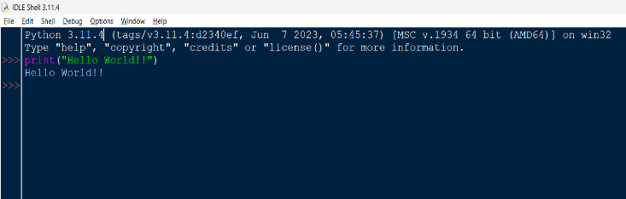
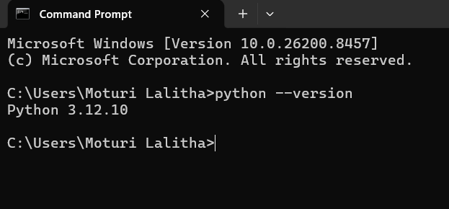
• Python
Figure 1: Python Installation Verification Figure 2: Python IDLE Execution

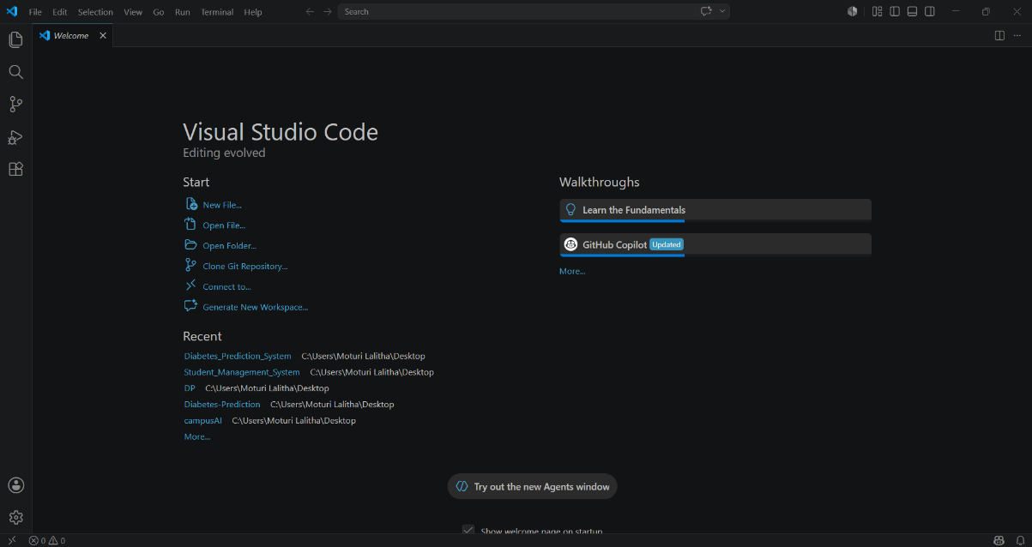
• Visual Studio Code (VS Code)
Figure 3: Visual Studio Code
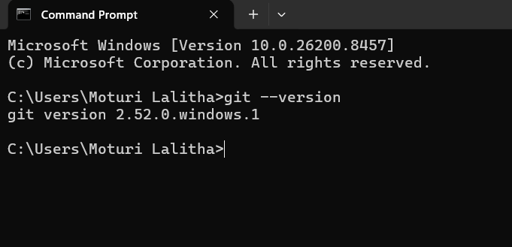
• Git

Figure 4: Git Installation Verification

- CREATE & SETUP GITHUB ACCOUNT
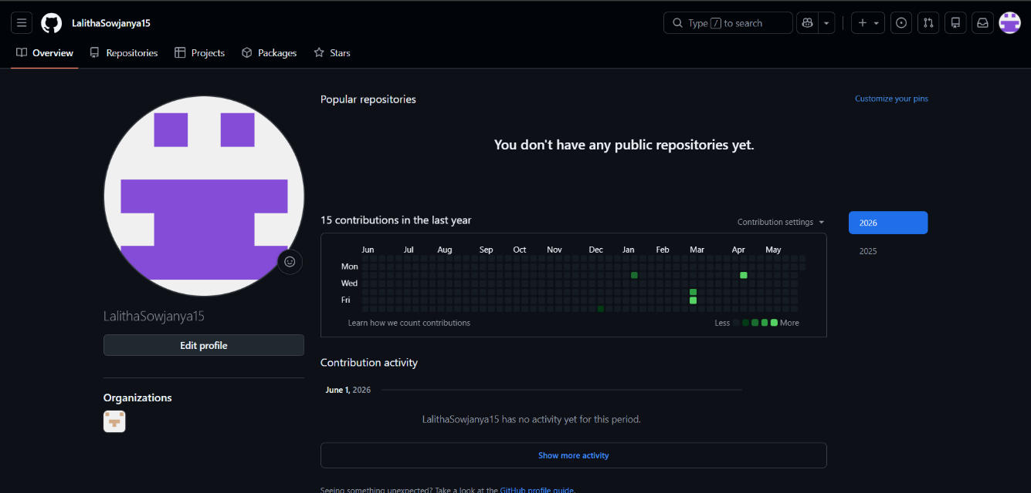
GitHub account was successfully created/verified. GitHub will be used throughout the cohort program for project management, version control, collaboration, and documentation.

Figure 5: GitHub Profile

3. RESEARCH TOPICS
3.1 Small Language Model (SLM)
Definition:
A Small Language Model (SLM) is a lightweight Artificial Intelligence language model designed to understand and generate human language while using fewer computational resources than Large Language Models (LLMs).

Features of SLM:
• Smaller model size
• Faster execution
• Lower memory usage
• Cost-effective deployment
• Can run on personal computers and laptops
• Suitable for educational and prototype projects

Limitations:
• Less knowledge compared to larger models
• Lower reasoning ability for complex tasks
• May provide less detailed responses

Examples:
• Phi • Tiny Llama • Small versions of Gemma • Small versions of Llama models

3.2 Retrieval-Augmented Generation (RAG)
Definition:
Retrieval-Augmented Generation (RAG) is an AI architecture that retrieves relevant information from external sources such as PDFs, documents, databases, and websites before generating a response through an LLM or SLM.

Features of RAG:
• Uses external information sources
• Improves response accuracy
• Reduces hallucinations
• Supports document-based question answering
• Provides access to updated information

How RAG Works:
User (Asks a question)
↓
Retrieve Relevant Information (External source)
↓
Provide Context to LLM/SLM
↓
Generate Response

Advantages:
• More accurate responses
• Access to private documents
• No need for retraining when new documents are added

Limitations:
• Depends on retrieval quality
• Response depends on information quality

4. PROBLEMS FACED DURING SETUP
No major issues were encountered during the setup process. Python, VS Code, Git, and GitHub were already available and functioning properly on the system.

5. WHAT I LEARNED TODAY
• Learned the purpose and importance of Python, VS Code, and Git in software development.
• Understood the role of GitHub in project collaboration.
• Learned the concept of Small Language Models (SLMs).
• Understood the differences between LLMs and SLMs.
• Learned the concept of Retrieval-Augmented Generation (RAG).
• Understood how RAG improves AI responses using external information sources.
• Learned the basic workflow of integrating AI models into applications.

6. CONCLUSION
This task provided an introduction to the development tools and AI concepts that will be used during the cohort program. Through this activity, I gained a foundational understanding of SLMs, RAG systems, GitHub workflow, and development setup, which will help in building future AI-based projects.

