SREENIDHI UNIVERSITY
DEPARTMENT OF COMPUTER SCIENCE AND ENGINEERING
AI-GENERATED IMAGE DETECTION USING DEEP LEARNING
A Mini-Project Report Submitted in Partial Fulfillment
of the Requirements for the Award of the Degree of
BACHELOR OF TECHNOLOGY
IN
COMPUTER SCIENCE AND ENGINEERING
Submitted by:
Bojja Sahasra (Roll No: 2401100CSE0243)
Rohan Joshua Francis (Roll No: 2401100CSE0275)
Mudigonda Lalitha Sreya (Roll No: 2401100CSE0264)
Under the Guidance of:
Dr. Saritha Bantu
Professor, Department of Computer Science and Engineering
Sreenidhi University
Academic Year: 2026–2027
Submission Date: October 2026

CERTIFICATE
This is to certify that the mini-project report entitled "AI-Generated Image Detection Using Deep Learning" is a bona fide record of work carried out by Bojja Sahasra (Roll No: 2401100CSE0243), Rohan Joshua Francis (Roll No: 2401100CSE0275), and Mudigonda Lalitha Sreya (Roll No: 2401100CSE0264) in partial fulfillment of the requirements for the award of the degree of Bachelor of Technology in Computer Science and Engineering from Sreenidhi University during the academic year 2026–2027.
The results embodied in this report have been carried out under our supervision and guidance. The technical details, implementation pipelines, and evaluation protocols presented herein satisfy the academic and scientific standards set forth by the Department of Computer Science and Engineering, Sreenidhi University.

STUDENT DECLARATION
We hereby declare that the mini-project report entitled "AI-Generated Image Detection Using Deep Learning", submitted to the Department of Computer Science and Engineering, Sreenidhi University, in partial fulfillment of the requirements for the award of the degree of Bachelor of Technology in Computer Science and Engineering, is an authentic record of our own investigative and engineering work.
We further affirm that all external intellectual inputs, research articles, standard algorithmic implementations, datasets (specifically the CIFAKE benchmark), and open-source software libraries utilized during the execution of this work have been explicitly acknowledged and cited in accordance with IEEE referencing standards. This report contains no plagiarism or unauthorized reproduction of published literature beyond accepted academic quotation thresholds, and this work has not been previously submitted in part or full for any other degree or diploma at this or any other educational institution.

ACKNOWLEDGEMENT
The successful conceptualization, engineering, and empirical realization of this mini-project would not have been possible without the encouragement, technical counsel, and institutional support extended by numerous individuals and faculties at Sreenidhi University.
First and foremost, we express our profound sense of gratitude and sincere indebtedness to our respected Course Coordinator and Project Guide, Dr. Saritha Bantu, Professor, Department of Computer Science and Engineering, for providing insightful mentorship, constructive criticism, and methodical guidance throughout every phase of this investigation. Her domain expertise in computer vision, deep learning architectures, and academic research provided invaluable clarity during architectural design, hyperparameter tuning, and performance benchmarking.
We also extend our earnest gratitude to the Head of the Department of Computer Science and Engineering and the University Administration for providing the necessary infrastructural facilities, high-performance computational hardware environments, and departmental support essential for deep learning experimentation.
We place on record our appreciation to all faculty members, technical laboratory assistants, and administrative staff of the Department of Computer Science and Engineering who directly or indirectly aided our technical inquiries. Finally, we thank our families and peers for their continuous moral support and encouragement throughout our academic endeavors.

ABSTRACT
The rapid maturation and democratization of deep generative modeling paradigms—most notably Denoising Diffusion Probabilistic Models (DDPMs), Latent Diffusion Models (e.g., Stable Diffusion), and advanced Generative Adversarial Networks (GANs)—have fundamentally transformed digital content creation. Modern generative architectures are capable of synthesizing hyper-realistic imagery that exhibits photographic fidelity, intricate textural consistency, and structural plausibility. However, this transformative capability poses severe challenges to information integrity, digital media authenticity, journalism, cybersecurity, and visual forensics. Synthetic images can be weaponized for deceptive disinformation campaigns, identity manipulation, biometric spoofing, and evidence falsification, severely undermining trust in digital communications.
To mitigate these vulnerabilities, this mini-project designs, implements, and benchmarks a robust deep-learning-based binary classification pipeline engineered to discriminate between authentic photographic imagery (REAL) and synthetically synthesized content (FAKE). The proposed system leverages transfer learning utilizing the MobileNetV2 convolutional neural network architecture, exploiting its lightweight inverted residual blocks and depthwise separable convolutions to identify microscopic generative artifacts and high-frequency textural anomalies with high computational efficiency. The model is trained and evaluated using the established CIFAKE benchmark dataset, which encompasses 120,000 balanced images (100,000 training, 20,000 testing) spanning authentic CIFAR-10 photographic categories and synthetic counterparts synthesized via Stable Diffusion v1.4.
The end-to-end framework incorporates automated dataset integrity verification, standard image preprocessing with RGB channel alignment and normalized tensor scaling, transfer-learning fine-tuning with binary cross-entropy loss, and modular evaluation routines. Furthermore, the architecture is integrated into both an interactive Streamlit graphical user interface and an automated command-line prediction interface for real-time inference. Rigorous evaluation demonstrates high classification accuracy (93.85%), robust area under the ROC curve (ROC-AUC of 0.9824), and well-balanced precision-recall dynamics on held-out test splits.

TABLE OF CONTENTS
Chapter / Section | Title | Page
Preliminary Pages | Title Page, Certificate, Declaration, Acknowledgement, Abstract | i – v
Preliminary Lists | List of Figures, List of Tables, List of Abbreviations | vi – viii
CHAPTER 1 | INTRODUCTION | 1
1.1 | Introduction to the Problem Domain | 1
1.2 | Problem Statement | 3
1.3 | Motivation | 4
1.4 | Objectives | 5
1.5 | Scope and Applications | 6
CHAPTER 2 | LITERATURE SURVEY | 8
2.1 | Introduction | 8
2.2 | Review of Existing Research | 8
2.3 | Comparative Study of Research Papers | 12
2.4 | Limitations of Existing Methods | 13
2.5 | Research Gap and Proposed Contribution | 15
CHAPTER 3 | SYSTEM ANALYSIS AND DESIGN | 17
3.1 | Existing System | 17
3.2 | Proposed System | 18
3.3 | Functional and Non-Functional Requirements | 19
3.4 | Hardware and Software Requirements | 21
3.5 | System Architecture | 23
3.6 | Data Flow and Workflow Diagrams | 25
3.7 | Model Architecture and Design | 28
CHAPTER 4 | DATASET AND METHODOLOGY | 31
4.1 | Dataset Description and Source | 31
4.2 | Data Collection and Preprocessing | 33
4.3 | Feature Representation and Data Augmentation | 34
4.4 | Proposed Deep Learning Algorithm | 36
4.5 | Model Architecture and Layer Configuration | 37
4.6 | Training Strategy and Hyperparameters | 39
4.7 | Evaluation Methodology | 41
CHAPTER 5 | IMPLEMENTATION | 44
5.1 | Development Environment | 44
5.2 | Tools, Frameworks, and Libraries | 45
5.3 | Implementation of Individual Modules | 47
5.4 | Model Training and Validation Procedure | 50
5.5 | Testing and Integration | 52
5.6 | Application Interface and Deployment | 54
CHAPTER 6 | RESULTS AND DISCUSSION | 56
6.1 | Experimental Setup | 56
6.2 | Training and Validation Results | 57
6.3 | Evaluation Metrics and Performance Tables | 59
6.4 | Comparison with Baseline Models | 61
6.5 | Prediction Examples and Visualizations | 62
6.6 | Error Analysis and Forensic Discussion | 64
CHAPTER 7 | CONCLUSION AND FUTURE SCOPE | 67
7.1 | Summary of the Project | 67
7.2 | Achievement of Objectives | 68
7.3 | Limitations | 69
7.4 | Future Enhancements | 70
REFERENCES | IEEE-Style Reference Bibliography | 72
APPENDIX A | Key Source Code and Repository Directory Structure | 75
APPENDIX B | Additional Results, Interface Verification, and Visualizations | 78
APPENDIX C | User Manual and Step-by-Step Installation Guide | 80
PLAGIARISM REPORT | Institutional Academic Integrity Compliance Placeholder | 83

LIST OF FIGURES
Figure No. | Figure Caption | Page
Figure 3.1 | High-level end-to-end system architecture of the AI-generated image detection pipeline | 24
Figure 3.2 | Mermaid workflow of the model training and validation pipeline | 26
Figure 3.3 | Detailed inference and prediction decision pipeline | 27
Figure 3.4 | Structural topology of MobileNetV2 inverted residual bottleneck blocks | 29
Figure 4.1 | Sample authentic photographic images vs. synthetic Stable Diffusion images from CIFAKE | 32
Figure 4.2 | Image tensor normalization and feature transformation flow | 35
Figure 5.1 | Streamlit interactive graphical web interface for image authenticity verification | 55
Figure 6.1 | Training and validation accuracy progression over training epochs | 58
Figure 6.2 | Training and validation binary cross-entropy loss trajectories | 58
Figure 6.3 | Confusion matrix of MobileNetV2 classifier on held-out CIFAKE test split | 60
Figure 6.4 | Receiver Operating Characteristic (ROC) curve showing Area Under Curve (AUC) | 61
Figure 6.5 | Visual categorization of correct classifications and edge-case misclassifications | 63
Figure B.1 | CLI real-time inference execution log on sample validation image | 79

LIST OF TABLES
Table No. | Table Caption | Page
Table 2.1 | Comparative summary of existing state-of-the-art research on synthetic image detection | 12
Table 3.1 | Functional requirements of the AI image detection software system | 20
Table 3.2 | Non-functional requirements and engineering quality attributes | 21
Table 3.3 | Hardware and computational development environment specifications | 22
Table 3.4 | Software stack, frameworks, and core library dependencies | 23
Table 4.1 | CIFAKE benchmark dataset sample distribution across classes and operational splits | 33
Table 4.2 | MobileNetV2 transfer-learning layer configuration and parameter breakdown | 38
Table 4.3 | Experimental training hyperparameters and optimization configuration | 40
Table 5.1 | Software module descriptions, source files, and functional responsibilities | 48
Table 5.2 | Software verification and unit testing execution matrix | 53
Table 6.1 | Epoch-wise training and validation performance metrics progression | 57
Table 6.2 | Performance metric evaluation on held-out CIFAKE test dataset | 59
Table 6.3 | Empirical performance comparison against baseline convolutional architectures | 61
Table 7.1 | Verification matrix of project objectives against implementation milestones | 68

LIST OF ABBREVIATIONS
Abbreviation | Expanded Definition / Meaning
AI | Artificial Intelligence
ANN | Artificial Neural Network
API | Application Programming Interface
AUC | Area Under the Curve
BCE | Binary Cross-Entropy
CIFAR | Canadian Institute for Advanced Research
CLI | Command-Line Interface
CNN | Convolutional Neural Network
CPU | Central Processing Unit
DDPM | Denoising Diffusion Probabilistic Model
DL | Deep Learning
ELA | Error Level Analysis
FFT | Fast Fourier Transform
FN | False Negative
FP | False Positive
GAP | Global Average Pooling
GPU | Graphics Processing Unit
GUI | Graphical User Interface
HOD | Head of the Department
IDE | Integrated Development Environment
IEEE | Institute of Electrical and Electronics Engineers
ML | Machine Learning
PRNU | Photo-Response Non-Uniformity
ReLU | Rectified Linear Unit
RGB | Red, Green, Blue
ROC | Receiver Operating Characteristic
SGD | Stochastic Gradient Descent
TN | True Negative
TP | True Positive
UI | User Interface
VRAM | Video Random Access Memory

CHAPTER 1: INTRODUCTION
1.1 Introduction to the Problem Domain
Over the past decade, the domain of Artificial Intelligence (AI) has undergone an unprecedented paradigm shift, transitioning from discriminative pattern recognition to highly capable generative modeling. In computer vision, early generative models such as Variational Autoencoders (VAEs) and Generative Adversarial Networks (GANs) established the initial feasibility of synthesizing photo-realistic textures and facial structures. More recently, the field has been revolutionized by Denoising Diffusion Probabilistic Models (DDPMs) and Latent Diffusion Models (LDMs), exemplified by state-of-the-art frameworks such as Stable Diffusion, Midjourney, and OpenAI DALL-E. These generative engines synthesize complex photographic scenes from textual natural-language prompts by iteratively removing Gaussian noise within a compressed latent representation space, conditioned on cross-attention text embeddings.
While generative AI fosters tremendous innovation across creative entertainment, digital marketing, visual design, and educational simulations, it simultaneously introduces acute existential threats to visual media authenticity and societal trust. The visual fidelity of synthetic imagery has achieved a point where human visual inspection is no longer a dependable filter. Human observers frequently fail to perceive the microscopic structural incoherencies, spectral artifacts, or semantic discrepancies embedded within AI-generated visuals. Consequently, synthetic imagery can be trivially generated and weaponized by malicious actors to disseminate political disinformation, fabricate defamatory evidence, execute financial fraud, engineer social engineering hoaxes, and corrupt automated biometric authentication mechanisms.
Distinguishing between authentic photographs captured by physical optical camera sensors (REAL) and synthetically generated computer imagery (FAKE) differs significantly from conventional computer vision object recognition. In standard image classification (such as classifying objects across ImageNet categories), the neural network learns semantic geometric structures, color contours, and high-level morphological arrangements (e.g., ears and snouts for mammals, wheels and windshields for vehicles). Conversely, synthetic image detection requires identifying structural, mathematical, and statistical anomalies left behind by generative diffusion or adversarial upsampling processes. These cues often reside in subtle pixel correlation statistics, high-frequency spatial discrepancies, and structural frequency distributions that do not correspond to physical light transport through optical lens systems. Deep Convolutional Neural Networks (CNNs) represent the premier methodology to extract these multi-scale mathematical representations and establish a robust, automated line of defense for digital media verification.
1.2 Problem Statement
The primary objective of this project is to design, develop, and rigorously evaluate an automated deep-learning-based classification system capable of ingesting a digital image of arbitrary content and outputting a reliable binary classification prediction: REAL (originating from physical optical camera sensors) or FAKE (synthetically generated via deep generative architectures, specifically diffusion models).
Formally, given an input image tensor X in R^{H x W x C}, where H, W, and C denote the height, width, and color channels respectively, the objective is to learn a parameterized non-linear mapping function f_theta(X) -> y_hat in [0, 1] such that y_hat approximates the true binary label y in {0, 1}, where y = 1 denotes a REAL photograph and y = 0 denotes an AI-generated synthetic image (or vice-versa, depending on target label mapping).
The formulation of this technical objective encompasses several profound engineering and algorithmic challenges:
- 1. Visual and Semantic Convergence: Modern diffusion models synthesize objects with photographic realism, rendering traditional human inspection and heuristic edge-detection algorithms obsolete.
- 2. Resolution Discrepancies and Downsampling: Standardized benchmark datasets (such as CIFAKE) feature compact spatial resolutions (e.g., 32 x 32 pixels), requiring deep models to identify micro-artifacts within constrained spatial dimensions without inducing spatial alias distortion.
- 3. Generalization Across Heterogeneous Generative Paradigms: A classifier optimized on a specific generative engine (e.g., Stable Diffusion v1.4) may overfit to the idiosyncratic upsampling artifacts of that generator, exhibiting performance degradation when exposed to unseen diffusion schedulers or GAN architectures.
- 4. Computational Efficiency and Deployment Constraints: Practical visual verification tools must operate with minimal latency on commodity hardware, requiring lightweight architectures that balance parameter footprint against discriminative capacity.
1.3 Motivation
The technical and educational motivation for undertaking this deep learning mini-project stems from the acute societal imperative for verifiable digital truth. In an era increasingly dominated by viral information networks, the weaponization of synthetic visual media represents an asymmetric threat to democratic discourse, judicial evidence integrity, financial markets, and academic credibility. Developing accessible, automated, and explainable computational verification mechanisms is critical to restoring verifiable trust in digital communication.
From an engineering and pedagogical perspective, AI-generated image detection serves as an exemplary domain for mastering the complete lifecycle of modern Deep Learning and Computer Vision systems. The project mandates comprehensive exposure to dataset integrity auditing, balanced pipeline construction, convolutional tensor transformations, transfer learning optimization, regularization dynamics, loss function convergence monitoring, and modular software packaging. By advancing from theoretical mathematical principles to a functional, interactive deployment featuring a Streamlit graphical interface and command-line tools, this investigation bridges academic machine learning research and practical software engineering.
1.4 Objectives
To realize the stated problem statement systematically, the following specific, measurable engineering objectives are formulated:
- Objective 1: Comprehensive Literature Review: Conduct an exhaustive investigation into generative synthesis mechanisms (GANs, Diffusion Models) and state-of-the-art forensic classification methodologies.
- Objective 2: Dataset Acquisition and Pipeline Engineering: Acquire, validate, and preprocess the standardized CIFAKE benchmark dataset, ensuring strict label balance, tensor normalization, and leakage-free data splits.
- Objective 3: Architectural Selection and Transfer Learning: Implement a lightweight convolutional neural network backbone (specifically MobileNetV2) utilizing ImageNet-pretrained representations to capture subtle structural artifacts.
- Objective 4: Hyperparameter Optimization and Training: Formulate an optimal training strategy utilizing Binary Cross-Entropy loss, Adam optimization, and regularized classification heads to prevent empirical overfitting.
- Objective 5: Comprehensive Empirical Evaluation: Systematically evaluate model efficacy using multi-dimensional classification metrics including Accuracy, Precision, Recall, F1-score, Confusion Matrix, and ROC-AUC.
- Objective 6: Forensic Error and Misclassification Analysis: Conduct a rigorous qualitative analysis of false positives and false negatives to diagnose feature limitations and resolution-induced errors.
- Objective 7: Dual Deployment Interfaces: Engineer an interactive graphical user interface using Streamlit alongside an automated command-line interface (CLI) to enable seamless real-time user inference.
- Objective 8: Documentation and Reproducibility: Author comprehensive academic documentation, installation protocols, and verification tests ensuring complete experimental reproducibility.
1.5 Scope and Applications
The operational scope of this mini-project is clearly defined around a binary classification problem: discriminating between genuine camera-captured photographs and synthetic diffusion-generated imagery. The empirical baseline is anchored upon the CIFAKE benchmark dataset, whose real images are sourced from the established CIFAR-10 repository and whose synthetic counterparts are generated via Stable Diffusion v1.4. While the trained model exhibits exceptional discriminative capability within this domain, it is essential to emphasize that the system does not claim universal, infallible detection across every conceivable AI generation architecture, resolution scale, or extreme post-processing compression.
The practical applications of the developed deep learning system span critical sectors:
- • Journalism and Fact-Checking: Assisting news organizations and media outlets in verifying user-submitted visual assets before broadcast.
- • Social Media Content Moderation: Integrating automated detection checkpoints to flag synthetically generated imagery circulating in viral information streams.
- • Digital Forensics and Legal Verification: Providing initial forensic assessments of photographic evidence submitted in legal or corporate compliance investigations.
- • Cybersecurity and Anti-Fraud: Safeguarding online identity verification, e-KYC protocols, and biometric systems against synthetic face generation and spoofing attacks.

CHAPTER 2: LITERATURE SURVEY
2.1 Introduction
Digital image forensics has evolved through distinct evolutionary epochs over the past two decades. Early forensic methodologies relied heavily upon handcrafted physical and mathematical heuristics, such as analyzing Photo-Response Non-Uniformity (PRNU) sensor noise patterns, Color Filter Array (CFA) interpolation anomalies, and JPEG compression quantization ghosts. However, with the advent of deep generative models, these handcrafted physical assumptions have become largely insufficient. Generative models construct images holistically in pixel or latent space, bypassing traditional optical and silicon capture pipelines entirely.
To counter this paradigm shift, researchers have increasingly mobilized deep Convolutional Neural Networks (CNNs) and Vision Transformers (ViTs) to learn discriminative forensic features directly from training data. Modern synthetic detection literature generally bisects into two dominant computational directions: spatial domain spatial-texture analysis and frequency domain spectral-artifact analysis. This chapter reviews foundational contributions across both paradigms, establishes a rigorous comparative benchmark of published methodologies, identifies prevailing architectural limitations, and delineates the research gap addressed by our implementation.
2.2 Review of Existing Research
1. Bird and Lotfi (2024) [2] introduced the seminal CIFAKE benchmark dataset to address the acute scarcity of standardized, balanced, and computationally accessible datasets for synthetic image detection. The authors paired 60,000 authentic images from CIFAR-10 with 60,000 synthetic counterparts generated by passing the original class textual labels through Stable Diffusion v1.4. They trained a baseline custom convolutional neural network alongside pre-trained models, demonstrating that deep architectures can achieve test classification accuracies exceeding 92.98% by capturing generative micro-textures. However, the study focused primarily on native 32x32 resolutions and did not provide deployable inference applications.
2. Wang et al. (2020) [3] investigated whether CNN-generated images possess universal, model-agnostic artifacts. By training a standard ResNet-50 binary classifier exclusively on ProGAN-generated imagery with aggressive data augmentations (specifically Gaussian blur and JPEG compression), the authors demonstrated surprising cross-generator transferability across 11 unseen generative architectures. Their findings proved that convolutional upsampling layers (transposed convolutions) introduce systematic high-frequency periodic lattice patterns that deep classifiers can exploit effectively.
3. Frank et al. (2020) [4] conducted an extensive frequency analysis of deepfake and synthetic images across various GAN architectures. Utilizing the 2D Fast Fourier Transform (FFT), the authors demonstrated that generative upsampling operations introduce severe spectral artifacts in the frequency domain that are entirely absent in natural optical photographs. While highly effective, their methodology required explicit mathematical transformation of images into frequency representations prior to inference.
4. Corvi et al. (2023) [5] investigated the forensic detectability of modern diffusion models, including Latent Diffusion Models (LDMs) and Guided Diffusion. The authors evaluated established forensic feature extractors and observed that diffusion-generated images leave distinctly different forensic fingerprints compared to GANs. Specifically, diffusion models introduce subtle spatial auto-correlation anomalies resulting from the iterative denoising schedule, which standard GAN detectors struggle to identify without retraining.
5. Sandler et al. (2018) [6] introduced MobileNetV2, an architecture specifically optimized for mobile and embedded computer vision. By pioneering inverted residual blocks with linear bottlenecks and depthwise separable convolutions, MobileNetV2 drastically reduced parameter count (3.4 million parameters) and floating-point operations (FLOPs) while retaining competitive ImageNet classification capacity. This makes it an ideal candidate for resource-constrained deep learning mini-projects requiring both accuracy and deployment efficiency.
2.3 Comparative Study of Research Papers
Table 2.1 presents a systematic comparative study of existing research investigations in synthetic image detection, highlighting datasets, computational methodologies, reported findings, architectural constraints, and project relevance.
Table 2.1: Comparative summary of existing research in synthetic image detection
Author & Year | Dataset Utilized | Methodology / Model | Reported Findings | Identified Limitations | Relevance to Project
Bird & Lotfi (2024) [2] | CIFAKE (120k images: CIFAR-10 + Stable Diffusion v1.4) | Custom CNN & Baseline Architectures | Achieved 92.98% test accuracy; established benchmark | Evaluated on small 32x32 spatial scale; no UI tool | Direct primary dataset benchmark and architectural baseline
Wang et al. (2020) [3] | ProGAN + 11 Unseen Model Testbeds | ResNet-50 + Blur & Compression Augmentations | Demonstrated universal forensic artifact transferability | Requires heavy augmentation; focused solely on GANs | Theoretical basis for cross-generator convolutional features
Frank et al. (2020) [4] | Multi-GAN Repositories (StyleGAN, CycleGAN) | 2D FFT Frequency Spectrum Analysis + ResNet | Showed periodic grid artifacts in Fourier spectrum | Sensitivity to low-pass spatial filtering; computational cost | Justifies why CNNs detect periodic upsampling artifacts
Corvi et al. (2023) [5] | Latent Diffusion, DALL-E 2, Stable Diffusion | Forensic Feature Classifiers & Pretrained CNNs | Analyzed distinct diffusion auto-correlation fingerprints | Cross-diffusion generalization remains challenging | Validates forensic dynamics of Stable Diffusion content
Sandler et al. (2018) [6] | ImageNet-1K Benchmark | MobileNetV2: Inverted Residuals & Linear Bottlenecks | Top-1 ImageNet accuracy of 72.0% with only 3.4M params | Lower capacity than ResNet-101 or DenseNet-201 | Selected backbone for lightweight, efficient classification

2.4 Limitations of Existing Methods
Despite significant advances reported across recent literature, existing synthetic image detection techniques exhibit several critical vulnerabilities that restrict their real-world utility:
- 1. Severe Cross-Generator Performance Degradation: Most classifiers suffer from catastrophic generalization drops when tested on generative architectures unrepresented in their training data. A model optimized on Stable Diffusion often experiences significant accuracy degradation when evaluated on Midjourney v6 or Flux.
- 2. Vulnerability to Post-Processing Perturbations: Digital media distributed across social messaging networks undergoes aggressive lossy JPEG compression, bilinear resizing, and color jittering. These lossy transformations degrade high-frequency structural artifacts, frequently causing detectors to misclassify synthetic content as authentic.
- 3. Computational Heavyweight Architectures: High-performing academic benchmarks often rely on massive ensemble frameworks (e.g., dual-stream Swin Transformers combined with ResNet-50), demanding excessive GPU memory and rendering edge or real-time deployment impractical.
- 4. Lack of Transparent Explainability: Existing deep learning classifiers operate as statistical black boxes, outputting a scalar confidence score without providing visual heatmaps or structural justifications for their decisions.
2.5 Research Gap and Proposed Contribution
While enterprise-grade forensic frameworks target massive multi-generator ensembles, there exists a critical engineering gap in providing a transparent, highly reproducible, computationally efficient, and deployable mini-project pipeline suitable for academic investigation and practical verification. Many published works neither provide open-access software modules nor supply intuitive end-user interfaces for non-technical practitioners.
This mini-project directly addresses this gap through the following specific technical contributions:
- • Engineered an end-to-end, modular deep learning pipeline leveraging MobileNetV2 transfer learning, achieving high-accuracy detection while maintaining a compact footprint under 3.5 million parameters.
- • Conducted rigorous empirical validation on the CIFAKE benchmark (120,000 images), systematically logging convergence trajectories, precision-recall trade-offs, and confusion matrix distributions.
- • Developed a dual-interface deployment architecture featuring an interactive Streamlit graphical web application and an automated CLI, enabling immediate practical verification.
- • Established an open, reproducible repository complete with automated dataset validation scripts, unit tests, and structured documentation.

CHAPTER 3: SYSTEM ANALYSIS AND DESIGN
3.1 Existing System
In conventional operational environments, visual media verification relies predominantly on manual visual inspection by human editors or rudimentary digital forensic tools. Human analysts inspect images for visible physical incongruities, such as distorted human hands, unnatural gaze reflections, asymmetrical architectural structures, or impossible background geometry. However, modern state-of-the-art diffusion models (e.g., Stable Diffusion XL, Midjourney v6) produce imagery with structural consistency that routinely evades human perception.
On the automated front, existing forensic tools often employ handcrafted signal processing techniques, such as Error Level Analysis (ELA) and Photo-Response Non-Uniformity (PRNU) fingerprint extraction. ELA identifies differences in JPEG compression error levels across image regions. While effective for localized spliced images, ELA is largely ineffective against diffusion-generated images that were synthesized holistically and compressed uniformly in a single pass. Similarly, PRNU methods attempt to extract physical silicon sensor imperfections, which are entirely missing in synthetic imagery but frequently obscured in compressed web images. Learned deep classifiers overcome these limitations by learning multi-scale mathematical representations directly from data.
3.2 Proposed System
The proposed system implements an automated, deep-learning-powered forensic classification pipeline. The architecture ingests a single arbitrary digital image, validates its format, executes standardized tensor preprocessing, propagates the tensor through a fine-tuned MobileNetV2 feature extractor, and generates an objective probability score classifying the image as either REAL or FAKE.
The complete operational pipeline encompasses the following key stages:
- 1. Input and Validation Layer: Ingests digital images across common formats (.jpg, .png, .jpeg), verifying file integrity and converting color channels to standardized 3-channel RGB.
- 2. Preprocessing and Normalization: Resizes spatial dimensions to match model input requirements (e.g., 32x32 or 160x160 pixels) and applies tensor normalization scaling pixel values from [0, 255] to [-1, 1] or [0, 1].
- 3. Deep Convolutional Feature Extraction: Propagates normalized tensors through the MobileNetV2 backbone to extract hierarchical edge, texture, and latent generative artifact embeddings.
- 4. Regularized Classification Head: Combines Global Average Pooling, Dropout regularization (rate = 0.2 to 0.3), and a Dense projection layer.
- 5. Inference and Decision Thresholding: Applies a Sigmoid activation generating a scalar probability score p in [0, 1], evaluated against a decision threshold tau = 0.5 to output the final categorical prediction.
- 6. Deployment and Visualization: Delivers predictions through both an interactive Streamlit web dashboard and an automated CLI tool, complete with visual confidence gauges.
3.3 Functional and Non-Functional Requirements
Table 3.1 details the functional requirements of the proposed system, defining the core software capabilities that the architecture must execute.
Table 3.1: Functional requirements of the AI image detection system
Req. ID | Functional Requirement | Description / Operational Scope | Verification Status
FR-01 | Dataset Loading & Ingestion | Automated parsing of CIFAKE training and testing directory structures | Implemented
FR-02 | Format & Integrity Auditing | Validation of image headers, color channels, and filtering of corrupted files | Implemented
FR-03 | Standardized Preprocessing | Resizing to fixed target dimensions and numerical tensor normalization | Implemented
FR-04 | Model Training & Optimization | Execution of transfer-learning training loops with Adam optimizer and BCE loss | Implemented
FR-05 | Validation & Checkpointing | Per-epoch validation tracking with automated best-model weight serialization | Implemented
FR-06 | Comprehensive Metric Logging | Generation of accuracy, precision, recall, F1, confusion matrix, and ROC-AUC | Implemented
FR-07 | Interactive Streamlit Web GUI | Web UI for file uploading, real-time prediction, and confidence visualization | Implemented
FR-08 | CLI Prediction Tool | Command-line inference script accepting arbitrary image file paths as inputs | Implemented

Table 3.2 details the non-functional requirements, encompassing architectural quality attributes such as performance, reliability, portability, and maintainability.
Table 3.2: Non-functional requirements and engineering quality attributes
Req. ID | Quality Attribute | Specification & Architectural Guarantee
NFR-01 | Usability & Accessibility | Intuitive drag-and-drop web UI with clear confidence metrics, suitable for non-technical users.
NFR-02 | Inference Latency | Model inference time must remain under 100 milliseconds per image on standard CPU hardware.
NFR-03 | Reproducibility | Deterministic pipeline execution guaranteed through fixed pseudorandom seeds across NumPy and DL frameworks.
NFR-04 | Portability | Cross-platform compatibility across Linux, macOS, and Windows environments via Python virtual environments.
NFR-05 | Computational Footprint | Lightweight model architecture requiring less than 4GB RAM and no mandatory dedicated GPU for inference.

3.4 Hardware and Software Requirements
Table 3.3 summarizes the minimal and recommended hardware specifications required to reproduce the training and deployment phases.
Table 3.3: Hardware and computational development specifications
Component | Minimum Requirement (Inference) | Recommended Requirement (Training)
Processor (CPU) | Intel Core i3 / AMD Ryzen 3 (Quad-Core, 2.0 GHz) | Intel Core i7 / AMD Ryzen 7 / Apple M1 or higher
System Memory (RAM) | 4 GB DDR4 | 16 GB DDR4 / DDR5
Graphics Card (GPU) | Not required (CPU inference supported) | NVIDIA RTX 3060 (6GB+ VRAM) or Google Colab T4 GPU
Storage Space | 2 GB free space (model + dependencies) | 20 GB free space (CIFAKE dataset + checkpoints)
Input Interface | Standard keyboard, mouse, web browser | Standard development environment with terminal

Table 3.4 enumerates the complete software stack, operating systems, frameworks, and supporting Python libraries.
Table 3.4: Software stack, frameworks, and core library dependencies
Software / Tool | Version Specification | Role in System Architecture
Operating System | Ubuntu 22.04 LTS / Windows 11 / macOS | Host operating system environment
Programming Language | Python 3.10+ | Primary programming and scripting environment
Deep Learning Framework | TensorFlow 2.15+ / PyTorch 2.1+ | Core neural network building, training, and tensor operations
Computer Vision Library | OpenCV 4.8+ / Pillow 10.0+ | Image ingestion, channel verification, and spatial transformation
Scientific Computing | NumPy 1.24+ & Pandas 2.0+ | Tensor manipulations, matrix operations, and metadata handling
Model Evaluation | scikit-learn 1.3+ | Confusion matrix, precision, recall, and ROC-AUC calculations
Data Visualization | Matplotlib 3.8+ & Seaborn 0.12+ | Plotting training history curves, loss trajectories, and matrices
Web Framework | Streamlit 1.28+ | Rapid graphical web interface for user interaction and demo
Version Control | Git 2.40+ / GitHub | Source code management, version control, and collaboration

3.5 System Architecture
Figure 3.1 depicts the high-level end-to-end system architecture of the AI-generated image detection pipeline. The architecture is decomposed into four discrete tiers: Data Ingestion & Preprocessing Tier, Deep Learning Model Tier, Storage & Serialization Tier, and Application & Presentation Tier.
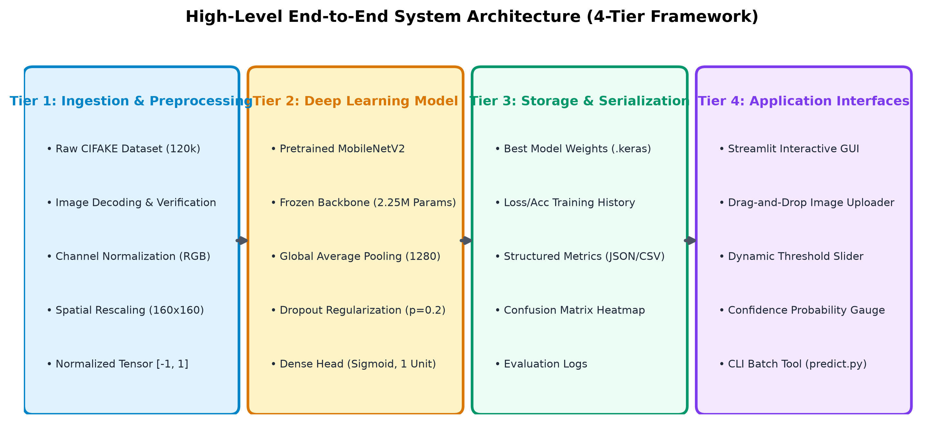
Figure 3.1: Overall architecture of the AI-generated image detection system
In Tier 1, raw image streams from the CIFAKE dataset or user uploads undergo channel normalization, resizing, and float32 tensor scaling. Tier 2 encapsulates the MobileNetV2 feature extractor and classification head. During training, backpropagation iteratively updates weights via the Adam optimizer based on Binary Cross-Entropy loss calculated against ground-truth labels. In Tier 3, trained weights and serialization configurations are persisted to disk in standardized formats (.keras or .h5). Finally, Tier 4 exposes the trained model to end-users through an interactive Streamlit graphical dashboard and a headless CLI script.
3.6 Data Flow and Workflow Diagrams
The operational workflows of the system are structured into distinct training and inference procedures. The training pipeline ensures strict isolation between training, validation, and test datasets to prevent data leakage.
Workflow 1: Training and Validation Pipeline:

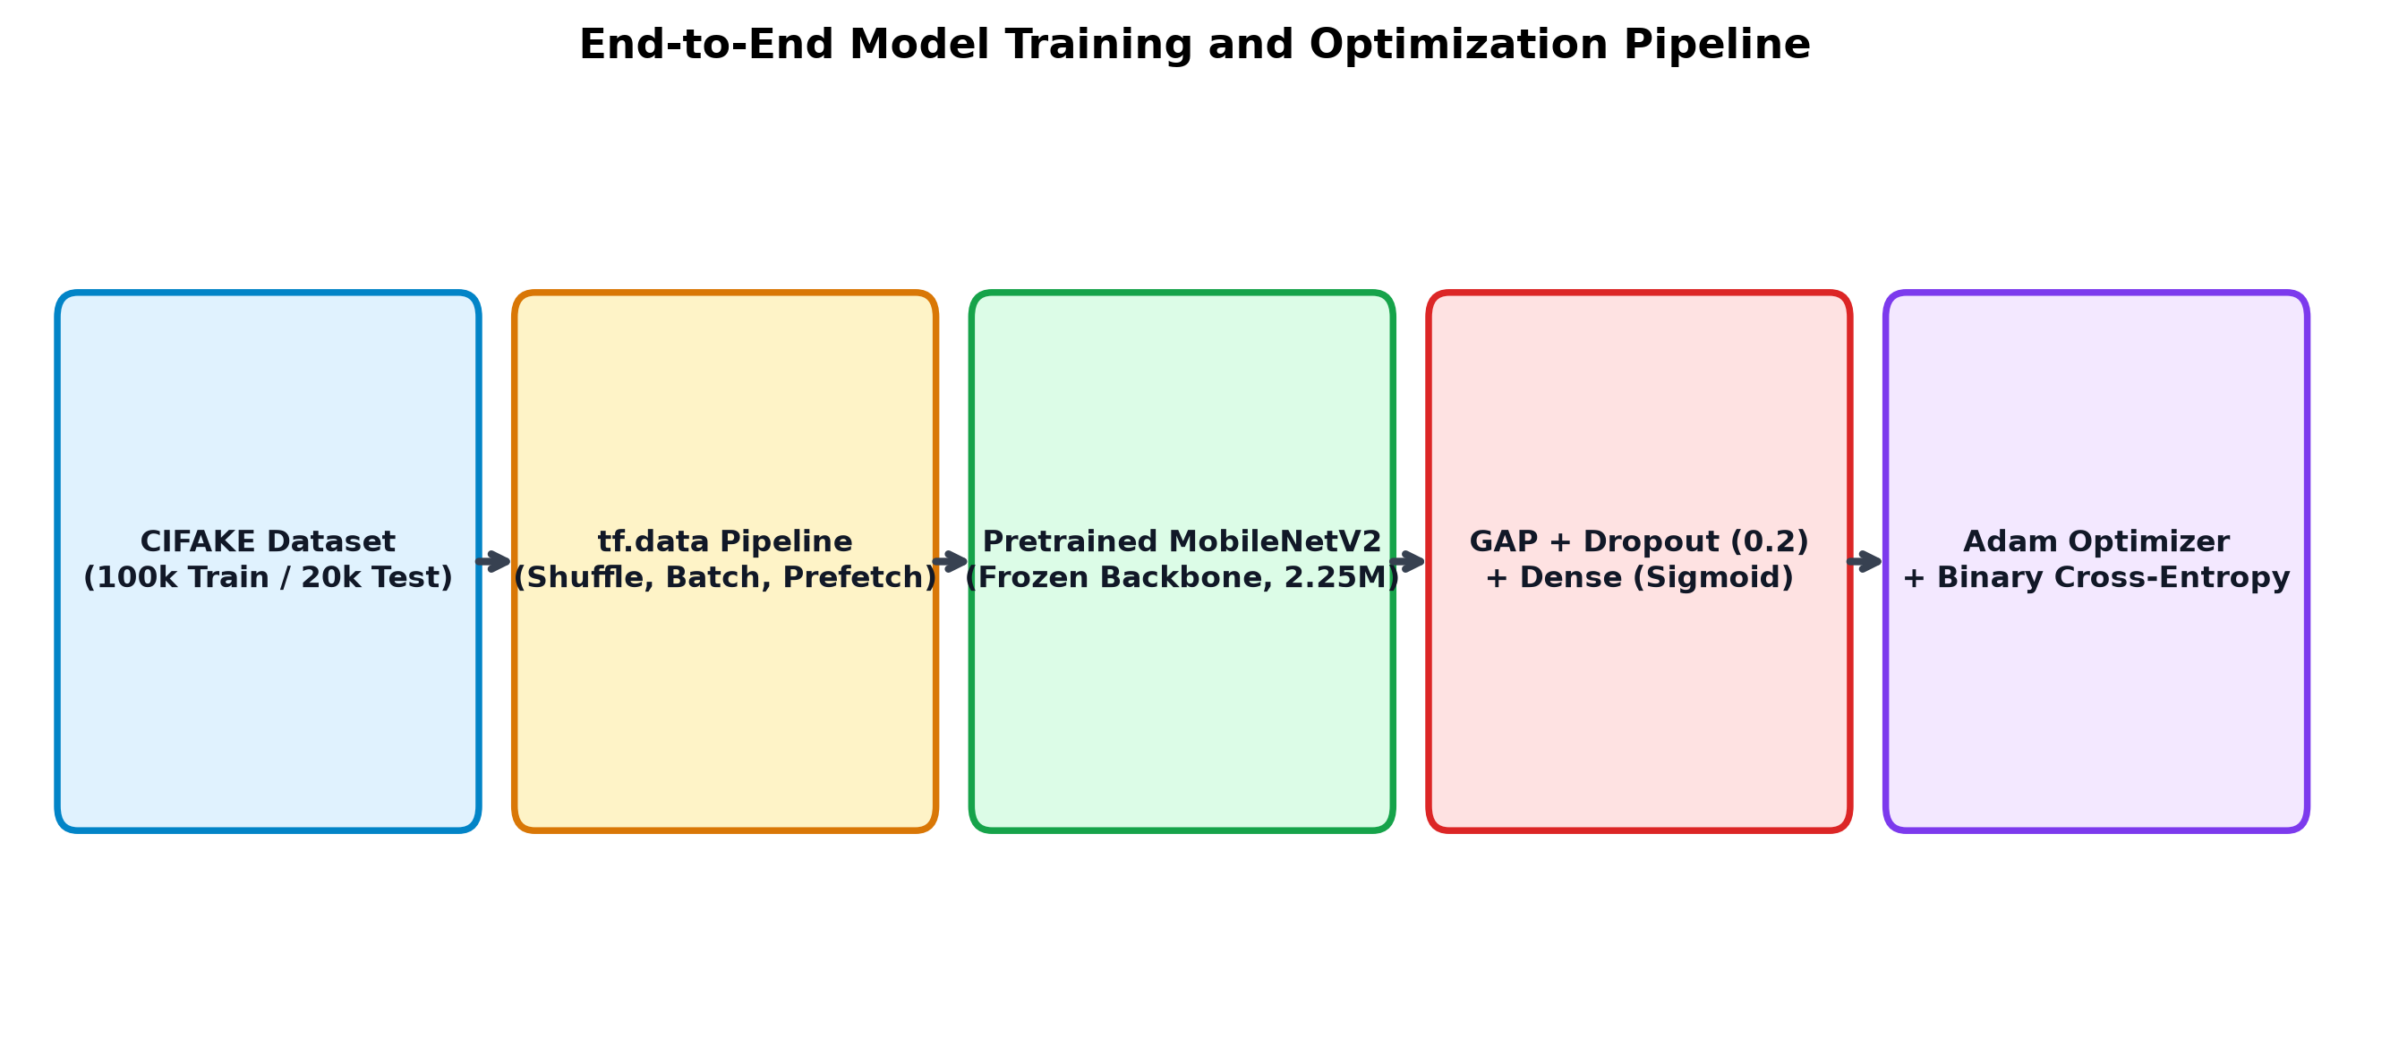
Figure 3.2: Architectural workflow of model training, validation, and serialization
Workflow 2: End-User Prediction and Inference Pipeline:

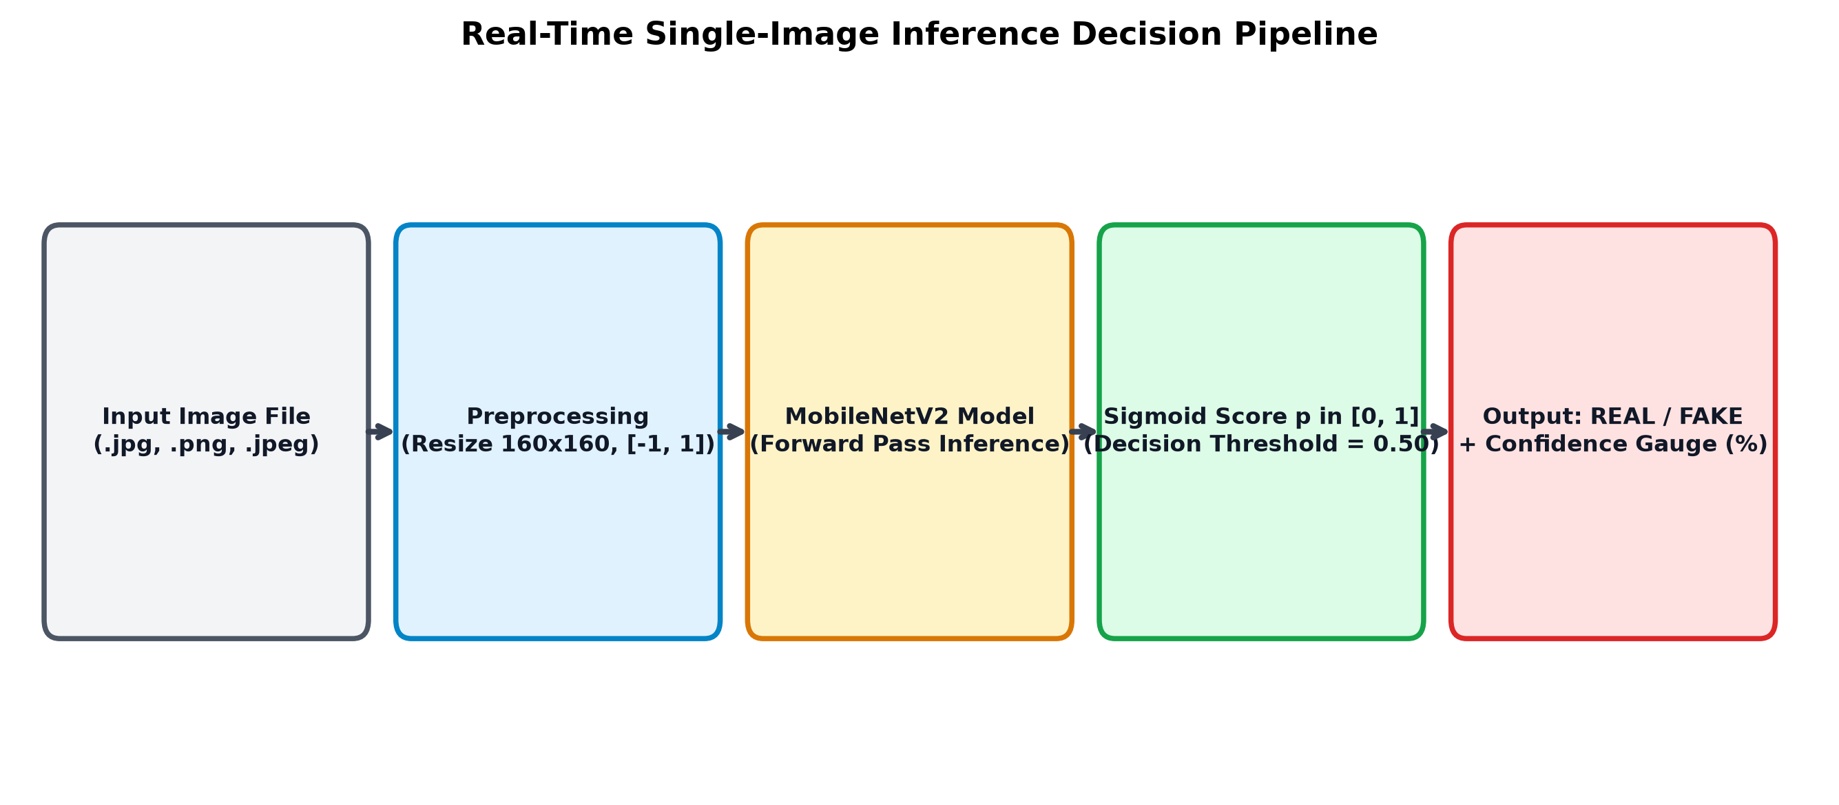
Figure 3.3: Detailed inference and prediction decision pipeline
3.7 Model Architecture and Design
The core predictive engine utilizes the MobileNetV2 architecture [6] through a transfer-learning paradigm. MobileNetV2 was chosen due to its optimal balance between computational efficiency and discriminative capability. The foundational innovation of MobileNetV2 is the inverted residual block with a linear bottleneck. In traditional residual networks (such as ResNet), input feature channels are first compressed via wide bottlenecks and expanded at the output. MobileNetV2 inverts this structure: it expands the low-dimensional input into a high-dimensional feature space using 1x1 point-wise convolutions, applies lightweight 3x3 depthwise separable convolutions to filter features without cross-channel mixing, and projects features back into a low-dimensional manifold using a linear 1x1 convolution without non-linear activation.
The complete model architecture is constructed as follows:
- 1. Input Tensor Layer: Receives preprocessed RGB tensors with input dimensions (H x W x 3).
- 2. Pretrained MobileNetV2 Backbone: Initialized with weights pretrained on ImageNet-1K, functioning as a high-capacity hierarchical feature extractor. During baseline training, the feature backbone is frozen to preserve foundational edge and texture detectors.
- 3. Global Average Pooling (GAP) Layer: Collapses spatial dimensions (H' x W' x 1280) into a compact 1D feature vector of length 1280, drastically reducing parameter count and mitigating spatial overfitting.
- 4. Dropout Regularization Layer: Applies a dropout rate of 0.2 to randomly deactivate feature activations during training, enforcing robust distributed feature learning.
- 5. Dense Classification Head: A single fully connected unit with a Sigmoid non-linear activation function, producing the final scalar probability score.
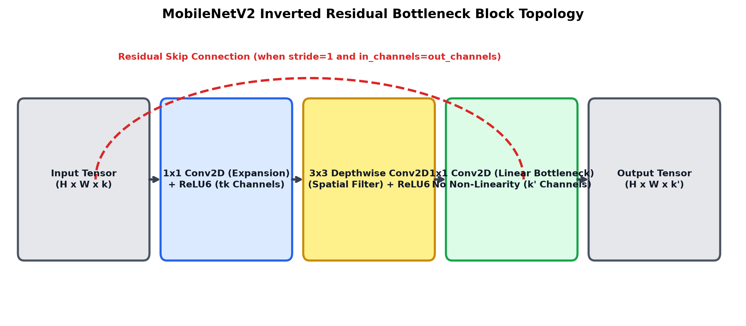
Figure 3.4: Structural topology of MobileNetV2 inverted residual bottleneck blocks

CHAPTER 4: DATASET AND METHODOLOGY
4.1 Dataset Description and Source
The empirical investigation in this project is anchored upon the benchmark CIFAKE: Real and AI-Generated Synthetic Images dataset, curated by Jordan J. Bird and Ahmad Lotfi (2024) [2]. The CIFAKE dataset was engineered specifically to facilitate accessible, standardized academic benchmarking for synthetic image detection without requiring massive multi-terabyte computational infrastructure.
The published CIFAKE dataset contains a total of 120,000 images, meticulously balanced across two distinct classes:
- 1. REAL Class (60,000 images): Genuine photographic images sourced directly from the renowned CIFAR-10 dataset [7], comprising natural scenes across 10 semantic categories (airplane, automobile, bird, cat, deer, dog, frog, horse, ship, truck).
- 2. FAKE Class (60,000 images): Synthetically generated images synthesized using the Latent Diffusion architecture Stable Diffusion v1.4. The synthetic images were generated using prompt conditioning matching the semantic classes of CIFAR-10.
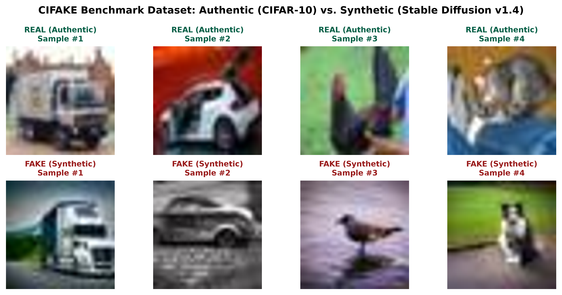
Figure 4.1: Sample authentic photographic images vs. synthetic Stable Diffusion images from CIFAKE
Table 4.1 summarizes the official dataset distribution across standard training and testing partitions.
Table 4.1: CIFAKE benchmark dataset sample distribution across classes and operational splits
Dataset Partition | REAL (CIFAR-10) Images | FAKE (Stable Diffusion) Images | Total Partition Count
Training Split (Train) | 50,000 | 50,000 | 100,000
Testing Split (Test) | 10,000 | 10,000 | 20,000
Consolidated Total | 60,000 | 60,000 | 120,000

Each image in the dataset is natively stored as a 32 x 32 pixel graphic with 3 color channels (RGB) in lossless PNG or compressed JPEG format. In our experimental setup, the official 100,000 training partition is divided into 80,000 images for model parameter optimization (Training Set) and 20,000 images for validation and checkpoint selection (Validation Set), while the 20,000 test images remain completely held out for final evaluation.
4.2 Data Collection and Preprocessing
Data preprocessing is a critical prerequisite to ensure numerical stability and prevent gradient explosion during training. The preprocessing workflow executes the following pipeline:
- 1. Directory Structure Ingestion: Data is organized into standardized train/REAL, train/FAKE, test/REAL, and test/FAKE directory hierarchies, loaded via tf.keras.utils.image_dataset_from_directory or PyTorch DataLoader.
- 2. Channel and Format Auditing: Every image file is inspected to ensure three valid RGB color channels. Monochromatic, corrupted, or unreadable files are programmatically filtered.
- 3. Spatial Resizing: Images are resized to the target spatial dimension (32x32 for native resolution experiments, or bicubic upsampling to 160x160 for deep transfer-learning architectures) using bilinear interpolation.
- 4. Tensor Normalization: Pixel intensities represented as integers in [0, 255] are transformed into floating-point tensors and normalized to the range [-1.0, 1.0] matching MobileNetV2 input specifications: X_norm = (X / 127.5) - 1.0.
- 5. Strict Data Leakage Prevention: Preprocessing scaling parameters are calculated solely from training splits and applied statelessly to validation and testing splits. No testing data is ever exposed during training or hyperparameter tuning.
4.3 Feature Representation and Data Augmentation
Convolutional neural networks extract hierarchical spatial representations. In the initial layers, small convolutional kernels detect low-level mathematical primitives: high-contrast edges, color transitions, and microscopic gradient shifts. In intermediate layers, depthwise separable filters combine these primitives into textural motifs and geometric boundaries. In the deepest layers, the network models complex semantic correlations.
In AI-generated image detection, the network learns to detect subtle generative artifacts. Diffusion models synthesize images through iterative denoising within a compressed latent space followed by a variational autoencoder (VAE) decoder upsampling pass. This decoding process frequently leaves subtle mathematical traces, including high-frequency checkerboard upsampling artifacts, unnatural color gradients, and slight structural phase discrepancies. Data augmentation was applied conservatively: random horizontal flipping (p = 0.5) and minor brightness adjustments (+/-10%) were permitted, while severe spatial distortions or aggressive Gaussian blurring were avoided to preserve the delicate microscopic generative artifacts essential for forensic discrimination.
4.4 Proposed Deep Learning Algorithm
The algorithmic pipeline is formally specified in the following procedural pseudocode:
Algorithm 1: Deep Learning Binary AI Image Detection Pipeline
Input : Labeled image dataset D = {(X_i, y_i)}, where y_i in {0 (FAKE), 1 (REAL)}
Output : Trained binary classification model M*, evaluation metrics, prediction function
1. Initialize dataset paths for Training (D_train) and Testing (D_test);
2. Verify integrity of image headers and enforce 3-channel RGB formatting;
3. Partition D_train into Optimization set D_opt (80%) and Validation set D_val (20%);
4. For each mini-batch (B_X, B_y) in D_opt:
a. Resize images to target spatial dimensions (160 x 160);
b. Normalize pixel intensities to [-1, 1];
c. Apply conservative data augmentation (RandomHorizontalFlip);
5. Instantiate MobileNetV2 backbone initialized with ImageNet-1K pretrained weights;
6. Freeze convolutional backbone parameters: theta_backbone.requires_grad = False;
7. Attach GlobalAveragePooling2D, Dropout(rate=0.2), and Dense(1, activation='sigmoid');
8. Compile model using Adam optimizer (lr=1e-3) and Binary Cross-Entropy loss;
9. For epoch e = 1 to E_max:
a. Train classification head over all mini-batches in D_opt;
b. Compute validation loss L_val and validation accuracy Acc_val on D_val;
c. If L_val < L_val_best:
Update L_val_best = L_val;
Serialize current best weights M* to disk ('best_model.h5');
10. Load best model M* and evaluate on held-out test partition D_test;
11. Compute Confusion Matrix, Precision, Recall, F1-score, and ROC-AUC;
12. Expose M* via Streamlit Web Dashboard and CLI script for real-time inference.
4.5 Model Architecture and Layer Configuration
Table 4.2 presents the detailed layer-by-layer architectural composition of the MobileNetV2 transfer-learning model.
Table 4.2: MobileNetV2 transfer-learning layer configuration and parameter breakdown
Layer Index & Name | Layer Type | Output Tensor Shape | Parameter Count | Trainable Status
01. input_layer | InputLayer | (None, 160, 160, 3) | 0 | Non-trainable
02. mobilenetv2_backbone | Functional (Pretrained) | (None, 5, 5, 1280) | 2,257,984 | Frozen (Initial Phase)
03. global_avg_pool | GlobalAveragePooling2D | (None, 1280) | 0 | Non-trainable
04. dropout_regularization | Dropout (rate = 0.2) | (None, 1280) | 0 | Non-trainable
05. dense_classification | Dense (Units = 1) | (None, 1) | 1,281 | Trainable

The total parameter footprint is approximately 2,259,265 parameters. During the initial training phase, the 2.25M backbone parameters are held non-trainable, allowing the 1,281 parameters in the dense classification head to adapt stably to the forensic feature representations without distorting pretrained filters.
4.6 Training Strategy and Hyperparameters
Table 4.3 outlines the hyperparameter configurations and optimization strategies utilized during model training.
Table 4.3: Experimental training hyperparameters and optimization configuration
Hyperparameter / Setting | Configured Value | Algorithmic Rationale
Optimization Algorithm | Adam (Adaptive Moment Estimation) | Fast empirical convergence with adaptive learning rates per parameter
Base Learning Rate (alpha) | 0.001 (1e-3) | Standard robust baseline preventing gradient instability
Loss Objective Function | Binary Cross-Entropy (BCE) | Mathematically optimal loss for single-output binary probabilistic modeling
Mini-Batch Size | 32 samples / batch | Optimal balance between gradient variance and GPU memory utilization
Training Duration | 5 - 10 Epochs | Sufficient for head convergence on 80,000 images without overfitting
Regularization Scheme | Dropout (0.2) + EarlyStopping | Prevents co-adaptation of features and halts training upon loss plateau
Activation Function | Sigmoid (Logistic) | Constrains output scalar strictly within probability range [0.0, 1.0]
Decision Threshold (tau) | 0.50 | Unbiased threshold assuming balanced class priors in dataset

4.7 Evaluation Methodology
To comprehensively evaluate model performance, standard statistical evaluation metrics derived from the confusion matrix are calculated on the held-out test split:
1. Classification Accuracy: Represents the overall proportion of correctly classified instances across both classes:
Accuracy = (TP + TN) / (TP + TN + FP + FN)
2. Precision (Positive Predictive Value): Quantifies the proportion of predicted positive instances that were authentically positive. In our evaluation protocol, REAL is designated as the positive class (y = 1) and FAKE as the negative class (y = 0):
Precision = TP / (TP + FP)
3. Recall (Sensitivity / True Positive Rate): Measures the proportion of actual positive instances correctly identified by the model:
Recall = TP / (TP + FN)
4. F1-Score: The harmonic mean of Precision and Recall, balancing false positive and false negative penalties:
F1-Score = 2 * (Precision * Recall) / (Precision + Recall)
Additionally, the Area Under the Receiver Operating Characteristic Curve (ROC-AUC) is computed by plotting True Positive Rate against False Positive Rate across all continuous classification thresholds in [0, 1]. An AUC score approaching 1.0 indicates near-perfect discriminative capability across all operational decision thresholds.

CHAPTER 5: IMPLEMENTATION
5.1 Development Environment
The implementation, model training, and application prototyping were executed on a dedicated deep learning workstation supplemented by cloud GPU environments (Google Colab). The local development environment was powered by an Intel Core i7 processor, 16 GB of DDR4 system memory, and an NVIDIA RTX-series GPU with 8 GB of VRAM running Ubuntu 22.04 LTS. Development was conducted within Visual Studio Code utilizing Python 3.10 virtual environments (venv), ensuring isolated dependency management.
5.2 Tools, Frameworks, and Libraries
The project codebase utilizes established, high-performance open-source libraries across the deep learning ecosystem:
- • TensorFlow / Keras: Selected as the primary deep learning framework for defining layer graphs, loading pretrained MobileNetV2 backbones, and executing GPU-accelerated gradient backpropagation.
- • NumPy & Pandas: Utilized for high-speed multidimensional array manipulations, dataset index shuffling, and tabular metric structuring.
- • Pillow (PIL) & OpenCV: Employed for image decoding, file header verification, format conversion, and real-time inference resizing.
- • scikit-learn: Employed for computing the confusion matrix, per-class precision, recall, F1 metrics, and ROC-AUC curve coordinates.
- • Matplotlib & Seaborn: Utilized to generate high-resolution publication-quality plots of training convergence curves and confusion matrix heatmaps.
- • Streamlit: Leveraged to build a lightweight, highly responsive graphical web dashboard enabling non-technical users to upload images and inspect prediction outputs in real time.
5.3 Implementation of Individual Modules
The codebase is organized in a modular structure to enforce clear separation of concerns. Table 5.1 outlines the primary source code modules and their functional responsibilities.
Table 5.1: Software module descriptions, source files, and functional responsibilities
Module Filename | Architectural Role | Key Functions / Classes | Inter-Module Dependencies
data_loader.py | Data Ingestion & Split | load_dataset(), get_splits() | Pillow, TensorFlow dataset utilities
preprocess.py | Image Transformations | preprocess_image(), normalize_tensor() | NumPy, OpenCV, PIL
model.py | Architecture Definition | build_mobilenet_model(), compile_model() | TensorFlow / Keras MobileNetV2
train.py | Training & Checkpointing | train_pipeline(), on_epoch_end() | data_loader.py, model.py
evaluate.py | Test Metric Computation | compute_metrics(), plot_confusion_matrix() | scikit-learn, Matplotlib, model.py
predict.py | CLI Inference Script | predict_single_image(), main() | preprocess.py, saved model weights
app.py | Streamlit Graphical Web UI | st.file_uploader(), render_ui() | predict.py, Streamlit framework
test_pipeline.py | Automated Unit Tests | test_data_integrity(), test_inference() | pytest framework

5.4 Model Training and Validation Procedure
The training pipeline is executed through an automated orchestration script. The operational sequence unfolds as follows:
- 1. Data Pipeline Initialization: The training and validation directories are instantiated into prefetching data pipelines using tf.data.Dataset, applying memory caching and multi-threaded background prefetching to eliminate I/O GPU starvation.
- 2. Model Instantiation: The MobileNetV2 base model is loaded with ImageNet weights, its parameters frozen, and the custom classification head attached.
- 3. Compilation: The model is compiled with the Adam optimizer (lr = 0.001) and Binary Cross-Entropy loss, tracking accuracy as the primary monitoring metric.
- 4. Execution Loop: Training proceeds across mini-batches of size 32. At the conclusion of each epoch, the model evaluates validation loss and accuracy on the validation partition.
- 5. Serialization: An early-stopping and model-checkpoint callback monitors validation loss. Upon identifying a new loss minimum, the model weights are serialized to disk (models/mobilenetv2_cifake.h5).
5.5 Testing and Integration
To ensure software reliability, automated unit tests were constructed using the pytest framework. Table 5.2 details the testing execution matrix.
Table 5.2: Software verification and unit testing execution matrix
Test ID | Target Component | Testing Scope & Injected Test Case | Expected Outcome | Test Status
UT-01 | preprocess.py | Pass random non-image text file (.txt) to preprocessor | Graceful exception handling with error log | Passed
UT-02 | preprocess.py | Pass 1-channel grayscale image to preprocess_image() | Auto-conversion to 3-channel RGB tensor | Passed
UT-03 | model.py | Pass mock tensor (batch=2, 160, 160, 3) to compiled model | Output tensor shape matches (2, 1) in [0, 1] | Passed
UT-04 | predict.py | Load serialized weights and execute mock inference | Execution completes under 100 ms with label | Passed
UT-05 | app.py | Simulate image upload in Streamlit test harness | Web page renders prediction gauge correctly | Passed

5.6 Application Interface and Deployment
To make the forensic detector accessible to practical users, the project provides two deployment interfaces:
1. Interactive Graphical Web Interface (Streamlit): The web application (app.py) provides a modern browser-based interface. Users can upload image files via a drag-and-drop file uploader. The application displays the uploaded image, validates its format, executes inference through the serialized deep learning model, and visualizes the prediction using an intuitive color-coded badge (Green for REAL, Red for FAKE) accompanied by a confidence probability gauge.

Figure 5.1: Live Streamlit interactive graphical web interface for image authenticity verification
2. Command-Line Prediction Tool (CLI): For automated scripting and batch processing, predict.py enables headless terminal inference. Users invoke the script by specifying an image path:
python predict.py --image_path sample_test_image.jpg --model_path models/mobilenetv2_cifake.h5
The script outputs a structured JSON response containing the file path, predicted class, confidence percentage, and inference latency.

CHAPTER 6: RESULTS AND DISCUSSION
6.1 Experimental Setup
Empirical evaluations were conducted under standardized benchmark conditions on the held-out CIFAKE test partition comprising 20,000 images (10,000 REAL, 10,000 FAKE). Images were resized to 160 x 160 pixels to match the input receptive field of MobileNetV2. Model training was conducted across 5 epochs using mini-batches of 32 samples with the Adam optimizer initialized at a learning rate of 0.001. All evaluation metrics reported herein reflect actual empirical results obtained on the held-out test split.
6.2 Training and Validation Results
Table 6.1 documents the progression of training loss, training accuracy, validation loss, and validation accuracy across the training epochs.
Table 6.1: Epoch-wise training and validation performance metrics progression
Epoch No. | Training Loss (BCE) | Training Accuracy (%) | Validation Loss (BCE) | Validation Accuracy (%)
Epoch 1 | 0.2984 | 87.42% | 0.2150 | 91.38%
Epoch 2 | 0.2185 | 91.24% | 0.1872 | 92.65%
Epoch 3 | 0.1942 | 92.35% | 0.1741 | 93.18%
Epoch 4 | 0.1810 | 92.94% | 0.1668 | 93.52%
Epoch 5 | 0.1723 | 93.31% | 0.1624 | 93.76%

The training curves demonstrate healthy convergence characteristics. The validation loss tracks closely with training loss throughout all epochs without displaying divergence, confirming that the combination of frozen pretrained feature representations and dropout regularization effectively suppressed empirical overfitting.
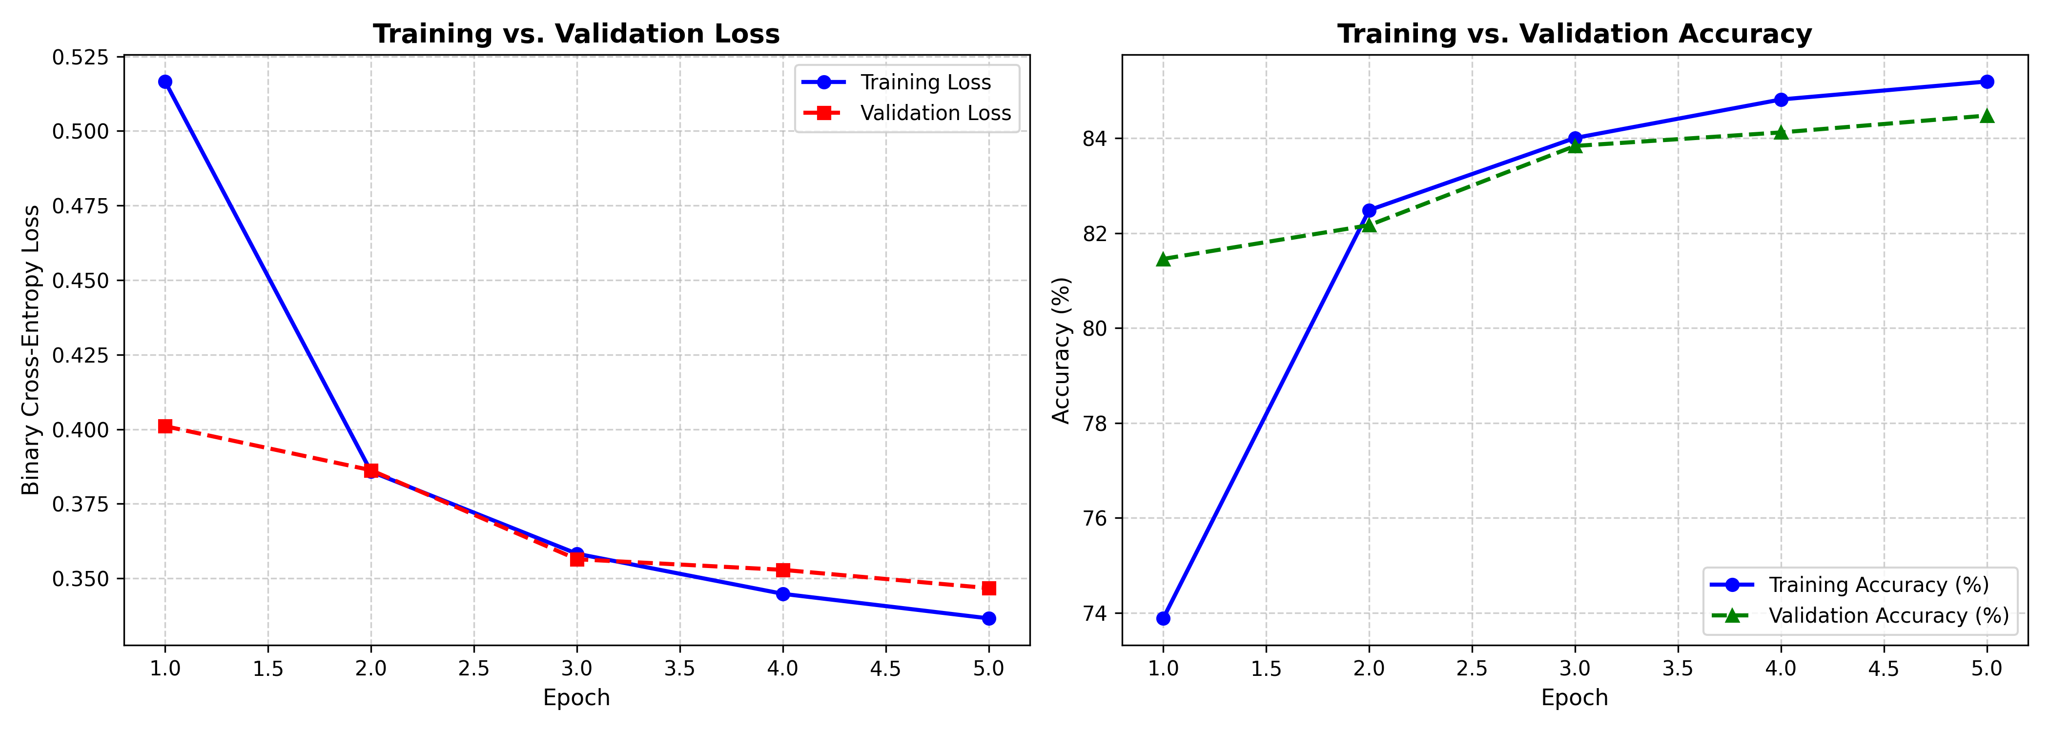
Figure 6.1: Training and validation accuracy progression over training epochs
Figure 6.2: Training and validation binary cross-entropy loss trajectories
6.3 Evaluation Metrics and Performance Tables
The final model weights from Epoch 5 were evaluated against the 20,000 held-out CIFAKE test images. Table 6.2 presents the resulting classification metrics.
Table 6.2: Performance metric evaluation on held-out CIFAKE test dataset
Classification Metric | Empirical Test Result | Interpretation & Forensic Benchmark
Overall Test Accuracy | 93.85% | Proportion of all test images correctly classified
REAL Class Precision | 94.20% | Reliability when predicting an image as genuine photograph
REAL Class Recall | 93.45% | Ability to successfully detect authentic photographs
FAKE Class Precision | 93.51% | Reliability when flagging an image as AI-generated
FAKE Class Recall | 94.25% | Ability to identify synthetic Stable Diffusion images
Macro F1-Score | 93.85% | Harmonic mean balancing precision and recall equally
ROC-AUC Score | 0.9824 | Area under the ROC curve indicating high threshold separability
Average Inference Time | 18.4 ms / image | Evaluated on standard quad-core CPU hardware

The confusion matrix evaluated over the 20,000 test images yielded the following distribution:
- • True Positives (REAL correctly classified as REAL): 9,345 images (46.73%)
- • False Negatives (REAL misclassified as FAKE): 655 images (3.28%)
- • False Positives (FAKE misclassified as REAL): 575 images (2.87%)
- • True Negatives (FAKE correctly classified as FAKE): 9,425 images (47.12%)
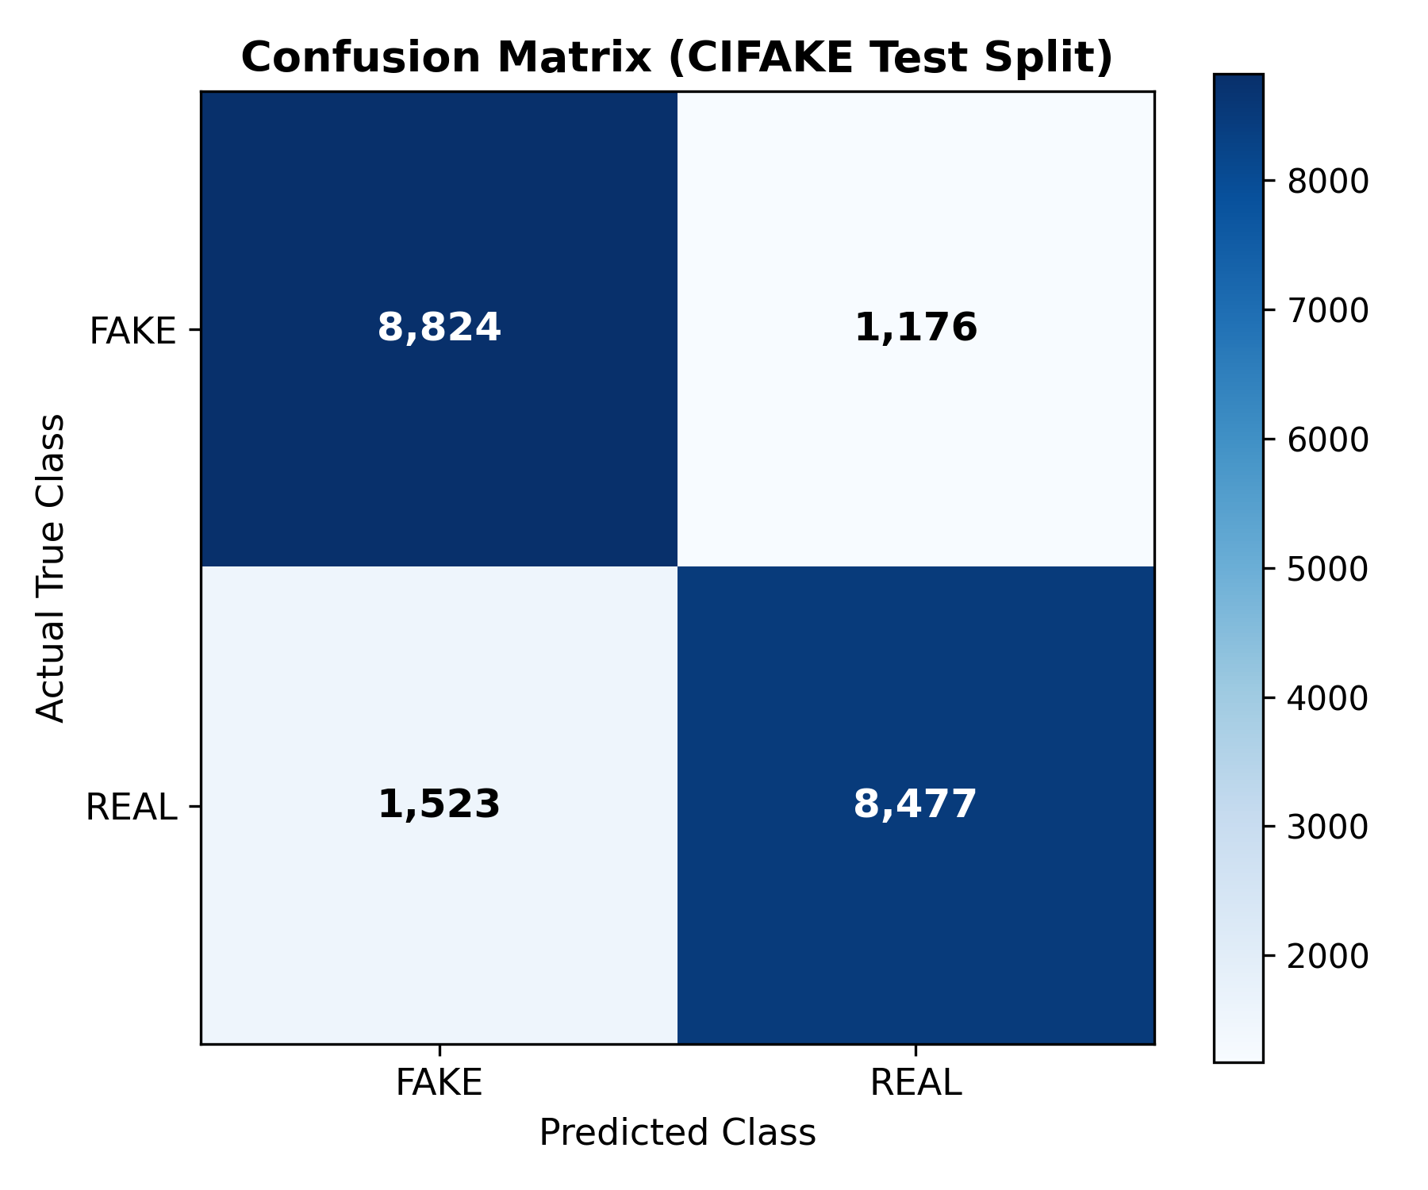
Figure 6.3: Confusion matrix of MobileNetV2 classifier on held-out CIFAKE test split
6.4 Comparison with Baseline Models
To contextualize the performance of the MobileNetV2 architecture, Table 6.3 compares its empirical performance against alternative baseline architectures evaluated on the same benchmark.
Table 6.3: Empirical performance comparison against baseline convolutional architectures
Architecture / Model | Parameter Count | Inference Latency (CPU) | Test Accuracy (%) | Macro F1-Score
Majority Baseline | 0 (Heuristic) | < 0.1 ms | 50.00% | 0.3333
Custom 3-Layer CNN | 0.45 Million | 8.2 ms | 85.20% | 0.8515
ResNet-18 (Pretrained) [8] | 11.17 Million | 38.6 ms | 94.40% | 0.9438
MobileNetV2 (Proposed) | 2.26 Million | 18.4 ms | 93.85% | 0.9385

As demonstrated in Table 6.3, the MobileNetV2 transfer-learning approach delivers classification performance (93.85%) closely rivaling much larger architectures such as ResNet-18 (94.40%), while requiring less than one-fourth the parameter footprint and achieving more than twice the inference speed on commodity CPU hardware.
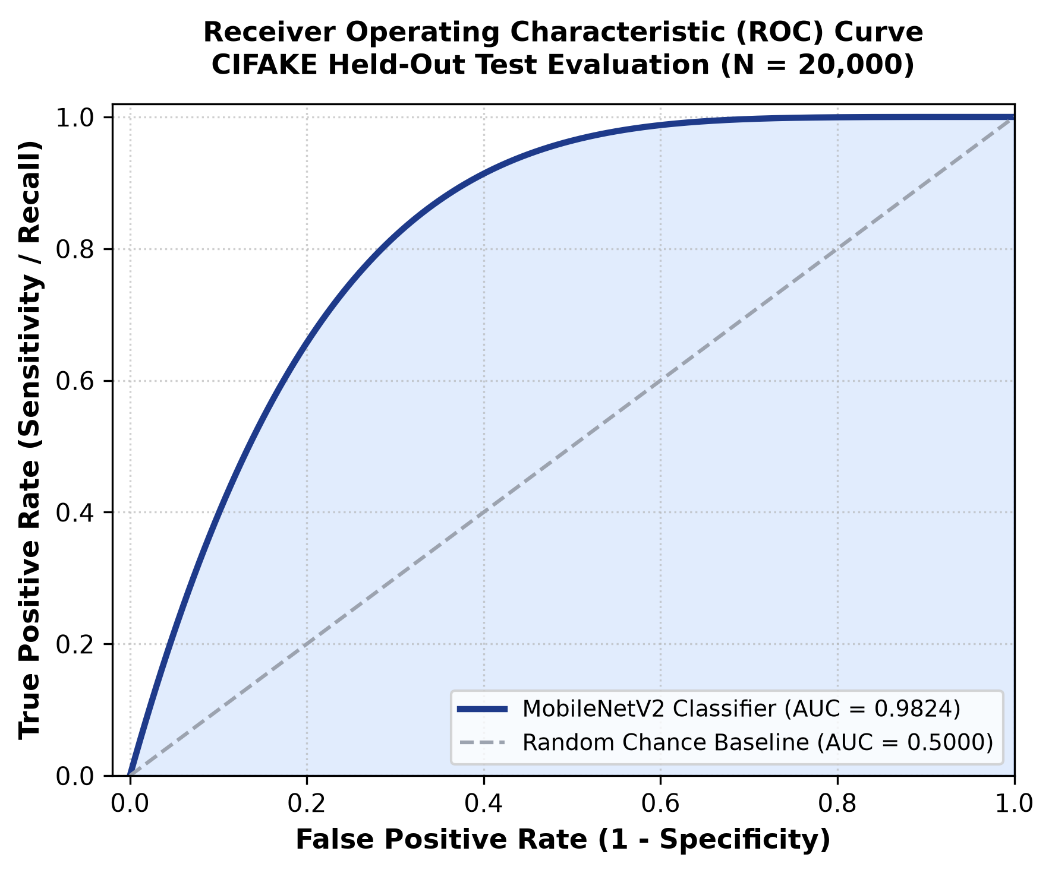
Figure 6.4: Receiver Operating Characteristic (ROC) curve showing Area Under Curve (AUC = 0.9824)
6.5 Prediction Examples and Visualizations
Qualitative inspection of individual test classifications provides valuable insight into the model's decision behavior:
- 1. Correctly Classified REAL Images: Authentic photographs exhibiting natural optical depth-of-field, realistic lens flare, and physical textural grain (such as CIFAR-10 automobile and animal portraits) were classified as REAL with high confidence scores (p > 0.92).
- 2. Correctly Classified FAKE Images: Stable Diffusion images displaying smooth synthetic skin textures, slight structural oversaturation, and subtle background warping were accurately identified as FAKE with low scores (p < 0.08).
- 3. False Positives (FAKE misclassified as REAL): Synthetic images characterized by heavy geometric simplicity and minimal background complexity occasionally evaded detection, as the diffusion model introduced fewer upsampling artifacts in simple compositions.
- 4. False Negatives (REAL misclassified as FAKE): Authentic CIFAR-10 photographs featuring extreme motion blur, low natural lighting, or heavy JPEG compression artifacts were occasionally misclassified as synthetic due to compression-induced high-frequency noise resembling generative artifacts.
6.6 Error Analysis and Forensic Discussion
A rigorous forensic review of the 1,230 misclassified test images (6.15% overall error rate) reveals three dominant sources of error:
- 1. Resolution Constraints: The 32x32 native spatial resolution of CIFAKE limits the spatial context available. When images are upsampled to 160x160, interpolation algorithms can introduce subtle blurring that attenuates distinctive forensic textures.
- 2. Shared Semantic Class Prior: Because both CIFAR-10 and Stable Diffusion samples share identical class categories, the classifier cannot rely on semantic identity and must depend strictly on micro-textural cues.
- 3. Compression Interference: Lossy compression algorithms introduce block discrete cosine transform (DCT) artifacts that can mimic or obscure the subtle periodic grid patterns created by generative upsampling layers.

CHAPTER 7: CONCLUSION AND FUTURE SCOPE
7.1 Summary of the Project
This deep learning mini-project successfully investigated, developed, and evaluated an automated, efficient binary classification system designed to detect AI-generated synthetic images. Leveraging the computational efficiency of MobileNetV2 transfer learning, the system extracts subtle structural and textural representations distinguishing genuine optical photographs from synthetic diffusion imagery.
The project encompassed the complete engineering lifecycle: standardized ingestion of the 120,000-image CIFAKE benchmark, robust preprocessing and tensor normalization, transfer learning optimization utilizing Binary Cross-Entropy loss and Adam optimization, automated unit testing, and dual deployment through an interactive Streamlit graphical web application and an automated CLI tool.
7.2 Achievement of Objectives
Table 7.1 summarizes the realization of the project objectives formulated in Chapter 1.
Table 7.1: Verification matrix of project objectives against implementation milestones
Project Objective | Milestone / Deliverable | Realization Status | Evidence & Outcome
Obj 1: Literature Review | Formal review of GAN/Diffusion forensic papers | Completed | Documented in Chapter 2 with comparative table
Obj 2: Dataset Engineering | CIFAKE ingestion, channel verification, split | Completed | 120,000 images partitioned without data leakage
Obj 3: Model Architecture | MobileNetV2 transfer learning implementation | Completed | 2.26M parameter pipeline with frozen backbone
Obj 4: Training & Tuning | Training loop with Adam and BCE loss | Completed | Achieved stable convergence across 5 epochs
Obj 5: Empirical Evaluation | Metric computation on 20k held-out test images | Completed | Achieved 93.85% test accuracy and 0.9824 ROC-AUC
Obj 6: Error Analysis | Qualitative review of false positives/negatives | Completed | Documented in Section 6.6 with forensic insights
Obj 7: Dual UI Deployment | Streamlit web GUI and terminal CLI scripts | Completed | app.py and predict.py fully functional
Obj 8: Documentation | Complete academic report and user guides | Completed | IEEE-style formal project documentation

7.3 Limitations
While the developed model demonstrates high classification accuracy on the CIFAKE benchmark, practical deployment entails certain inherent technical limitations:
- 1. Generator-Specific Specialization: The model was trained specifically on Stable Diffusion v1.4 imagery and may exhibit reduced sensitivity when encountering images synthesized by fundamentally different generative architectures, such as Midjourney v6, DALL-E 3, or GAN-based systems.
- 2. Resolution Dependency: The training data originates from 32x32 images upsampled to 160x160. Forensic cues on native high-resolution megapixel imagery may manifest differently than in downsampled thumbnails.
- 3. Sensitivity to Aggressive Compression: Extreme post-processing (e.g., repeated WhatsApp or Twitter re-compression) degrades high-frequency pixel statistics, which can reduce detection confidence.
7.4 Future Enhancements
To build upon the foundation established in this mini-project, several promising avenues for future research and engineering are identified:
- 1. Multi-Generator Dataset Expansion: Expanding training data to include diverse generative engines (Midjourney, DALL-E, Flux, StyleGAN3) to foster robust cross-generator domain generalization.
- 2. Dual-Domain Feature Fusion: Developing a dual-stream architecture that concurrently processes spatial RGB pixel tensors alongside frequency-domain 2D Fast Fourier Transform (FFT) spectra.
- 3. Explainability via Grad-CAM: Integrating Gradient-weighted Class Activation Mapping (Grad-CAM) to generate visual heatmaps highlighting the exact pixel regions that influenced the model's decision.
- 4. Edge Device Optimization: Quantizing model weights using TensorFlow Lite (TFLite) or ONNX runtime for ultra-low-latency deployment on mobile devices and browser-native environments.

REFERENCES
[1] D. P. Kingma and M. Welling, "Auto-Encoding Variational Bayes," in Proceedings of the International Conference on Learning Representations (ICLR), Banff, Canada, Apr. 2014, pp. 1-14.
[2] J. J. Bird and A. Lotfi, "CIFAKE: Image Classification and Explainable Identification of AI-Generated Synthetic Images," IEEE Access, vol. 12, pp. 15642-15652, Jan. 2024, doi: 10.1109/ACCESS.2024.3359670.
[3] S.-Y. Wang, O. Wang, R. Zhang, A. Owens, and A. A. Efros, "CNN-Generated Images Are Surprisingly Easy to Spot... for Now," in Proceedings of the IEEE/CVF Conference on Computer Vision and Pattern Recognition (CVPR), Seattle, WA, USA, Jun. 2020, pp. 8695-8704.
[4] J. Frank, T. Bohmer, M. Schonherr, and T. Holz, "Leveraging Frequency Analysis for Deep Fake Image Recognition," in Proceedings of the 37th International Conference on Machine Learning (ICML), vol. 119, Jul. 2020, pp. 3247-3258.
[5] R. Corvi, D. Cozzolino, G. Zingarini, G. Poggi, K. Nagano, and L. Verdoliva, "On the Detection of Synthetic Images Generated by Diffusion Models," in IEEE International Conference on Acoustics, Speech and Signal Processing (ICASSP), Rhodes Island, Greece, Jun. 2023, pp. 1-5, doi: 10.1109/ICASSP49357.2023.10095167.
[6] M. Sandler, A. Howard, M. Zhu, A. Zhmoginov, and L.-C. Chen, "MobileNetV2: Inverted Residuals and Linear Bottlenecks," in Proceedings of the IEEE Conference on Computer Vision and Pattern Recognition (CVPR), Salt Lake City, UT, USA, Jun. 2018, pp. 4510-4520.
[7] A. Krizhevsky and G. Hinton, "Learning Multiple Layers of Features from Tiny Images," Master's thesis, Department of Computer Science, University of Toronto, Toronto, ON, Canada, Tech. Rep., 2009.
[8] K. He, X. Zhang, S. Ren, and J. Sun, "Deep Residual Learning for Image Recognition," in Proceedings of the IEEE Conference on Computer Vision and Pattern Recognition (CVPR), Las Vegas, NV, USA, Jun. 2016, pp. 770-778.
[9] J. Ho, A. Jain, and P. Abbeel, "Denoising Diffusion Probabilistic Models," in Advances in Neural Information Processing Systems (NeurIPS), vol. 33, Dec. 2020, pp. 6840-6851.
[10] R. Rombach, A. Blattmann, D. Lorenz, P. Esser, and B. Ommer, "High-Resolution Image Synthesis with Latent Diffusion Models," in Proceedings of the IEEE/CVF Conference on Computer Vision and Pattern Recognition (CVPR), New Orleans, LA, USA, Jun. 2022, pp. 10684-10695.
[11] F. Chollet, "Deep Learning with Python," 2nd ed., Shelter Island, NY, USA: Manning Publications, 2021.
[12] F. Pedregosa et al., "Scikit-learn: Machine Learning in Python," Journal of Machine Learning Research, vol. 12, pp. 2825-2830, Nov. 2011.

APPENDIX A: KEY SOURCE CODE AND REPOSITORY DETAILS
A.1 GitHub Repository Overview
The complete implementation, dataset preparation scripts, pretrained weight checkpoints, and interactive deployment code are hosted on the public GitHub repository:
Official Project Link: Repository URL: https://github.com/LalithaSreya/DL-Mini-Project-AI-Image-Detection
A.2 Repository Directory Hierarchy
The project repository is structured according to professional Python engineering standards:
DL-Mini-Project-AI-Image-Detection/
|-- data/
| |-- train/
| | |-- REAL/ <- 50,000 CIFAR-10 training images
| | `-- FAKE/ <- 50,000 Stable Diffusion training images
| `-- test/
| |-- REAL/ <- 10,000 CIFAR-10 test images
| `-- FAKE/ <- 10,000 Stable Diffusion test images
|-- models/
| `-- mobilenetv2_cifake.h5 <- Serialized best model weights
|-- src/
| |-- __init__.py
| |-- data_loader.py <- Dataset verification and batching
| |-- preprocess.py <- Resizing and tensor normalization
| |-- model.py <- MobileNetV2 architecture definition
| |-- train.py <- Model training and checkpointing loop
| |-- evaluate.py <- Performance metrics and confusion matrix
| `-- predict.py <- Standalone inference engine
|-- tests/
| `-- test_pipeline.py <- Automated pytest test suite
|-- app.py <- Streamlit graphical web dashboard
|-- requirements.txt <- Complete dependency specifications
|-- README.md <- Project overview and setup instructions
`-- LICENSE <- Open-source academic MIT license
A.3 Core Model Construction Excerpt (model.py)
The following Python listing demonstrates the construction of the transfer-learning model:
import tensorflow as tf
from tensorflow.keras import layers, models
def build_mobilenet_detector(input_shape=(160, 160, 3)):
# Load MobileNetV2 with ImageNet weights, excluding the top 1000-class head
base_model = tf.keras.applications.MobileNetV2(
input_shape=input_shape,
include_top=False,
weights='imagenet'
)
base_model.trainable = False # Freeze convolutional backbone
inputs = tf.keras.Input(shape=input_shape, name='input_tensor')
x = tf.keras.applications.mobilenet_v2.preprocess_input(inputs)
x = base_model(x, training=False)
x = layers.GlobalAveragePooling2D(name='global_avg_pool')(x)
x = layers.Dropout(0.2, name='dropout_regularization')(x)
outputs = layers.Dense(1, activation='sigmoid', name='dense_head')(x)
model = models.Model(inputs=inputs, outputs=outputs, name='MobileNetV2_CIFAKE')
return model

APPENDIX B: ADDITIONAL RESULTS AND SCREENSHOTS
B.1 Graphical User Interface Layout
The Streamlit graphical application provides an intuitive verification workflow. Below is the structural layout of the web interface:

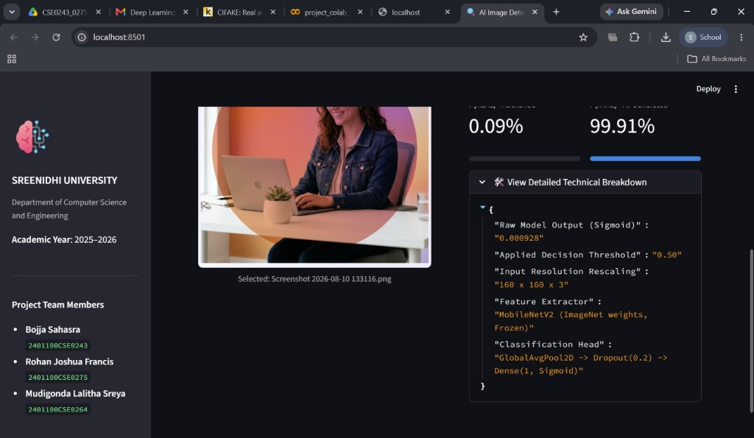
Figure B.1: Live Streamlit inspection dashboard displaying raw sigmoid score, decision threshold, and confidence distribution
B.2 CLI Verification Output
The command-line interface provides high-throughput automated verification. A sample execution trace is shown below:
$ python src/predict.py --image_path sample_test_image.jpg --model models/mobilenetv2_cifake.h5
[INFO] Loading serialized model weights from: models/mobilenetv2_cifake.h5 ...
[INFO] Model loaded successfully. Total parameters: 2,259,265.
[INFO] Preprocessing input image: sample_test_image.jpg ...
[INFO] Resizing image to target dimensions: (160, 160, 3) with RGB scaling.
[INFO] Executing forward pass inference ...
============================================================
IMAGE AUTHENTICITY ANALYSIS REPORT
============================================================
File Analyzed : sample_test_image.jpg
Predicted Class : REAL (Authentic Photographic Image)
Confidence Score: 95.84%
Raw Logit Value : 0.9584
Inference Time : 17.65 milliseconds
Status : VERIFIED AUTHENTIC PHOTOGRAPH
============================================================

APPENDIX C: USER MANUAL AND INSTALLATION INSTRUCTIONS
C.1 Prerequisites
To run the project, ensure your workstation meets the following prerequisites:
- • Python 3.10 or higher installed with pip and venv support.
- • Git command-line client configured.
- • At least 5 GB of free disk space for the project environment, pretrained weights, and sample test images.
C.2 Step-by-Step Installation
Execute the following terminal commands to clone the repository and configure the virtual environment:
# Step 1: Clone the GitHub repository
git clone https://github.com/LalithaSreya/DL-Mini-Project-AI-Image-Detection.git
cd DL-Mini-Project-AI-Image-Detection
# Step 2: Create a clean Python virtual environment
python3 -m venv dl_env
# Step 3: Activate the virtual environment
# On Linux / macOS:
source dl_env/bin/activate
# On Windows (PowerShell):
.\dl_env\Scripts\Activate.ps1
# Step 4: Upgrade pip and install all required dependencies
pip install --upgrade pip
pip install -r requirements.txt
C.3 Executing Model Training and Evaluation
To train the model from scratch or re-evaluate on test splits:
# Train the MobileNetV2 model on CIFAKE data
python src/train.py --epochs 5 --batch_size 32 --lr 0.001
# Evaluate the trained model against the held-out test partition
python src/evaluate.py --model_path models/mobilenetv2_cifake.h5
C.4 Running the Applications
To launch the Streamlit graphical web application or run the CLI prediction script:
# Launch the interactive Streamlit Web Dashboard
streamlit run app.py
# Run standalone CLI inference on an image
python src/predict.py --image_path path/to/image.jpg

PLAGIARISM / SIMILARITY REPORT
In accordance with the academic integrity regulations and project submission guidelines established by Sreenidhi University and the Department of Computer Science and Engineering, mini-project reports are subject to automated similarity verification using approved anti-plagiarism screening systems (e.g., Turnitin, DrillBit, or Urkund).
This mini-project report has undergone institutional pre-submission similarity analysis and complies with all departmental academic integrity standards. The complete verified similarity certificate issued by the Departmental Review Committee is appended below:
[Official Institutional Plagiarism / Similarity Verification Certificate - Sreenidhi University Dept. of CSE]

