How to Create a job in jenkins

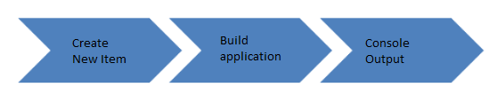

How to Create a Job in Jenkins

**Step 1) Login to Jenkins**

To create a Jenkins job, log on to your Jenkins dashboard by visiting your Jenkins installation path. Usually, it will be hosted on localhost at [http://localhost:8080](http://localhost:8080/) If you have installed Jenkins in another path, use the appropriate URL to access your dashboard as shown in the below Jenkins job creation example.

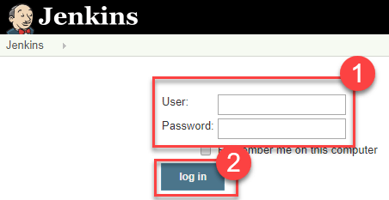

**Step 2) Create New Item**

Click on “**New Item**” at the top left-hand side of your dashboard.

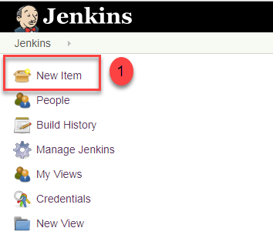

**Step 3) Enter Item details**

In the next screen,

1. Enter the name of the item you want to create. We shall use the “Hello world” for this demo.
2. Select Freestyle project
3. Click Okay

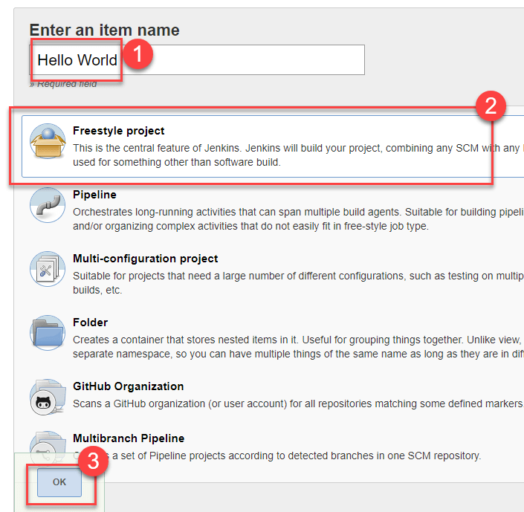

**Step 4) Enter Project details**

Enter the details of the project you want to test.

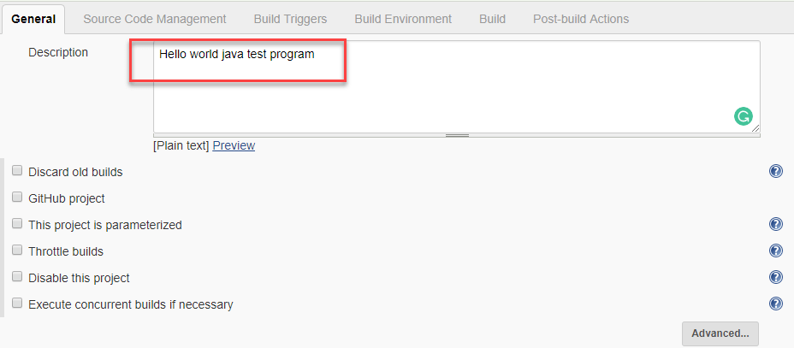

**Step 5) Enter repository URL**

Under Source Code Management, Enter your repository URL. We have a test repository located at <https://github.com/kriru/firstJava.git>

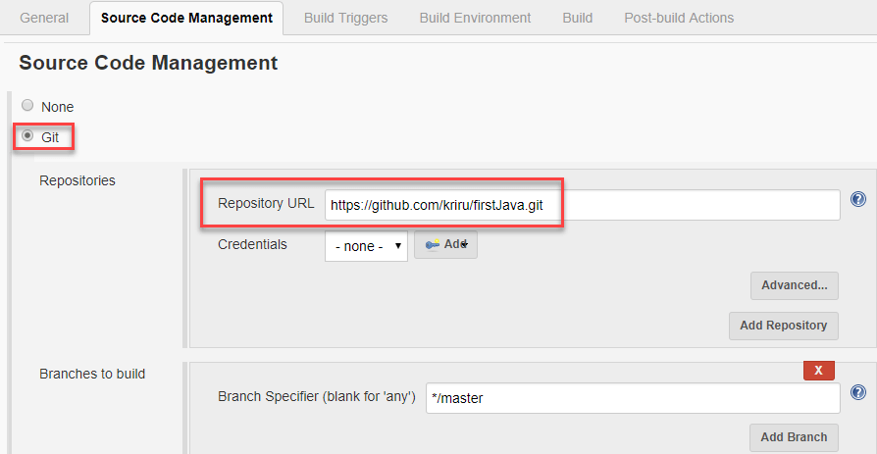

It is also possible for you to use a local repository.

If your GitHub repository is private, Jenkins will first validate your login credentials with GitHub and only then pull the source code from your GitHub repository.

**Step 6) Tweak the settings**

Now that you have provided all the details, it’s time to build the code. Tweak the settings under the **build** section to build the code at the time you want. You can even schedule the build to happen periodically, at set times.

Under **build**,

1. Click on “**Add build step**”

2. Click on “**Execute Windows batch command**” and add the commands you want to execute during the build process.

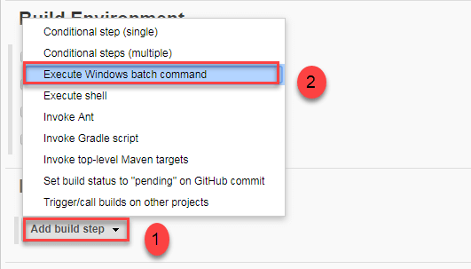

Here, I have added the java commands to compile the java code.

I have added the following windows commands:

javac HelloWorld.java

java HelloWorld

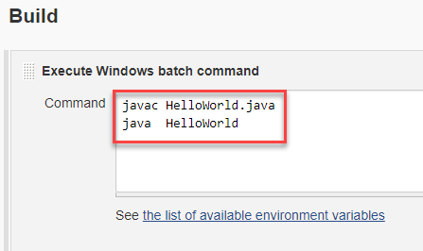

**Step 7) Save the project**

When you have entered all the data,

1. Click **Apply**
2. **Save**the project.

**Step 8) Build Source code**

Now, in the main screen, Click the **Build Now**button on the left-hand side to build the source code.

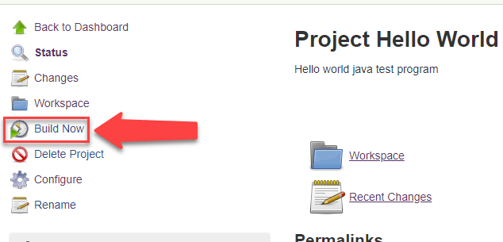

**Step 9) Check the status**

After clicking on **Build now,**you can see the status of the build you run under **Build History**.

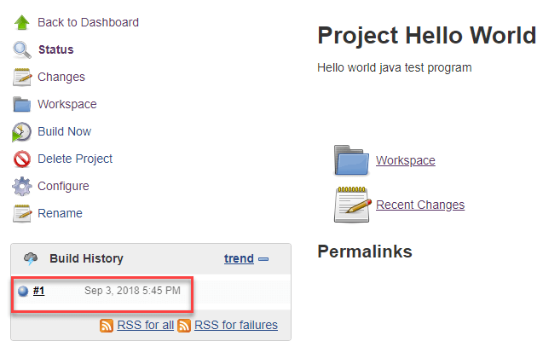

**Step 10) See the console output**

Click on the **build number**andthenClick on **console output**to see the status of the build you run. It should show you a success message, provided you have followed the setup properly as shown in the below Jenkins create new job example.

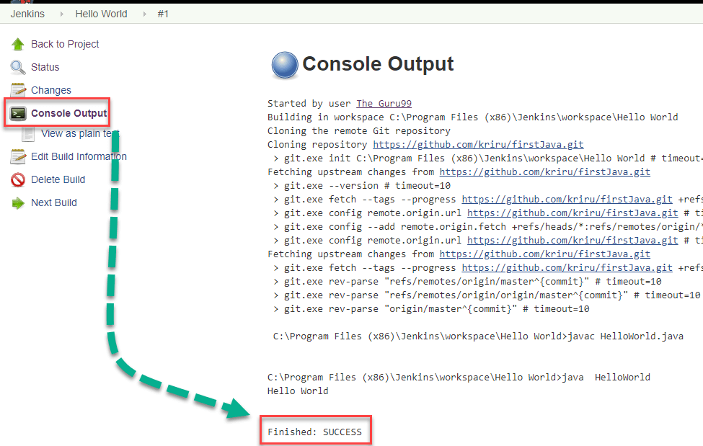

In sum, we have executed a HelloWorld program hosted on GitHub. Jenkin pulls the code from the remote repository and builds continuously at a frequency you define.