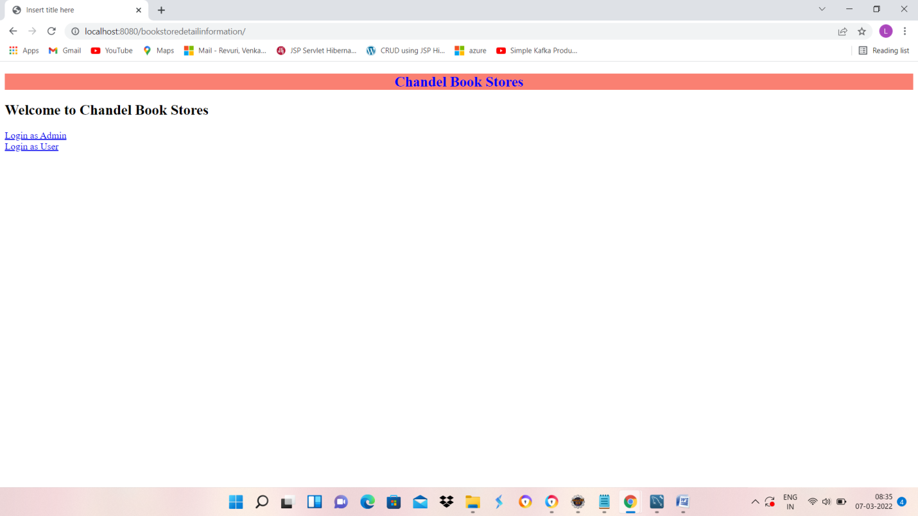

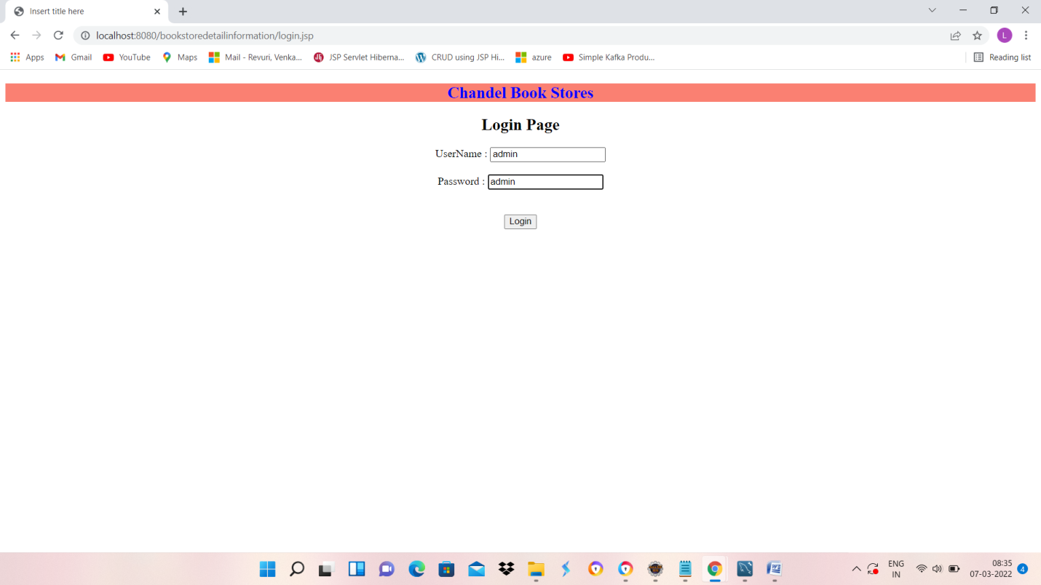

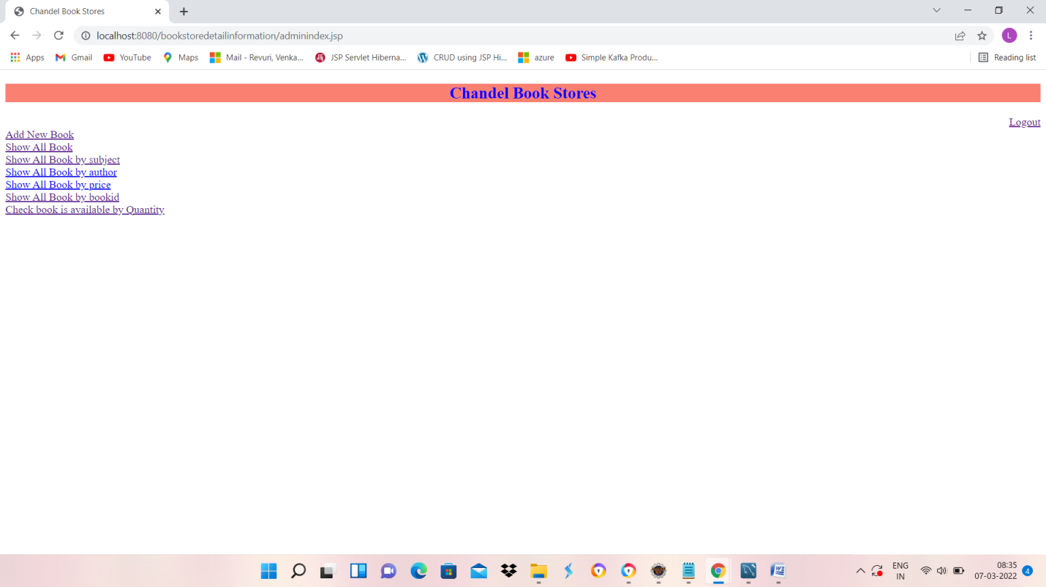

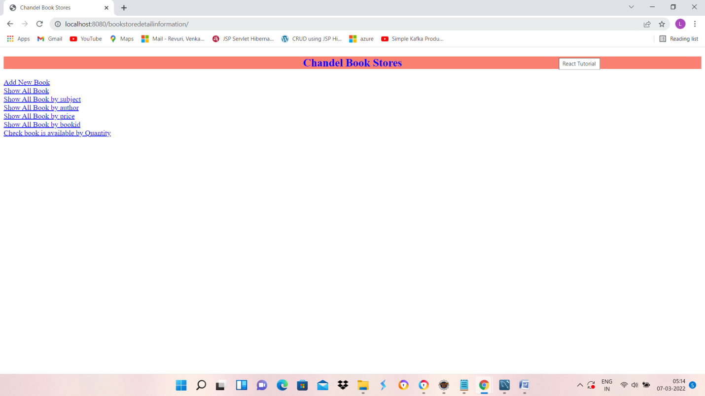

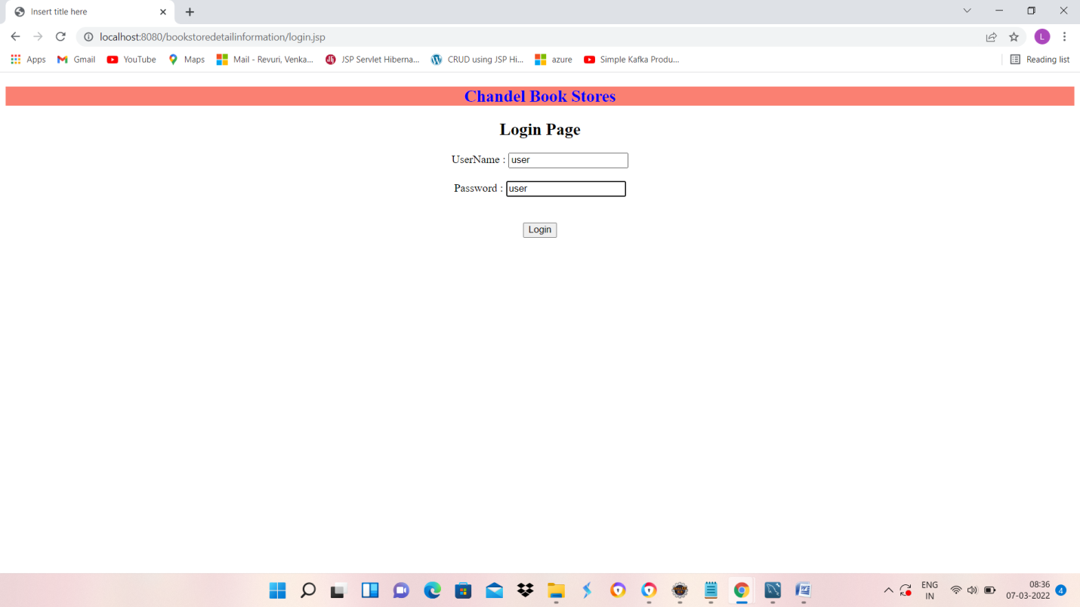

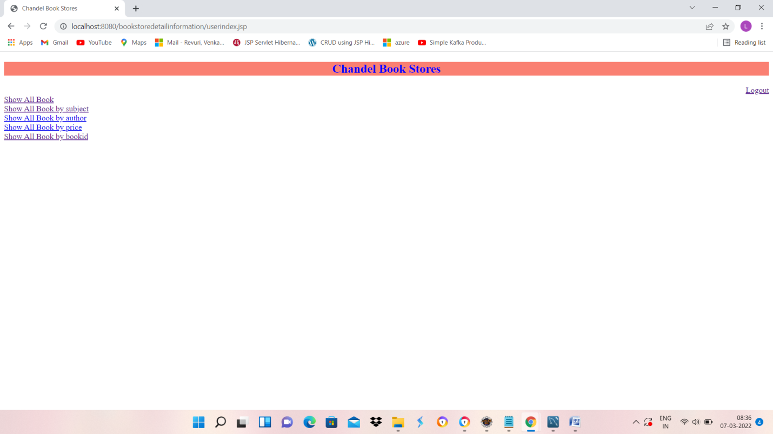

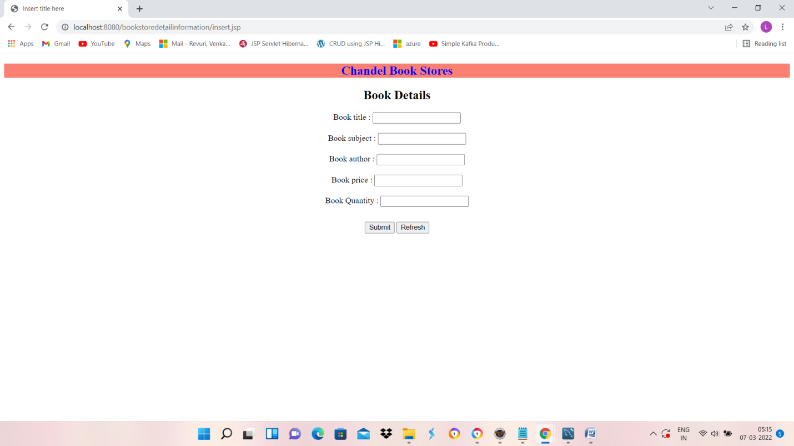

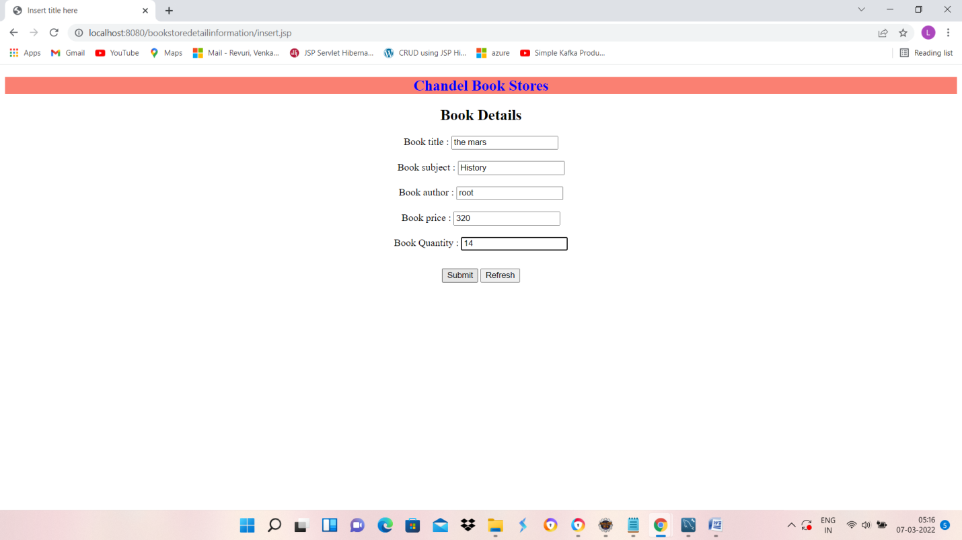

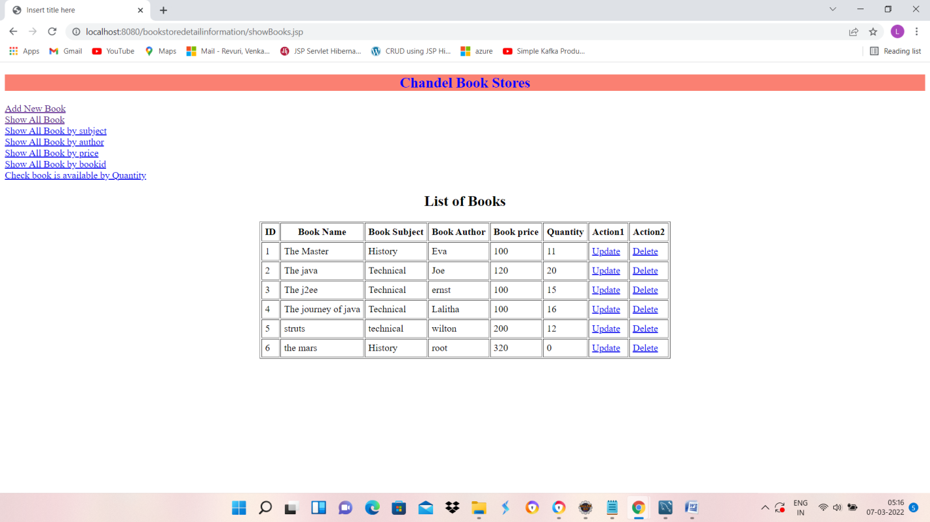

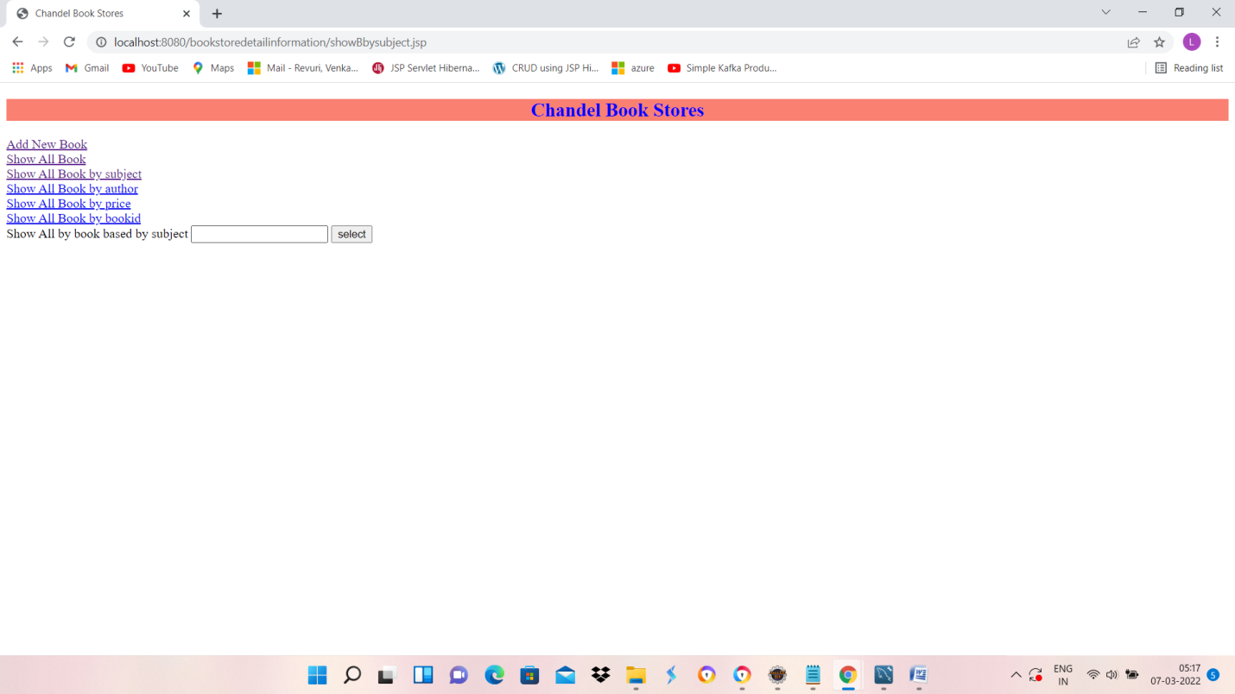

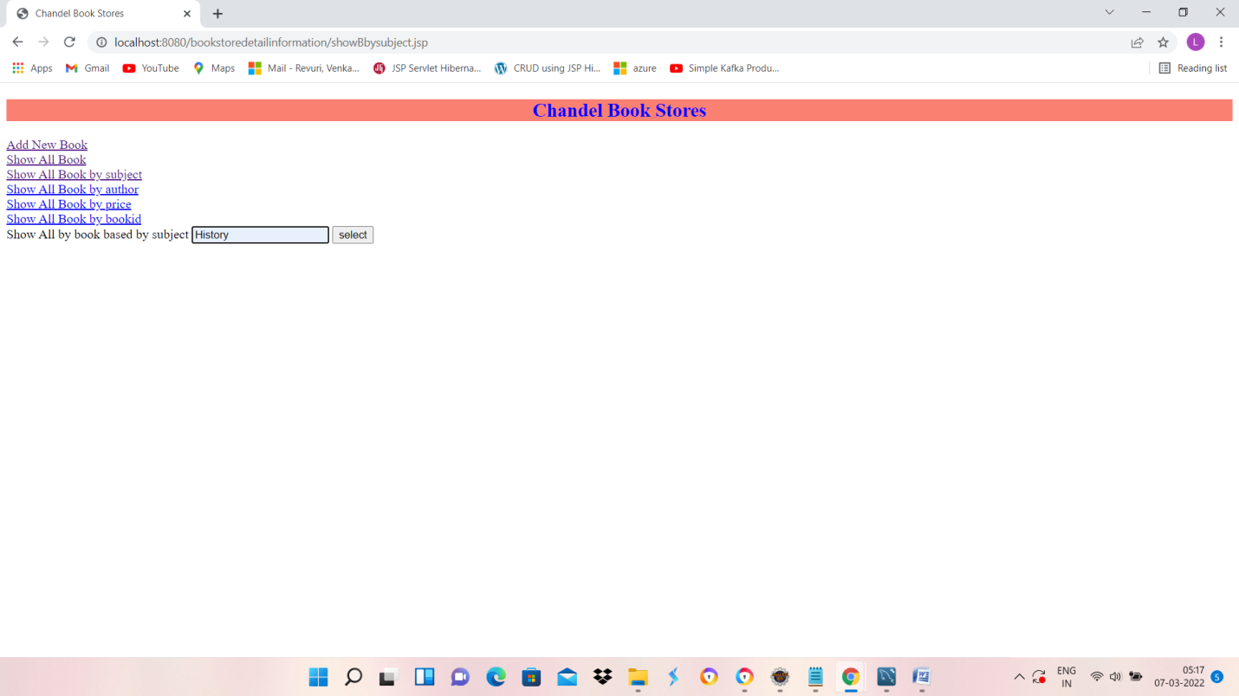

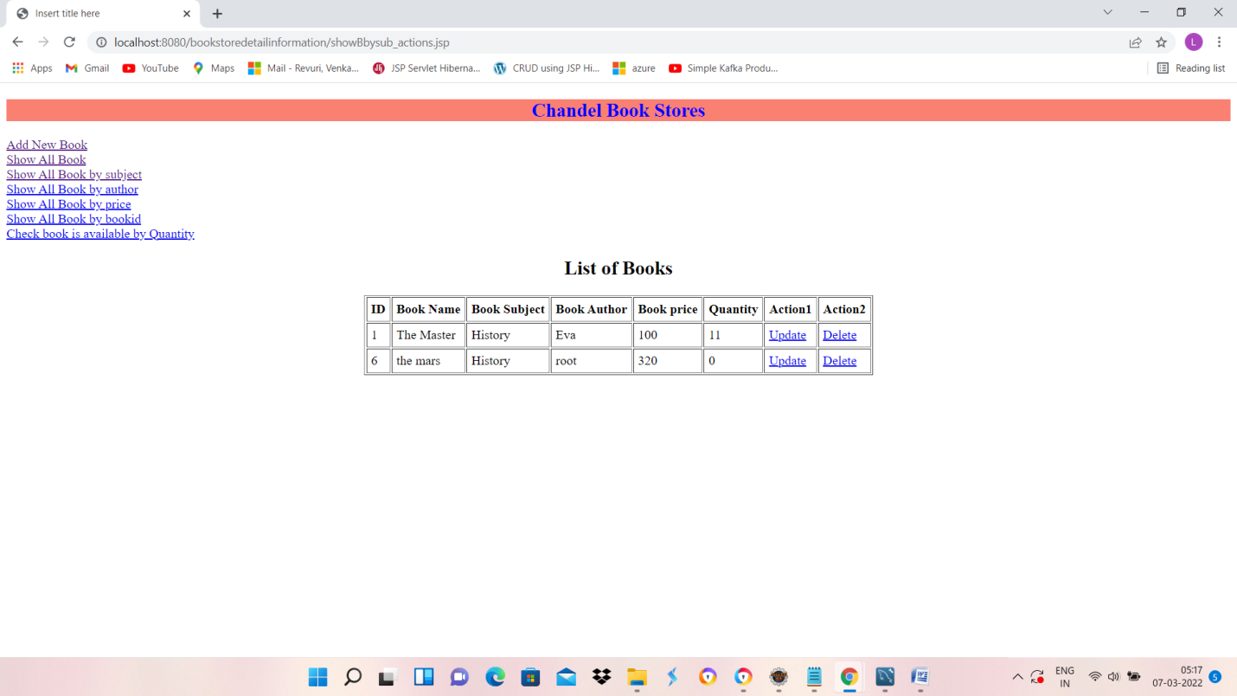

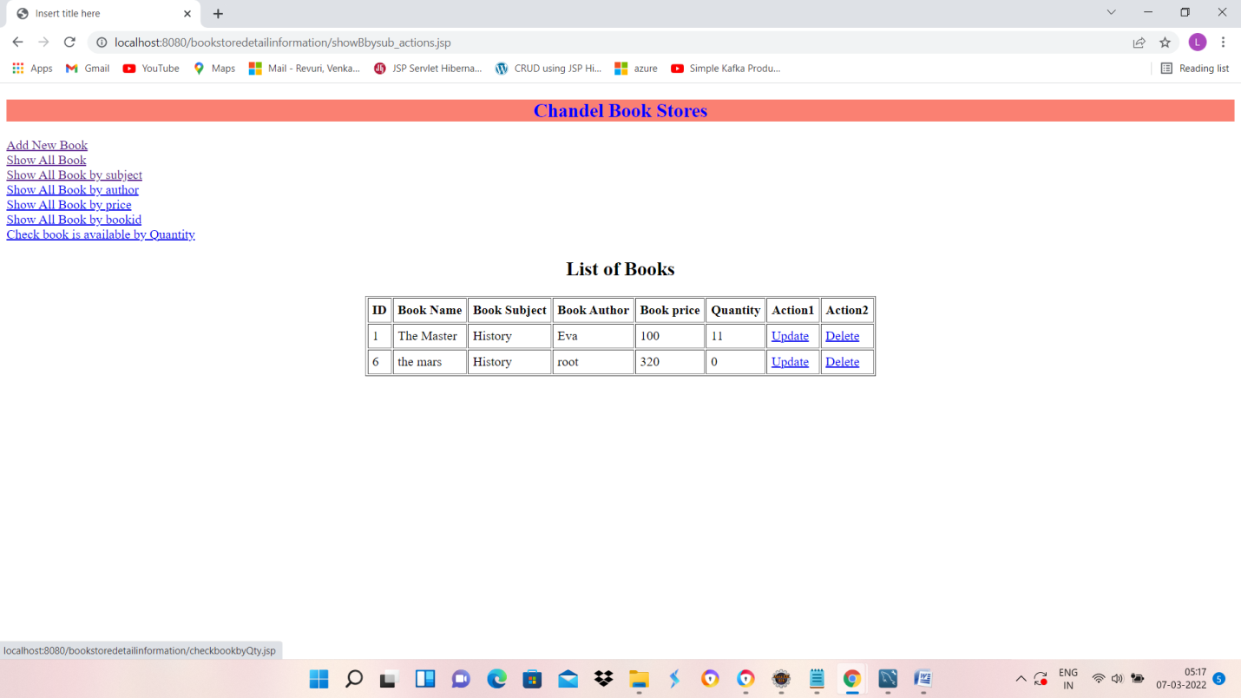

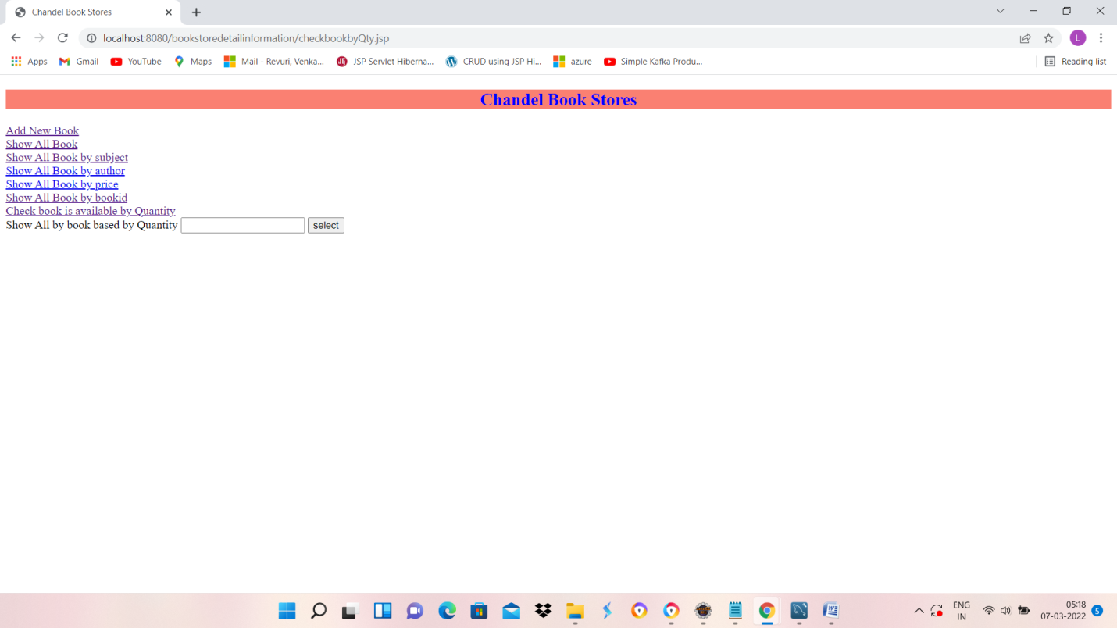

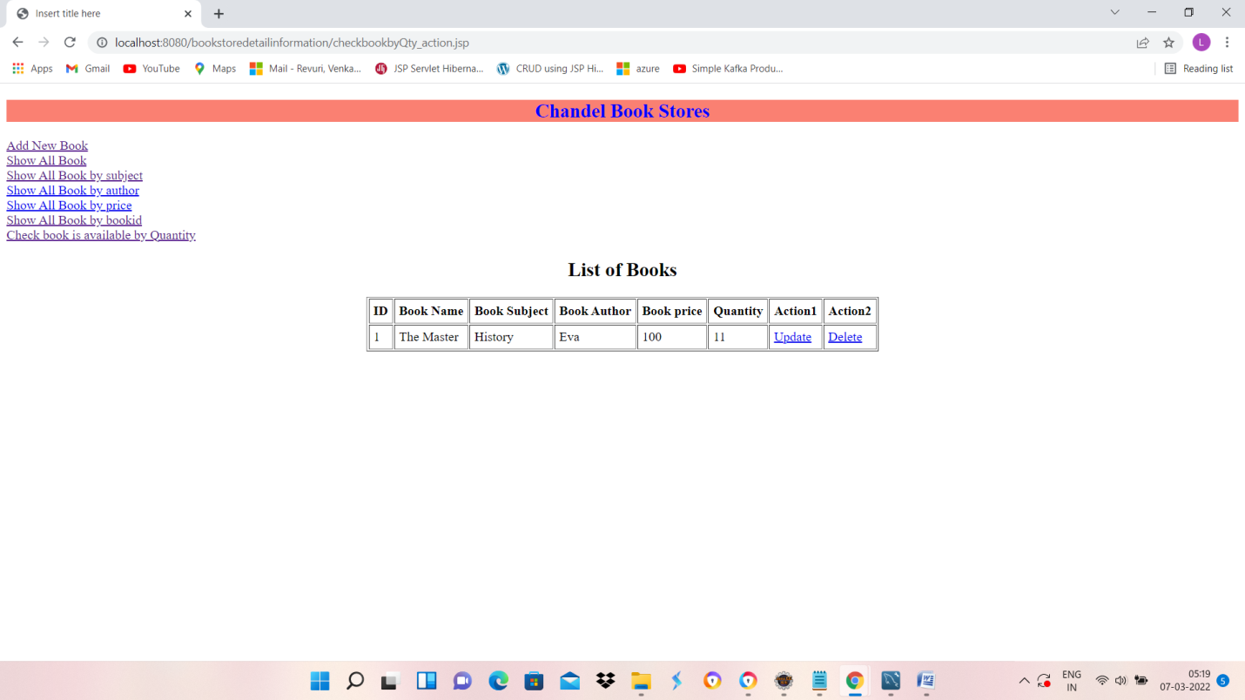

use bookdetailsinfo;

create table booksinfo

( bookid int auto_increment primary key,

btitle varchar(30),

bsubject varchar(30),

bauthor varchar(50),

price int

);

select * from booksinfo where bookid=1;

ALTER TABLE booksinfo

ADD Quantity int NOT NULL

AFTER price;

update booksinfo set Quantity=10 where bookid=1;

update booksinfo set Quantity=20 where bookid=2;

update booksinfo set Quantity=15 where bookid=3;

update booksinfo set Quantity=16 where bookid=4;

update booksinfo set Quantity=12 where bookid=5;

ALTER TABLE booksinfo modify COLUMN Quantity int DEFAULT 0;

create table credentials

( id int auto_increment primary key,

username varchar(30),

password varchar(30)

);

insert into credentials(username,password) values('user','user');

select * from credentials;