A MINI PROJECT REPORT OF APP DEVELOPMENT ON
SMART INVENTORY
Inventory, Billing and Low-Stock Alert System for Small Shops
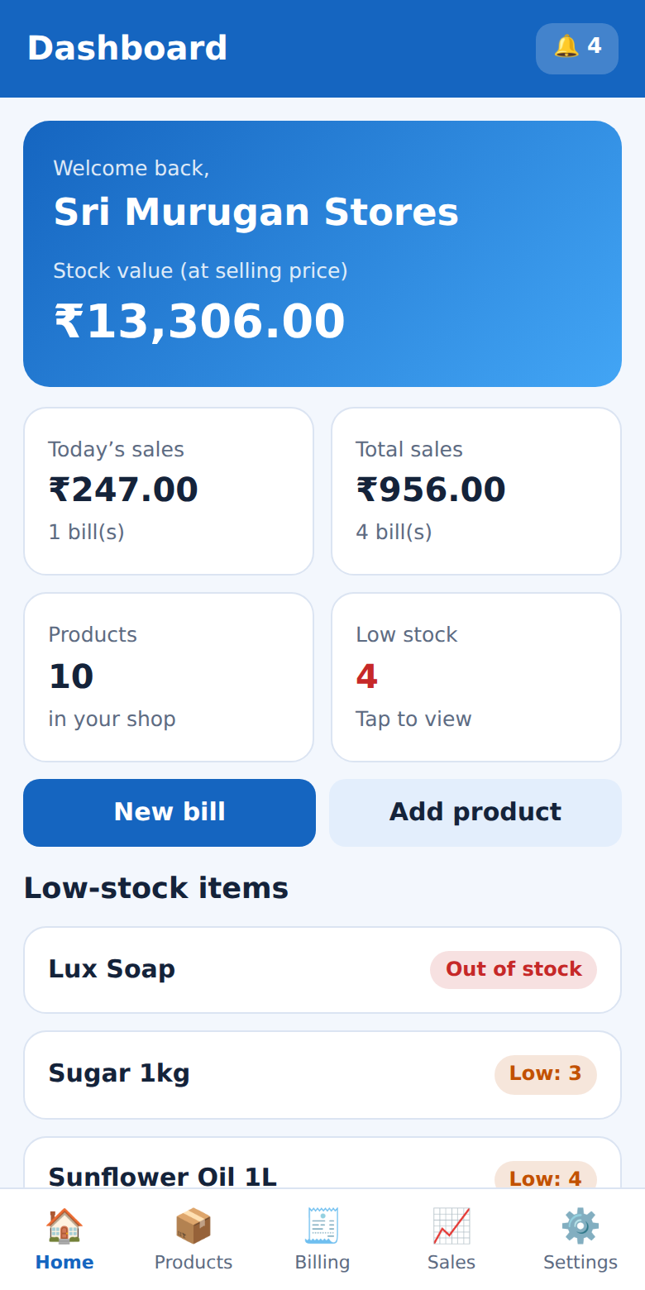
Submitted by
- Lalith Khala ] – [ 814724104081]
[B.K.Nihil Dharsini] - [814724104105]
[M.Prakash] - [814724104115]
III year-CSE-B
[SRM TRP Engineering College]
Academic Year 2026 – 2027
Abstract
Small retail shops still depend on paper registers and calculators to track stock and prepare bills. This is slow, error-prone and gives the owner no warning when an item is about to run out. Commercial inventory software is usually costly, complex and needs internet access.
Smart Inventory is a lightweight, mobile-first web application built with HTML, CSS and vanilla JavaScript. A shop owner can register, add products with price and stock, create bills with automatic totals, view sales history, and receive low-stock alerts. Stock is reduced automatically when a bill is confirmed, and each sale is processed as an all-or-nothing transaction so that stock and bills never go out of sync. Data is stored in the browser’s localStorage separately for every shop, and passwords are protected with salted SHA-256 hashing. The app works offline on phones and desktops, supports light and dark themes and uses the Indian Rupee (₹) format.
Keywords: Inventory Management, Billing, Low-Stock Alert, JavaScript, localStorage.
Table of Contents
1. Introduction 3
2. System Analysis 4
3. System Design 5
4. Implementation 6
5. Testing 9
6. Conclusion and Future Scope 9

1. Introduction

1.1 Background and Problem Statement
Inventory is the stock of goods a shop keeps for sale and is usually its largest investment. In many small shops stock is recorded in notebooks and bills are written by hand, which leads to calculation mistakes, slow searching of old bills and the owner learning that an item is finished only when a customer asks for it. Shop owners need a simple, affordable tool to maintain products, generate correct bills, keep stock updated automatically and be warned before an item runs out.

1.2 Objectives
- Provide secure registration and login so each shop sees only its own data.
- Manage products with price, stock quantity and a custom low-stock alert level.
- Prepare itemised bills with automatic totals, customer name and payment mode (Cash, UPI, Card).
- Reduce stock automatically after every bill and keep stock and billing consistent.
- Show sales summaries (today, last 7 days, all) and low-stock alerts, working offline.

1.3 Scope
The system is meant for single-shop use on one device. Multi-device sync, GST invoice formats, barcode scanning and supplier management are listed as future enhancements.
Fig 1.1 Smart Inventory dashboard (home screen)

1.4 Organisation of the Report
Chapter 2 presents the system analysis, Chapter 3 the design, Chapter 4 the implementation with the project’s real code and screenshots, Chapter 5 the testing, and Chapter 6 the conclusion and future scope.

2. System Analysis

2.1 Existing and Proposed System
The existing manual method has calculation errors, no automatic stock reduction, no early warning for low items, and records that can be lost or altered. The proposed system replaces it with one web application: the owner adds products once, creates bills by tapping items, and the system calculates totals, reduces stock, stores the bill and updates the dashboard instantly. It is technically feasible (standard web technologies only), economically feasible (no licence, hosting or server cost) and operationally feasible (large buttons and plain-language messages).

2.2 Requirements
ID | Functional requirement
FR1 | User registration and login with email and password.
FR2 | Add, edit, search and delete products.
FR3 | Increase or decrease stock, blocking negative stock.
FR4 | Cart, checkout, payment mode and customer name.
FR5 | Automatic stock deduction and running invoice numbers.
FR6 | Sales history by period and bill details.
FR7 | Low-stock and out-of-stock alerts with restock option.

Item | Specification
Device / OS | Smartphone, tablet or PC; Android, iOS, Windows, Linux or macOS
Browser | Chrome, Edge, Firefox or Safari (recent versions)
Languages | HTML5, CSS3, JavaScript (ES6)
Storage / Tools | Browser localStorage (about 5 MB); VS Code, Chrome DevTools

2.3 Non-Functional Requirements
- Usability: mobile-first layout, large touch targets and clear error messages.
- Performance: screens render instantly because data is read from local memory.
- Security: salted password hashing, per-account data separation and HTML-escaped output.
- Reliability: a sale is atomic – if saving fails, stock and bill are rolled back.
- Portability: runs on any modern browser; supports light and dark themes.

2.4 Feasibility Study
Type | Assessment
Technical | Uses only standard web technologies supported by all modern browsers; no server or database software is needed.
Economic | No licence fees, hosting or paid libraries, so it suits shops with a very small budget.
Operational | Large buttons, bottom navigation and plain-language messages make it usable by non-technical owners on a phone.

3. System Design

3.1 Architecture
Smart Inventory is a single-page application with three layers running in the browser. The presentation layer is index.html and style.css (a container, a dialog and a toast). The application layer is script.js, which holds authentication, products, billing, reports and alerts, and redraws the screen with a render() function. The data layer is localStorage, which stores one JSON object (users, products, bills) plus the logged-in user id. Every product and bill carries the owner’s user id so each shop sees only its own data.

3.2 Data Design
Entity | Fields
Users | id, shop, owner, email, salt, h (password hash), th (default alert level)
Products | id, uid, name, cat, price, qty (stock), th (alert level)
Bills | id, uid, no (invoice number), cust, pay, items [pid, name, price, qty], total, at (time)

3.3 Module Description
Module | Description
Authentication | Registration with validation (names, valid email, password of 6+ characters, confirmation, duplicate check) and login using salted hash comparison.
Product | Add, edit, delete and search products; stock chip is green (in stock), orange (low) or red (out of stock).
Stock | Add or remove stock; removal is blocked if stock would become negative.
Billing | Product search, +/− cart limited to available stock, checkout dialog and bill confirmation.
Sales | Filter bills by Today / Last 7 days / All, show totals and open bill details.
Alerts | Lists products at or below alert level, lowest stock first, with a bell counter in the header.
Settings | Change shop name and default alert level; logout.

3.4 Process Flow of Billing
Step | Action
1 | Owner searches or taps products to add them to the cart (limited to available stock).
2 | Owner taps Checkout; the dialog lists items and the total.
3 | Owner enters an optional customer name and selects Cash, UPI or Card.
4 | On Confirm, the system re-checks that every item still has enough stock.
5 | Stock is reduced, the bill is created with the next invoice number and saved.
6 | If saving fails, the database snapshot is restored (rollback) and an error is shown.
7 | The cart is cleared, dashboard and alerts update, and the invoice is displayed.

3.5 Security Design
- Only a SHA-256 hash of salt and password is stored; a new random salt is used for every account.
- All user-entered text passes through esc() before display, preventing HTML/script injection.
- Every query filters by the logged-in user’s id, so one shop cannot see another shop’s data.
- Because the app is fully client-side, data protection also depends on the security of the device.

4. Implementation
The project uses HTML5 (including the native <dialog> element), CSS3 (flexbox, grid, CSS variables, dark mode), JavaScript ES6, the Web Crypto API and localStorage. It consists of three files: index.html (15 lines), style.css (41 lines) and script.js (98 lines). The code below is taken directly from the project’s script.js (formatted for readability), together with screenshots of the screens it produces.

4.1 Data storage and helper functions
The whole database is one JavaScript object saved as JSON in localStorage. P() and B() return only the logged-in user’s products and bills, and low() returns the products at or below their alert level, lowest stock first.
function load() {
try {
db = JSON.parse(localStorage.getItem("si_db"));
} catch (e) {}
db = db || { users: [], products: [], bills: [] };

function save() {
try {
localStorage.setItem("si_db", JSON.stringify(db));
return true;
} catch (e) {
return false;
}

const P = () => db.products.filter((p) => p.uid === me.id);

const B = () => db.bills.filter((b) => b.uid === me.id);

const low = () =>
P()
.filter((p) => p.qty <= p.th)
.sort((a, b) => a.qty - b.qty);

4.2 Salted password hashing
async function hash(p, s) {
if (!window.crypto || !crypto.subtle) return btoa(s + ":" + p);
const b = await crypto.subtle.digest("SHA-256", new TextEncoder().encode(s + ":" + p));
return [...new Uint8Array(b)].map((x) => x.toString(16).padStart(2, "0")).join("");

4.3 Product list and stock chips
chip() chooses the label and colour of the stock indicator – green, orange (low) or red (out of stock) – as seen in the product list.
const chip = (p) =>
p.qty <= 0
? '<span class="chip out">Out of stock</span>'
: p.qty <= p.th
? `<span class="chip low">Low: ${p.qty}</span>`
: `<span class="chip ok">${p.qty} in stock</span>`;
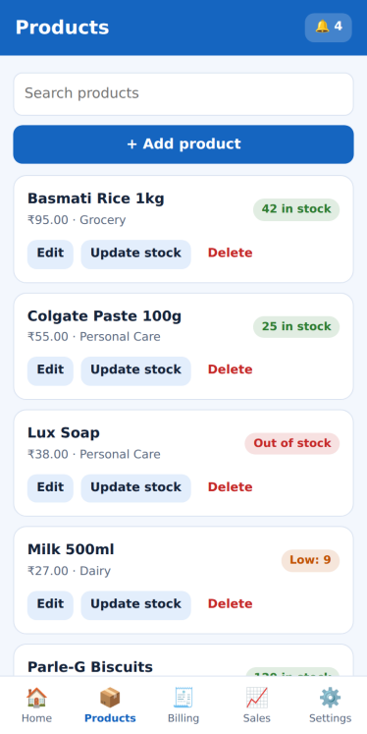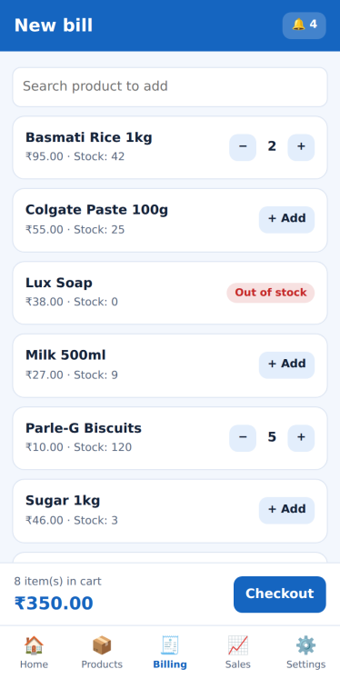
Fig 4.1 Product list with stock chips Fig 4.2 Billing with cart bar

4.4 Cart quantity control
The cart quantity cannot exceed available stock, which prevents over-selling at the first step.
function cadd(id, d) {
const p = P().find((x) => x.id === id),
n = (cart[id] || 0) + d;
if (n > p.qty) {
toast(`Only ${p.qty} of ${p.name} in stock`);
return;
}
if (n <= 0) delete cart[id];
else cart[id] = n;
bl();

4.5 Atomic billing (sell function)
sell() checks the stock of every item, takes a snapshot of the database, reduces stock, creates the bill with the next invoice number and saves. If saving fails, the snapshot is restored so stock and bills never become inconsistent.
function sell() {
const it = cartItems();
if (!it.length) return err("The cart is empty.");
for (const { p, n } of it)
if (n > p.qty)
return err(`Not enough stock for “${p.name}”. Available: ${p.qty}, requested: ${n}.`);
const snap = JSON.stringify(db),
items = it.map(({ p, n }) => ({ pid: p.id, name: p.name, price: p.price, qty: n }));
it.forEach(({ p, n }) => {
p.qty -= n;
});
const bill = {
id: uid(),
uid: me.id,
no: Math.max(0, ...B().map((b) => b.no)) + 1,
cust: $("#cu").value.trim() || "Walk-in Customer",
pay: $("#py").value,
items,
total: r2(items.reduce((s, i) => s + i.price * i.qty, 0)),
at: Date.now(),
};
db.bills.push(bill);
if (!save()) {
db = JSON.parse(snap);
me = db.users.find((u) => u.id === me.id);
return err("Could not save the bill. Nothing was changed.");
}
cart = {};
render();
showBill(bill.id);
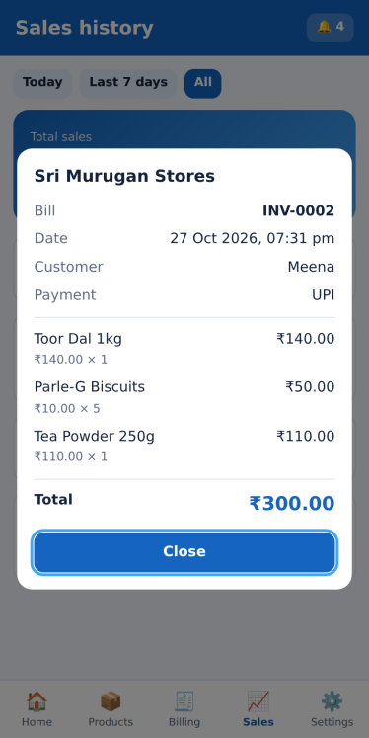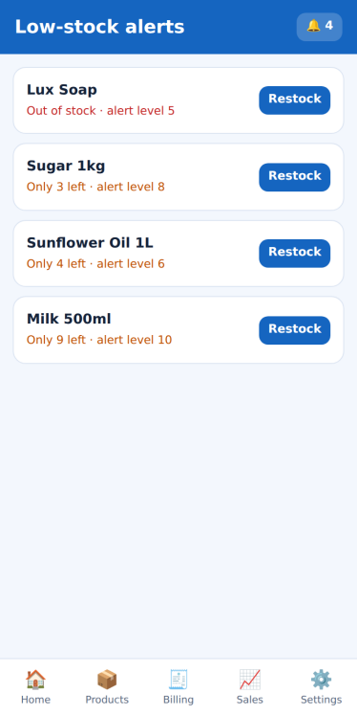
Fig 4.3 Invoice after confirming a bill Fig 4.4 Low-stock alerts

4.6 Low-stock alerts view
function alertsView() {
const l = low();
if (!l.length)
return '<div class="card"><b>All good!</b><p class="mu">No product is at or below its low-stock level.</p></div>';
return l
.map(
(p) =>
`<div class="card row"><div><b>${esc(p.name)}</b><br><small class="${p.qty <= 0 ? "out" : "low"}">${p.qty <= 0 ? "Out of stock" : "Only " + p.qty + " left"} · alert level ${p.th}</small></div><button class="sm" onclick="stockD('${p.id}')">Restock</button></div>`,
)
.join("");

4.7 Responsive, theme-aware styling
The following lines are from style.css. CSS variables hold the colours and a media query redefines them for dark mode.
:root{...--bg:#f3f7fd;--card:#fff;--tx:#14233a;--mu:#5d6b82;--pr:#1565c0;...}
@media (prefers-color-scheme:dark){:root:not([data-theme="light"]){--bg:#0e1623;--card:#172234;--tx:#e8eef8;...}}
nav{position:fixed;bottom:0;left:0;right:0;display:flex;background:var(--card);border-top:1px solid var(--bd);...}

5. Testing
Black-box manual testing was done for valid, invalid and boundary inputs on mobile and desktop sizes.
No. | Test case | Expected result | Status
1 | Register with password of 4 characters | Error: at least 6 characters | Pass
2 | Register with an existing email | Error: account already exists | Pass
3 | Login with wrong password | Error: wrong email or password | Pass
4 | Add product with price 0 | Error: enter a valid price | Pass
5 | Remove more stock than available | Error: only N in stock | Pass
6 | Add to cart more than stock | Toast: only N in stock | Pass
7 | Confirm bill with 3 items | Stock reduced, invoice shown | Pass
8 | Stock falls to alert level | Orange chip, bell count rises | Pass
9 | Product name containing HTML tags | Shown as plain text | Pass
10 | Reload the page | Data and login persist | Pass

All test cases passed; the atomic billing logic prevented negative stock and mismatched records.

6. Conclusion and Future Scope
Smart Inventory gives small shops a simple, free and offline-capable tool: products are added once, bills are made in a few taps, sales are summarised, and low-stock alerts appear before items run out. Automatic stock deduction and all-or-nothing billing keep records trustworthy.
Limitations: data is stored in one browser on one device, with no cloud backup, multi-user roles or GST invoice printing. Future scope: cloud database and sync, barcode scanning, PDF/GST invoices, CSV export, sales charts, expiry tracking, PWA installation and regional-language support.

References
[1] MDN Web Docs – JavaScript Guide, Web Storage API and SubtleCrypto.digest(), developer.mozilla.org.
[2] W3C – HTML5 Specification, www.w3.org.
[3] Ian Sommerville, Software Engineering, Pearson Education.

