**Module 10 Week 6**

**REACT**

HandOn 1

import React from 'react';

function App() {

return (

<div>

<h1>Welcome to the first session of React</h1>

</div>

);

}

export default App;

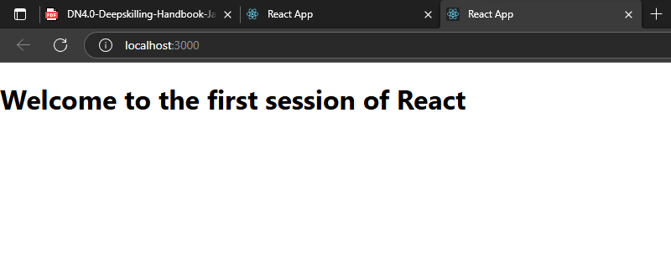

**HandsOn 2**

import React, { Component } from 'react';

class About extends Component {

render() {

return (

<div>

<h3>Welcome to the About Page of Student Management Portal</h3>

</div>

);

}

}

export default About;

import React, { Component } from 'react';

class Contact extends Component {

render() {

return (

<div>

<h3>Welcome to the Contact Page of Student Management Portal</h3>

</div>

);

}

}

export default Contact;

import React, { Component } from 'react';

class Home extends Component {

render() {

return (

<div>

<h3>Welcome to the Home Page of Student Management Portal</h3>

</div>

);

}

}

export default Home;

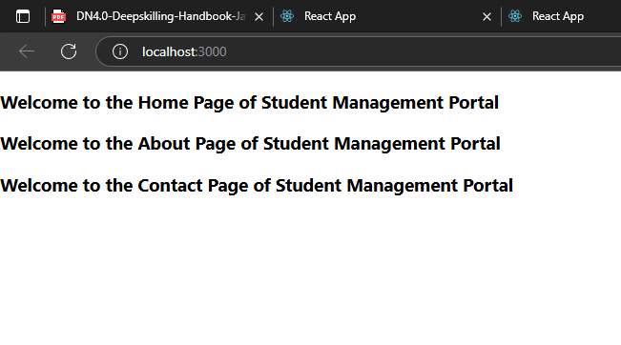

**HandsOn 3**

import '../Stylesheets/mystyle.css';

const percentToDecimal = (decimal) => {

return (decimal.toFixed(2) * 100) + "%";

};

const calcScore = (total, goal) => {

return percentToDecimal(total / goal);

};

export const CalculateScore = ({ Name, School, total, goal }) => (

<div className="formastyle">

<h1><font color="brown">Student Details:</font></h1>

<div className="Name">

<b> Name: </b> <span>{Name}</span>

</div>

<div className="School">

<b> School: </b> <span>{School}</span>

</div>

<div className="Total">

<b> Total: </b> <span>{total}</span>

<br />

<b> Marks: </b> <span>{goal}</span>

</div>

<div className="Score">

<b> Score: </b>

<span>

{calcScore(total, goal)}

</span>

</div>

</div>

);

.Name {

font-weight: 300;

color: blue;

}

.School {

color: crimson;

}

.Total {

color: darkmagenta;

}

.formastyle {

text-align: center;

font-size: large;

}

.Score {

color: forestgreen;

}

import React from 'react';

import './App.css';

import { CalculateScore } from './Components/CalculateScore';

function App() {

return (

<div>

<CalculateScore

Name="Steeve"

School="DNV Public School"

total={284}

goal={3}

/>

</div>

);

}

export default App;

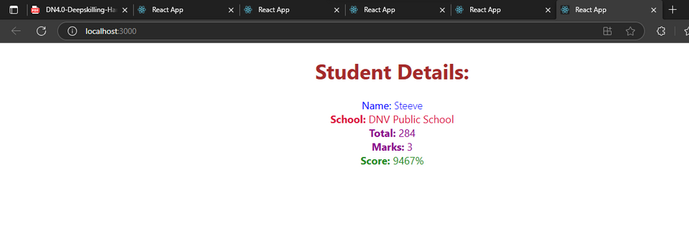

**HandsOn 4**

import React from "react";

import Posts from "./Posts";

function App() {

return (

<div className="App">

<Posts />

</div>

);

}

export default App;

class Post {

constructor(id, title, body) {

this.id = id;

this.title = title;

this.body = body;

}

}

export default Post;

import React from "react";

import Post from "./Post";

class Posts extends React.Component {

constructor(props) {

super(props);

this.state = {

posts: [],

error: null

};

}

loadPosts() {

fetch("https://jsonplaceholder.typicode.com/posts")

.then((res) => res.json())

.then((data) => {

const postList = data.map(

(p) => new Post(p.id, p.title, p.body)

);

this.setState({ posts: postList });

})

.catch((err) => this.setState({ error: err }));

}

componentDidMount() {

this.loadPosts();

}

componentDidCatch(error, info) {

alert("An error occurred: " + error.message);

}

render() {

return (

<div>

<h2>Blog Posts</h2>

{this.state.posts.map((post) => (

<div key={post.id}>

<h3>{post.title}</h3>

<p>{post.body}</p>

</div>

))}

</div>

);

}

}

export default Posts;

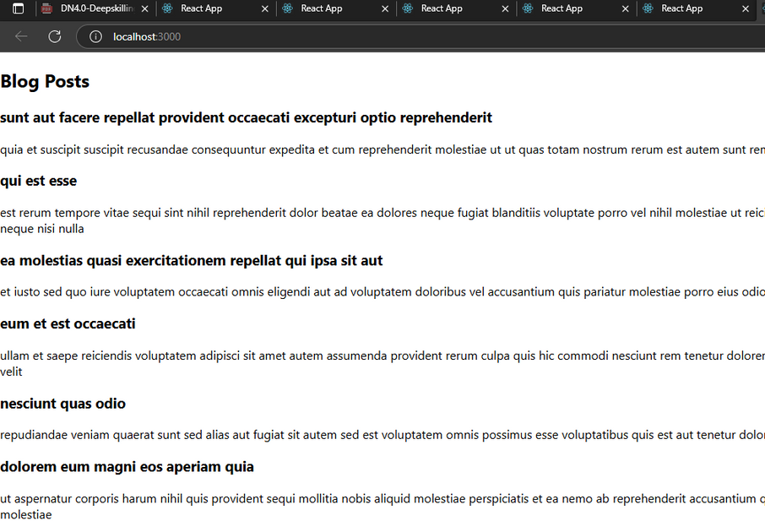

**HandsOn 6**

import React from 'react';

import { BrowserRouter as Router, Routes, Route, Link } from 'react-router-dom';

import Home from './Home';

import TrainersMock from './TrainersMock';

import TrainersList from './TrainersList';

import TrainerDetails from './TrainerDetails';

function App() {

return (

<Router>

<div>

<nav>

<Link to="/">Home</Link> |{" "}

<Link to="/trainers">Trainers</Link>

</nav>

<hr />

<Routes>

<Route path="/" element={<Home />} />

<Route path="/trainers" element={<TrainersList trainers={TrainersMock} />} />

<Route path="/trainer/:id" element={<TrainerDetails />} />

</Routes>

</div>

</Router>

);

}

export default App;

import React from 'react';

function Home() {

return (

<div>

<h2>Welcome to Trainers Portal</h2>

<p>Select a menu to view details.</p>

</div>

);

}

export default Home;

class Trainer {

constructor(trainerId, name, email, phone, technology, skills) {

this.trainerId = trainerId;

this.name = name;

this.email = email;

this.phone = phone;

this.technology = technology;

this.skills = skills;

}

}

export default Trainer;

import React from 'react';

import { useParams } from 'react-router-dom';

import TrainersMock from './TrainersMock';

function TrainerDetails() {

const { id } = useParams();

const trainer = TrainersMock.find(t => t.trainerId === parseInt(id));

if (!trainer) return <p>Trainer not found.</p>;

return (

<div>

<h2>{trainer.name}'s Details</h2>

<p><strong>Email:</strong> {trainer.email}</p>

<p><strong>Phone:</strong> {trainer.phone}</p>

<p><strong>Technology:</strong> {trainer.technology}</p>

<p><strong>Skills:</strong> {trainer.skills}</p>

</div>

);

}

export default TrainerDetails;

import React from 'react';

import { Link } from 'react-router-dom';

function TrainersList({ trainers }) {

return (

<div>

<h2>Trainer List</h2>

<ul>

{trainers.map((t) => (

<li key={t.trainerId}>

<Link to={`/trainer/${t.trainerId}`}>{t.name}</Link>

</li>

))}

</ul>

</div>

);

}

export default TrainersList;

import Trainer from './Trainer';

const TrainersMock = [

new Trainer(1, "Aathma", "aathma@abc.com", "9999911111", "Java", "Spring Boot, Microservices"),

new Trainer(2, "Arjun", "arjun@abc.com", "8888822222", "React", "Hooks, Router"),

new Trainer(3, "Meena", "meena@abc.com", "7777733333", "Python", "Flask, Django")

];

export default TrainersMock;

