**MODULE 3 PL/SQL EXERCISES**

**Exercise 1: Control Structures**

CREATE TABLE CUSTOMERS (

CUST_ID NUMBER PRIMARY KEY,

NAME VARCHAR2(100),

AGE NUMBER,

BALANCE NUMBER,

ISVIP VARCHAR2(5)

);

CREATE TABLE LOANS (

LOAN_ID NUMBER PRIMARY KEY,

CUST_ID NUMBER,

INTEREST_RATE NUMBER,

DUE_DATE DATE,

FOREIGN KEY (CUST_ID) REFERENCES CUSTOMERS(CUST_ID)

);

BEGIN

-- Scenario 1: Apply 1% discount for customers above 60

FOR cust IN (SELECT * FROM CUSTOMERS) LOOP

IF cust.AGE > 60 THEN

UPDATE LOANS

SET INTEREST_RATE = INTEREST_RATE - 1

WHERE CUST_ID = cust.CUST_ID;

END IF;

END LOOP;

-- Scenario 2: Mark customers with balance > 10000 as VIP

FOR cust IN (SELECT * FROM CUSTOMERS) LOOP

IF cust.BALANCE > 10000 THEN

UPDATE CUSTOMERS

SET ISVIP = 'TRUE'

WHERE CUST_ID = cust.CUST_ID;

END IF;

END LOOP;

-- Scenario 3: Print reminders for loans due in next 30 days

FOR loan_rec IN (

SELECT L.LOAN_ID, L.CUST_ID, L.DUE_DATE, C.NAME

FROM LOANS L

JOIN CUSTOMERS C ON L.CUST_ID = C.CUST_ID

WHERE L.DUE_DATE <= SYSDATE + 30

) LOOP

DBMS_OUTPUT.PUT_LINE('Reminder: Loan ID ' || loan_rec.LOAN_ID ||

' for customer ' || loan_rec.NAME ||

' is due on ' || TO_CHAR(loan_rec.DUE_DATE, 'DD-MON-YYYY'));

END LOOP;

END;

/

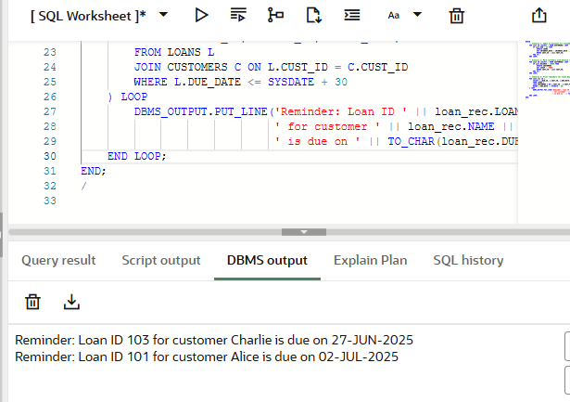

**Exercise 2: Error Handling**

CREATE TABLE ACCOUNTS (

ACC_ID NUMBER PRIMARY KEY,

BALANCE NUMBER

);

CREATE TABLE EMPLOYEES (

EMP_ID NUMBER PRIMARY KEY,

NAME VARCHAR2(100),

SALARY NUMBER

);

CREATE TABLE CUSTOMERS (

CUST_ID NUMBER PRIMARY KEY,

NAME VARCHAR2(100),

AGE NUMBER,

BALANCE NUMBER

);

CREATE OR REPLACE PROCEDURE SafeTransferFunds (

from_acc_id IN NUMBER,

to_acc_id IN NUMBER,

amount IN NUMBER

) AS

from_balance ACCOUNTS.BALANCE%TYPE;

BEGIN

SELECT BALANCE INTO from_balance FROM ACCOUNTS WHERE ACC_ID = from_acc_id;

IF from_balance < amount THEN

RAISE_APPLICATION_ERROR(-20001, 'Insufficient funds in source account.');

END IF;

UPDATE ACCOUNTS SET BALANCE = BALANCE - amount WHERE ACC_ID = from_acc_id;

UPDATE ACCOUNTS SET BALANCE = BALANCE + amount WHERE ACC_ID = to_acc_id;

COMMIT;

DBMS_OUTPUT.PUT_LINE('Transfer successful.');

EXCEPTION

WHEN OTHERS THEN

ROLLBACK;

DBMS_OUTPUT.PUT_LINE('Error during transfer: ' || SQLERRM);

END;

/

CREATE OR REPLACE PROCEDURE UpdateSalary (

emp_id IN NUMBER,

percent IN NUMBER

) AS

BEGIN

UPDATE EMPLOYEES

SET SALARY = SALARY + (SALARY * percent / 100)

WHERE EMP_ID = emp_id;

IF SQL%ROWCOUNT = 0 THEN

RAISE_APPLICATION_ERROR(-20002, 'Employee ID not found.');

END IF;

COMMIT;

DBMS_OUTPUT.PUT_LINE('Salary updated successfully.');

EXCEPTION

WHEN OTHERS THEN

ROLLBACK;

DBMS_OUTPUT.PUT_LINE('Error updating salary: ' || SQLERRM);

END;

/

CREATE OR REPLACE PROCEDURE AddNewCustomer (

p_id IN NUMBER,

p_name IN VARCHAR2,

p_age IN NUMBER,

p_balance IN NUMBER

) AS

BEGIN

INSERT INTO CUSTOMERS VALUES (p_id, p_name, p_age, p_balance);

COMMIT;

DBMS_OUTPUT.PUT_LINE('Customer added successfully.');

EXCEPTION

WHEN DUP_VAL_ON_INDEX THEN

DBMS_OUTPUT.PUT_LINE('Error: Customer with ID ' || p_id || ' already exists.');

WHEN OTHERS THEN

DBMS_OUTPUT.PUT_LINE('Other error: ' || SQLERRM);

END;

/

EXEC SafeTransferFunds(1, 2, 1000);

EXEC UpdateSalary(101, 10);

EXEC AddNewCustomer(1, 'David', 30, 5000);

EXEC AddNewCustomer(3, 'Eva', 25, 3000);

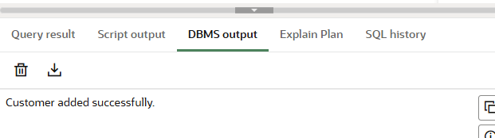

**Exercise 3: Stored Procedures**

CREATE TABLE SAVINGS_ACCOUNTS (

ACC_ID NUMBER PRIMARY KEY,

BALANCE NUMBER

);

CREATE TABLE EMPLOYEES (

EMP_ID NUMBER PRIMARY KEY,

NAME VARCHAR2(100),

DEPT VARCHAR2(50),

SALARY NUMBER

);

CREATE TABLE ACCOUNTS (

ACC_ID NUMBER PRIMARY KEY,

BALANCE NUMBER

);

CREATE OR REPLACE PROCEDURE ProcessMonthlyInterest AS

BEGIN

UPDATE SAVINGS_ACCOUNTS

SET BALANCE = BALANCE + (BALANCE * 0.01);

COMMIT;

DBMS_OUTPUT.PUT_LINE('Monthly interest applied to all savings accounts.');

EXCEPTION

WHEN OTHERS THEN

ROLLBACK;

DBMS_OUTPUT.PUT_LINE('Error applying interest: ' || SQLERRM);

END;

/

EXEC ProcessMonthlyInterest;

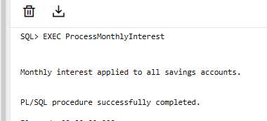

CREATE OR REPLACE PROCEDURE UpdateEmployeeBonus (

    dept_name IN VARCHAR2,

    bonus_percent IN NUMBER

) AS

BEGIN

    UPDATE EMPLOYEES

    SET SALARY = SALARY + (SALARY * bonus_percent / 100)

    WHERE DEPT = dept_name;

    IF SQL%ROWCOUNT = 0 THEN

        RAISE_APPLICATION_ERROR(-20002, 'No employees found in department ' || dept_name);

    END IF;

    COMMIT;

    DBMS_OUTPUT.PUT_LINE('Bonus applied to department: ' || dept_name);

EXCEPTION

    WHEN OTHERS THEN

        ROLLBACK;

        DBMS_OUTPUT.PUT_LINE('Error applying bonus: ' || SQLERRM);

END;

/

EXEC UpdateEmployeeBonus('IT', 10);

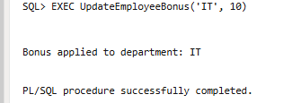

CREATE OR REPLACE PROCEDURE TransferFunds (

    from_acc IN NUMBER,

    to_acc IN NUMBER,

    amount IN NUMBER

) AS

    from_balance ACCOUNTS.BALANCE%TYPE;

BEGIN

    SELECT BALANCE INTO from_balance FROM ACCOUNTS WHERE ACC_ID = from_acc;

    IF from_balance < amount THEN

        RAISE_APPLICATION_ERROR(-20001, 'Insufficient funds');

    END IF;

    UPDATE ACCOUNTS SET BALANCE = BALANCE - amount WHERE ACC_ID = from_acc;

    UPDATE ACCOUNTS SET BALANCE = BALANCE + amount WHERE ACC_ID = to_acc;

    COMMIT;

    DBMS_OUTPUT.PUT_LINE('Funds transferred successfully.');

EXCEPTION

    WHEN OTHERS THEN

        ROLLBACK;

        DBMS_OUTPUT.PUT_LINE('Error transferring funds: ' || SQLERRM);

END;

/

EXEC TransferFunds(1, 2, 2000);

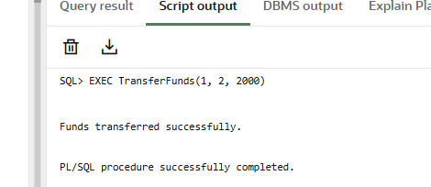

**Exercise 6: Cursors**

CREATE TABLE Customers (

CustomerID NUMBER PRIMARY KEY,

Name VARCHAR2(100)

);

CREATE TABLE Accounts (

AccountID NUMBER PRIMARY KEY,

CustomerID NUMBER REFERENCES Customers(CustomerID),

Balance NUMBER(12,2)

);

CREATE TABLE Transactions (

TransactionID NUMBER PRIMARY KEY,

CustomerID NUMBER REFERENCES Customers(CustomerID),

Amount NUMBER(10,2),

TransactionDate DATE

);

CREATE TABLE Loans (

LoanID NUMBER PRIMARY KEY,

CustomerID NUMBER REFERENCES Customers(CustomerID),

Amount NUMBER(12,2),

InterestRate NUMBER(5,2)

);

DECLARE

CURSOR GenerateMonthlyStatements IS

SELECT c.CustomerID, c.Name, t.Amount, t.TransactionDate

FROM Customers c

JOIN Transactions t ON c.CustomerID = t.CustomerID

WHERE TRUNC(t.TransactionDate, 'MM') = TRUNC(SYSDATE, 'MM');

v_cust_id Customers.CustomerID%TYPE;

v_name Customers.Name%TYPE;

v_amount Transactions.Amount%TYPE;

v_date Transactions.TransactionDate%TYPE;

BEGIN

OPEN GenerateMonthlyStatements;

LOOP

FETCH GenerateMonthlyStatements INTO v_cust_id, v_name, v_amount, v_date;

EXIT WHEN GenerateMonthlyStatements%NOTFOUND;

DBMS_OUTPUT.PUT_LINE('Customer: ' || v_name || ' | Amount: ' || v_amount || ' | Date: ' || v_date);

END LOOP;

CLOSE GenerateMonthlyStatements;

END;

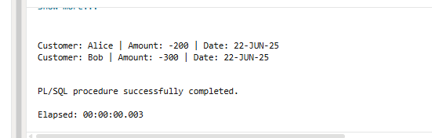

DECLARE

    CURSOR ApplyAnnualFee IS

        SELECT AccountID, Balance FROM Accounts;

    v_account_id Accounts.AccountID%TYPE;

    v_balance Accounts.Balance%TYPE;

    annual_fee CONSTANT NUMBER := 500;

BEGIN

    OPEN ApplyAnnualFee;

    LOOP

        FETCH ApplyAnnualFee INTO v_account_id, v_balance;

        EXIT WHEN ApplyAnnualFee%NOTFOUND;

        UPDATE Accounts

        SET Balance = Balance - annual_fee

        WHERE AccountID = v_account_id;

    END LOOP;

    CLOSE ApplyAnnualFee;

    COMMIT;

END;

/

SELECT * FROM Accounts;

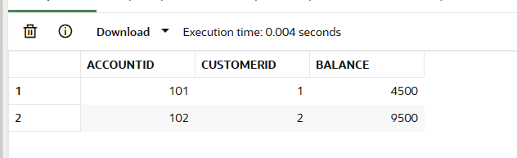

DECLARE

    CURSOR UpdateLoanInterestRates IS

        SELECT LoanID, Amount FROM Loans;

    v_loan_id Loans.LoanID%TYPE;

    v_amount Loans.Amount%TYPE;

BEGIN

    OPEN UpdateLoanInterestRates;

    LOOP

        FETCH UpdateLoanInterestRates INTO v_loan_id, v_amount;

        EXIT WHEN UpdateLoanInterestRates%NOTFOUND;

        IF v_amount >= 15000 THEN

            UPDATE Loans SET InterestRate = 7.0 WHERE LoanID = v_loan_id;

        ELSE

            UPDATE Loans SET InterestRate = 6.5 WHERE LoanID = v_loan_id;

        END IF;

    END LOOP;

    CLOSE UpdateLoanInterestRates;

    COMMIT;

END;

SELECT * FROM Loans;

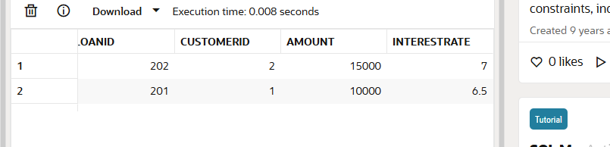

**Exercise 4: Functions**

CREATE TABLE Customers (

CustomerID NUMBER GENERATED BY DEFAULT AS IDENTITY PRIMARY KEY,

Name VARCHAR2(100),

DateOfBirth DATE

);

CREATE TABLE Loans (

LoanID NUMBER GENERATED BY DEFAULT AS IDENTITY PRIMARY KEY,

CustomerID NUMBER,

LoanAmount NUMBER,

InterestRate NUMBER, -- Annual %

DurationYears NUMBER

);

CREATE TABLE Accounts (

AccountID NUMBER GENERATED BY DEFAULT AS IDENTITY PRIMARY KEY,

CustomerID NUMBER,

Balance NUMBER

);

CREATE OR REPLACE FUNCTION CalculateAge(dob DATE)

RETURN NUMBER

IS

age NUMBER;

BEGIN

age := FLOOR(MONTHS_BETWEEN(SYSDATE, dob) / 12);

RETURN age;

END;

/

SELECT Name, CalculateAge(DateOfBirth) AS Age FROM Customers;

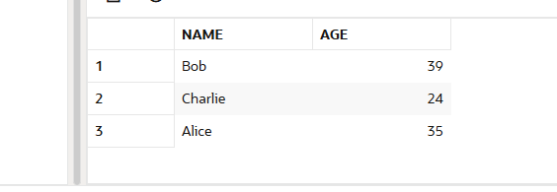

CREATE OR REPLACE FUNCTION CalculateMonthlyInstallment(

    amount NUMBER, rate NUMBER, years NUMBER

) RETURN NUMBER

IS

    r NUMBER := rate / 12 / 100;

    n NUMBER := years * 12;

    emi NUMBER;

BEGIN

    emi := (amount * r * POWER(1 + r, n)) / (POWER(1 + r, n) - 1);

    RETURN ROUND(emi, 2);

END;

/

SELECT

    LoanID,

    CalculateMonthlyInstallment(LoanAmount, InterestRate, DurationYears) AS EMI

FROM Loans;

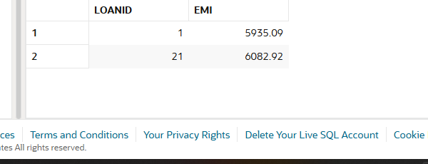

CREATE OR REPLACE FUNCTION HasSufficientBalance(acc_id NUMBER, amt NUMBER)

RETURN CHAR

IS

    bal NUMBER;

BEGIN

    SELECT Balance INTO bal FROM Accounts WHERE AccountID = acc_id;

    IF bal >= amt THEN

        RETURN 'Y';

    ELSE

        RETURN 'N';

    END IF;

EXCEPTION

    WHEN NO_DATA_FOUND THEN

        RETURN 'N';

END;

/

SELECT

    AccountID,

    HasSufficientBalance(AccountID, 1000) AS IsEligible

FROM Accounts;

