**A SYSTEM TO DETECT WRONG-WAY VEHICLES ON SMART HIGHWAYS AND ISSUE E-CHALLAN FOR THEM**

**FIELD OF INVENTION**

The field of smart highways is relevant to the current invention.

The answers provided by the current innovation apply to civil engineering and Smart Highways.

With an IoT-enabled environment, the current invention connects sensor and computing-based solutions to Smart Highways.

More specifically, the present invention covers the system that recognizes and sends out e-challan to wrong-way vehicles entering Smart Highways. The current invention thanks the highway patrol for stopping the wrong way to protect other people.

**BACKGROUND AND PRIOR ART**

Because it is described in the background section, it should not automatically be concluded that the subject matter is prior art. Similarly, it shouldn't be presumed that a problem mentioned in the background section or connected to its subject matter has already been known in the prior art. The material in the background section merely serves to illustrate several methods, which alone may qualify as innovations.

Some of the prior works are listed herewith:

N. H. Lin, Y. L. Aung, and W. K. Khaing, "Automatic Vehicle License Plate Recognition System for Smart Transportation," *2018 IEEE International Conference on Internet of Things and Intelligence System (IOTAIS)*, Bali, Indonesia, 2018, pp. 97-103, doi: 10.1109/IOTAIS.2018.8600829.

R. Kumar, M. Gupta, S. Shukla, and R. K. Yadav, "E-Challan Automation for RTO using OCR," *2021 Third International Conference on Inventive Research in Computing Applications (ICIRCA)*, Coimbatore, India, 2021, pp. 1-8, doi: 10.1109/ICIRCA51532.2021.9545082.

Goel, S.K., Kavita, Shukla, M. (2018). Enforcement of Automatic Penalty (e-Penalty) to Govern the Traffic Rule Violators in Digitized INDIA Using I.C.T. In Hemanth, D., Smys, S. (eds) Computational Vision and Bio Inspired Computing. Lecture Notes in Computational Vision and Biomechanics, vol 28. Springer, Cham. <https://doi.org/10.1007/978-3-319-71767-8_68>.

C. Bhatt, D. Arora, G. R. Kumar, P. Bhatt and T. Singh, "Paving the Way to Safety: An Automated Traffic Management and Challan Generation System," *2024 International Conference on Intelligent and Innovative Technologies in Computing, Electrical and Electronics (IITCEE)*, Bangalore, India, 2024, pp. 1-6, doi: 10.1109/IITCEE59897.2024.10467897.

G. A. Senthil, R. V. Lakshmi Priya, S. Geerthik, G. Karthick and R. Lavanya, "Safe Road AI: Real-Time Smart Accident Detection for Multi-Angle Crash Videos using Deep Learning Techniques and Computer Vision," *2024 3rd International Conference on Applied Artificial Intelligence and Computing (ICAAIC)*, Salem, India, 2024, pp. 617-622, doi: 10.1109/ICAAIC60222.2024.10575074.

**OBJECTIVE OF THE INVENTION**

The idea behind the current invention is to create a system that can identify wrong-side vehicles, issue an e-challan for them, and thank the highway patrol for it.

**SUMMARY**

The proposed wrong-way vehicle detection system utilizes an IoT-enabled architecture that coordinates cameras and RFID readers along highways to enhance road safety. High-definition camera modules are strategically placed to capture real-time video footage of vehicles, while RFID cards in each vehicle are tracked by RFID readers at entry and exit points. A Raspberry Pi microcontroller processes data from both cameras and RFID readers to detect wrong-way vehicles and issue e-challans. The system functions by detecting vehicles via cameras and RFID readers, capturing RFID card information and video footage. Image processing algorithms then analyze the footage to identify wrong-way vehicles, with RFID data helping to validate the direction of travel. Upon identifying a wrong-way vehicle, the system retrieves the vehicle's information from the RFID database and automatically generates an e-challan, which is sent to the vehicle owner. The database maintains comprehensive records of vehicles using RFID information, ensuring accurate correlation with camera footage for precise identification. This system offers significant benefits, including enhanced road safety by detecting and addressing wrong-way driving, efficient traffic management through real-time monitoring, automated enforcement with e-challan issuance, and accurate detection using combined RFID and camera data.

In conclusion, the proposed wrong-way vehicle detection system, leveraging IoT-enabled architecture with integrated camera modules, RFID technology, and a Raspberry Pi microcontroller, represents a significant advancement in highway safety and traffic management. By utilizing real-time video footage and RFID data, the system effectively identifies and addresses wrong-way driving incidents, automatically issuing e-challans to violators. This automated and precise approach enhances road safety, streamlines traffic monitoring, and ensures efficient enforcement of traffic laws. The implementation of this innovative technology on smart highways promises to significantly reduce the risks associated with wrong-way driving, ultimately leading to safer and more efficient roadways.

**BRIEF DESCRIPTION OF THE DRAWINGS**

The pictures have been created to better explain and describe the concept. Drawings offer a full description of the idea and bring together other components of the proposed innovation.

The suggested invention's architecture is shown in Figure 1.

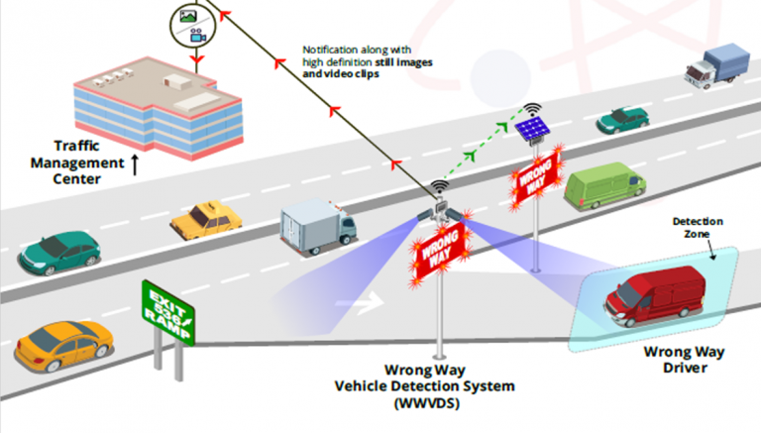

FIGURE 1

The integrated Wrong Way Vehicle Detection System (WWVDS) utilizes a camera module, RFID reader, and Raspberry Pi to enhance traffic enforcement by automatically detecting wrong-way drivers and issuing e-challans. The camera captures images of the violating vehicle, while the RFID reader scans any vehicle tags. The Raspberry Pi processes the data to extract license plate numbers, verifies vehicle information through a central database, and generates an e-challan detailing the offense. The system sends the e-challan to the vehicle owner via SMS, email, and mail, and facilitates fine payment through an online portal. It efficiently manages records, follows up on unpaid fines, and supports various enforcement actions, streamlining traffic regulation and improving road safety.

The flowchart describes an automated system for issuing challans (fines) using IoT and machine learning technologies. The process begins with the initialization of the IoT-based system, which sets the initial value of the RFID (Radio Frequency Identification) to NULL. The system then reads the value of the RF. If the RF value is not NULL, it continues reading; if it is NULL, the system captures the Fastag (an electronic toll collection tag used in India). The captured Fastag information is stored in a database, after which a challan is issued. Notifications about the issued challan are sent to both the vehicle owner and the relevant government authority, concluding the process.

Additionally, the system includes a sub-process where a camera initializes and reads data, setting a result variable (RES) to 0. This data undergoes machine learning-based analysis, and the result is computed. If the result variable (RES) equals 1, the system proceeds with capturing the FASTag, updating the database, and issuing the challan as previously described. The integration of IoT and machine learning ensures efficient monitoring and enforcement of regulations.

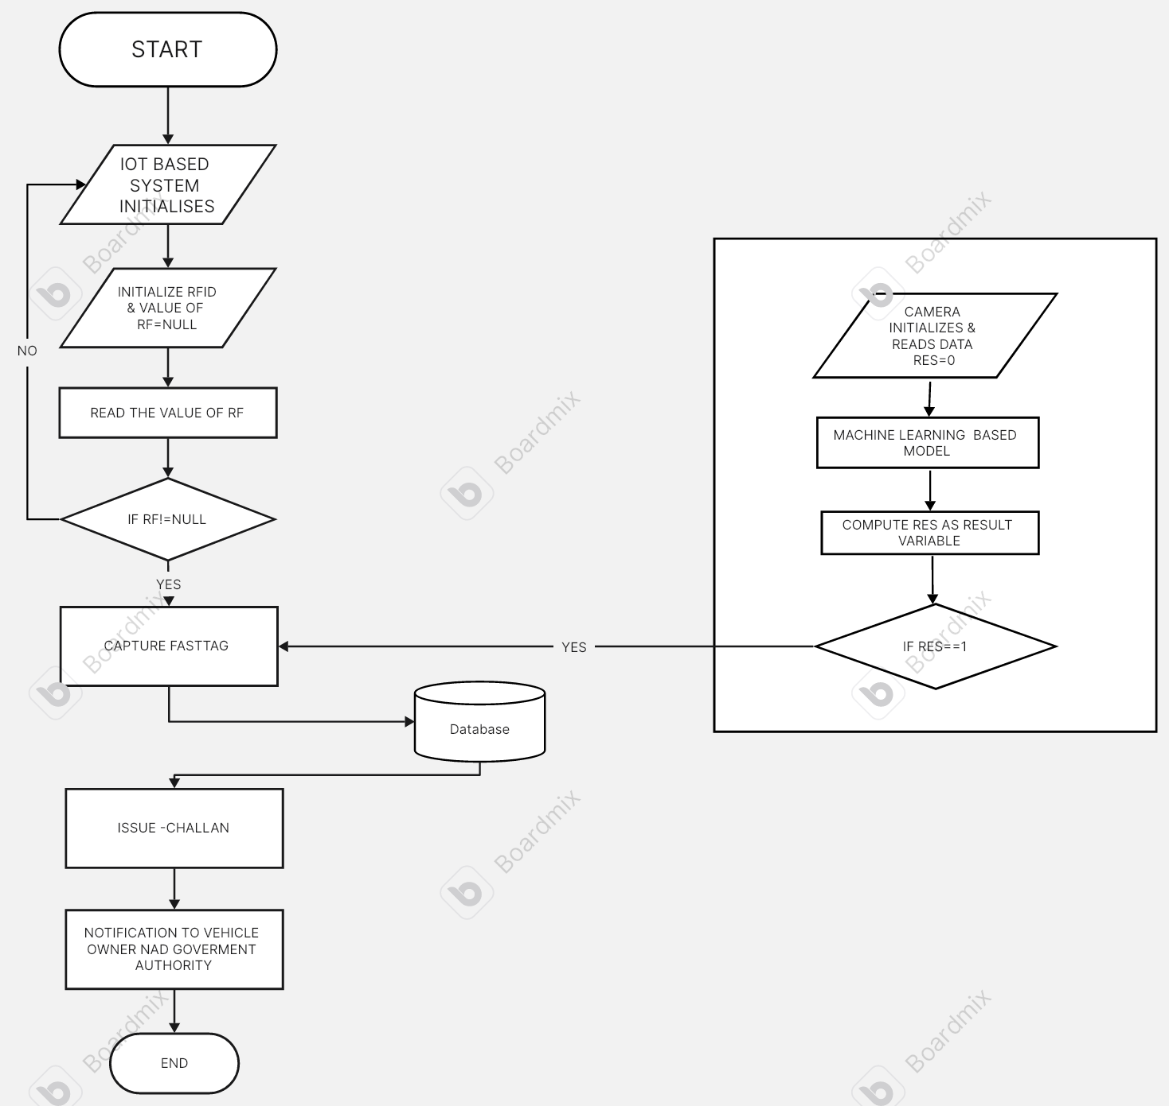

FIGURE 2

**DETAIL DESCRIPTION**

The proposed wrong-way vehicle detection system employs an IoT-enabled architecture designed to enhance road safety by coordinating high-definition cameras and RFID readers along highways. Here’s a detailed description of its components and operation:

**System Components**

1. **High-Definition Camera Modules**: Strategically placed along highways to capture real-time video footage of vehicles.
2. **RFID Readers**: Positioned at entry and exit points to track RFID cards embedded in each vehicle.
3. **Raspberry Pi Microcontroller**: Serves as the central processing unit that integrates and analyzes data from both cameras and RFID readers.
4. **RFID Cards**: Installed in vehicles to provide unique identification and facilitate tracking.

**System Operation**

1. **Initialization and Data Capture**:
   * The IoT system initializes, activating the cameras and RFID readers.
   * Vehicles entering the highway are detected by RFID readers, which log their entry using the RFID card information.
   * Cameras capture real-time video footage of the vehicles
2. **Data Processing**:
   * The Raspberry Pi microcontroller collects data from both the RFID readers and the cameras.
   * The RFID readers track the vehicle's RFID card at both entry and exit points, logging its movement.
3. **Image Processing and Analysis**:
   * Image processing algorithms analyze the captured video footage to identify vehicles traveling in the wrong direction.
   * RFID data is used to validate the direction of travel, ensuring accurate detection.
4. **Wrong-Way Detection**:
   * If a vehicle is detected traveling the wrong way, the system cross-references the RFID data to confirm the vehicle’s identity and direction of travel.
   * The vehicle’s information, including its unique RFID identifier, is retrieved from the database.
5. **E-Challan Issuance**:
   * Upon confirming a wrong-way driving incident, the system automatically generates an e-challan (electronic fine) for the violator.
   * The e-challan is sent to the vehicle owner, using contact information linked to the RFID card.
6. **Database Management**:
   * The database maintains comprehensive records of all vehicles, including RFID information and camera footage.
   * This ensures accurate correlation and validation for precise identification of wrong-way drivers.

**CLAIMS**

**We claim:**

1. Leveraging an IoT-enabled architecture, high-definition cameras, RFID technology, and a Raspberry Pi microcontroller..
2. Effectively identifying and addressing wrong-way driving incidents.
3. Integrating real-time video footage and RFID data for precise detection and automated enforcement.
4. Enhancing road safety and streamlining traffic monitoring.
5. Reducing the risks associated with wrong-way driving when implemented on smart highways.
6. Leading to safer and more efficient roadways.

**ABSTRACT**

We propose an advanced wrong-way vehicle detection system that enhances highway safety and traffic management by integrating IoT-enabled architecture, high-definition cameras, RFID technology, and a Raspberry Pi microcontroller. This system identifies and addresses wrong-way driving by capturing and analyzing real-time video footage and RFID data. Strategically placed cameras monitor vehicles, while RFID readers track vehicles at entry and exit points. The microcontroller processes this data to detect wrong-way vehicles, with RFID data confirming travel direction. Upon detection, the system retrieves vehicle information from an RFID ,database and automatically issues an electronic challan. This technology promises to enhance road safety, streamline traffic monitoring, and reduce wrong-way driving risks, leading to safer and more efficient roadways.