**Gujarat University (2023-24)**  
  
**PRESIDENT INSTITUTE OF COMPUTER APPLICATION**

Shayona Study Campus, Shayona City, Ghatlodiya,Ahmedabad, Gujarat - 380061

INDEX

|  |  |  |
| --- | --- | --- |
| Contents |  | Pg No. |
| Group details |  | 3 |
| Project title |  | 4 |
| About project |  | 5 |
| Acknowledgement |  | 6 |
| Company profile |  |  |
| * About company |  | 7 |
| * Company certificate |  | 8 |
| College certificate |  | 9 |
| Existing System |  | 10 |
| Proposed System |  | 11 |
| Tools & Technology |  | 12 |
| Project Modules |  |  |
| * Admin |  | 14 |
| * Customer |  | 15 |
| Use-Case Diagram |  |  |
| * Admin Use-Case |  | 17 |
| * Customer Use-Case |  | 18 |
| Activity Diagram |  |  |
| * Admin Activity |  | 20 |
| * Customer Activity |  | 21 |
| Sequence Diagram |  |  |
| * Customer Sequence |  | 23 |
| Class Diagram |  |  |
| * Class Diagram |  | 25 |
| Entity -Relationship Diagram |  |  |
| * ER Diagram |  | 26 |
| Data Dictionary |  | 28 |

**SUBMITTED BY :-**

|  |
| --- |
| **GROUP NUMBER :- 29** |

|  |  |
| --- | --- |
| **NAME** | **ENROLLMENT NUMBER** |
| PATEL MARVIN | 202112102546 |
| SHAHU LALIT | 202112102601 |
| GOLANI AMRUT | 202112102450 |

**BRIGHT HEALTH**

**ABOUT BRIGHT HEALTH :-**

* Bright health is basically an organization that aware the youth about their lifestyle.
* That helps the youth to understand how the street-food or outside-food is damage their health.
* So, we give them the best information for their health as well as cure of the disease they have.

**ACKNOWLEDGMENT :-**

* First, I would like to thank “**mr. Manesh patel**’’ for his expert advice and guidance and encouragement for making us to this project nicely and in a serious way.
* The success and final outcome of this project required the guidance and assistance of many people and I am very privileged to have all this with the completion of our project. I have done everything I have done only because of such supervision and support and I will never forget to thank them.

**COMPANY PROFILE** :-

* We have a team of professional qualified website developers in Ahmedabad, Gujarat, India.
* We strive to build and create beautiful mobile apps and brilliant web experience in emerging technologies and hence contributing towards building a solid ecosystem of sustainable software’s development.
* We focus on every element that can improve your experience during the process of product development. You dream it and we will help you achieve it.
* Our commitment to quality, on-time delivery and cost control helps us to retain 85% of clients. If you are looking for a cost-effective software solution give us a call and we will be happy to help you bring your product/service into reality.

**Email** : [info@waytowebgroup.com](mailto:info@waytowebgroup.com)

**Phone** : 8460071515

**Address** : 405, 3rd Eye-2 Building, Near Joyalukkas,

Above Mcdonald, Opp. Parimal Garden,

Panchavati Cross Road, Ambawadi,

Ahmedabad – 380006.

**COMPANY CERTIFIATE**  
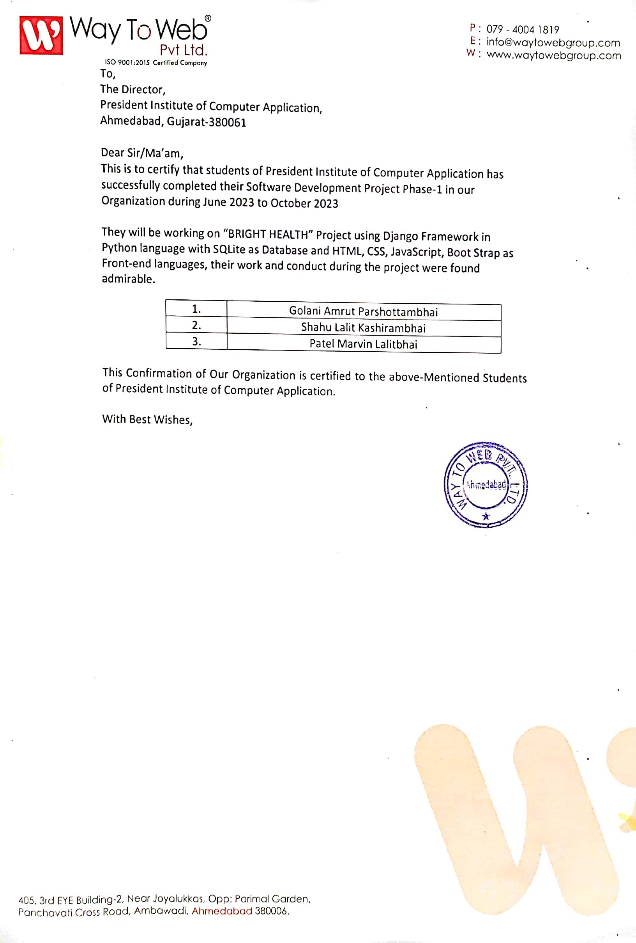

**COLLEGE CERTIFICATE**

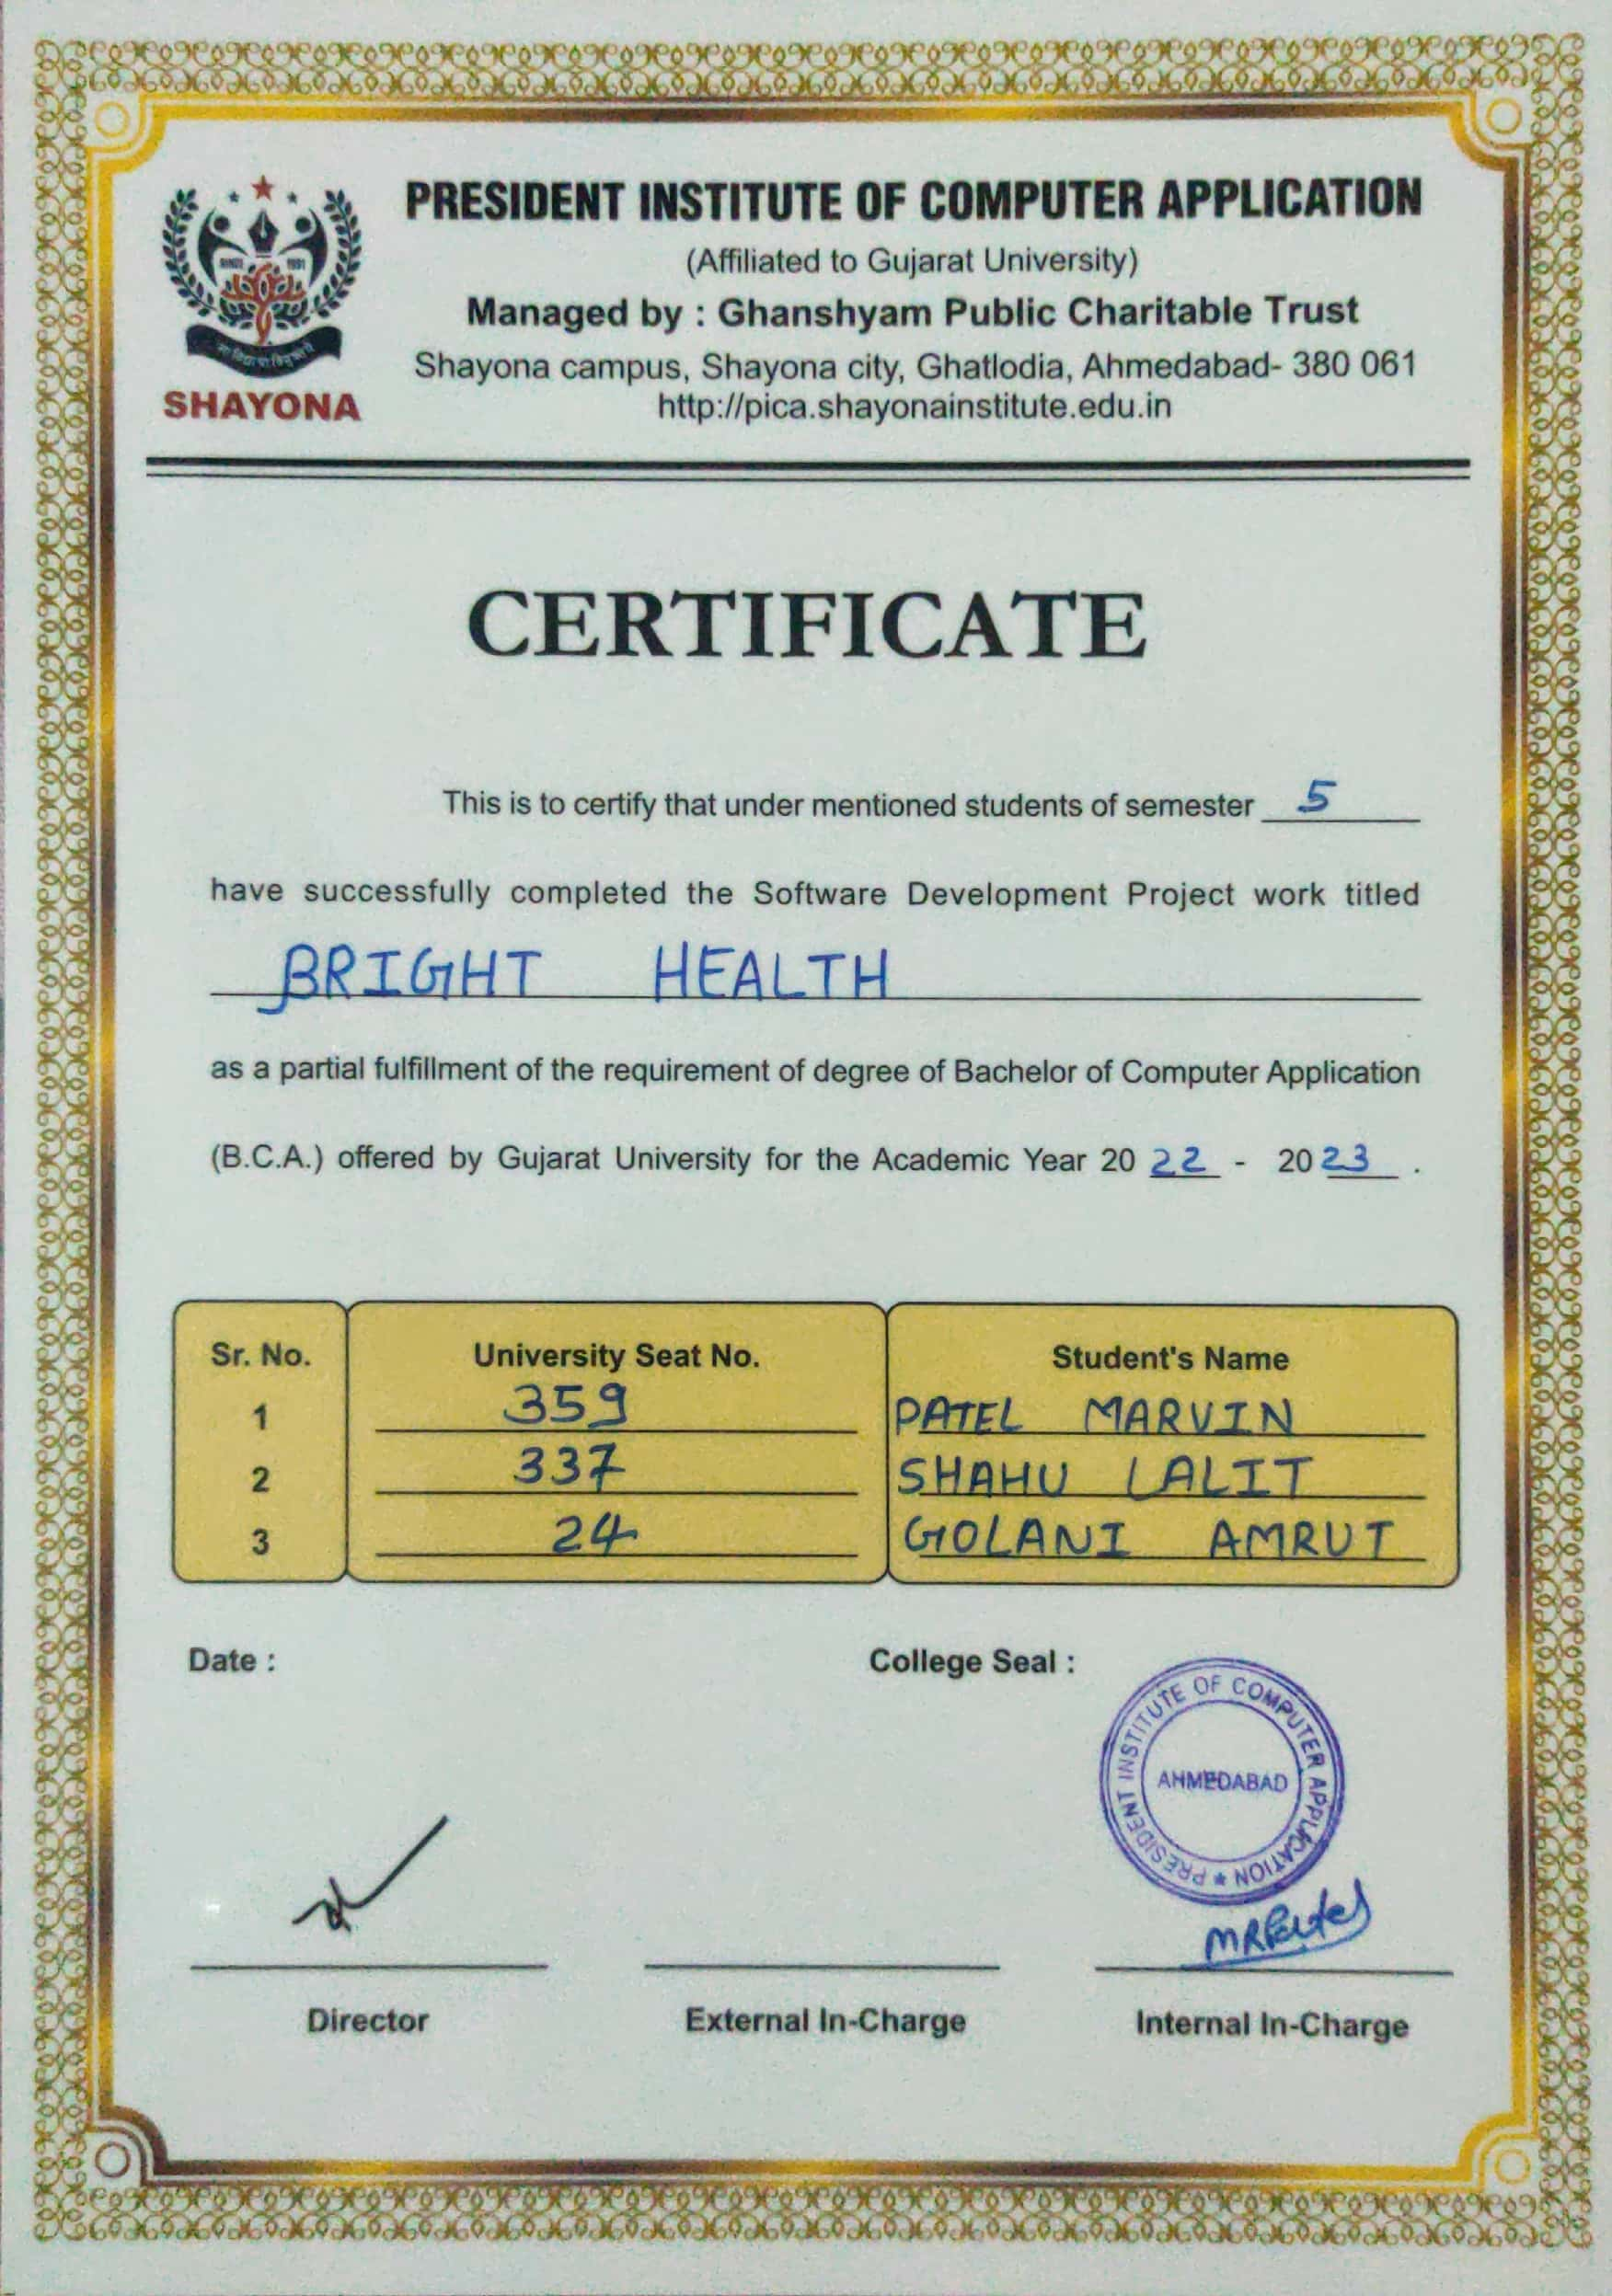

**EXISTING SYSTEM :-**

* As of today’s generation, especially youngster is very affected by junk food and social media.
* The youth is not aware what they eat and how it damage to their health in future.
* In existing system, that side only health related information provided. not for buying medicine.
* There is many sites that give one or two disease information in it.
* Over 22 Million Youngster have the ashthma in india.

**PROPOSED SYSTEM :-**

* In our system, is the many information include youth lifestyle.
* This system provides the all information of common diseases and as well as other ones.
* Due to some limitations of existing system we are proposing this system.
* Our Project will guide the young people with proper guidance about health.
* Our site will give proper and all disease’s information in the site and improve youngster’s lifestyle.

**DEVELOPMENT TOOLS :-**

* + **FRONT-END TOOLS**
    - Html5
    - Css3
    - Javascript
    - Bootstrap
  + **BACK-END TOOLS**
    - Python (Django Framework)
  + **DATABASE TOOL**
    - SQLite

**DEVELOPMENT TECHNOLOGY :-**

* + **SOFTWARE REQUIREMENT**
    - i3 gen (Minimum)
    - Windows 7 & Above
    - 8 GB Ram
  + **DOCUMENTATION TOOL**
    - Word
  + **MOBILE**
    - 3 GB Ram & 32 GB Rom

**PROJECT MODULES :-**

* **Admin**
* **Customer**

**ADMIN :-**

* **Login**
* **Manage Profile**
* **Manage Customer Interest**
* **Manage Disease**
* **Manage Disease Information**
* **Manage Customer Suggestions**
* **Manage Feedback**
* **Log out**

**CUSTOMER :-**

* **Register**
* **Login**
* **Manage Profile**
* **Update Profile**
* **Search Interest**
* **Give Suggestions**
* **Give Feedback & Rating**
* **Log out**

**USE-CASE DIAGRAM :-**

**ADMIN :-**

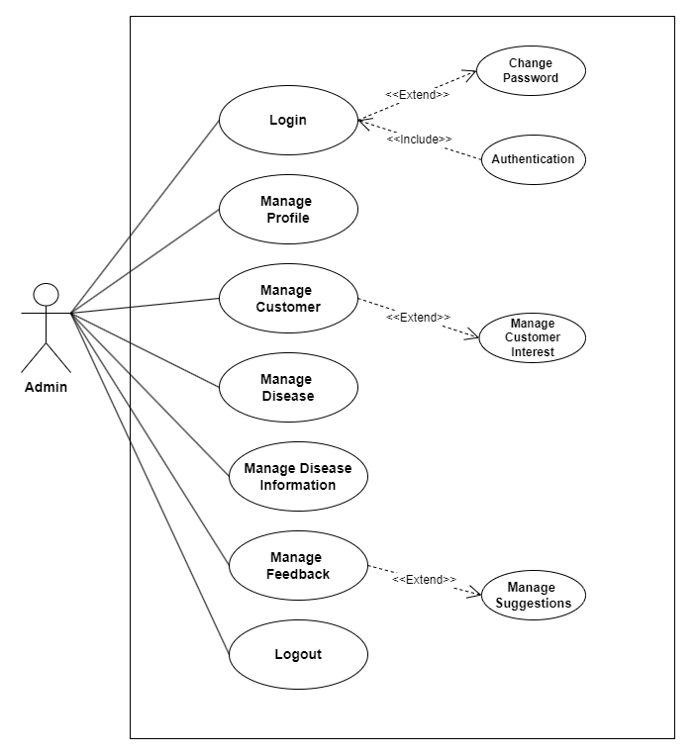

**CUSTOMER :-**

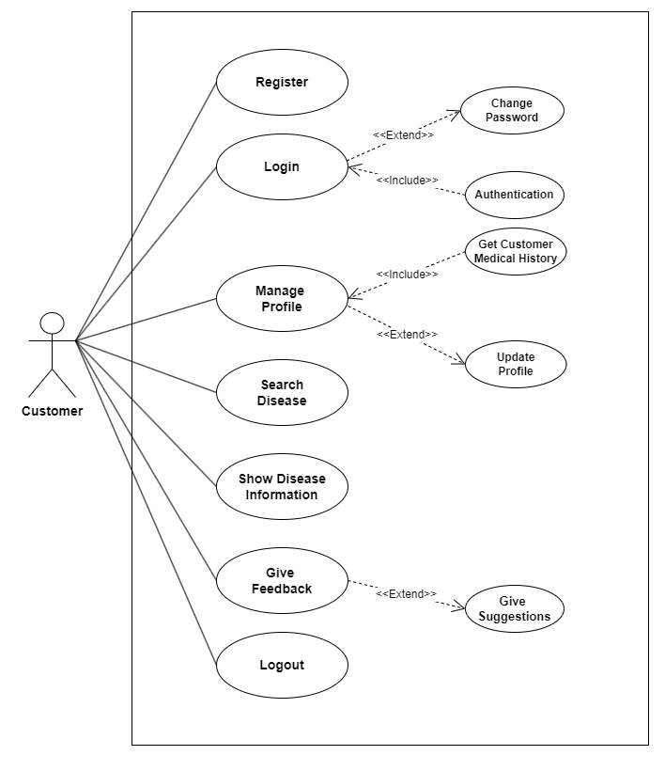

**ACTIVITY DIAGRAM :-**

**ADMIN :-**

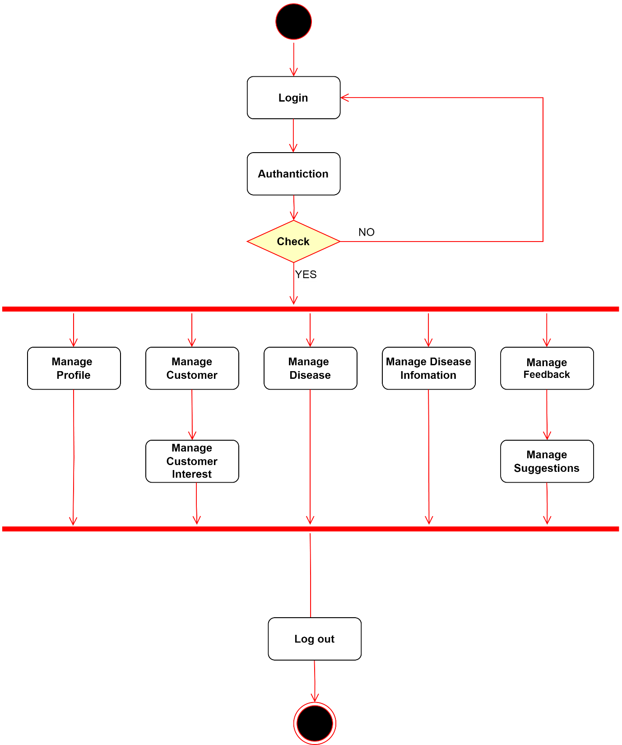

**CUSTOMER :-**

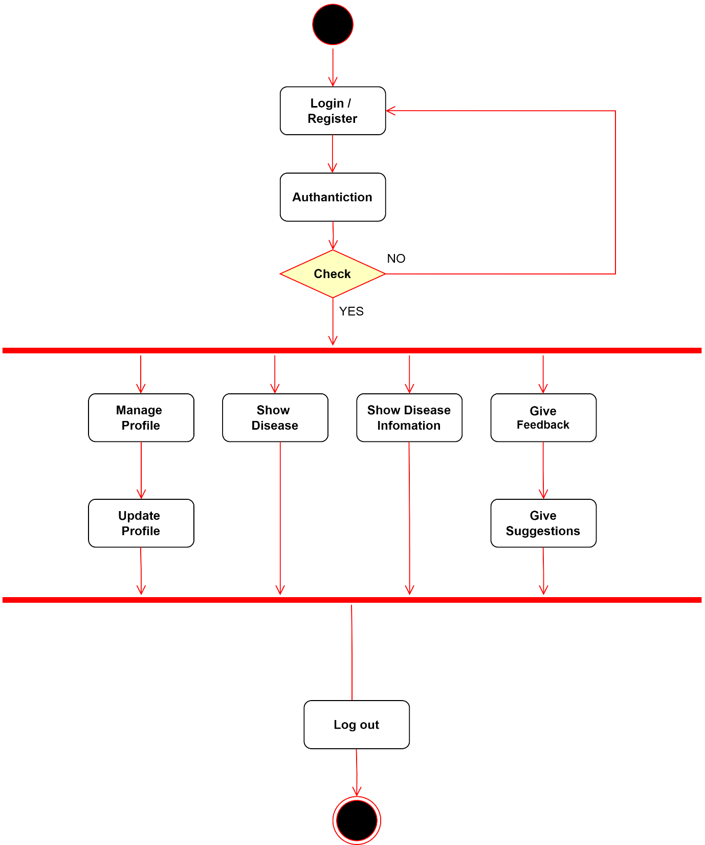

**SEQUENCE DIAGRAM :-**

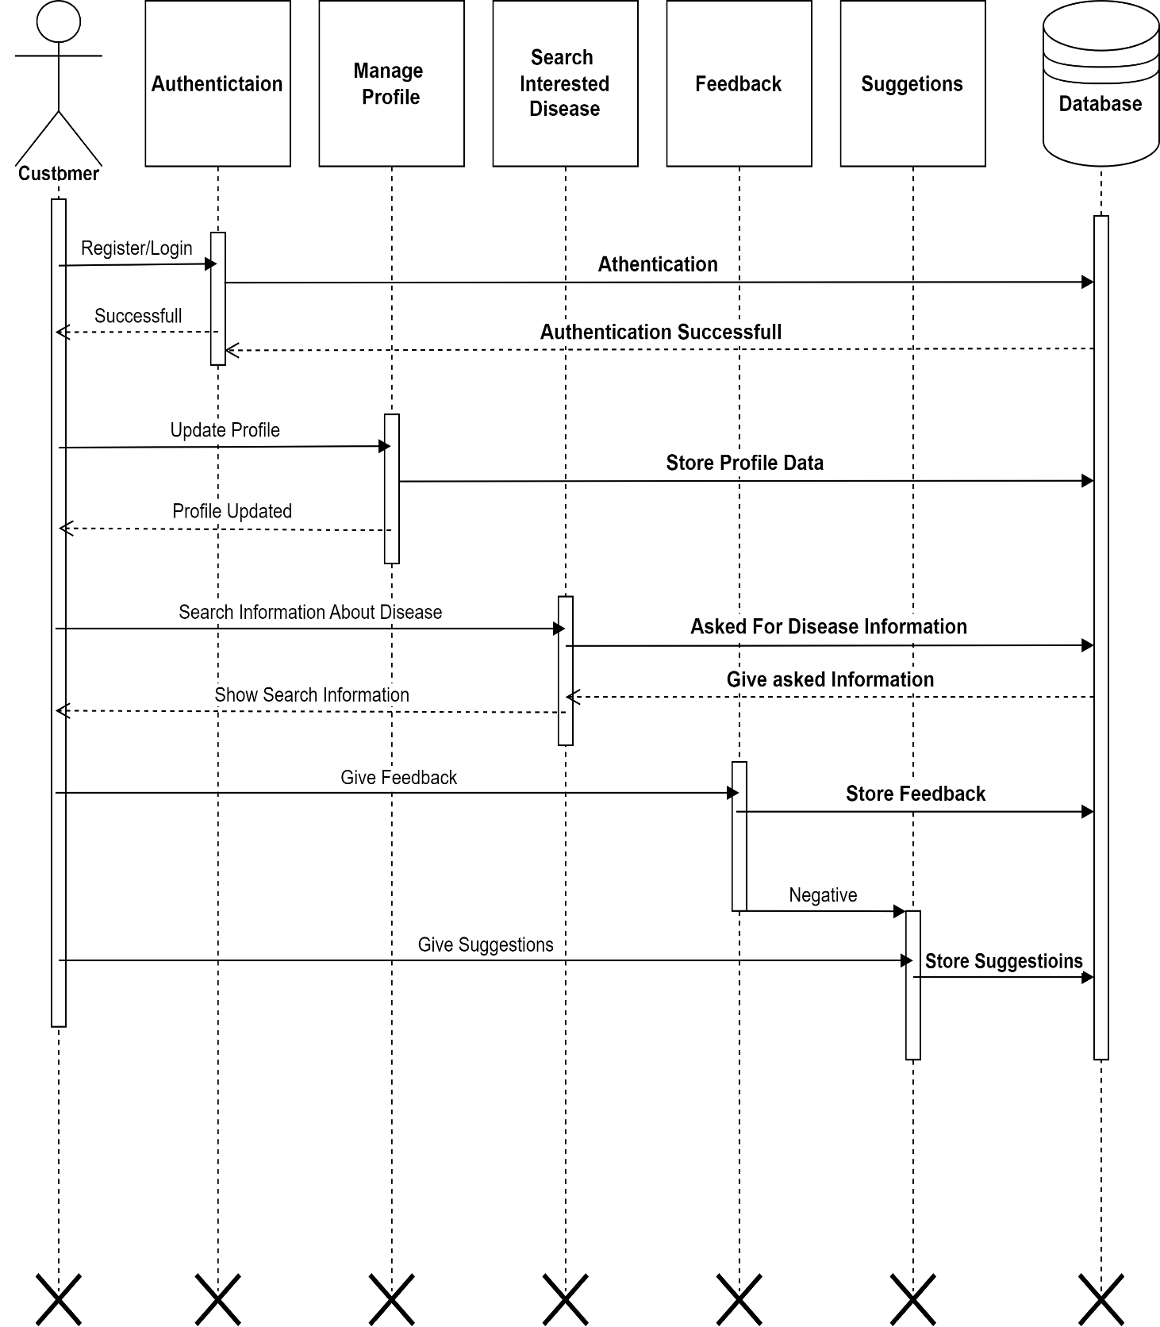

**CLASS DIAGRAM :-**

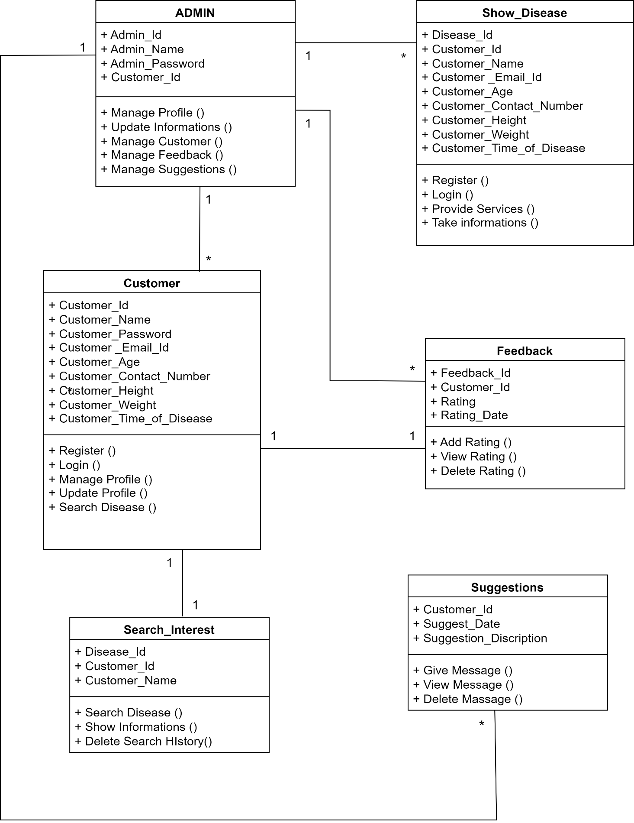

**ENTITY RELATION DIAGRAM :-**

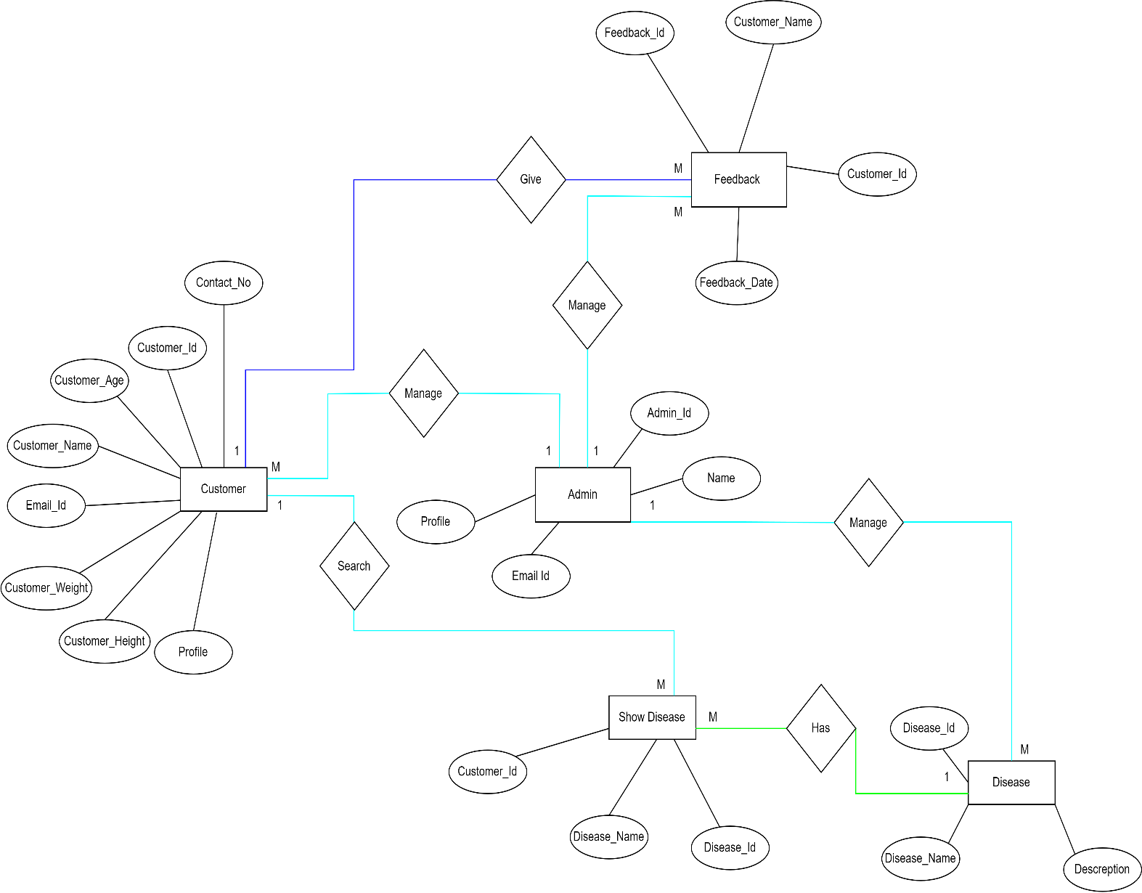

**DATA DICTIONARY :-**

**Table Name**

* **ADMIN**
* **CUSTOMER**
* **LOGIN**
* **REGISTER**
* **DISEASE**
* **FEEDBACK**

**ADMIN TABLE :-**

|  |  |  |  |  |  |
| --- | --- | --- | --- | --- | --- |
| **Sr.No.** | **Field Name** | **Type** | **Size** | **Constraints** | **Description** |
| 1 | Admin_Id | int | 10 | Primary key | Represents Admin id |
| 2 | Admin_Name | varchar | 15 | Not null | Represents admin name |
| 3 | Password | int | 10 | Not null | Represents admin password |

**CUSTOMER TABLE :-**

|  |  |  |  |  |  |
| --- | --- | --- | --- | --- | --- |
| **Sr.No.** | **Field Name** | **Type** | **Size** | **Constraints** | **Description** |
| 1 | Customer_Id | int | 10 | Primary key | Represents Customer id |
| 2 | Customer_Name | varchar | 15 | Not null | Represents Customer name |
| 3 | Email_Id | varchar | 15 | Not null | Represents Customer email-id |
| 4 | Contact_No | number | 10 | Not null | Represents Customer Contact no |
| 5 | Password | int | 10 | Not null | Represents Customer password |
| 6 | Customer_Height | Float | 10 | - | Represent Customer Height |
| 7 | Customer_Weight | Float | 10 | - | Represent Customer Weight |

**LOGIN TABLE :-**

|  |  |  |  |  |  |
| --- | --- | --- | --- | --- | --- |
| **Sr.No.** | **Field Name** | **Type** | **Size** | **Constraints** | **Description** |
| 1 | Login_Id | int | 10 | Primary key | Represents Login id |
| 2 | Login_Email | varchar | 15 | Not null | Represent Email id |
| 3 | Password | varchar | 10 | Not null | Represent Password |

**REGISTER TABLE :-**

|  |  |  |  |  |  |
| --- | --- | --- | --- | --- | --- |
| **Sr.No.** | **Field Name** | **Type** | **Size** | **Constraints** | **Description** |
| 1 | Full_Name | varchar | 20 | Primary key | Represents Login id |
| 2 | E-mail | varchar | 15 | Not null | Represent Email id |
| 3 | Password | varchar | 10 | Not null | Represent Password |

**DISEASE TABLE :-**

|  |  |  |  |  |  |
| --- | --- | --- | --- | --- | --- |
| **Sr.No.** | **Field Name** | **Type** | **Size** | **Constraints** | **Description** |
| 1 | Disease_Id | int | 20 | Primary key | Represents Disease id |
| 2 | Disease_Name | varchar | 20 | Not null | Represents Disease name |

**FEEDBACK TABLE :-**

|  |  |  |  |  |  |
| --- | --- | --- | --- | --- | --- |
| **Sr.No.** | **Field Name** | **Type** | **Size** | **Constraints** | **Description** |
| 1 | Feedback_Id | int | 10 | Primary key | Unique identifier for a feedback entry. |
| 2 | Customer_Id | int | 10 | Foreign Key | ID of the Customer who provided the feedback. |
| 3 | Customer_Name | varchar | 15 | Not null | Name of the Customer for feedback. |
| 4 | Feedback | varchar | - | Not null | Textual feedback or comments from the Customer. |
| 5 | Feedback_Date | datetime | - | Not null | Date and time when the feedback was submitted. |

**THANK YOU**