Task3-text

Lallu Nikerthil Prathapan

11/5/2021

install.packages(“Rmarkdown”)

#Average monthly maximum temperature of Germany for 12 months #tmin = average monthly minimum temperature (°C * 10) install.packages(“raster”)

#Gets Germany administrative boundaries and plot it 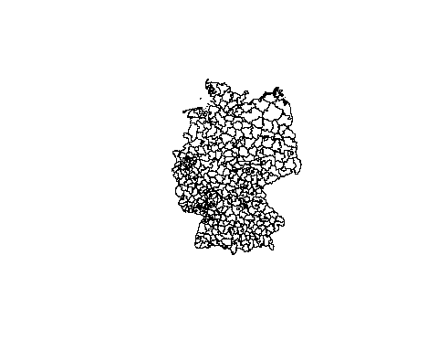 #Gets the Average monthly maximum temp data from world clim and plot it

max_tem<- getData("worldclim",var="tmax",res=.5,lon=10,lat=51)  
plot(max_tem)

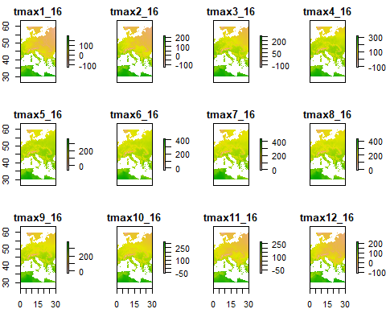 #crops max_tem to the extend of germany

max_tem1 <-crop(max_tem,germany)  
spplot(max_tem1)

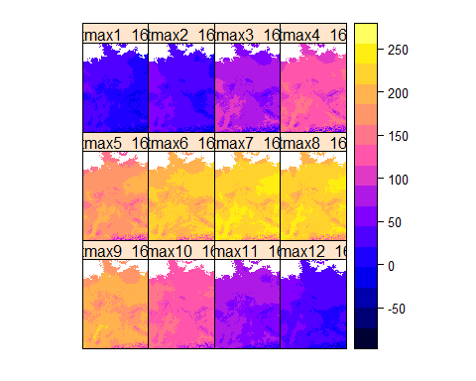 #Masks max_temp to the shape of Germany

max_tem2 <-mask(max_tem1,germany)  
spplot(max_tem2,main="Average monthly Maximum temperature of germany for 12 months")

