

**RKDF UNIVERSITY**

**Ranchi , Jharkhand**

**INTERNSHIP REPORT**

Submitted by

**Lalsha Kumari (001CSE23GT026)**

*in partial fulfillment for the award of the degree*

*of*

***Bachelor of Engineering***

*in*

***Computer Science and Engineering***

**RKDF University**

Ranchi , Jharkhand

An Autonomous Institiution

MAY 2025

**BONAFIDE CERTIFICATE**

Certified that this internship report

**“ HOSPITAL MANAGEMENT“**

is the bonafide work of

**LALSHA KUMARI ( 001CSE23GT026)**

who carried out the project work under my supervision

SIGNATURE OF HOD SIGNATURE OF SUPERVISIOR

**Shubhangni Dey Dr. Kirti Verma**

HEAD OF DEPARTMENT SUPERVISOR

Computer science and Engineering Computer science and Engineering

**RKDF University , Ranchi , Jharkhand RKDF University , Ranchi , Jharkhand**

Submitted for the Autonomous End Semester Examination Internship Project

**INTERNAL EXAMINER EXTERNAL EXAMINER**



**Hospital Management using Full stack Web Development with Python**

**ABSTRACT**

The **Online Doctor's Appointment System** is a comprehensive full-stack web application developed to streamline and enhance the process of booking medical consultations for patients, doctors, and clinic administrators. Built using **Java (JSP)** for the backend, **SQL** for database management, and integrated with modern frontend technologies **HTML5** and **CSS3**, the platform offers a user-friendly interface and efficient functionality. It facilitates seamless appointment scheduling, doctor availability tracking, and administrative oversight, ultimately contributing to the digital transformation of healthcare services.

The project was developed as a group effort by –

**LALSHA KUMARI(001CSE23GT026)** under the valuable mentorship of **Mr**. **Shashi Kumar Tanti Sir**.

The primary objective of the **Online Doctor's Appointment System** is to automate and manage various aspects of the medical consultation process, including patient registration, doctor listings, appointment scheduling, availability tracking, and consultation history management. The system ensures secure login for different user roles—patients, doctors, and administrators—each with customized functionalities. The backend is powered by robust **Java-based frameworks (Django)**, ensuring data consistency, security, and performance, while the frontend offers a responsive and user-friendly interface using **HTML5** and **CSS3**.

This project not only addresses the limitations of traditional appointment booking methods but also offers a scalable and maintainable solution for healthcare service providers. It reflects the collaborative effort and practical implementation of full-stack web development skills, effective project management, and real-world problem-solving abilities.

**Acknowledgement**

We would like to express our sincere gratitude to everyone who contributed to the successful completion of our project titled **"Hospital Management** developed using full-stack web technologies including **python(Django),** and **SQL database**.

First and foremost, we are deeply thankful to our mentor, **Mr** **Shashi Kumar Tanti Sir**, for his invaluable guidance, continuous support, and encouragement throughout the development of this project. His technical expertise and constructive feedback played a crucial role in shaping our understanding and refining our implementation.

We also extend our appreciation to our institution and faculty members for providing the necessary resources and a conducive environment for learning and development.

This project was a collaborative effort, and we, **Lalsha Kumari** are grateful to each other for the strong teamwork, dedication, and effort put in at every stage—from initial planning to final deployment.

Lastly, we thank our families and friends for their constant support and motivation, which inspired us to give our best.

* **Lalsha Kumari**

**B.Tech(C.S.E)**

**Semester – IV**

**(001CSE23GT026)**

**Table of Contents**

1. Introduction …………………………………………………………….. 4

2. Chapter 1 – Introduction to HTML …………………………………….. 5

2.1About HTML

2.2Some basic codes in HTML ………………………………………….

* 1. Marquee Tag in Html

2.4Tables and Forms in Html

1. Chapter 3 – SQL

4.1Installing SQL 10g……………………………………

4.2Connecting to Database …………………………………..

* 1. Basics queries of SQL …………………………………..

1. Chapter 5 – Developing our Group Project

6.1 Creating Frontend ………………………………………..

6.2 Creating Tables in Database ……………………………………..

6.3 Final output

1. References

**Introduction**

In today’s fast-paced and digitally driven world, accessing healthcare in a timely and organized manner is essential. Traditional methods of booking doctor appointments—such as in-person visits or phone calls—are often time-consuming, inefficient, and prone to scheduling errors. This not only affects patient satisfaction but also places an unnecessary administrative burden on healthcare providers.

To address these challenges, we have developed an **Online Doctor's Appointment System** — a web-based application designed to streamline and automate the process of booking medical consultations. This system provides a centralized digital platform where patients can book appointments, doctors can manage their schedules, and administrators can oversee operations with ease and efficiency.

The application is built using **Java JSP and Servlets** for the server-side logic and dynamic content generation, ensuring a robust and scalable backend. For data storage and retrieval, **SQL** is used to create and manage a structured database that efficiently handles user accounts, appointment records, doctor schedules, and consultation histories. The user interface is crafted using **HTML5** and **CSS3** to deliver a clean, intuitive, and responsive experience across all user roles—patient, doctor, and administrator.

**Key functionalities of the Online Doctor's Appointment System include:**  
• **Patient Module**: Registration, login, profile management, doctor browsing by specialization, appointment booking, and consultation history.  
• **Doctor Module**: Profile management, schedule setup, appointment viewing, and status updates.  
• **Admin Module**: Verification of patient and doctor accounts, system monitoring, and report generation.

The **Online Doctor's Appointment System** not only enhances the accessibility and efficiency of healthcare services but also lays a scalable foundation for future integration with features like automated SMS/email reminders, teleconsultation support, electronic prescriptions, and real-time availability tracking.

Through this project, we aimed to leverage full-stack web development to create a reliable, user-friendly, and effective solution for modern healthcare appointment management.

**Chapter 1 – Introduction to HTML**

**1.1 About Html**

**HTML** stands for **HyperText Markup Language**. It is the standard language used to create and structure content on the **World Wide Web**. HTML provides the basic building blocks for web pages, allowing developers to define elements like headings, paragraphs, links, images, tables, forms, and more.

**What is HTML?**

HTML is not a programming language; it is a **markup language**. This means it is used to "mark up" text and other content to tell a web browser how to display it. It consists of **elements** or **tags**, which are enclosed in angle brackets like <tagname>...</tagname>.

**Basic Structure of a HTML Document**

**<!DOCTYPE html>**

**<html>**

**<head>**

**<title>My First Web Page</title>**

**</head>**

**<body>**

**<h1>Welcome to HTML!</h1>**

**<p>This is a simple paragraph.</p>**

**</body>**

**</html>**

**Key Components:**

* <!DOCTYPE html>: Declares the document type and version of HTML.
* <html>: The root element of an HTML page.
* <head>: Contains metadata, such as the page title, links to stylesheets, etc.
* <title>: Sets the title shown in the browser tab.
* <body>: Contains the content that is displayed on the webpage, such as text, images, and links.
* <h1> to <h6>: Headings of different levels.
* <p>: Paragraph tag used for blocks of text.

2.2 Some basic codes in HTML

<html>

<body>

Hello <br>

World <hr>

<p align="left">Raja</p>

<p align = "right">Harsh</p>

<p align = "center">Riya</p>

<h1>Ram</h1>

<h2>Shyam</h2>

<h3>Raghav</h3>

<h4>Ram</h4>

<h5>Shyam</h5>

<h6>Raghav</h6>

<font face="chiller" size="+7" color="red">Welcome</font>

<img src="a.jpg" border = 1 height=300 width=300 alt="flower">

<a href="a.html">click</a>

<a href="a.html" target ="_self">click</a>

<a href="a.html" target ="_blank">click</a>

<a href="http:www.google.com"><img src="ab.jpg" height=100 width = 100 ></a>

<table border=1>

<tr><th>Roll</th><th>Name</th></tr>

<tr><td>1</td><td>Mangru</td></tr>

</table>

</body>

</html>

**2.3 Marquee Tag in HTML**

<html>

<body>

<marquee>welcome</marquee>

<marquee direction="left">LEFT</marquee>

<marquee direction="right">RIGHT</marquee>

<marquee direction="up">UP</marquee>

<marquee direction="down">DOWN</marquee>

<marquee behavior="scroll">SCROLL</marquee>

<marquee behavior="alternate">ALTERNATE</marquee>

<marquee behavior="slide">SLIDE</marquee>

<marquee bgcolor="yellow" direction=right scrolldelay="300">welcome to my college</marquee>

</body>

</html>

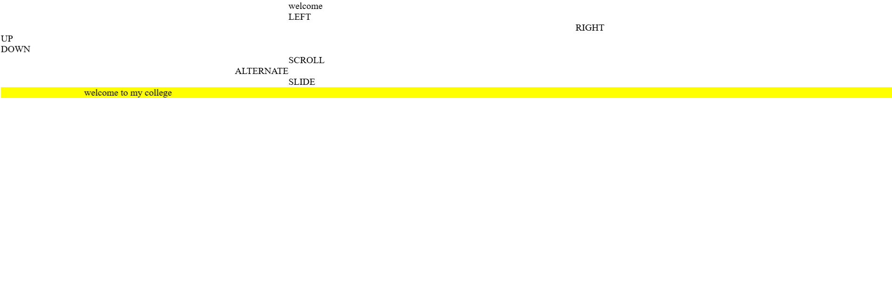

**2.4 Table and Forms in Html**

**Forms :**

<html>

<body>

<h1>HTML FORMS</h1>

<form name="frm">

NAME<input type="text" name="nm" size="20"> <br><br><br>

PASSWORD<input type="password" name="pwd" size="20"> <br><br><br>

GENDER<input type="radio" name="rd" value="male">Male

<input type="radio" name="rd" value="female">Female

<br><br><br>

NEWSPAPER<input type="checkbox" name="c1" value="Telegraph">Telegraph

<input type="checkbox" name="c2" value="Times Of India">Times Of India

<input type="checkbox" name="c3" value="Pioneer">Pioneer

<input type="checkbox" name="c4" value="Hindustan Times">Hindustan Times

<br><br><br>

Country

<select name="con">

<option>India</option>

<option>Japan</option>

<option>Nepal</option>

<option>Bhutan</option>

<option>Bangladesh</option>

</select>

<br>

<br><br>

HOBBY

<select multiple=true>

<option>Cricket</option>

<option>Football</option>

<option>Hockey</option>

<option>Dance</option>

<option>Table Tennis</option>

</select>

<br>

<br><br>

ABOUT US

<textarea rows=6 cols=10>

</textarea>

<br><br><br>

phone number<input type="number" name="ph" size=20><br><br><br>

date of birth<input type="date" name="dt" ><br><br><br>

<input type="submit" value="submit">

</form>

</body>

</html>

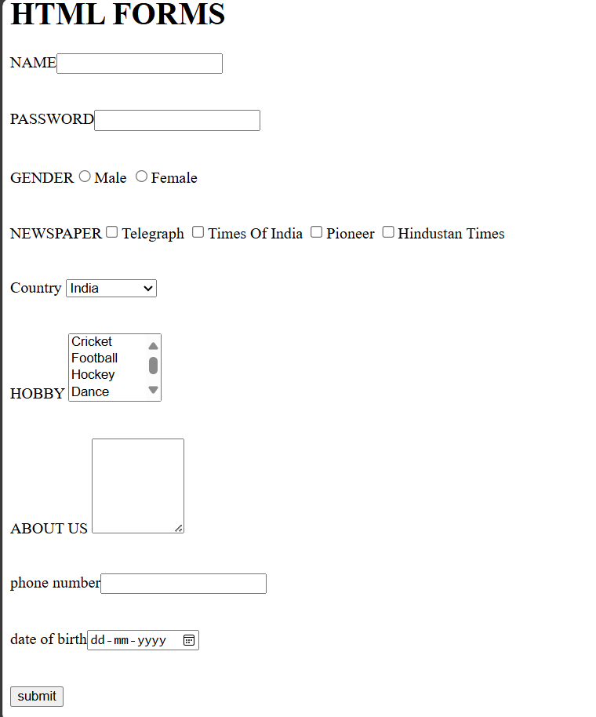

**Tables**

<html>

<body>

<h1>HTML Table</h1>

<form name="frm">

<table border=1 bgcolor=yellow cellspacing=5>

<tr><td>NAME</td><td>

<input type="text" name="nm" size="20"> </td></tr>

<tr><td>PASSWORD</td><td><input type="password" name="pwd" size="20"></td></tr>

<tr><td>GENDER</td><td><input type="radio" name="rd" value="male">Male

<input type="radio" name="rd" value="female">Female</td></tr>

<tr><td>NEWSPAPER</td><td><input type="checkbox" name="c1" value="Telegraph">Telegraph</td></tr>

<tr><td></td><td>

<input type="checkbox" name="c2" value="Times Of India">Times Of India</td></tr>

<tr><td></td><td><input type="checkbox" name="c3" value="Pioneer">Pioneer</td></tr>

<tr><td></td><td>

<input type="checkbox" name="c4" value="Hindustan Times">Hindustan Times</td></tr>

<tr><td>Country</td><td><select name="con">

<option>India</option>

<option>Japan</option>

<option>Nepal</option>

<option>Bhutan</option>

<option>Bangladesh</option>

</select></td></tr>

<tr><td>Hobby</td><td><select multiple=true>

<option>Cricket</option>

<option>Football</option>

<option>Hockey</option>

<option>Dance</option>

<option>Table Tennis</option>

</select></td></tr>

<tr><td>About Us</td><td><textarea rows=6 cols=10>

</textarea></td></tr>

</table>

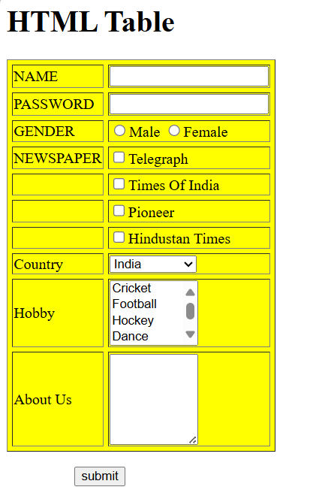</form>

&nbsp&nbsp&nbsp&nbsp&nbsp&nbsp&nbsp&nbsp&nbsp&nbsp&nbsp

&nbsp&nbsp&nbsp&nbsp&nbsp

</body>

</html>

path in the server’s search bar :

6 . Chapter 5 – Developing my Project

**6.1 Creating Front End**

<!DOCTYPE html>

<HTML>

    <HEAD>

        <style>

            .button-33 {

  background-color: #c2fbd7;

  border-radius: 100px;

  box-shadow: rgba(44, 187, 99, .2) 0 -25px 18px -14px inset,rgba(44, 187, 99, .15) 0 1px 2px,rgba(44, 187, 99, .15) 0 2px 4px,rgba(44, 187, 99, .15) 0 4px 8px,rgba(44, 187, 99, .15) 0 8px 16px,rgba(44, 187, 99, .15) 0 16px 32px;

  color: green;

  cursor: pointer;

  display: inline-block;

  font-family: CerebriSans-Regular,-apple-system,system-ui,Roboto,sans-serif;

  padding: 7px 20px;

  text-align: center;

  text-decoration: none;

  transition: all 250ms;

  border: 0;

  font-size: 16px;

  user-select: none;

  -webkit-user-select: none;

  touch-action: manipulation;

}

.button-33:hover {

  box-shadow: rgba(44,187,99,.35) 0 -25px 18px -14px inset,rgba(44,187,99,.25) 0 1px 2px,rgba(44,187,99,.25) 0 2px 4px,rgba(44,187,99,.25) 0 4px 8px,rgba(44,187,99,.25) 0 8px 16px,rgba(44,187,99,.25) 0 16px 32px;

  transform: scale(1.05) rotate(-1deg);

}

.main a{

   text-decoration: none;

   color: purple;

}

.main h3:hover{

}

            </style>

            <meta charset="UTF-8">

            <meta name="viewport" content="width=device-width, initial-scale=1.0">

            <style>

                * {

                    margin: 0;

                    padding: 0;

                    box-sizing: border-box;

                }

                body {

                    font-family: Arial, sans-serif;

                }

                .navbar {

                    background-color:white;

                    overflow: hidden;

                    display: flex;

                    justify-content: center;

                    padding: 10px 0;

                }

                .navbar a {

                    color: purple;

                    text-decoration: none;

                    padding: 14px 20px;

                    transition: 0.3s;

                    cursor: pointer;

                }

                .navbar a:hover, .navbar a.active {

                    background-color: turquoise;

                    border-radius: 5px;

                }

            </style>

            <script>

                document.addEventListener("DOMContentLoaded", function() {

                    const links = document.querySelectorAll(".navbar a");

                    links.forEach(link => {

                        link.addEventListener("click", function() {

                            links.forEach(l => l.classList.remove("active"));

                            this.classList.add("active");

                        });

                    });

                });

            </script>

        <Title>Valley View Hospital</Title>

    </HEAD>

    <BODY STYLE="COLOR:MidnightBlue">

        <table>

            <tr>

                <td><img src="logo.jpg" height="150" width="250"></td>

                <td width="1400" bgcolor="Floralwhite" style="color:darkmagenta"><h1><CENTER><font size=+7><b>Valley View Hospital</b>

 </font></CENTER></h1></td>

            </tr>

        </table><hr>

        <div class="navbar">

            <a href="#home">HOME</a>

            <a href="#about">ABOUT US</a>

            <a href="doctorspage.html">DOCTORS</a>

            <a href="department.html">DEPARTMENT</a>

            <a href="enquiry.html">ENQUIRY</a>

            <a href="feedback.html">FEEDBACK</a>

            <a href="help.html">HELP-DESK</a>

        </div>

        <hr><br>

        <marquee><h4 STYLE="COLOR:teal">HEALTHCARE AT YOUR FINGERTIPS.EXPERTS CARE, ANYTIME, ANYWHERE.</h4></marquee><hr>

<h2><center><u>Valley view Hospital - Your Trusted Online Doctor Appointment Platform</u></center></h2>

<table>

    <tr>

        <td width="800"><p font size="+6">Valley view Hospital is your one-stop solution for easy and reliable online doctor appointments.

            We connect patients with experienced healthcare professionals, ensuring quality

            medical care from the comfort of home. Whether you need a routine consultation,

            specialist advice, or urgent care, our platform makes booking an appointment

            quick and hassle-free. With secure video consultations and expert guidance,

             we bring healthcare closer to you—anytime, anywhere. Your health, our priority!

             Valley view Hospital is a trusted online platform that revolutionizes the way you access medical

             care. With just a few clicks, you can book an appointment with top-rated doctors, specialists,

              and healthcare professionals—anytime, anywhere. Whether it's a routine check-up, urgent

               medical advice, or ongoing health management, our secure and convenient telemedicine

                services ensure you receive the care you need from the comfort of your home.</p><br>

             <h3><b>Why Choose Valley View Hospital?</b></h3>

             <p font size="+6">✔ 24/7 Access to Trusted Doctors – Connect with experienced healthcare professionals at your convenience.

             ✔ Fast & Easy Appointments – No more waiting in long queues—book instantly and get the care you need.

             ✔ Secure & Private Consultations – Your health data is safe with our encrypted and confidential system.

             ✔ Affordable & Reliable Healthcare – Quality medical services at your fingertips, without breaking the bank.

             At Valley view Hospital, we believe that healthcare should be accessible, efficient, and stress-free.

             Because your well-being matters, we make it easier than ever to connect with the right doctor—wherever you are!</p></td>

            <td><img src="doc.jpeg" width="700" height="300"></td>

    </tr>

</table><hr>

<table bgcolor="lightgrey">

    <tr>

        <td width="600" height="150"><CENTER><img src=avatar.jpg width="200" height="150" ></CENTER></td>

        <td width="600" height="150"><CENTER><img src=avatar.jpg width="200" height="150" ></CENTER></td>

        <td width="600" height="150"><CENTER><img src=avatar.jpg width="200" height="150" ></CENTER></td>

    </tr>

</table>

<table bgcolor="lightgrey">

    <tr>

        <td width="600" height="50"><center><A HREF="admin.html"><button class="button-33">ADMIN</button></A></center></td>

        <td width="600" height="50"><CENTER><A HREF="patient.html"><button class="button-33">PATIENT</button></A></CENTER></td>

        <td width="600" height="50"><CENTER><A HREF="doctor.html"><button class="button-33">DOCTOR</button></A></CENTER></td>

   </tr>

</table><HR>

    <CENTER><h2 STYLE="COLOR:DARKGREY">NEW USER</h2></CENTER><center><A HREF="register.html"><button class="button-33">REGISTER</button></A></center>

    <hr>

    <h1 STYLE="COLOR:BLACK"><CENTER><U>OUR EXPERT DOCTORS</U></CENTER></h1>

    <h5>our doctors are highly skilled, compassionate, and committed to providing top-quality healthcare.

         Available anytime, they offer expert medical advice and treatment tailored to your needs.

        With a patient-first approach, we ensure accessible and reliable care for all.</h5>

        <table>

            <tr>

<td><Center><img src="lalsha.jpg" width="350" height="200"></Center></td>

            </tr>

        </table>

        <table>

            <tr>

                <td ><pre><H3>           Lalsha Kumari

        </table><HR>

                  DIRECTOR, VALLEY VIEW HOSPITAL,RANCHI

                </H3></pre></td>

            </tr>

        </table><HR>

        <h1 STYLE="COLOR:BLACK">

           <CENTER> <U>HOW VALLEY VIEW HOSPITAL WORKS</U></CENTER>

        </h1>

        <p font size="+5">Valley view Hospital' online doctor's appointment platform provides a convenient way for patients

            to access medical care from anywhere. Users can create an account, browse qualified doctors by specialty,

            and schedule appointments at their convenience. The platform offers consultations via video calls, voice

             calls, or chat, allowing doctors to assess symptoms, provide medical advice, and issue digital prescriptions.

              Secure online payments make transactions hassle-free.<br><br>

            Patients can also schedule follow-up consultations for ongoing care. This service is ideal for non-emergency

             conditions, second opinions, and routine health concerns, eliminating the need for long waiting times at clinics.

              With a user-friendly interface and a network of licensed healthcare professionals, Life Savers ensures quick and

               reliable medical assistance.<br><br>

            By bridging the gap between patients and doctors through digital technology, Valley View Hospital enhances accessibility,

             affordability, and efficiency in healthcare, making it easier for individuals to receive timely medical attention

             from the comfort of their homes.<br><hr>

            <h1 style="color:black">

            <CENTER><U>OUR SERVICES</U></CENTER>

            </h1>

            <ul>

            <P FONT SIZE="+6">

               <li><B>General Consultations –</B> Diagnosis and treatment for common illnesses like colds, flu, headaches, and fever.</li>

               <li><B>Chronic Disease Management –</B> Guidance for managing conditions like diabetes, hypertension, asthma, and arthritis.</li>

                <li><b>Mental Health Support –</B> Counseling and therapy for anxiety, depression, stress, and insomnia.</li>

                <li><B>Dermatology Services –</B> Online consultation for skin conditions like acne, rashes, eczema, and infections.</li>

                <li><B>Pediatric Care –</B> Virtual consultations for children’s health concerns, including vaccinations and nutritional advice.</li>

                <li><B>Gynecology & Women's Health –</B> Advice on menstrual issues, pregnancy care, contraception, and menopause.</li>

                <li><B>Prescription Services –</B> E-prescriptions for necessary medications.</li>

                <li><B>Second Opinions –</B> Specialist consultations for critical health conditions.</li>

                <li><B>AI-Powered Symptom Checker –</B> An interactive tool to help patients understand their

                symptoms before booking an appointment.</li>

                <li><B>Multi-Language Support –</B> Offering services in different languages for wider accessibility.</li>

                <li><B>Electronic Health Records (EHR) –</B> Secure storage for patient history and prescriptions for easy access.</li>

                <li><B>Instant Consultation Option –</B> Feature for urgent cases where patients need immediate advice.</li>

                <li><B>Integrated Pharmacy Services –</B> Allowing patients to order prescribed medications online.</li>

                <li><B>Health Tracking Dashboard –</B> A personalized section where users can track their vitals, appointments, and medication schedules.</li>

                <li><B>Appointment Reminders –</B> Automated SMS and email notifications for upcoming consultations.</li>

                <li><B>24/7 Customer Support –</B> Ensuring patients get assistance in booking appointments or addressing queries.</li>

            </P>

            </ul>

            <h1 style

    </BODY>

</HTML>

**profile.html**

<!DOCTYPE html>

<HTML>

<HEAD>

<meta charset="UTF-8">

<meta name="viewport" content="width=device-width, initial-scale=1.0">

<style>

.circle-frame {

width: 150px; /* Adjust as needed */

height: 150px; /* Ensure width and height are equal */

border-radius: 50%; /* Makes the image circular */

overflow: hidden; /* Ensures the image stays within the circle */

border: 5px solid teal; /* Optional: Adds a border around the circle */

display: flex;

justify-content: center;

align-items: center;

}

.circle-frame img {

width: 100%;

height: 100%;

object-fit: cover; /* Ensures the image fills the circle without distortion */

}

</style>

<style>

table {

border-collapse: separate;

border-spacing: 0 15px; /* 10px space after each row */

}

</style>

<Title>PROFILE</Title>

</HEAD>

<BODY STYLE="COLOR:teal">

<table>

<tr>

<td><img src="logo.jpg" height="150" width="250"></td>

<td width="1400" bgcolor="teal" style="color:beige"><h1><CENTER><font size=+7><b>VALLEY VIEW HOSPITAL</b>

</font></CENTER></h1></td>

</tr>

</table><hr>

<center><div class="circle-frame">

<img src="lalsha.jpg" alt="Circular Image">

</div>

<H1>DR. LALSHA KUMARI</H1>

<H3>DIRECTOR , VALLEY VIEW HOSPITAL</H3>

<h3>CONTACT-7667216821</h3>

</center>

<center>

<table font size="+7">

<tr><td WIDTH="300">EDUCTION QUALIFICATION</td><TD>MBBS, MD, MS, DNB ,MHA</TD></tr>

<tr><td WIDTH="300">NAME OF THE INSTITUTE</td><TD>ALL INDIA INTITUTE OF MEDICAL SCIENCE</TD></tr>

<tr><td WIDTH="300">EXPERIENCE</td><TD>15 YEARS EXPERIENCE IN HOSPITAL ADMINISTRATION</TD></tr>

<TR></TR>

<tr><td WIDTH="300">MY KEY SKILLS</td><TD>Leadership, decision-making, and crisis management<BR>

Knowledge of NABH/NABL accreditation, healthcare laws, and ethics<BR>

Strategic planning and patient care advocacy</TD></tr>

<tr><td WIDTH="300">CERTIFICATE</td><TD>Fellowship in Hospital Administration (FHA)<BR>

PG Diploma in Healthcare/Hospital Management </TD></tr>

</table>

<H3>AIM:-"To create a patient-centric, technologically advanced,<BR>

and sustainable healthcare ecosystem that ensures quality, <BR>accessibility, and affordability for all.</H3>

</center>

</BODY>

</html>

**ADMIN LOGIN(admin.html)**

<!DOCTYPE html>

<html>

<head>

<meta charset="UTF-8">

<meta name="viewport" content="width=device-width, initial-scale=1.0">

<style>

* {

margin: 0;

padding: 0;

box-sizing: border-box;

}

body {

font-family: Arial, sans-serif;

}

.navbar {

background-color:white;

overflow: hidden;

display: flex;

justify-content: center;

padding: 10px 0;

}

.navbar a {

color: purple;

text-decoration: none;

padding: 14px 20px;

transition: 0.3s;

cursor: pointer;

}

.navbar a:hover, .navbar a.active {

background-color: turquoise;

border-radius: 5px;

}

</style>

<script>

document.addEventListener("DOMContentLoaded", function() {

const links = document.querySelectorAll(".navbar a");

links.forEach(link => {

link.addEventListener("click", function() {

links.forEach(l => l.classList.remove("active"));

this.classList.add("active");

});

});

});

</script>

<script language="javascript">

function check()

{

var x,y;

x=frm.nm1.value;

y=frm.nm2.value;

if(x=="" ||y=="")

{

alert("no fields can be blank");

return false;

}

if(x=="riya" && y=="ayushivi1404")

{

alert("correct user");

return true;

}

else

{

alert("Incorrect user");

return false;

}

}

</script>

</head>

<title>

ADMIN LOGIN

</title>

</head>

<BODY>

<CENTER>

<H1> <FONT SIZE=+6>ADMIN LOGIN</FONT></H1><HR><BR><BR>

<head>

<body>

<table>

<tr>

<td><img src="logo.jpg" height="150" width="250"></td>

<td width="1400" bgcolor="teal" style="color:beige"><h1><CENTER><font size=+7><b>LIFE SAVERS</b>

</font></CENTER></h1></td>

</tr>

</table><hr>

<div class="navbar">

<a href="FRONT.html" class="active">HOME</a>

<a href="about.html">ABOUT US</a>

<a href="doctorspage.html">DOCTORS</a>

<a href="department.html">DEPARTMENT</a>

<a href="enquiry.html">ENQUIRY</a>

<a href="feedback.html">FEEDBACK</a>

<a href="help.html">HELP-DESK</a>

</div>

<hr><br>

<form name="frm" onsubmit="return check();" method="get" action="dash1.html">

<b>Enter Name</b><input type="text" name="nm1" size=20><br><br>

Password<input type="password" name="nm2" size=20><br>

<input type="submit" value="submit">

</form></body></html>

**Patient register.html**

<!DOCTYPE html>

<html>

<head>

<meta charset="UTF-8">

<meta name="viewport" content="width=device-width, initial-scale=1.0">

<style>

* {

margin: 0;

padding: 0;

box-sizing: border-box;

}

body {

font-family: Arial, sans-serif;

}

.navbar {

background-color:white;

overflow: hidden;

display: flex;

justify-content: center;

padding: 10px 0;

}

.navbar a {

color: purple;

text-decoration: none;

padding: 14px 20px;

transition: 0.3s;

cursor: pointer;

}

.navbar a:hover, .navbar a.active {

background-color: turquoise;

border-radius: 5px;

}

</style>

<script>

document.addEventListener("DOMContentLoaded", function() {

const links = document.querySelectorAll(".navbar a");

links.forEach(link => {

link.addEventListener("click", function() {

links.forEach(l => l.classList.remove("active"));

this.classList.add("active");

});

});

});

</script>

<style>

table {

border-collapse: separate;

border-spacing: 0 15px; /* 10px space after each row */

}

</style>

<title>

REGISTRATION FORM

</title>

</head>

<BODY><form action="register.jsp" method="post">

<table>

<tr>

<td><img src="logo.jpg" height="150" width="250"></td>

<td width="1400" bgcolor="teal" style="color:beige"><h1><CENTER><font size=+7><b>LIFE SAVERS</b>

</font></CENTER></h1></td>

</tr>

</table><hr>

<div class="navbar">

<a href="#home" class="active">HOME</a>

<a href="about.html">ABOUT US</a>

<a href="doctorspage.html">DOCTORS</a>

<a href="department.html">DEPARTMENT</a>

<a href="enquiry.html">ENQUIRY</a>

<a href="feedback.html">FEEDBACK</a>

<a href="help.html">HELP-DESK</a>

</div>

<hr><br>

<CENTER>

<H1> <FONT SIZE=+6>REGISTRATION FORM</FONT></H1><HR><BR><BR>

<table>

<tr><td><H4>NAME</H4></td><td><input type ="text" placeholder="Enter name" input size="30" name="nm1"></td></tr>

<tr><td WIDTH="100"><H4>GENDER</H4></td><td><input type="radio" name="nm2" value="male">MALE<input type="radio" name="rd" value="female" name="nm2">FEMALE</td></tr>

<TR><TD><h4>AGE</h4></TD><td><input type="number" placeholder="Enter your age" input size="3" name="nm3"></td></TR>

<tr><td><h4>EMAIL</h4></td><td><input type="text" placeholder="Enter your email" name="nm4"></td></tr>

<tr><td><h4>CONTACT</h4></td><td><input type="number" placeholder="Enter your phone no." input size="20" name="nm5"></td></tr>

<tr><td><h4>ADDRESS</h4></td><td><input type="text" placeholder="Enter your address" input size="50" name="nm6"></td></tr>

<tr><td><h4>STATE</h4></td><td><select name="nm7">

<option>select</option>

<option>Andhra Pradesh</option>

<option>Arunachal Pradesh</option>

<option>Assam</option>

<option>Bihar</option>

<option>Chhattisgarh</option>

<option> Goa</option>

<option>Gujarat</option>

<option>Haryana</option>

<option>Himachal Pradesh</option>

<option>Jharkhand</option>

<option>Karnataka</option>

<option>Kerala</option>

<option>Madhya Pradesh</option>

<option>Maharashtra</option>

<option> Manipur</option>

<option> Meghalaya</option>

<option>Mizoram</option>

<option> Nagaland</option>

<option>Odisha</option>

<option>Punjab</option>

<option> Rajasthan</option>

<option> Sikkim</option>

<option>Tamil Nadu</option>

<option> Telangana</option>

<option> Tripura</option>

<option> Uttar Pradesh</option>

<option> Uttarakhand</option>

<option> West Bengal</option>

</td></tr>

<tr><td><h4>PASSWORD</h4></td><TD><input type="text" placeholder="Enter a password" input size="15" name="nm8"></TD></tr>

<tr><td><h4>CONFIRM PASSWORD</h4></td><td><input type="text" placeholder="Re-enter your password" name="nm9"></td></tr>

<tr><td><center><input type=submit onclick="SUBMIT" value="submit"></center></td></tr>

</table>

</CENTER>

</form>

</BODY>

</html>

**Doctor registration.html**

<!DOCTYPE html>

<html>

<head>

<meta charset="UTF-8">

<meta name="viewport" content="width=device-width, initial-scale=1.0">

<style>

* {

margin: 0;

padding: 0;

box-sizing: border-box;

}

body {

font-family: Arial, sans-serif;

}

.navbar {

background-color:white;

overflow: hidden;

display: flex;

justify-content: center;

padding: 10px 0;

}

.navbar a {

color: purple;

text-decoration: none;

padding: 14px 20px;

transition: 0.3s;

cursor: pointer;

}

.navbar a:hover, .navbar a.active {

background-color: turquoise;

border-radius: 5px;

}

</style>

<script>

document.addEventListener("DOMContentLoaded", function() {

const links = document.querySelectorAll(".navbar a");

links.forEach(link => {

link.addEventListener("click", function() {

links.forEach(l => l.classList.remove("active"));

this.classList.add("active");

});

});

});

</script>

<style>

table {

border-collapse: separate;

border-spacing: 0 15px; /* 10px space after each row */

}

</style>

<title>

DOCTOR'S REGISTRATION FORM

</title>

</head>

<BODY><form action="doctor registration.jsp" method="post">

<table>

<tr>

<td><img src="logo.jpg" height="150" width="250"></td>

<td width="1400" bgcolor="teal" style="color:beige"><h1><CENTER><font size=+7><b>LIFE SAVERS</b>

</font></CENTER></h1></td>

</tr>

</table><hr>

<div class="navbar">

<a href="FRONT.html" class="active">HOME</a>

<a href="about.html">ABOUT US</a>

<a href="doctorspage.html">DOCTORS</a>

<a href="department.html">DEPARTMENT</a>

<a href="enquiry.html">ENQUIRY</a>

<a href="feedback.html">FEEDBACK</a>

<a href="help.html">HELP-DESK</a>

</div>

<hr><br>

<CENTER>

<H1> <FONT SIZE=+6>DOCTOR'S REGISTRATION FORM</FONT></H1><HR><BR><BR>

<table>

<tr><td><H4>NAME</H4></td><td><input type ="text" placeholder="Enter name" input size="30" name="nm1"></td></tr>

<tr><td WIDTH="100"><H4>GENDER</H4></td><td><input type="radio" name="nm2" value="male">MALE<input type="radio" name="rd" value="female" name="nm2">FEMALE</td></tr>

<TR><TD><h4>AGE</h4></TD><td><input type="number" placeholder="Enter your age" input size="3" name="nm3"></td></TR>

<tr><td><h4>EMAIL</h4></td><td><input type="text" placeholder="Enter your email" name="nm4"></td></tr>

<tr><td><h4>CONTACT</h4></td><td><input type="number" placeholder="Enter your phone no." input size="20" name="nm5"></td></tr>

<tr><td><h4>ADDRESS</h4></td><td><input type="text" placeholder="Enter your address" input size="50" name="nm6"></td></tr>

<tr><td><h4>QUALIFICATION</h4></td><td><input type="text" placeholder="Enter your highest qualificaton" input size=30 name=nm7</td></tr>

<tr><td><h4>NAME OF THE INSTITUTE</h4></td><TD><INPUT TYPE=TEXT placeholder="Name the institute" input size="30" name="nm8"></TD></tr>

<tr><td><h4>SPECIALISATION</h4></td><td><input type="text" placeholder="Any feild SPECIALISATION"name=nm9></td></tr>

<tr><td><h4>WORKING EXPERIENCE</h4></td><td><input type="number" placeholder="if any" name="nm10"></td></tr>

<tr><td><h4>STATE</h4></td><td><select name="nm11">

<option>select</option>

<option>Andhra Pradesh</option>

<option>Arunachal Pradesh</option>

<option>Assam</option>

<option>Bihar</option>

<option>Chhattisgarh</option>

<option> Goa</option>

<option>Gujarat</option>

<option>Haryana</option>

<option>Himachal Pradesh</option>

<option>Jharkhand</option>

<option>Karnataka</option>

<option>Kerala</option>

<option>Madhya Pradesh</option>

<option>Maharashtra </option>

<option> Manipur</option>

<option> Meghalaya</option>

<option>Mizoram</option>

<option> Nagaland</option>

<option>Odisha</option>

<option>Punjab</option>

<option> Rajasthan</option>

<option> Sikkim </option>

<option>Tamil Nadu</option>

<option> Telangana</option>

<option> Tripura</option>

<option> Uttar Pradesh</option>

<option> Uttarakhand</option>

<option> West Bengal</option>

</td></tr>

<tr><td><h4>PASSWORD</h4></td><TD><input type="text" placeholder="Enter a password" input size="15" name="nm12"></TD></tr>

<tr><td><h4>CONFIRM PASSWORD</h4></td><td><input type="text" placeholder="Re-enter your password" name="nm13"></td></tr>

<tr><td><center><input type=submit onclick="SUBMIT" value="submit"></center></td></tr>

</table>

</CENTER>

</form>

</BODY>

</html>

**6.2 Creating Tables in Databases**

**patient table**

Create table patient (Name Varchar(20),gender varchar(30),age varchar(20),email varchar(30),contact varchar(20),address varchar(50),state varchar(20),dob varchar(20),password varchar(10), confirm password varchar(20));

**doctor table**

Create table doctor (Name Varchar(20),gender varchar(30),age varchar(20),email varchar(30),contact varchar(20),address varchar(50),qualification varchar(20),name of institute varchar(30),specification varchar(30), working experience int(10),state varchar(20),dob varchar(20),password varchar(10), confirm password varchar(20));

OUTPUT

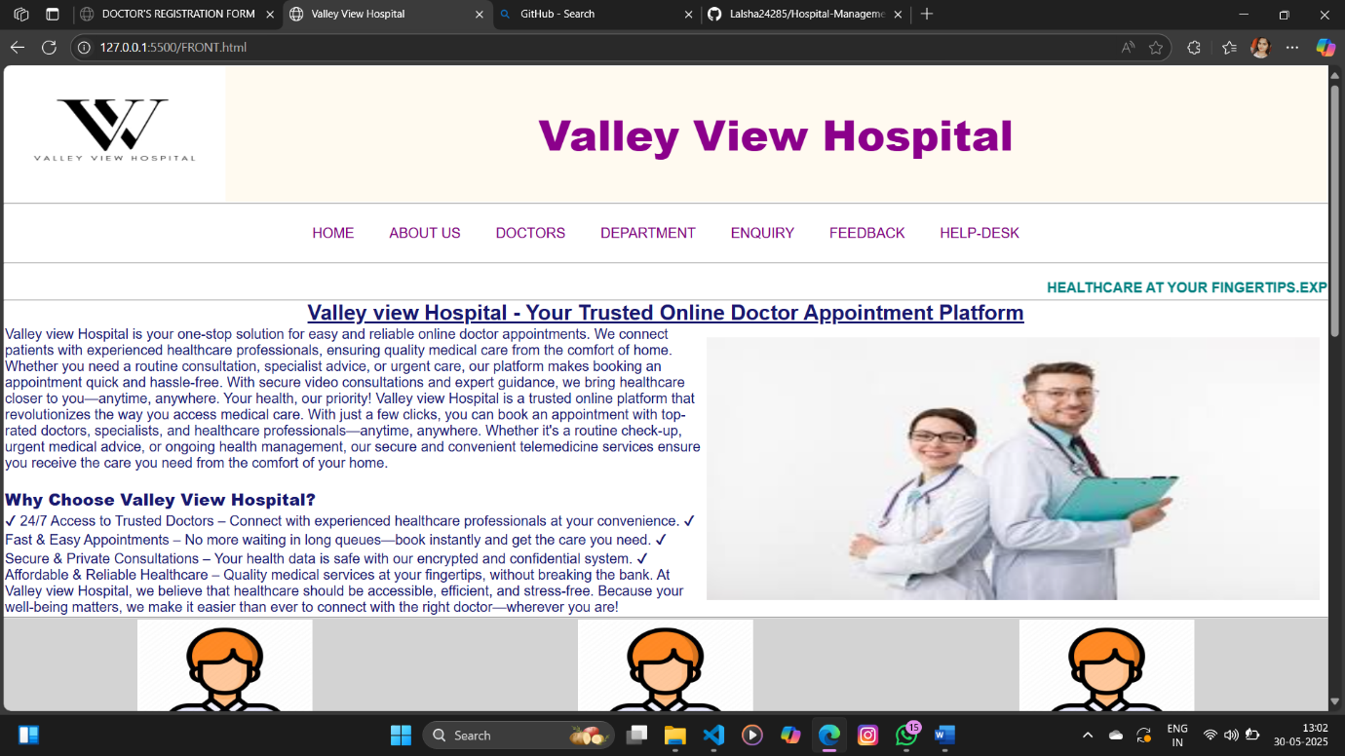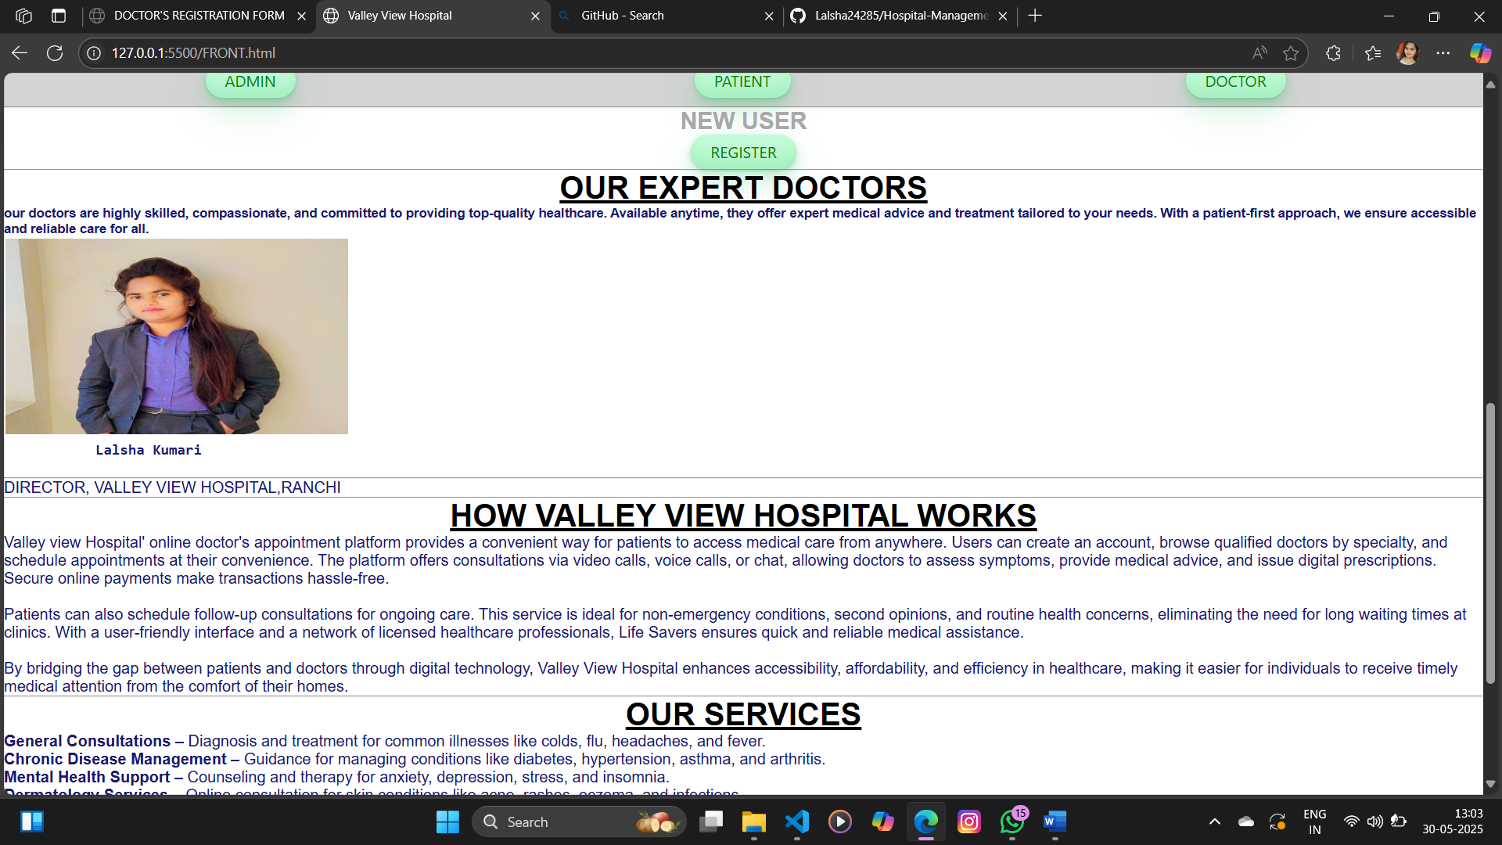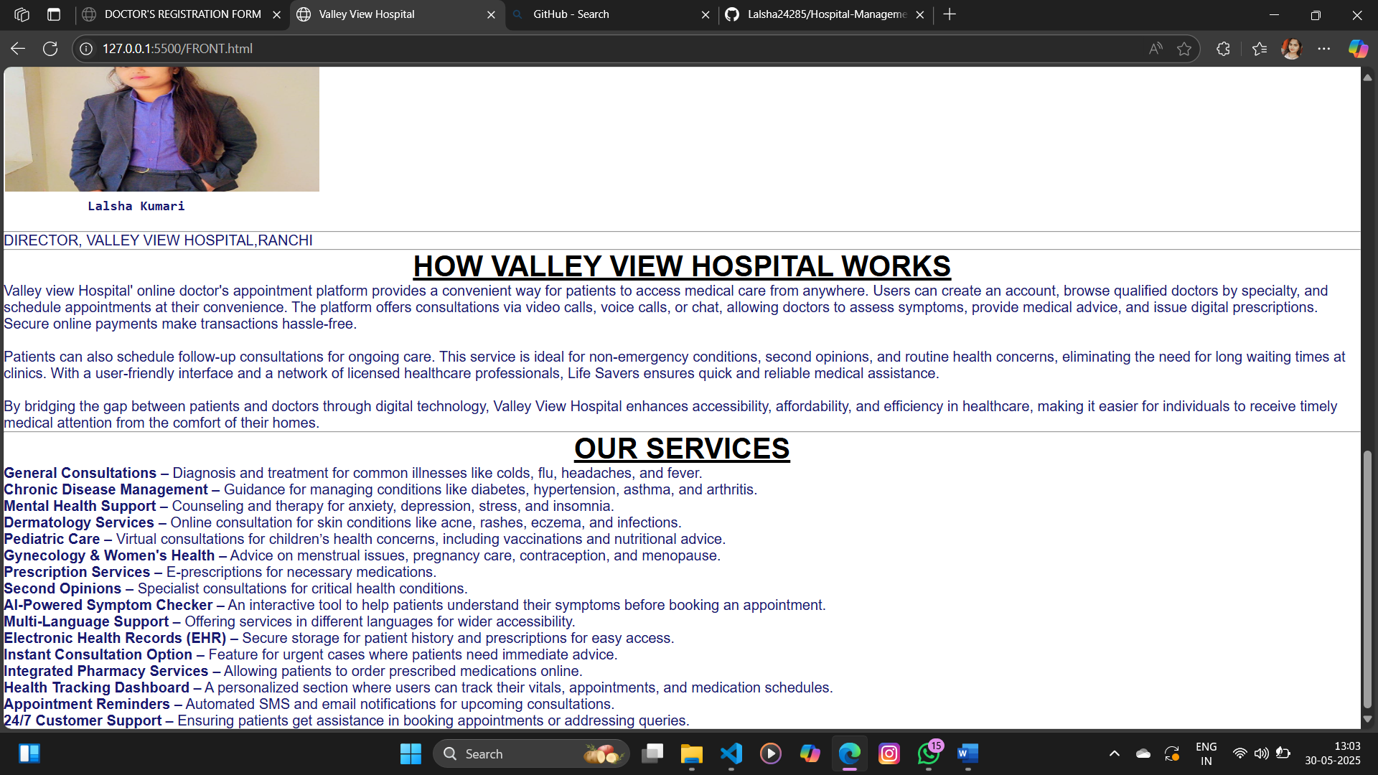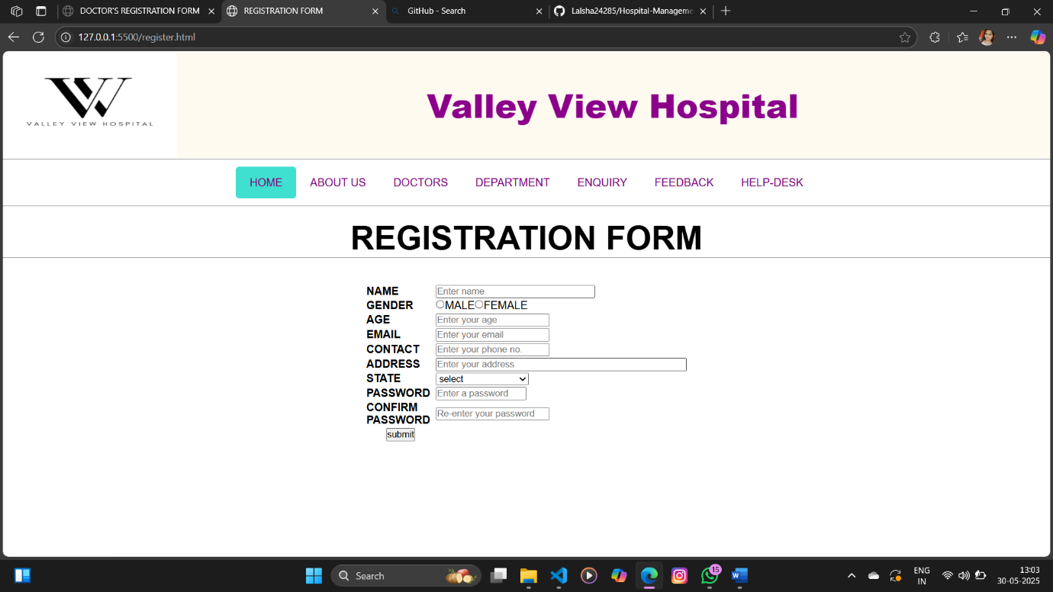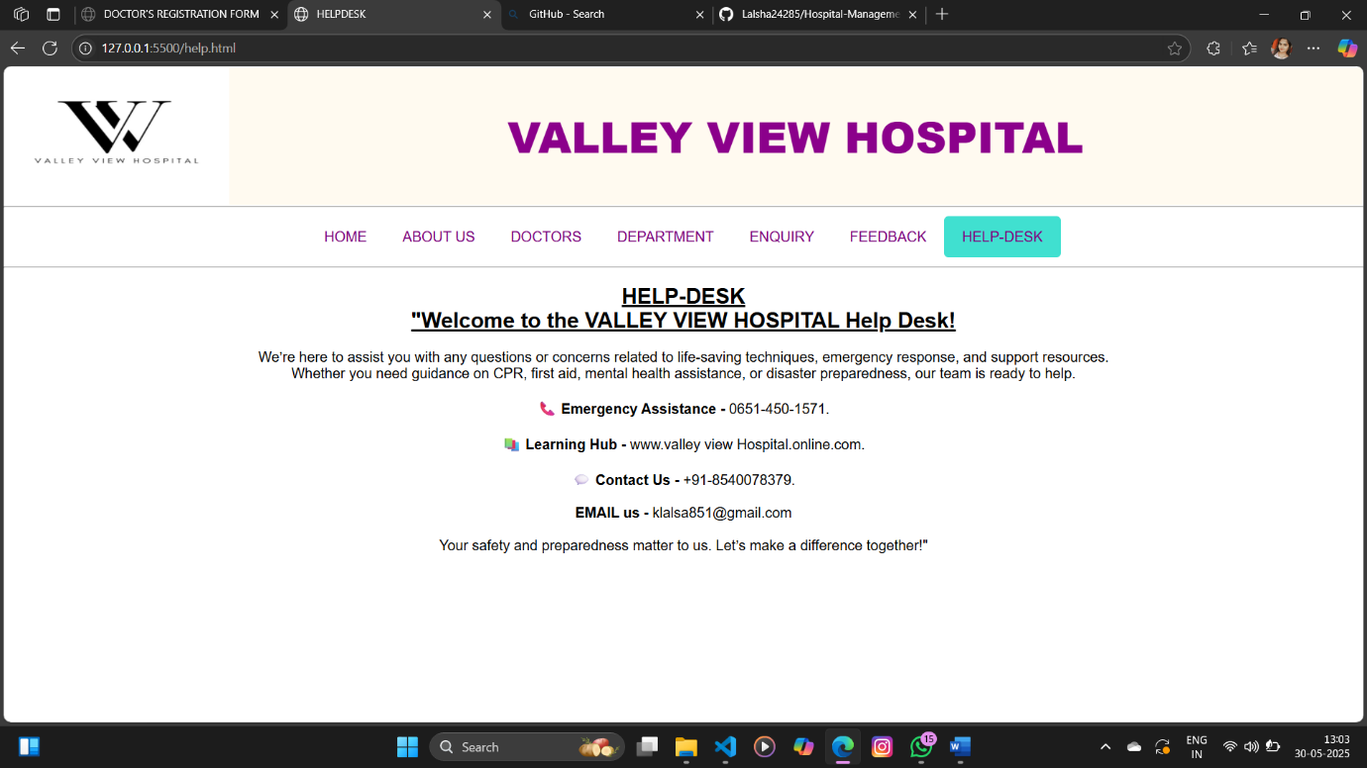

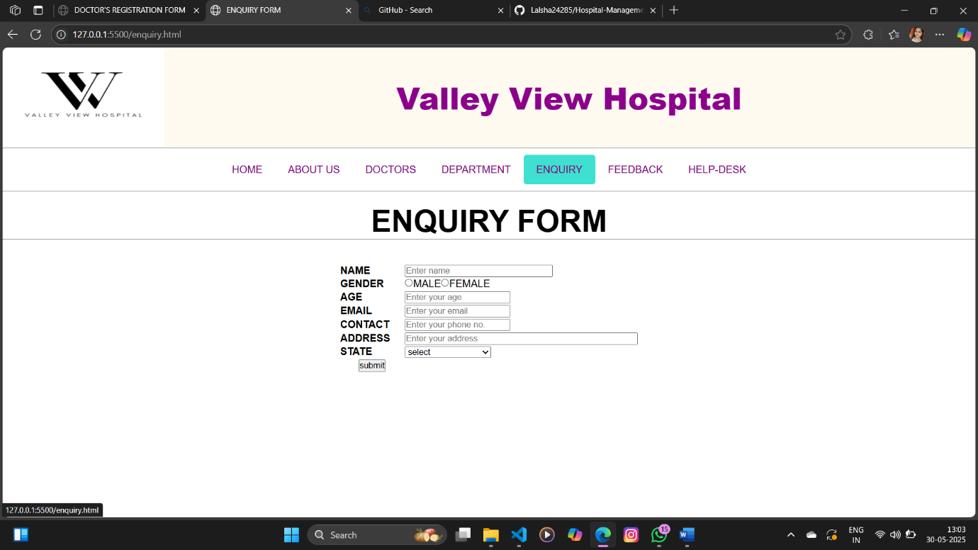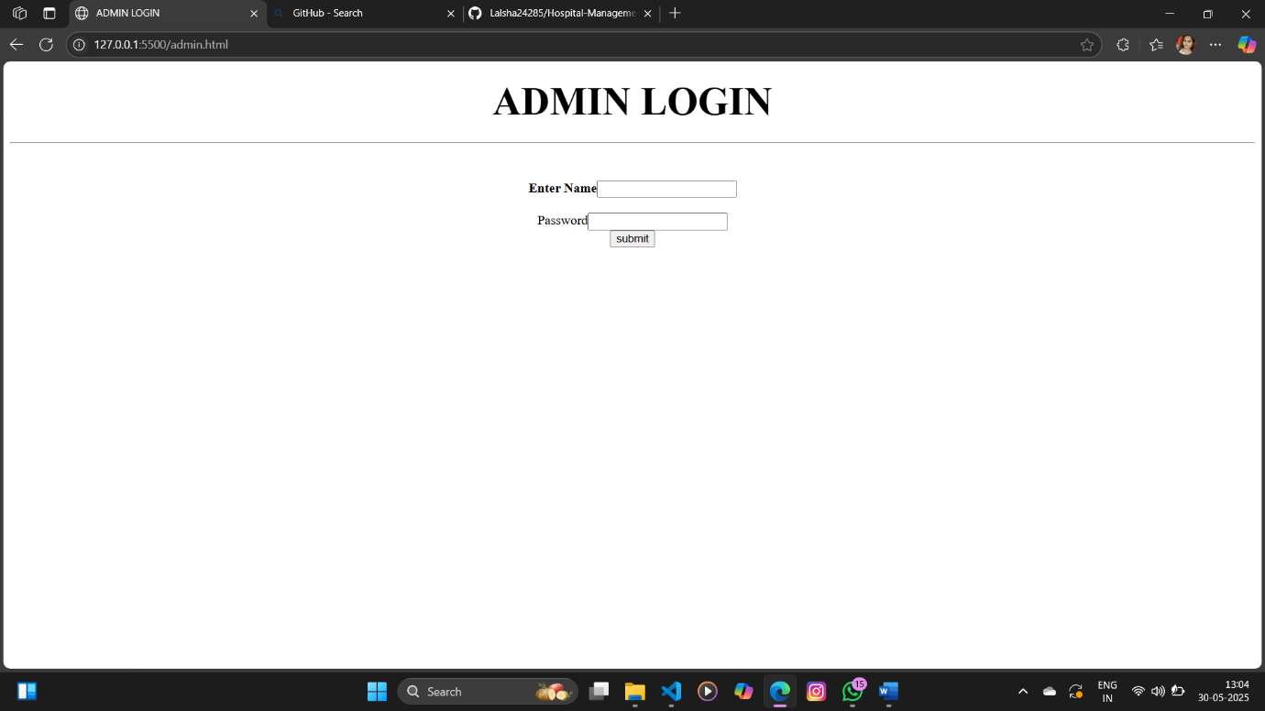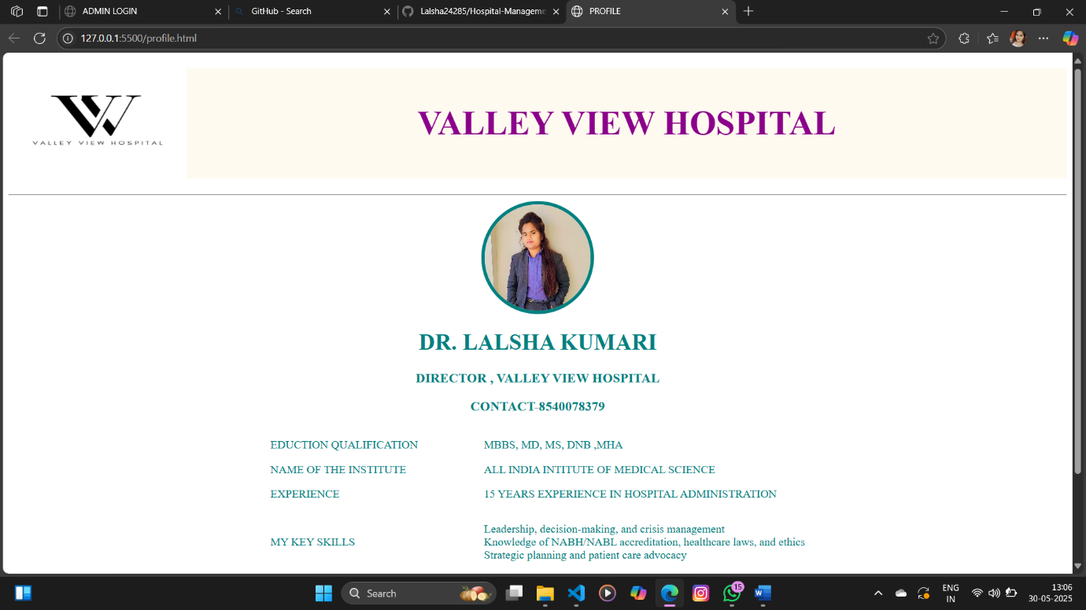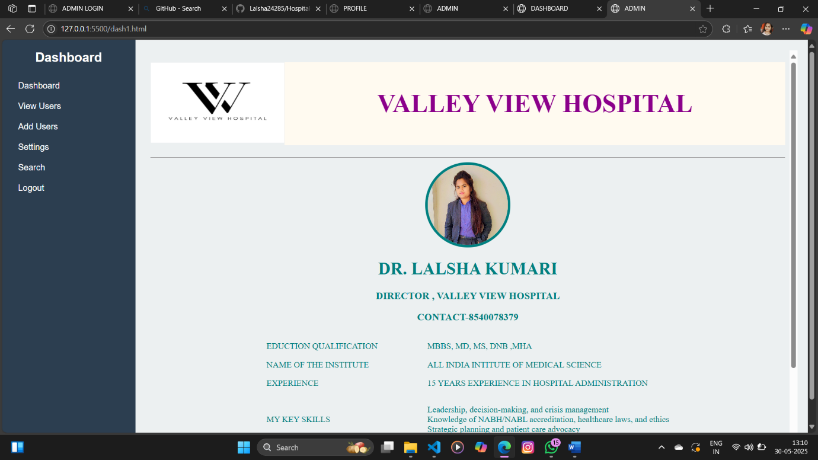

* + 1. **References**

1. **Oracle.** *Java Platform, Standard Edition Documentation.* Available at: <https://docs.oracle.com/javase/>  
   Accessed on: May 2025.
2. **Spring Framework.** *Spring Boot Reference Documentation.* Available at: <https://spring.io/projects/spring-boot>  
   Accessed on: May 2025.
3. **Thymeleaf.** *Thymeleaf: Java XML/XHTML/HTML5 Template Engine.* Available at: <https://www.thymeleaf.org/>  
   Accessed on: May 2025.
4. **Mozilla Developer Network (MDN).** *HTML, CSS, and JavaScript documentation.* Available at: <https://developer.mozilla.org/>  
   Accessed on: May 2025.
5. **MySQL.** *MySQL 8.0 Reference Manual.* Available at: <https://dev.mysql.com/doc/>  
   Accessed on: May 2025.
6. GeeksforGeeks. *Full Stack Web Development Tutorial.* Available at: <https://www.geeksforgeeks.org/full-stack-web-development/>  
   Accessed on: May 2025.
7. **Baeldung.** *Guide to Spring Boot and Full Stack Web Development.* Available at: <https://www.baeldung.com/spring-boot>  
   Accessed on: May 2025.
8. **Stack Overflow.** *Community-driven Q&A for programming and software development.* Available at: <https://stackoverflow.com/>  
   Accessed on: May 2025.
9. **Github upload link:**-