

**Module 1: Hands-On 1:**

**Sign-Up on AWS**

**Steps to Sign up on the AWS Management Console**

**Step 1:** To create a new AWS account, go to [**aws.amazon.com**](http://aws.amazon.com) and choose **Create an AWS Account.**

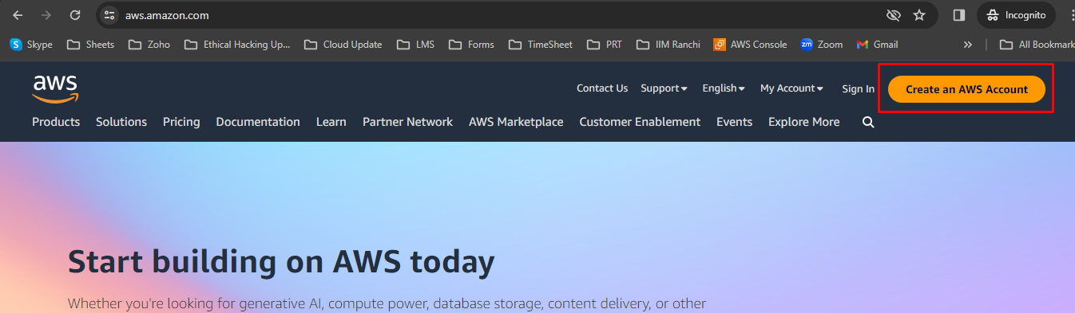

**Step 2:** Enter an **email address** and an **account name**.

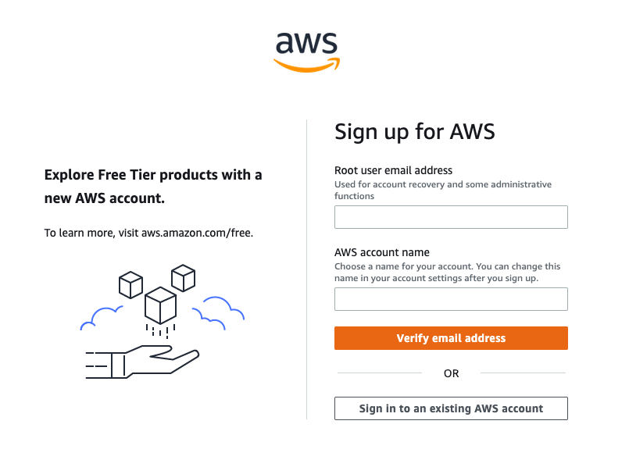

**Step 3:** Select **Verify email address.**

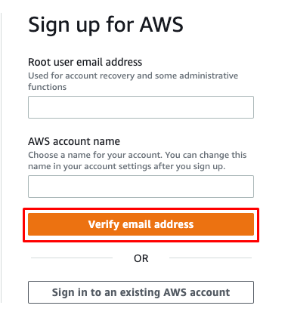

**Step 4:** Create your **Root user password**.

**Step 5:** Once you have entered and **confirmed** your password, choose **Continue (step 1 of 5).**

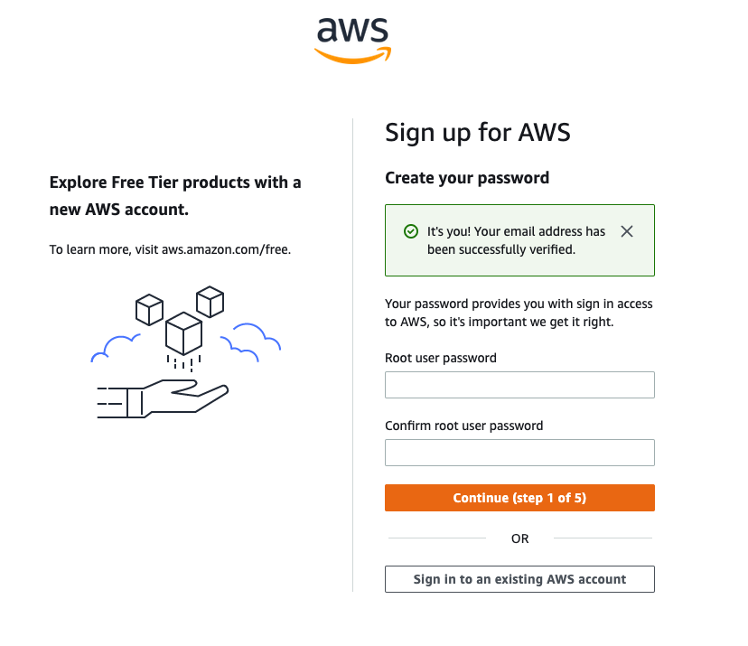

**Step 6:** Choose between a **personal account**.

**Step 7:** Once you have selected the account type, fill out the **Contact Information** about the account.

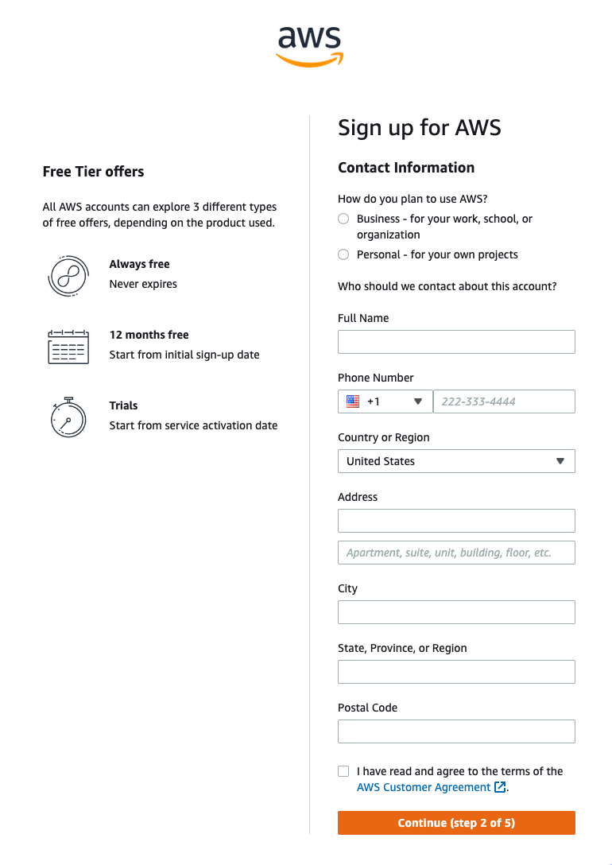

**Step 8:** At the end of this form, please read through the terms of the **AWS Customer Agreement** and **select the checkbox** to accept them.

**Step 9:** Choose **Continue (step 2 of 5)** to proceed to the next screen.

**Step 10:** Enter your **Billing Information** details.

**Step 11:** Select **Verify and Continue (step 3 of 5)** to proceed.

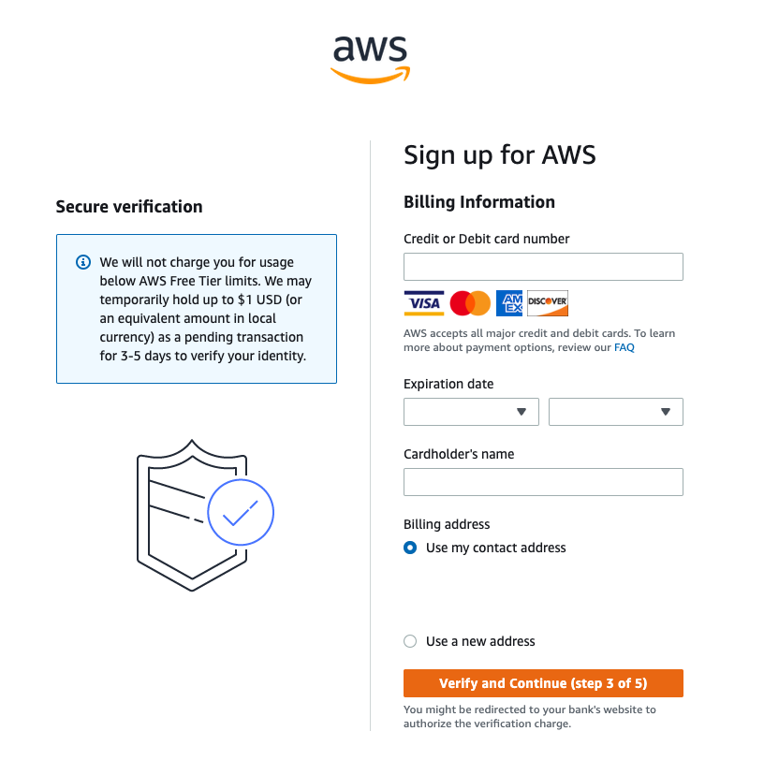

**Step 12:** Choose how you want to confirm your identity. For the **Text message (SMS)** option, you will be sent a numeric code to enter; choose **Send SMS (step 4 of 5).**

**Step 13:** Enter the code as appropriate for your verification choice, then choose **Continue** to proceed to the final step.

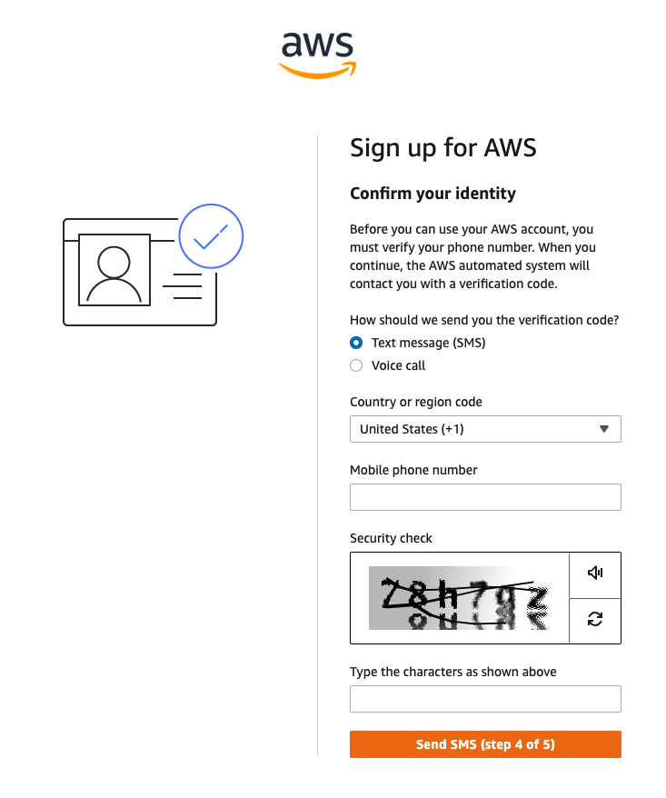

**Step 14:** Choose a support plan. We recommend the **Basic Plan.**

**Step 15:** To finish creating your account, choose **Complete sign-up.**

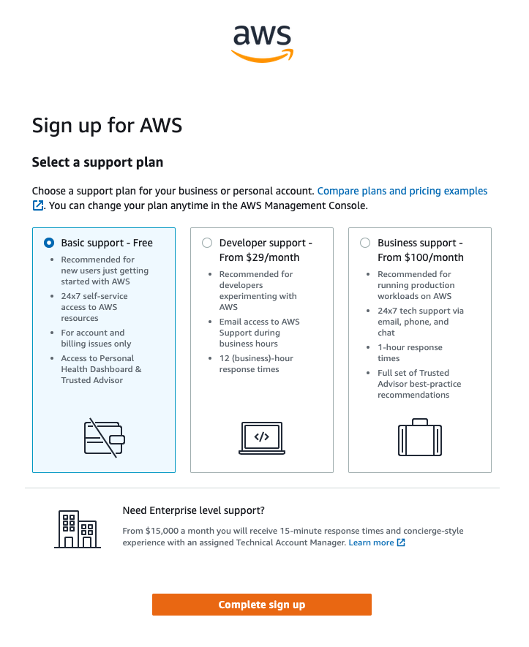

**Congratulations! Your account is now set up and being activated. When activation is complete, you will receive an email from AWS. Use the credentials you created in this module to log in to your root account.**